|  |
| --- |
| Department of Software Engineering  Mehran University of Engineering and Technology, Jamshoro |

|  |  |  |  |
| --- | --- | --- | --- |
| Course: SWE324 - Data Warehousing and Data Mining | | | |
| Instructor | Rabeea Jaffari | **Practical/Lab No.** | 06,07,08 |
| Date | 07 May 2019 | **CLOs** | CLO-4: P3 & P4 |
| Signature |  | **Assessment Score** | 1 Marks |

|  |  |
| --- | --- |
| Topic | To become familiar with DW implementation, query execution and result analysis |
| Objectives | * To learn physical DW Design * To learn executing queries in DW * To learn analyzing results of DW queries |

|  |
| --- |
| Lab Discussion: Theoretical concepts and Procedural steps |

|  |
| --- |
| Lab Tasks |
| Submission Date: |

Generate reports using both MDX and Excel Pivot table for the following scenarios:

1. Display the standard cost of all the products along with their categories according to the regions in which they were sold. Which region is the most and the least expensive according to the result retrieved?

**Pivot Table**

The most and the least expensive according to the result retrieved **UNITED STATE**

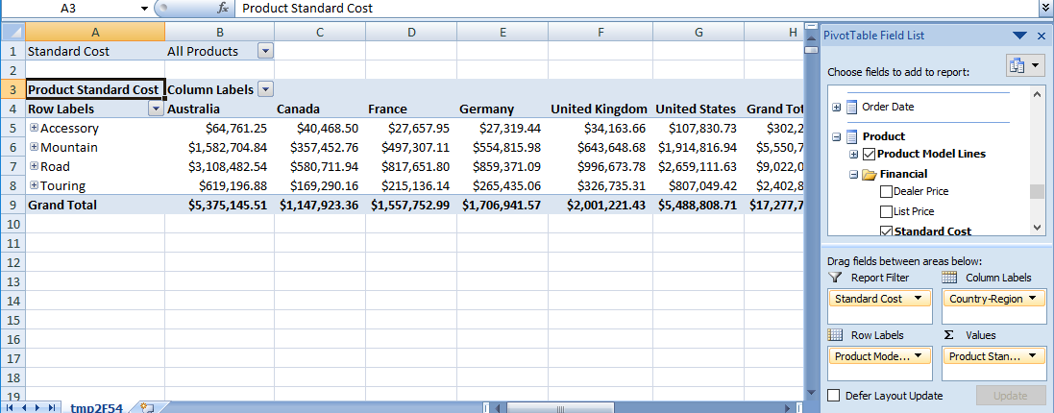

1. Display the Tax amount for customers according to their educations and occupations over calendar year. Do these factors impact the tax amount paid by a customer? Which class of customers pays the highest tax amount?

**Pivot Table**

Ans:- Yes these factor impact on customer you can see in image given Below.

-The Bachelors class pays highest tax amount.

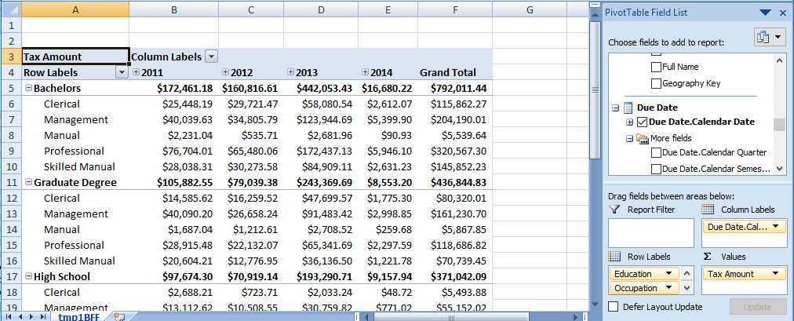

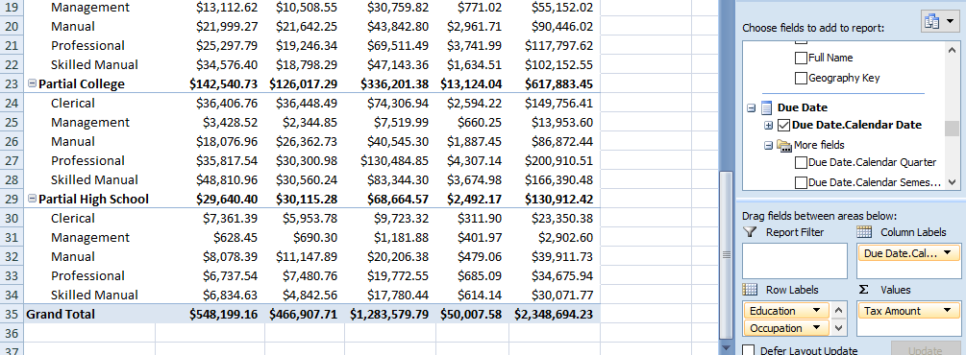

* **Generate reports using MDX**

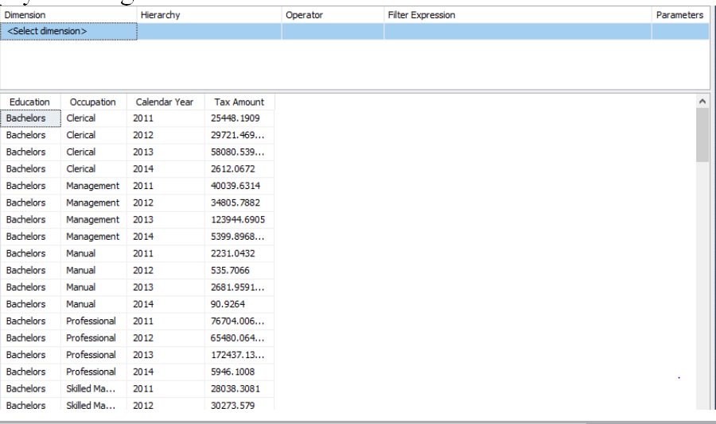

1. Display the sales amount for all products (use product hierarchy) purchased according to the calendar year and filter the results according to the customers’ genders. What type of customers bought the most Biking products?

**Pivot Table**

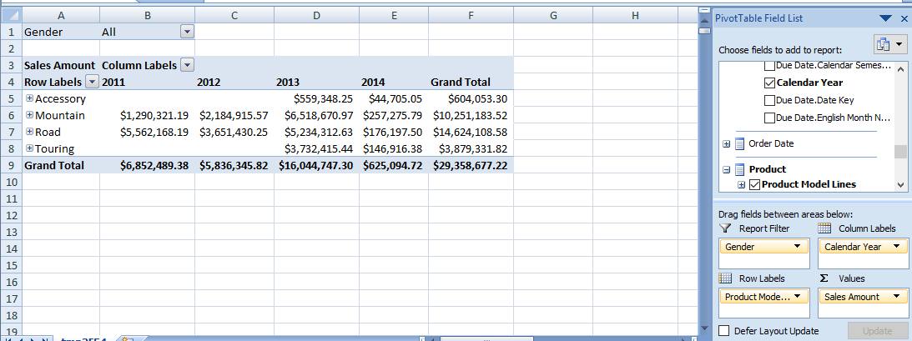

* **Generate reports using MDX**

The Female bought the most biking Products Show In Below Image.

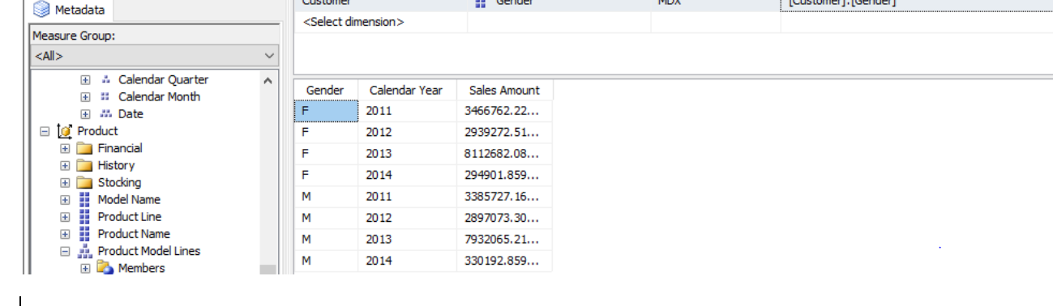

1. Display the total days required to manufacture the products (use product hierarchy) according to region and time (use date hierarchy).

**Pivot Table**

|  |  |  |  |  |  |  |  |  |
| --- | --- | --- | --- | --- | --- | --- | --- | --- |
| **Days To Manufacture** | **Column Labels** |  |  |  |  |  |  |  |
| **Row Labels** | **Australia** | **Canada** | **France** | **Germany** | **United Kingdom** | **United States** | **Unknown** | **Grand Total** |
| Accessory | 0 | 0 | 0 | 0 | 0 | 0 | 0 | 0 |
| Components | 44 | 44 | 44 | 44 | 44 | 44 | 44 | 44 |
| Mountain | 220 | 220 | 220 | 220 | 220 | 220 | 220 | 220 |
| Road | 349 | 349 | 349 | 349 | 349 | 349 | 349 | 349 |
| Touring | 115 | 115 | 115 | 115 | 115 | 115 | 115 | 115 |
| **Grand Total** | **728** | **728** | **728** | **728** | **728** | **728** | **728** | **728** |

1. Display the order quantity for all the products ordered by customers according to their marital statuses and genders. Filter the results for customers having yearly income greater than or equal to 50,000.

**Pivot Table**

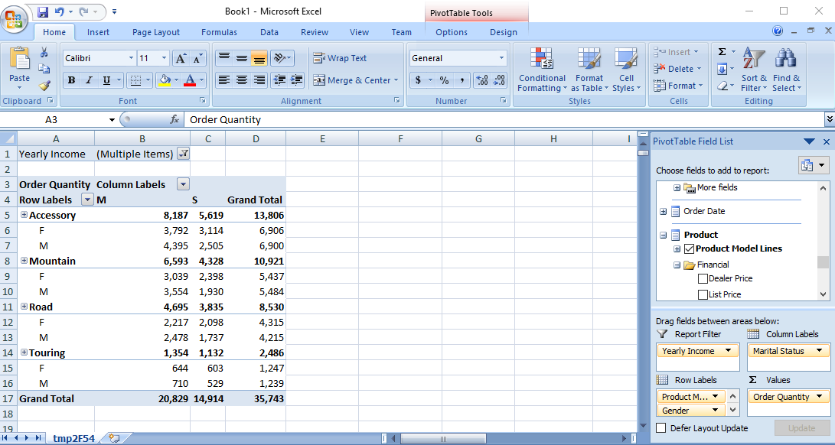

* **Generate reports using MDX**

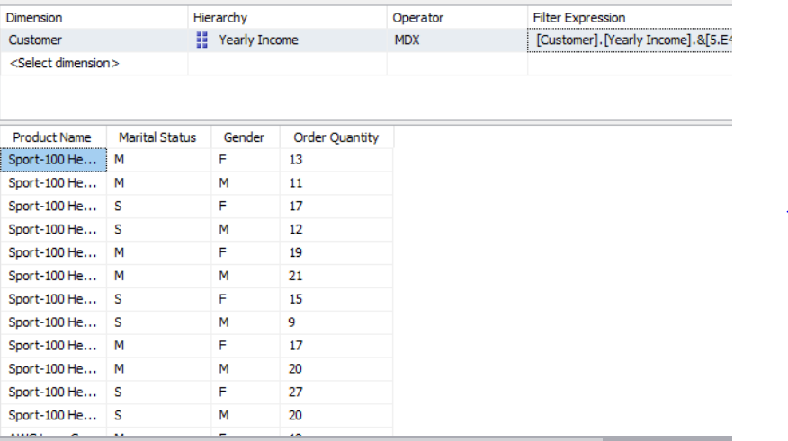

**Task: 6** Generate pivot charts for any 3 scenarios mentioned above to better visualize the data.

**Scenario – 1** Display the order quantity for all the products ordered by customers according to their marital statuses and genders. Filter the results for customers having yearly income greater than or equal to 50,000.

**Pivot Chart:**

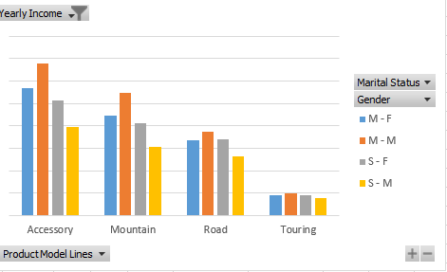

**Scenario – 2** Display the sales amount for all products (use product hierarchy) purchased according to the calendar year and filter the results according to the customers’ genders. What type of customers bought the most Biking products?

**Pivot Chart For Female:**

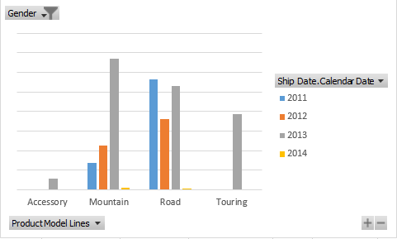

**Pivot Chart For Male:**

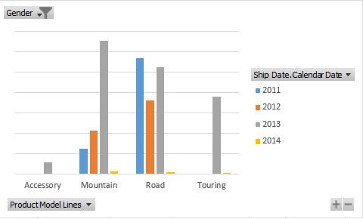

**Scenario – 3 :** Display the standard cost of all the products along with their categories according to the regions in which they were sold. Which region is the most and the least expensive according to the result retrieved?

**Pivot Chart:**

