7/26/2020

DIP

Assignment # 4

University of Engineering and technology taxila

Usama Zafar

17-se-73

Abdul Wahab

17-SE-65

Vehicle recognotion using Brand system

We have used more than 110 images of Pakistani Cars, specifically

1. Toyota
2. Mehran
3. Suzuki (Bolan)

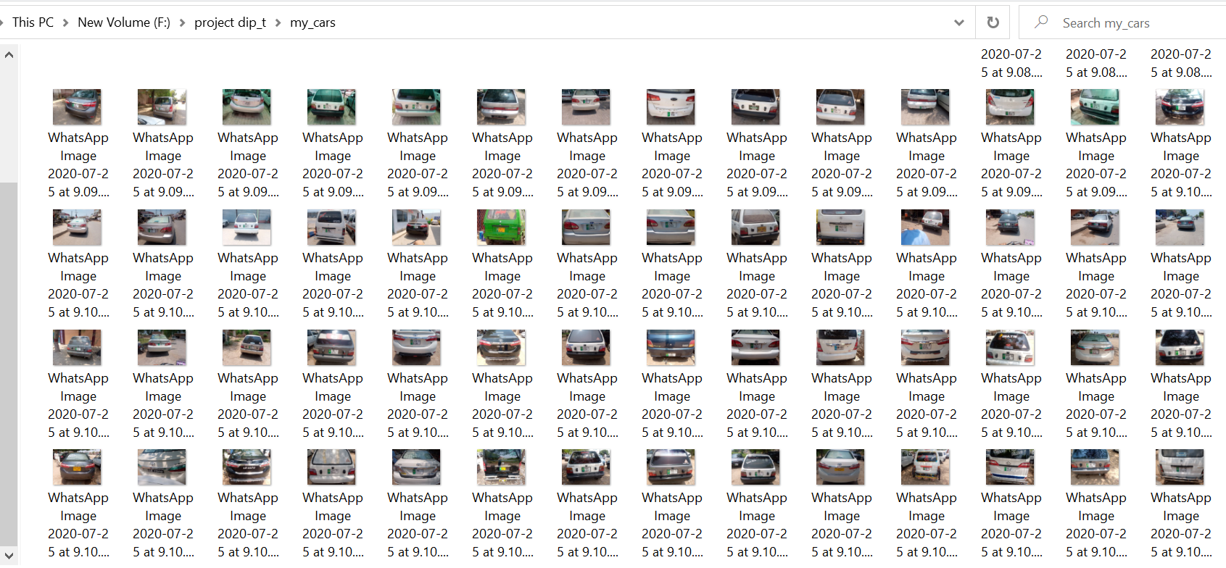

# Preprocessing

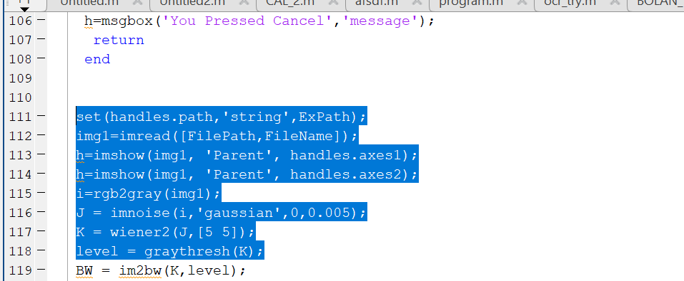

# Template matching

NCC is also tried for matching the template with the image..

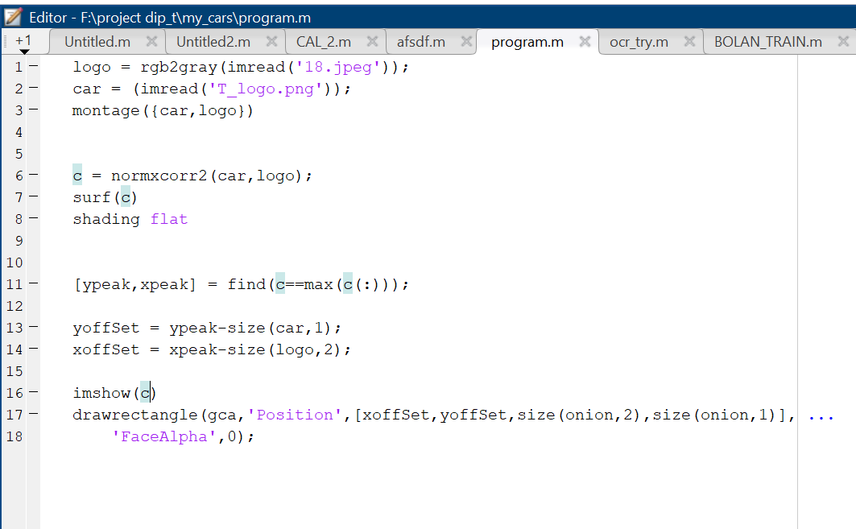

But this was not as useful as OCR.

# OCR Training

Different brands are trained separately

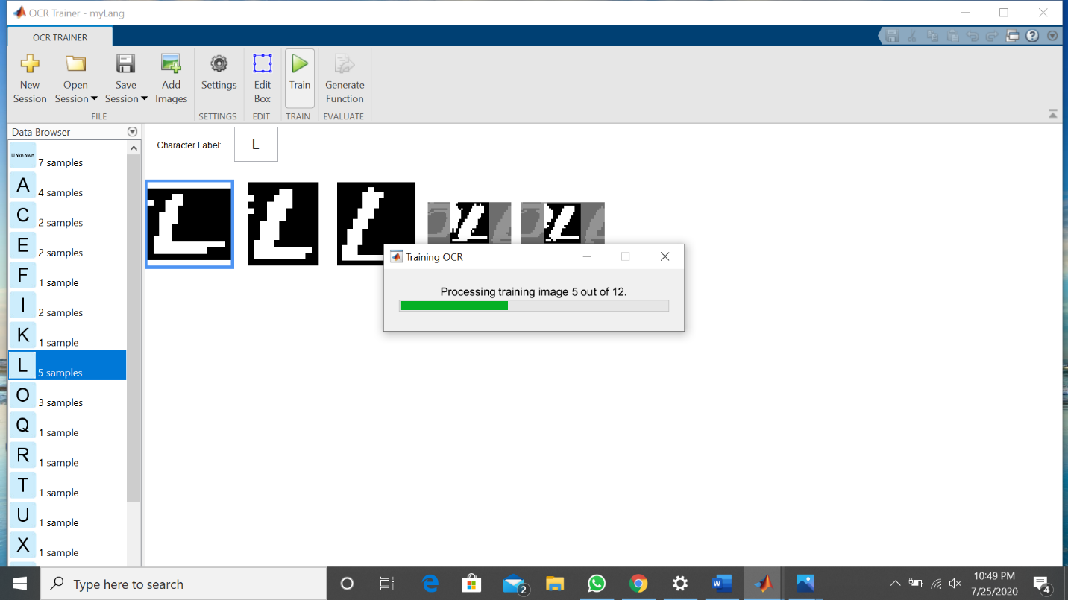

# For Toyota OCR training

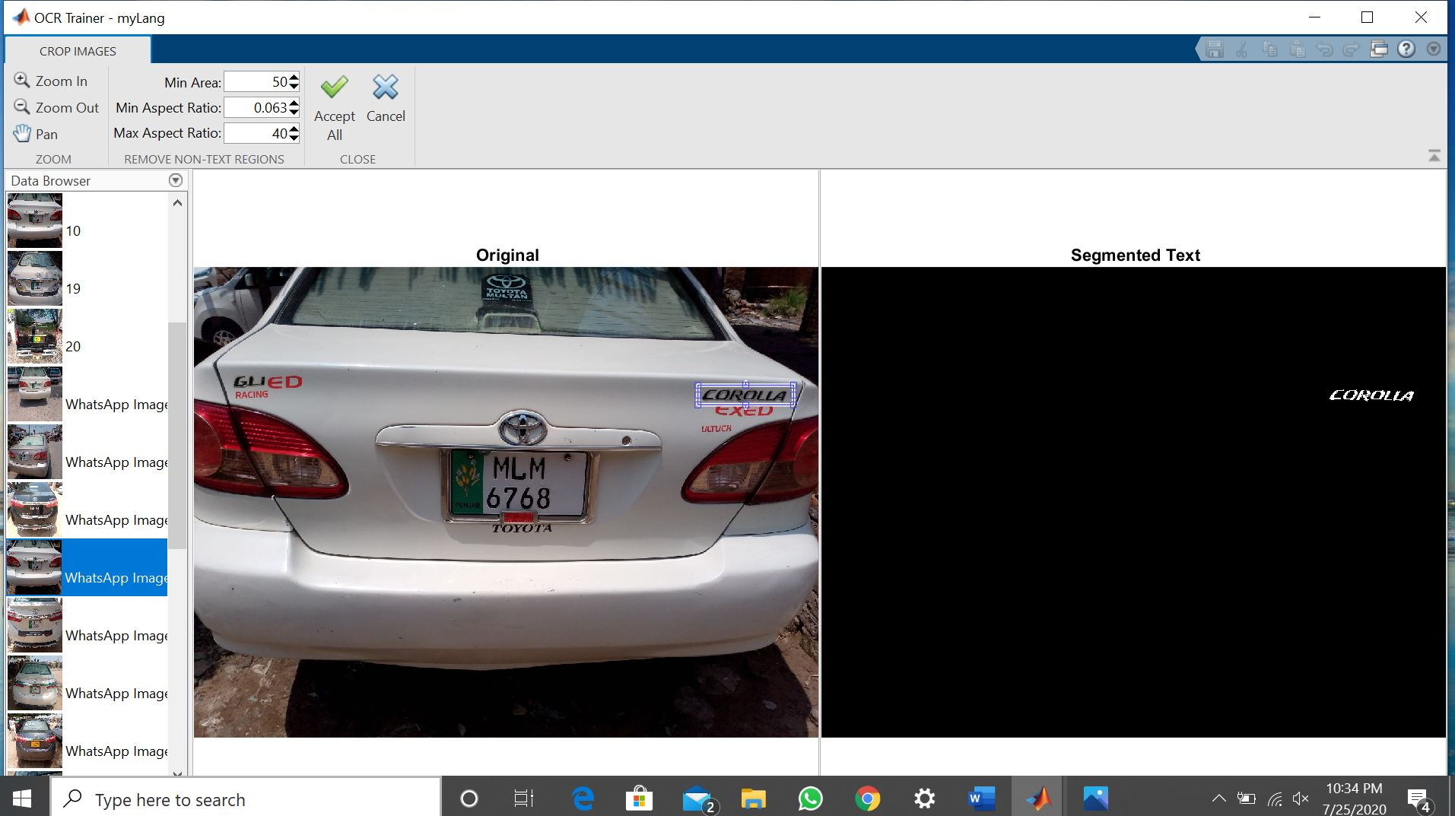

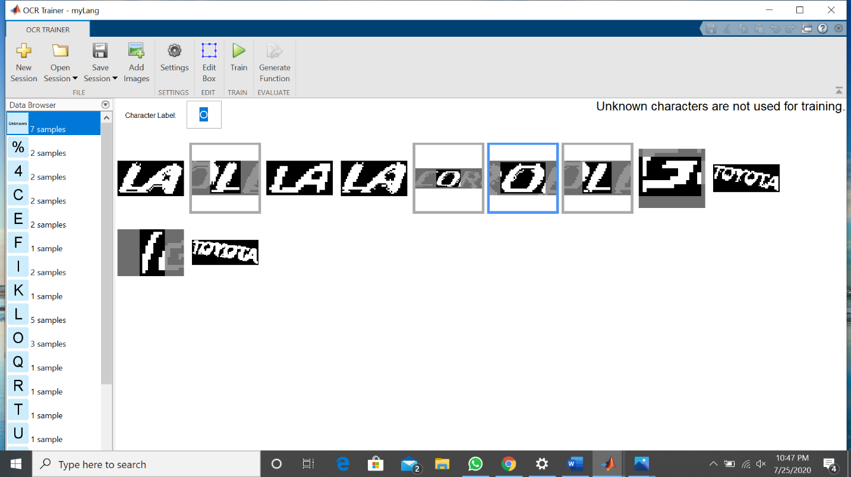

# For MEHRAN Cars OCR training is as followed

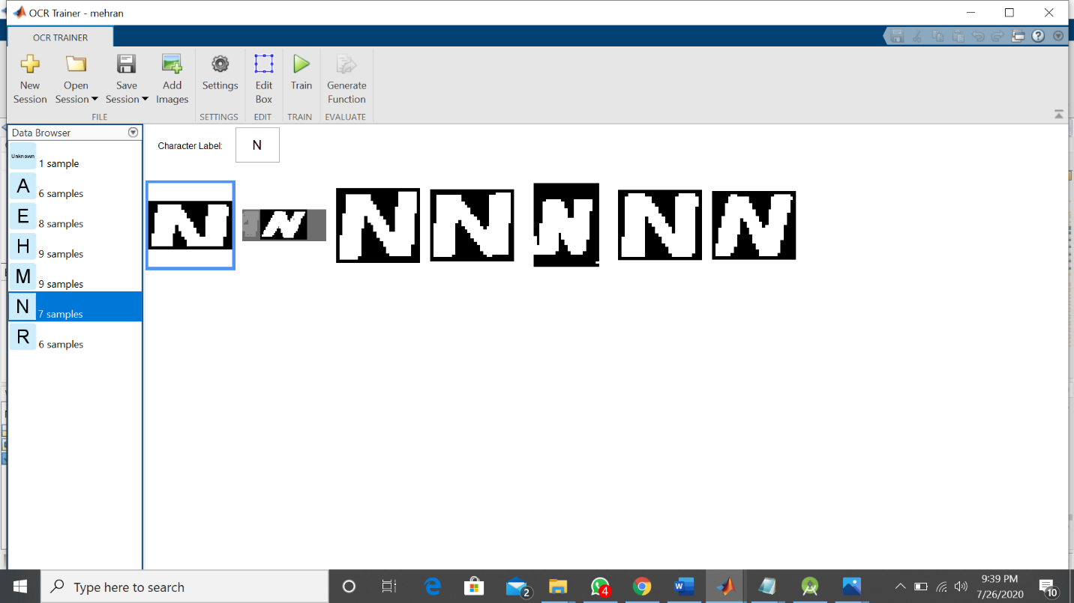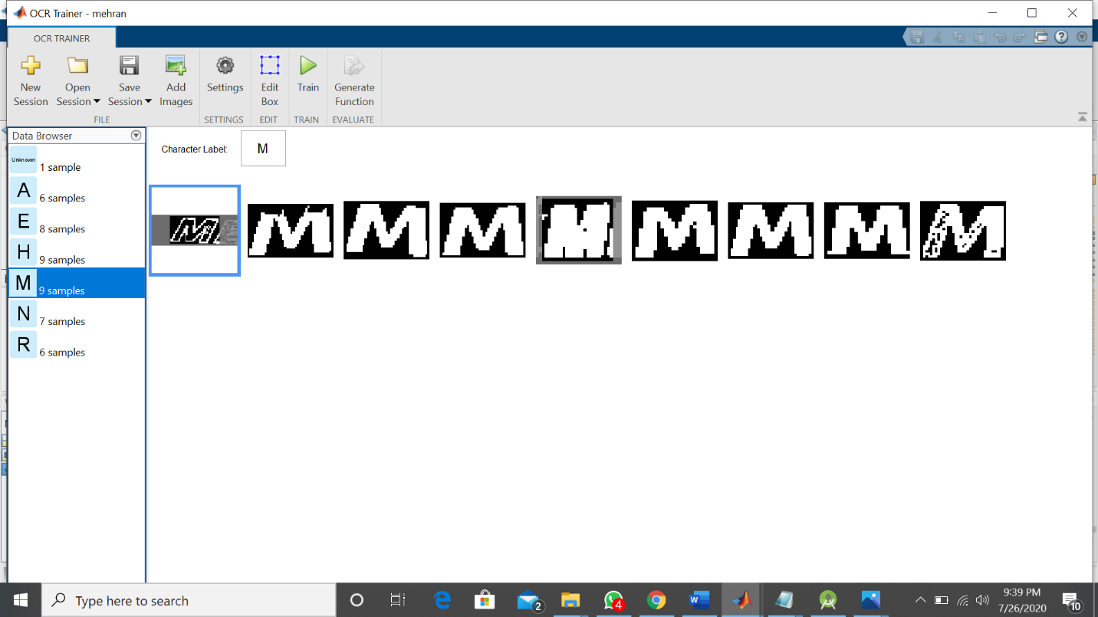

After training OCR results

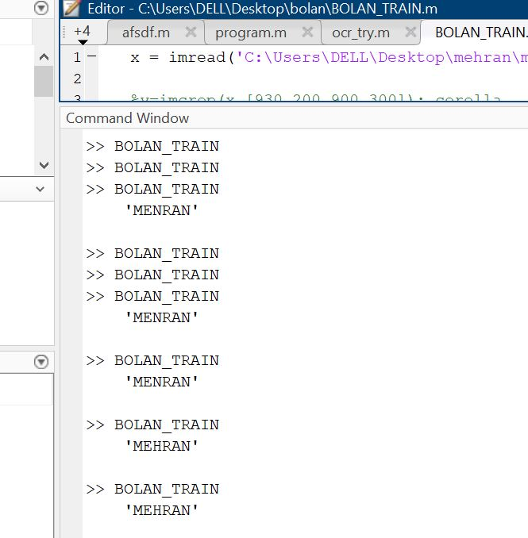

# OCR code behind GUI in version2.m file

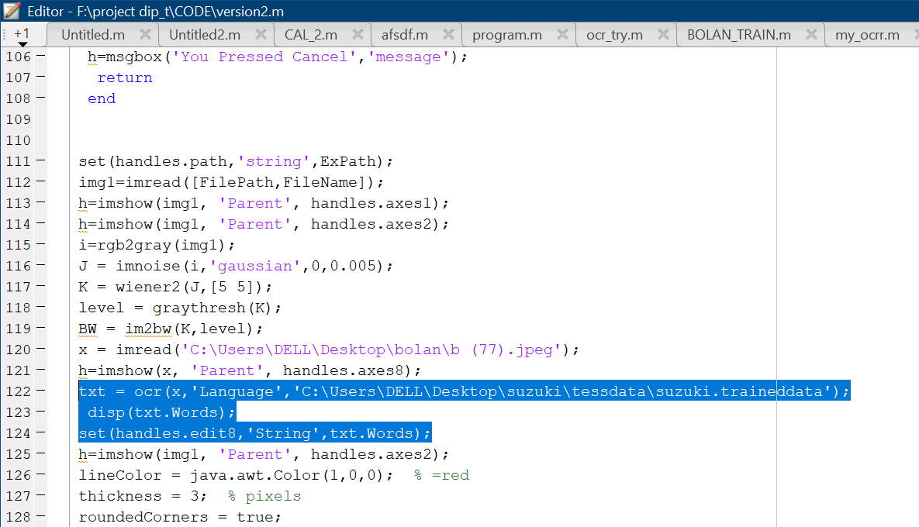

# Gui is designed using fig in matlab.

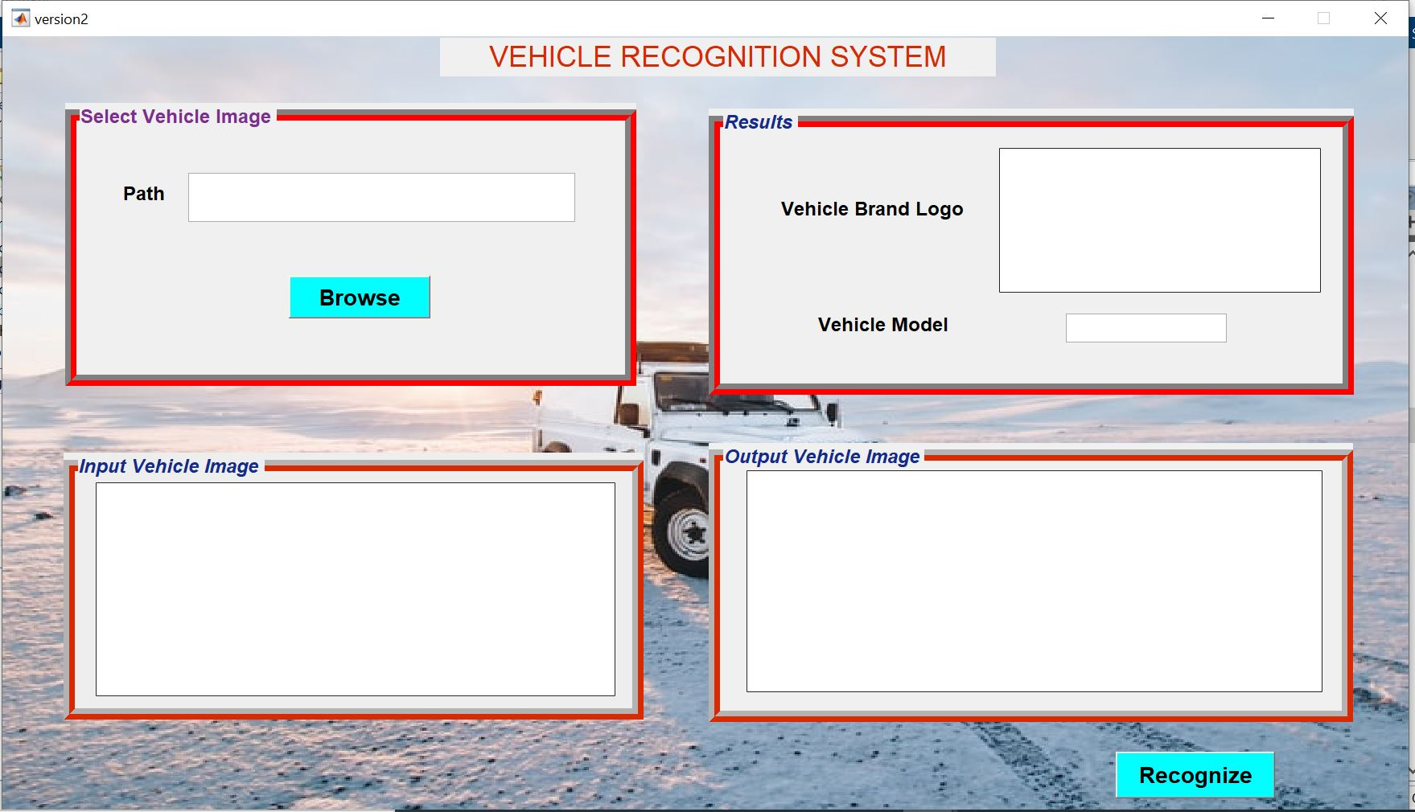

User can browse AND LOAD input image as

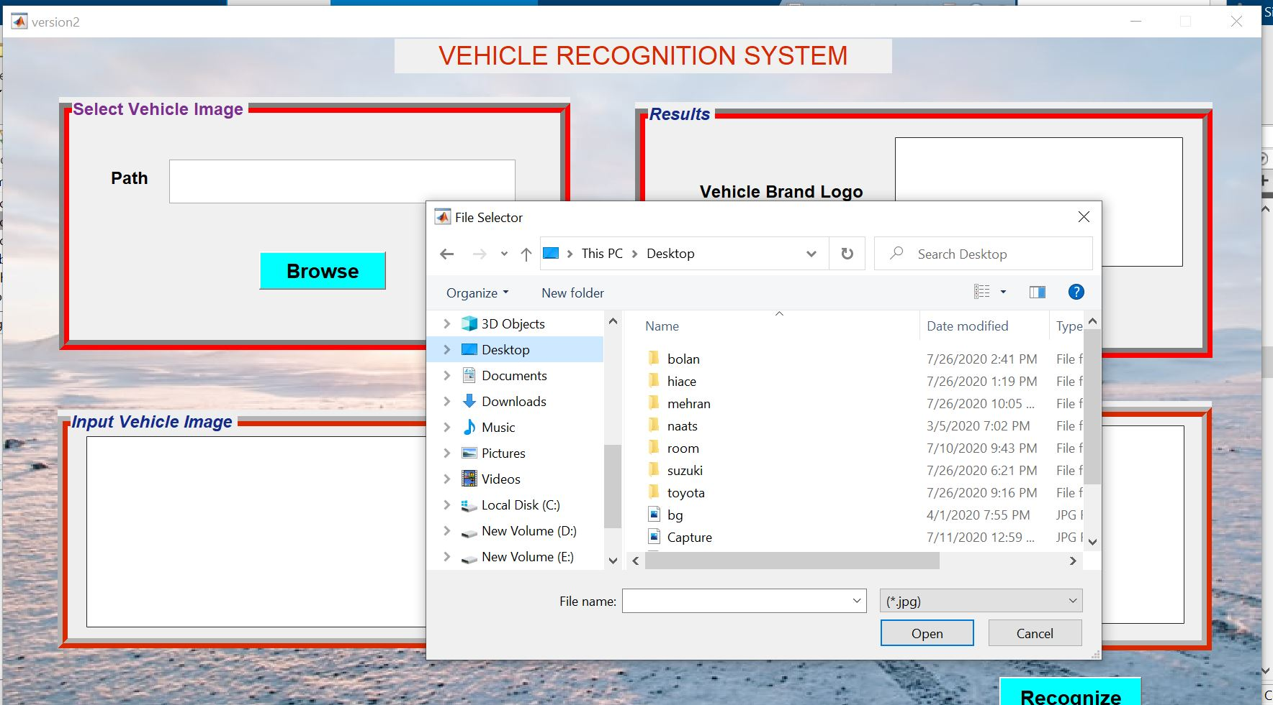

# Validation checks

If no image is selected for input then message dialog box is shown as Cancelled.

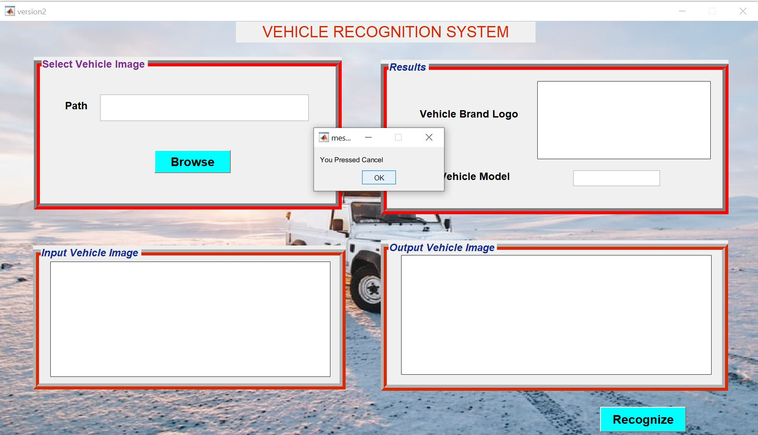

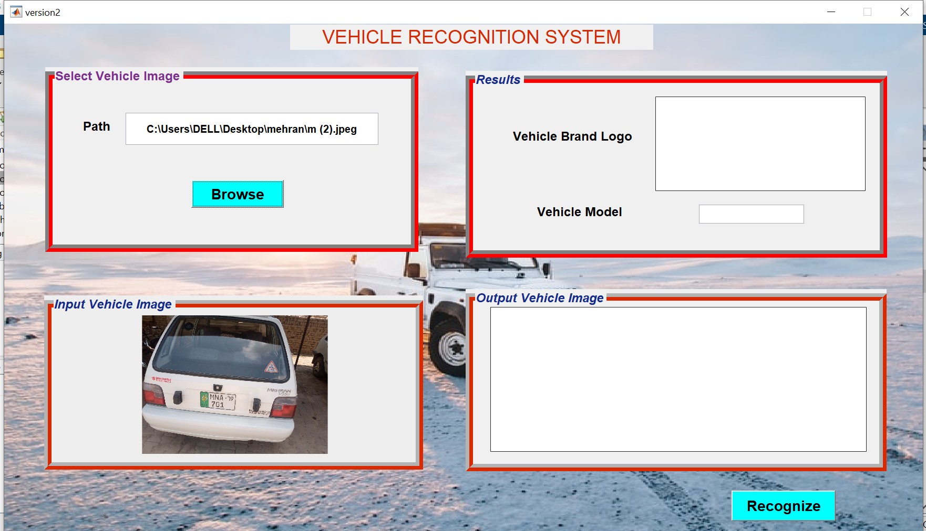

The input image is Preprocessed then Specific ROI is extracted and checked by the OCR.

