Abdul Wahab 17-se-65

Usama Zafar 17-se-73

DIP Assignment

Preprocessing

Q1. Pick any standard image from the matlab. Compute and display the histogram of that image. You can use built in functions only for reading and displaying images (imread/ imshow etc).

a=imread("cameraman.tif");

% a=rgb2gray(A);

% subplot(3,1,1);

imshow(a);

title('original image');

[r,c]=size(a);

z=zeros(1,256);

for i=1:r

for j=1:c

b=a(i,j);

z(b+1)=z(b+1)+1;

end

end

N=sum(z);

p=zeros(1,256);

s=zeros(1,256);

c=zeros(1,256);

r=zeros(1,256);

for k=1:256

p(k)=z(k)/N;

if k==1

c(k)=p(k);

s(k)=c(k)*255;

r(k)=floor(s(k));

else

c(k)=c(k-1)+p(k);

s(k)=c(k)*255;

r(k)=floor(s(k));

end

end

subplot(3,1,3)

stem(r,z)

title('histogram')

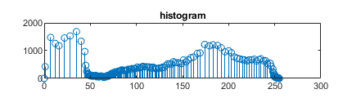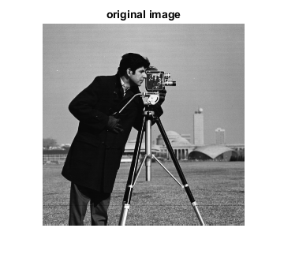

Q2. Decompose your term project in three phases. Implement the pre-processing stage of your project by applying image enhancement filters/other relevant tasks for your project.

**Vehicle Type and its brand recognition**

Flowchart

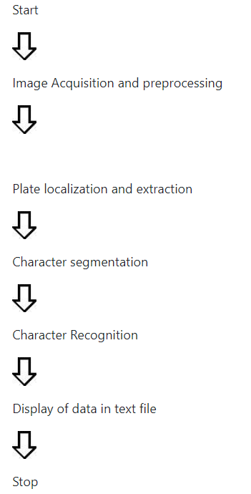

Preprocessing Stage of Project

The initial part of image process for Vehicle car place Recognition is to get pictures of vehicles. Electronic devices like optical (digital/video) camera, digital camera etc. may be accustomed capture the non-inheritable  pictures. For this project, vehicle pictures are soft on a Panasonic FX thirty photographic camera. The images will be stored as JPEG format on the camera.

Dataset collected for project is of two types. One is colored images.

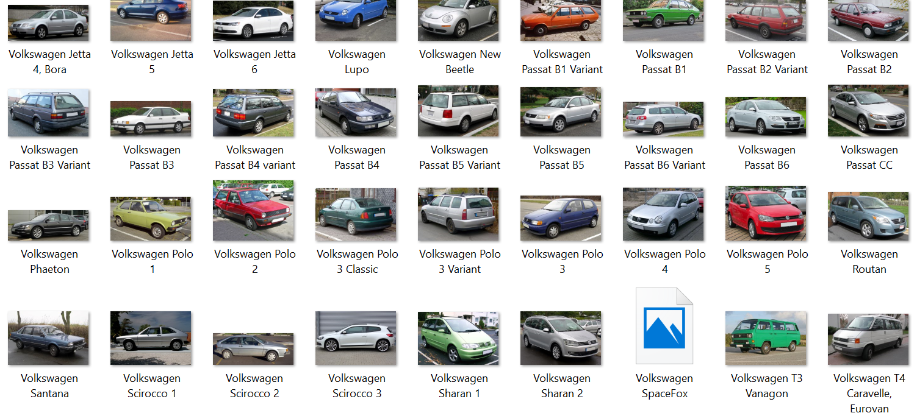

And the other one contains the images of vehicles from back side.

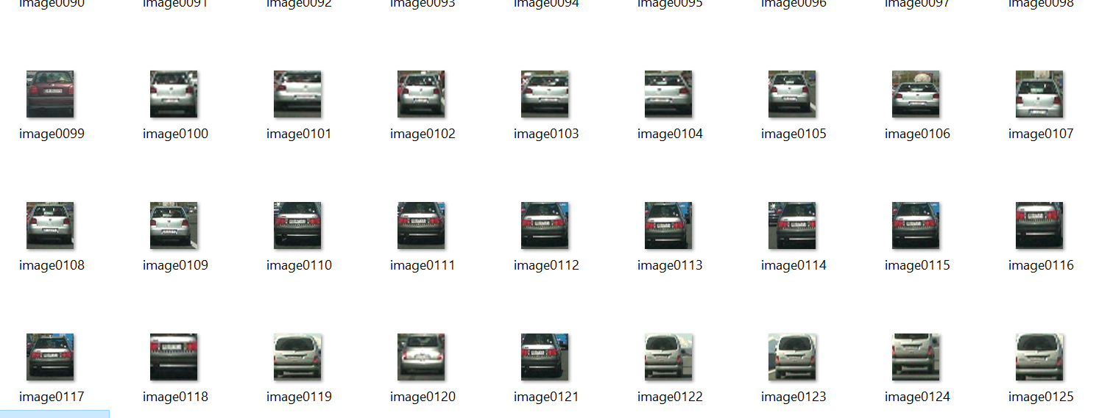

**Preprocessing Techniques:**

Gray scale conversion: From the 24-bit color value of each pixel (i,j) the R, G and B components are separated and the 8-bit gray value is calculated using buit-in methods of matlab.

img = imread("C:\Users\Wahab Bhai\Downloads\matlab assign\1.jpeg");

imshow(img);

noise=imnoise(img);

imshow(noise);

a= rgb2gray(img);

anoi=imnoise(a)

imshow(anoi);

y = medfilt2(anoi);

imshow(y);

Median filtering: Median filter is a non-linear filter, which replaces the gray value of a pixel by the median of the gray values of its neighbors. This operation removes salt-and-peeper noise from the image.

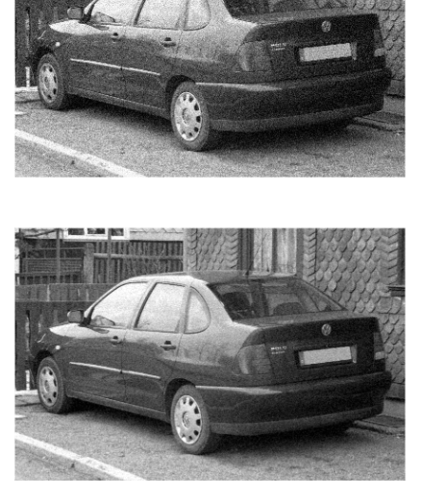

As RGB color space is greatly affected by light, we cannot use it to determine colors. So We need to change the color image to Gray scale image using rgb2gray function.

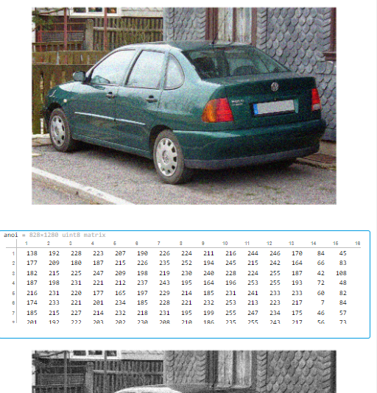

# References

<https://www.mathworks.com/help/images/image-enhancement-and-restoration.html>

<https://www.ukdiss.com/examples/ocr-based-vehicular-recognition-using-segmentation.php>

<https://www.mathworks.com/help/images/roi-based-processing.html>