Software Requirements Specification

for

<Android Battery Saver System>

Version 1.0 approved

Prepared by <Mian Muhammad Usama Bin Riaz>

<Indus University>

<31/5/2017>

Table of Contents

Table of Contents ii

Revision History ii

1. Introduction 1

1.1 Purpose 1

1.2 Document Conventions 1

1.3 Intended Audience and Reading Suggestions 1

1.4 Product Scope 1

1.5 References 1

2. Overall Description 2

2.1 Product Perspective 2

2.2 Product Functions 2

2.3 User Classes and Characteristics 2

2.4 Operating Environment 3

2.5 Design and Implementation Constraints 3

2.6 User Documentation 4

2.7 Assumptions and Dependencies 4

3. External Interface Requirements 4

3.1 User Interfaces 4

3.2 Hardware Interfaces 6

3.3 Software Interfaces 7

3.4 Communications Interfaces 7

4. System Features 7

4.1 System Feature 1 8

4.2 System Feature 2 (and so on) 9

5. Other Nonfunctional Requirements 15

5.1 Performance Requirements 15

5.2 Safety Requirements 15

5.3 Security Requirements 15

5.4 Software Quality Attributes 15

5.5 Business Rules 15

6. Other Requirements 16

Appendix A: Glossary 16

Appendix B: Analysis Models 16

Appendix C: To Be Determined List 16

Revision History

|  |  |  |  |
| --- | --- | --- | --- |
| **Name** | **Date** | **Reason For Changes** | **Version** |
|  |  |  |  |
|  |  |  |  |

1. **Introduction:-**
   1. **Purpose:-**

*This document describes the software requirements and specification (SRS) for an Android Battery Saver System. The document is intended for the customer and the developer (designers, testers, maintainers). The reader is assumed to have basic Knowledge of Battery Saver and Android system. The purpose of this document is to understanding of requirement of Android Battery Saver system.*

* 1. **Document Conventions**

*The font used is Arial. Headings’ font size is 16 and for subheadings it is 12(both in bold and italics). Calibri is used for the body with size 11.*

* 1. **Intended Audience and Reading Suggestions**

*The general user who uses this document are the buyer who wants to buy this app the app developer who deploy this app the project manager, the designer, the tester and the maintainer.*

* 1. **Product Scope**

*This System is an innovative Application allowing the System to take the usage from Build-in classes and put a list in front of the user for him to review. The List also consists of the applications taking the battery usage and also determines the battery level. If the Battery level is low and the consumption of apps is more the system will trigger an alarm telling the user to force stop or close the apps.*

* 1. **References**

http://www.androidauthority.com/android-battery-saver-tips-tricks-189882/

[**http://www.hongkiat.com/blog/android-app-save-battery/**](http://www.hongkiat.com/blog/android-app-save-battery/)

[**https://www.androidpit.com/how-to-save-battery-life**](https://www.androidpit.com/how-to-save-battery-life)

[**http://nevonprojects.com/android-battery-saver-system/**](http://nevonprojects.com/android-battery-saver-system/)

[**http://ieeexplore.ieee.org/xpl/downloadCitations**](http://ieeexplore.ieee.org/xpl/downloadCitations)

**2. Overall Description**

**2.1 Product Perspective**

*This app provides the best power settings to saves the battery time of your device or your tablet. It provides long lasting time to your mobile phone battery. When alarm is trigger and user enabled battery saver, then Battery saver switch off all the extra functions like WiFi, Bluetooth, GPS, sound and other energy consuming apps on the device. The app will notify when the power gets down in percentage and  
it even shows the charging stages.*

**2.2 Product Functions**

*By using this application user can save their phone’s battery, this app provides them time to use their phone. The main functions that are uses in battery saver system.*

* **Saver**: *The saver option of the Battery saver aims at minimizing battery consumption by switching on/off the services that are not needed at the time but consumes battery life.*
* **Battery status display*:*** *It shows the battery life remaining and tells how to fast charge, full charge or trickle charge the device.*
* **Optimize button:** *That looks for problem apps and optimizes background processes to extend your battery life just that extra smidgen more.*
* **Monitor*:****This section helps to monitor the device in such a way that we can easily infer the apps which are consuming the battery and by how much.*
* **Notification & Reminder:** *With notification settings, you can set the charge, low power and mode which reminders for your device*.

**2.3 User Classes and Characteristics**

*There are several users of the battery saver system.*

**Customers** *are simply members of public with no special training.*

**Developers** *who develop the app.*

**Maintainers** *are the person who must be experienced about technical things, and should maintain app time to time and should be responsible to update the app regularly and improve quality of software.*

**2.4 Operating Environment**

*The environment, technologies, and hardware platform that should be used in this project is listed down:*

* *This app only applicable in android series.*
* *Android version should be at least 4.0 in which app should work.*
* *This app linked with mobile phones battery to overcome the rate of consumption.*
* *This app connected with ram of mobile phones to kill unnecessary apps.*
* *This app is connected with sensor of mobile phone to get notify about low battery.*

**2.5 Design and Implementation Constraints**

**Battery saver**

* *If your phone notify turn on battery saver mode.*
* *Enable battery saver.*

**Mode**

**Saving Mode: (Use in lowest Battery Status)**

* *Device Brightness set to 10%*
* *In Activate WiFi of the Device*
* *Stand By time to 15 seconds*

**Sleep Mode: (Use when you sleep)**

* *Turn Off Call & SMS and turn ON the Flight Mode*
* *Set Vibrations Off.*
* *Airplane Mode.*
* *Sound Off and mute media sound too.*
* *Brightness set to 10% or minimum level.*

**Customized Mode**

* *You can Customize app usages as your need to save Battery Power.*
* *Can adjust the battery saving setting freely depend on your need and usage.*
* *Can adjust WiFi, Bluetooth, vibration, sound, device brightness, synchronization and stand by time.*

**Display Battery Status**

* *Display battery percentage remaining.*
* *Display battery time remaining.*
* *Display affecting apps.*

**Phone cooler**

* *Scan C.P.U.*
* *Cool down apps which are affected.*

**Optimizer**

* *Optimizes background process.*
* *Extend your battery life just that extra smidgen more.*

**Boost**

* *Release RAM.*
* *By turn off un useful apps*.

**Draining your battery**

* *Use to see a list of all apps and how much battery power they're using.*
* *If any app is not necessary for user seems to take up a disproportionate amount of power, consider uninstalling it.*

## 

**2.6 User Documentation**

*The short description is provided to users to understand the features or functions of app which helps them easy use of the app*.

**2.7 Assumptions and Dependencies**

* *Not damaged in battery of mobile phone.*
* *If battery is damaged battery saver never work.*
* *C.P.U of mobile should process correctly.*
* *RAM of mobile phone work properly.*
* *Sensor of mobile phone was not damaged.*
* *Sensor of mobile phone sense correctly*.

1. **External Interface Requirements**

**3.1 User Interfaces**

*The interface of the Battery saver system must be like this. The following is just an example for a possible interface to the Battery saver system.*

*Firstly, the battery saver give the message to the user to recommend to on battery saver system, when the battery level of mobile phone is less than or equal to 20% (as shown in fig 1.0).*

*Second way for the user to on battery saver by going directly on battery saver app and on the saver mode of the battery. By clicking the battery saver app user can find more option to perform various task like Phone cooler, Optimize, Smart, Boost, Monitor, Mode and Battery details and other various option (as shown in fig 1.1).*

**2:35 PM**

Monday, May 1

Turn on Battery Saver

Battery is low

**System update downloaded**

Android system update

Fig 1.0

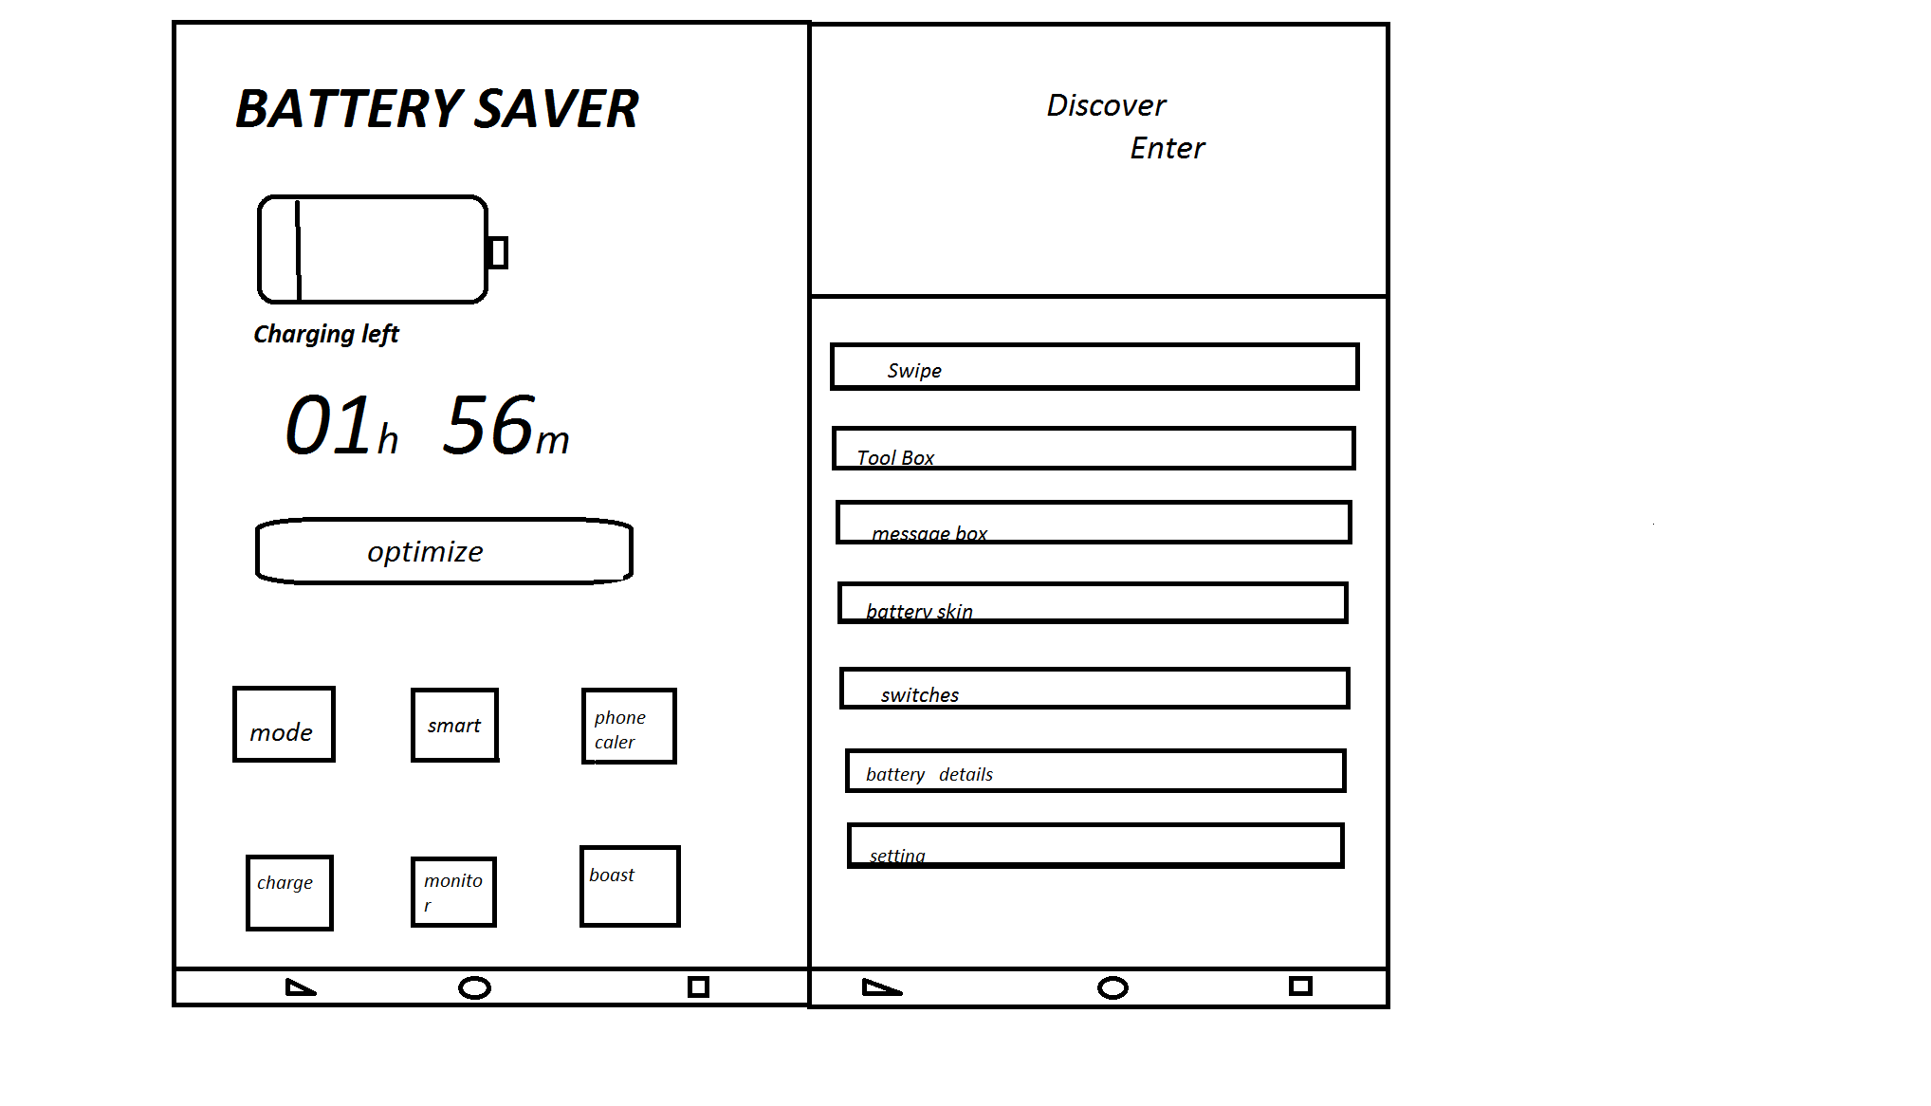

Fig. 1.1

* 1. **Hardware Interfaces**

*The battery saver system uses various hardware components of mobile phone to save the battery of the phone.*

**Mobile Battery**

*The mobile battery is the most important hardware component used by battery saver it is the basic need for battery saver. Because the battery saver app is used to save the battery, without the link* of the app with battery the app doesn’t save the battery. That’s why the connection of the app with battery is most important for the app.

**Sensor**

*The connection of battery saver with sensor is also most important for battery saver because with the help of sensor battery saver indicate that the battery is low and adjust the brightness automatically for user to save the battery of mobile phone*.

**Processor**

*Battery saver is connected with the processor for determining the apps runs on the system, and to find which app is consuming most power of the battery.*

**RAM**

*Battery saver system is linked with the RAM for showing what app consume high power of the system and for killing those apps who consume high power.*

**3.3 Software Interfaces**

*The various types of software connected with Battery saver system.*

1. *Mobile Brightness system is connected with battery saver system, while in saving mode the brightness in adjusted automatically.*
2. *The vibration mode of the mobile phone is connected with battery saver system for when mobile is in saving mode so it can be disconnected from vibration mode.*
3. *The battery saver app is linked with C.P.U of the system for determining or showing the further apps running details.*
4. *The each and every app of mobile phone, to show the status of each app, to show which app consume more energy of the system, to kills those apps who consume more battery of the mobile.*
   1. **Communications Interfaces**

*The communication interface should have following specification.*

1. *Electronically the app is communicated with battery of mobile phone to consume low power of energy of your mobile.*
2. *When battery is low of your mobile phone, so the battery saver gives the message or recommendation to user to turn on the battery saver mode, so there should be also a communication with user of battery saver app*.

**4. System Features**

*The main and most important features of battery saver system are as follows*.

**4.1 Saver**

Saver

User

* + 1. **Description and Priority**

*The saver option of the Battery saver aims at minimizing battery consumption by switching on/off the saver option.*

* + 1. **Stimulus/Response Sequences**

1. *Go to settings tab battery.*
2. *Tab to battery saver.*
3. *Choose the option turn on/off saver.*
4. *When Batter saver is enabled, the Android status bar and system toolbar are colored orange-red.*

**4. 1.3 Functional Requirements**

*The basic requirement for this feature is to save the battery of mobile phone.*

**4.2 Optimize button**

Optimize Button

User

**4.2.1 Description and Priority**

*That looks for problem apps and optimizes background processes to extend your battery life just that extra smidgen more*.

**4.2.2 Stimulus/Response Sequences**

1. *Go to battery saver app.*
2. *Screen appears with various options.*
3. *Chose optimizing button.*
4. *After selecting optimize button screen shows all the apps which optimized by battery saver*.

**4.2.3 Functional Requirements**

1. *The first requirements for this feature is to determining the detected apps.*
2. *The second requirement is to free the RAM.*
3. *The third requirement is to save battery of the phone.*

**4.3 Monitor**

Monitor

User

**4.3.1 Description and Priority**

*This section helps to monitor the device in such a way that we can easily infer the apps which are consuming the battery and by how much.*

**4.3.2 Stimulus/Response Sequences**

*1. Go to battery saver app.*

*2. Screen appears with various options.*

*3. Tab to monitor option.*

*4. Now user can see all apps which are in process in your system and this option display every detail about the apps running on system.*

**4.3.3 Functional Requirements**

*The requirement for this feature is to see those apps which affects the system and to monitor overall system.*

**4.4 Phone Cooler**

Phone Cooler

User

**4.4.1 Description and Priority**

*It scans C.P.U and cool down the apps which are heating up the phones.*

**4.4.2 Stimulus/Response Sequences**

*1. Open battery saver app.*

*2. Screen displays various options.*

*3. Tab to phone cooler option.*

*4. By selecting this user can see the scanning process and which app over heat the phone and battery status of the phone.*

**4.4.3 Functional Requirements**

*The requirement is to overcome the heat of the phone which appear by continuous process of apps in system and see the battery status.*

**4.5 Mode:**

Mode

User

**4.5.1 Description and Priority**

*User can select the saving, sleep or customize mode option to turn off the mobile data, network, wifi and other service not needed at the time. You can also add a mode and can customize it according to the requirement changing the screen brightness, screen timeout, Bluetooth and mobile data etc.*

**4.5.2 Stimulus/Response Sequences**

1. *Open battery saver app.*
2. *Screen displays various options.*
3. *Tab to mode option.*
4. *Now Screen appears the saving, sleep and customize mode option.*
5. *When user select each option according to his choice battery saver save battery by following some conditions.*

**4.5.3 Functional Requirements**

*The requirement for this feature is to save battery consumption according to user customization and according to user needs.*

**4.6 Boost**

Boost

User

**4.6.1 Description and Priority**

*The boost option is used to releasing the RAM from chunks of Data. It is used to free the RAM from unwanted or unnecessary processes.*

**4.6.2 Stimulus/Response Sequences**

* + - 1. *Open battery saver app.*
      2. *Screen displays various options.*
      3. *Tab to boost option.*
      4. *The screen displays the process boosting and show how much memory is released*.

**4.6.3 Functional Requirements**

*The requirement is to high the speed of the phone and turn off unnecessary apps.*

**4.7 Draining your battery**

Draining Battery

User

**4.7.1 Description and Priority**

*Use to see those apps which consumes more power and how much power each app consumes.*

* + 1. **Stimulus/Response Sequences**
       1. *Open battery saver app.*
       2. *Screen displays various options.*
       3. *Main screen shows setting option.*
       4. *By selecting setting option.*
       5. *Menu is pop up with different features.*
       6. *Select battery Draining Option.*
       7. *The screen appears which shows all the apps containing high power usage and display how much power it consumes.*
    2. **Functional Requirements**

*The requirement is to list down the all high power consumption apps.*

1. **Other Nonfunctional Requirements**
   1. **Performance Requirements**

*Performance requirement is the most valuable requirement for this product which are fast scanning process, fast free RAM process, fast charging process, maximum time given to the user after turning on the battery saver mode. There should be maximum time limit provides to system for users to used extra amount of time when battery power is almost going to dead. If the saving time and provided time is low than the product is going to face high level of dissatisfaction.*

* 1. **Safety Requirements**

*There are so many factors that can influence battery life from the apps user use and install, to how obsessively user check mobile phone. Even how user use Battery Saver’s settings and how often user do stuff like hit optimize can make a big difference. If user wrongly use the app than it may will be harmful for mobile phones and second factor is after turning on the saver button the other app which user run on mobile phone is slow down and apps performance should be weak. So to overcome these problems users have to provide short description about the battery saver and provide the guidelines that turn off the battery saver when battery power is maximum.*

* 1. **Security Requirements**

*In security requirement there should be pointed that every app should be secure while in the process of scanning, boosting and optimizing. While in the process of killing apps the battery saver doesn’t affect the data of the target apps so the app must be secure and should can’t loss the data of targeted apps*.

* 1. **Software Quality Attributes**

*The software quality attributes are such as follows:*

1. *The app should always notify or available when the battery power is low or when user want the need of battery saver app.*
2. *The app should be developed in such a way that the developer easily do reuse process of this app.*
3. *The app should provide maintainability process after developing.*
4. *The beta test is used in the testing process.*
5. *The app should be easy to use.*
   1. **Business Rules**

*N/A*

**6. Other Requirements**

*The other requirements which are not the requirements of this project but that are most useful for this project as the functional requirements. In other requirements battery is very important and the sensor of phone is needed to detect that when battery saver is needed for the user or which time battery saver notify the user to on battery saver.*

**Appendix A: Glossary**

**Abbreviation**

*The following abbreviation are used in this SRS.*

1. *App stands for application in this SRS.*
2. *C.P.U stands for Central Processing Unit in this SRS.*
3. *RAM stands for Random Access Memory in this SRS.*
4. *Wifi stands for Wireless Fidelity in this SRS.*
5. *GPS stands for Global Positioning System in this SRS.*
6. *SRS stands for Software Requirement and Specification*.

**Acronyms**

*The following acronyms are used in this SRS.*

1. *App stands for application in this SRS.*
2. *C.P.U stands for Central Processing Unit in this SRS.*
3. *RAM stands for Random Access Memory in this SRS.*
4. *Wifi stands for Wireless Fidelity in this SRS.*
5. *GPS stands for Global Positioning System in this SRS.*
6. *SRS stands for Software Requirement and Specification*.

**Appendix B: Analysis Models**

*N/A*

**Appendix C: To Be Determined List**

*N/A*