1-done

2- CAT is showing all the content of the file while MORE doesn’t show all of the content.

3- the difference between that RM is used to remove a file while RMDIR is used to remove a directory

4-a-



4-b-

4-c

the absolute path is home/osama/user

the relative path is home/user

5-



6-

7-

i. cd

ii. cd ~

iii. cd $home

v. cd/home/usama

8. press w then tab

9.

10.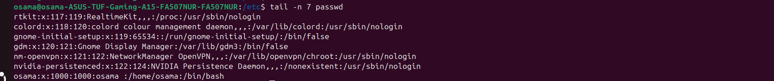

11.

12.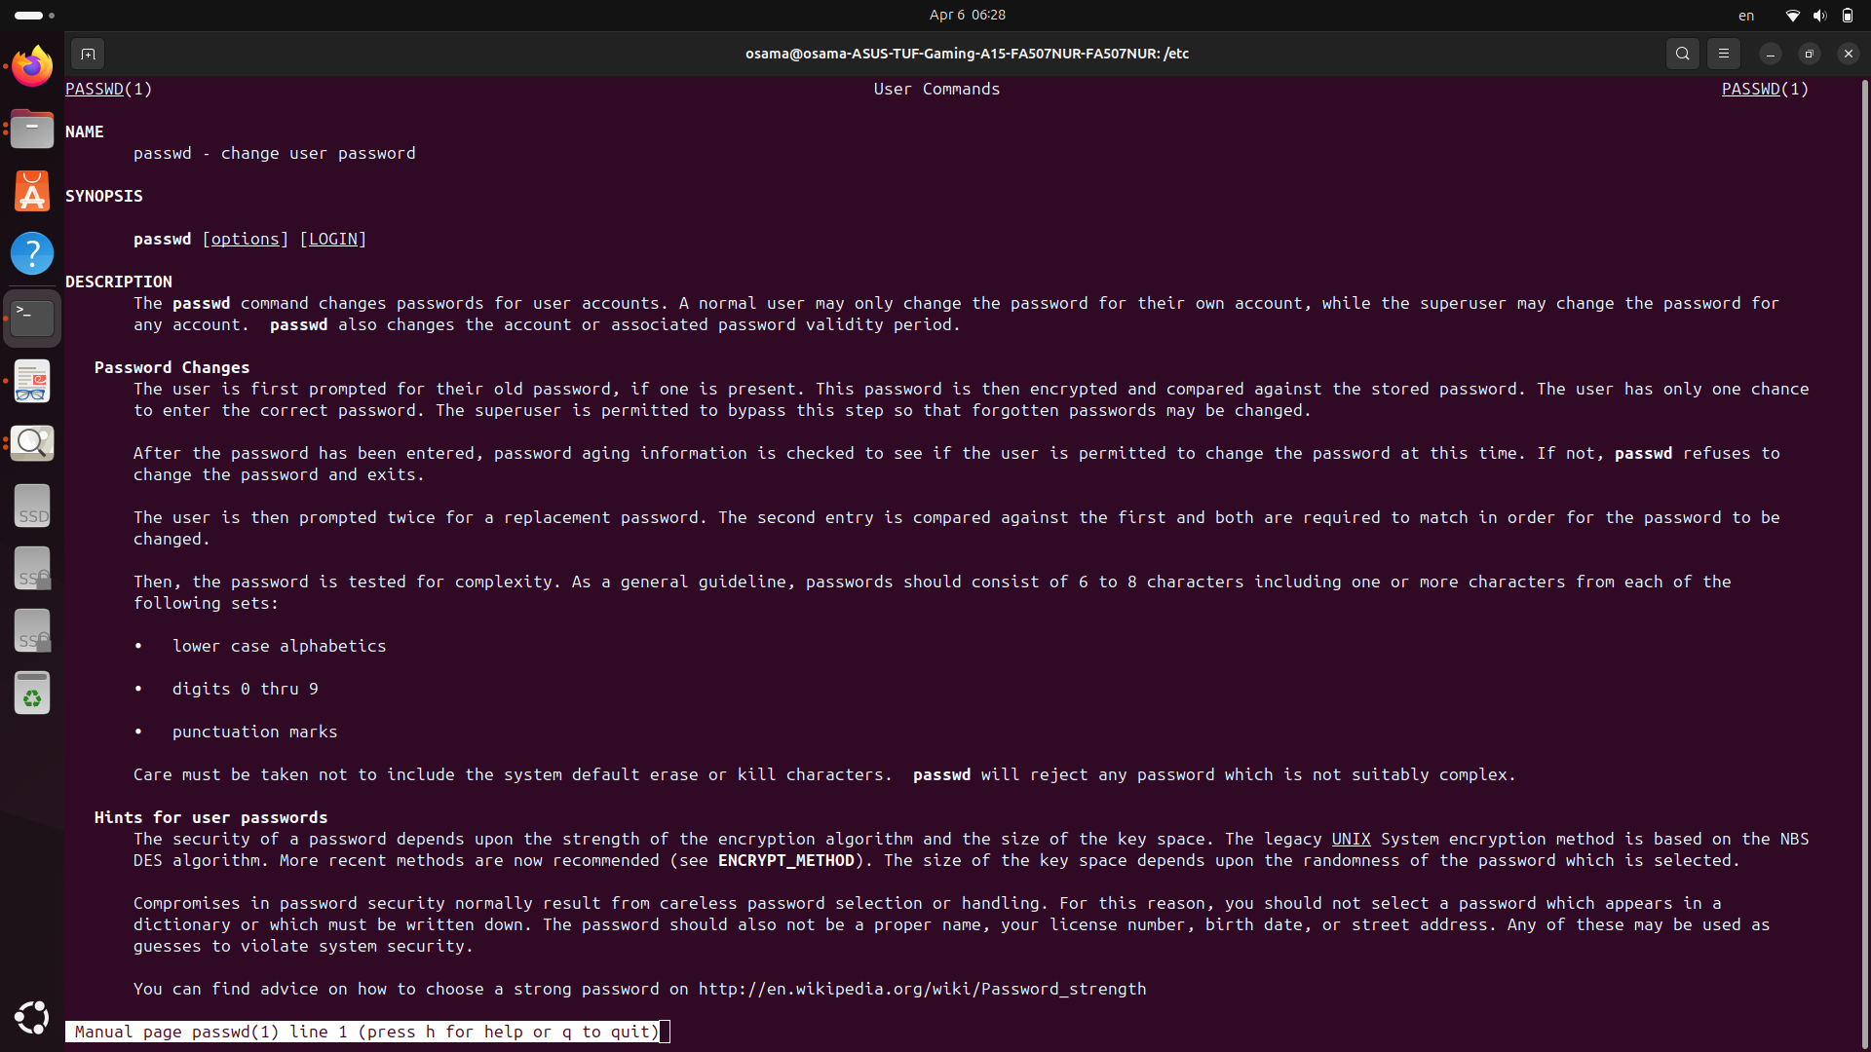

13.

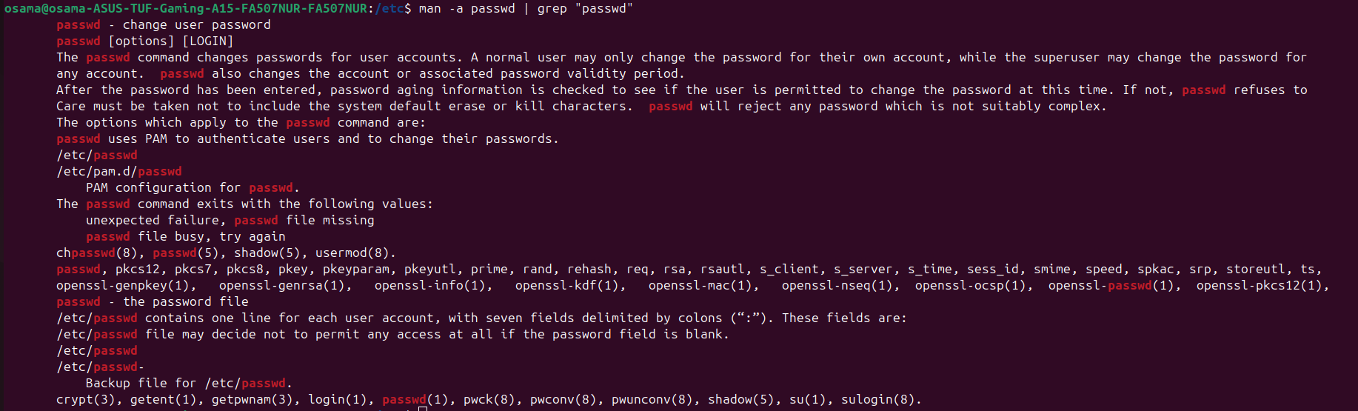

14.

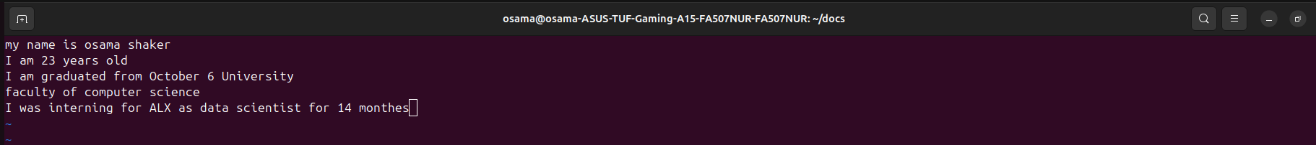

15.

1. press enter or j in normal mode
2. press k
3. 
4. 5G in the normal mood
5. dd then 5G then dd
6. step to the end of the line by A

16.