A Simple Virality Algorithm

I was wondering about the tik tok viral algorithm and then I thought about the Indian apps just like tik tok. I was wondering if I could help app like Roposo design an efficient and simple algorithm for there creators to get more exposure.

Then I started it on an online Java compiler to design one and guess what I think I found something useful of course I will consult this with various others as well.

What I designed is an algorithm/Program that activates as the user is scrolling through videos as the counter—by one it will be activated and It will be sign that a person liked it. We will them use that to show it to more people as the counter decreases again and again this will indicate it is worth being viral.

Here is the Snapshot of the Simple Program I wrote:

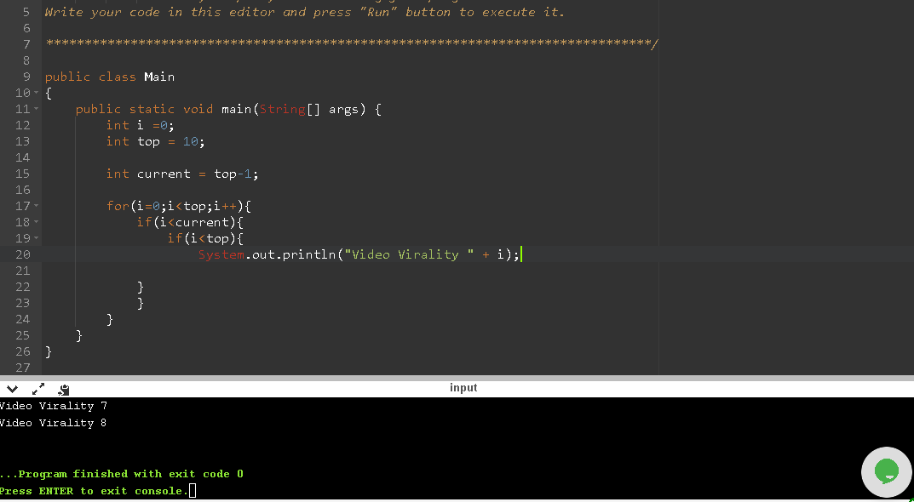

This was the result I declared the variables I,top and current. Then I created the loop and a nested If to compare the values for the virality problem. The Second If statement just prints out the value of i but we can easily manipulate with the technology we have.

I know it’s a stupid algorithm I am still reading the book Introduction to Algorithms (CLRS). But it’s just for fun I thought it might be of some help.

Thank You Reading it and I would love to have some feedback.