NATIONAL UNIVERSITY OF COMPUTER AND EMERGING SCIENCES

ISLAMABAD

OPERATING SYSTEMS SPRING 2019

ASSIGNMENT 03

Instructions:

- Zero marks will be awarded to the students involved in plagiarism.

- All the submissions will be done on slate.

- Create separate file for each question.

- Be prepared for viva or anything else after the submission of assignment for two weeks.

Threading and Locks

Question 1: Submit .cpp file.

Multiplication of matrix does take time surely. Time complexity of matrix multiplication is O (n^3) using normal matrix multiplication. But, is there any way to improve the performance of matrix multiplication using normal method. Multi-threading can be done to improve it. In multi-threading, instead of utilizing a single core of your processor, we utilizes all or more core to solve the problem. You have to create different threads, each thread evaluating one element of resultant matrix.

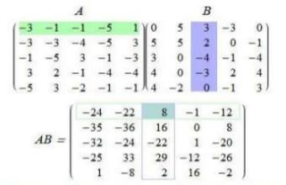

The value 8 is calculated using only one thread so; you have to calculate each value of resultant matrix using a thread. Take two matrices

(A and B of size 3x3 both) from user your resultant matrix is of size

3x3 you have to create 9 threads for calculation of each value of resultant matrix.

Question 2: Submit three .cpp files and three .txt files.

Input.txt file is given with this assignment. You have to use this input.txt file in this question. You have to read your inpu.txt file line by line in main thread, create a thread against your each line of file and pass that line to your created thread. Each thread has to capitalize the line pass to it and write it on output.txt your writing should be done char by char. First you have to implement this without using any lock or join, and then you have to do it using Mutex and generate output.txt, in last you have to implement it using Binary Semaphore and generate output.txt.

Question 3: Submit .cpp file.

You have to use input.txt file in this question also. There are total 12 lines in the input.txt. You have to read this file using multiple threads each line should be read by only one thread. But only three threads are allowed to read from file at a time. Each thread will output its read line. You have to use semaphore.

Question 4: Submit .cpp file.

Generate numbers from 1 to 100 using hundred threads each thread will generate a number and print its number. But each 5th thread should not generate number and print until all the remaining 80 threads executed. Which means the numbers which are multiple of 5 will be printed at the end.

