**Super Mario**

**Computer Organization & Assembly Language**

**Project Report**

**Group Members:**

* Usama Zafar (i170012)
* Usama Rasheed (i170212)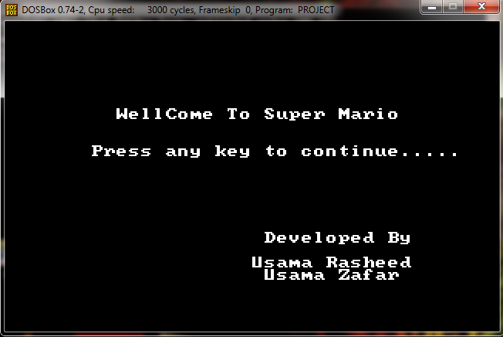

**Project Feature Status:**

* Mario ------------------------------------ done
* Thorough design
* Multiple designs (running/standing/Flying)
* Mario Movement --------------------------- done
* Standard
* Hurdles ----------------------------------- done
* Flag ----- --------------------------------- done
* Enemy ------------------------------------ done
  + Movement
  + Collision Detection
  + Perk ------------------------------------ done
  + Coin
* Screens ------------------------------------ done
  + Welcome
  + Ending

**Extra Features:**

* Transition Screen
* Score Count (fully implemented)
* Stages Count (fully implemented)

**Screens:**

* Starting Screen: A well-crafted screen with a super Mario Welcome screen and Name of the developers.
* Transition Screens : A screen used to signal the completion of a level
* Ending Screens: Two screens which show if the player has won the game or lost it.

**General Overview:**

The Overall Project has been successfully completed and all the requirements are met. In addition, significant work has been done on the interface and extra innovative ideas have also been implemented.

We have successfully completed all the phases of the project. We have displayed the obstacles and flag and Mario, Enemy, Castle, Coin and dragon. We have used the concept of arrays in our project in which we have stored the colour of pixels in arrays and printed those pixels using a 2-d Array. For left and right movement, we are using the LEFT, RIGHT UP and Down keys for the movement of the Mario. We have used the interrupt 13h with screen resolution of **320x200**.We have tried our level best to do as much as possible for us to do and hope for the good and better marks.

**LEVEL 1:**

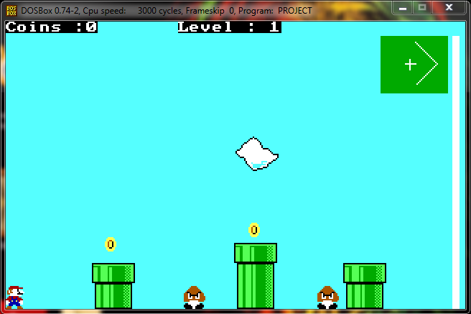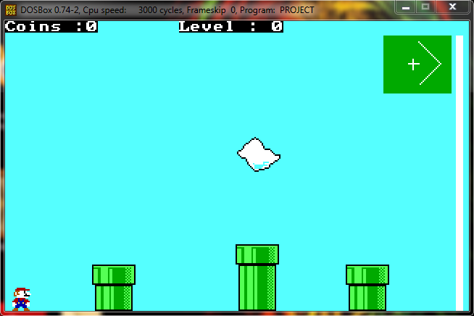 **LEVEL 2:**

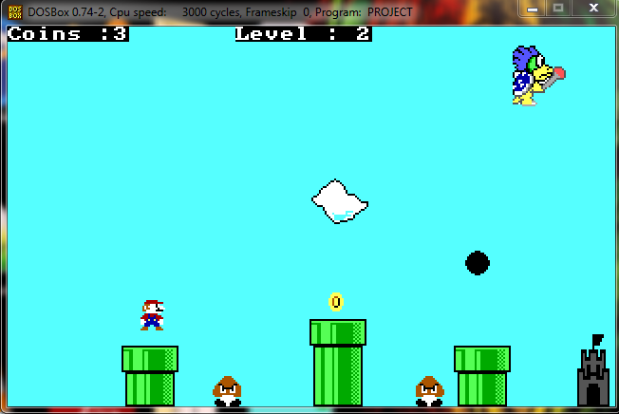**LEVEL 3:**

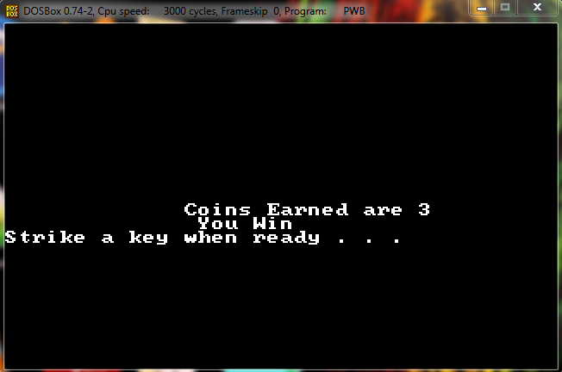**ENDING SCREEN:**

**Functions:**

* Arrays of Pepsi (Mario) and Enemy contains the colours Pixel by pixel.

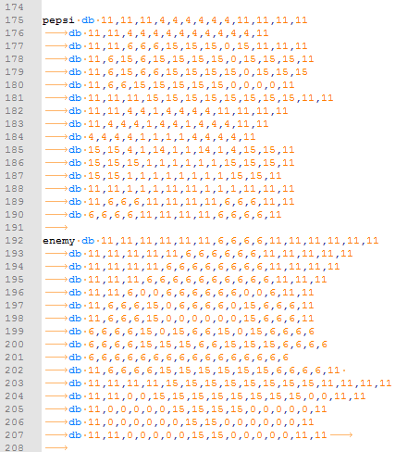

* 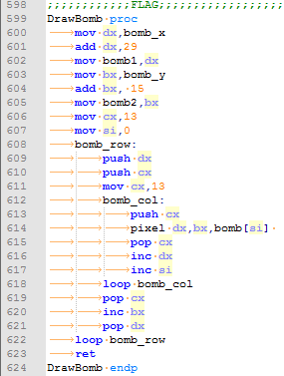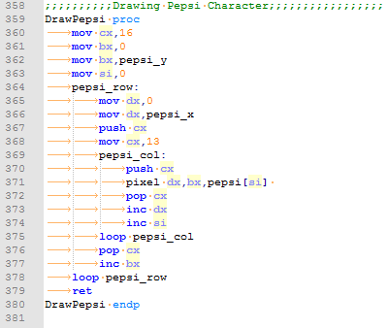Function of Drawing the Mario and Bomb using 2-d Array
* Checks for Collision between the Enemy and the Mario(Pepsi)

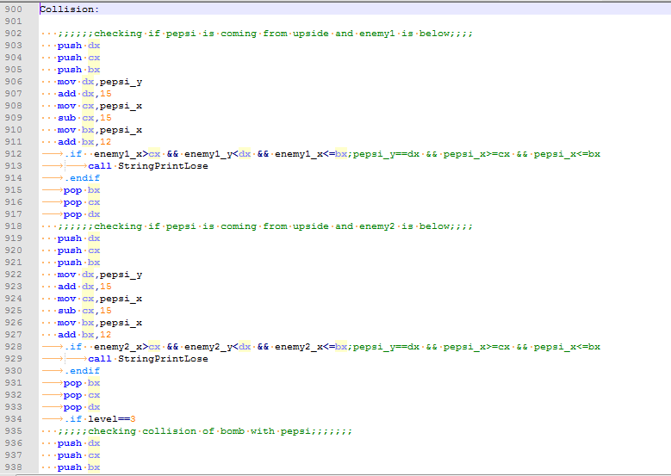

* Checks for the collision between Mario and Coin (Coin Detection)

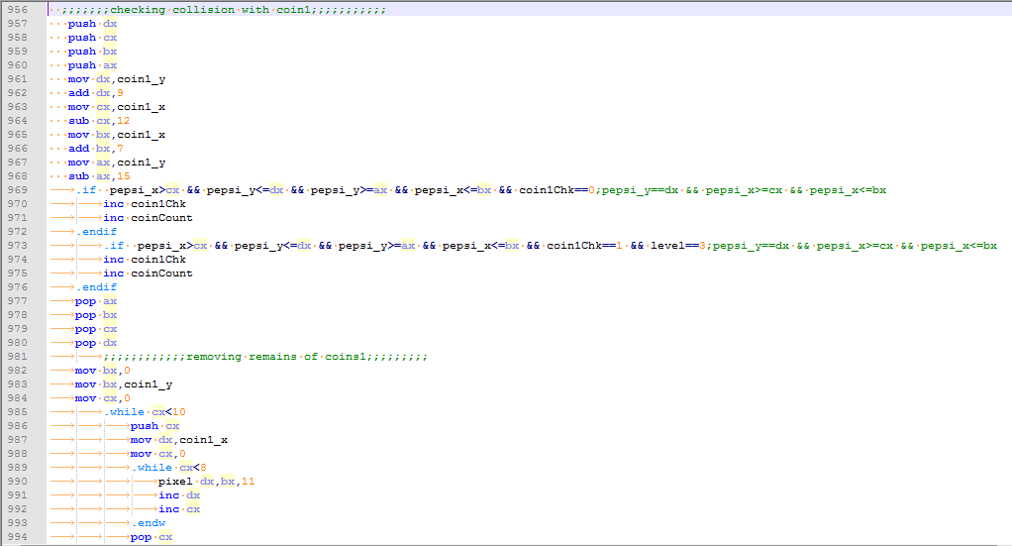

* Movement of enemy from left to right and vice virsa

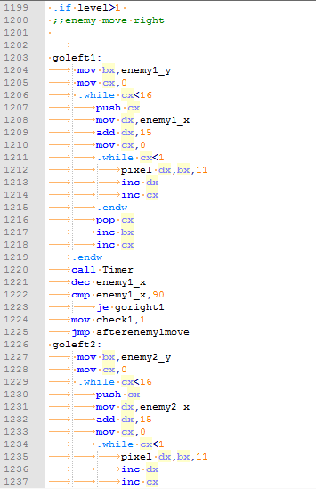

* Timer Function for 1 second ,Level Screen and Score printing

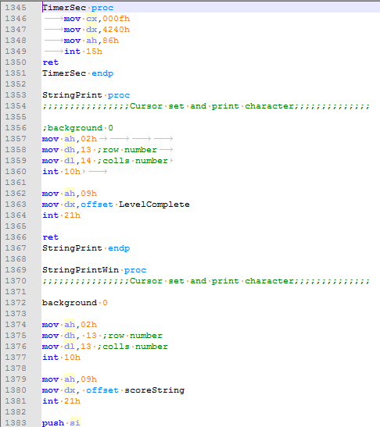

* Movement of Mario on the Keys UP,DOWN,LEFT AND RIGHT Keys

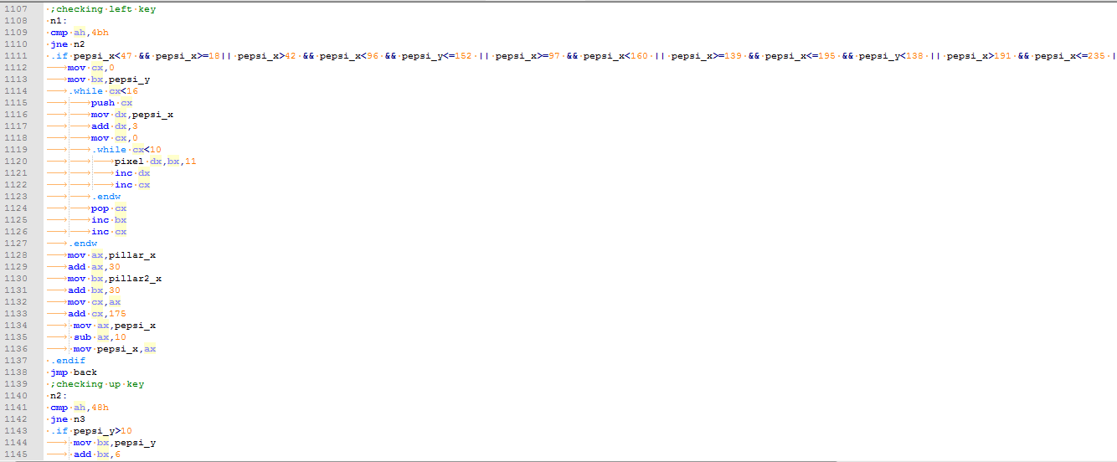

* Function for Welcome Screen

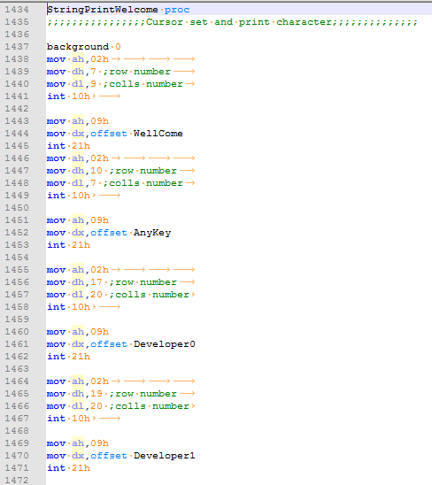

**THE END**

😊