SportIQ — Model Build Approach
Data collection, feature engineering, model training, and probability serving
for SportIQ's NBA and football prediction models

Companion to SportIQ-PRD.docx and SportIQ-TDD.docx — describes what is actually
built and running, not the intended design where the two differ.

1. Overview
SportIQ predicts match outcomes for two sports with materially different models, sharing one common serving interface:
- NBA: a single XGBoost binary classifier (home win / away win) — the simpler market, no draws.
- Football: a two-layer stack — Poisson expected-goals (xG) regressors feed a multiclass (home/draw/away) classifier — because a 3-way market with draws needs a different shape than a coin-flip market.
Both sports share the same architecture: a common DataSourceAdapter interface abstracts external data providers, a common BaseModel.predict() interface abstracts model inference, and a models_registry database table decides which trained artefact is actually serving predictions at any given moment (promotion is a database update, not a redeploy).
This document describes the real, currently-running pipeline — not aspirational design. Where a design decision changed after being tried (e.g. an odds-data-quality bug found while computing an ROI metric), that is called out rather than smoothed over.

2. End-to-End Architecture
The pipeline splits cleanly into two halves that share code but run on different schedules: an offline training pipeline (run manually, produces a versioned artefact) and an online serving pipeline (runs continuously via Celery, consumes whichever artefact is currently marked active).

2.1 Offline training pipeline
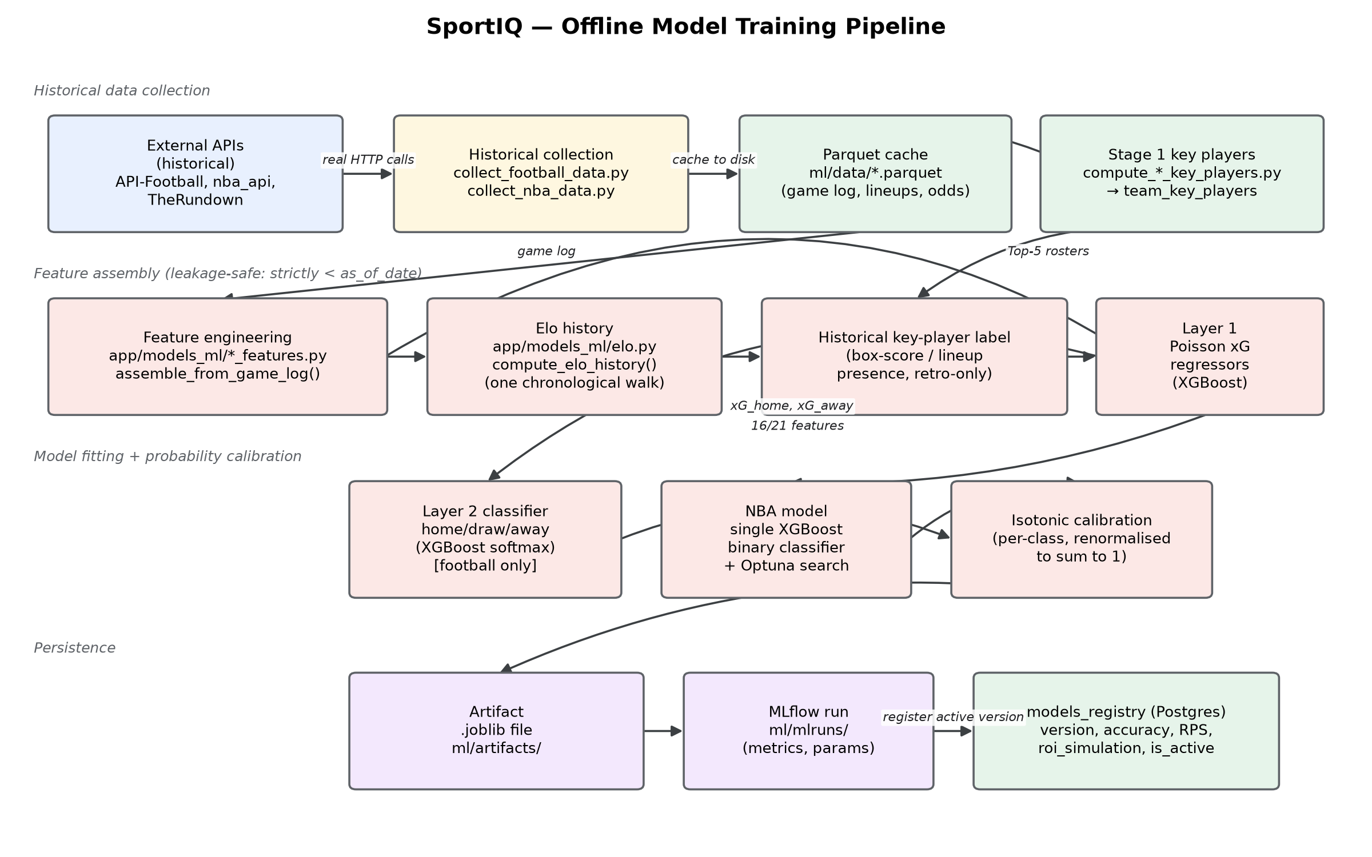
Figure 1 — historical data collection through to a registered models_registry row.

2.2 Online serving & retrodiction pipeline
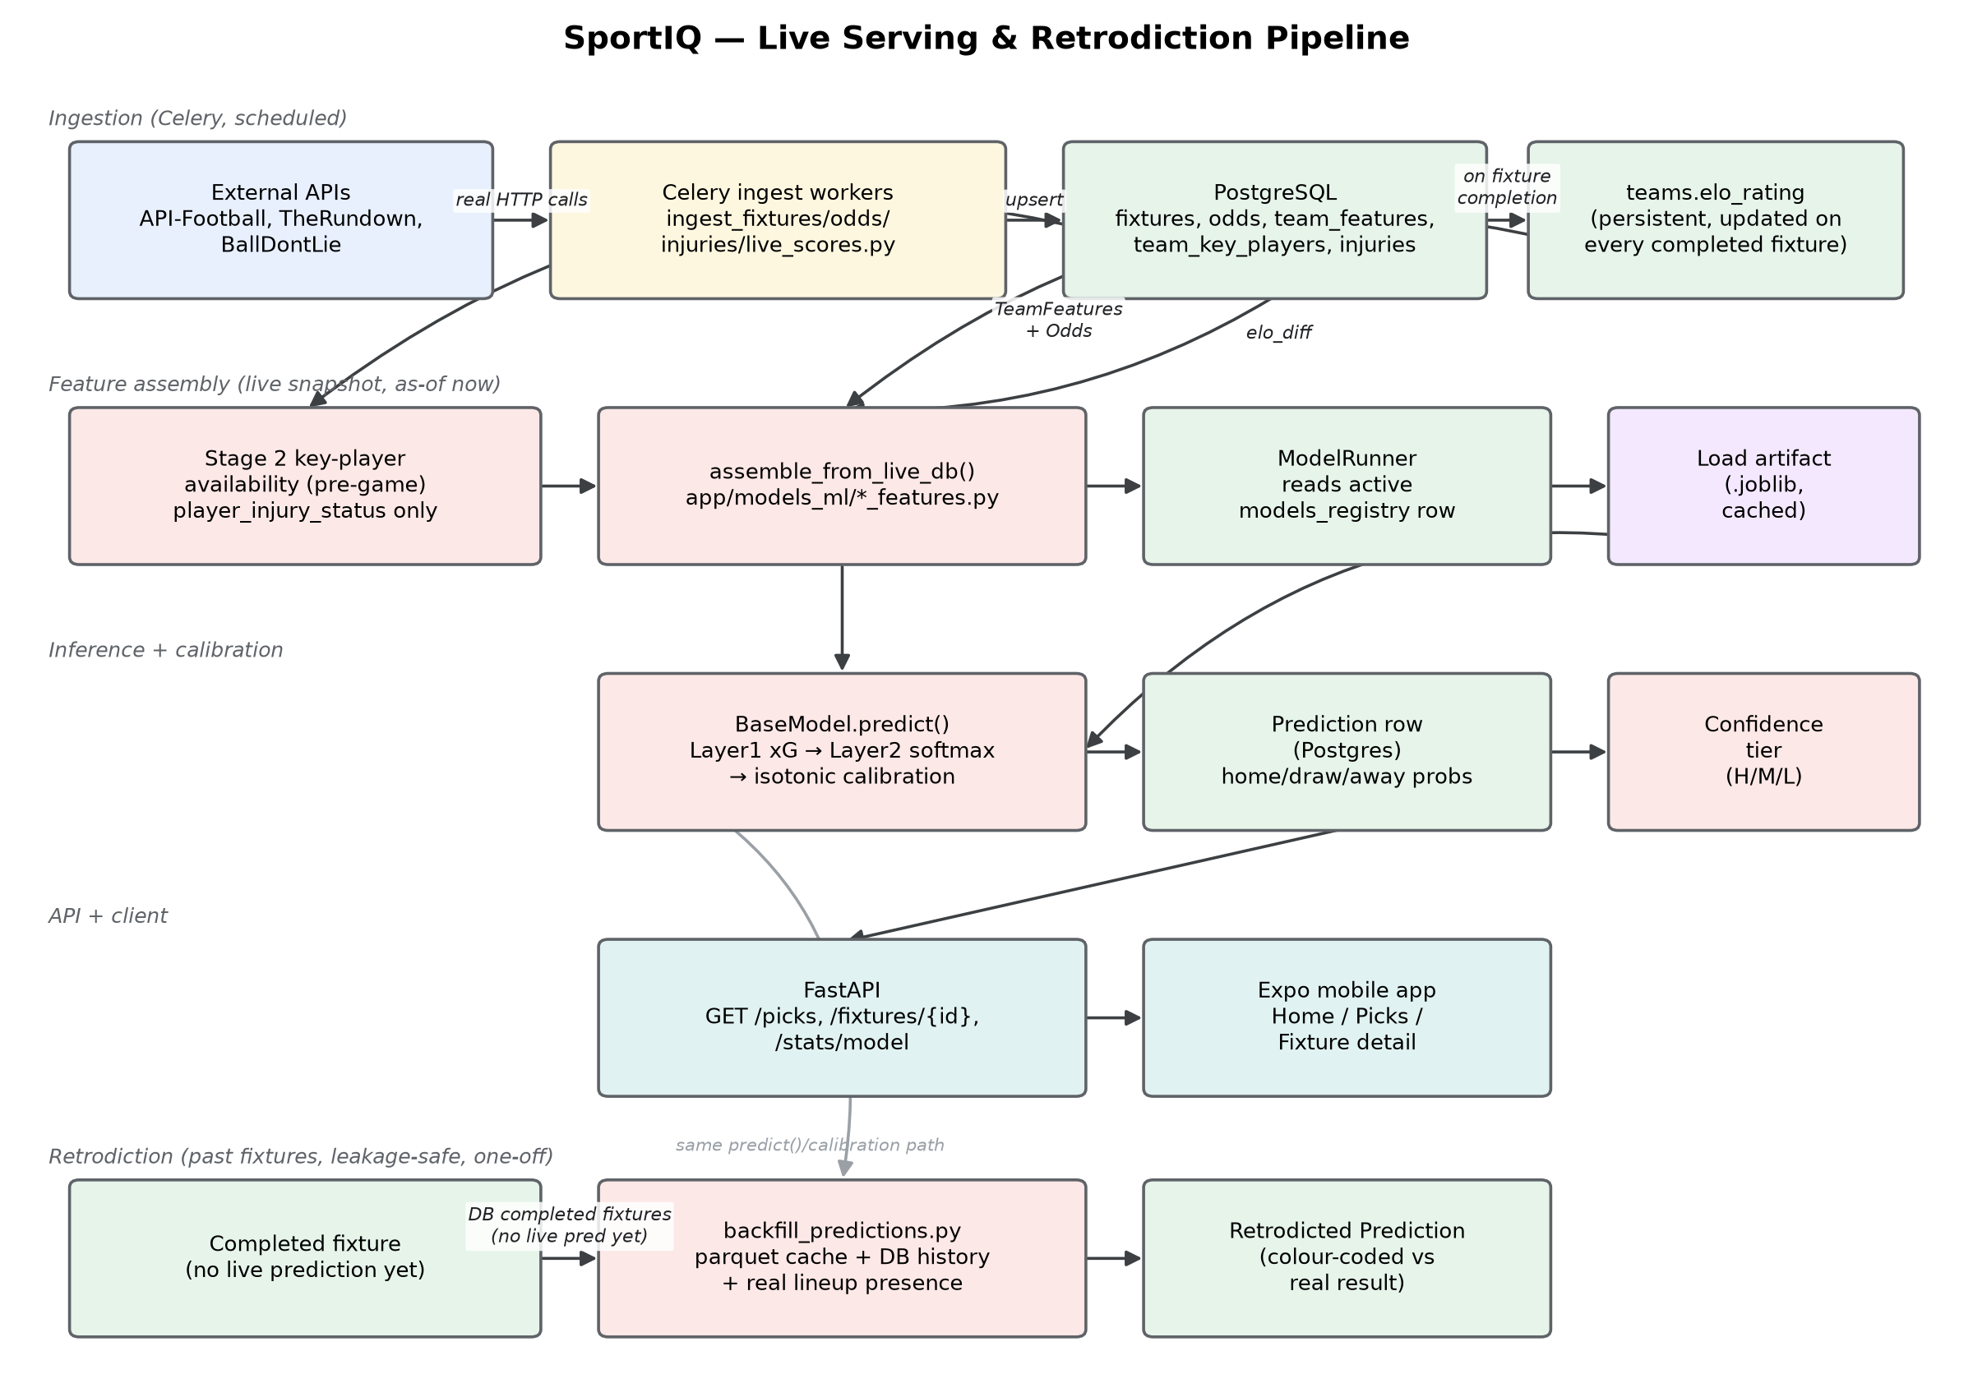
Figure 2 — live ingestion through to a served prediction, plus the separate, leakage-safe retrodiction path for already-completed fixtures.

3. Data Collection (External APIs)
All third-party data is accessed only through a DataSourceAdapter abstract interface (fetch_fixtures, fetch_team_stats, fetch_odds, fetch_injuries) — no worker or route ever calls a provider's SDK/HTTP client directly. This keeps every provider swap or addition a config/adapter change, not a schema or business-logic change.
Provider | Used for | Key real-world findings
API-Football  (v3.football.api-sports.io) | Football fixtures, team stats, injuries, lineups, H2H, and (Brasileirão only) odds | Reached directly (not via RapidAPI, despite the original design doc assuming that). Pro plan (7,500 req/day) unlocked current-season fixtures, full historical coverage back to 2021, and per-league odds coverage.
TheRundown  (via RapidAPI) | Odds/moneyline for NBA and the 5 European football leagues | Odds arrive in American format (converted to decimal on ingest). Only 3 of ~15 bookmaker affiliates return real (non-masked) prices on this subscription. Has zero Brazil-league coverage.
BallDontLie  (api.balldontlie.io) | NBA live fixtures and team stats | Cursor-based pagination; embeds full team objects so no separate team lookup is needed. Injuries endpoint is paid-tier gated and returns 401 on this key.
nba_api  (stats.nba.com) | Historical NBA training data only — game logs, player box scores | Blocks all cloud-provider IPs at the network level, so it is strictly an offline, local/VPS-only tool — never called from a production worker.

3.1 Historical (training-time) collection
Two one-off scripts populate the local parquet cache used for training and, later, retrodiction:
- ml/training/collect_nba_data.py — ~14,460 game-log rows and ~154,345 player-box-score rows across 6 NBA seasons, plus a bounded real odds sample (60 dates).
- ml/training/collect_football_data.py — generalised to a per-league config so both EPL and Brasileirão are collected without one overwriting the other's cache: 3,800 game-log rows and 40,760–42,971 lineup-presence rows per league (1 API call per fixture — no bulk lineup endpoint exists), 5 seasons each (2021–2025). Brasileirão has zero historical odds — TheRundown has no Brazil coverage, and API-Football's own odds don't extend to arbitrary past dates.

3.2 Live (serving-time) ingestion
A set of scheduled Celery workers keep the database current for live inference:
Worker | Runs | Writes
ingest_fixtures.py | Daily | Fixture rows (7 days back + 7 days ahead), TeamFeatures snapshots, Stage 2 key-player availability, Elo persistence hook
ingest_odds.py | Every 5 min | Odds rows, matched to fixtures by provider ID or by team-abbreviation + kickoff-time fuzzy join
ingest_injuries.py | Scheduled | player_injury_status rows; triggers re-inference within 3 hours of kickoff if a key player's status changed
ingest_live_scores.py | Every 5 min | FixtureLiveState (live score/status) by re-querying a ±1 day window; also settles completed-fixture outcomes and Elo

4. Data Processing
Every provider uses its own ID space for the same real-world team or fixture. The core processing job is resolving those into one internal representation, without ever silently fabricating a value for missing data:
- ID resolution: get_or_create_team() resolves a provider's team ID against Team.external_id; fixtures.external_id dedupes fixtures per provider; fixtures.odds_provider_external_id handles the case where the odds provider and the stats provider disagree on ID space (BallDontLie fixtures + TheRundown odds, or API-Football fixtures + TheRundown odds) — resolved via a team-abbreviation + kickoff-time tolerance-window join, cached after the first successful match.
- Missing-data handling: a genuinely unknown value is always represented as None/null, never a fabricated neutral value. Example: API-Football returns the string "0.0" for a team's goals-average before its season has started — this is gated on matches-played > 0 rather than trusted at face value, so a new season correctly shows unknown, not a misleading zero.
- Status/settlement: a fixture's status (scheduled/live/completed) is normalised across providers' differing vocabularies. The moment a fixture completes with real scores, an idempotent settlement step writes a MatchResult/Outcome row and updates both teams' persistent Elo rating exactly once.
- Deduplication: TeamFeatures rows are delete-then-inserted per (team, fixture) on every ingest run, so re-running ingestion daily before a fixture's kickoff never accumulates duplicate feature rows.

5. Feature Engineering
app/models_ml/nba_features.py and app/models_ml/football_features.py are each the single source of truth for their sport's feature vector, via two functions that must stay in lock-step:
- assemble_from_game_log() — training-time, reads the parquet game log, strictly filters every stat to before the match date (the leakage guard).
- assemble_from_live_db() — serving-time, reads the same features from live database rows and fresh API calls (H2H, odds). If these two functions ever diverge, the model sees different inputs live than it was trained on.

5.1 Football's 21 features
Category | Features
Team form / strength | attack_str_home/away, defence_str_home/away, form_pts_home/away (last-5 rolling), home_win_rate_home, away_win_rate_away
Schedule | rest_days_home/away
Head-to-head | h2h_win_rate_home, h2h_avg_goals_scored_home, h2h_avg_goals_allowed_home (vs this specific opponent)
Key-player availability | key_players_available_home/away, key_players_per_combined_home/away (Big3/Top5 design, §5.3)
Market signal | moneyline_implied_prob_home (sparse — real odds only exist for a bounded EPL sample)
Rating / momentum (new) | elo_diff (home minus away — see §5.2), win_streak_home/away

16 of these were the original feature set; elo_diff, win_streak_home/away, and the two H2H-goals features were added in a later pass, adopted from feature-engineering ideas in the product owner's own prior personal NBA-prediction notebooks.

5.2 Elo rating — a genuinely different kind of feature
Every other feature above is independently re-derivable from a filtered rolling window over past games. Elo cannot be: a team's rating is the accumulated result of a sequential walk over every one of its past games, each one updating both participants at once. This forces two distinct code paths that compute the same real quantity:
- Training: compute_elo_history() walks the full historical game log once, in chronological order, producing each team's rating as of just before each fixture.
- Serving: teams.elo_rating is real, persistent, per-team state, incrementally updated exactly once per completed match — the model only ever sees elo_diff (home minus away), since Elo is only meaningful relatively.

5.3 Big3/Top5 key-player availability — a two-stage, leakage-aware design
This feature answers "is this team missing one of its most important players?" without ever leaking the game's own outcome into the prediction that describes it. It is built in two deliberately separate stages:
- Stage 1 (season-level, backward-looking): ranks each team's Top 5 players by a trailing performance metric (NBA: an approximated WS/48 and PER-style score; football: API-Football's own real per-match rating stat) and writes it once per team/season — completely independent of any single game's box score.
- Stage 2 (pre-game, forward-looking, LIVE): checks each Top-5 player's pre-game injury-report status only (player_injury_status) — never box-score/lineup presence, since knowing who actually played would leak the very outcome being predicted.
- Historical label (training only, a third, clearly separate function): derives the same signal from real box-score/lineup presence for already-completed games — legitimate as a backtest label, and explicitly kept out of the live module so it can never be imported into Stage 2 by accident. A regression test in both sports' test suites asserts the two diverge on the same underlying facts.

6. Model Build

6.1 NBA — single binary classifier
A single XGBoost binary classifier (home win / away win), hyperparameter-tuned via 50 Optuna trials, then isotonic-calibrated. Trained on a temporal split (train: 4 seasons, validate: 1 season, test: 1 season, 2020-21 through 2025-26) so no future season ever leaks into training.

6.2 Football — two-layer Poisson + classifier stack
- Layer 1: two XGBoost Poisson regressors (objective=count:poisson), one per side, predict expected goals (xG) from the full feature vector — a Poisson objective matches the count-like nature of goals scored far better than a generic regression loss.
- Layer 2: an XGBoost multiclass classifier (objective=multi:softprob) predicts home/draw/away from Layer 1's two xG outputs plus a subset of context features not already summarised by xG (form, H2H, key-player availability, moneyline, Elo diff, win streaks).
- Calibration: one-vs-rest isotonic regression per class, fit on validation predictions, then renormalised to sum to 1 at inference — the 3-way-market extension of NBA's simpler binary calibration.
Documented simplification: Layer 2 trains on Layer 1's own in-sample predictions for the training split. A proper stacked-generalisation setup would use out-of-fold Layer-1 predictions there instead — flagged, not hidden, since it is a materially larger amount of code for a first real version.

6.3 Training data and real results
Model | Data window | Test accuracy | Baseline  (“always home”) | Other metrics
NBA | 6 seasons (2020-21..2025-26), 16 features | 68.57% | 55.43% | Brier/RPS 0.2002; +20.9% flat-stake ROI (n=29, small sample)
Football | EPL + Brasileirão pooled, 5 seasons each (2021-2025), 21 features | 47.89% | 46.45% | RPS 0.2138 (3-way, lower is better); ROI -11.5% (n=45, small sample, not a demonstrated edge)

Football's own accuracy is modest against its baseline — a real, expected consequence of a 3-way market with draws being intrinsically harder to call than NBA's binary market, not a quality gap in the pipeline. All figures above are genuinely computed on held-out test seasons, not cross-validated on training data.

6.4 Artefact and registry
Every training run produces three real outputs, tying a specific trained model to a specific, inspectable record:
- Artefact: a single .joblib file (ml/artifacts/) bundling both Layer-1 regressors (football) or the single classifier (NBA), plus fitted calibrators.
- MLflow run: params and metrics logged to a local file-based MLflow store (ml/mlruns/) for experiment comparison across training runs.
- models_registry row (Postgres): version string (e.g. football_xgb_v20260729144210), artefact_path, accuracy, rps_score, roi_simulation, and an is_active flag. Promoting a new model to production is a database update (set the new row's is_active=true, the old one's to false) — never a redeploy. ModelRunner reads the active row per sport at inference time and lazily loads/caches its artefact.

7. Probability Calculation (Serving)
A single inference call, BaseModel.predict(features), runs the same path for every request:
- Assemble the feature vector (assemble_from_live_db, or assemble_from_game_log for retrodiction).
- Football only: run both Layer-1 Poisson regressors to get (xG_home, xG_away).
- Run the classifier — Layer 2 (football, taking xG + context features) or the single NBA classifier — to get raw softmax/sigmoid probabilities.
- Apply the fitted isotonic calibrator to each class independently.
- Renormalise the calibrated probabilities to sum to 1 (a degenerate all-zero calibration output falls back to the raw, still-valid probabilities rather than propagating a NaN).
- Derive a confidence tier (High/Medium/Low) from the winning probability's margin over the other outcomes.
- Persist a Prediction row (home_prob, draw_prob, away_prob, model_version, confidence_tier).
This same predict()/calibration code path is reused, unmodified, for retrodiction (app/workers/backfill_predictions.py) — only the feature-assembly function and its inputs differ (a historical game log instead of a live snapshot), which is precisely what keeps retrodicted probabilities on the same footing as live ones rather than a separate, harder-to-trust approximation.

7.1 From probability to a “pick”
GET /picks layers a real expected-value calculation on top of the raw probabilities: for each fixture above a user-set minimum-odds threshold, EV = (model_probability × odds) − 1 is computed for every outcome with a real market price, and fixtures are ranked by EV — the product's core differentiating feature, kept fast via Redis caching.

8. Known Limitations (Stated Plainly)
- Football's overall accuracy (47.89%) is modest in absolute terms — expected for a 3-way market with draws, not a defect, but not yet a strong basis for confident staking.
- ROI figures for both sports are small-sample and directional only, not statistically robust claims of a real betting edge.
- Football training data covers EPL and Brasileirão only; the other 3 seeded European leagues have no historical training data collected yet.
- Moneyline-implied-probability is sparse for football (a bounded ~60-date odds sample) and entirely absent for Brasileirão and for arbitrary past retrodicted fixtures.
- Key-player availability depends on injury-report data existing at all — several injury adapters remain stubbed pending API access.

