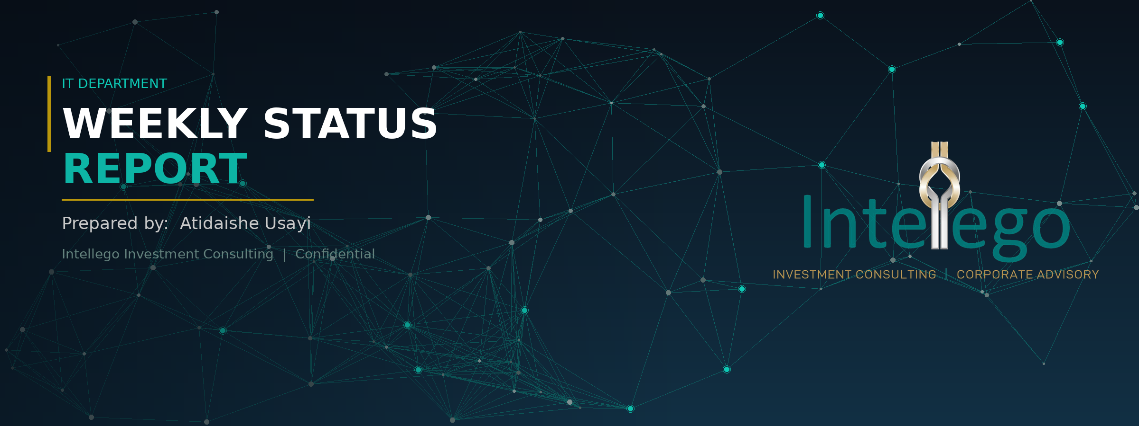

|| Intellego Investment Consultants

01. Network and Infrastructure

- No network challenges were experienced during the reporting period.
- The network operated steadily, with all users maintaining reliable access to core services.
- Continuous monitoring remains in place to support stability and ensure sustained optimal network performance.
02. Security Updates and User Awareness

- Cybersecurity awareness continues to remain a key focus across the organization.
- Users are continuously reminded to exercise caution when handling emails, links, and file attachments.
Staff are encouraged to adhere to the following security protocols:
- Verify sender identities before responding to emails or clicking links.
- Avoid opening suspicious attachments or unknown links.
- Report any unusual activity or suspected phishing attempts to IT immediately.
- Maintaining strong user awareness and access control practices continues to reduce the organization’s exposure to cybersecurity threats and potential data breaches.

03. Website Statistics and Performance

- Website performance monitoring continued during the reporting period with key metrics under active review.
Metrics currently under review:
- Active sessions and unique visitors
- Visit duration and session depth
- These insights continue to support the ongoing optimization of website performance and user engagement levels, and a detailed report is attached to the email.

04. Operational Updates

- The GroWealth Unit Trust Report for March was successfully published on the website and distributed to the mailing list.
- A gadget was procured for William to address the identified issues impacting operational efficiency. The IT Machine Asset Register has been updated accordingly to reflect this procurement.
- The ESET Antivirus licence was renewed to maintain a cyber-safe environment and ensure continued endpoint protection across the organisation.

05. IT Machine Asset Register

INTELLEGO INVESTMENT CONSULTANTS — LAPTOP ASSET REGISTER

15  Total | 9  Good | 2  Fair | 2  Bad | 2  Personal | 0  Under Repair

User | Model | Processor | Date Procured | Condition | Notes / Issues
Atidaishe | Personal Device | — | — | Personal | IT is operating on personal device — company device required as the personal device is misbehaving SSD transition required
Tapiwa | HP ProBook 450 G7 | Core i5, 10th Gen | 2020 | Bad | Touchpad issues — aging hardware, replacement required
William | HP ProBook 440 G10 | Core i5, 13th Gen | 2026 | Good | None
Tariro | HP ProBook 450 G8 | Core i5, 11th Gen | 2022 | Good | None
Tatenda | HP Laptop 15s | Core i7, 12th Gen | 2024 | Good | None
Arnold | HP ProBook 450 G7 | Intel Core i5 | 2021 | Fair | Some Keypads are unfunctional
Runyararo | HP ProBook 450 G8 | Core i5, 11th Gen | 2022 | Fair | Slow processing - RAM extension recommended
Lazarus | HP ProBook 440 G10 | Core i5 | 2026 | Good | None
Godfrey | HP ProBook 450 G10 | Core i7, 13th Gen | 2025 | Good | None
Isaac | HP Personal Device | - | - | Good | None
Owen | HP ProBook 450 G10 | Core i7, 13th Gen | 2025 | Good | None
Welcome | HP ProBook | Core i5, 11th Gen | 2021 | Good | None
Elvis | HP ProBook 450 G7 | Core i5, 10th Gen | 2019 | Bad | Processing issues — aging hardware, replacement required
Tino | HP ProBook 450 G7 | Core i5, 10th Gen | 2025 | Good | None
Letwin | HP ProBook 450 G6 | Core i5 | 2020 | Good | None
Elizabeth | Personal Device (GT) | — | — | Personal | No company laptop assigned -using personal device for work
END OF REPORT | IT Department — Intellego Investment Consultants | 06 May 2026

