**EE 374 PROJECT REPORT**



**ELECTRICAL AND ELECTRONICS ENGINEERING DEPARTMENT**

**Student Name & Surname:** Berkay İPEK

**Student ID:** 2304814

**Section:** 2

**1.Introduction**

In transmission systems, it is important to model lines because it can cause losses. Therefore, before deciding which cable (or conductor type) will be used, losses should be calculated. Then, it should be selected according to results. In this project, the aim is to calculate Xpu Zpu and Rpu from given parameters. In other words, series resistance & reactance and shunt susceptance of the line (given conductor type, length, Vbase, Sbase, number of circuits, number of bundles, phase locations, and distance between bundles in a text file) is calculated by just single MATLAB function.

**2. Applied Methods**

* **Taking data from a text and csv file**

Firstly, to be able to open text file, *fopen* is used. Then, *fgetl* function is used to get data from text line by line. At this point if statements are used to check whether it gives correct result or not. Also, numerical parameters are converted to double types, which helps to manipulate easily. After finishing to read data, file is closed by *fclose*. For csv file (conductor type data), different method is applied. *Readtable* function is used; however, the data type, table, is not easy to manipulate. Therefore, table is converted to array, by using *table2array*. Then, array is divided into column by column (names,RACs etc.). Afterwards, the index of desired conductor type is found. By using this index number, desired parameters are taken.

* **Calculating req & GMRbundle depending on only the number of bundles (N_bundles)**

To be able to manipulate data in this part, switch operator is used instead of writing lots of if statements. GMRbundle Calculations: GMRbundle is basically calculated for N_bundle is equal to 1,2,3,4. (Figure 3) The same method is applied for N_bundle =5 and 6 since their diagonal length of pentagon and hexagon. However, for heptagonal it is not easy to calculate. (Figure 4)

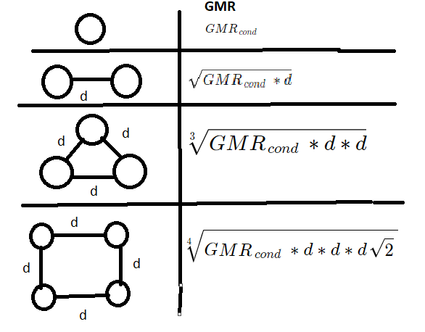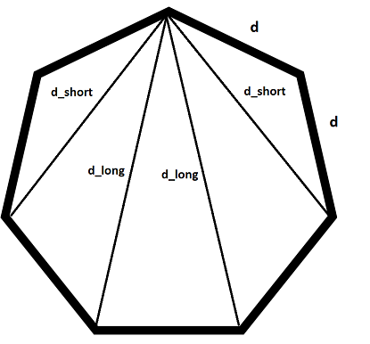

**Figure 1:** GMR calculation for N_bundle =1,2,3,4 & Diagonals for heptagon

To calculate its diagonal parameters for N_bundle=7,8 *cosine theorem* is used as you can see it in Figure 4. R_eq is calculated by using same method. Only difference is that firstly outside diameter is divided by two to get r_eq_cond value.

* **Calculating req & GMRbundle & GMD depending on only the number of circuits (N_circuit)**

If the number of circuits is one, there is no difference for calculations of GMR and r_eq. However, GMD is calculated in this part firstly. It can be calculated by formulas.

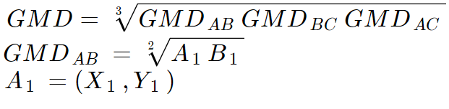

If the number of circuits is two, all three parameters should be calculated again. For GMR, we should divide it into three sub-GMR: GMRaa GMRbb GMRcc. GMRaa = the distance between phase a1 and phase a2. Then, taking geometrical mean of these three sub-GMR values will provide us GMR. This calculation is valid for r_eq. For GMD, the only difference will be GMDAB calculation as follows:



* **Calculating R, L and C**

For the calculation of L, it is 2x10-7x ln (GMD/GMR) in H/m. For R value, it is divided by (N_bundle*N_circuit) due to parallelization of used conductors. For C value, earth effect is considered. (Note that prime values are corresponding to its symmetric with respect to x axis.)

When N_circuit is one, H1 should be |A1A1’|, which is double of absolute value of y coordinate of A phase. H2 and H3 can be calculated with phase B and phase C, respectively. On the other hand, H12 is basically |A1B1’|, which can be calculated by distance between A1 (x1, y1) and B1’ (x2, -y2). (Again, H13 and H23 can be found by using similar method.) Then we can use the formula given in CommonProblems.pdf:

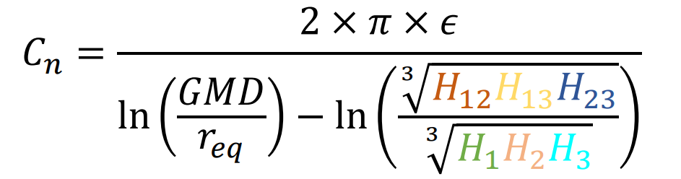

When N_circuit is two, H1 can be found by geometric mean value of |A1A1’|, |A1A2’|, |A2A2’|, |A2A1’|. H2 and H3 can be calculated with phase B and phase C, respectively. On the other hand, H12 is the geometric mean of |A1B1’|, |A1B2’|, |A2B2’|, |A2B1’|. (Again, H13 and H23 can be found by using similar method.)

**2. Assumptions**

* Data files (csv and txt) is assumed to be designed properly.
* The shape of bundles is assumed to be regular polygon.
* Conversions of units is assumed as 1mil = 1609.344 m; 1 in = 0.0254 m; 1 ft = 0.3048; f=50 Hz; epsilon zero value = 8.854187817x10-12 F/m
* y coordinates of given phases corresponds to its height from ground.

metin içeren bir resim

Açıklama otomatik olarak oluşturuldumetin içeren bir resim

Açıklama otomatik olarak oluşturuldumetin içeren bir resim

Açıklama otomatik olarak oluşturuldu**3. Test Results**

metin içeren bir resim

Açıklama otomatik olarak oluşturuldu

**Figure 2:** Example txt file data (1 and 2, respectively) and results of our project

From expected outputs and figure 2, there is a small difference between them due to rounding property of MATLAB. By using format long, this difference can be smaller.

Also, by changing parameters in input_file_example1.txt, the observation is written into table1. By looking results, we can decide which parameter has an effect on Xpu Bpu or Rpu. Also, by changing conductor type, the most proper conductor type under specific design parameters can be found.

**Table 1:** How parameters affect results for input_file_example1.txt

|  |  |  |  |
| --- | --- | --- | --- |
|  | **Xpu** | **Bpu** | **Rpu** |
| As number of bundle conductors per phase increases | Decreases | Increases | Decreases |
| As bundle of distance increases | Decreases | Increases | *Does not change* |
| As length of line increases | Increases | Increases | Increases |
| As the height length of phases increases (y) | *Does not change* | Decreases slightly | *Does not change* |
| As the length between phases increases (x) | Increases | Decreases | *Does not change* |

It should be noted that while creating this table, data which has two circuits is used. Therefore, the results are valid for this type of modeling. Also, it should be noted that changing parameters about bundle distance or phase location does not affect on resistance value, which is expected. However, if number of bundles is increased, R will decrease due to parallelization. Increasing in parameter, length, results in an increase in all parameters. Although the earth effect is considered in this project, it is not significant for calculation as you can see in table 1.

**4.Conclusion**

In this project, modeling of transmission line is applied. By giving parameters, it calculates Bpu Xpu and Rpu. These parameters are important for power system simulations. Also, this code is giving us almost correct results. The difference between theoretical and experimental results is so small that it can be neglected. Moreover, if same algorithm was applied more faster languages, such as FORTRAN, C etc., it would be implemented in simulations (such as PSS®E) directly.