We perform exploratory data analysis on the climbed data, and define a new feature rate_residual ( rate_residual = price/price_new ), and use datetime to calculate the number of days in use (num_day).

The following figures are the distribution of the preservation rate of different license_location, different color, different standard, different gearbox, and different num_trans.

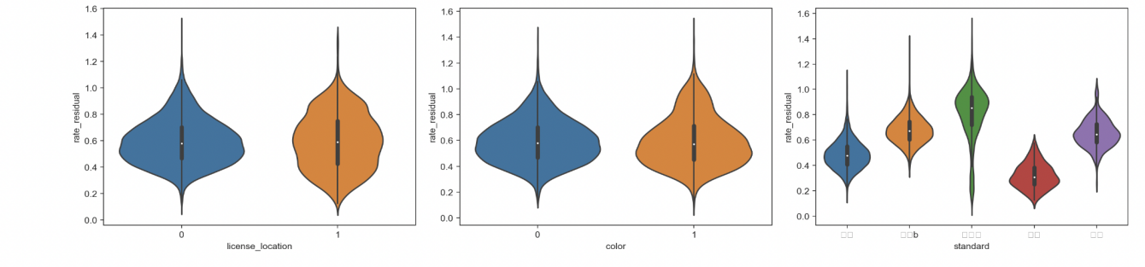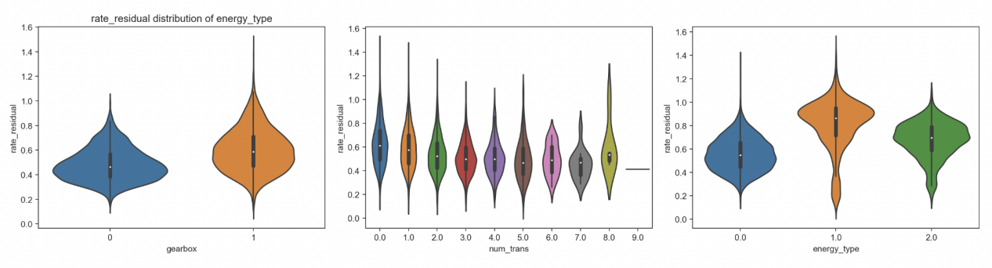

The following figures are the relationship between num_day, rate_residual, and mileage under different energy_type.

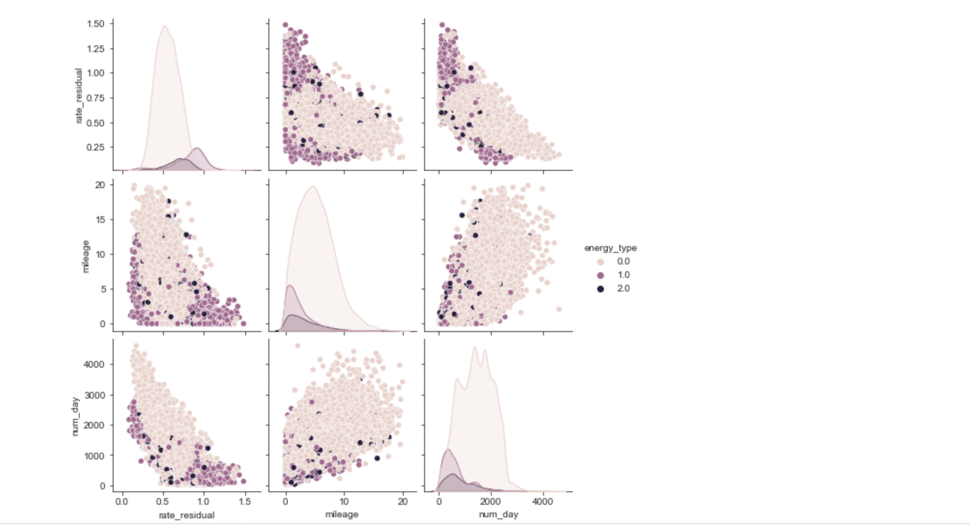

The following figures are the relationship between the price, mileage and displacement of used cars of different colors.

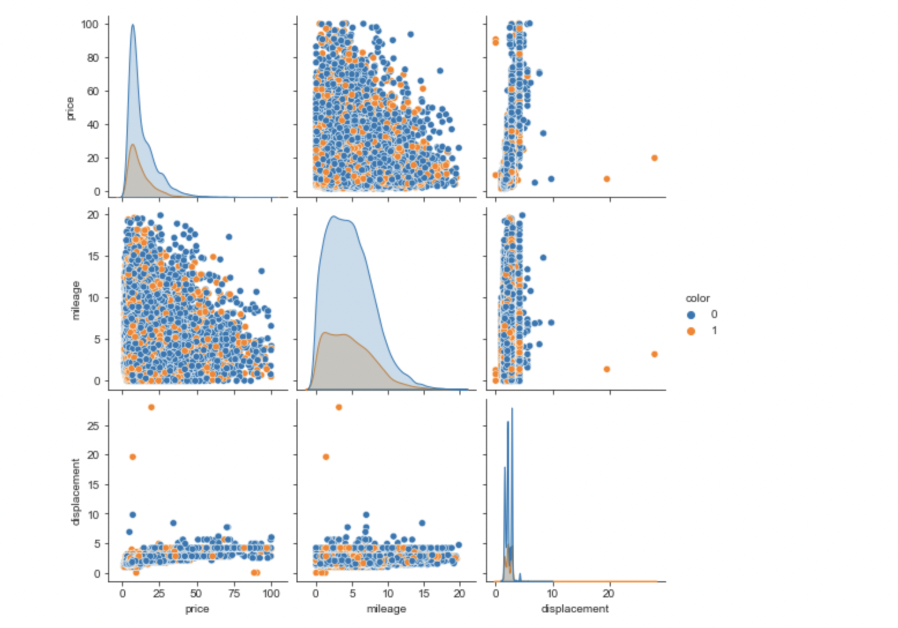

The following figures are density distribution under different energy_type, different color, different license_location.

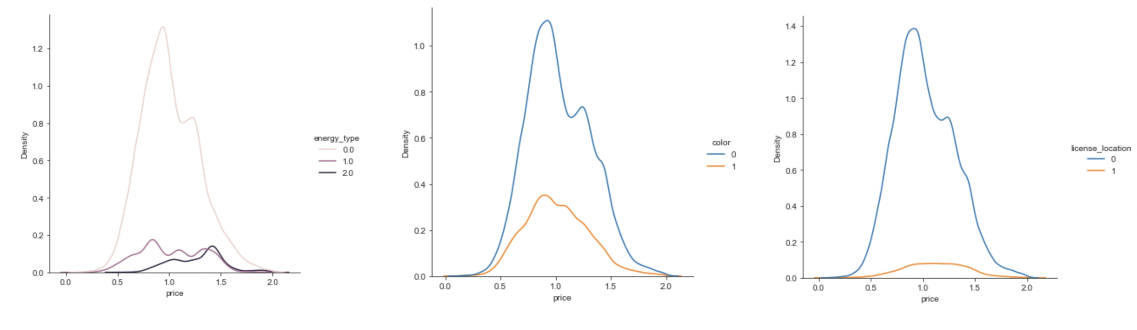

The following figure is the correlation between 13 different features shows that price_new has a great correlation with price, mileage has a sub-correlation with price, and official_endurance has a certain correlation with price.

