

#### [Company Name]

DCIM Onboarding Project

Version 0.1

October 12, 2016

#### Presented by: Phil Pennington, Mei Luo

# Data Center Infrastructure Management (DCIM) Checklist

This checklist document addresses the need for a summary project work-plan associated with project objectives outlined in a separate Statement of Work document.

## Overview

<YOUR COMPANY> recently deployed the **NLyte** software solution for **Data Center Infrastructure Management** (DCIM) purposes and seeks collaborative consultative assistance with the **DCIM Onboarding** project.

The primary **DCIM Onboarding** activities are illustrated by the following functional-area diagram.

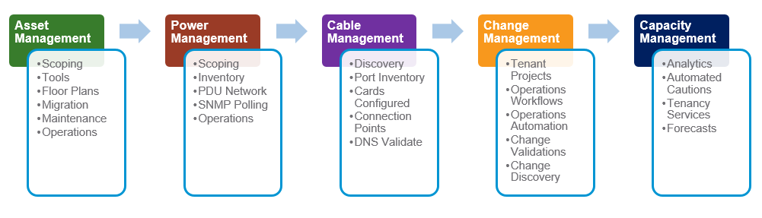

Project objectives associated with this **document** focus specifically upon elements of the **Asset Management** and **Change Management** functional-areas along with supporting DCIM System Administrator role activities. All other DCIM functional areas are considered out-of-scope relative to this phase of the <YOUR COMPANY> DCIM Onboarding project.

**Asset Management** onboarding activities are represented as follows.

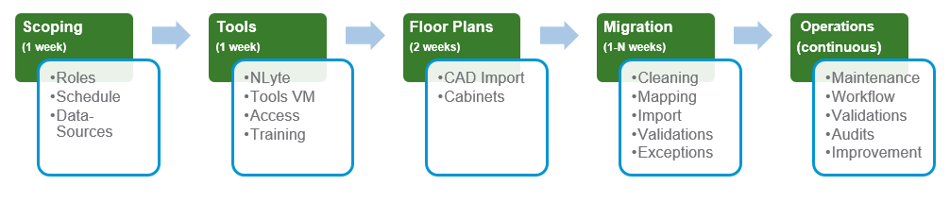

**Change Management** onboarding activities are illustrated as follows.

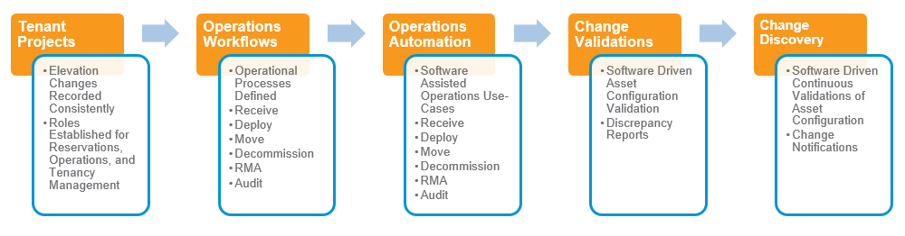

## Tools Management

Start Estimate: 10/14/2016

Initial Complete Estimate: 11/01/2016

Maintenance Mode Complete Estimate: 12/31/2016

Project Estimated Hours: 32

Dependencies:

* Availability of Solution Domain configuration parameters and <YOUR COMPANY> application meta-data.
* Base configuration of the Production Server and administrative remote access.
* NLyte Support Services initial installation/configuration of the Production Server.

The following checklists are associated with administration of DCIM solution software, systems, and services.

### Production Server Configuration

| Completed | Task | Time (est) | RACI | Notes |
| --- | --- | --- | --- | --- |
|  | Coordinate with NLyte Support Services for installation and configuration of NLyte software. | 2 | R:PP,A:RP | Initial installation tentatively scheduled for Wednesday, 10/19, 10:30 AM, PST. |
|  | Configure baseline Windows Server and SQL Server software. | 1 | R:PP+RP | Production configuration must version-match the Test system configuration for database import/export purposes. Windows Server 2008 R2, SQL Server 2012, |
|  | User accounts configuration | 1 | R:PP,A:RP | Need identification of DCIM Administrators and DCIM Users. If users are members of LDAP group, then ensure that those user accounts are established via NLyteGroupSync.exe. |
|  | User roles configuration | 1 | R:PP,A:RP | Utilize the NLyte BDM Tools to configure access privileges for the following user-roles:   * DCIM Admin * DCIM Technician * Catalog Managers * Reservations Managers * Power Managers * Operations Managers * Tenant Managers |
|  | IIS Configuration | 1 | R:PP,A:RP | Import certificate and enable SSL configuration for NLyte web-applications.  Configure the default website as a DCIM Portal page. |
|  | NLyte Administrative Tool Customizations | 2 | R:PP,A:RP,C:JM | Utilize the NLyte Administrators Console to customize the following deployment properties:   * LDAP Integration * Cabinet Usage Categories   + Please provide a list of desired categories (e.g. IT Operations, Disaster Recovery, Cloud Services, etc.) * Location Purpose Categories * Warranty Records Schema Configuration * Asset Record Substatus Configuration (e.g. Received, Loaner, RMA, etc) * Custom fields per asset type (e.g. Tenant End User, Tenant Manager, OpEx CostCenter, etc) |
|  | SQL Server and SQL BI Server Configuration | 1 | R:PP,A:RP,C:ML | Configure the following utilizing SQL Management Studio:   * Database maintenance plans (backup, optimize) * SQL User Accounts * Db Compression |
|  | NLyte Applications Configuration | 1 | R:PP,A:RP | Configure the following applications as licensed and installed by NLyte Support Services:   * Audit Tools * Goods Receiving * NLyte Integration Module (not licensed – TBD) * Bulk Data Migration |

### Test Server Configuration

Replicate the Production Server configuration onto the Test Server environment. Accomplish this on a periodic basis as data-migration activity progresses. The initial backup/restore should occur subsequent to Floor Plan creations are completed on the Production Server.

| Completed | Task | Time (est) | RACI | Notes |
| --- | --- | --- | --- | --- |
|  | Accomplish Server and NLyte application administrative configuration per the Production server specifications noted above. | 3 | R:PP,A:RP | * Carefully preserve the meta-data associated with the test environment including Services, IIS, SQL, SRS, DW/BI, and accounts configurations |
|  | Export the Production databases and Import them into the Test environment. | 2 | R:PP,  A:RP | * NLyte SQL * NLyte BI/DW |
|  | Post Import Reconfiguraton | 1 | R:PP,A:RP | * Copy and reconfigure any SRS reports. * Reconfigure per-environment meta-data including URLs, connection strings, SQL accounts, Service Accounts, etc. |

## Site Management

Start Estimate: 10/20/2016

Initial Complete Estimate: 11/04/2016

Maintenance Mode Complete Estimate: 12/31/2016

Project Estimated Hours: 24

Dependencies:

* Tools Management – Production Configuration – Initial Configuration Completed

The following checklists are associated with initial configuration of site-level floor plans and cabinet configurations.

### Review

| Completed | Task | Time (est) | RACI | Notes |
| --- | --- | --- | --- | --- |
|  | Location Groups Definition | 1 | R:PP+RP | * Identify locations by Region-Country-County-City-Building-Floor-Room names. * Create corresponding NLyte locations. * Create virtual rooms per location for movement of assets during Decommission, RMA, Loaner-Return, etc. |
|  | Obtain Site/Room Floor Plan Images and Measurements | 1 | R:RP+ML | * CAD, PDF, or IMG files per site and per room with dimensions. |
|  | Create NLyte Floor Plans and Room Diagrams. | 20 | R:ML  A:RP | * Utilize the NLyte Floor Planner to create facility and room diagrams per site/room. |
|  | Configure Cabinets per Room | 2 | R:ML  A:RP | * Obtain inventory of cabinet models, names, asset tags, count, and floor-plan layouts (i.e. rows), and power thresholds per facility/room/cabinet. * Configure NLyte Catalog Models for each cabinet type. |

## Tenant Management

Start Estimate: 11/01/2016

Initial Complete Estimate: 11/04/2016

Maintenance Mode Complete Estimate: 12/31/2016

Project Estimated Hours: Portion of 80 total estimated for Asset Record Migration

Dependencies:

* Tools Management Complete
* Availability of Business and Support Group information
* Business Group to Asset record mapping follows completion of Asset Management – Data Migration and continuing maintenance thereafter.

The following checklists are associated with initial configuration <YOUR COMPANY> Business and Support Groups.

### Business Group and Support Groups

| Completed | Task | Time (est) | RACI | Notes |
| --- | --- | --- | --- | --- |
|  | Business Group record import and configuration | 2 | R:PP+ML; A:RP | * Tenant names, contacts. * Ensure that these people are joined to the associated LDAP group for corresponding NLyte access. * Per business group cost-centers numbers. |
|  | Support Group record import and configuration | 2 | R:PP+ML; A:RP | * Operations team names and contact info. * Ensure that these people are joined to the associated LDAP group for corresponding NLyte access. * Per Support group cost-centers numbers. |
|  | Asset to Business Group record mapping | 3 | R:PP+ML; A:RP | * Upon completion of Asset Record migrations, establish Business Group ownership records utilizing the NLyte BDM tool; Asset to BG maps template. * Leverage the asset record cost center value as a relational key between entities. |
|  | Contacts to Business Group record mapping | 3 | R:PP+ML; A:RP | * Upon completion of Asset Record migrations, and Business Group record migrations, establish mapping between contacts and Business Groups. Utilize the NLyte BDM tool; Account to BG maps template. * Leverage the asset record cost center value as a relational key between entities. |
|  | Contacts to Assets record mapping | 3 | R:PP+ML; A:RP | * Create custom fields for TenantEndUser and TenantManager. * Create associations between assets and Tenants. |

## Asset Management

### Asset Record Data Migration

Start Estimate: 11/04/2016

Initial Complete Estimate: 12/05/2016

Maintenance Mode Complete Estimate: 12/31/2016

Project Estimated Hours: 80

Dependencies:

* Tools Management Complete
* Site Management Complete
* Availability of complete Asset Inventory records

| Completed | Task | Time (est) | RACI | Notes |
| --- | --- | --- | --- | --- |
|  | Assess per-site asset records |  | R:RP+ML+PP; A:JM | * <YOUR COMPANY> to provide asset inventory records (i.e. spreadsheets) for assessment of data-migration timelines and work-items. |
|  | Establish data-migration catalog mappings |  | R:ML+PP; A:RP | * Create model name mapping tables. * Create location name mapping tables. * Create cabinet name mapping tables. * Create RU name mapping tables. * Establish repeatable processes for import of <YOUR COMPANY> inventory records and export of NLyte compatible asset records. * Import NLyte compatible asset records. * Wash, rinse, repeat as needed. |
|  | Per Site Data Migration and Asset Record Import |  | R:ML+PP; A:RP | * Asset inventory lists. * <YOUR COMPANY> to NLyte model mappings. * <YOUR COMPANY> to NLyte location mappings (site, room, cabinet, RU location) * Asset record per-field syntax cleaning and normalization. * Bulk Import per cabinet and/or per asset type. |
|  | Data Migration Validation |  | R:RP+ML; A:JM | * Coordinate cabinet and row-level audit/validation of data-migration with Operations teams. * Provide corrective audit details for remediation. |
|  | Continuous Audits |  | R:RP+PP+ML; A:JM | * Provide guidance to the Operations teams on use of the NLyte Audit Tool for auditing, reporting, and correcting asset configurations. |
|  | Continuous Operations |  | R:PP+ML+RP; A:JM | * Provide informal training on People + Process + Tools in order to establish maintenance mode |

### Asset Management Operations Use Cases

Start Estimate: 11/11/2016

Initial Complete Estimate: 12/16/2016

Maintenance Mode Complete Estimate: 12/31/2016

Project Estimated Hours: 16

Dependencies:

* Asset Data Migration progress established.
* Coordination with site-level Operations team-members.

| Completed | Task | Time (est) | RACI | Notes |
| --- | --- | --- | --- | --- |
|  | Continuous Audits |  | R:RP+PP+ML; A:JM | * Provide guidance on use of the NLyte Audit Tool for auditing, reporting, and correcting asset configurations. |
|  | Continuous Operations |  | R:PP+ML+RP; A:JM | * Provide informal training on People + Process + Tools in order to establish maintenance mode operations. |
|  | Define high-level Operations Use Cases and Corresponding Processes |  | R:RP+PP+ML; A:JM | * Outline Operations processes including:   + Reservations   + Decommissions   + Moves   + Deployments   + RMAs   + Loaners   + Others? |
|  | Identify Operations per Role Use-Cases |  | R:RP+PP+ML; A:JM | * Representative Roles include:   + DCIM Administrators   + Operations Technician   + Reservations Manager   + Operations Manager   + Catalog Manager   + Tenant Manager   + Power Manager |
|  | Provide Baseline How-To Documentation on Tools Usage per Operations Role and Use Case |  | R:PP+ML; A:RP | * Create check-list type NLyte Tools usage scenario documentation for Operations team-members. * Publish documentation as PDF within the Project Portal website. |

## Change Management and Workflow Management

### NLyte/Service CMDB Configuration

TBD

### NLyte/Service Change Management Configuration

TBD

## NLyte Analytics and Dashboard Reports

## SQL Reporting Services

### NLyte Analytics Reports Configuration (SRS)

TBD

## Planning for Power Management

### NLyte Integrator

TBD

### PDU Inventory

TBD

## DCIM Technology Roadmap

### Next-Steps with NLyte and DCIM Solutions

The primary DCIM vendor, NLyte Software, licenses several products and components supporting DCIM Operations. For planning-purposes, the following product components are required or recommended. The NLyte Core Engine components (illustrated in red) are assumed to have been already purchased by <YOUR COMPANY>. The optional components (illustrated in green) are recommended additional purchases. Actual costs are typically negotiated with the vendor directly. NLyte also provides product packaging options that will include many of components within a single comprehensive license. Facilities Integration is not addressed herein but would deserve consideration for longer-term plans or if enterprise licensing advantages were available. NLyte recently purchased and has integrated a facilities and power management technology known as “FieldView” but now renamed “NLyte NEO”. NEO includes active monitoring and alerting capabilities along with an ability to derive and apply heuristic facility management policies.

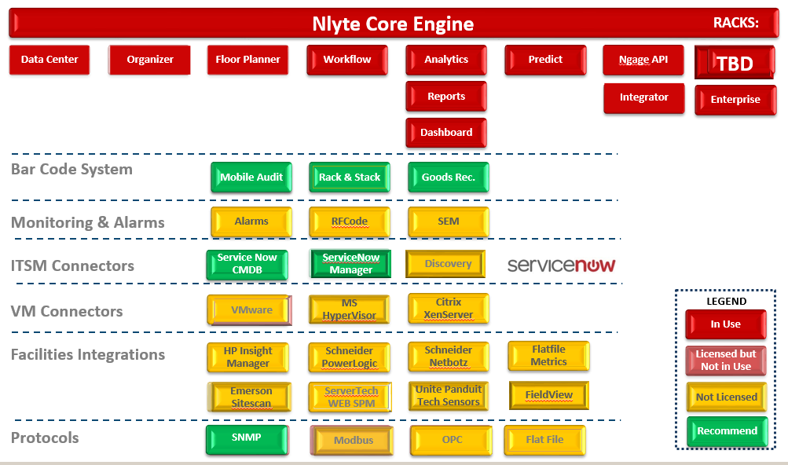

| Recommended Add-On Components | | Purpose | Notes |
| --- | --- | --- | --- |
| Mobile Audit | A tablet+scanner Operations Center application for auditing and recording asset changes. | Recommended for Audit efficiencies. |
| Rack & Stack | A tablet+scanner Operations Center application optimizing asset record capture during deployment. Available during the Summer, 2016. | Recommended for Deployment efficiencies. |
| Goods Receiving | A tablet+scanner Receiving Center application optimized for bulk-asset receiving. | Recommended for Receiving efficiencies. |
| ServiceNow CMDB | Integration component providing asset record synchronization with the ServiceNow Configuration Management Data Base. | Essential for Asset Management |
| ServiceNow Manager | Integration component provided Operations Workflow integration between NLyte and ServiceNow. | Recommended for Ticketing Systems Integration |
| SNMP Integrator | Integration component necessary for polling data-center devices including Power Distribution Units and Powerstrips. | Essential for Power Management |

The following illustration provides a proposed roadmap for DCIM technology adoption. Recommendations are to first accomplish a per-site asset inventory on a cabinet-by-cabinet basis in order to establish an inventory-confidence baseline. This project phase should be quickly followed by enablement of Operations Change Control in order to ensure ongoing operational consistency. Reports and consistency metrics will subsequently serve to enable a Continuous Improvement initiative. Finally, Power Management enablement forms the basis for future Capacity Management and Environmental Monitoring objectives. The dates noted herein are relative for illustrative purposes.

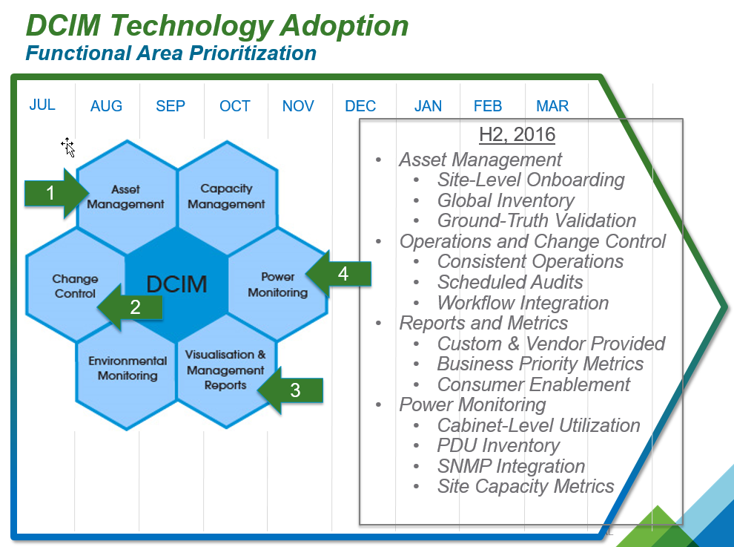

The following illustration suggests a timeline for the activities associated with the People, Process, and Tools based IT Operations project. A detailed project plan is dependent upon availability of cross-team resources and corresponding collaboration schedules.

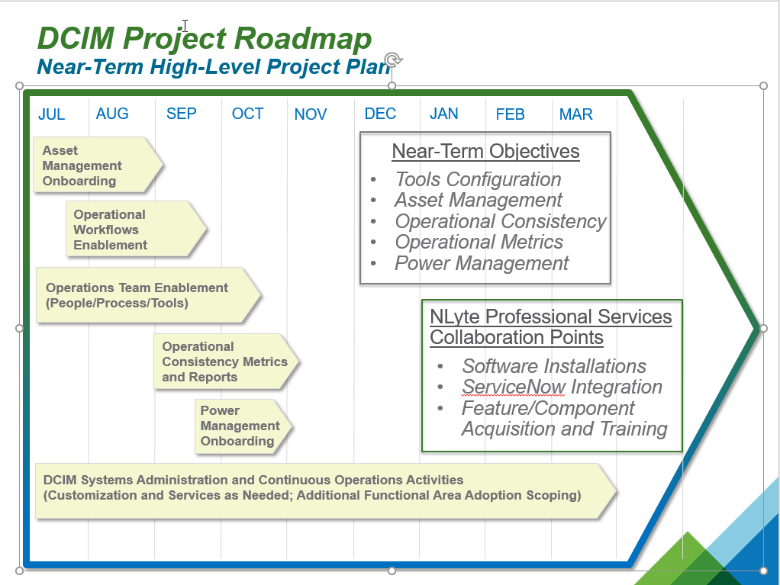

## Template Checklist

### Sample Checklist

| Completed | Task | Time (est) | RACI | Notes |
| --- | --- | --- | --- | --- |
|  |  |  |  |  |
|  |  |  |  |  |
|  |  |  |  |  |
|  |  |  |  |  |
|  |  |  |  |  |
|  |  |  |  |  |
|  |  |  |  |  |
|  |  |  |  |  |