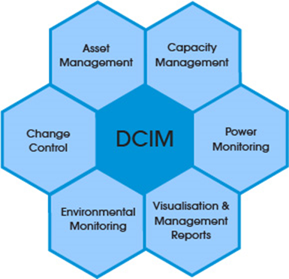

DCIM Technology Adoption

A Practioner’s insights

Phil Pennington | PhilPennington.com | February, 2017

# Data Center Infrastructure Management (DCIM)

What is?

Motivations?

Summary info

http://datacenterknowledge.com

## Operational readiness

Everyone naturally expects consistent data. Good business decisions depend upon insights gained from consistent business operations analytics. Even so, few seem to understand the intrinsic relationship between business operations capability and resultant quality of analytical information. Business sponsors often expect consistency in reporting that would be impossible without corresponding prior operations enablement.

The following illustration depicts this correspondence. You may recognize that the shape of the curve between the axis is exponential and not directly proportional. This shape works in our favor per the following observations.

* A slight increase in *Operational Consistency* (i.e. a movement to the right along the horizontal axis) results in a dramatic increase in *Data Consistency* (i.e. upward movement along the vertical axis). In other words, a small operational improvement can go a long way.
* How can we know our consistency position on this curve? That’s a function of metrics. *Operational Consistency* measurements provide insights into where we are at any point in time.
* How can we improve our consistency position? That’s the art and science of *Operations Management* involving *People, Processes, and Technologies*. Or, more specifically, the organizational application of *Roles, Workflow, and Automation* to business processes.

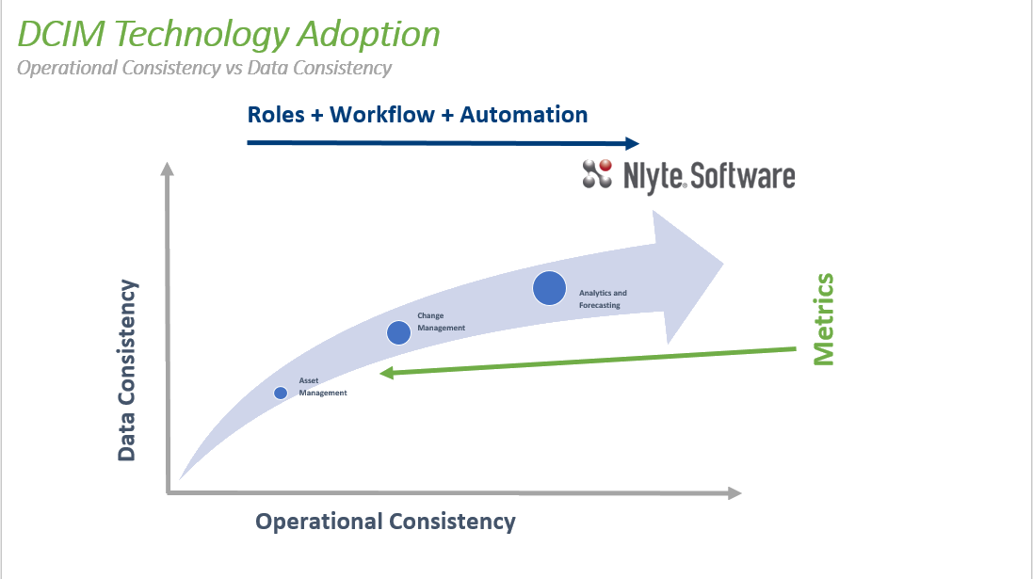

## PROJECT PRIOrities

Note the following key prerequisites for a successful DCIM project…

* Sponsorship
* Adoption Roadmap
* Onboarding Plan

### Sponsorship

Most projects require the following three *levels* of engaged and continuous sponsorship. Without these, the risks of failure multiply. Unfortunately, many enterprises trend toward an outsourcing dependency that fails to recognize the intrinsic organizational culture changes brought about by DCIM. Recommendations are to outsource very selectively and then only within the context of specific deliverables. First and foremost ensure that your sponsors and stakeholders are actively engaged and driving DCIM adoption.

|  |  |  |
| --- | --- | --- |
| Sponsorship Level | Enterprise Roles | Accountability |
| *Executive* | * Vice-President * CxO | * Signature sponsors of the corporate “DCIM Initiative”. * Evangelizes corporate initiatives. * Chair of major milestone project reviews. |
| *Business* | * Sr. Directors * General Managers * Regional Directors | * Business stakeholders. * Enables cross-team collaboration. * Approve project objectives, plans, and milestone deliverables. * Identify new business capabilities and opportunities. * Assign and enable technical resources. |
| *Technical* | * Operations Managers * DCIM Solutions Consultants * Technical IT Operations Staff Members | * Execute the DCIM Onboarding Plan. * Establish Operations Team roles. * Establish Operations Workflows. * Implement technical solutions. * Achieve project milestone deliverables. * Scale-out via staff technical training and role enablement. |

### Adoption Roadmap

The following illustration provides a high-level roadmap for DCIM technology adoption based upon functional-area priority.

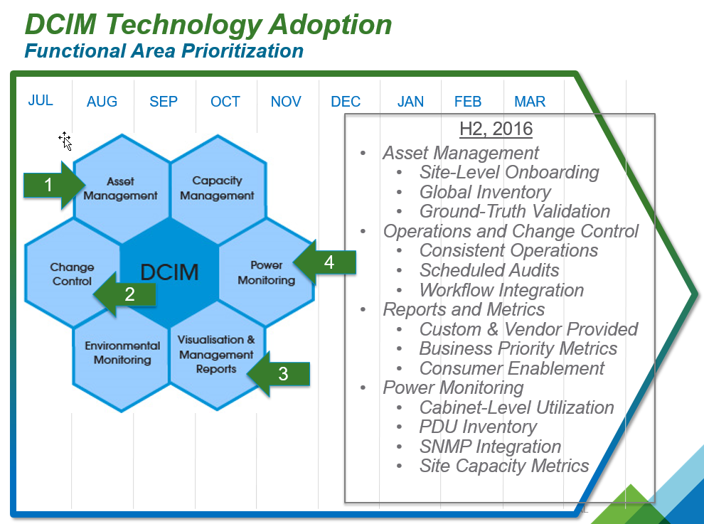

Recommendations are to first accomplish *Asset Management* inventory and data-migration followed-by or concurrently with operations *Change Control*. These two feature/functional areas underpin all other areas. Subsequent feature/functional area adoption is largely business objectives dependent.

If possible, conduct your *Asset Inventory* data-migration on a cabinet-by-cabinet basis. A practical goal is to achieve a concurrent cabinet-by-cabinet validation audit. Most often, it is a mistake to accomplish inventory data-migration on a room or site level even if your source data-set includes all records for these. The reason is that you will learn from data-mapping exceptions, learn how to correct these exceptions, and gain subsequent data-migration benefits.

This project phase should be quickly followed by enablement of simple *Operations Change Control* workflows. The primary objective of Change Control is to accurately and consistently execute Operational use-case scenarios. Any operation that results in a change to the asset inventory should be documented with at least an interim checklist. Example operations include asset deployments, moves, returns, and decommissions. Of course, the longer-term goal is to formally define, automate, and refine all operations workflows using the *Workflow Management* functionality within DCIM tools.

Initially, however, Change Control may not necessarily entail completion of sophisticated Workflows or integration with external ticketing systems. In many cases, it is more expedient early-on to simply define and document basic Operations scenarios. Then, spend time training Operations staff to execute their roles per the defined standards (allowing for minor variations) and to gain familiarity with DCIM tools.

Thereafter, as time and capability permit, integrate with Change Control systems and ideally use Workflow to incrementally increase asset lifecycle automation and thus overall operations consistency.

Reports and consistency metrics will subsequently serve to enable *Continuous Improvement* initiatives. Finally, *Power Management* capability forms the basis for future *Capacity Management* and *Environmental Monitoring* objectives.

### Onboarding Plan

The following illustration leverages the feature/functional areas of DCIM to list corresponding high-level project planning activity-areas for rolling-out DCIM solutions.

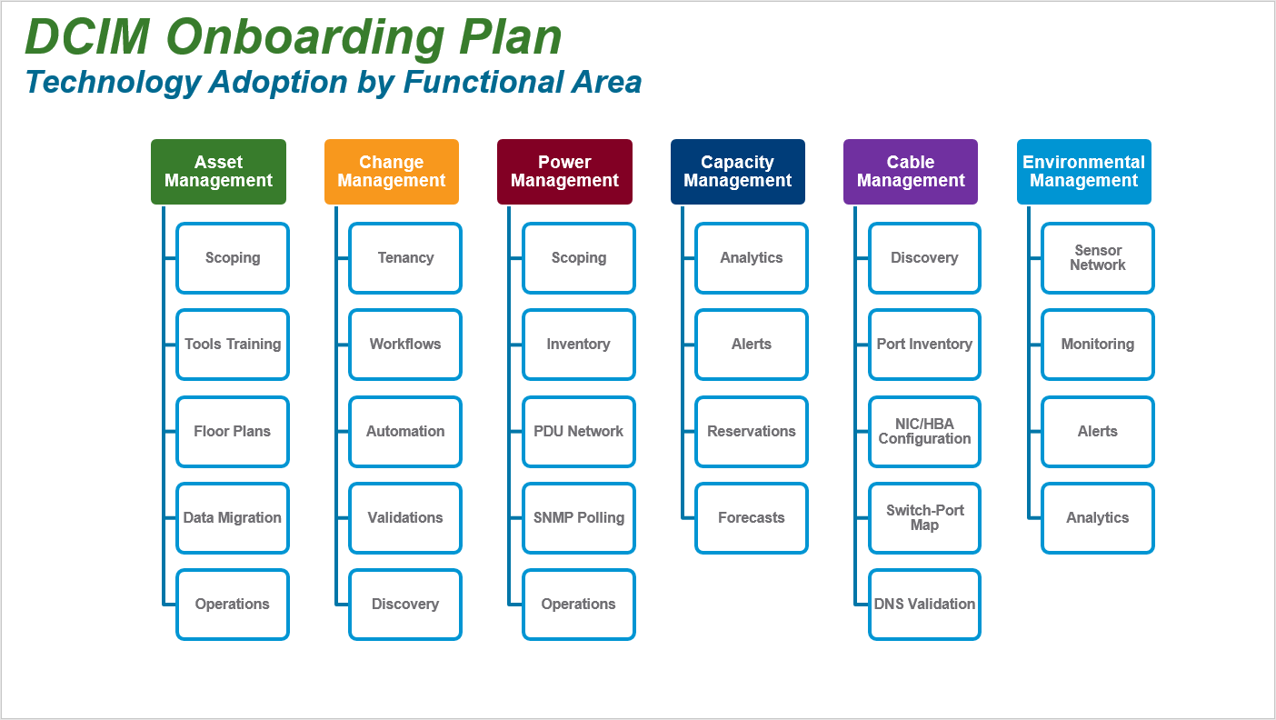

Within the functional area of Asset Management, for example, subproject activities include Scoping, Tools Training, Floor Plan imports, Data Migrations, and continuous Operations. This perspective enables a somewhat traditional project management approach for DCIM technology adoption with step-wise resourcing of work-items within each phase of each functional area.

Herein, we will explore each of these DCIM functional areas in more detail. However, this approach, by itself, is missing another key perspective. That perspective is illustrated below.

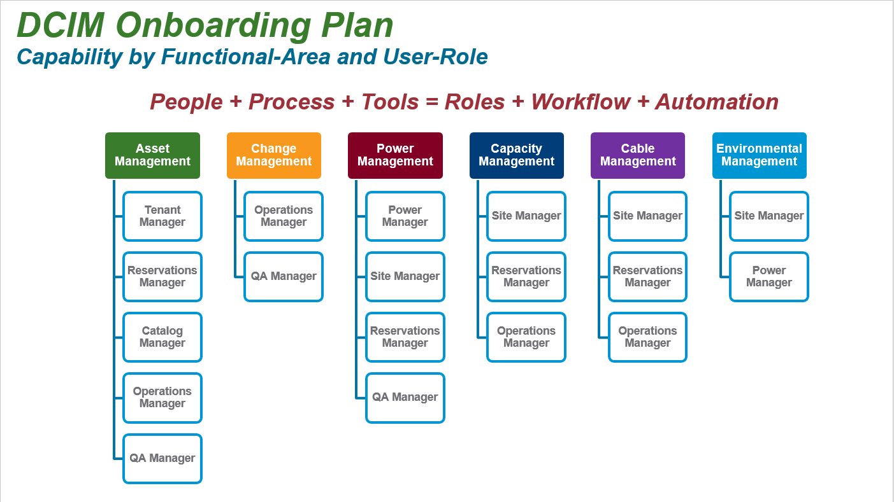

IT services fulfillment is known to be a People + Process + Tools equation. DCIM solutions present the opportunity to map this equation onto a corresponding Roles + Workflow + Automation solution domain. Hence, a key endeavor is to identify Operations Roles that participate in each DCIM functional area.

For example, within Asset Management, participating Operations Roles include Tenant Manager, Reservations Manager, Catalog Manager, Operations Manager, and QA Manager.

Once Roles are defined, then the Operations Usage Scenarios for each Role become more obvious as illustrated below.

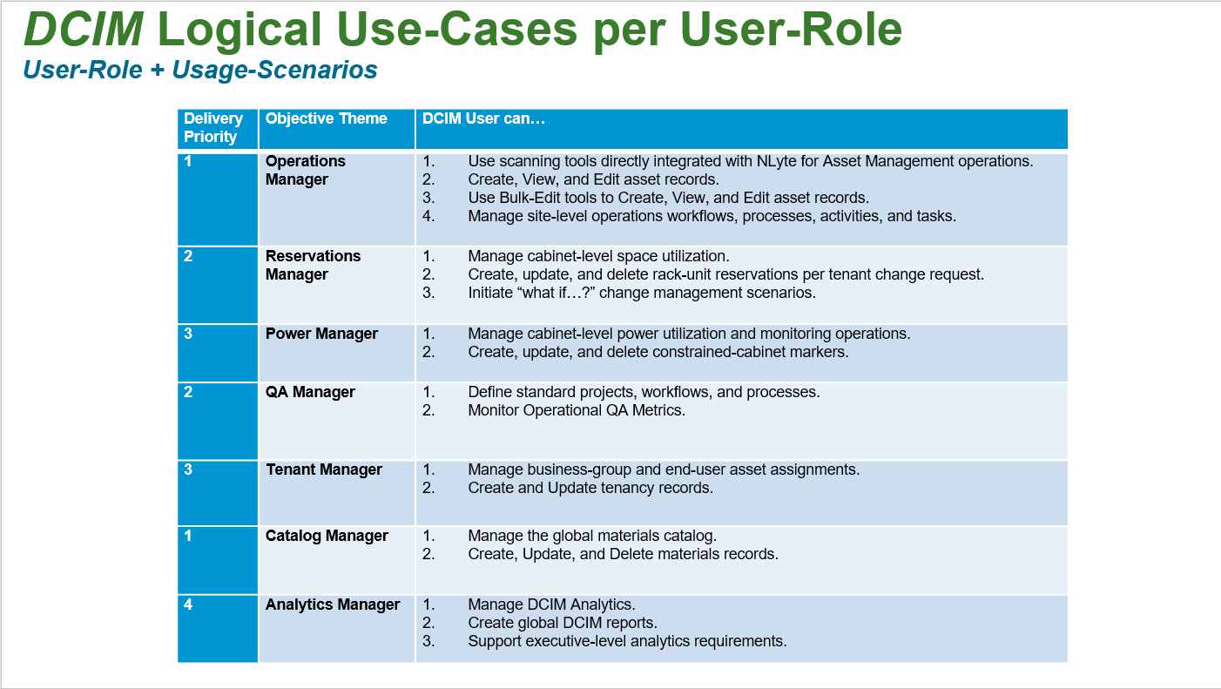

The Reservations Manager role, for example, utilizes DCIM Tools to accomplish specific usage scenarios. These include management of cabinet-level space and power utilization. The Reservations Manager is an initial approver of change requests and correspondingly creates, updates, and deletes cabinet rack-unit reservations per change request.

The Operations Manager role utilizes DCIM Tools to receive assets, deploy those assets to production, audit assets, and accomplish asset lifecycle tasks including moves and decommissions.

Thus, a DCIM Onboarding Plan should account for both DCIM feature/functional technology adoption and logical use-case per user-role definition.

The following illustration suggests a timeline for the activities associated with the People, Process, and Tools based IT Operations project. A detailed project plan is dependent upon availability of cross-team resources and corresponding collaboration schedules.

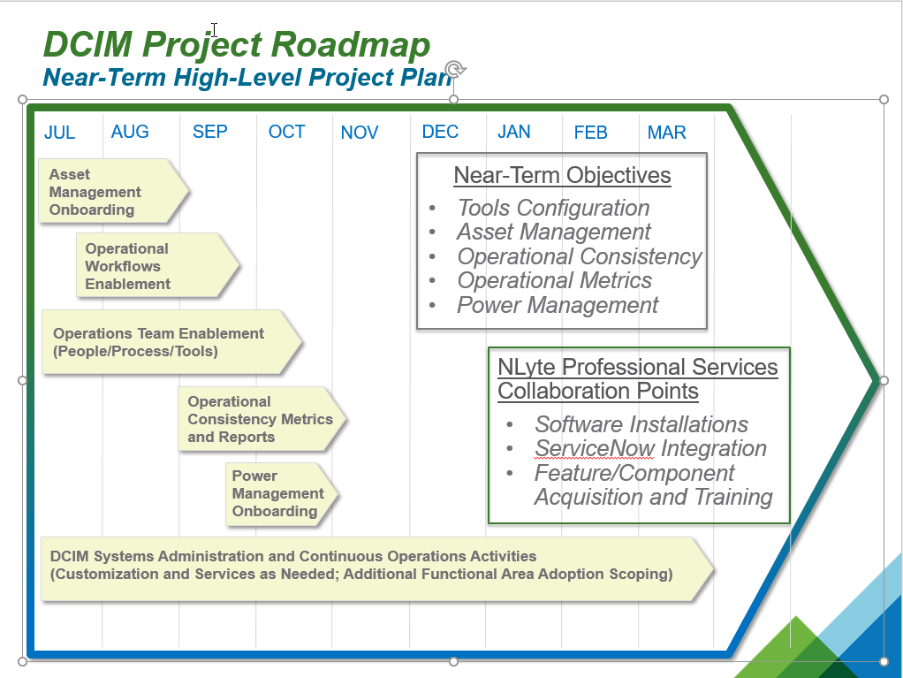

## Functional Area Technology Adoption

### Asset Management

### Change Management

### Power Management

### Capacity Management

### Cable Management

### Environmental Management

## Logical use-case Technology Adoption

### Establishing User Roles

### Example – Reservations Manager – Reserve RU

### Example – Operations Manager – Receive Assets

### Example – Operations Manager – Deploy Assets

### Example – Power Manager – Constrain Cabinets

## Technology Roadmap

Your primary DCIM vendor, such as NLyte Software, licenses products and components supporting DCIM Operations. For planning purposes, identify vendor-provided functional components that are required or recommended. For example, components of the NLyte Core Engine (illustrated in red) would be provided by default. Additional optional components (illustrated in green) are purchased separately. Actual costs and package options are typically negotiated with the vendor directly and perhaps within the context of a single comprehensive license. Facilities and *Environmental Monitoring* integration is not addressed herein but would deserve consideration for longer-term DCIM technology adoption plans or if enterprise licensing advantages were available.

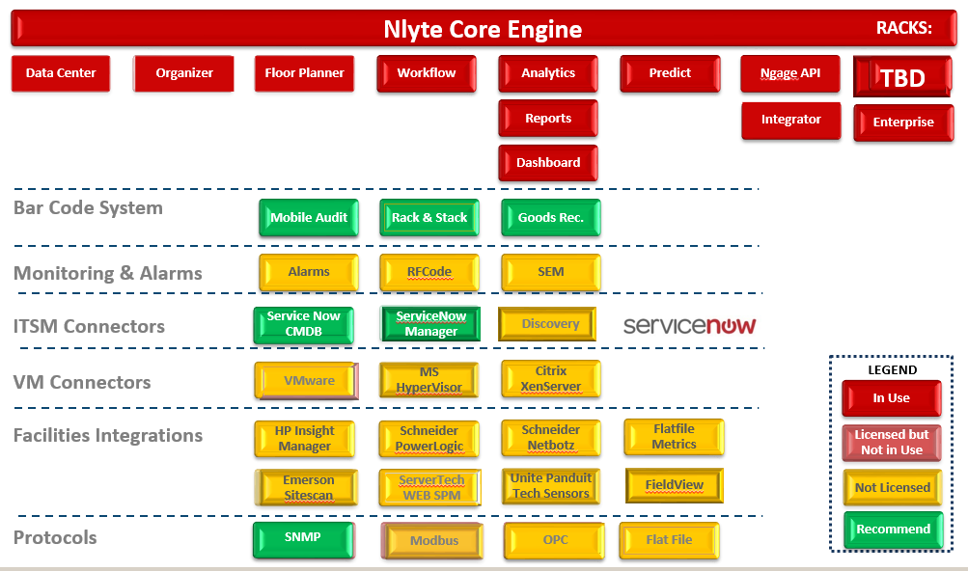

| Typical Recommended Add-On Components | | Purpose | Notes |
| --- | --- | --- | --- |
| Mobile Audit | A tablet+scanner Operations Center application for auditing and recording asset changes. | Recommended for Audit efficiencies. |
| Goods Receiving | A tablet+scanner Receiving Center application optimized for bulk-asset receiving. | Recommended for Receiving efficiencies. |
| ServiceNow CMDB | Integration component providing asset record synchronization with the ServiceNow Configuration Management Data Base. | Essential for Asset Management |
| ServiceNow Manager | Integration component provided Operations Workflow integration between NLyte and ServiceNow. | Recommended for Ticketing Systems Integration |
| SNMP Integrator | Integration component necessary for polling data-center devices including Power Distribution Units and power-strips. | Essential for Power Management |
| NEO | Environmental Monitoring, Alerts, and Power Management solution. | Recommended for fine-tuned site management. |