#### VMware IT

DCIM Catalog Manager

Version 0.1

April 3, 2017

#### Presented by: Phil Pennington

# Operations Management Scenarios

This checklist document addresses the usage scenarios associated with the Data Center Infrastructure Management (DCIM) **Catalog Manager** role.

## Overview

The following illustration highlights the primary feature areas of a DCIM solution and suggests user-roles with responsibilities within each area. IT Operational business activities map to a combination of People, Processes, and Tools. DCIM tools support business objectives by enabling Roles definitions, corresponding Workflows, and Automation of tasks. The **Catalog Manager** role possesses the specific responsibility of managing the global materials catalog.

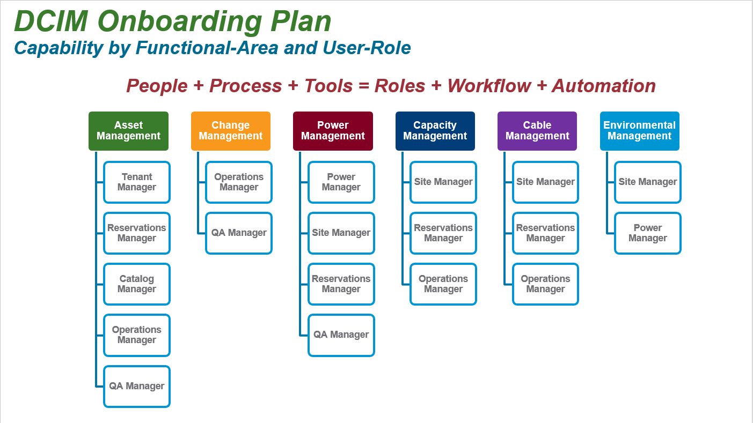

The following illustration suggests several logical use-cases associated with DCIM user-roles. Note that this isn’t a completing listing, but rather a starting-point for definition of those roles and use-cases matching our organizational business requirements. Ideally, DCIM tools enable these use-cases with only minor customizations.

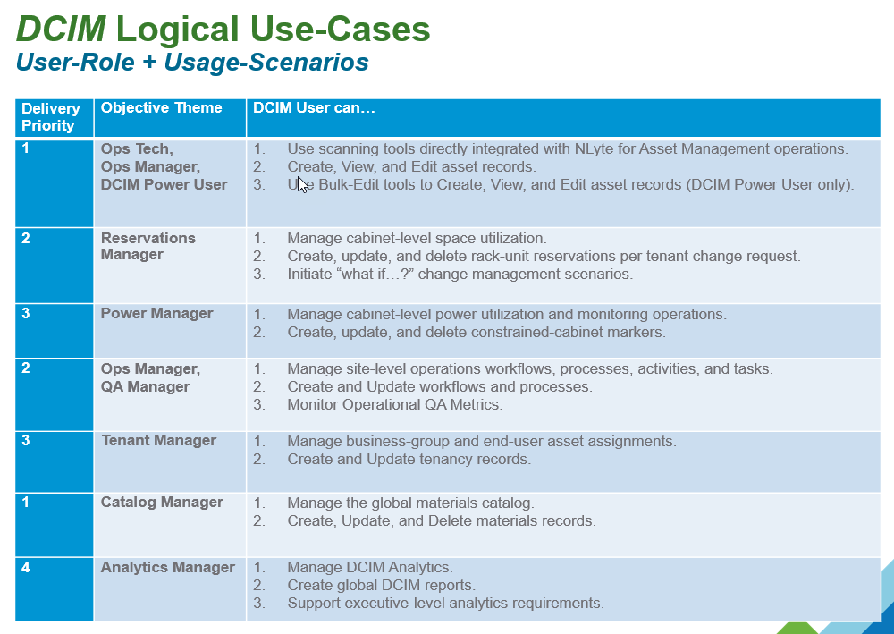

Note that the **Catalog Manager** role is primarily responsible for management of the Materials Catalog.

This document focuses only upon the following key activities utilizing the NLyte DCIM tools for **Catalog Management** tasks.

* Given that a material is not available within the NLyte Catalog, add a User-Defined material type.

## Add User-Defined Material

Catalog Management practices vary per location and business processes. Herein, the following assumptions apply.

* New catalog entries are required most-often by the site Reservations Manager upon a new deployment request. When the Reservations Manager seeks to establish a reservation, and discovers that the material type is not available, then a new user-defined material is required.

### New Catalog Material Prerequisites

The Catalog Manager should receive the following material data-sheet information within the context of a catalog change request.

* Material Type
  + Cabinet
  + Chassis
  + KVM Switch
  + Network
  + Peripheral <subtype – e.g. storage>
  + Power Strip (cabinet PDU)
  + Standard Server
  + Blade Server
  + UPS
  + Other <provide description>
* Manufacturer
  + Product datasheet URL
* Model (specific)
* Power
  + Type (One Phase, Two Phase, Three Phase)
  + Power Consumption (average kW)
  + Voltage Requirement
  + Plug Type
  + Diverse Power Required?
* Rack-Unit Size
* External Height (mm)
* External Width (mm)
* External Depth (mm)
* Weight (kg)
* Airflow
  + Front to Back
  + Back to Front
  + Side to Side
* Cabinet Mounting
  + Standard 19”
  + Standalone
  + Other (specify)

## Material Request Example

For example, assume the following simple new material request details:

* Material Type: Peripheral, storage
* Manufacturer: Synology
* Model: RackStation RS3617xs
* DataSheet: <http://www.synology.com/en-us/products/RS3617xs#spec>
* Power Type: One Phase
* Power Consumption: .116 kW
* 120/240V, 2 plugs, diverse power required
* Standard data-center plug and cable
* RU Size: 2
* External Height: 88 mm
* External Width: 445 mm
* External Depth: 570 mm
* Weight: 13.3 kg

### Step 1, Ensure that the Material Request is Legitimate

Use the NLyte Materials Search feature to confirm that the requested material is not already present within the Catalog. Use wild-card searches or variations on the model name. If an existing material type is present, then utilize that instead of creating a new user-defined material type.

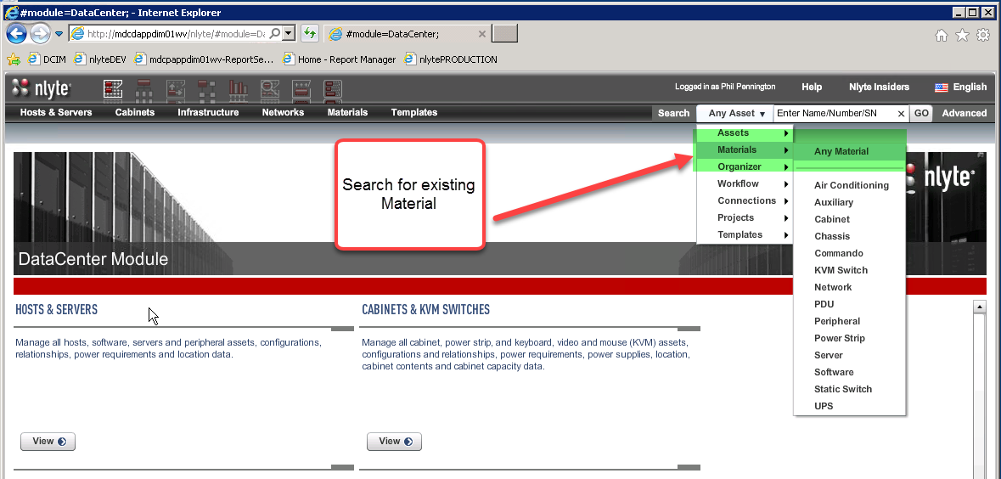

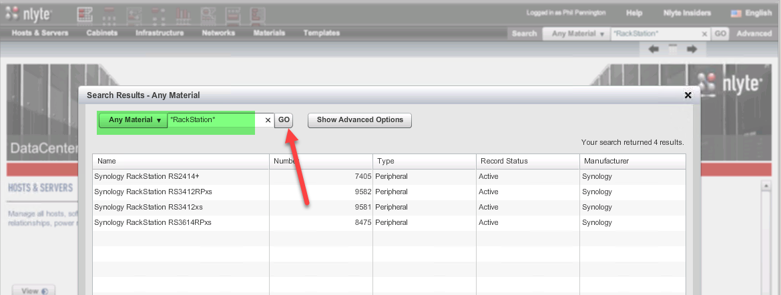

If one of the existing catalog types will not suffice, then proceed to create a user-defined model. You may also wish to open a support ticket with NLyte and ask that the new model be added to the catalog.

### Step 2, Create the User-Defined Material

The Material may be added using either the NLyte UI or the NLyte BDM tool. The suggested approach is to primarily use the NLyte UI. However, it may be useful to concurrently open the NLyte BDM tool to reference and compare with existing material records.

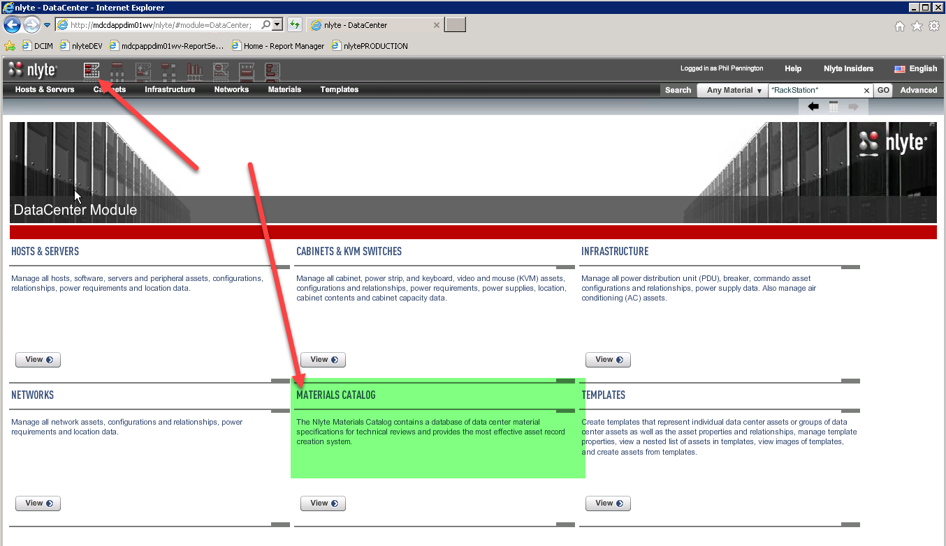

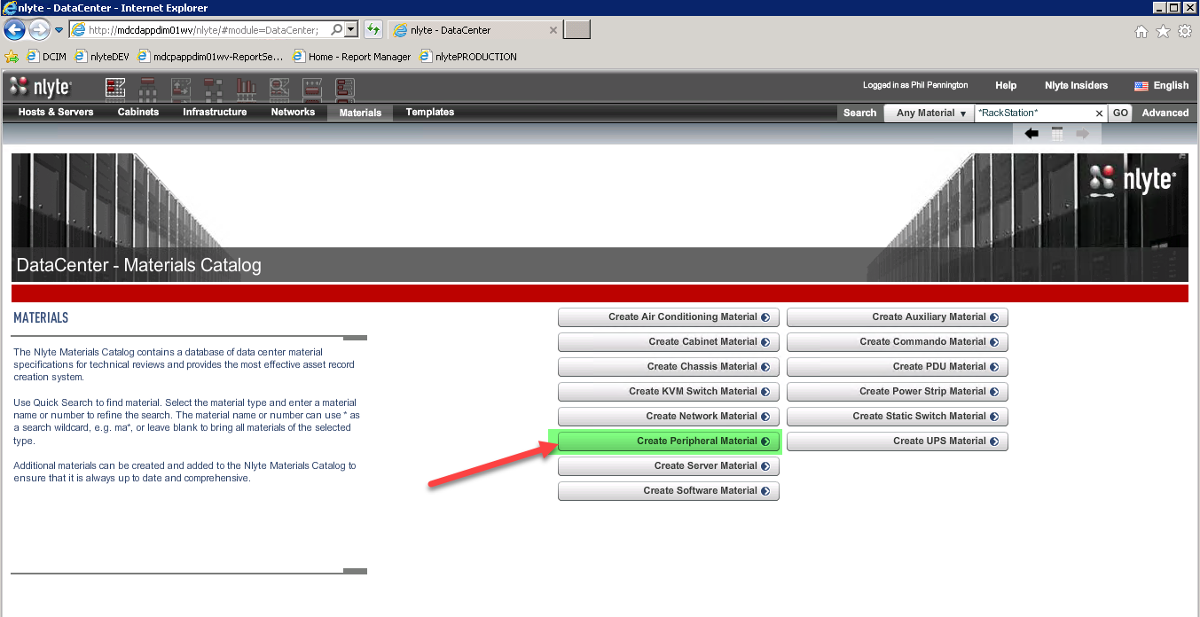

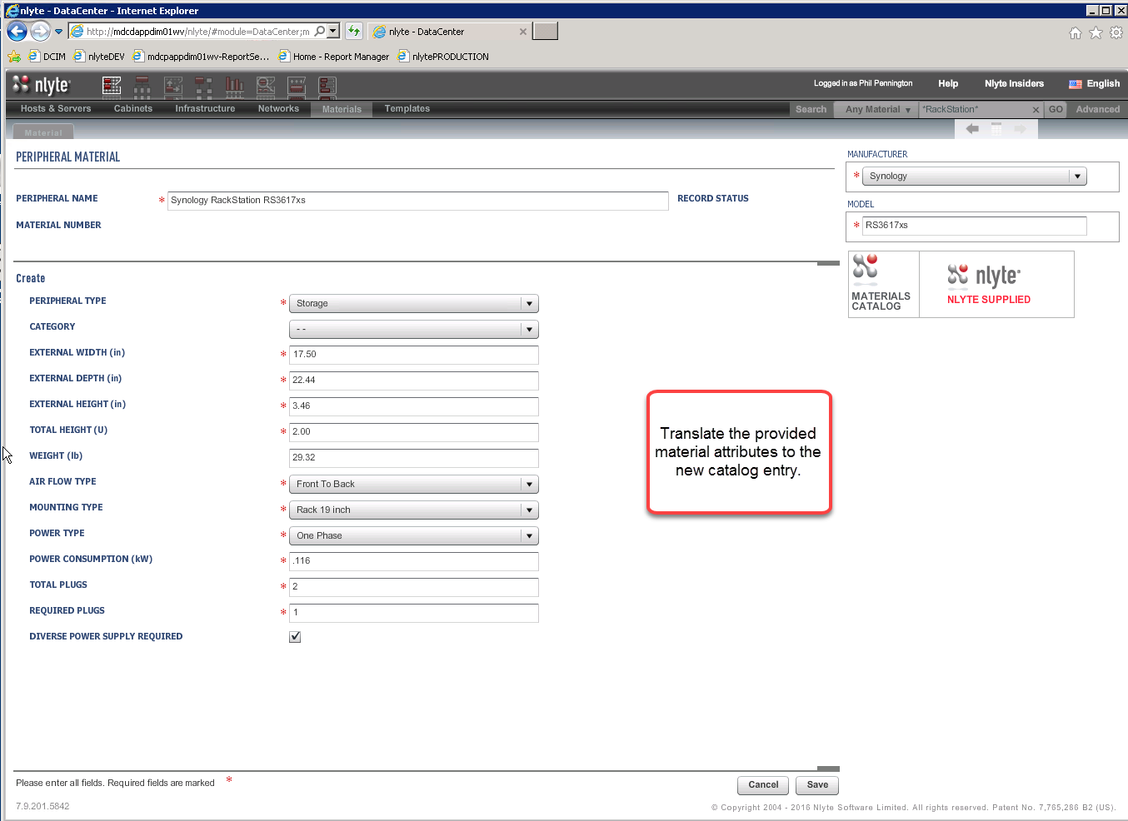

Press Save.

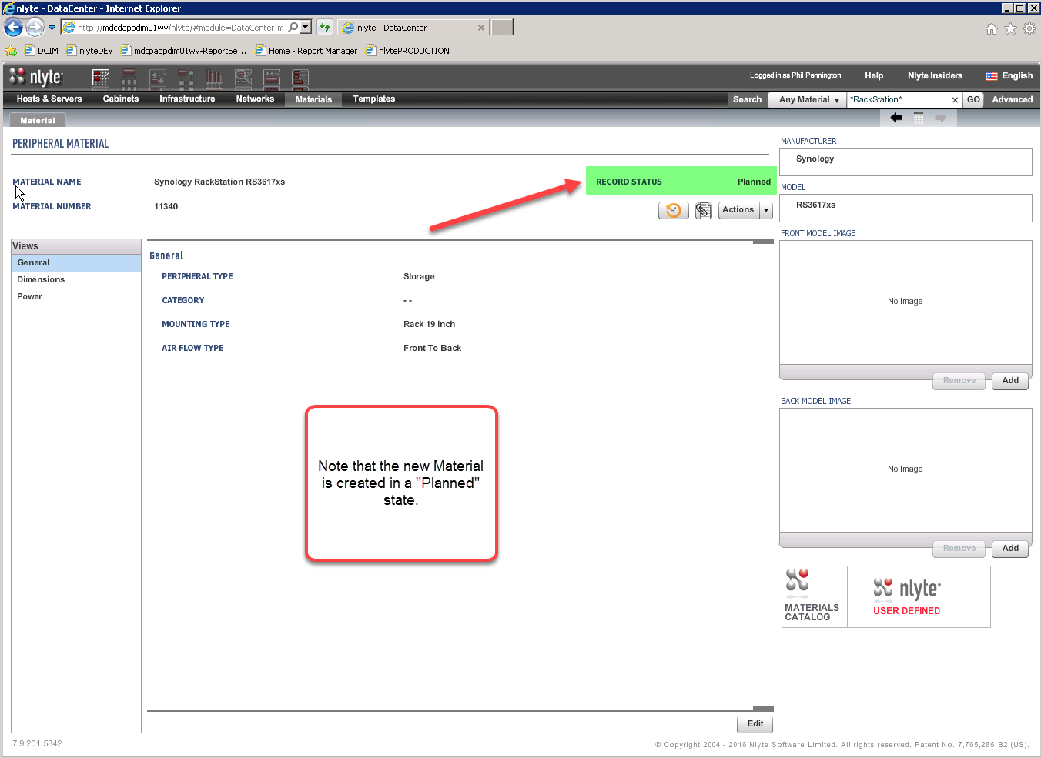

Optionally, use the “Add” buttons to add front and back images of this material into the catalog record.

### Step 3, Activate the Material

