#### VMware IT

DCIM OPERATIONS Manager

Version 0.1

April 3, 2017

#### Presented by: Phil Pennington

Contents

Operations Management Scenarios 3

Overview 3

New Asset Receiving 5

Asset Receiving Prerequisites 5

Receive Asset Example 5

Step 1, Unpackage the Asset and Apply Asset Tag 5

Step 2, Find the Corresponding NLyte Asset Reservation 6

Step 3, Update the NLyte Asset Record 9

New Asset Deployment 10

Asset Deployment Prerequisites 10

Deploy Asset Example 10

Step 1, Locate the Target Cabinet Location 10

Step 2, Establish the Final RU Location with the Cabinet 12

Step 3, Complete the Asset Record Creation 14

Step 3, Update the Corresponding Operations Ticket with the Asset Record Summary 16

Move Asset Request 16

Move Ticket Prerequisites 16

Step 1, Receive and Execute the Asset Move Work-Order 17

Step 2, Locate the Asset Record 18

Step 6, Complete the Move Request 19

Decommission Asset Request 19

Decommission Ticket Prerequisites 19

Step 1, Receive and Execute the Asset Decommission Work-Order 20

Step 2, Locate the Existing NLyte Asset Record 21

Step 3, Complete the Decommission Request 22

# Operations Management Scenarios

This checklist document addresses the usage scenarios associated with the Data Center Infrastructure Management (DCIM) **Operations Manager** role.

## Overview

The following illustration highlights the primary feature areas of a DCIM solution and suggests user-roles with responsibilities within each area. IT Operational business activities map to a combination of People, Processes, and Tools. DCIM tools support business objectives by enabling Roles definitions, corresponding Workflows, and Automation of tasks. The **Operations Manager** role possesses responsibilities in several DCIM functional-areas.

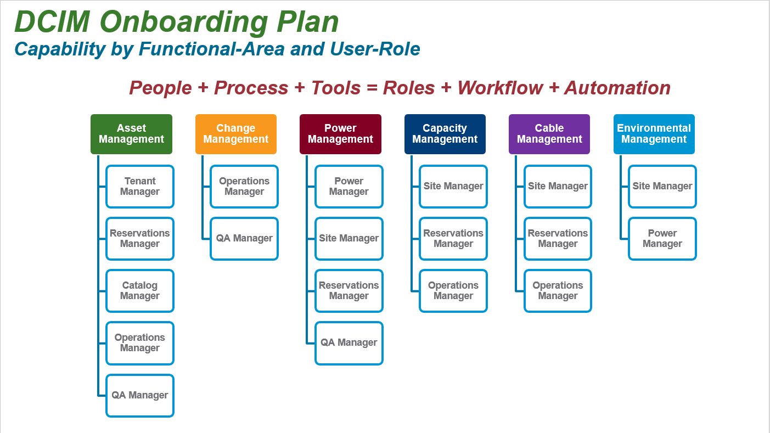

The following illustration suggests several logical use-cases associated with DCIM user-roles. Note that this isn’t a completing listing, but rather a starting-point for definition of those roles and use-cases matching our organizational business requirements. Ideally, DCIM tools enable these use-cases with only minor customizations.

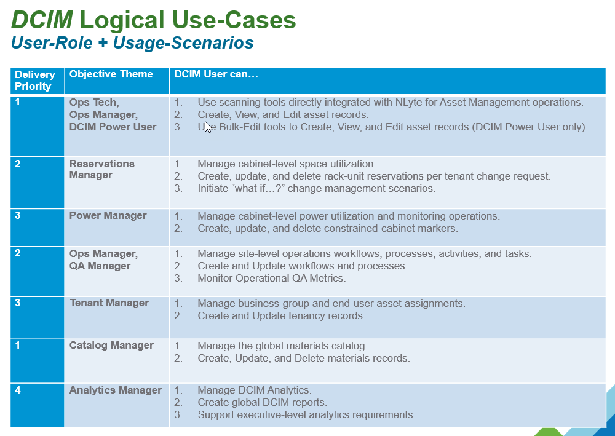

Note that the **Operations Manager** role is primarily responsible for management of site-level **Change Management** and **Operational Workflow** activities.

In many cases, a Change Request will entail necessary combinations of activities and tasks. For example, a newly received asset should have been preceded by a corresponding Reservation Request. Thus, the Operational tasks of asset receiving, deployment, and configuration are follow-on activities in a broader multi-role requisition-acquisition-receiving-deployment cross-organizational workflow.

Herein, the **Operations Manager** role applies to any operations team-member, perhaps reporting to the site Operations Manager, and executing activities and tasks within the context of data-center operations.

This document focuses only upon the following key activities utilizing the NLyte DCIM tools for **Operations Management** tasks.

* Given a newly received asset, update the pre-procurement asset reservation record with an asset tag, serial number, and any additional “receiving time” configuration parameters.
* Given a new asset, deploy the asset and update the procurement asset record operational-active status configuration parameters.

## New Asset Receiving

Asset Receiving practices vary per location and business processes. Herein, the following assumptions apply.

* Assets are received at the fulfillment of business purchasing, logistics, and facilities package handling procedures defined separately from this document.
* The operations team receives packages with adequate information necessary to correlate with prior Reservations Management activities. Ideally, the received package will be marked with the ServiceNow ticket number corresponding to a pre-procurement asset record. Within NLyte, the “PR Number” field is used as the project ticket number. This number should appear on the received asset invoice or packaging. If not, then the DCIM Management Team should select an alternate attribute that is commonly available as an identifying attribute throughout the asset acquisition lifecycle.
* *The* ***NLyte Goods Receiving*** *module is the preferred DCIM tool for automation of asset receiving. However, the instructions herein assume that this tool is not available. Refer to the NLyte Goods Receiving tool documentation posted at http://dcim.eng.vmware.com*.

### Asset Receiving Prerequisites

The Operations Manager should possess a “Receive Asset” subtask within the context of any operations change request (perhaps originating from a ServiceNow workflow). The following deployment attributes are minimally required for adequate receiving workflow.

* A “Ticket Number” or other identifying attribute corresponding to the new deployment project.
* New Asset Tags that will be applied to each received asset and scanned into the asset record.
* A staging area into which assets are placed prior to subsequent deployment operations. This staging area inventory is herein assumed to be not managed within NLyte.

## Receive Asset Example

For example, assume the following simple receive asset request details:

* Received inventory includes a single server; a Dell R730 model.
* ServiceNow Ticket Number = RITM00777777
* Asset Tag = 123456
* Serial Number = 123456

### Step 1, Unpackage the Asset and Apply Asset Tag

This activity is location and business process dependent in practice.

### Step 2, Find the Corresponding NLyte Asset Reservation

A key operational consistency objective is to anticipate changes. This example extends the operational workflow completed in a prior task by the Reservations Manager. Hence, we anticipate that an asset reservation record exists within NLyte as illustrated below.

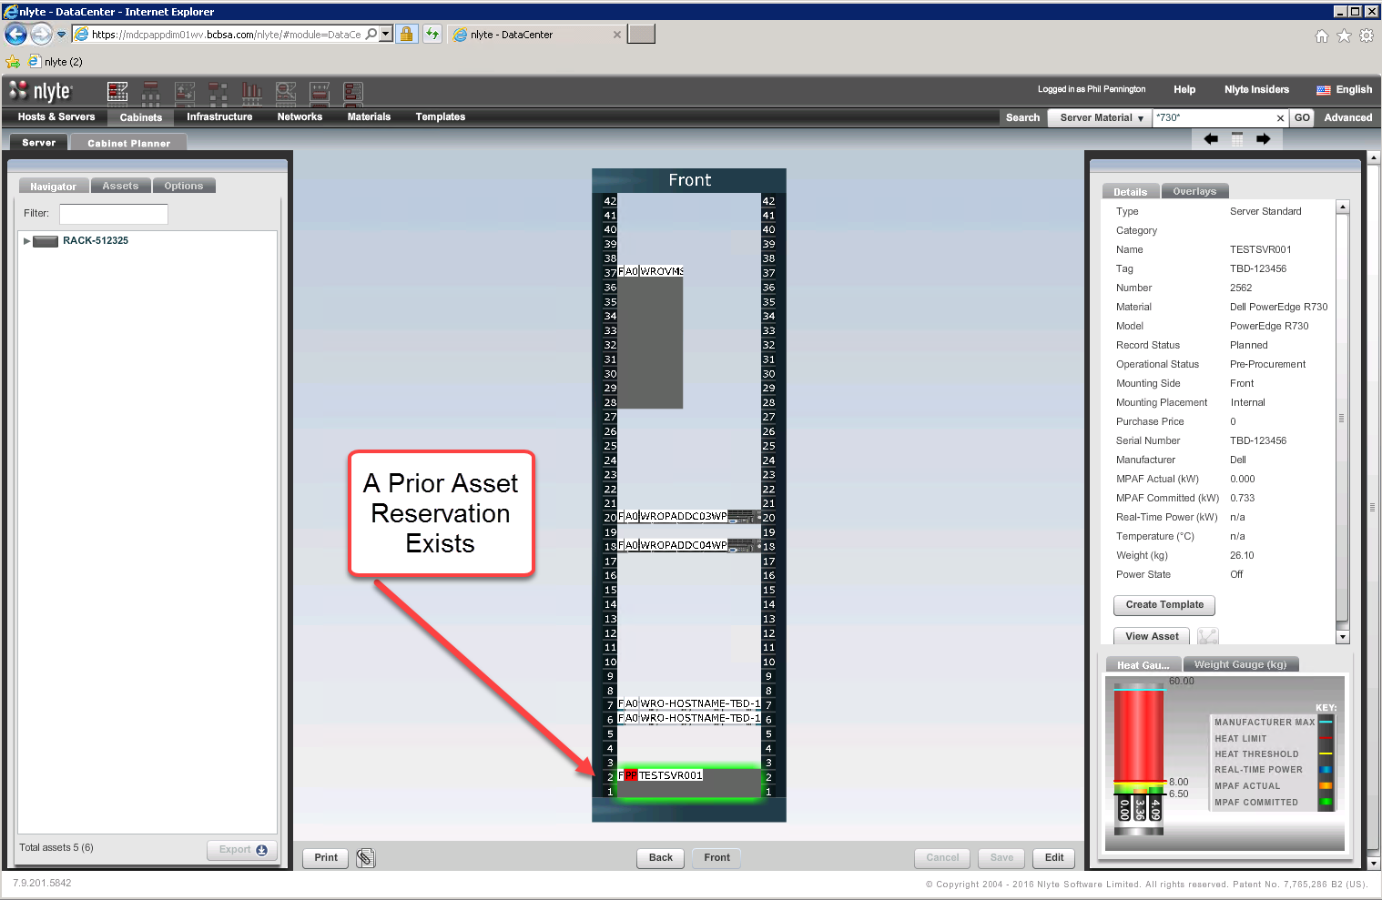

This record is found using the NLyte Advanced Search feature and entering the “Ticket Number” within the “PR Number” field as follows.

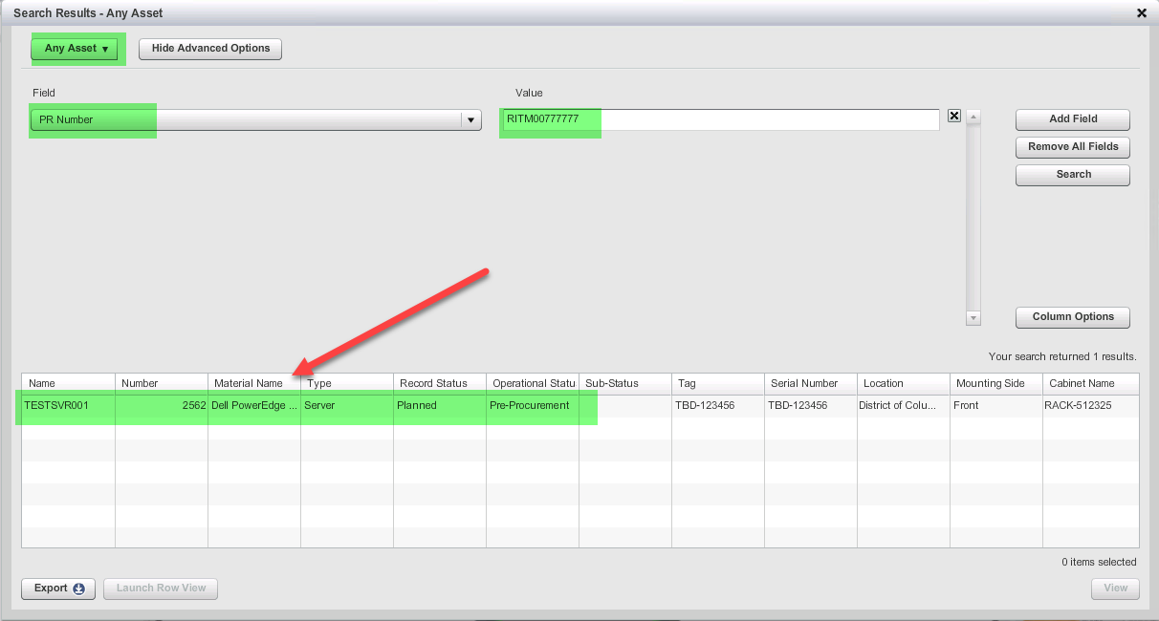

Select the discovered asset record to open the asset view as follows.

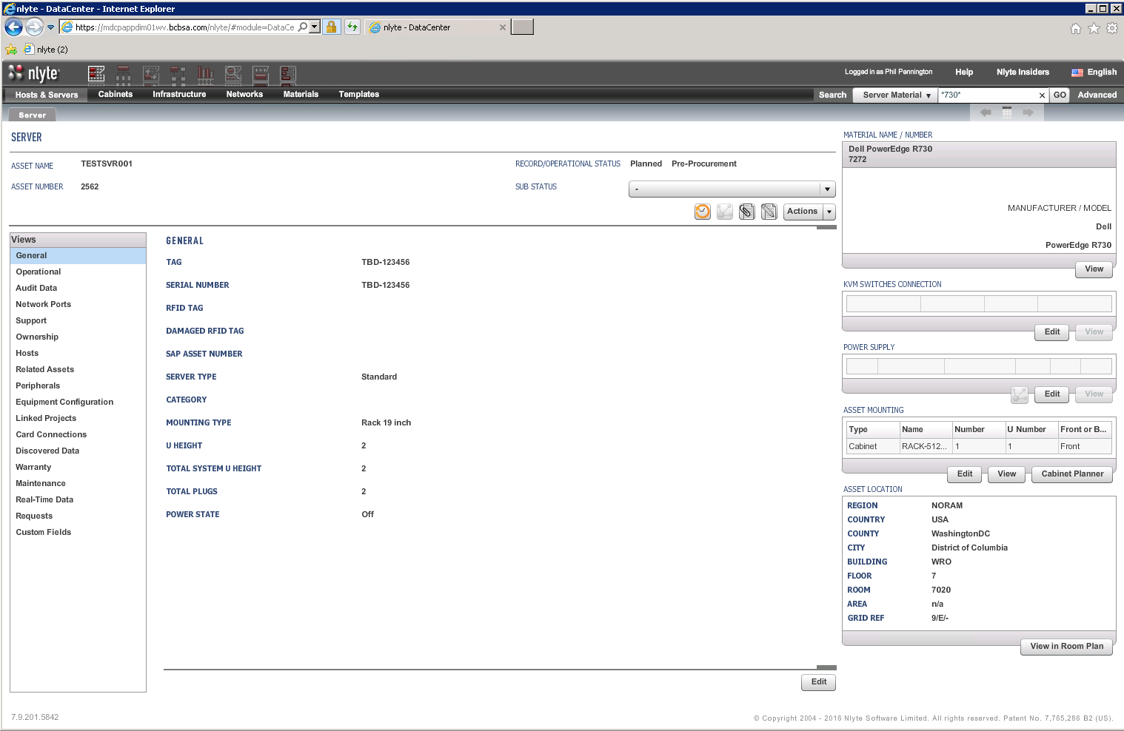

### Step 3, Update the NLyte Asset Record

Now, edit this record and scan in the applied Asset Tag number and Serial Number. Update any additional fields per common asset receiving practice.

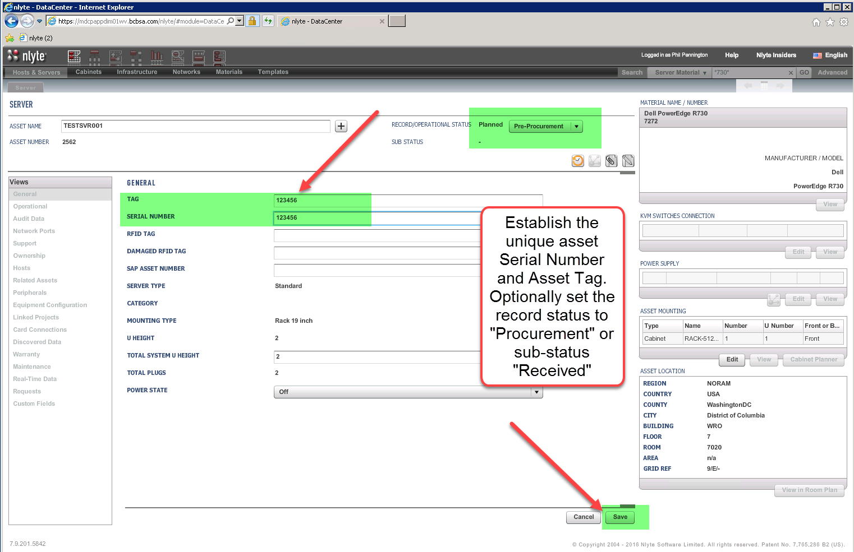

This complete the Operations – Asset Receiving workflow. The asset may be placed in a holding area for subsequent Asset Deployment workflow processing.

## New Asset Deployment

Asset Deployment practices vary per location and business processes. Herein, the following assumptions apply.

* *The* ***NLyte Audit Tool*** *is the preferred DCIM tool for partial automation of asset deployment. However, the instructions herein assume that this tool is not available. Refer to the NLyte Audit Tool documentation posted at* <http://dcim.eng.vmware.com>*.*

### Asset Deployment Prerequisites

The Operations Manager should possess a “Deploy Asset” subtask within the context of any operations change request (perhaps originating from a ServiceNow workflow). The following deployment attributes are minimally required for adequate deployment workflow.

* A “Ticket Number” or other identifying attribute corresponding to the new deployment project.
* The asset inventory associated with the deployment ticket is available in the “Receiving – Staging” area and will be physically moved to the final cabinet location.

## Deploy Asset Example

For example, assume the following simple deployment request details:

* Received inventory includes a single server; a Dell R730 model.
* ServiceNow Ticket Number = RITM00777777
* Asset Tag = 123456

### Step 1, Locate the Target Cabinet Location

Leverage the NLyte Advanced Search function to locate the asset record. Search by Asset Tag or Ticket Number. Or, if the ticket includes the asset hostname, then use the Simple Search function to locate the asset record. Once found, open the Cabinet Planner as illustrated below.

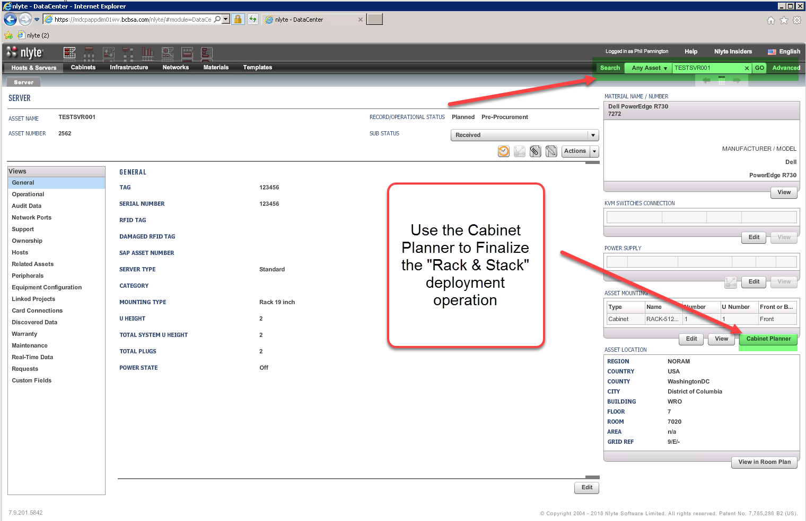

### Step 2, Establish the Final RU Location with the Cabinet

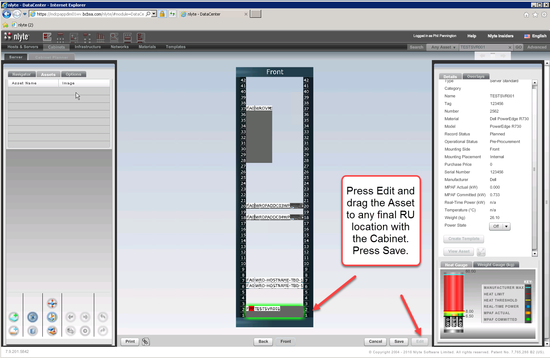

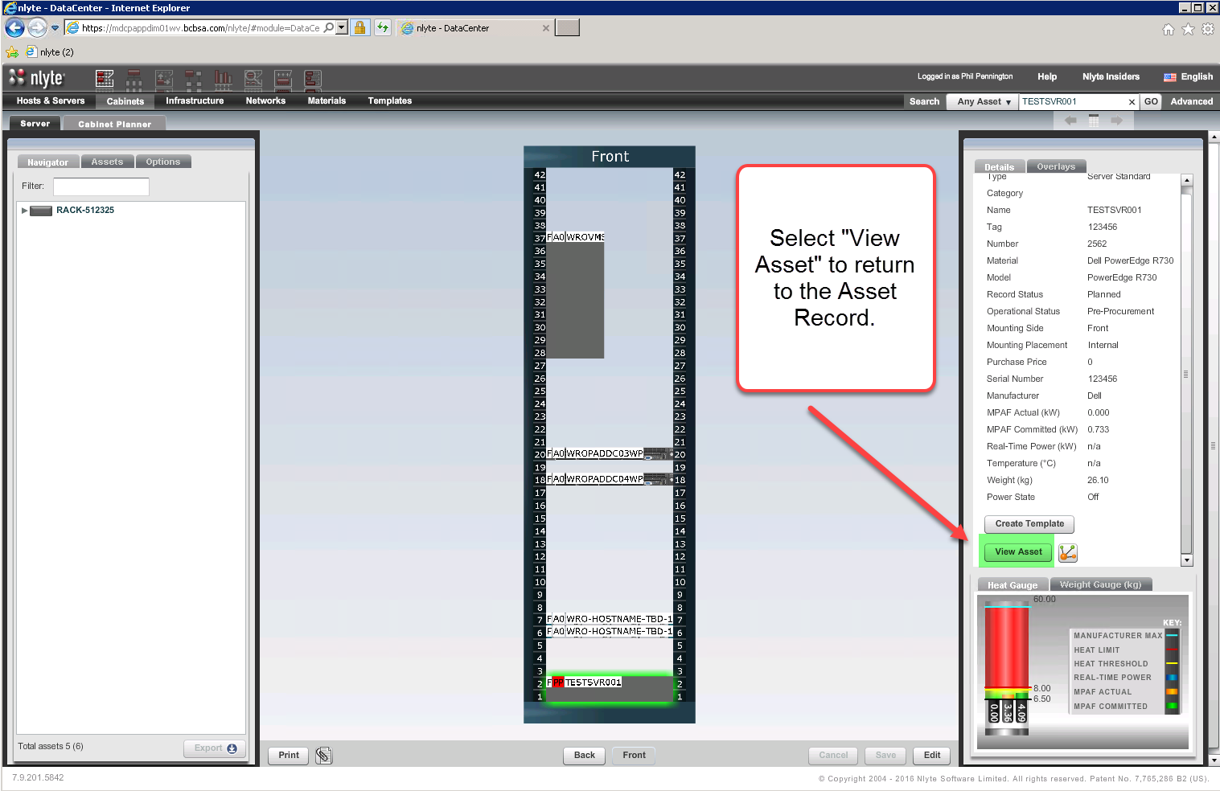

### Step 3, Complete the Asset Record Creation

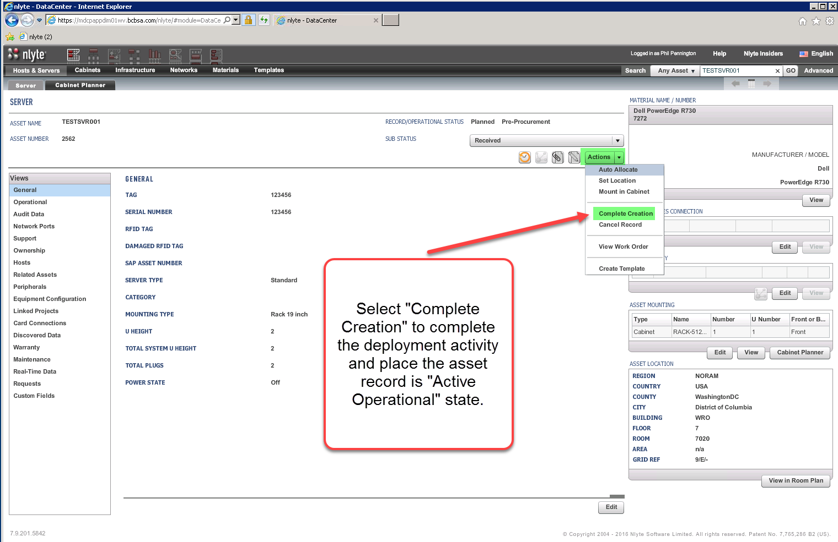

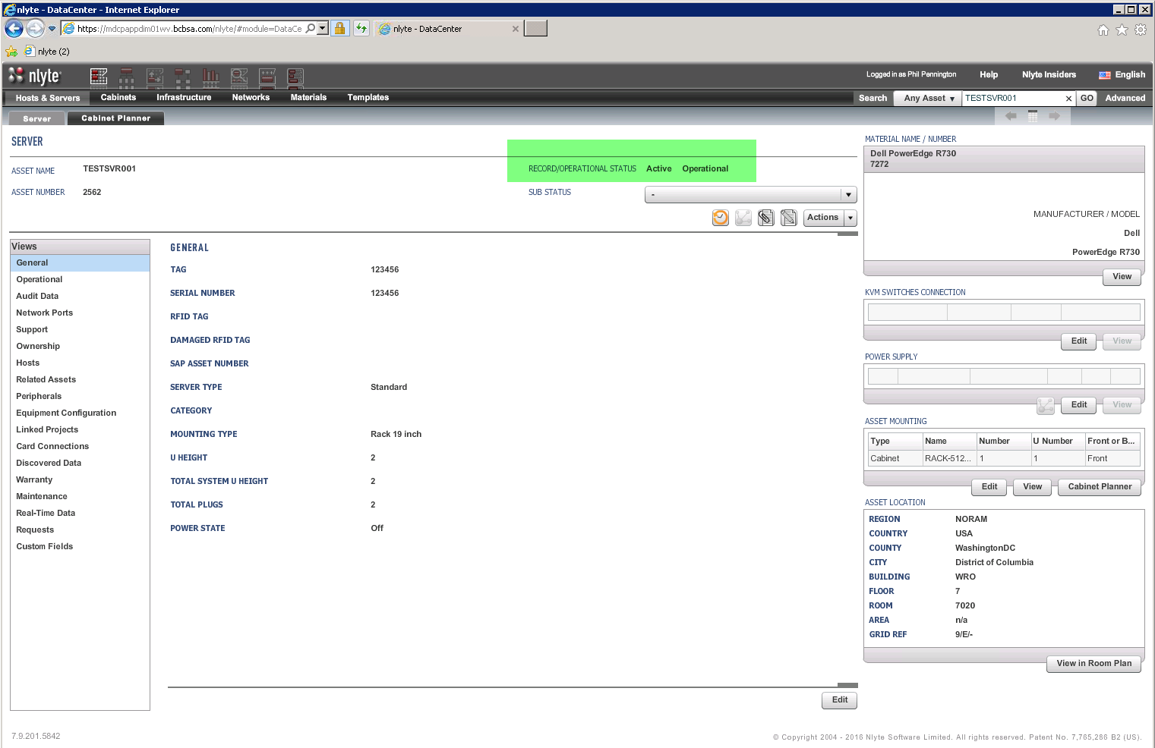

### Step 3, Update the Corresponding Operations Ticket with the Asset Record Summary

Utilize the “View Work Order” function of the Asset Record to export a deployment summary page.

Or, export a ticket-inventory list using the NLyte Advanced Search function; exporting the list to Excel for separate attachment onto the ServiceNow ticket.

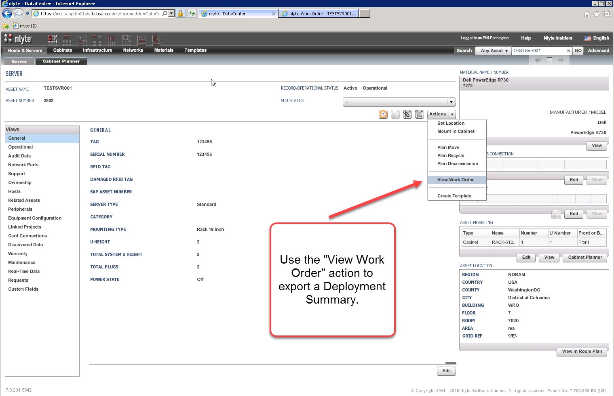

## Move Asset Request

### Move Ticket Prerequisites

The Operations Manager should receive an Asset Move ticket or work-order per business processes.

For example, assume the following simple move request details:

* ServiceNow Ticket Number = RITM00888888
* Hostname = TESTSVR001
* Target Cabinet = RACK-512338

### Step 1, Receive and Execute the Asset Move Work-Order

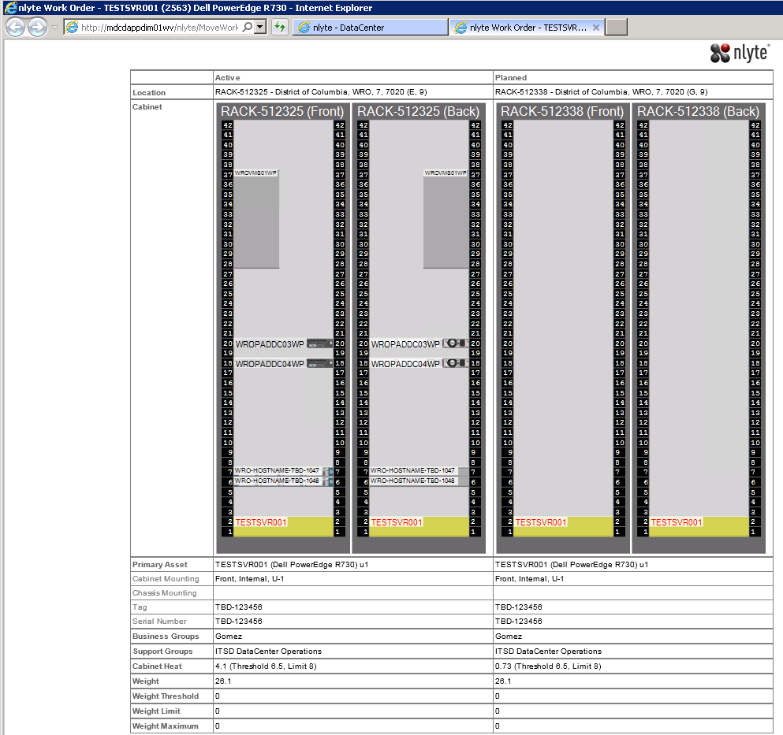

### Step 2, Locate the Asset Record

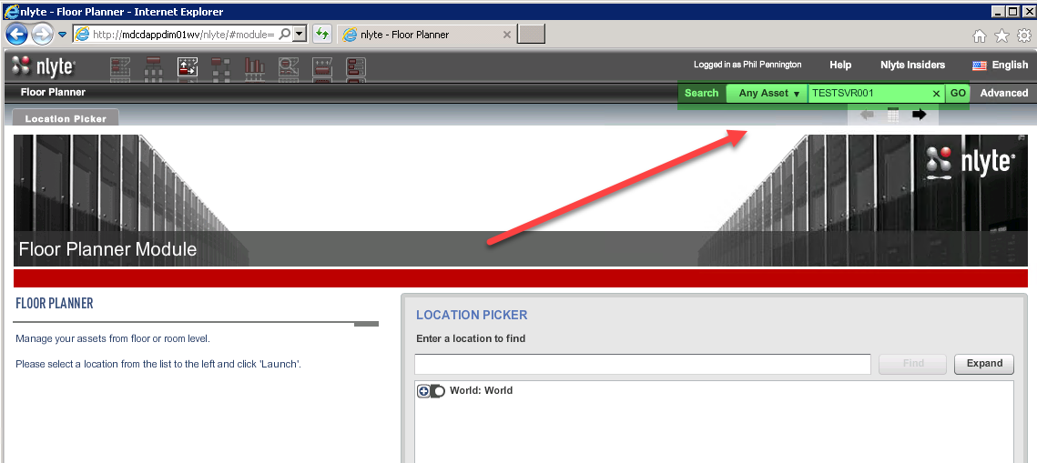

Note: Optionally search for the asset by Ticket Number. Use the Advanced Search and type the Ticket Number into the “PR Number” field.

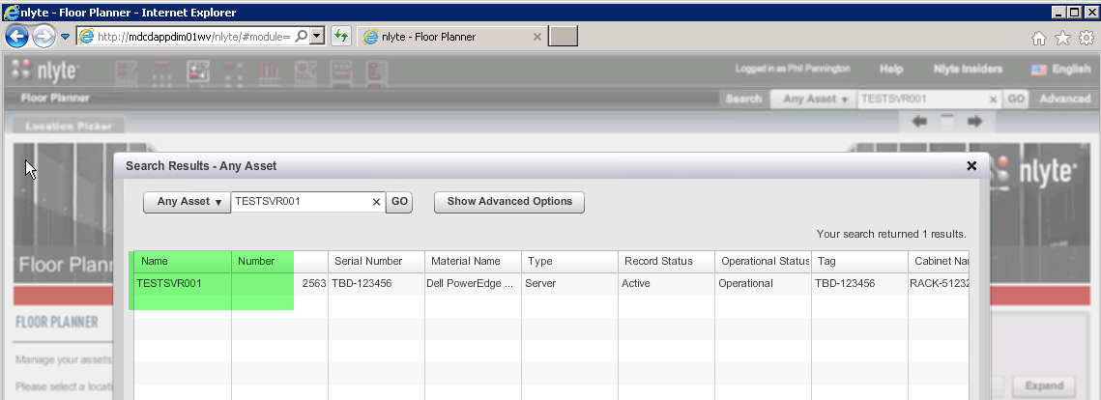

### Step 6, Complete the Move Request

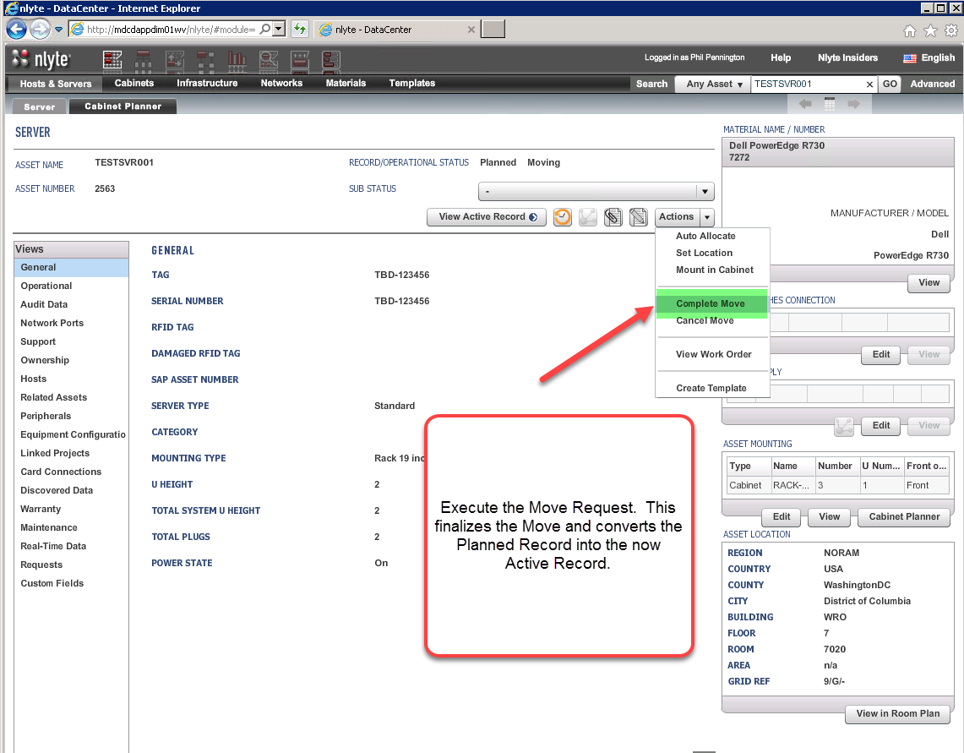

## Decommission Asset Request

### Decommission Ticket Prerequisites

The Operations Manager should receive and operations change request (perhaps originating from a ServiceNow workflow).

For example, assume the following simple decommission request details:

* ServiceNow Ticket Number = RITM00999999
* Hostname = TESTSVR001

### Step 1, Receive and Execute the Asset Decommission Work-Order

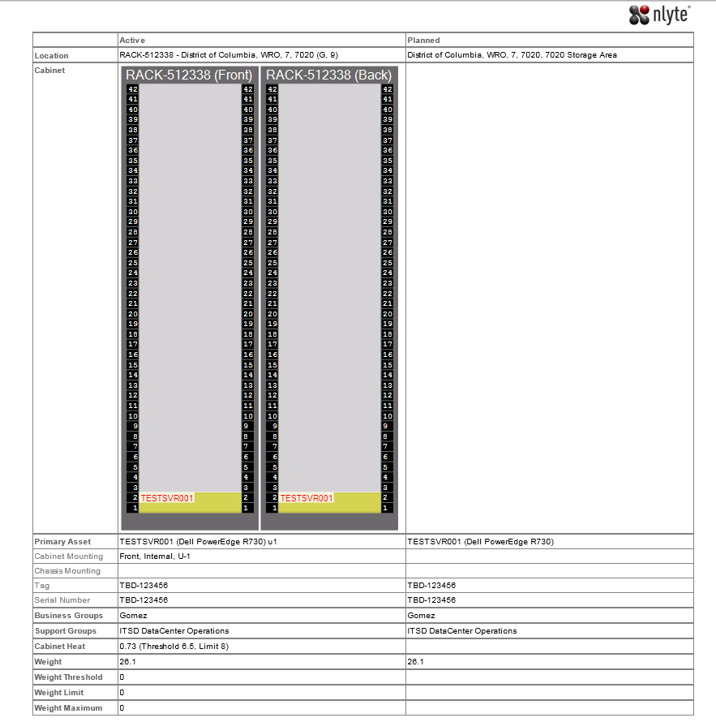

### Step 2, Locate the Existing NLyte Asset Record



Note: Optionally search for the asset by Ticket Number. Use the Advanced Search and type the Ticket Number into the “PR Number” field.



### Step 3, Complete the Decommission Request

