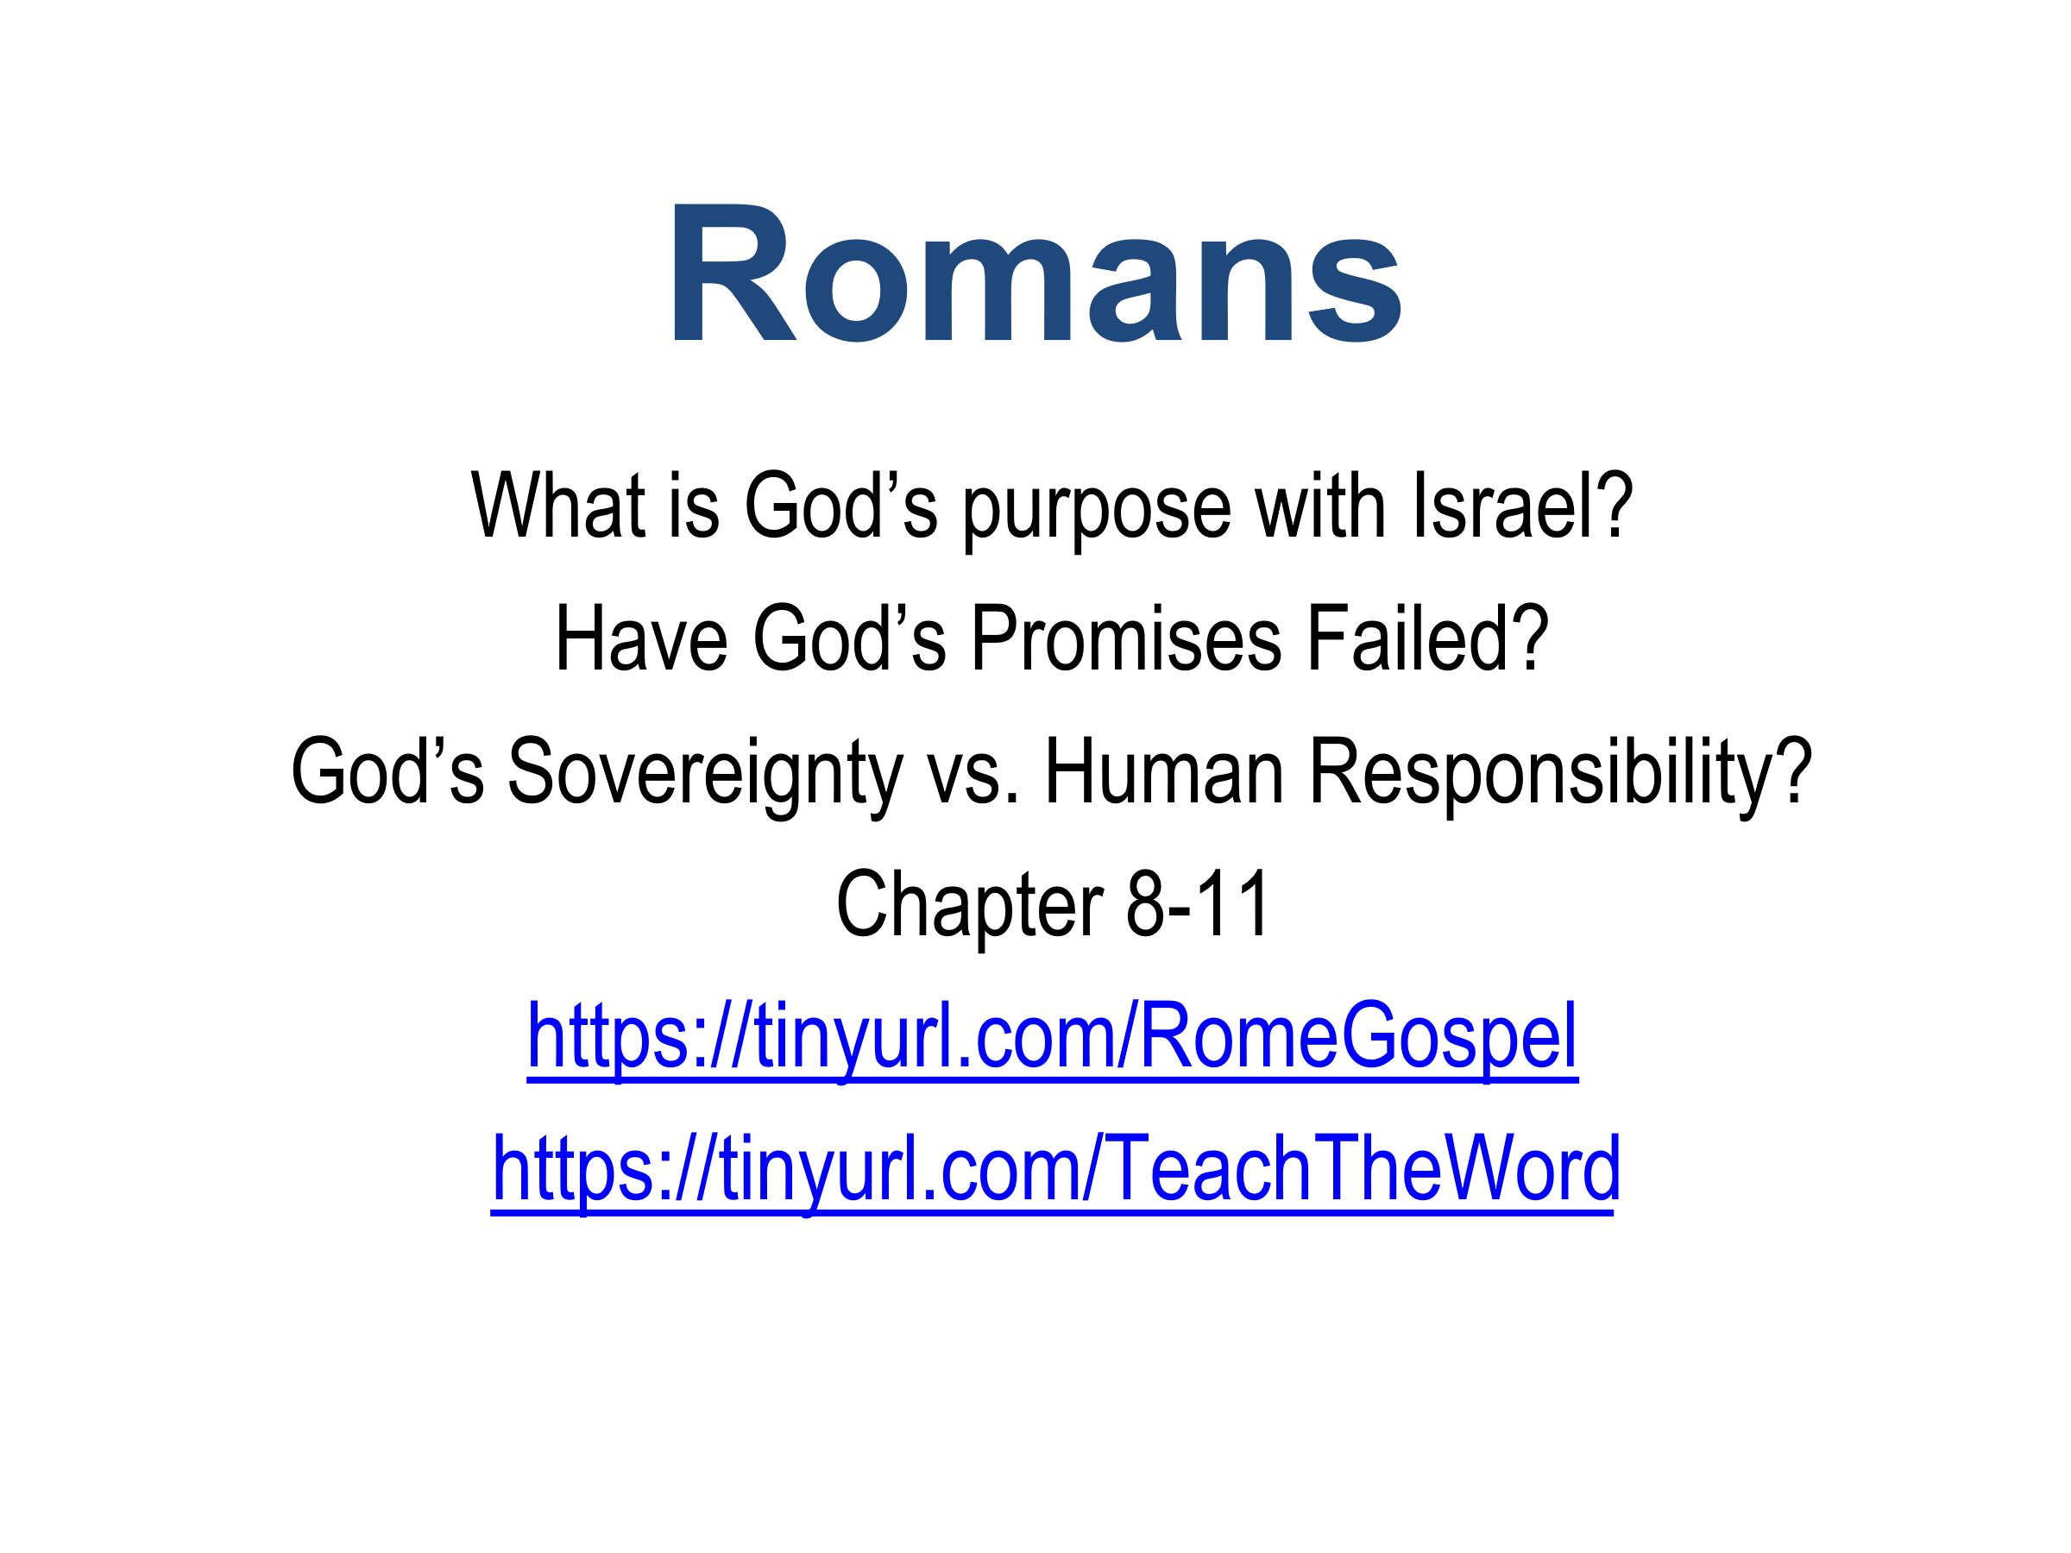

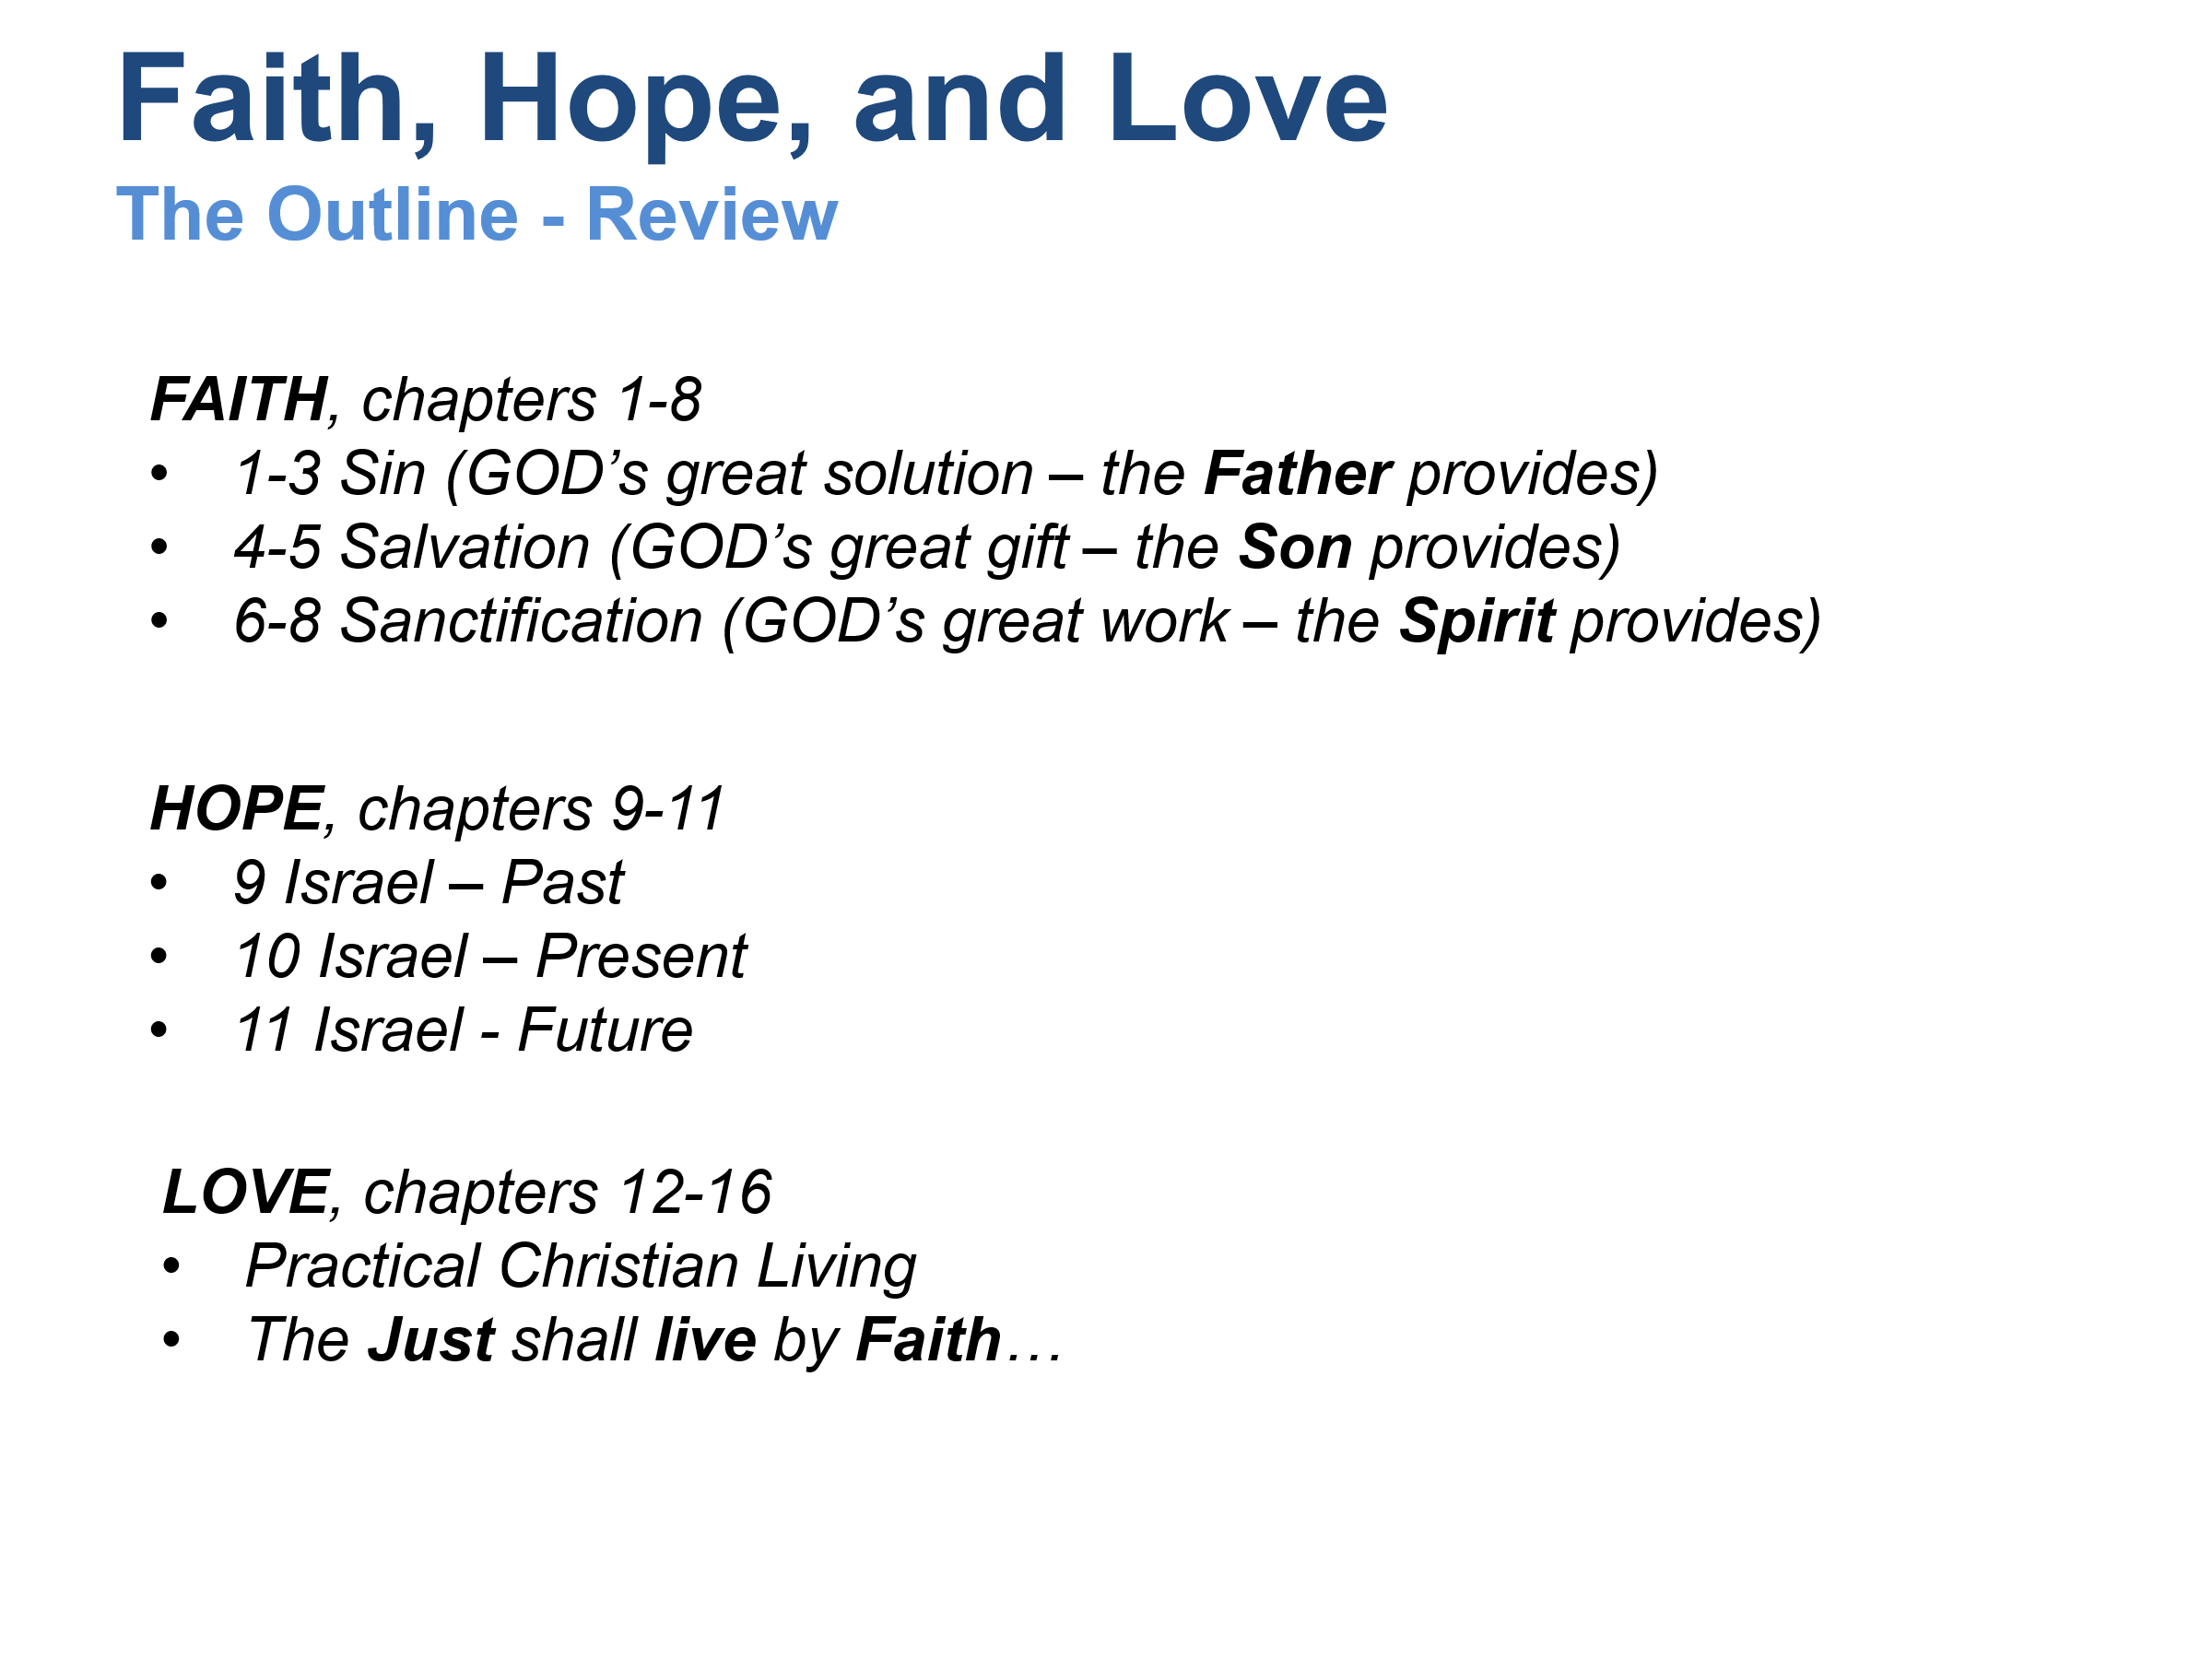

Romans 8-11 is one continuous argument. Unfortunately, chapter divisions often cause readers to isolate Romans 9 from Romans 8 and 10-11. When read together, Paul's emphasis becomes clearer.
The question Paul is answering is:
If God chose Israel, why have so many Israelites rejected the Messiah? Has God's word failed?
His answer is:
No. God's purpose has never depended upon ethnic descent, human privilege, or human achievement. God remains sovereignly faithful to His promises, and He is accomplishing His redemptive plan exactly as intended.

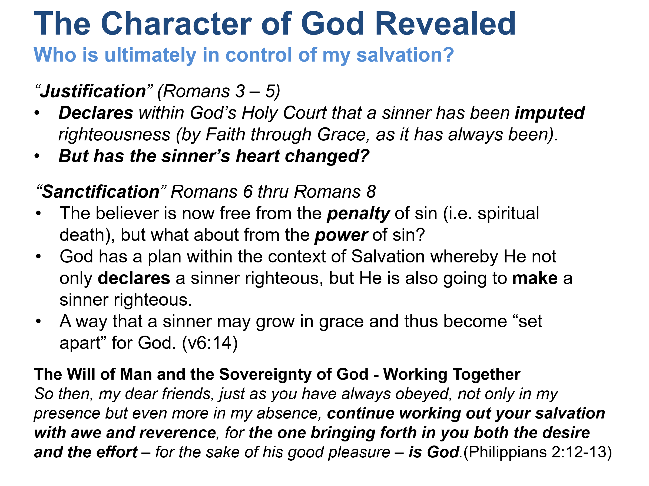

Bringing This Back to Romans 8
Romans 8:28-30 is not saying:
"Man contributes nothing."
Nor is it saying:
"Man saves himself."
Paul's emphasis is that God is ultimately responsible for bringing His people to glory.
- The believer genuinely loves God (v. 28).
- The believer genuinely walks according to the Spirit (v. 4).
- The believer genuinely puts sin to death (v. 13).
Yet underneath all of these actions is God's prior and continuing work.
The earliest Christians would likely have answered this way:
- Can a human turn toward God by the exercise of his will? Yes, because God created man with moral agency and calls him to respond.
- Can a human contribute to the basis of his own justification? No. Salvation is grounded in Christ's work, not man's merit.
- Who is ultimately in control of salvation? God. Yet God works through, rather than against, the human will He created.
That understanding is very close to how Irenaeus, Justin Martyr, Clement, and the other pre-200 writers typically spoke about grace, faith, obedience, and salvation.

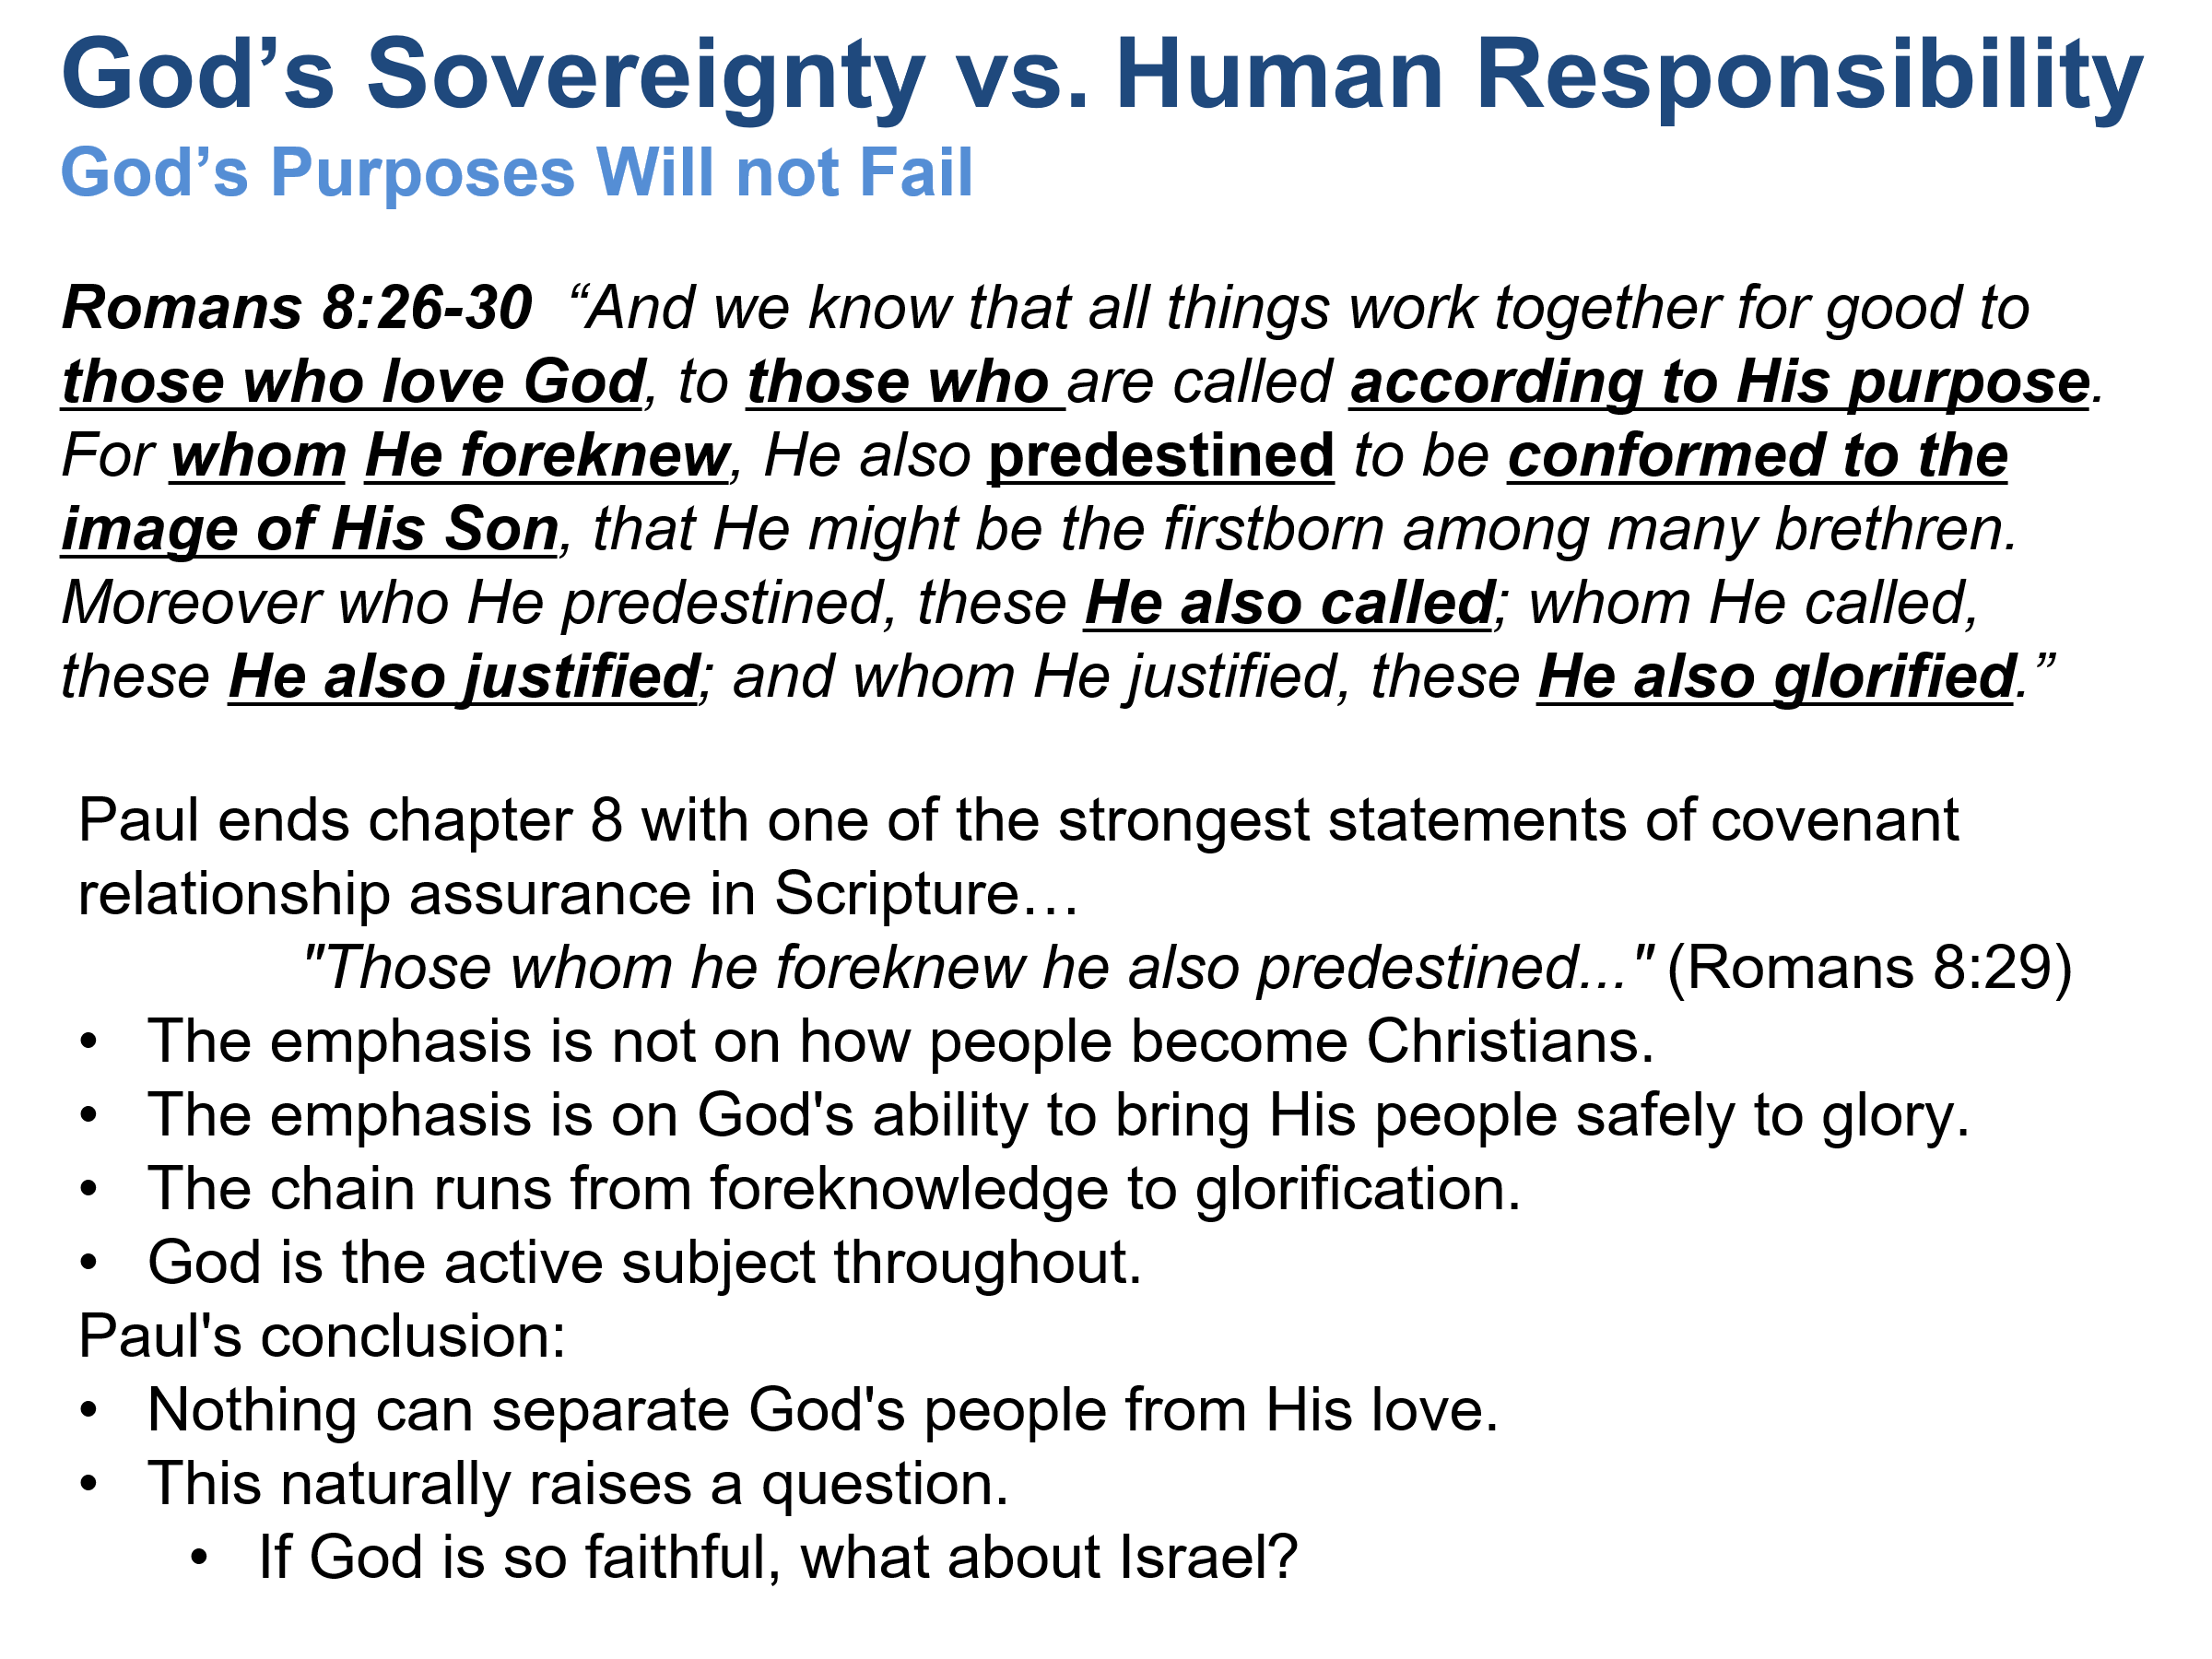

The Will of Man and the Sovereignty of God - working together
In form, a type of Double Predestination:
- Belief equals predestination to salvation.
- Disbelief equals predestination to stumble further.
John 6:35-37 Jesus said to them, “I am the bread of life. The one who comes to me will never go hungry, and the one who believes in me will never be thirsty. But I told you that you have seen me and still do not believe. Everyone whom the Father gives me will come to me, and the one who comes to me I will never send away. (John 6:35-37)
John 10:27-29 My sheep listen to my voice, and I know them, and they follow me. I give them eternal life, and they will never perish; no one will snatch them from my hand. My Father, who has given them to me, is greater than all, and no one can snatch them from my Father’s hand.
1Peter 2:6-10 For it says in scripture, “Look, I lay in Zion a stone, a chosen and precious cornerstone, and whoever believes in him will never be put to shame.” So you who believe see his value, but for those who do not believe, the stone that the builders rejected has become the cornerstone , and a stumbling-stone and a rock to trip over. They stumble because they disobey the word, as they were destined to do. But you are a chosen race, a royal priesthood, a holy nation, a people of his own, so that you may proclaim the virtues of the one who called you out of darkness into his marvelous light. You once were not a people, but now you are God’s people. You were shown no mercy, but now you have received mercy.
Php 2:12-13 So then, my dear friends, just as you have always obeyed, not only in my presence but even more in my absence, continue working out your salvation with awe and reverence, for the one bringing forth in you both the desire and the effort – for the sake of his good pleasure – is God.
Php 1:6 For I am sure of this very thing, that the one who began a good work in you will perfect it until the day of Christ Jesus.
Eph 2:10 For we are his creative work, having been created in Christ Jesus for good works that God prepared beforehand so we can do them.

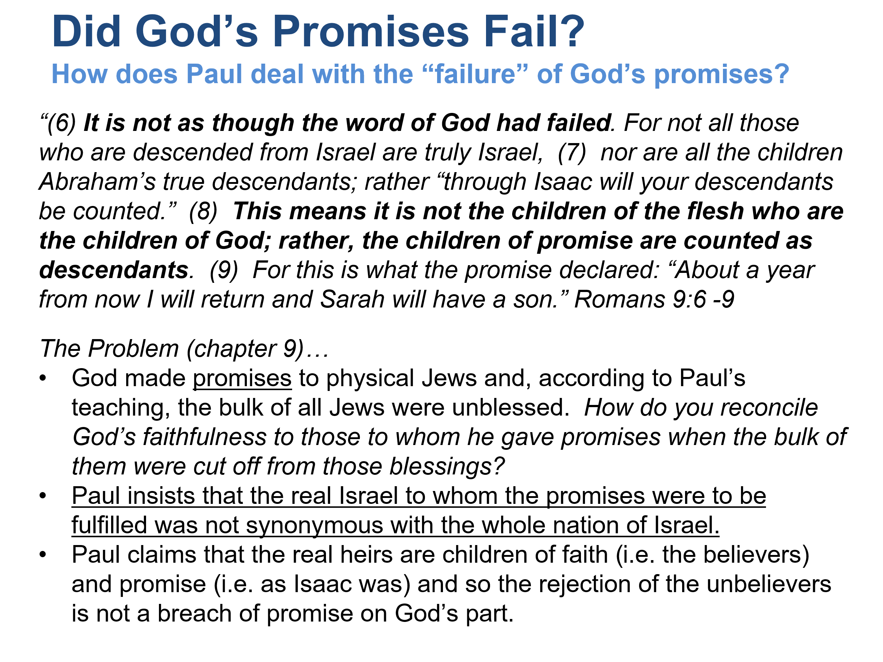

Romans 9: Has God's Word Failed?
Paul begins: "It is not as though the word of God has failed." (Romans 9:6)
This is the controlling thesis of chapters 9-11.
Israel's unbelief appears to challenge God's promises.
Paul says it does not.
Why?
Because God's covenant purposes were never based merely on physical descent.

Isaac over Ishmael
Both are Abraham's sons.
Yet God chose Isaac.
Why?
To demonstrate:
God's purpose existed before human achievement.

Jacob over Esau
Paul intensifies the example.
Before either child was born:
"in order that God's purpose according to election might stand..." (Romans 9:11)
The point is not that Jacob was morally superior.
Neither had done good or evil.
God's redemptive purpose moved forward through Jacob.
Notice that Paul is speaking about the historical covenant line through which the Messiah would come.
The immediate context concerns Israel's role in salvation history.

Pharaoh
Paul then uses Pharaoh.
God raised Pharaoh up to demonstrate His power.
Pharaoh became an instrument in God's larger plan.
Again, the point is God's sovereignty over history.

The Potter and the Clay
This is often read as an abstract discussion of individual predestination.
Yet Paul is drawing heavily from Jeremiah 18.
In Jeremiah, the clay represents nations.
God has authority over nations and peoples.
Paul's point:
The Creator has the right to direct history according to His purposes.
Israel cannot accuse God of injustice simply because He includes Gentiles in His plan.

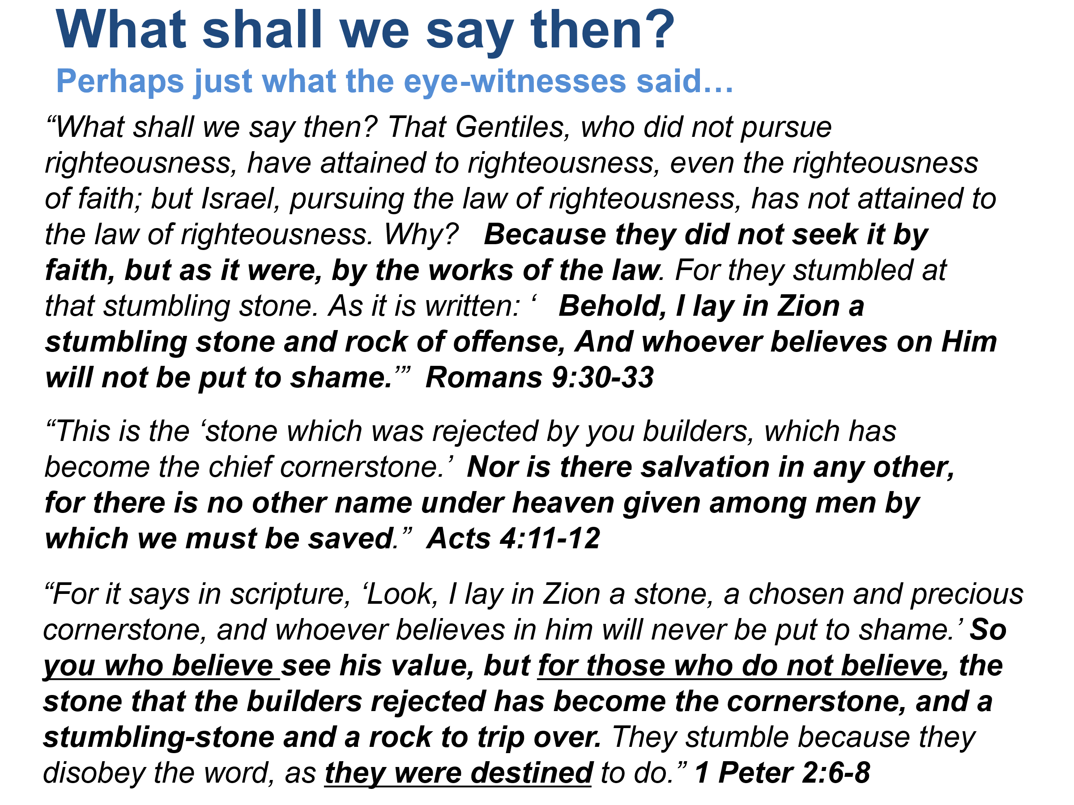

Israel's Hardening
- Paul teaches that Israel's rejection has a purpose.
- Their stumbling opened the door for Gentile inclusion.
- Gentile salvation is then intended to provoke Israel to jealousy.
- God uses both Jewish rejection and Gentile inclusion to advance His larger plan.
1Pe 2:4-10 So as you come to him, a living stone rejected by men but chosen and precious in God’s sight, (5) you yourselves, as living stones, are built up as a spiritual house to be a holy priesthood and to offer spiritual sacrifices that are acceptable to God through Jesus Christ. (6) For it says in scripture, “Look, I lay in Zion a stone, a chosen and precious cornerstone, and whoever believes in him will never be put to shame.” (7) So you who believe see his value, but for those who do not believe, the stone that the builders rejected has become the cornerstone , (8) and a stumbling-stone and a rock to trip over. They stumble because they disobey the word, as they were destined to do. (9) But you are a chosen race, a royal priesthood, a holy nation, a people of his own, so that you may proclaim the virtues of the one who called you out of darkness into his marvelous light. (10) You once were not a people, but now you are God’s people. You were shown no mercy, but now you have received mercy.
Genesis 15:6
- Abraham was reckoned to righteousness by his faith when he was still a Gentile, two chapters before the covenant sign of circumcision was placed upon his flesh and 400+ years before the Mosaic Law.
- At the time Abraham was “saved” he wasn’t “Jewish”. (Rom 4:9-12)
- Abraham did no works to acquire righteousness, it was by a gift of grace. (Romans 4:4)
The Lord delights in keeping His promises…
- Galatians 3:15-29
Jacob’s heirs include “all believers”…
- Promises extended first to the Jew (Romans 1:16) then to the Gentile – but only to those who believe by faith as Abraham did.
- The Israelite without faith was never regarded as a partaker of the promises. Galatians 3:16-18
- John 8:31-47; Deuteronomy 18:15-19; Acts 3:21-23
The Promises of GOD are the currency upon which man-kind’s ultimate hope and destiny rest. Discuss how GOD made promises to Abraham, Moses and the Israelites, and to us (Jer 31:31).
Galatians 3:15-18
15 Brothers and sisters, I offer an example from everyday life: When a covenant has been ratified, even though it is only a human contract, no one can set it aside or add anything to it. 16 Now the promises were spoken to Abraham and to his descendant. Scripture does not say, “and to the descendants,” referring to many, but “and to your descendant,” referring to one, who is Christ. 17 What I am saying is this: The law that came four hundred thirty years later does not cancel a covenant previously ratified by God, so as to invalidate the promise. 18 For if the inheritance is based on the law, it is no longer based on the promise, but God graciously gave it to Abraham through the promise.
Galatians 3:19-29
19 Why then was the law given? It was added because of transgressions, until the arrival of the descendant to whom the promise had been made. It was administered through angels by an intermediary. 20 Now an intermediary is not for one party alone, but God is one. 21 Is the law therefore opposed to the promises of God? Absolutely not! For if a law had been given that was able to give life, then righteousness would certainly have come by the law. 22 But the scripture imprisoned everything under sin so that the promise could be given – because of the faithfulness of Jesus Christ – to those who believe. 23 Now before faith came we were held in custody under the law, being kept as prisoners until the coming faith would be revealed. 24 Thus the law had become our guardian until Christ, so that we could be declared righteous by faith. 25 But now that faith has come, we are no longer under a guardian. 26 For in Christ Jesus you are all sons of God through faith. 27 For all of you who were baptized into Christ have clothed yourselves with Christ. 28 There is neither Jew nor Greek, there is neither slave nor free, there is neither male nor female – for all of you are one in Christ Jesus. 29 And if you belong to Christ, then you are Abraham’s descendants, heirs according to the promise.
Deuteronomy 18:15-19
15 The LORD your God will raise up for you a prophet like me from among you – from your fellow Israelites; you must listen to him. 16 This accords with what happened at Horeb in the day of the assembly. You asked the LORD your God: “Please do not make us hear the voice of the LORD our God any more or see this great fire any more lest we die.” 17 The LORD then said to me, “What they have said is good. 18 I will raise up a prophet like you for them from among their fellow Israelites. I will put my words in his mouth and he will speak to them whatever I command. 19 I will personally hold responsible anyone who then pays no attention to the words that prophet speaks in my name.
Acts 3:21-23
21 This one heaven must receive until the time all things are restored, which God declared from times long ago through his holy prophets. 22 Moses said, ‘The Lord your God will raise up for you a prophet like me from among your brothers. You must obey him in everything he tells you. 23 Every person who does not obey that prophet will be destroyed and thus removed from the people.’

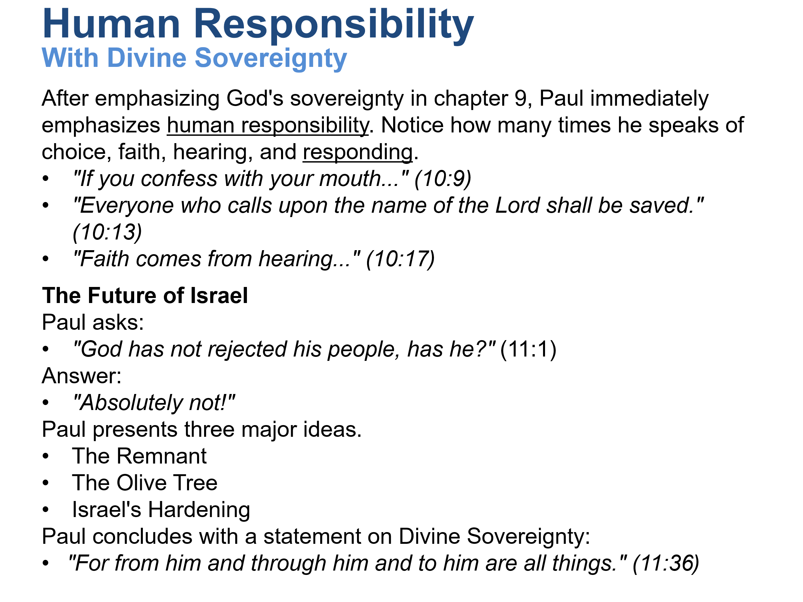

Israel's problem is not lack of opportunity.
- Israel heard.
- Israel understood.
- Israel largely refused.
Paul does not blame God for Israel's unbelief.
- He blames Israel.
- This chapter prevents us from reading Romans 9 as strict fatalism.
The Remnant
Just as in Elijah's day, God preserved a faithful remnant.
God's promises continue through believing Jews.
The Olive Tree
This is one of the most important images in the entire section.
The tree represents God's covenant people.
- Some Jewish branches were broken off.
- Why? Unbelief.
Gentile branches were grafted in.
- Why?
- Faith.
Notice Paul's explanation:
- "They were broken off because of unbelief, but you stand by faith." (11:20)
The distinction is faith versus unbelief.
Not ethnicity.
Israel's Hardening
Paul teaches that Israel's rejection has a purpose.
Their stumbling opened the door for Gentile inclusion.
Gentile salvation is then intended to provoke Israel to jealousy.
God uses both Jewish rejection and Gentile inclusion to advance His larger plan.
What Is Paul Teaching About Human Will?
Yet Paul never removes human responsibility.
Throughout chapters 10 and 11:
- People believe.
- People refuse.
- People obey.
- People disobey.
- People are hardened.
- People can be grafted back in through faith.
Notice Romans 11:23:
- "And even they — if they do not continue in their unbelief — will be grafted in."
- Paul still speaks as though response matters.
What Is Paul Teaching About Sovereignty?
The dominant theme of Romans 9-11 is unquestionably God's sovereignty.
Paul repeatedly emphasizes:
- God's election
- God's purpose
- God's mercy
- God's faithfulness
- God's control of history
The entire section culminates with:
- "For from him and through him and to him are all things." (11:36)
- This is one of the strongest declarations of divine sovereignty in the Bible.

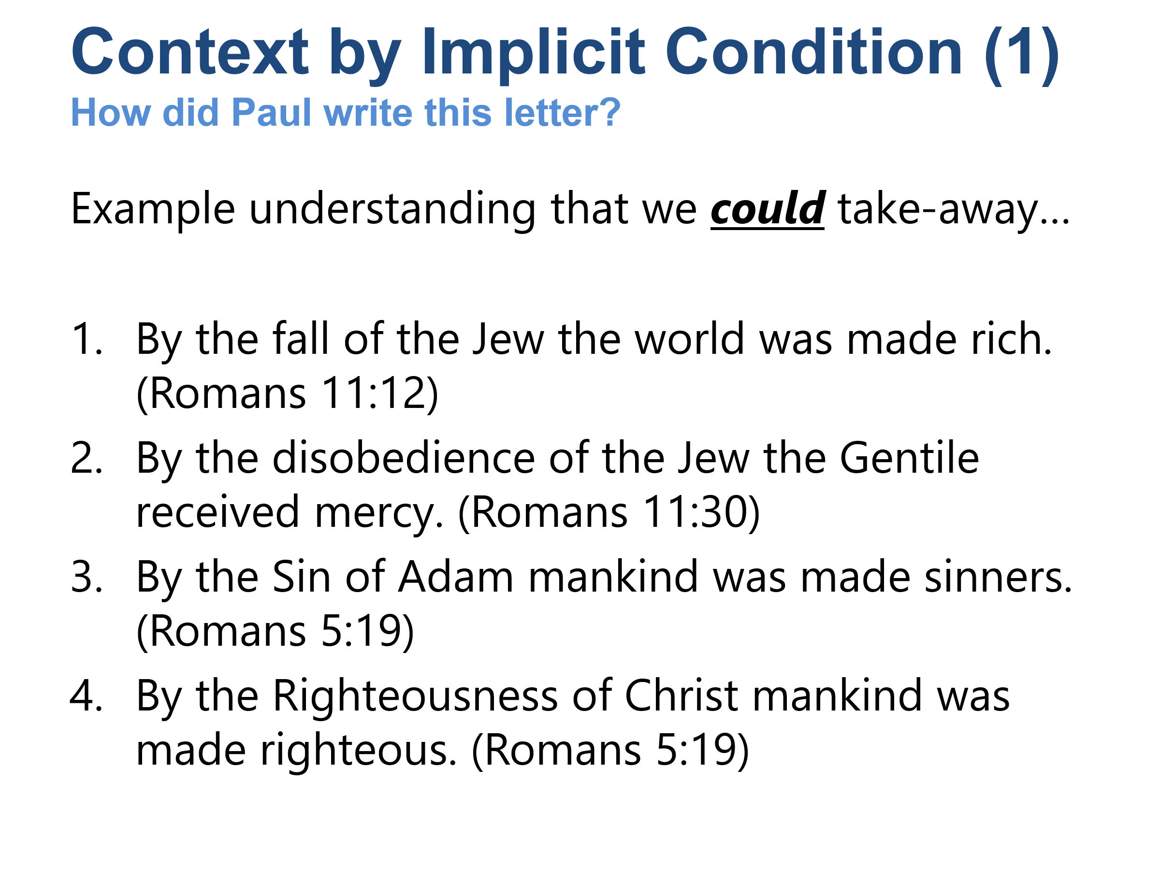

There are no explicit conditions on these statements, right? Are there implicit conditions within the context of the scriptural text itself?
- Is there unconditional justification for mankind in regards to Christ?
- Is there unconditional condemnation for mankind in regards to Adam?

Rom 11:11-15 I ask then, they did not stumble into an irrevocable fall, did they? Absolutely not! But by their transgression salvation has come to the Gentiles, to make Israel jealous. (12) Now if their transgression means riches for the world and their defeat means riches for the Gentiles, how much more will their full restoration bring? (13) Now I am speaking to you Gentiles. Seeing that I am an apostle to the Gentiles, I magnify my ministry, (14) if somehow I could provoke my people to jealousy and save some of them. (15) For if their rejection is the reconciliation of the world, what will their acceptance be but life from the dead?
Rom 11:25-33 For I do not want you to be ignorant of this mystery, brothers and sisters, so that you may not be conceited: A partial hardening has happened to Israel until the full number of the Gentiles has come in. (26) And so all Israel will be saved, as it is written: “The Deliverer will come out of Zion; he will remove ungodliness from Jacob. (27) And this is my covenant with them, when I take away their sins.” (28) In regard to the gospel they are enemies for your sake, but in regard to election they are dearly loved for the sake of the fathers. (29) For the gifts and the call of God are irrevocable. (30) Just as you were formerly disobedient to God, but have now received mercy due to their disobedience, (31) so they too have now been disobedient in order that, by the mercy shown to you, they too may now receive mercy. (32) For God has consigned all people to disobedience so that he may show mercy to them all. (33) Oh, the depth of the riches and wisdom and knowledge of God! How unsearchable are his judgments and how unfathomable his ways!
Rom 5:19 For just as through the disobedience of the one man many were made sinners, so also through the obedience of one man many will be made righteous.

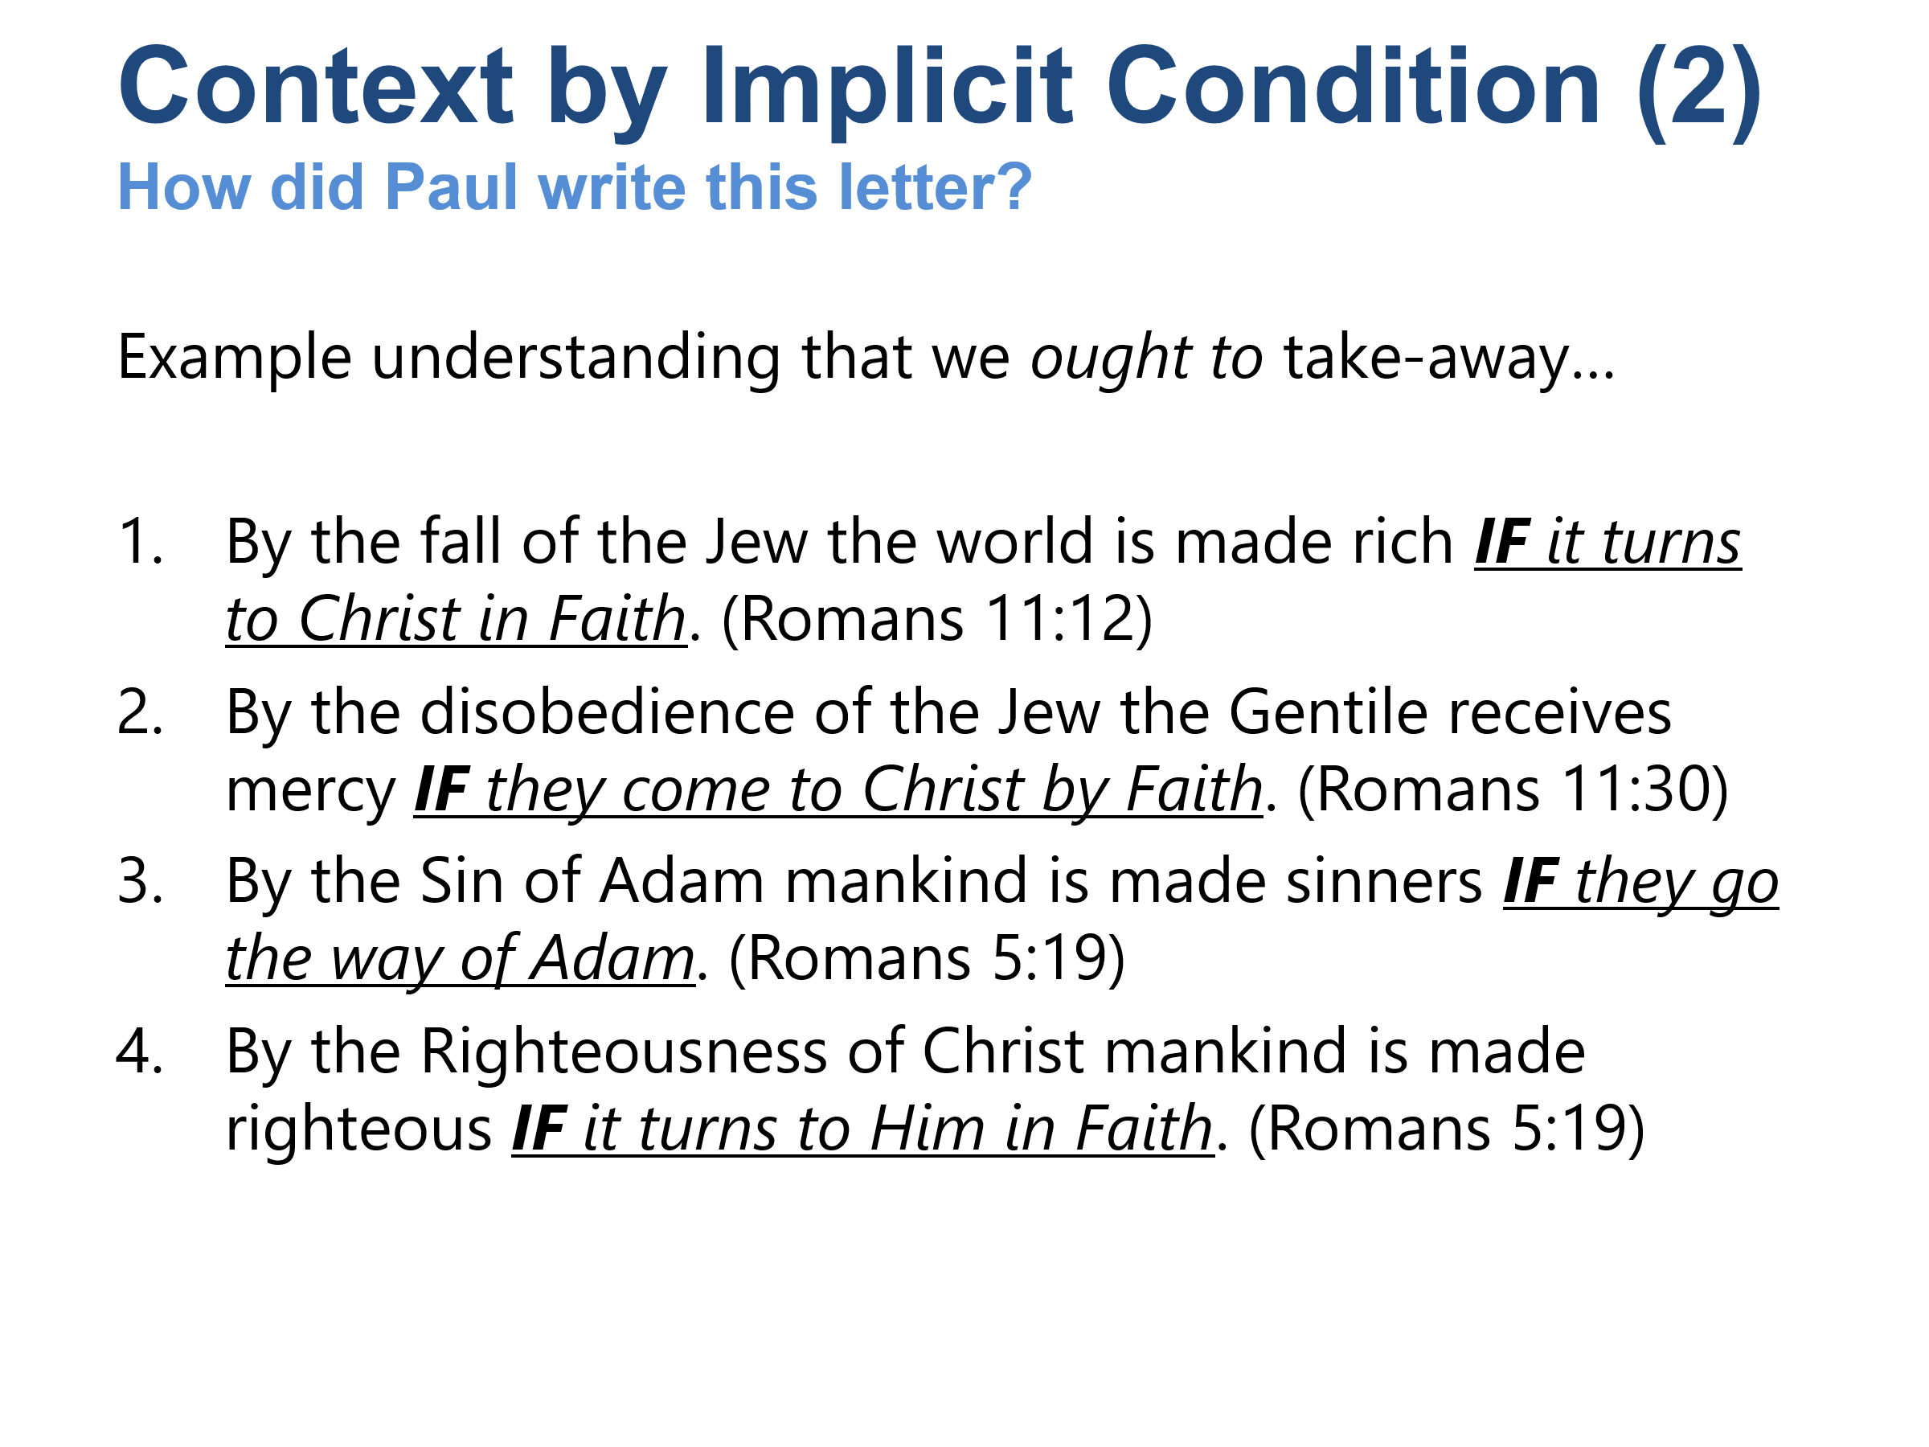

Here are interpretations of the text given recognition of implicit conditions. How can we know that these conditions are truly implied?
The conditions of faith are an already-held position, not based upon the lexical content of these passages (see Romans 5:12-21).
Rom 5:12-21 So then, just as sin entered the world through one man and death through sin, and so death spread to all people because all sinned – (13) for before the law was given, sin was in the world, but there is no accounting for sin when there is no law. (14) Yet death reigned from Adam until Moses even over those who did not sin in the same way that Adam (who is a type of the coming one) transgressed. (15) But the gracious gift is not like the transgression. For if the many died through the transgression of the one man, how much more did the grace of God and the gift by the grace of the one man Jesus Christ multiply to the many! (16) And the gift is not like the one who sinned. For judgment, resulting from the one transgression, led to condemnation, but the gracious gift from the many failures led to justification. (17) For if, by the transgression of the one man, death reigned through the one, how much more will those who receive the abundance of grace and of the gift of righteousness reign in life through the one, Jesus Christ! (18) Consequently, just as condemnation for all people came through one transgression, so too through the one righteous act came righteousness leading to life for all people. (19) For just as through the disobedience of the one man many were made sinners, so also through the obedience of one man many will be made righteous. (20) Now the law came in so that the transgression may increase, but where sin increased, grace multiplied all the more, (21) so that just as sin reigned in death, so also grace will reign through righteousness to eternal life through Jesus Christ our Lord.

The Main Point
If we step back and look at Romans 8-11 as a whole, Paul's primary concern is not:
- "Can an individual determine his eternal destiny by free will?"
Nor is it:
- "Are individuals predestined to heaven or hell regardless of faith?"
His primary concern is:
- Can God's redemptive purpose fail because Israel largely rejected Christ?
His answer is:
- No.
God remains sovereign.
- God's promises remain intact.
- God is using:
- Jewish belief,
- Jewish unbelief,
- Gentile faith,
- Gentile inclusion,
- to accomplish His purpose in Christ.
Thus Romans 8-11 is fundamentally a defense of the faithfulness and sovereignty of God in salvation history. Human response remains real and morally significant, but the controlling theme is that God's plan does not depend on human success, human ancestry, or human merit. God's purpose stands, and He is working through the free actions, failures, faith, and unbelief of both Jews and Gentiles to bring about the salvation He promised from the beginning.

The Restoration Movement's soteriology (theory on salvation) can be summarized as follows:
God
- Loves all people.
- Desires all to be saved.
- Sent Christ for the whole world.
Christ
- Made a complete once-for-all atonement (i.e. abolished the power of) for sin.
- Is the sole basis of salvation.
Man
- Is fallen and sinful.
- Retains the ability to respond to God's gospel.
Holy Spirit
- Works primarily through the inspired Word.
- Calls people through the gospel message.
Conversion
- Hearing
- Faith
- Repentance
- Confession
- Baptism
Salvation
- Entirely dependent upon God's grace.
- Received through obedient faith.
- Not earned by works.
Sanctification
- Continues throughout the Christian life.
- Requires ongoing faithfulness and growth.
The central conviction is that God genuinely offers salvation to all people through the gospel, and that every person is responsible to respond in faith and obedience to that offer.

