Week1-Righteousness-Notes
Sunday, January 4, 2026
7:25 AM

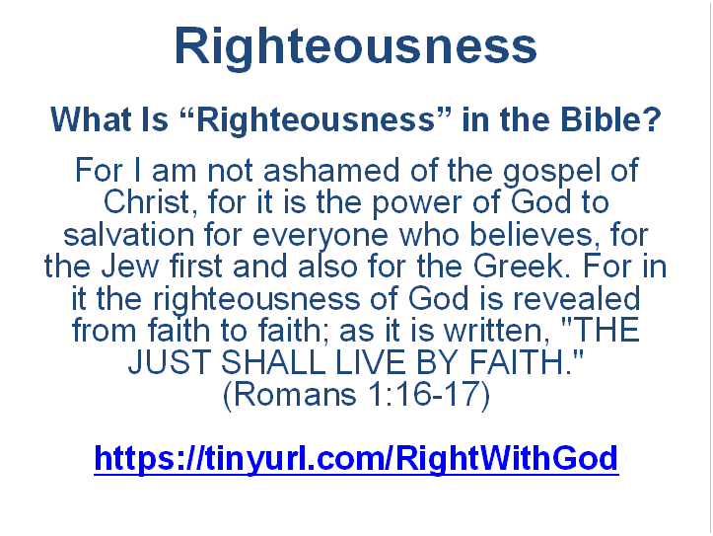
What is “Righteousness” in the Bible?
Discussion Questions
How would you explain “righteousness” in simple words?
Why must God define righteousness, not people?
What parts of God’s character stand out most in these verses?
How does knowing God’s righteousness change the way we see sin?

Early Christian Understanding of Righteousness
Early Christian teachers understood righteousness as:
- God’s nature.
- God’s gift.
- God’s work in His people.
- They rejected the idea that righteousness is earned.
- They taught that righteousness is shared by God through faith and obedience.

This fits with apostolic teaching:
Romans 1:17 “For the righteousness of God is revealed in the gospel from faith to faith, just as it is written, ‘The righteous by faith will live.’”
- Righteousness flows from God to people.
- It does not rise from people to God.

Why This Matters for the Whole Study
- If we misunderstand righteousness at the start, everything else breaks.
- If righteousness starts with man, we end in pride or despair.
- If righteousness starts with God, we end in humility and trust.
This sets up the entire contrast of the study:
- The righteousness of man is self-made and unstable.
- The righteousness of God is revealed, given, and life-giving.

Expanded Discussion Questions
If righteousness comes from God’s nature, how should that shape our view of morality?
Why is it dangerous to define righteousness by culture or personal experience?
How does seeing God as righteous before seeing ourselves as sinners change our response to Him?
In what ways does God’s righteousness expose both our sin and our hope?

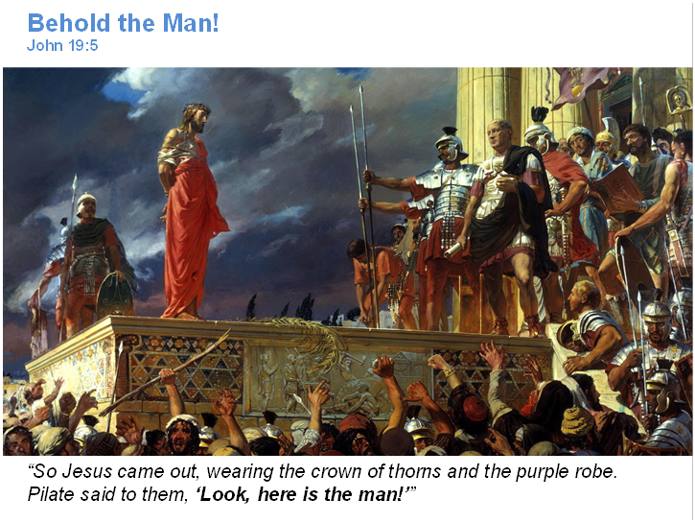
Ecce Homo
(“Behold the Man”)
by Antonio Ciseri, 1871
The title comes from John 19:5: “So Jesus came out, wearing the crown of thorns and the purple robe. Pilate said to them, ‘Look, here is the man!’”
Subject and Scene
The painting depicts Pontius Pilate presenting Jesus to the crowd.
Jesus stands:
silent
bound
crowned with thorns
wearing a faded purple robe
The crowd below is chaotic and aggressive.
Roman authority stands firm and detached.
This visual tension is intentional.
Biblical Context
John 19:4–6 : “Then Pilate went outside again and said to them, ‘Look, I am bringing him out to you, so that you may know that I find no reason for an accusation against him.’
So Jesus came out… When the chief priests and their officers saw him, they shouted out, ‘Crucify! Crucify!’”
Ciseri paints the moment where:
innocence stands exposed
power avoids responsibility
the crowd demands judgment
Theological Emphasis
This is not a sentimental Christ.
Jesus is:
humiliated
restrained
visibly human
Yet He stands above the crowd, literally and morally.
This reflects Isaiah 53:7: “He was oppressed and afflicted, yet he did not open his mouth.”
Ciseri emphasizes:
moral contrast, not drama
silence over spectacle
righteousness without defense
Connection to this Study Theme
This image visually captures:
the righteousness of God standing silent
the righteousness of man expressed through law, crowd pressure, and political calculation
Pilate represents system-driven order.
The crowd represents fear-driven morality.
Jesus represents God’s righteousness without control.
John 18:36 : “My kingdom is not from this world.”
That contrast is the heart of the painting.

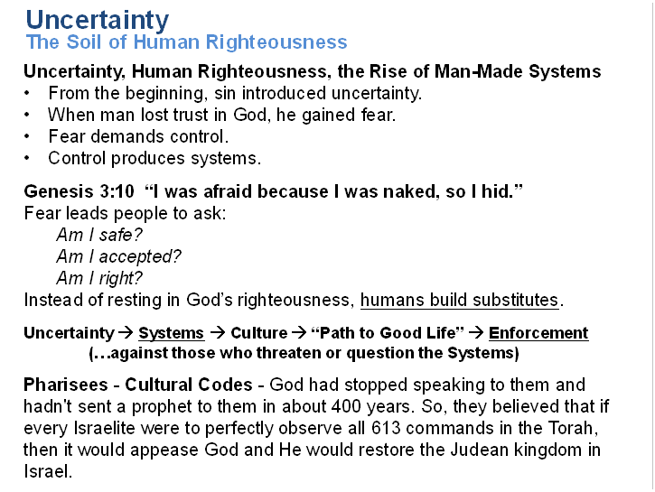

Uncertainty, Human Righteousness, and the Rise of Man-Made Systems
Cultural Identity – the Pharisees, the Sadducees – Developed Theological Systems – Drove Culture – Enforced Their Own Righteousness
- The Levites (scribes and priests) were prohibited from owning their own land, so they depended on contributions for food and goods.
- That also means they never had to work the land or do the manual labor needed to produce what they ate.
- They were of a higher class in society and culture.
- They were insulated from the consequences of their own teaching.
- Jesus identifies this problem…
- It’s easy to write a law that says “don’t pick heads of grain on the Sabbath because that’s work” when you yourself are never starving or hungry enough to consider doing that.
- Matthew 23:4 : “They tie up heavy, cumbersome loads and put them on other people’s shoulders, but they themselves are not willing to life a finger to move them.”
How does this relate to the Church today?
- This same generalized pattern leads to Churches forcing truth-tellers out of the community for making everyone else uncomfortable.
- Once the truth-tellers are gone, though, the culture inevitably loses touch with reality.
When the people creating the systems and creating the culture and enforcing their own righteousness don’t experience the consequences of what they teach then they will always drift farther from reality.
But, we have God’s word…! (they said)
- When the religious leaders drifted away from truth, they didn’t see any difference between God’s word and their own words about God’s word.
- Do we (i.e. broader Christendom) have a similar problem today?
  - Is the Bible silent on some cultural topics? (Does the Bible provide clarity on all cultural topics?)
  - Does this cause uncertainty?
  - How do we deal with that…? Extrapolate using Human Reasoning?
Consequences
- Just like in Jesus’ time, things get harmful when you have this combination of culture that has drifted from reality and teachers who stop seeing any difference between their extrapolations from scripture and the actual scripture itself.
- They have stopped teaching with humility and all those personal beliefs and interpretations get codified into man-made systems of theology.
- Some will benefit… some will be harmed.
- There are a lot of instinctual and emotional forces working against those who seek God’s righteousness in every aspect of their life’s.
- When humans elevate their systems of theology to be indisputably correct (certain), then they are essentially claiming to be God.
- The “system” and “cultural norm” makes them feel certain. They want that feeling more than they respect Truth.
We won’t be able to withstand the culture around us if we aren’t SECURE IN HIM first. Trust and Obey.
We need to prioritize Christ as Truth personified and respect God’s Word as His revelation of truth accordingly. Human interpretation or extrapolation are theory only.
We need to prioritize relationship… this is the heart of the New Covenant, relationship with God Himself, and relationship with one another. (Matthew 22)
Relationship can be uncertain, messy, not logical. Systems are certain, logical. But, relationships are better, spiritual, and meaningful, and come with God’s blessings.

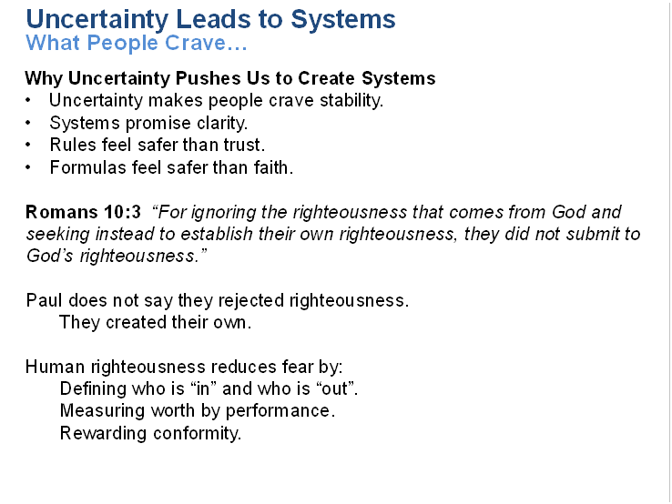

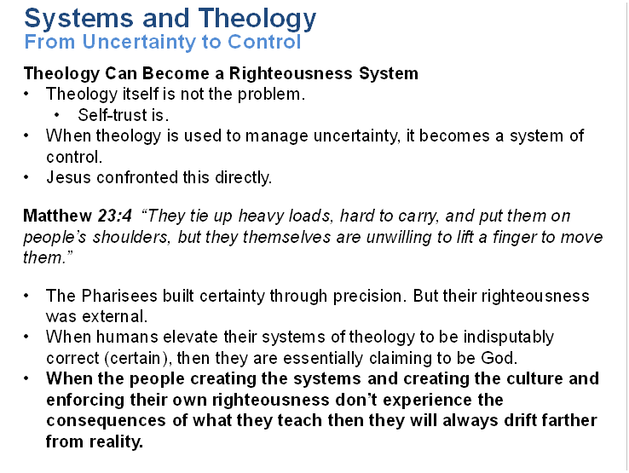

Theology Can Become a Righteousness System
When the people creating the systems and creating the culture and enforcing their own righteousness don’t experience the consequences of what they teach then they will always drift farther from reality.
But, we have God’s word…! (they said)
- When the religious leaders drifted away from truth, they didn’t see any difference between God’s word and their own words about God’s word.
- Do we (i.e. broader Christendom) have a similar problem today?
  - Is the Bible silent on some cultural topics? (Does the Bible provide clarity on all cultural topics?)
  - Does this cause uncertainty?
  - How do we deal with that…? Extrapolate using Human Reasoning?
Consequences
- Just like in Jesus’ time, things get harmful when you have this combination of culture that has drifted from reality and teachers who stop seeing any difference between their extrapolations from scripture and the actual scripture itself.
- They have stopped teaching with humility and all those personal beliefs and interpretations get codified into man-made systems of theology.
- Some will benefit… some will be harmed.
- There are a lot of instinctual and emotional forces working against those who seek God’s righteousness in every aspect of their life’s.
- When humans elevate their systems of theology to be indisputably correct (certain), then they are essentially claiming to be God.
- The “system” and “cultural norm” makes them feel certain. They want that feeling more than they respect Truth.
We won’t be able to withstand the culture around us if we aren’t SECURE IN HIM first. Trust and Obey.
We need to prioritize Christ as Truth personified and respect God’s Word as His revelation of truth accordingly. Human interpretation or extrapolation are theory only.
We need to prioritize relationship… this is the heart of the New Covenant, relationship with God Himself, and relationship with one another. (Matthew 22)
Relationship can be uncertain, messy, not logical. Systems are certain, logical. But, relationships are better, spiritual, and meaningful, and come with God’s blessings.

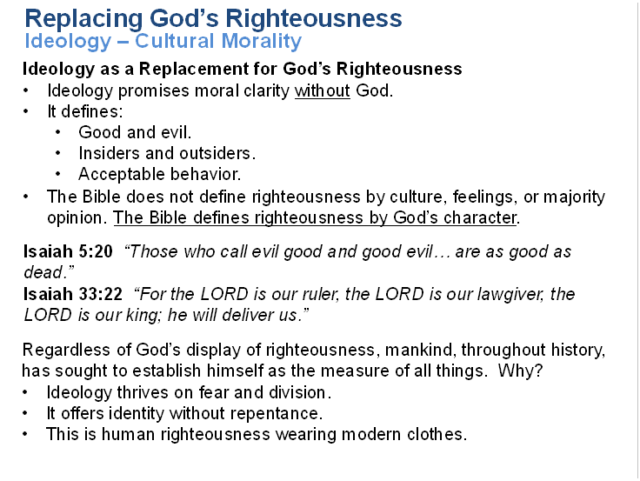
Ideology as a Replacement for God’s Righteousness
Biblical Righteousness Is Relational, Not Cultural
- The Bible does not define righteousness by culture, feelings, or majority opinion.
- It defines righteousness by God.
Isaiah 33:22 “For the LORD is our ruler, the LORD is our lawgiver, the LORD is our king; he will deliver us.”
- When people define righteousness, it shifts.
- What is “right” today may be “wrong” tomorrow.
- When God defines righteousness, it is stable and true.
- This is why Scripture consistently warns against doing what is “right in one’s own eyes”
Judges 21:25 In those days there was no king in Israel; everyone did what was right in his own eyes.

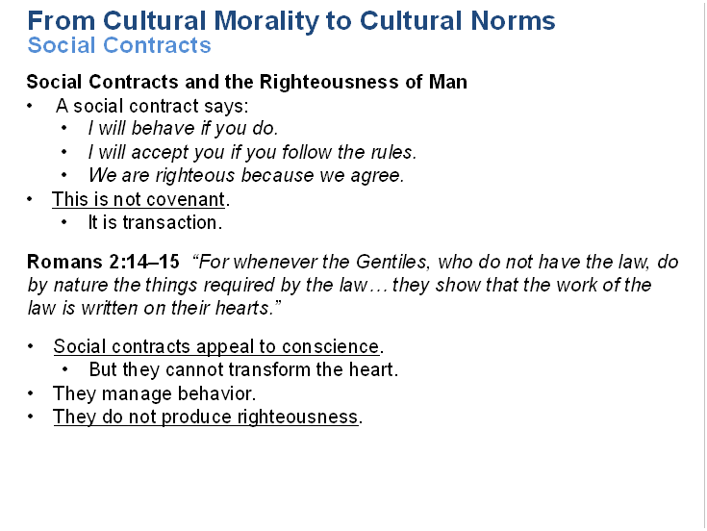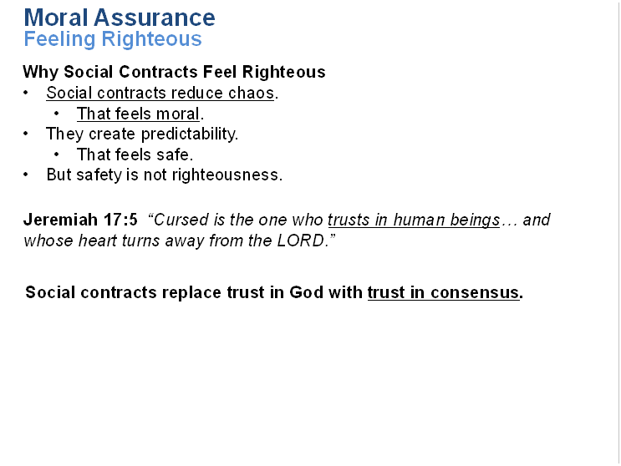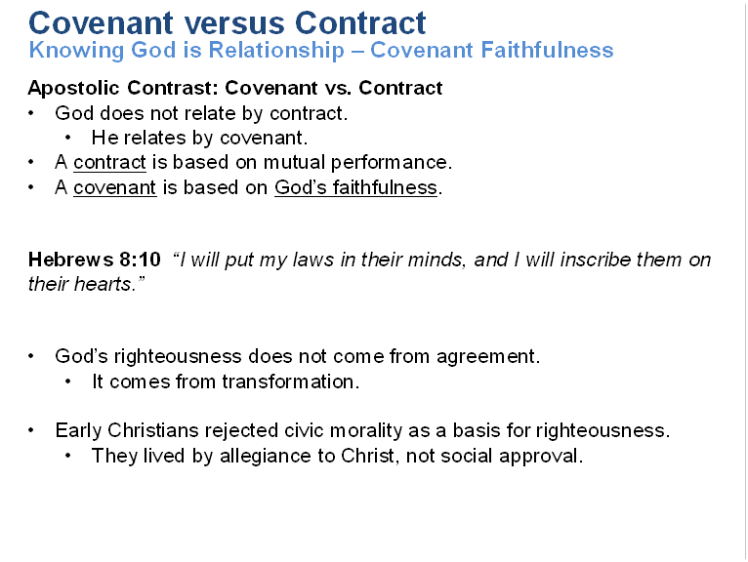

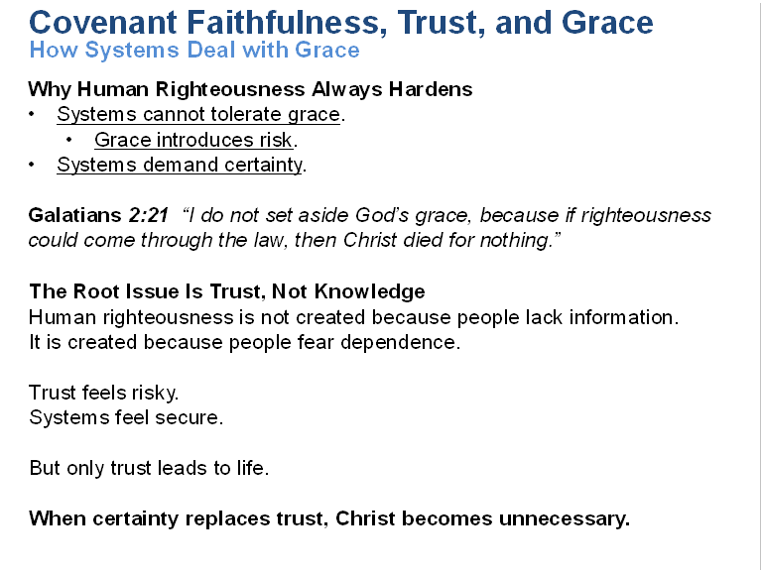

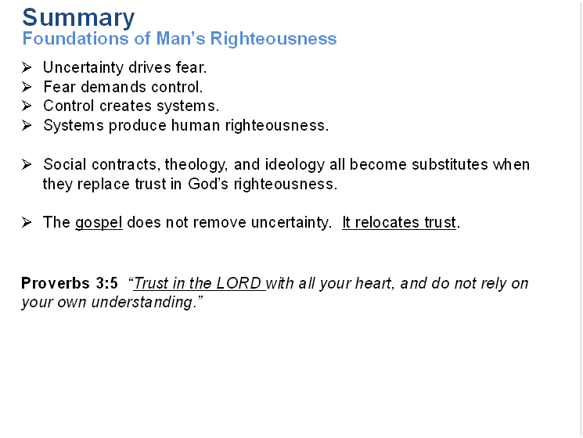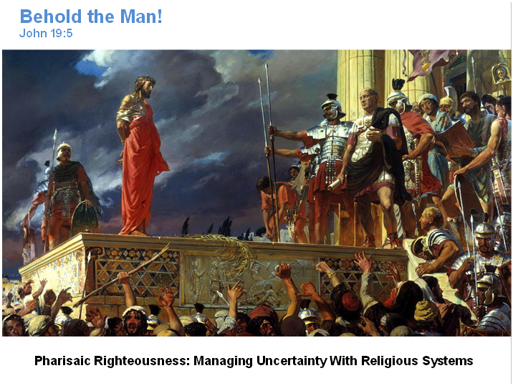

Pharisaic Righteousness: Managing Uncertainty With Religious Systems
Pharisaic righteousness did not start with rebellion.

It started with fear.
Israel feared losing identity, purity, and God’s favor.
So they built layers of rules to protect themselves.

Jesus exposes this.

Matthew 23:23

“You give a tenth of mint, dill, and cumin, yet you neglect what is more important in the law—justice, mercy, and faithfulness.”

The Pharisees were not rejecting righteousness.
They were trying to control it.

How uncertainty shaped their system

Fear of disobedience led to rule expansion
Fear of impurity led to separation
Fear of judgment led to performance-based assurance

Their system promised certainty:

If I do this, I am righteous.
If I avoid that, I am safe.

Jesus shows the flaw.

Luke 18:9

“Jesus also told this parable to some who were confident that they were righteous and looked down on everyone else.”

Confidence replaced trust.
Comparison replaced repentance.

This is the righteousness of man wearing religious clothing.

2. Modern Church Culture: New Systems, Same Instinct

The forms change.
The instinct stays the same.

Modern churches often rebuild Pharisaic righteousness without realizing it.

Common modern versions

Moral performance as spiritual proof
Doctrinal precision as righteousness
Political alignment as holiness
Ministry output as faithfulness

None of these are evil on their own.
They become dangerous when they provide identity and assurance.

Galatians 3:3

“After beginning with the Spirit, are you now trying to finish by human effort?”

Uncertainty drives this.

Fear of being wrong
Fear of being excluded
Fear of losing control

So systems form:

behavioral codes
cultural expectations
unspoken social contracts

You belong if you comply.
You are “righteous” if you align.

This is not covenant.
It is managed morality.

3. Faith-Based Obedience vs System-Based Morality (Scriptural Contrast)

A. Faith-Based Obedience

Faith-based obedience flows from trust.
It begins with God’s action, not ours.

Romans 4:5

“But to the one who does not work, but believes in the one who declares the ungodly righteous, his faith is credited as righteousness.”

Key traits:

obedience grows from relationship
repentance stays central
humility remains possible
love fulfills the law

Galatians 5:6

“The only thing that matters is faith working through love.”

Faith does not remove obedience.
It roots obedience in trust.

B. System-Based Morality

System-based morality flows from fear.
It begins with control.

Colossians 2:20–23

“Why do you submit to them as if you lived in the world? … They have the appearance of wisdom… but they are of no value against fleshly indulgence.”

Key traits:

obedience replaces trust
rules replace conscience
conformity replaces transformation
pride or despair results

Systems can shape behavior.
They cannot produce righteousness.

C. Jesus’ Summary of the Difference

Matthew 5:20

“Unless your righteousness goes beyond that of the experts in the law and the Pharisees, you will never enter the kingdom of heaven.”

“Beyond” does not mean more rules.
It means a different source.

One comes from man upward.
The other comes from God downward.

Final Synthesis

Pharisaic righteousness, modern church systems, and moral ideologies all share the same root:

Uncertainty without trust.

So humans:

build systems
form contracts
enforce conformity
call it righteousness

But God offers something else.

Romans 1:17

“The righteousness of God is revealed in the gospel from faith to faith.”

God’s righteousness is not negotiated.
It is revealed.

And it is received by trust, not managed by systems.

How Grace Dismantles Fear-Based Systems in the New Testament

1. Fear Builds Systems. Grace Exposes Them.

Fear always asks:
How do I protect myself?
How do I stay accepted?

Grace asks something else:
Who is God, and can He be trusted?

Romans 8:15

“For you did not receive the spirit of slavery leading again to fear, but you received the Spirit of adoption.”

Fear produces slavery.
Grace produces sonship.

Systems need fear to survive.
Grace removes the fear that systems depend on.

2. Grace Removes the Need for Control

Fear-based systems work by control:

- rules
- penalties
- social pressure

Grace replaces control with relationship.

Galatians 4:4–7

“So you are no longer a slave but a son, and if you are a son, then you are also an heir through God.”

A slave needs rules to survive.
A son lives from belonging.

Once belonging is secure, control loses its power.

3. Grace Shifts Obedience From Fear to Love

Fear-based obedience asks:
What happens if I fail?

Grace-based obedience asks:
How do I honor the one who loves me?

1 John 4:18

“There is no fear in love, but perfect love drives out fear.”

Fear cannot coexist with love.
When love rules, systems collapse.

4. Grace Dismantles Religious Hierarchies

Fear-based systems require mediators:

- experts
- gatekeepers
- elites

Grace gives direct access to God.

Hebrews 4:16

“Therefore let us confidently approach the throne of grace to receive mercy and find grace whenever we need help.”

Confidence replaces dependence on religious authority structures.

This is why grace always threatens institutional control.

5. Grace Ends the Need for Performance Identity

Fear-based systems define worth by performance.

Grace defines identity by Christ.

Ephesians 2:8–9

“For by grace you are saved through faith… it is the gift of God; it is not from works.”

If righteousness is a gift,
there is nothing left to earn.

Systems collapse when comparison loses meaning.

6. Grace Replaces External Rules With Internal Transformation

Fear systems manage behavior.
Grace changes the heart.

Titus 2:11–12

“For the grace of God has appeared… training us to reject godless ways.”

Grace teaches.
Law demands.

Fear controls from the outside.
Grace forms from the inside.

7. Grace Breaks Social Contracts Inside the Church

Social contracts say:

- behave and belong
- conform and be accepted

Grace says:

- belong, therefore grow

Romans 15:7

“Receive one another, just as Christ also received you.”

Christ did not receive us after improvement.
He received us before it.

This destroys transactional righteousness.

8. Grace Destroys the Economy of Shame

Fear-based systems need shame to function.

Grace absorbs shame.

Hebrews 12:2

“He endured the cross, disregarding its shame.”

When shame is removed,
fear loses its leverage.

9. Grace Makes the Law Obsolete as a Control System

The Law exposed sin.
Grace removes condemnation.

Romans 8:1

“There is therefore now no condemnation for those who are in Christ Jesus.”

Without condemnation:

- fear loses urgency
- systems lose authority
- trust becomes possible

10. Why Grace Is So Threatening

Grace cannot be controlled.
It cannot be measured.
It cannot be monopolized.

Galatians 5:1

“For freedom Christ has set us free.”

Freedom is dangerous to systems.
But it is essential for life.

11. Apostolic Pattern: From System to Life

Every New Testament shift follows this pattern:

- from law to life
- from fear to faith
- from performance to promise
- from system to Spirit

2 Corinthians 3:17

“Now the Lord is the Spirit, and where the Spirit of the Lord is present, there is freedom.”

Final Summary

Fear builds systems to protect identity.
Grace reveals identity so systems are no longer needed.

Fear asks: Am I safe?
Grace answers: You are mine.

And once that is settled,
righteousness no longer needs to be managed.

How the Early Church Resisted System-Driven Religion

1. They Resisted Replacing Christ With a System

The apostles did not offer a new religious structure.
They proclaimed a risen Lord.

Acts 2:36

“God has made this Jesus whom you crucified both Lord and Christ.”

Their allegiance was personal, not institutional.
Christ was not the foundation of a system.
He was the center of life.

This is why the church spread before it had buildings, creeds, or hierarchies.

2. They Rejected Law as a Control Mechanism

The first major crisis tested this directly.

Should Gentile believers submit to the Jewish Law?

The apostles answered clearly.

Acts 15:10–11

“Why are you putting God to the test by placing on the neck of the disciples a yoke that neither our ancestors nor we have been able to bear?”

They refused to rebuild the Law as a righteousness system.

This moment defined the church:

- no ethnic righteousness
- no performance entry
- no system replacing grace

3. They Centered Fellowship, Not Regulation

Early Christian life was relational, not procedural.

Acts 2:42

“They were devoting themselves to the apostles’ teaching and to fellowship, to the breaking of bread and to prayer.”

Notice what is missing:

- no rulebook
- no enforcement structure
- no membership system

Order existed.
Control did not.

4. They Lived Without Temple Dependence

The early church did not build a replacement temple.

They believed something radical.

1 Corinthians 3:16

“Do you not know that you are God’s temple and that God’s Spirit lives in you?”

This removed sacred space as a control tool.

No priesthood monopoly.
No sacred geography.
No system of access.

5. They Resisted Religious Elites

Authority existed, but it was relational and accountable.

Matthew 23:8

“But you are not to be called ‘Rabbi,’ for you have one Teacher and you are all brothers.”

Early leaders served.
They did not dominate.

1 Peter 5:2–3

“Shepherd the flock of God among you… not as lording it over those entrusted to you.”

System-driven religion needs rank.
The early church emphasized brotherhood.

6. They Refused Social Contract Morality

The church did not blend into Roman civic religion.

Their righteousness did not come from social approval.

Acts 5:29

“We must obey God rather than people.”

They were willing to suffer exclusion rather than compromise allegiance.

This is why persecution followed.
Grace-made people do not submit easily to moral systems.

7. They Practiced Voluntary, Not Enforced, Obedience

Giving, service, and sacrifice were not compelled.

2 Corinthians 9:7

“Each one of you should give just as he has decided in his heart… for God loves a cheerful giver.”

Fear systems demand compliance.
Grace invites response.

This preserved sincerity and humility.

8. They Kept Repentance Central

System religion minimizes repentance.
It prefers rule-keeping.

The early church preached repentance constantly.

Acts 3:19

“Therefore repent and turn back so that your sins may be wiped out.”

Repentance keeps power from settling into systems.

It keeps everyone equal at the foot of the cross.

9. They Expected the Spirit to Lead

The early church trusted the Spirit more than structure.

Romans 8:14

“For all who are led by the Spirit of God are the sons of God.”

This did not mean chaos.
It meant dependence.

Systems promise predictability.
The Spirit requires trust.

10. They Warned Against Returning to Systems

The apostles repeatedly warned believers not to go backward.

Galatians 5:4

“You have been severed from Christ, you who are trying to be justified by the law.”

Returning to system-based righteousness was seen as spiritual danger.

Not maturity.
Not stability.

11. Why This Resistance Could Not Last Forever

By the late second and third centuries:

- persecution increased
- growth demanded organization
- fear re-entered

Systems slowly replaced trust.

But the New Testament witness remains clear:

- life before institution
- grace before structure
- covenant before contract

Final Summary

The early church resisted system-driven religion by:

- centering on Christ, not control
- trusting grace over law
- valuing relationship over regulation
- obeying from love, not fear
- living by covenant, not contract

They were not anti-order.
They were anti-replacement.

Anything that replaces trust in God’s righteousness becomes the righteousness of man.

How the New Testament Balances Order Without Control

1. Order Comes From Life, Not Enforcement

In the New Testament, order grows out of shared life in Christ.
It is not imposed from above.

1 Corinthians 14:33

“For God is not a God of disorder but of peace.”

Peace flows from God’s presence, not from strict regulation.

Order is the fruit of the Spirit working in people, not the result of tight systems.

2. Authority Is Functional, Not Positional

Authority exists, but it serves the body.
It is not a chain of command.

Ephesians 4:11–12

“It was he who gave some as apostles, some as prophets, some as evangelists, and some as pastors and teachers, to equip the saints.”

Leaders equip.
They do not control.

Their role is temporary and purpose-driven.

3. Leadership Is Plural, Not Centralized

The New Testament avoids single-point control.

Acts 14:23

“They appointed elders for them in the various churches.”

Plural elders prevent domination.
Shared leadership limits abuse.

This keeps authority relational and accountable.

4. Submission Is Mutual, Not Coerced

Submission is voluntary and reciprocal.

Ephesians 5:21

“Submitting to one another out of reverence for Christ.”

This removes hierarchy as a control tool.

Submission flows from shared reverence, not fear.

5. Teaching Guides Conscience, Not Compliance

Teaching shapes understanding.
It does not replace conscience.

Romans 14:5

“Each person must be fully convinced in his own mind.”

The apostles respected personal conviction in non-essential matters.

Systems demand uniformity.
The New Testament allows space for growth.

6. Correction Restores, Not Punishes

Discipline exists, but its goal is restoration.

Galatians 6:1

“Restore such a person in a spirit of gentleness.”

Gentleness protects dignity.
Fear-based systems use discipline to maintain power.

Grace-based order uses it to heal.

7. Freedom Is Protected, Not Feared

Freedom is not chaos.
It is responsibility before God.

Galatians 5:13

“You were called to freedom… only do not use your freedom as an opportunity for the flesh.”

The solution to misuse is love, not control.

8. Unity Is Rooted in Christ, Not Rules

Unity comes from shared life in Christ.

Philippians 2:1–2

“If there is any encouragement in Christ… be of the same mind.”

Unity is cultivated, not enforced.

Rules can create compliance.
They cannot create love.

9. Decisions Are Discerned, Not Dictated

Major decisions were made together.

Acts 15:28

“For it seemed best to the Holy Spirit and to us…”

This shows:

- prayer
- listening
- consensus
- humility

No single authority claimed control.

10. Boundaries Are Clear but Few

The apostles focused on essentials.

Acts 15:19–20

“We should not cause extra difficulty for those Gentiles who are turning to God.”

They resisted over-regulation.

Clarity without excess preserves freedom.

11. Christ Remains the Only Head

No structure replaces Christ’s authority.

Colossians 1:18

“He himself is the head of the body, the church.”

Every human structure is temporary.
Christ alone governs the body.

Final Summary

The New Testament balance looks like this:

- Order without coercion
- Leadership without domination
- Discipline without shame
- Unity without uniformity
- Authority without control

This balance works only when trust in God’s righteousness remains central.

Once fear replaces trust,
control replaces order.

