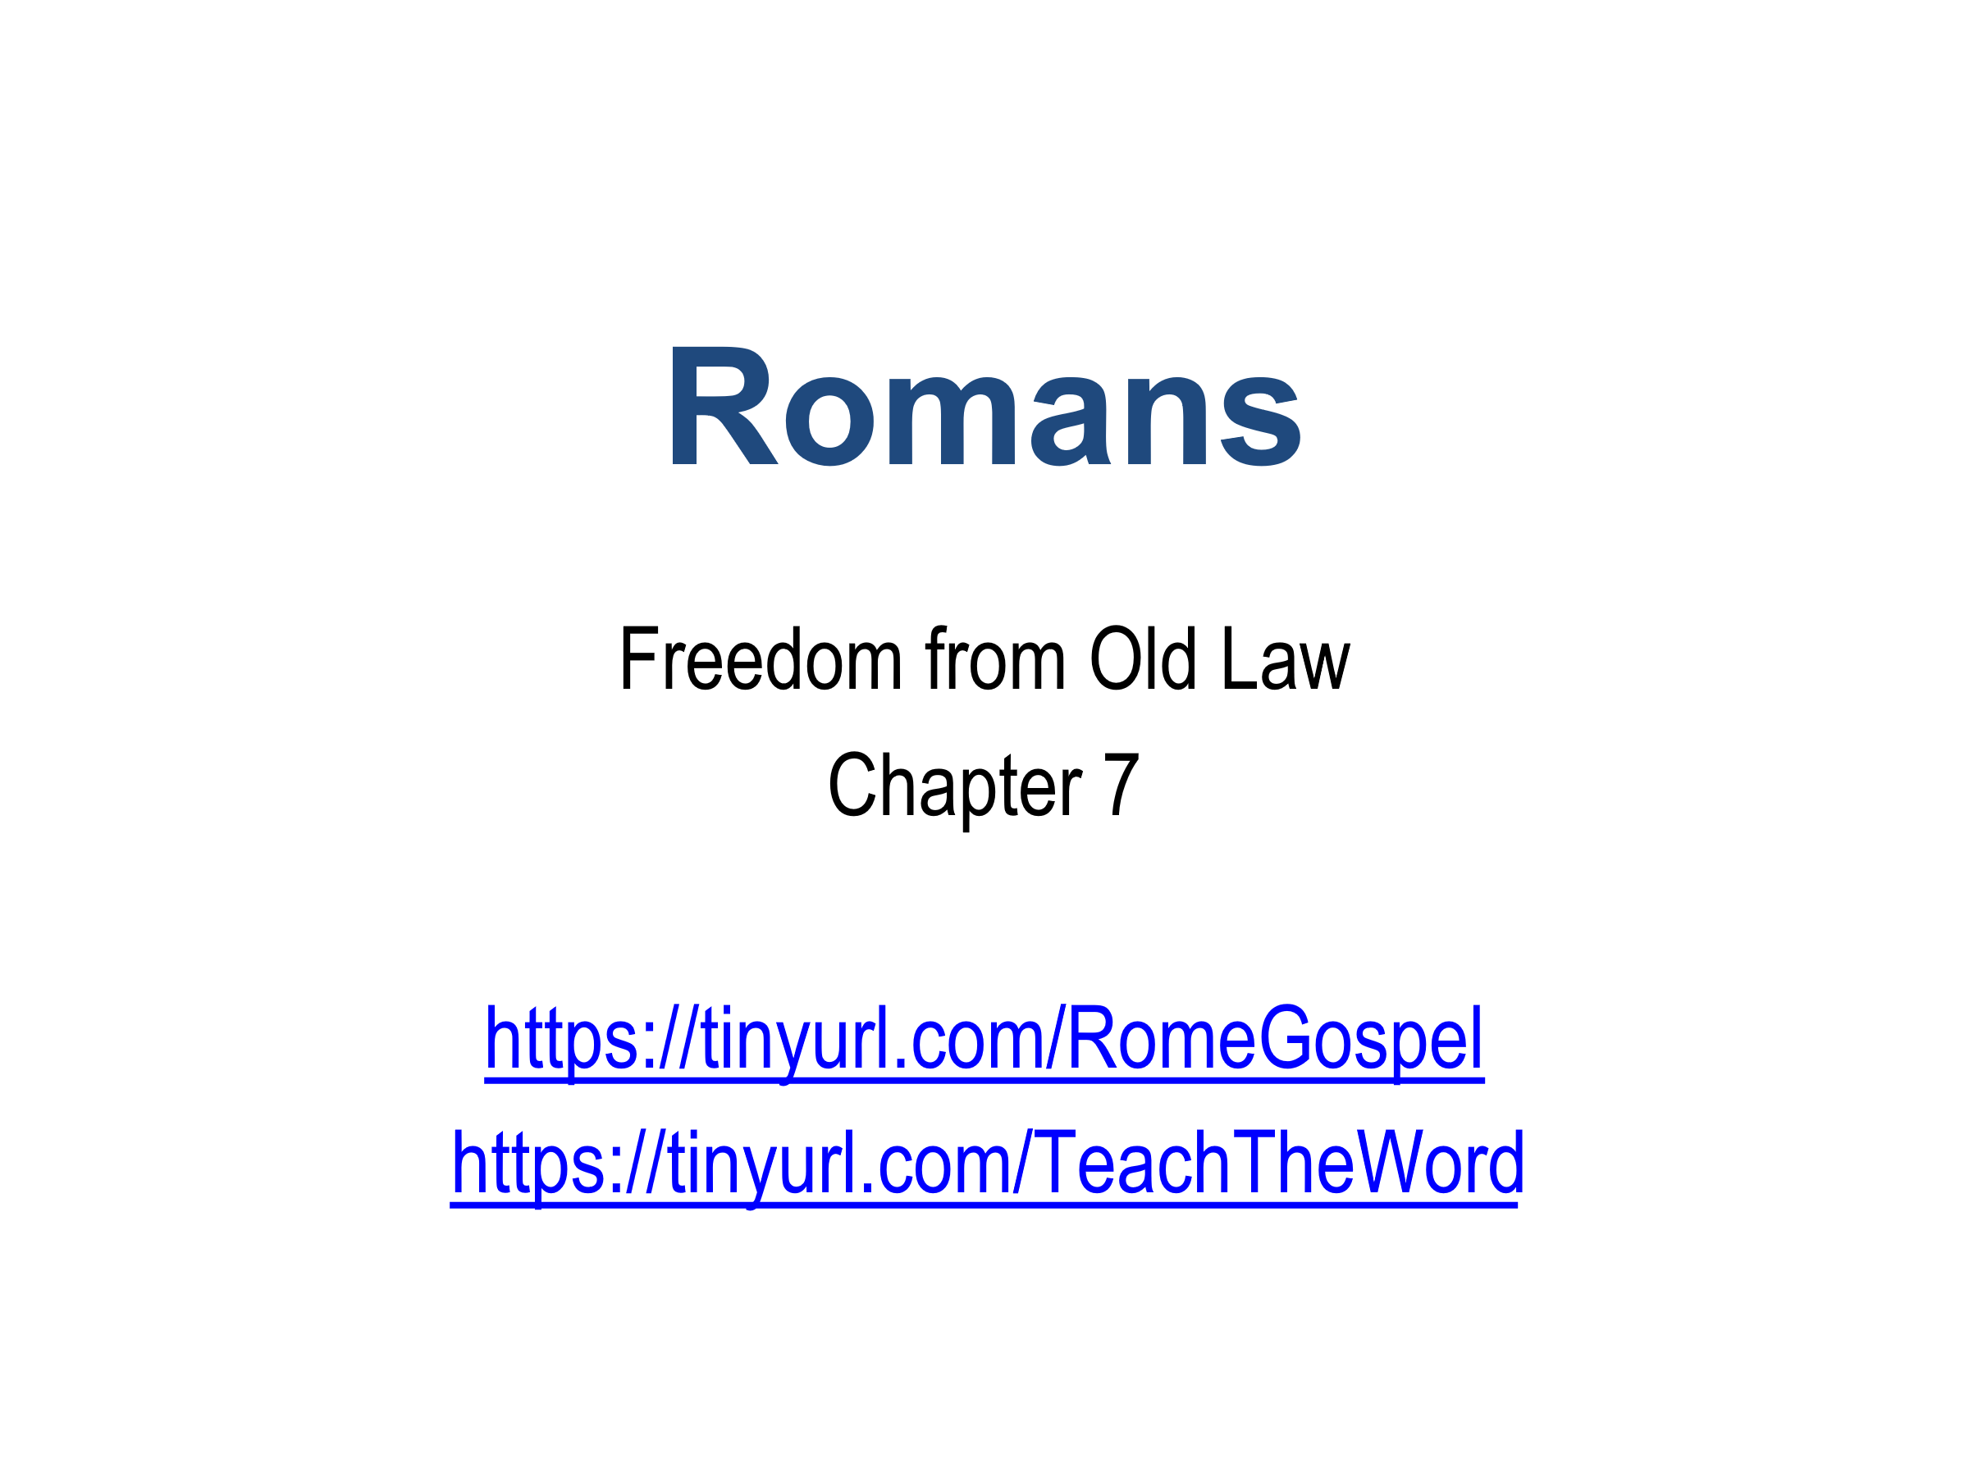

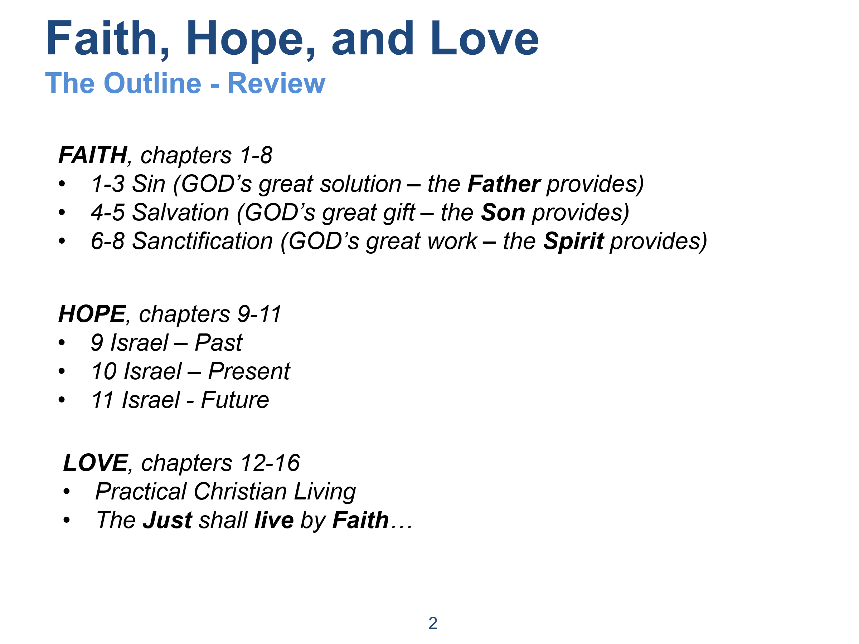

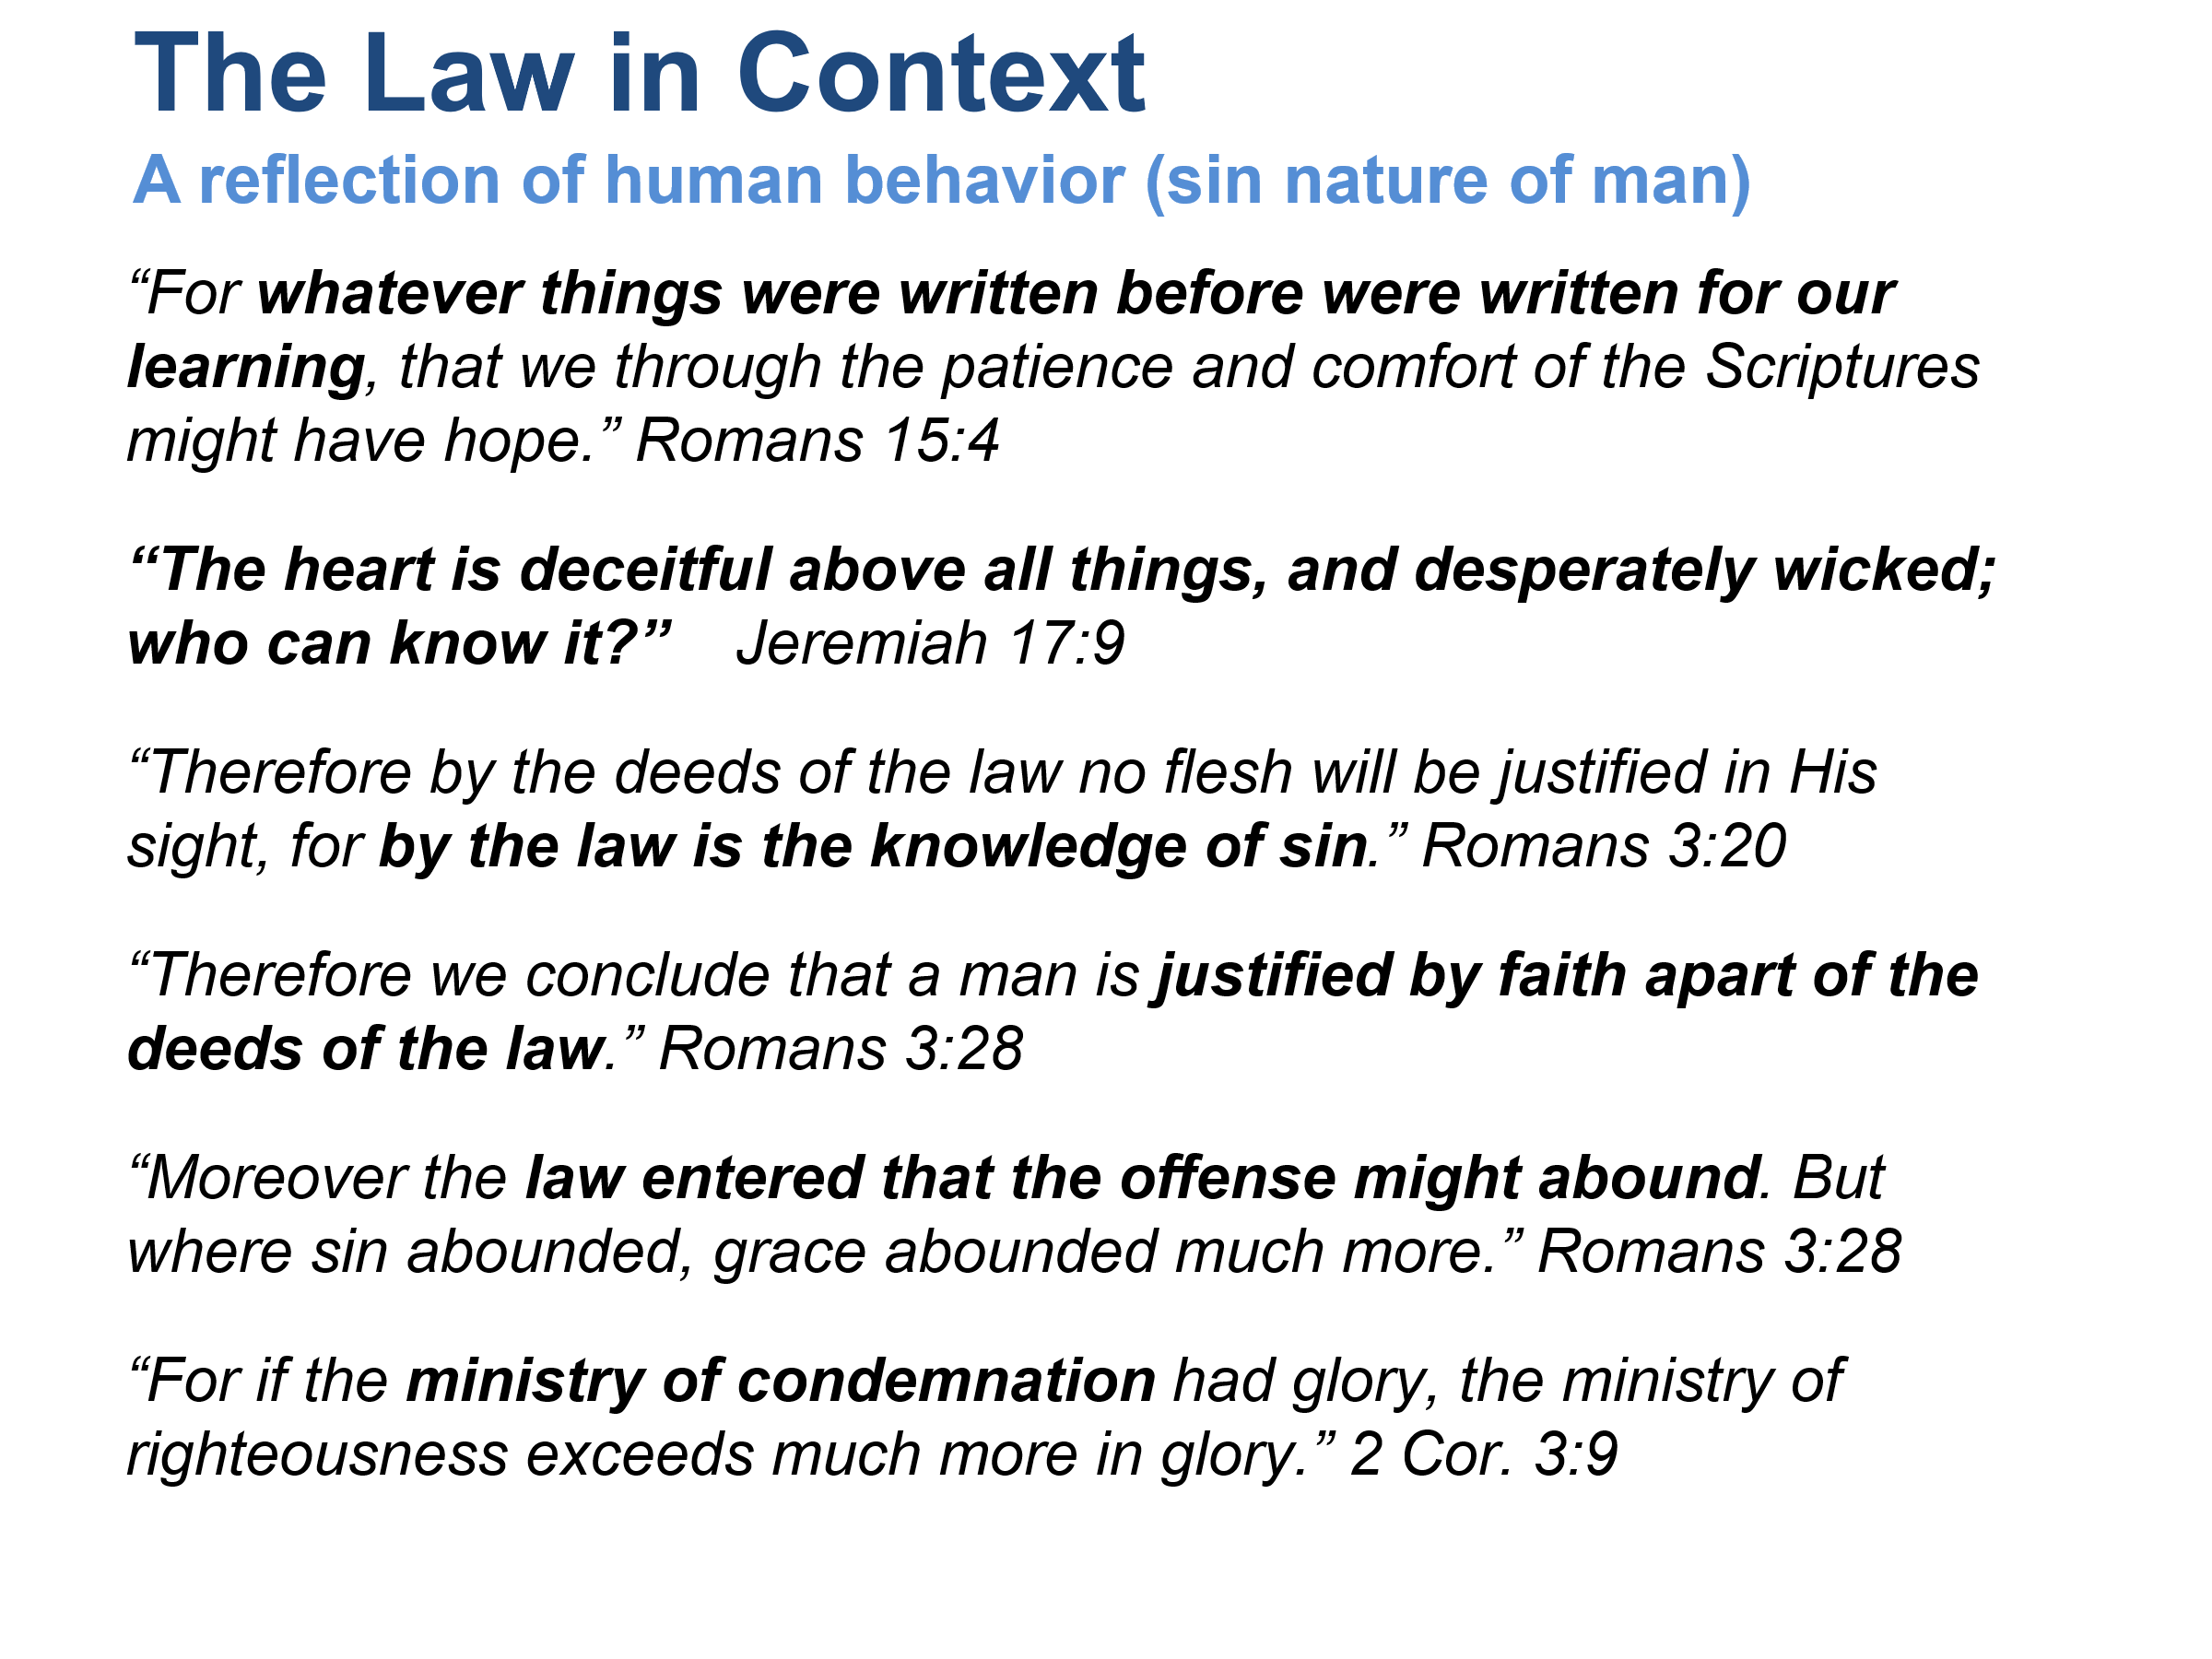

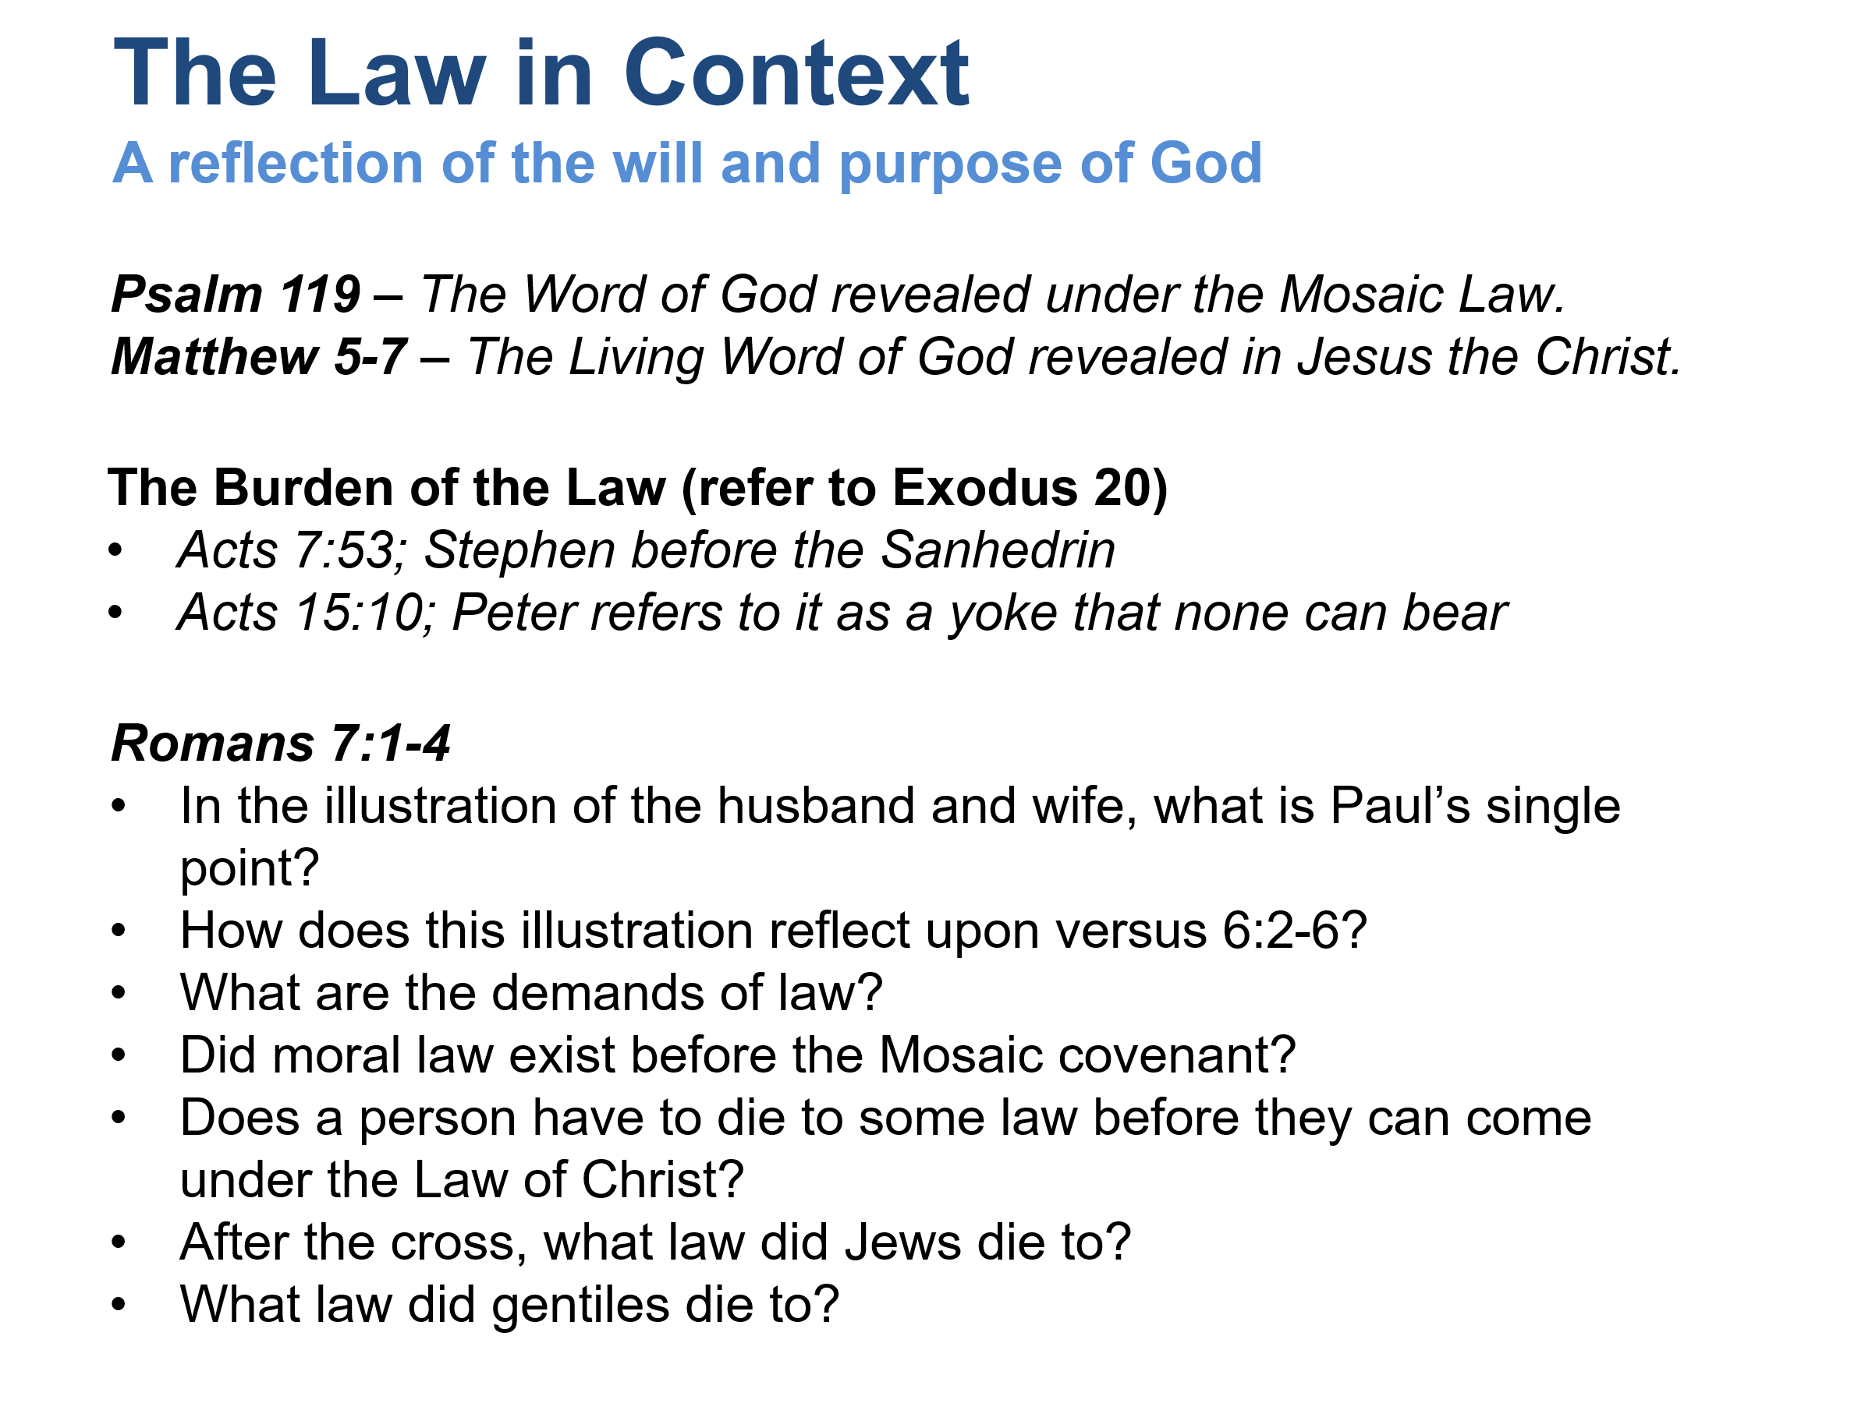

Psalm 119 and Matthew 5–7 affirm the goodness and righteousness reflected in God’s commands.
1. In the illustration of the husband and wife, what is Paul’s single point? (Romans 7:1-4)
Paul’s point is simple:
Death ends the legal authority of a covenant relationship.
A wife is bound to her husband while he lives. If he dies, she is released from that legal bond and is free to belong to another.
Paul applies this principle spiritually:
“Therefore, my brothers and sisters, you also died to the law through the body of Christ, so that you could belong to another, namely to Him who was raised from the dead…” (Romans 7:4, NET)
The focus is not marriage itself. The focus is that death releases a person from the jurisdiction of a law covenant.
2. How does this illustration reflect upon Romans 6:2-6?
Romans 6 teaches that believers have been united with Christ in His death.
We died with Christ.
We were buried with Christ.
We were raised with Christ.
Romans 7 builds on that truth.
Because we died with Christ, our former relationship to law as a covenant of condemnation has ended.
The death of Romans 6 becomes the basis for the release of Romans 7.
3. What are the demands of law?
Law demands:
Perfect obedience.
Continuous obedience.
Personal obedience.
James writes:
“For the one who obeys the whole law but fails in one point has become guilty of all of it.” (James 2:10)
Law does not offer grace.
Law identifies sin, exposes sin, and condemns sin.
Romans 3:20 says:
“For through the law comes the knowledge of sin.”
The Law is a mirror, not a savior.
4. Did moral law exist before the Mosaic Covenant?
Yes. Sin existed before Sinai.
Examples include:
Cain’s murder (Genesis 4)
The violence before the Flood (Genesis 6)
Sodom’s wickedness (Genesis 19)
Joseph calling adultery “sin against God” (Genesis 39:9)
Paul addresses this in Romans 5:13-14.
People sinned before Moses because God’s moral standards existed before the Mosaic Law.
The Mosaic Covenant did not create morality.
It codified and revealed God’s righteous standards in a covenant form for Israel.
5. Does a person have to die to some law before they can come under the Law of Christ?
Yes.
Paul teaches that believers die to their former covenantal relationship before entering a new relationship with Christ.
No one can be simultaneously under the old covenant and the new covenant as governing systems.
The believer dies with Christ and is united to Christ.
This allows him to serve:
“in the newness of the Spirit and not in the oldness of the letter” (Romans 7:6).
6. After the cross, what law did Jews die to?
Jewish believers died to the Mosaic Law Covenant.
This includes:
The Ten Commandments as covenant stipulations.
Ceremonial regulations.
Civil regulations governing Israel.
Paul specifically says:
“you also died to the law through the body of Christ” (Romans 7:4).
Since Romans is written largely to Jews familiar with Moses, “the law” here primarily refers to the Mosaic covenant.
Acts 15 and Galatians show the apostles refusing to place Gentiles under that covenant.
7. What law did Gentiles die to?
Gentiles were never under the Mosaic Covenant.
However, they were under:
The law written on the heart (Romans 2:14-15).
The universal moral accountability of God’s righteousness.
The condemnation that comes from sin.
In a broader sense, they died to their former standing under condemnation and became united to Christ.
Both Jew and Gentile arrive at the same place:
Not justified by law (Romans 3:20).
Justified by faith (Romans 3:28).
United in Christ.
Living under the Law of Christ (Galatians 6:2; 1 Corinthians 9:21).

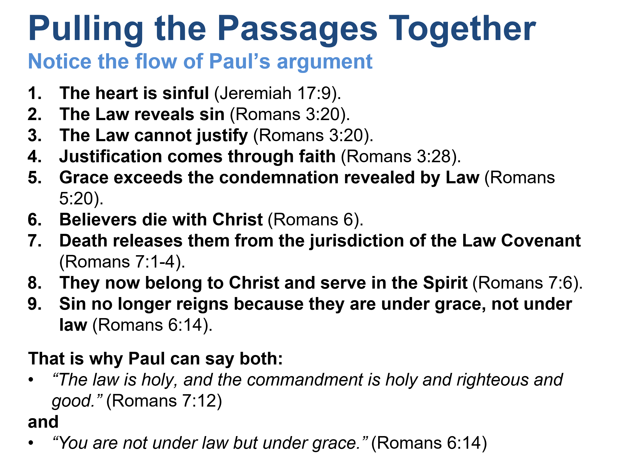

This does not mean God’s moral character changes. Psalm 119 and Matthew 5–7 affirm the goodness and righteousness reflected in God’s commands. What changes is the believer’s relationship to those commands. We are no longer seeking righteousness through the Law. We have received righteousness through Christ and now obey from a transformed heart through the Spirit.

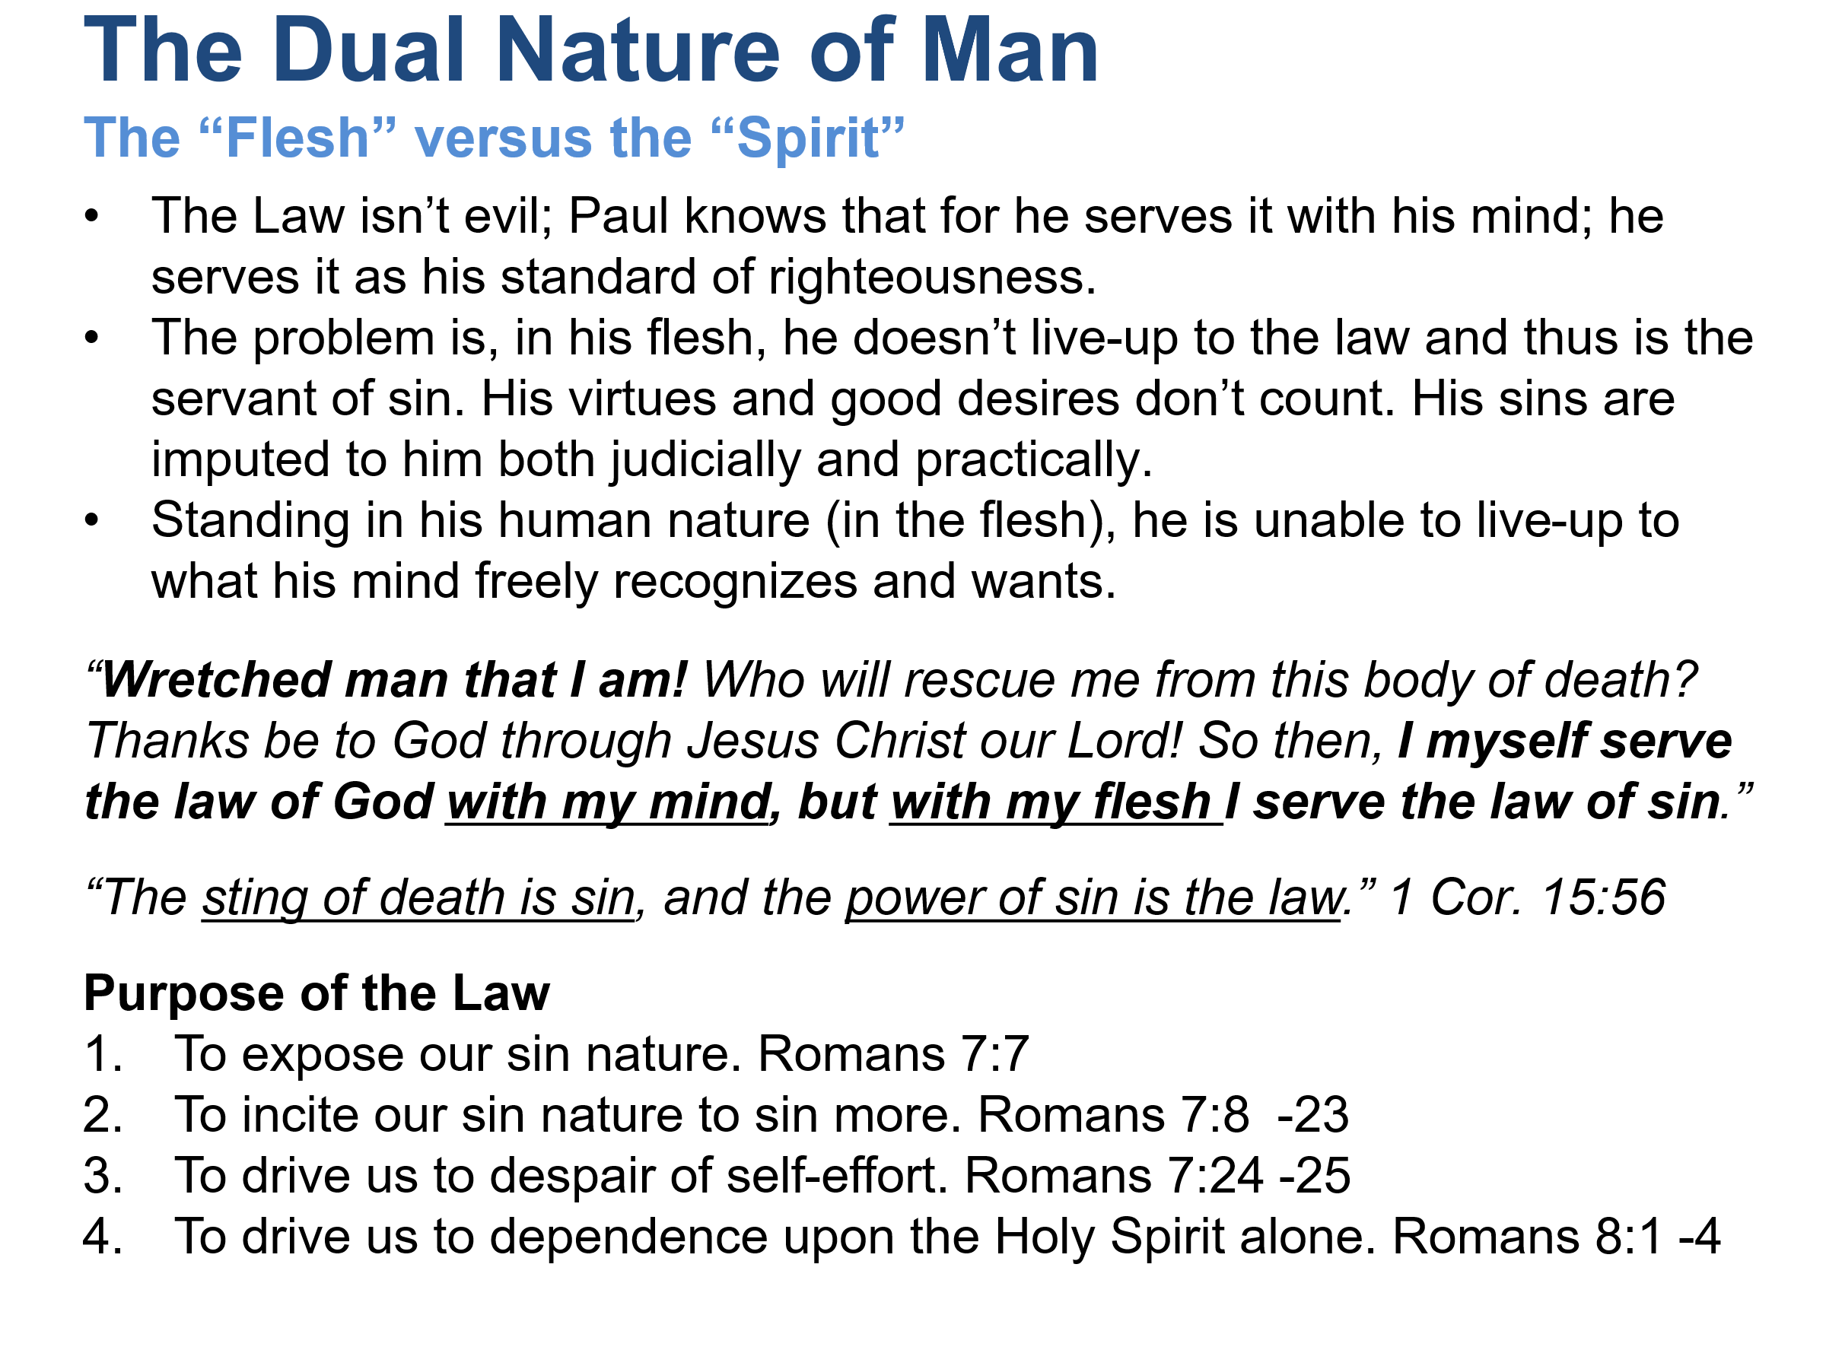

Romans 7:13-24 is one of the most discussed passages in the New Testament. Christians have disagreed over whether Paul is describing his life before conversion, a Jew under the Law, or the ongoing struggle of a believer. Whatever position one takes, the passage must fit within Paul’s larger argument in Romans 6-8.
Is sin a condition, or is sin a deviation from the holy will of God?
The Bible speaks of sin in both ways.
Sin is an act of transgressing God’s will:
“Everyone who practices sin also practices lawlessness; indeed, sin is lawlessness.” (1 John 3:4)
But Paul also speaks of Sin as a power or principle that operates within fallen humanity.
In Romans 7, sin is personified:
- Sin deceives (7:11)
- Sin kills (7:11)
- Sin dwells in me (7:17, 20)
- Sin produces coveting (7:8)
So sin is both:
- Individual acts against God’s will.
- A corrupting power that resides in fallen humanity.
What gives sin its power to inflict death? (1 Corinthians 15:56)
Paul writes:
“The sting of death is sin, and the power of sin is the law.”
The Law does not create sin.
The Law exposes sin, defines sin, and brings accountability.
Without God’s command:
- Coveting remains hidden.
- Rebellion remains concealed.
- Guilt remains less obvious.
The Law shines light on sin.
Sin then exploits the commandment and produces condemnation.
That is why Paul says:
“Sin, seizing the opportunity through the commandment…” (Romans 7:11)
Is the Law spiritual?
Yes.
Paul explicitly says:
“For we know that the law is spiritual…” (Romans 7:14)
The problem is not the Law.
The Law comes from God.
The problem is fallen humanity.
The Law is holy.
Man is sinful.
The Law reveals the disease but cannot cure it.
What are the different laws in his members?
Paul uses “law” in several different senses.
1. The Law of God
God’s revealed will.
“I delight in the law of God in my inner being.” (7:22)
2. The Law of Sin
The principle of rebellion operating in fallen flesh.
“I see a different law in my members…” (7:23)
3. The Law of the Mind
The inward desire to agree with God’s will.
“waging war against the law of my mind…” (7:23)
These are not separate legal codes.
They are competing governing principles.
When Paul says, “It is no longer I who do it,” is he rejecting responsibility?
No.
Paul is not saying:
“The devil made me do it.”
Nor is he saying:
“I am innocent.”
Instead, he is distinguishing between:
- His renewed desire to serve God.
- The sinful impulses still operating in the flesh.
Notice that he repeatedly confesses the sin as his own experience.
He is explaining the source of the conflict, not denying accountability.

Is the wretched man incapable of doing any good?
Not entirely.
He desires good.
He recognizes good.
He approves of good.
But he lacks the power to consistently perform it.
The problem is not knowledge.
The problem is inability.
The Law can inform the conscience but cannot transform the heart.
Is the wretched man captive to the law of sin and death?
According to Romans 7:23, yes.
That is exactly why he cries out:
“Wretched man that I am! Who will rescue me from this body of death?” (7:24)
The rescue has not yet been explained.
The answer arrives immediately in Christ.
Does the wretched man live in a body of death?
Yes.
The phrase points to mortal, fallen human existence.
The body itself is not evil.
But it is the arena in which sin operates and through which death reigns.
Romans 8 will later speak of the redemption of the body.

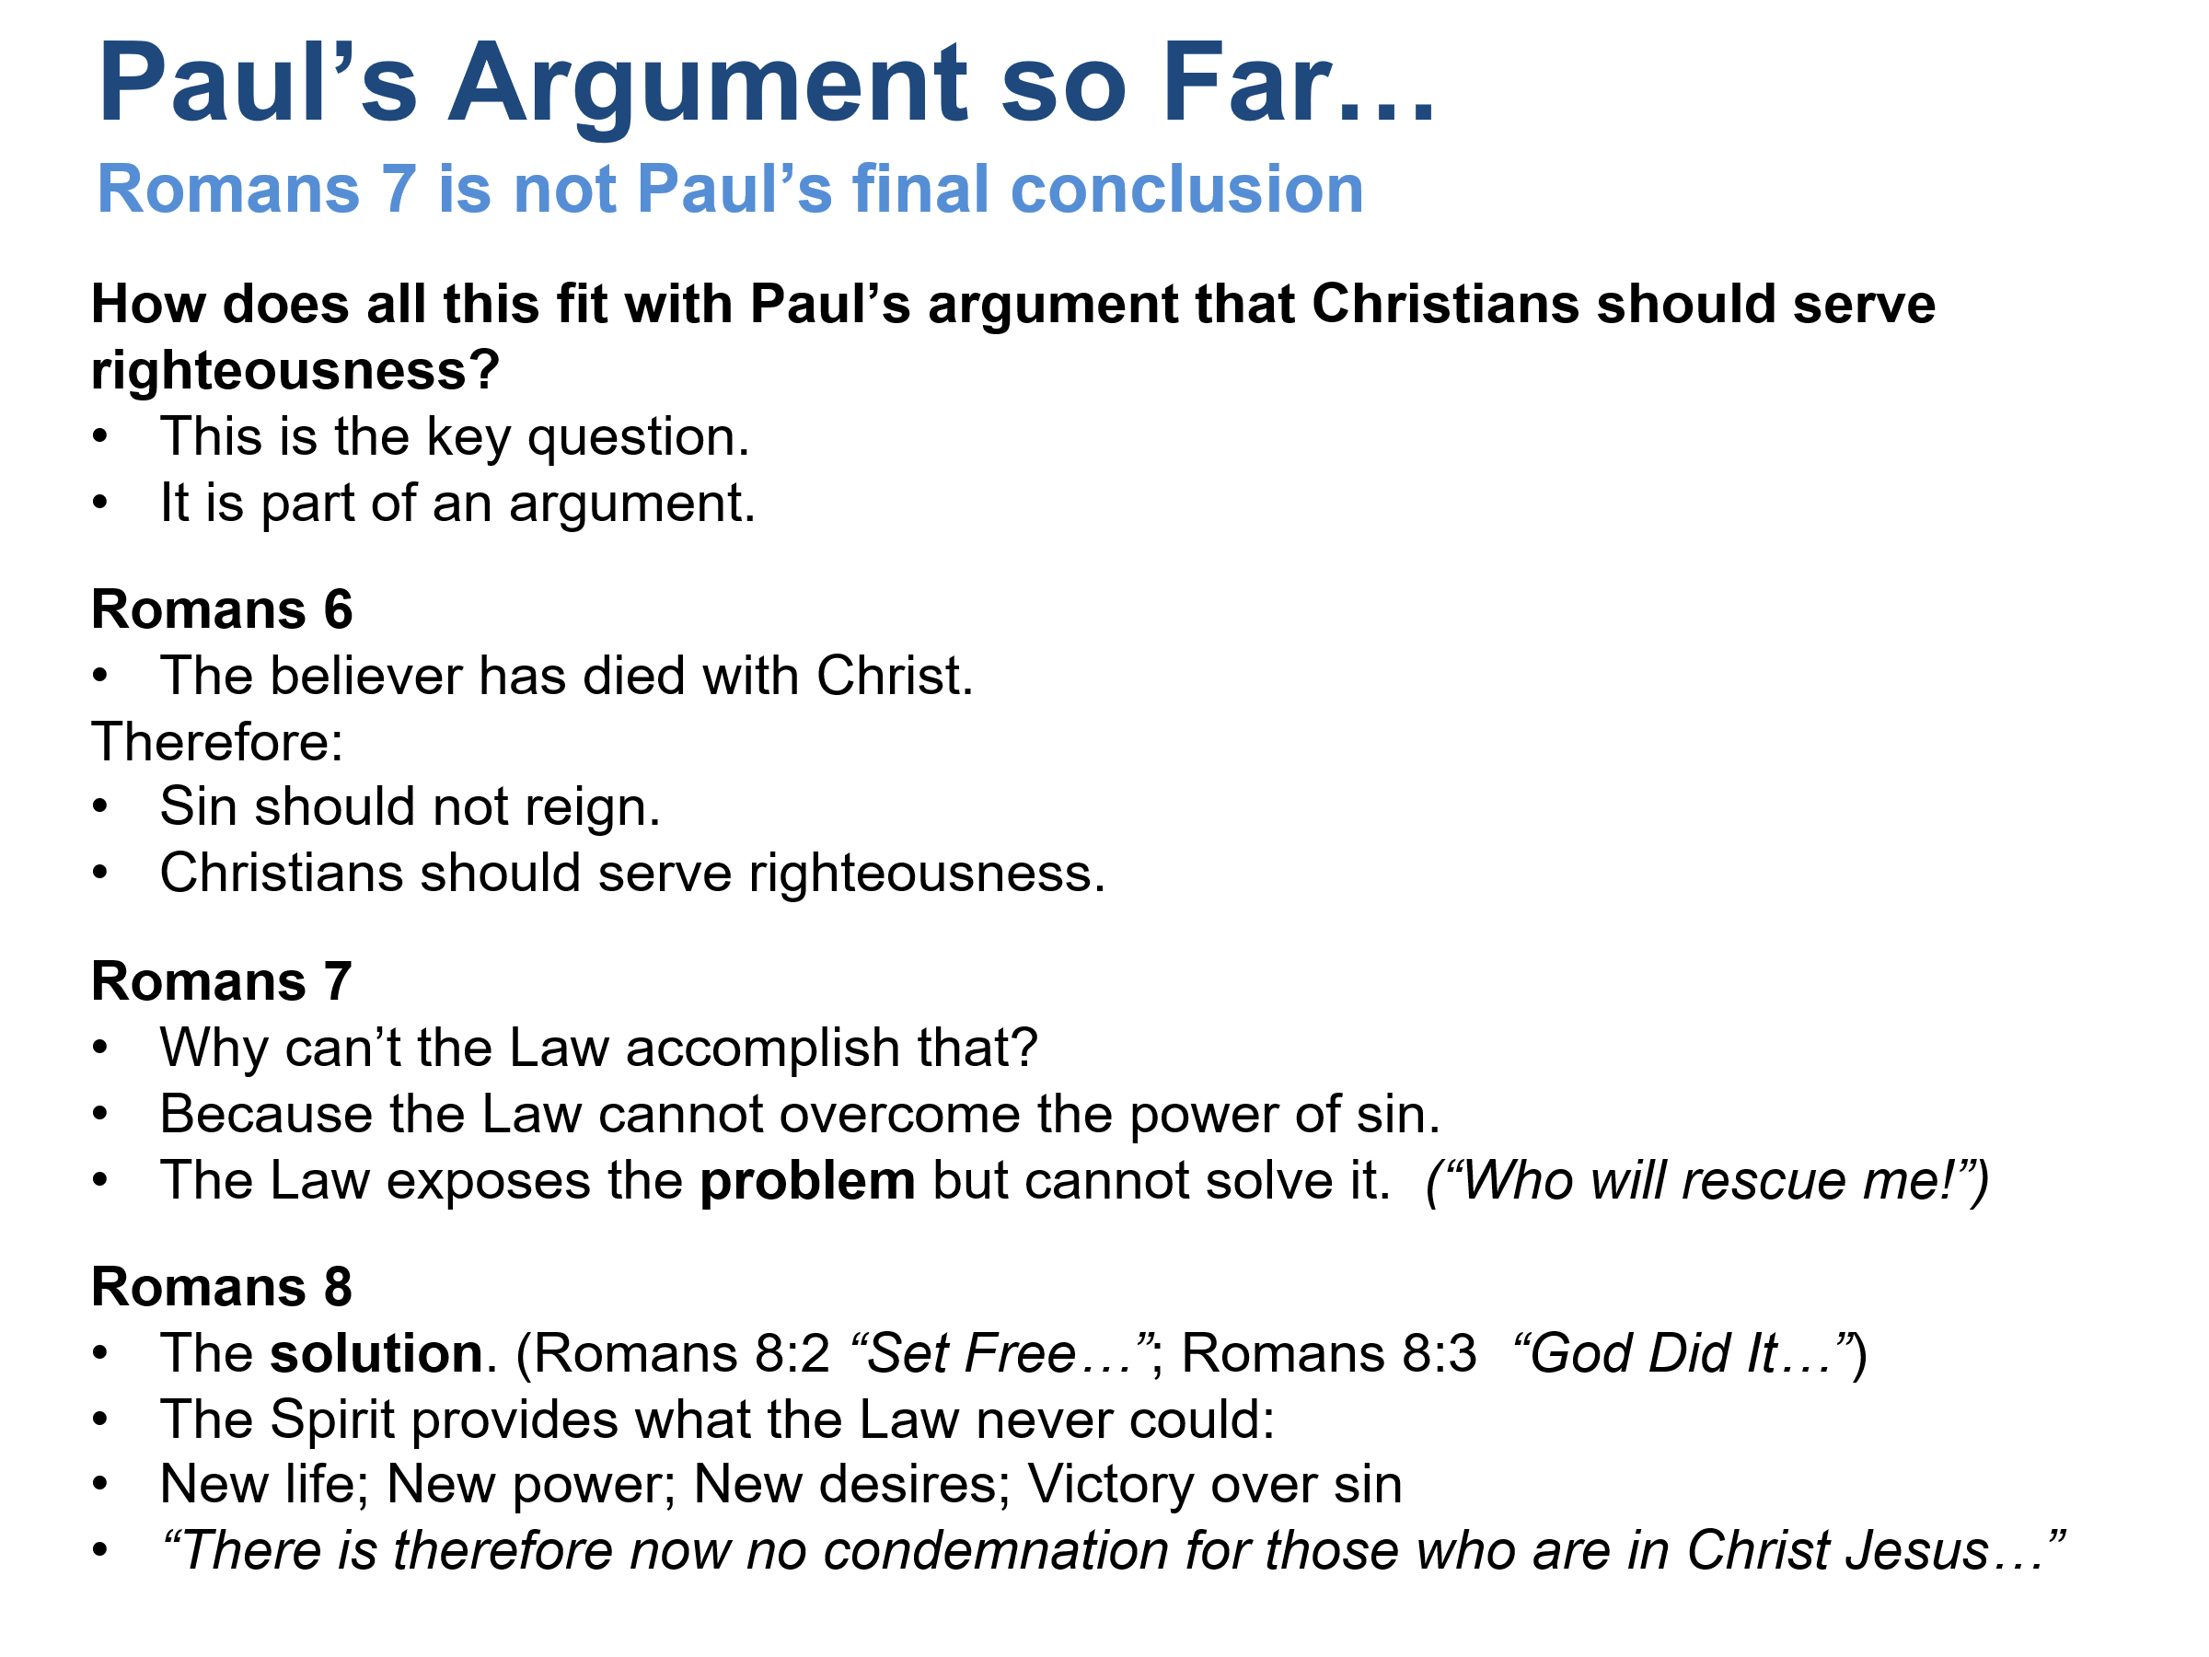

Romans 8
The solution.
“For the law of the Spirit of life in Christ Jesus has set you free from the law of sin and death.” (Romans 8:2)
What the Law could not do:
“God did…” (Romans 8:3)
So Romans 7 is not Paul’s description of the normal Christian life as one of perpetual defeat. It is his explanation of why Law cannot produce righteousness. Romans 8 provides the answer: the believer serves righteousness not through the power of Law, but through union with Christ and the indwelling Holy Spirit.
The cry of Romans 7:24:
“Who will rescue me?”
finds its answer in Romans 8:1-2:
“There is therefore now no condemnation for those who are in Christ Jesus. For the law of the Spirit of life in Christ Jesus has set you free from the law of sin and death.” (NET)

