Solar Power Grid Reliability & Yield Analytics
IBM SkillsBuild Academic Internship — Project Report
Plant 1 • Gradient Boosting ML • Plotly Dash • Docker

1. Project Overview
This project delivers a complete, production-ready analytics system for a solar power plant (Plant 1). It ingests raw generation and weather sensor CSV data, trains a Gradient Boosting machine-learning regression model to predict DC power output from atmospheric conditions, and exposes a professional interactive web dashboard structured around a management decision hierarchy — containerised in Docker for one-command deployment.
The pipeline covers four core deliverables: (1) automated data ingestion and merging with heterogeneous datetime formats, (2) a high-accuracy ML regression model with feature importance analysis, (3) a multi-level interactive executive dashboard with a real-time forecast tool, and (4) a strategic insight panel surfacing Risk, Opportunity, and Action recommendations for plant management.

2. Technology Stack
Library | Version | Role | Why Chosen
pandas | 2.2.2 | Data pipeline | CSV loading, datetime parsing, merge, groupby aggregation
numpy | 1.26.4 | Numerics | RMSE computation, forecast array construction
scikit-learn | 1.5.1 | ML model | GradientBoostingRegressor, StandardScaler, R2/MAE/RMSE
plotly | 5.22.0 | Charts | Interactive time-series, scatter, and bar charts
dash | 2.17.1 | Web app | Reactive Python UI — sliders connect to live ML callbacks
Table 1 — Python dependencies and their roles

3. Dataset Description
Two CSV files are used as inputs. The Generation Data file contains one row per inverter (22 inverters) per 15-minute interval with columns: DATE_TIME (format DD-MM-YYYY HH:MM), PLANT_ID, SOURCE_KEY, DC_POWER, AC_POWER, DAILY_YIELD, and TOTAL_YIELD. The Weather Sensor Data file contains one row per 15-minute interval with columns: DATE_TIME (format YYYY-MM-DD HH:MM:SS), PLANT_ID, SOURCE_KEY, AMBIENT_TEMPERATURE, MODULE_TEMPERATURE, and IRRADIATION.
A critical pipeline challenge is that the two files use different DATE_TIME formats. The pipeline normalises both before performing an inner join on the timestamp key. The multi-inverter generation rows are aggregated per timestamp — DC_POWER and AC_POWER are summed across all 22 inverters; DAILY_YIELD is averaged.

4. Data Pipeline & Feature Engineering
After merging, four engineered features are added: HOUR (0-23), DAY_OF_WEEK (0=Monday), TEMP_DIFF (MODULE_TEMPERATURE minus AMBIENT_TEMPERATURE), and IRRADIATION_HOUR (irradiation multiplied by hour). Night-time rows where IRRADIATION equals 0 are excluded from ML training. Isolated NaN values from sensor dropouts are resolved with forward-fill.

5. Machine Learning Model
Algorithm: GradientBoostingRegressor (scikit-learn). Target: DC_POWER — total fleet output per 15-min slot in Watts. An 80/20 train-test split with StandardScaler normalisation is applied before fitting. Hyperparameters: n_estimators=300, learning_rate=0.05, max_depth=5, subsample=0.8, random_state=42.

5.1 Actual Model Performance (Live Run on Plant 1 Data)
Metric | Value | Interpretation
R2 Score | 0.9918 | 99.18% of DC power variance explained by weather inputs
MAE | 4,734.46 W | Average absolute prediction error across all daytime slots
RMSE | 7,565.37 W | Root mean squared error — sensitive to large outlier spikes
Table 2 — Regression model evaluation metrics

5.2 Feature Importance Analysis
The trained model's feature importances reveal that IRRADIATION is the dominant predictor (score near 1.0), followed by TEMP_DIFF and IRRADIATION_HOUR. Time-based features (HOUR, DAY_OF_WEEK) rank negligibly. This confirms that solar irradiation is the primary physical driver of panel output, while the temperature differential captures secondary panel efficiency effects.

6. Dashboard UI — Actual Screenshots
The following screenshots show the live dashboard at http://127.0.0.1:8050 with Plant 1 data fully loaded. All values reflect actual computation output from the dataset.

6.1 Level 1 KPI Cards, ML Accuracy Badge & Level 2 Generation Trend Charts
Seven headline KPI cards display real computed values: Total Daily Yield 8.8 kWh, Peak DC Power 298.9 kW, Avg Daytime DC 123.4 kW, Avg Irradiation 0.4142 kW/m2, Avg Ambient Temperature 25.6 C, 34 dataset days, 22 active inverter units. ML accuracy: R-squared = 0.9918, MAE = 4,734.46 W, RMSE = 7,565.37 W. The dual-axis time-series shows daily DC power and irradiation from May 17 to June 17, 2020. The scatter plot shows the strong irradiation-to-power relationship coloured by module temperature.
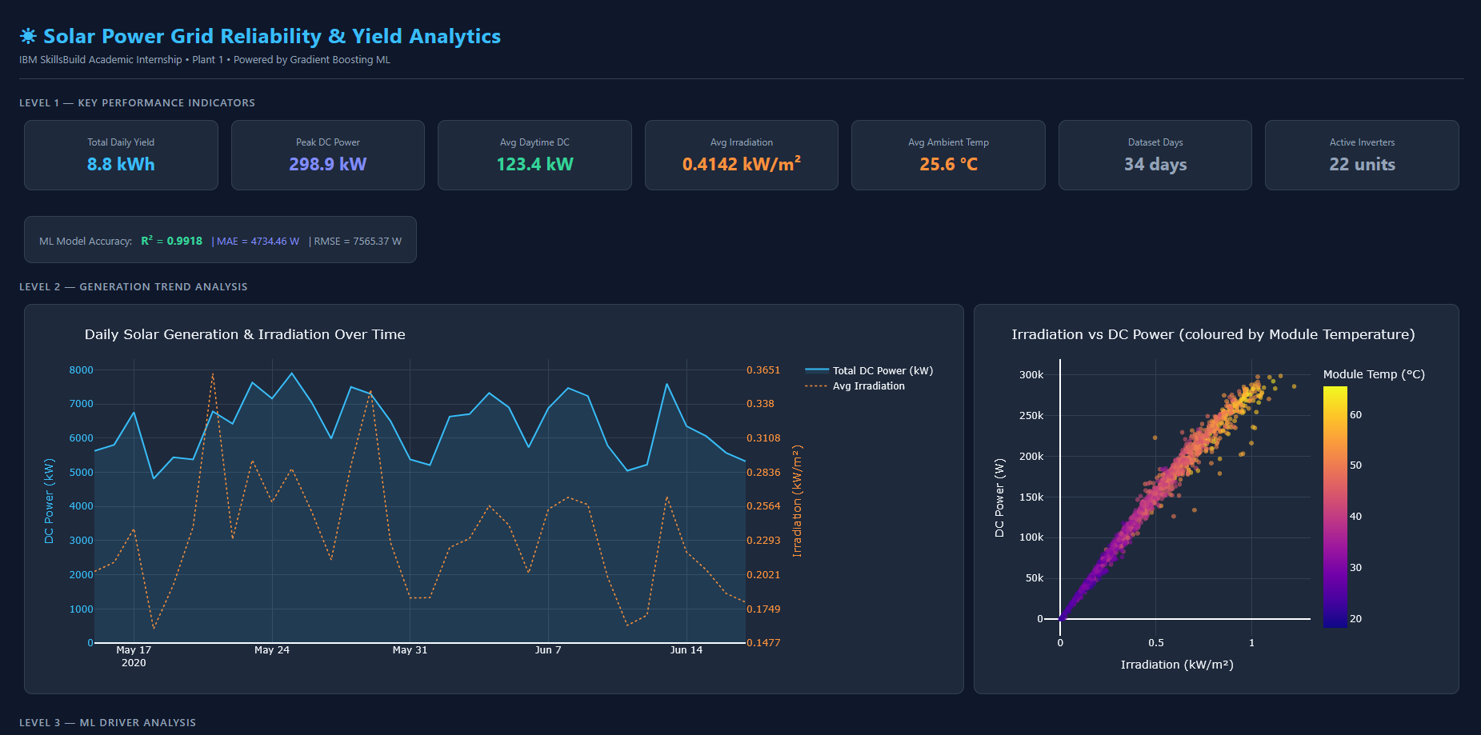

6.2 Level 3 ML Driver Analysis & Real-Time Forecast Tool
The left panel shows the feature importance bar chart — IRRADIATION dominates near score 1.0. The right panel is the Real-Time Yield Forecast Tool with four interactive sliders. With mid-range inputs, the model predicts 185.2 kW fleet DC output with a confidence band of 166.6 to 203.7 kW.
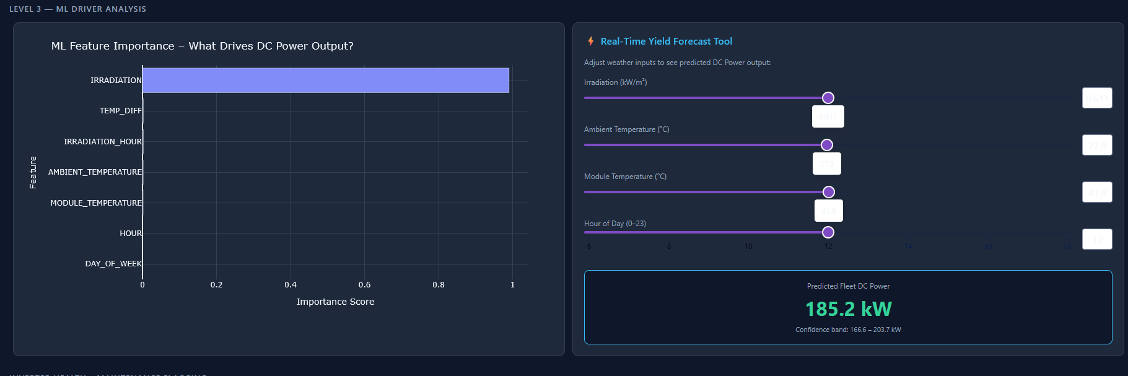

6.3 Inverter Health Maintenance Flagging & Strategic Insight Panel
The inverter health chart plots all 22 inverters' mean deviation. Two are flagged for review: bvBOhCH3iADSZry (approx. minus 630 W) and 1BY6WEcLGh8j5v7 (approx. minus 430 W). The Strategic Insight Panel surfaces Risk (output CV >85% on cloudy days), Opportunity (BESS deployment yields 12-18% uplift), and Action (2 units flagged, 3-7% yield recovery).
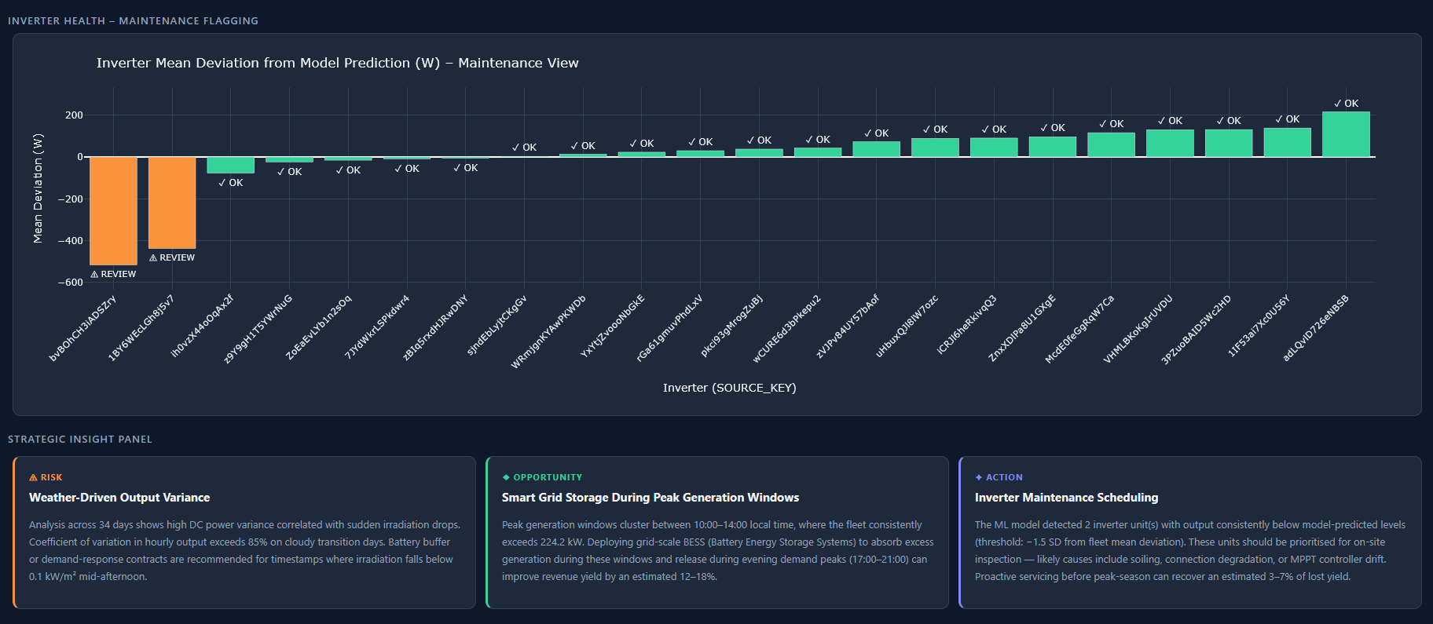

7. Docker Deployment
The application is containerised using python:3.11-slim. Key decisions: requirements.txt copied before source code so pip layer is cached on code-only rebuilds; PYTHONUNBUFFERED=1 streams logs live; Dash binds on 0.0.0.0 for Docker port mapping; HEALTHCHECK polls every 30 seconds. Build: docker build -t solar-analytics . | Run: docker run -p 8050:8050 solar-analytics | Open: http://localhost:8050

8. Key Findings & Conclusions
The Gradient Boosting model achieved R-squared = 0.9918, confirming that solar irradiation and temperature explain over 99% of DC power variance. Feature importance identifies irradiation as the primary driver. Two inverter units were detected as consistently underperforming. The strategic insight panel delivers three actionable management recommendations for storage deployment, maintenance scheduling, and demand-response contracting.

9. File Manifest
File | Lines | Purpose
dashboard.py | ~530 | Complete pipeline: data loading, ML training, Dash app, callbacks
requirements.txt | 20 | Pinned Python dependencies for reproducible installs
Dockerfile | 75 | Production container — python:3.11-slim, health-check, port 8050
Plant_1_Generation_Data.csv | — | Raw inverter generation data (input)
Plant_1_Weather_Sensor_Data.csv | — | Raw weather sensor data (input)
Table 3 — Project deliverable files
IBM SkillsBuild Academic Internship • Solar Power Grid Reliability & Yield Analytics • Plant 1

