MultipoolMiner relies on the 3rd party tool HWiNFO64 to gather power usage information
The following document describes the necessary integration steps:
1. Download and install HWiNFO64
https://www.hwinfo.com/download/
Both variants (Installer & Portble) will do, just ensure you are using the x64 version.
Accept the default installation directory (any other directory will be fine too).
2. Run HWiNFO64 and configure like this
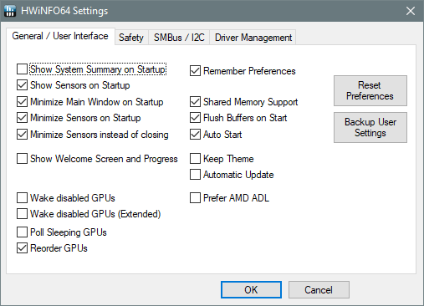

This will autostart HWiNFO64 on each boot and will keep it running in the task bar.
Important:
HWiNFO64 needs to be left running while MPM is running, otherwise the power usage readout will fail.
3. Configure the hardware sensors
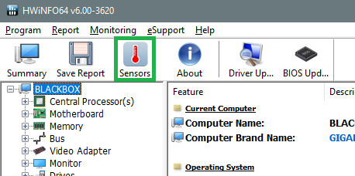

4. Identify the power usage relevant sensors
E.g. for a Nvidia GTX 1080ti
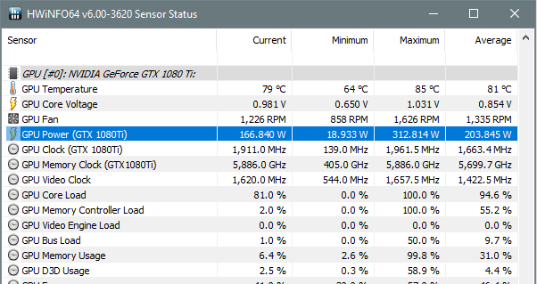

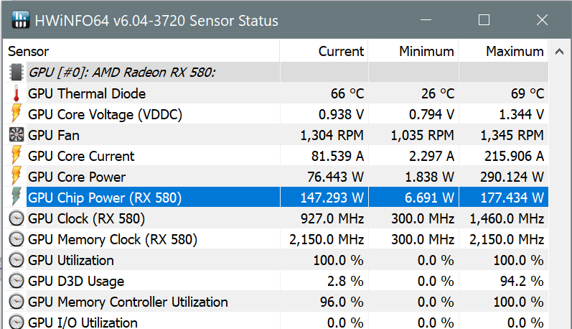
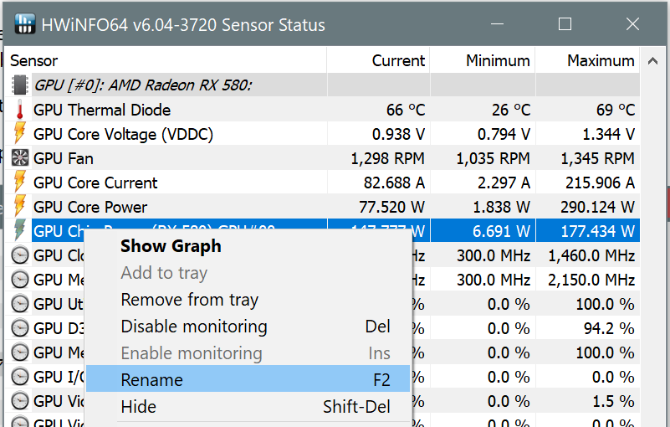
or for a AMD RX 580:

Important: for AMD make sure you select 'GPU Chip Power' and NOT 'GPU Core Power'!
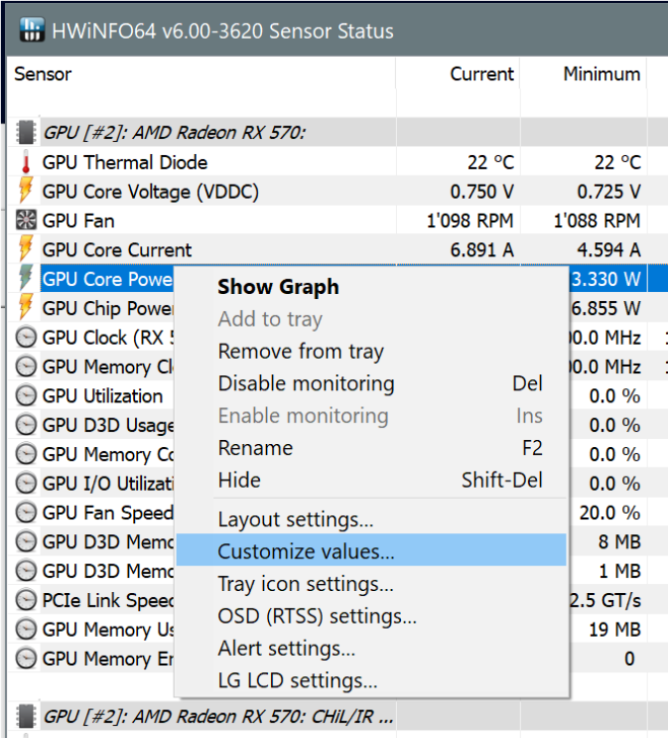
for your CPU:
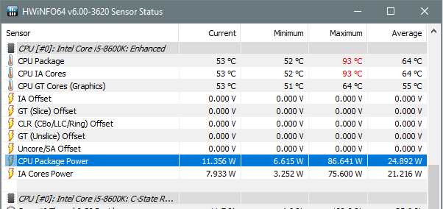

5. Rename the power sensor
Important: Steps 5 and 6 must to be done for each enabled mining device.
Select the sensor, then right-click and select 'Rename F2':
Then rename the sensor name to contain the devices name, e.g ‘ GPU#00’ (as found in the web GUI, separated by a space character):
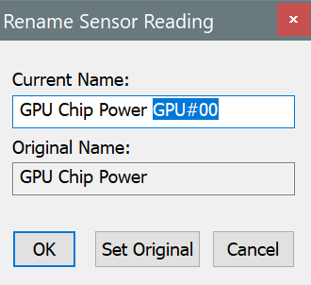

Note: You can also add other information, e.g. (RX580) to the sensor name. However it is essential that the sensor name contains GPU#nn / CPU#nn as shown above.
Important: Only ONE sensor name per device can contain the device name. This is the sensor MPM will use to get the power usage from.
6. Configure each relevant power usage sensor
Important: This step needs to be done for each enabled mining device
Select the sensor, then right-click and select 'Customize values...':

then select the tab 'HWiNFO Gadget':
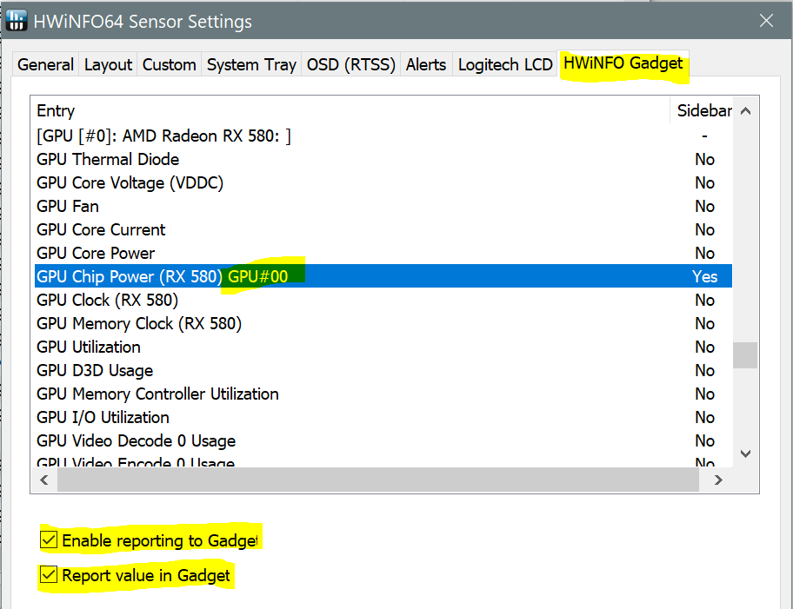

and tick both checkboxes:
- Enable reporting to Gadget
- Report value in Gadget
This will tell HWiNFO64 to constantly update the sensor values to the following registry key
Computer\HKEY_CURRENT_USER\Software\HWiNFO64\VSB
7. Configure the sensor polling interval
In the sonsors dialog click on

Then configure the polling period to something small like 997ms
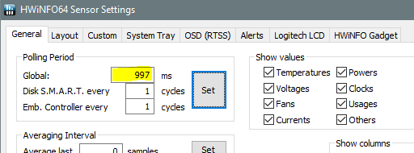

Important: The polling period shoud be less than 2 seconds to ensure thar MPM will have access to current data
8. Run Regedit.exe and verify that the sensor mapping information is available
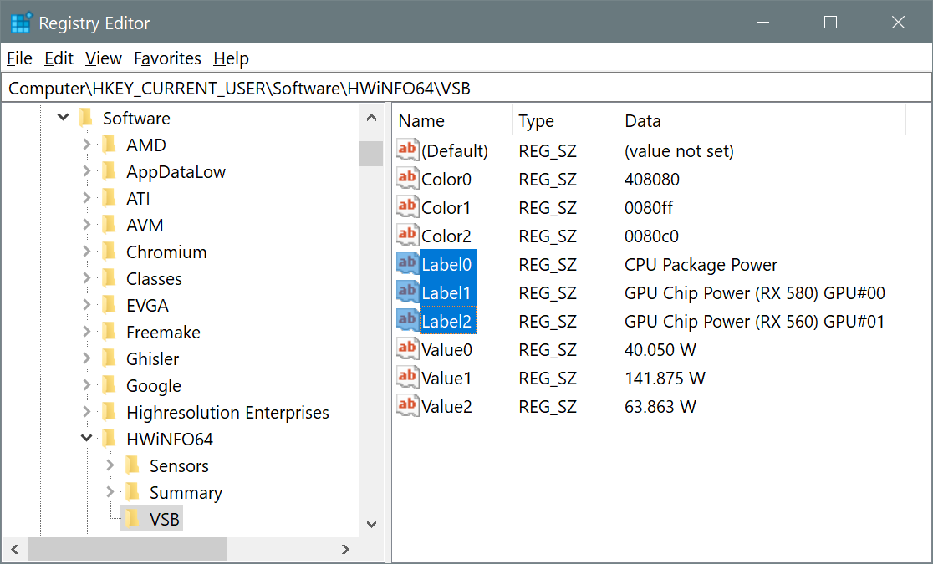
(press F5 repeatedly to verify that the values will get updated periodically)
9. Create scheduled task to restart HWiNFO64 after a driver crash (optional)
Under some circumstances HWiNFO64 needs to be restarted after a GPU driver crash.
The following scheduled task takes care of this.
1. Open the scheduled task editor: CMD -> Schtasks.exe
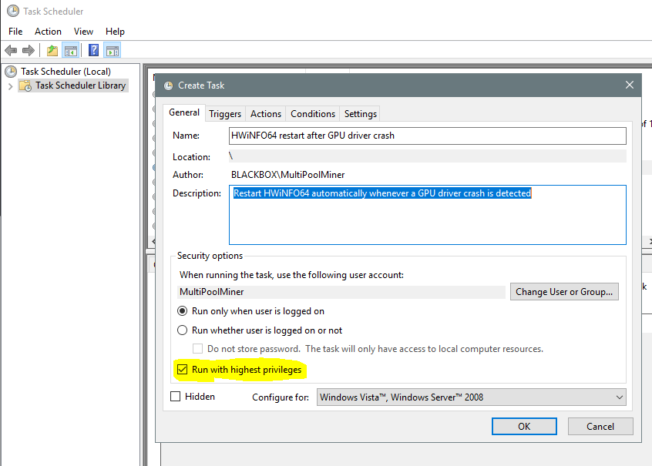
2. Create a new scheduled task as shown

Make sure you tick ‘Run with highest privileges’
