**User Interface Details**

**Login Window**

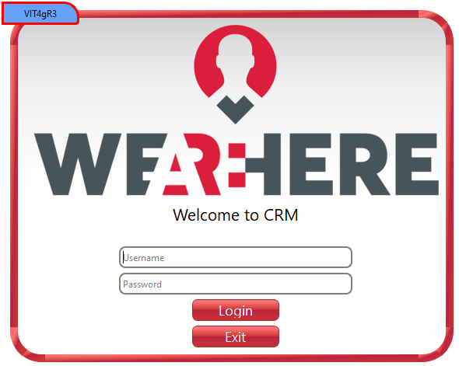

1. **Username and Password**
   * Access is granted to users whose username and password are saved by the main Gmail account user of Google Drive.
   * If the user's access permission is Admin, they are directed to the Choices - Admin menu; if the access permission is User, they are directed to the Choices menu.
   * A customized login page is created for the application.
   * There are two separate input elements for the username and password.
   * There is a login button that will react to these two pieces of information.
   * There is a warning message that will indicate whether the login was successful or not when the button is clicked.
   * Optionally, an exit button can be included to close the application window.

**Choices**

**A) Choices Admin**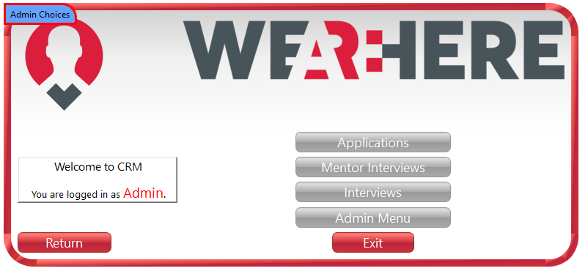

1. **Applications**
   * The Applications button directs the admin to the initial applications window.
2. **Mentor interviews**
   * The Mentor interviews button directs the admin to the mentor window.
3. **Interviews**
   * The Interviews button directs the admin to the interviews window.
4. **Admin Menu**
   * The Admin button directs the admin to the Admin window.

**B) Choices**

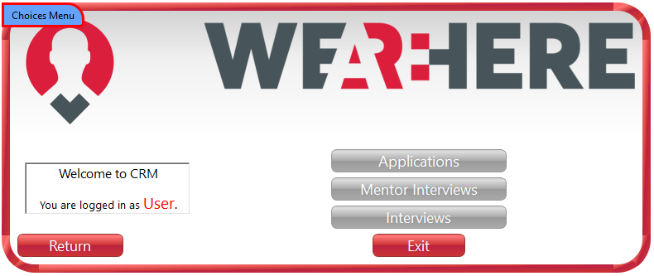

1. **Applications**
   * The Applications button directs the user to the initial applications window.
2. **Mentor Interviews**
   * The Mentor Interviews button directs the user to the mentor window.
3. **Interviews**
   * The Interviews button directs the user to the interviews window.

**Applications**

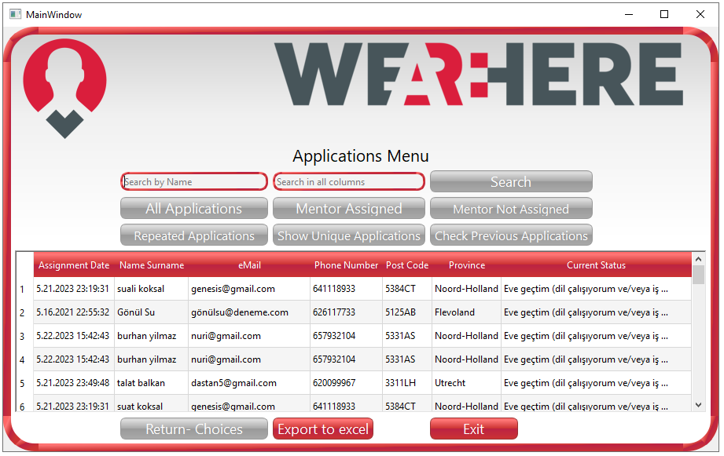

1. **Search**
   * Can search for names within the text entered in the text line (e.g., entering 'Me' will bring all names starting with 'Me' recorded in the drive).
2. **All Applications**
   * When the All Applications button is clicked, all applications recorded in the applications file on the drive are displayed on the screen.
3. **Assigned Mentor Interviews (Related Column in Applications File)**
   * When the Assigned Mentor Interviews button is clicked, individuals who have been assigned a mentor meeting after applying are displayed on the screen.
4. **Mentor Not AssignedInterviews**
   * When the Mentor Not AssignedInterviews button is clicked, individuals who have not yet been assigned a mentor after applying are displayed on the screen.
5. **Repeated Applications Button**
   * When the Repeated Applications Button is clicked, individuals who have registered with the same name and email address (only repeated candidates) in the applications file on the drive are displayed on the screen.
6. **Previous VIT Control Button**
   * When the Previous VIT button is clicked, all candidates who are common in the VIT1, VIT2, and Applications files or in any combination are displayed on the screen (to see if a candidate has applied to more than one VIT).
7. **Show Unique Applications**
   * When the Show Unique Applications is clicked, records in the applications file are filtered and displayed without duplicate records (if a name is registered more than once, this record is displayed only once).
8. **Return to Choices Screen**
   * When the Return to Choices Screen button is clicked, the user returns to the Choices screen.

**Mentor menu**

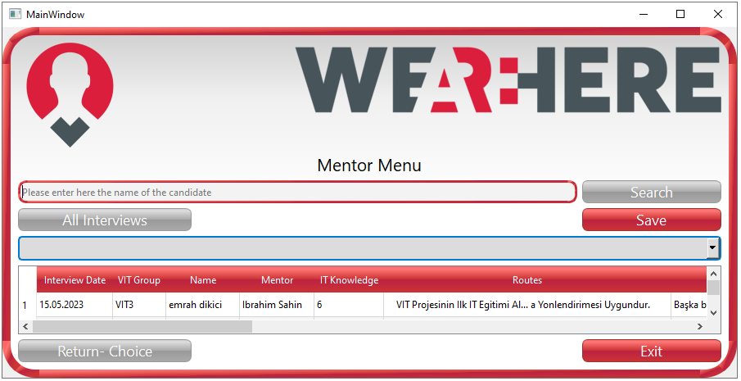

1. **Search**
   * Can search for names within the text entered in the text line.
2. **All Interviews**
   * When the All Interviews button is clicked, All Interviews recorded in the Mentor file are displayed on the screen.
3. **Return to Choices Screen**
   * When the Return to Choices Screen button is clicked, the user returns to the Choices screen.

**Interviews**

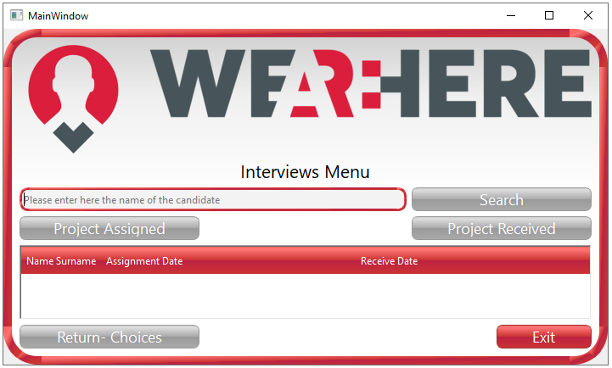

1. **Search**
   * Can search for names within the text entered in the text line.
2. **Project Assigned (Related Column in Interviews File)**
   * When this button is clicked, candidates whose projects have been sent and are recorded in the Interviews file are displayed on the screen.
3. **Project Received (Related Column in Interviews File)**
   * When this button is clicked, candidates whose projects have been received and are recorded in the Interviews file are displayed on the screen.
4. **Return to Choices Screen**
   * When the Return to Choices Screen button is clicked, the user returns to the Choices screen.

**Admin Menu**

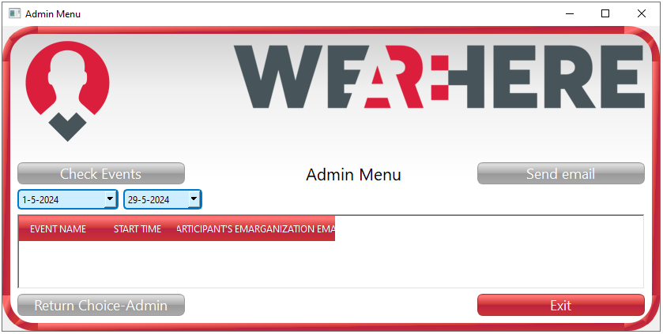

1. **Check Events Button**
   * This button displays the events recorded on Google Drive.
2. **Send eMail Button**
   * After fetching the events from the calendar, this button allows sending automatic emails to the email addresses registered for the events.
3. **Return Choice-Admin Screen Button**
   * When this button is clicked, the admin returns to the Choices-Admin screen.