### **Exercise 1: Control Structures**

### 

### **Scenario 1: Senior Citizen Interest Discount**

BEGIN

FOR loan_rec IN (SELECT * FROM Loans l JOIN Customers c ON l.CustomerID =c.CustomerID) LOOP

IF MONTHS_BETWEEN(SYSDATE, loan_rec.DOB)/12 > 60 THEN

UPDATE Loans

SET InterestRate = InterestRate - 1

WHERE LoanID = loan_rec.LoanID;

END IF;

END LOOP;

END;

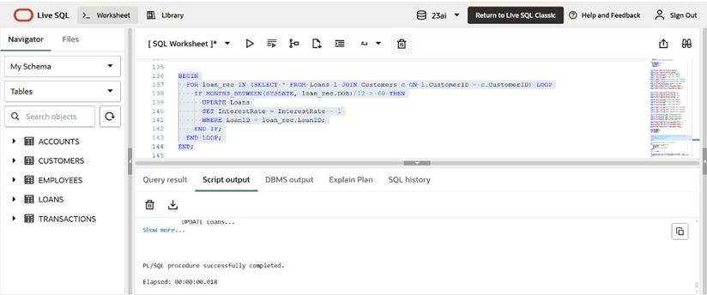

**Scenario 2: VIP Status Eligibility**

ALTER TABLE Customers ADD IsVIP CHAR(1); -- One-time schema update

BEGIN

FOR cust_rec IN (SELECT * FROM Customers) LOOP

IF cust_rec.Balance > 10000 THEN

UPDATE Customers

SET IsVIP = 'T'

WHERE CustomerID = cust_rec.CustomerID;

END IF;

END LOOP;

END;

select * from CUSTOMERS;

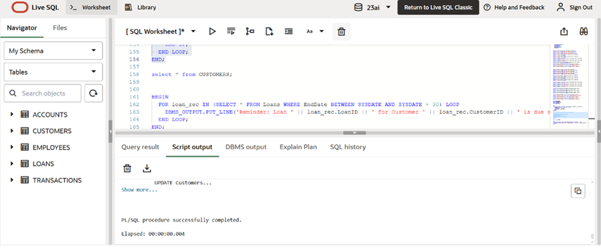

**Scenario 3: Loan Due Reminders**

BEGIN

FOR loan_rec IN (SELECT * FROM Loans WHERE EndDate BETWEEN SYSDATE AND SYSDATE + 30) LOOP

DBMS_OUTPUT.PUT_LINE('Reminder: Loan ' || loan_rec.LoanID || ' for Customer ' || loan_rec.CustomerID || ' is due soon.');

END LOOP;

END;

