## **Exercise 3 – Stored Procedures**

**Scenario 1: Apply Monthly Interest**

CREATE OR REPLACE PROCEDURE ProcessMonthlyInterest IS

BEGIN

DBMS_OUTPUT.PUT_LINE('Starting monthly interest processing...');

FOR rec IN (SELECT AccountID, Balance FROM Accounts WHERE AccountType 'Savings') LOOP

UPDATE Accounts

SET Balance = Balance + (rec.Balance * 0.01)

WHERE AccountID = rec.AccountID;

DBMS_OUTPUT.PUT_LINE('Interest applied to AccountID: ' ||rec.AccountID);

END LOOP;

DBMS_OUTPUT.PUT_LINE('Monthly interest processing completed.');

END;

BEGIN

ProcessMonthlyInterest;

END;

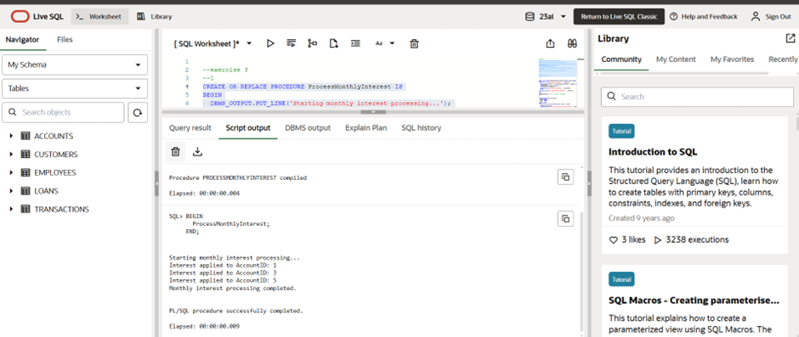

### **Scenario 2: Department-Wise Bonus Update**

CREATE OR REPLACE PROCEDURE UpdateEmployeeBonus(p_Department VARCHAR2, p_BonusPct NUMBER) IS

BEGIN

DBMS_OUTPUT.PUT_LINE('Applying bonus for department: ' || p_Department);

FOR emp IN (SELECT EmployeeID, Salary FROM Employees WHERE Department = p_Department) LOOP

UPDATE Employees

SET Salary = Salary + (Salary * p_BonusPct / 100)

WHERE EmployeeID = emp.EmployeeID;

DBMS_OUTPUT.PUT_LINE('Bonus applied to EmployeeID: ' || emp.EmployeeID);

END LOOP;

DBMS_OUTPUT.PUT_LINE('Bonus update completed for department: ' || p_Department);

END;

BEGIN

UpdateEmployeeBonus('IT', 10); -- 10% bonus for IT department

END;

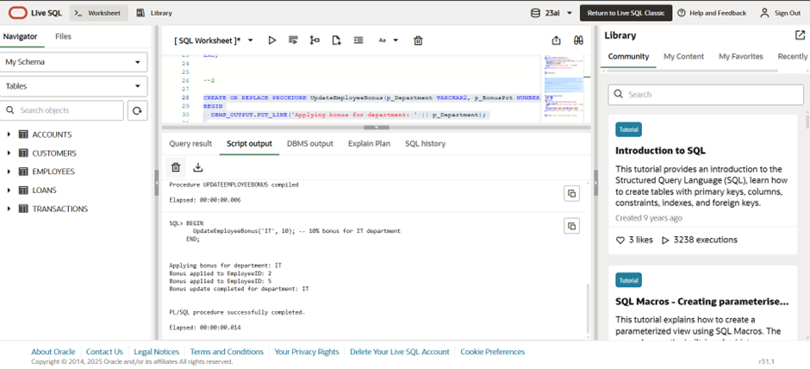

### **Scenario 3: Transfer Between Accounts**

CREATE OR REPLACE PROCEDURE TransferFunds(

p_FromAcct NUMBER,

p_ToAcct NUMBER,

p_Amount NUMBER

) IS

v_Balance NUMBER;

BEGIN

SELECT Balance INTO v_Balance FROM Accounts WHERE AccountID = p_FromAcct;

IF v_Balance < p_Amount THEN

DBMS_OUTPUT.PUT_LINE('Transfer failed: Insufficient balance in AccountID ' || p_FromAcct);

RETURN;

END IF;

UPDATE Accounts SET Balance = Balance - p_Amount WHERE AccountID p_FromAcct;

UPDATE Accounts SET Balance = Balance + p_Amount WHERE AccountID p_ToAcct;

DBMS_OUTPUT.PUT_LINE('Successfully transferred ' || p_Amount || ' from Account ' || p_FromAcct || ' to Account ' || p_ToAcct);

END;

BEGIN

TransferFunds(3, 4, 500); -- Transfer ₹500 from AccountID 3 to AccountID 4

END;

