## **Creating Account and Loan Microservices**

**Microservice 1: Account Service**

package com.cognizant.account.controller;

import org.springframework.web.bind.annotation.GetMapping;

import org.springframework.web.bind.annotation.PathVariable;

import org.springframework.web.bind.annotation.RestController;

import java.util.Map;

import java.util.HashMap;

@RestController

public class AccountController {

@GetMapping("/accounts/{number}")

public Map<String, Object> getAccount(@PathVariable String number) {

Map<String, Object> account = new HashMap<>();

account.put("number", number);

account.put("type", "savings");

account.put("balance", 234343);

return account;

}

}

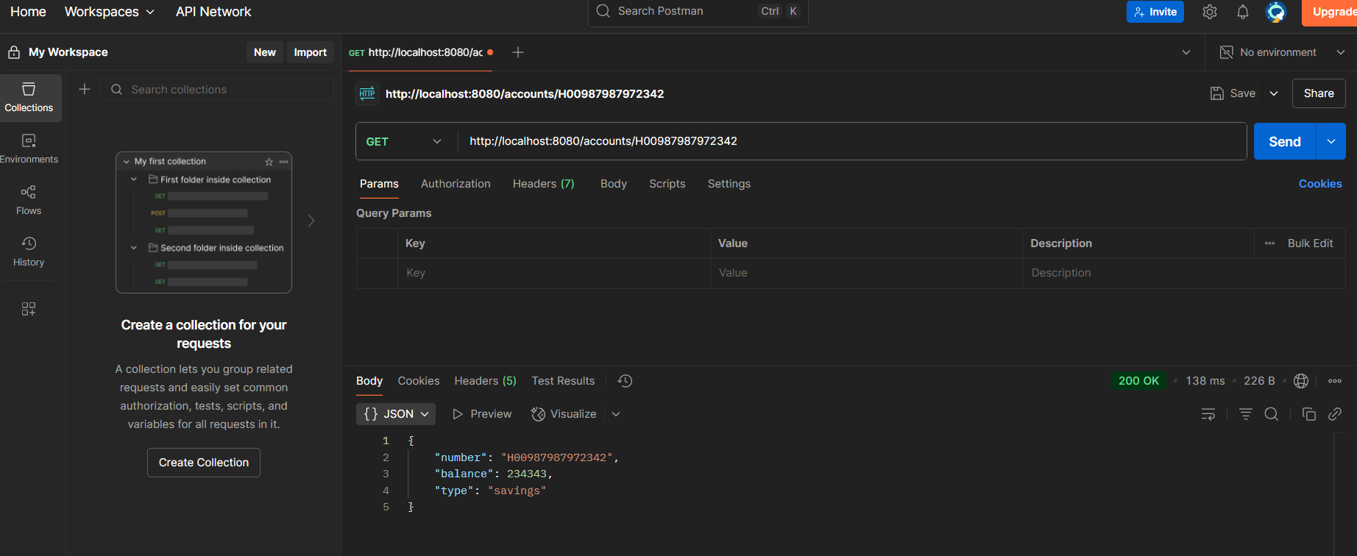

**Microservice 2: Loan Service**

### **Create Loan Controller**

package com.cognizant.loan.controller;

import org.springframework.web.bind.annotation.GetMapping;

import org.springframework.web.bind.annotation.PathVariable;

import org.springframework.web.bind.annotation.RestController;

import java.util.Map;

import java.util.HashMap;

@RestController

public class LoanController {

@GetMapping("/loans/{number}")

public Map<String, Object> getLoan(@PathVariable String number) {

Map<String, Object> loan = new HashMap<>();

loan.put("number", number);

loan.put("type", "car");

loan.put("loan", 400000);

loan.put("emi", 3258);

loan.put("tenure", 18);

return loan;

}

}

### 