Chapter III
Methodology Result and Discussion

This chapter presents the methods, and activities to conduct an evaluation of the solution presented, the dedicated website for the ACLC College Sorsogon as a primary online platform.
This study will utilize the qualitative research advantages of conducting philosophical research . It is to gather relevant data and information to achieve the anticipated outcome. That is to establish a website which will positively impact the institution in terms of online presence and credibility, as well as determine the effectiveness of the proposed solution to the given problem. Proponents will perform an evaluation to determine the effectiveness of the proposed solution; this is through gathering useful feedback from the admin (the person to administer the website), after deploying the website for a given period of time. The most critical feedback to gather is from those randomly chosen people to visit the website and give their users theirs. This phase should be conducted after establishing the website. Below are the brief summary of the requirements in building the website.

Software Design, Products, and/or Processes
In this study, proponents will build the website from scratch by utilizing opensource programs. After some research, the proponents decided to take advantage of the advantages the GNU Debian/Linux operating system may offer, particularly their latest stable release, the Debian 11 codenamed “Bullseye” see [17, 18, 19]. In the Linux realm, the combination of the Linux kernel [20], some tools e.g., tools from the GNU project [21], and a package manager is commonly known as a linux distribution, otherwise known as a “distro” [20]. The Debian distribution is known for its stability equipped with the reliability of the Linux kernel. Linux servers are well known for their reliability where users are able to perform most system administration tasks with zero downtime.
In setting-up the web-server, proponents will utilize Apache web-server on top of the fresh Debian 11 install. Apache is one of the most popular web-server applications. Apache is responsible for providing users with their requested resources or webpages over the internet. Since wordpress is written in PHP [23] and requires a database manager like MariaDB [27]. Proponents will utilize the LAMP stack [24] in order to fulfill the prerequisites for installing WordPress [25]. MariaDB is one of the most popular Relational Database Management (RDBMS) [26]. MariaDB is a fork of MYSQL; thus it is intended to maintain high compatibility with [28]. It is used to manage sensitive data, in an application or a system. Its compatibility with, as well as the fact that it is free and open-source software made it a popular choice, particularly for developers. After issuing several commands and queries creating a database for the WordPress installation, the WordPress is ready to install. Wordpress is one of the most popular easy-to-learn content management systems [15, 22]. Wordpress utilizes plugins to aid in carrying out several crucial tasks, e.g. Duplicator. Duplicator is used in performing migration and backup.
Take note that before performing the actual process of setting-up the web-server, it is important to first determine the computer system specifications, e.g. Processor, RAM, System-type, OS, to be running the web-server. After the successful installation and configuration of the web-server, the proponents can then begin establishing the website as well as publishing the basic necessary contents of the website. Afterwards, the proponents may perform the evaluation.
System Architecture
To allow a convenient access to the website for both the visitors and the admin, a domain name is a very important part of it, as the website is meant to be managed with ease. Wordpress will be utilized on top of the Apache web-server. Since the website will utilize WordPress, administering the website will be a lot easier and less complicated. Just to give an idea, the website admin can manage the website by logging-in to the WordPress admin dashboard through any web-browser on any device connected to the internet. Though the web-server doesn't require a Graphical User Interface (GUI), the proponents installed it on top of a Desktop OS (Operating System) Debian 11 KDE [19, 20, 29], particularly one of the proponent's for it is cost effective. In order to successfully run WordPress on top of the Apache web-server, the LAMP stack [24] and some configuration needs to be met. Finally, after meeting the requirements, WordPress is ready to be installed. For detailed process refer to [30]. This website will be hosted on a laptop with the following relevant system information:
- OS: Debian GNU/Linux 11 (bullseye) x86_64
- Host: Aspire A314-22 V1.08
- Kernel: 5.10.0-10-amd64
- Shell: bash 5.1.4
- CPU: AMD Ryzen 5 3500U with Radeon Vega Mobile Gfx (8) @ 2.100GHz
- GPU: AMD ATI 05:00.0 Picasso
- Memory: 3881MiB / 9959MiB
Once the initial setup is complete, the website is ready to have its webpages and content authored and published; then it is ready to be deployed finally, the proponents can proceed with the evaluation phase.
Conceptual Design
Below are the diagrams which illustrate the basic concept of the client-server relationship as well as how the concept of the DNS (Domain Name System) works [33]. Websites commonly conform to the client-server relationship as well as to the latest standards of web-technologies. The second illustration below illustrates the basic concept of how a domain name works.
Client-Server Relationship
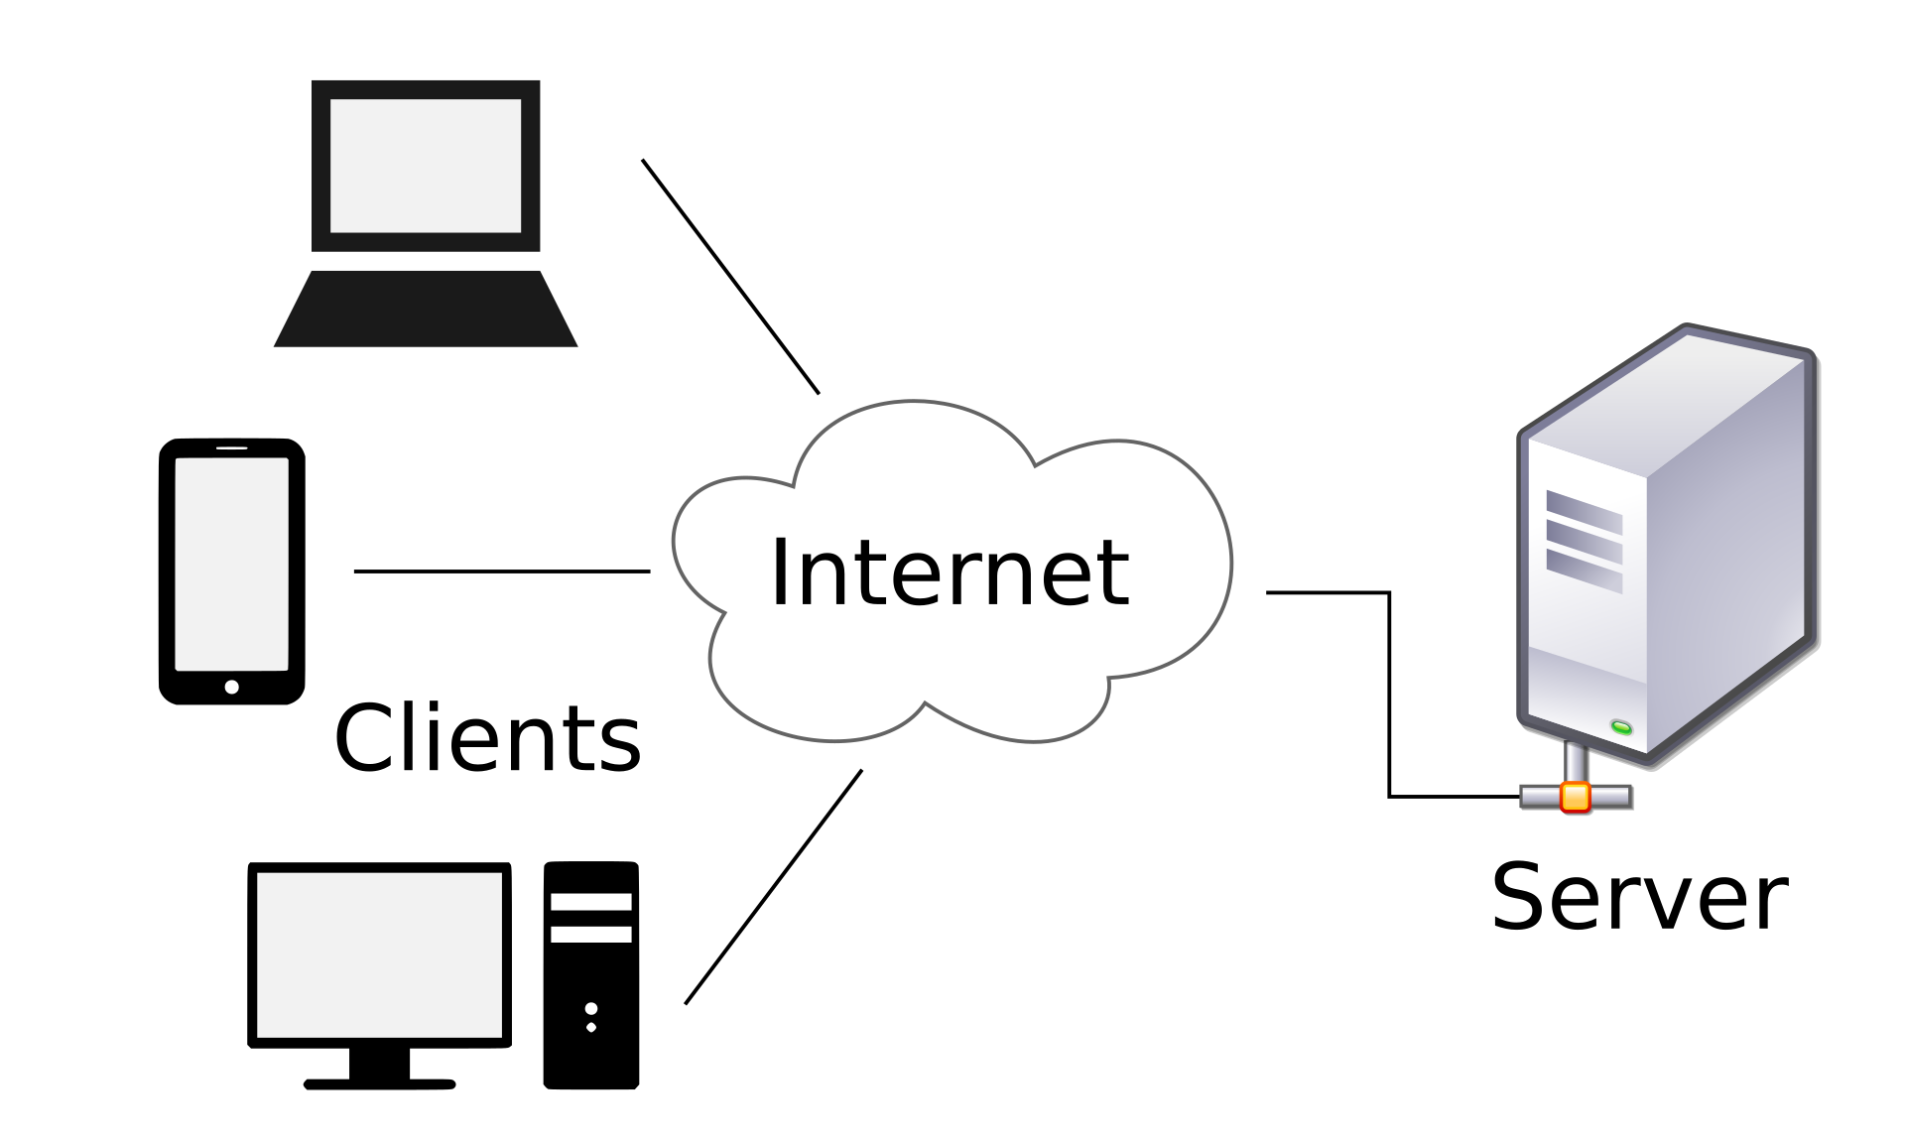

How DNS (Domain Name System) works [33]?
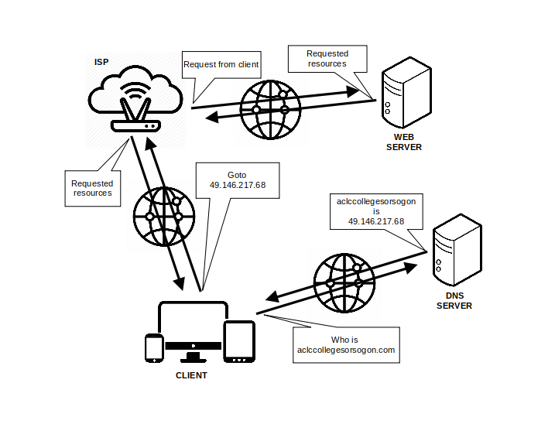
Cost Benefit Analysis
This study will benefit from open-source software, which will be utilized to host and build the website. Most of the software that will make up the website is free of charge. This makes this study cost-effective. These softwares include Apache, MariaDB, LAMP stack and Wordpress. However, since this study utilizes mostly free and open-source software, the proponents prefer self-hosting the web-server to maximize cost-effectiveness configuration process may cost time since they will have to dedicate a significant amount of additional research effort in configuring the server. Compared to prefering third-party web-hosting services where providers take care of the web-server configuration. Anyway, the benefit of using WordPress is that, migration could be convenient; this is by using a plug-in like Duplicator, the migration from self-hosted server to a third-party hosting service is made easy. For the website to be accessible to the user, the proponents acquired a registered domain name which makes it easy to visit the website rather than typing an IP (Internet Protocol) address. This may largely impact the way the accessibility of the site from a visitors perspective. The proponents will then need to evaluate the website after building it; in this process they may gather data from the users and determine if the website is effective as the proposed solution. Moreover, they may as well use some of that data collected to make use of it in improving the website based on visitors preferences.
Requirement Analysis
ACLC College Sorsogon is known for its reputation in providing IT (Information Technology) related courses. The proponents have observed that the institution primarily utilizes Facebook for disseminating information; this includes critical public advisories, school announcements, etc. Based on their observation, most of the educational institutions these days possess websites, then utilize it to spread information relevant to their institutions; their websites provide positive impact to these institutions. Aside from the efficiency of publishing content to the internet, by utilizing a proprietary website, it provides an institution with a professional approach to their online presence. It is the proponents objective to establish an effective primary online platform in the form of a website to improve the institutions credibility, especially in it's professional online aspects.

- A domain name is required before configuring the server as it is needed in the configuration process.
- As this website will be run on top of a self-hosted web-server, the proponents will apply their knowledge in IT on configuring the server and installing WordPress.
- Before conducting the evaluation phase, the website must be established online and basic fundamental contents should have been published.
- The evaluation should be as simple as possible, for it is only to validate the changes made after the testing phase and provide information to determine if a reiteration to this phase is needed, making sure that the website is well-established and functional.
- Data will be gathered from the website administrator (the website administrator is the institution personnel responsible for managing the website after the deployment).
- Data should also be extracted from the selected website visitors; these visitors will provide the proponents with the most important data for they represent the common website visitors.
- The findings of the data analysis phase should be presented as well as the conclusion of the study.

System Architecture/System Flow
The website to be built was deemed to serve as a primary platform for which visitors could view important information relevant to the institution. The homepage of this website will contain three main navigation elements such as announcements, posts, contact-us. The about-us hyperlink may not be necessary, for the proponents have thought of placing information commonly found in it to place directly on the homepage body. Each navigation element will be associated with a hyperlink that points to a relevant webpage and content. For the administrator there is a dedicated WordPress dashboard where he/she can login, create, modify, delete, and publish webpages. The diagrams below should represent the basic client-server relationship [32] as well as the system flow of the website for both the visitors and the admin.

Block Diagrams
Below is the basic concept of the website input-output which illustrates both the admin’s and the user/website visitor’s perspective. The first illustration presents the basic process of accessing the website from the end-user’s perspective. The last illustration provides a simple view of the underlying process of accessing the website on the administrator’s perpective.
Front-end System Flow Diagram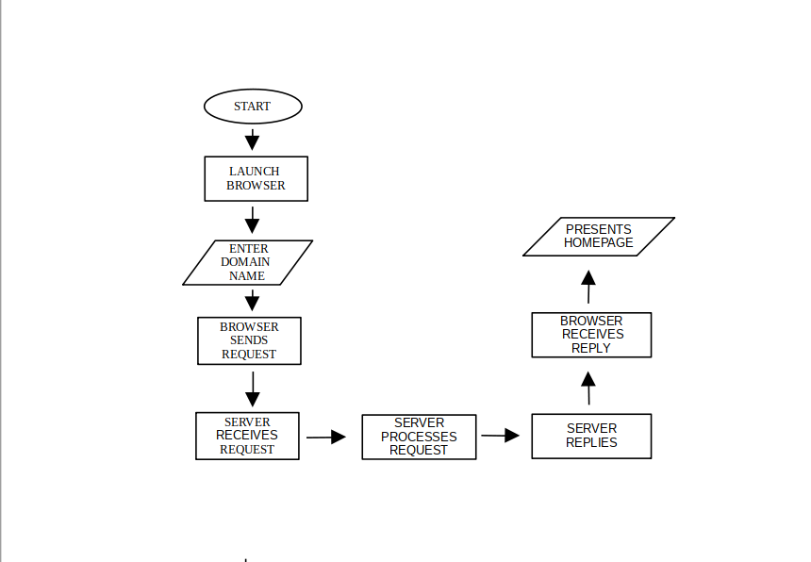
Back-end System Flow
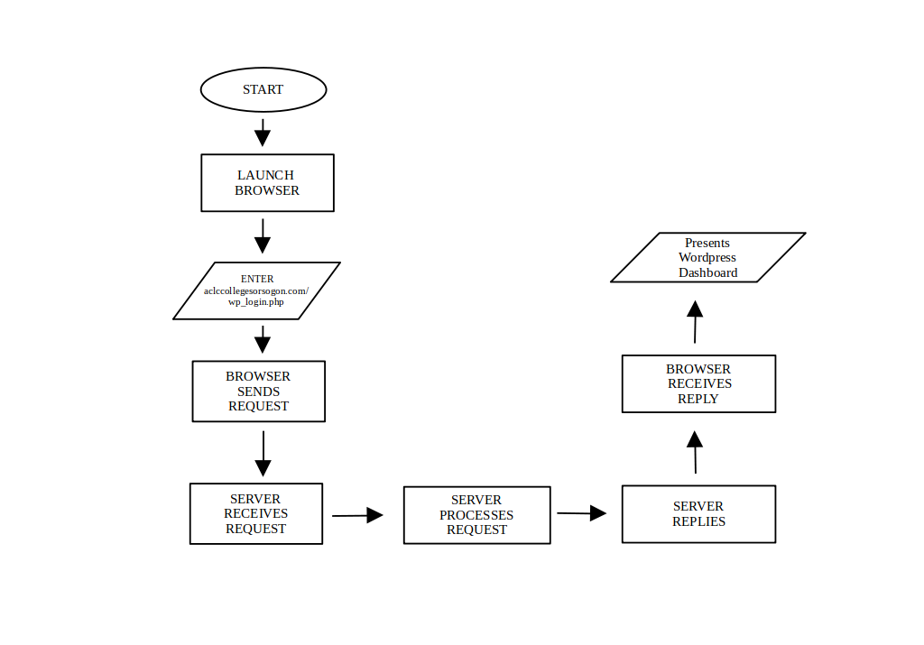
Development and Testing
In developing the website, the proponents will take an unconventional approach based on the waterfall model. The waterfall model is one of the earliest models of software development in which tasks are executed in a sequence manner where we start from the top with feasibility and flow down through various tasks with implementation into the live environment [37], [38]. A waterfall model is a breakdown of project activities into linear sequential phases [36] it originated in the manufacturing and construction industries [36].

Waterfall Model
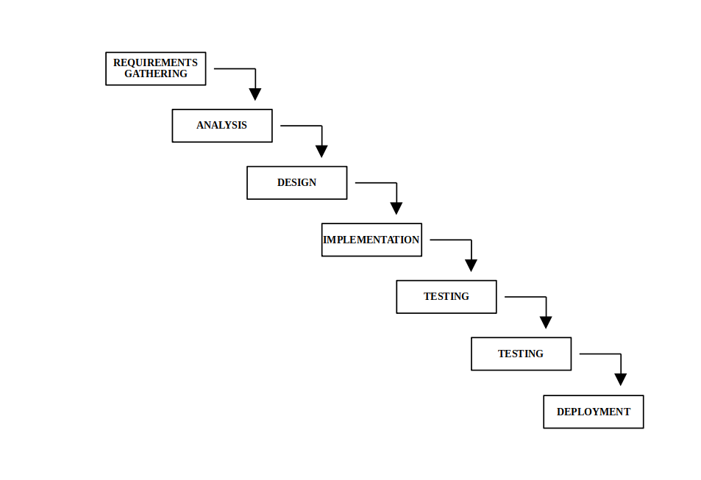

It will be built and structured with the help of a CMS. Its front-end structure will take the top-down approach and will be based on a sequential model. The first phase of building this website is requirements gathering and analysis. All possible requirements for the system to be developed were captured in this phase and documented [38].

The second phase will be the design phase. The requirement specifications from the first phase are studied in this phase and the system design is prepared. This system design helps in specifying hardware and system requirements and helps in defining the overall system architecture [38].

In the third phase, which is the implementation, the input from the design phase is implemented. The actual work will begin, building the website following the design made in the previous phase.The testing phase is where the website will be placed to user acceptance testing. After the testing the software will be deployed through the deployment phase. The last phase provide improvement as well as appropriate modifications.
Input and Output Reports and Analysis
Here’s a visual representation of the websites basic input/output process, which provide a brief introduction of how a website is displayed on the web-browser window. After landing on to the homepage the user may click the navigation element to simply request for the content of that hyperlink, e.g., clicking the category video on the navigation simply brings-up a webpage containing all the videos which are published in the site.

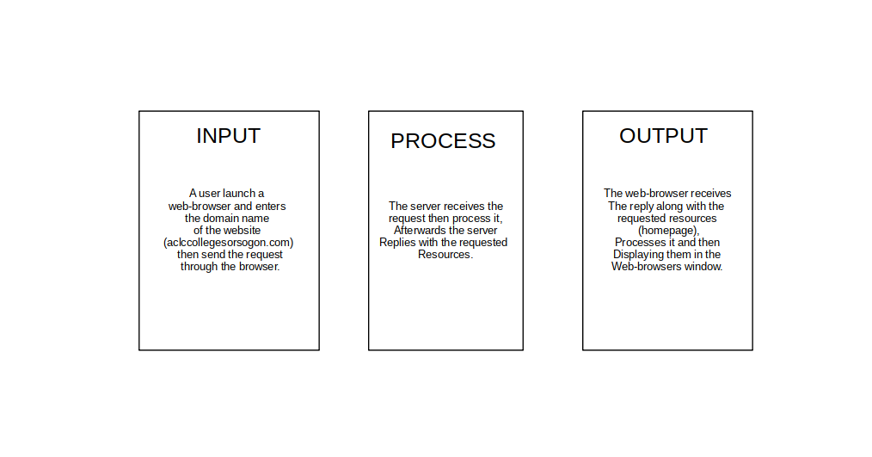

The same process can be observed in real world resource sharing using a URL (Universal Resource Locator) as well as a URI (Universal Resource Identifier) e.g., aclccollegesorsogon.com/post/. Otherwise, common visitors utilize those navigation elements available in the interface. Below is the input/output process for the admin dashboard since the website utilizes wordpress. One of the biggest benefits of utilizing WordPress as the CMS for this site is that the administrator can easily manage the website through its dashboard anytime, anywhere with the help of a web-browser connected to the internet, making the process less complicated.

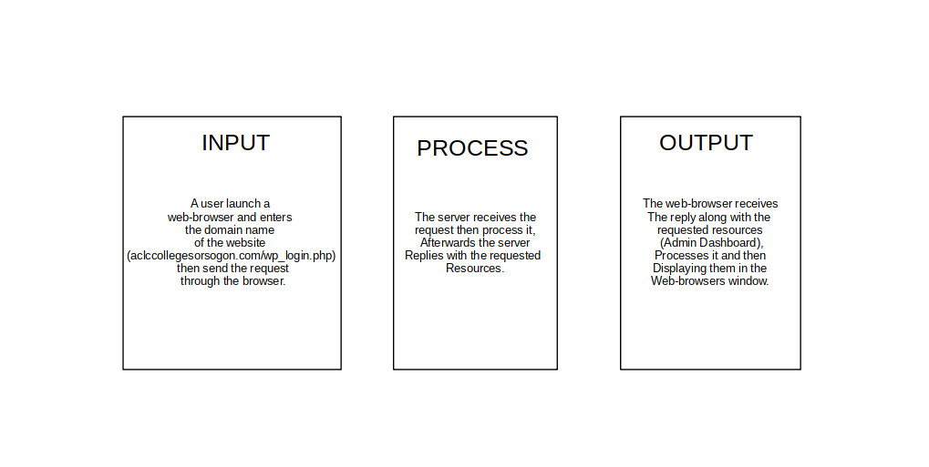

Description of the Prototype
This study is very much concerned with the front-end. This website will encompass a minimal and intuitive design as well as the structure. The homepage will contain the ACLC College logo along with its name for its header. Then the navigation will have the navigation elements, announcements which will contain critical press-releases, public advisories including the soft copies of these documents, etc... posts that contain those important non-critical information, contact-us will provide the quick view of contact information relevant to the institution that will be helpful in reaching the institution. Along with previously mentioned navigation elements, are videos and images categories. Clicking one of these, e.g., videos will present the webpage containing all the videos published on the website.

Implementation Plan
In implementing the website the requirements are strictly needed to be achieved. In setting-up and configuring the web-server, it would consume at least a day considering that a domain name is already acquired and available. In implementing the design and giving the website its structure, this task will be allotted with two to five days of executing the task. All in all, in putting the website online, the proponents will dedicate five days to a week since a CMS will be used, which will greatly impact the building of the website. The availability considering that most of the software is open-source, makes the implementation cost-effective. Structuring the website will be based on the top-down approach [39] as well as the sequential model [40] since this website will be mainly for disseminating information and information is time sensitive. Implementing this website is very critical for this study as it will also be subjected to an evaluation to determine the website’s effectiveness as proposed. However, if the study is a success, the solution may be adapted in to production. Though this document states that a personnel with little to no knowledge can manage the website, since the website is crucial component to the institution in providing accurate information, the institution itself can provide the administrator with a self-paced training which is highly available through online tutorials as well as the wordpress documentation which would largely aid in understanding and learning the WordPress.

