

ACLC College Sorsogon

The Development of
ACLC College Sorsogon Website

A Thesis Proposal Presented to ACLC Faculty

In Partial Fulfillment of the Requirements for the Degree
Bachelor of Science in Information Technology

Presented by
Mr. Anton Philip A. Jintalan
Mr. John Jeric Buenaobra
Mr. Edmar Lustan
DECEMBER 20, 2022
Chapter I
Project and it’s Background
Project Context
Over the years, ACLC (AMA Computer Learning Center) College Sorsogon has consistently provided high-quality education. The institution is well-known for nurturing, and developing aspiring world-class professionals, particularly in the field of IT (Information Technology). The institution specializes in delivering skill-based courses, empowering the students with the latest, most up-to-date quality skills and knowledge. The institution is very proud of itself, in spite of its small size. It is also worth mentioning that students at the institution mostly come from far away municipalities. Most of them choose to study at the institution, knowing that someday they can be one of the many successful professionals produced by the famous ACLC College of Sorsogon.
While technological advancement as well as innovation are unavoidable, so is the need to improve the institution as it keeps on evolving, along with the ever-changing world of technology. The school utilizes the power of technology to provide an excellent, quality education. From learning facilities to their processes to transactions, all use a touch of technology. This research was proposed for one simple but seemingly valuable reason. The ACLC College of Sorsogon utilizes their Facebook page as the primary online platform for showcasing as well as promoting the institution while also publishing important additional content.
The main idea behind this research is that, being a technology-driven institution well-known for its excellence in the field of IT, it is important as well as a matter of pride to have its own dedicated website. As aspiring IT professionals, the proponents themselves were taught that innovation as well as promoting efficiency through IT solutions are their responsibilities. The idea may seem too simple, yet from the researchers' perspective, this could make a significant change. Not to argue, it seems very simple, yet nobody gave it a try. "Everyone can do simple things to make a difference, and every little bit really does count [1].”
Therefore, the proponents deemed it an opportunity to contribute by means of this simple website. This website is proposed to be utilized for disseminating information in addition to showcasing the triumphs relevant to the institution. Rather than relying on other platforms, such as pretending that the institution can't develop its own website. Another thing is that after developing this website, there will be an open opportunity for future researchers to contribute by gradually enhancing it according to the ever-changing technology requirements. In the future, website maintenance may not be a problem. This aspect could be managed by the school's IT department while serving as an educational environment in the concept of real-world hands-on website maintenance. The students may engage in actual website maintenance, affording the benefit of free on-premise maintenance while still providing quality education to the students. This possibility is justified considering the institution uses web development as well as information security, etc. as part of its IT curriculum. Another reason is that an institution's dedicated website is very crucial, particularly to institutions like the ACLC College, which specializes in computer-related courses and is engaged in the world of technology.
Purpose and Description
In order for this study to be fruitful, it will be conducted through qualitative research. The purpose of this qualitative philosophical research is to corroborate theories with respect to the effectiveness of a website in providing accessible information while having a professional and formal approach to online presence. The need for a reliable, attractive, and effective web existence is increasing as the internet and technology have become a vital part of the education process . The ACLC College of Sorsogon relies on its Facebook page to make school-related information available to the public. Developing a website requires adhering to standards and discipline. As an IT-orriented institution, the school possesses the appropriate knowledge as well as the ability to develop its own website.
"Web sites - properly constructed - are information systems. They efficiently structure content to provide visitors with knowledge and insight. They deliver "the goods [2]." . Also, most people use the internet to research about any institute. “So, having a website makes a strong impact on the image of your institute by increasing its visibility. It also helps to gain instant digital identity and global presence [3].”. As far as the concern of this study, the website being proposed should provide the credible online presence that the institution should have. "Web sites may also serve as "interfaces" providing bridges and translations to connect users to other wordly experiences. Given the sometimes poorly organized resources available on the Web, a good school Website helps people find educationally worthwhile information with a minimum of wasted time and wandering [2].” The importance of having an online presence may seem very crucial. Specifically, websites are primarily for disseminating information.

Objective of the Study
The aim of this study is to establish a dedicated website that will serve as the main professional platform for the institution in publishing information as well as school-related content. Thus determine the effectiveness of the website based on the proponents criterion. This study is supposed to achieve the following goals.
- Set up and configure a self-hosted web-server to host the dynamic website.
- To be able to Utilize WordPress [16, 22] in building the website to provide a user-friendly CMS (Content Management System ) [15].
- Establish a functional website online.
- Deploy the website and acquire useful user feedback from the personnel who will manage it after one week of being deployed for the evaluation of the website.

Significance of the Study
This study proposes to contribute to the progress of the institution, thus addressing the need for a website, as it is supposed to disseminate information in addition to showcasing important information regarding the institution. This includes announcements, blog posts, etc. The study should benefit all the bodies involved. The proponents will provide fundamental knowledge, including the concept hereafter, to the next researcher who aims to further improve the website. While in the process of developing the website, proponents shall acquire crucial soft technical skills imperative to an IT professional's responsibilities. To achieve the anticipated outcomes of this study, proponents need to collaborate. Proponents will further develop their collaboration as well as software development skills as the study goes on. Future researchers will have the opportunity to contribute to the cause of this study, since this study should be open to all willing to contribute or induce improvements.

Scope and Delimitation
The main focus of this project is the design of the institution's website. As for the concern, the design should offer the imperative online presence of the institution, all the while adhering to the standards. As the study proceeds, the proponents will be highly committed to the development of this project, getting their hands wet in utilizing the web technologies necessary. The proposed website is limited to only the development. With regard to this project, the scope of the study is merely limited to the development of the website. The project will be used as the institution's main online platform for publishing content, providing the institution with its own professional identity by means of its own platform.
Chapter II
Related Literature

This chapter contains related literature and studies relevant to the study being proposed. The resources were deemed of high value to the current study being proposed.

Related Literature
In Hugo Delgado's article, “Advantages and Benefits of Having a Website on the Internet [4],” he mentioned the internet's advantage in providing consumers' information with 24/7 availability, capable of being accessed from any location. He also referred to the utilization of the internet in terms of promoting it as a necessity and not a luxury, particularly in today's world where the internet is commonly utilized for accessing and providing information. One good reason for implementing a website, according to a section of his article titled “What are the main reasons for a company to implement a website? [4]” is to “expand your market from a local level to a national or even international level [4].” Organizations should take advantage of this efficiency, as the internet offers a very convenient way of providing and accessing information. Organizations should take advantage of this efficiency. Another crucial aspect of a website discussed in the article was its user-friendliness. Having an intuitive, easy-to-navigate website where visitors are able to achieve their intent with minimal effort is a must for a website to be successful.

According to Aprillia Adella Suyanto Author of “Increasing the Brand Awareness of Ambassador School Surabaya through A Website [5]” he argues the effectiveness of a website in promoting brand awareness. “People find it difficult to look for some information since the Ambassador School itself does not have a certain platform to help them in introducing their service and showing what makes them different from other schools. In this case, Ambassador School Surabaya only relies on using social media, which are Instagram and Facebook, to promote their service. Even so, all of these platforms are not effective in increasing the brand awareness of this school because it do not contain any information or proofs that highlight its uniqueness [5]”. Based on his observation, he decided to utilize a website to showcase the institution, thus making emphasis on certain aspects. Similar to the aim of this study, he also believes that a website will provide the institution with a credible and professional appearance to the public.

Yofrina Octika Gultom and Henni Gusfa of Universitas Mercu Buana Jakarta and authors of “Online Communication Strategy in Promoting Personal Development Program of Non-governmental Organization through Website [6]“ Believed that people nowadays uses the internet to quickly gain access to important information. They also believe that the internet has become the mainstream tool for scholarly research, mainly because it offers the convenience and accessibility of information. “The internet is becoming a mainstream tool for scholarly research, chiefly because of its ability to access data quickly and conveniently [6]“. This information is frequently in the form of web content or simply embedded in a webpage. In the article the NGO’s (Non-Governmental Organizations) has leveraged the advantages of internet and website technology mainly “to build awareness, to facilitate training programs, to reduce cost, to raise funds, to manage information to disseminate information, to communicate with personnel, and to avoid travel costs [6]”.
In his article entitled “The 6 Fundamentals of Digital Marketing 2016 [7]” Dan Morley emphasized the criticality of a website in the online world. He also discussed how a website should be a priority it terms of online presence. He said “Having a quality website is critical to success in the online world. After all, your website should be at the center of your online presence [7].” He then discussed the importance of a well-planned website; thus it should serve its original purpose; see [7]. According to Shaher R. Elayyan, “Nowadays, websites are considered as one of the important sources of information for a wide spectrum of audience. There are various types of websites including sites for government organizations, business, sports, and education. Educational websites are designed by universities, schools and research centers to introduce experiences to relevant audiences all over their academic levels [8]”.

Related Studies
In today’s society, using a website is something one does daily. There is an incredibly large amount of websites out there, and every website has a purpose. Previous research states that to fulfill that purpose it is important to consider the user experience of a website. The ex-perience of using a website can be both good and bad and may determine if one will visit and use that website again. It can also give the user an opinion and impression of the company behind the website as a whole. Therefore, it seems important to consider the user experience of a website. User experience (UX) and the importance of considering and evaluating it in connection to websites is well documented in literature [9].

Website design elements such as navigation options, typeface size, typographic layout, element organization, color schemes, pictures, and graphics (images and icons) may promote either rejection or
acceptance, which in turn can be key to attract and retain visitors, and make a sale (Moys, 2014; Ou & Sia, 2010; Cyr, Head & Larios, 2010; Chen & Barnes, 2007). A disorganized layout with ill-placed elements and a multitude of colored text objects can be unappealing and confusing, leading to a negative response (Sonderegger, Sauer & Eichenberger, 2014). Conversely, an organized layout with easy-to-read text and appealing images may elicit a welcoming appeal and positive response. With a multitude of sites vying for a piece of the market share, so it is crucialo businesses toesign a web page that effectively grabs, retains, and sells to a visitor [10].

According to Selina Goodman’s study entitled "Supporting information sharing in families at risk of bowel cancer through a secure website [11]". She concluded, based on data she collected, that patients need more support from health professionals to adjust to and then disseminate information about their diagnosis. In her study, she aimed to investigate whether a secure website could support families with an increased risk of bowel cancer to share information with their relatives. The survey data reflected how difficult genetic information was to assimilate initially. Most participants indicated that a follow-up appointment would be ‘helpful’ and three out of four participants would have wanted more information at the time of their diagnosis. The survey data were consistent with the results of an earlier survey (Lapointe et al... 2013) with 246 men and women who had received genetic test results relating to gene variants. Lapointe found that over half (52%) were “highly 231 interested” in having access to an educational website to help support them communicate information about the genetic diagnosis to other family members. Goodman's study implies the huge help of IT (Information Technology), particularly a website, in securely disseminating crucial information. This information may be helpful to those diagnosed with the disease and those who are relatives and may be concerned about their health [11].
A university education is considered to be one of the most important steps that a student takesin his or her life. It determines the future and possibly affects the whole life. Nowadays, the World Wide Web connects students from all over the world by allowing them to access information for any university sitting at home, making it easier for them to make choices. Choosing a university for your studies is the most important part of applying for a degree. If the information on the website is incorrect or outdated, it can cost the university its reputation and limit students to explore their options. It is important to realize that students think of the website experience as a step towards their future. They need direction, and if they are sitting many miles away they will not be coming to visit the facility before admission, so it is the university’s responsibility to provide them with adequate information and a chance to experience the university before getting there. Since the amount of universities providing quality education is no longer limited, it is essential that Uppsala University’s IT department provide prospective students with all the information that will convince them to head in their direction [12].

CMS (Content Management System) [15] are utilized to author webpages; it makes the process less complex and mostly doesn't require an institution or organization to hire professional web developers to build and manage the website from scratch. In the modern information world, there is now sea changing information generation, distribution, and digitalize access. Today we are living information age. Information on the web is growing tremendously, and searching on the internet today can be compared to dragging a net across the surface of the ocean the internet is explosion created a new set of problems for site administrators. Producing and managing content was becoming increasingly difficult. A system was needed to manage, create and distribute various forms of content have the content management system was created. Most CMS’s are built on the LAMP (Linux Apache MySQL PHP) stack are cost and free opensource software [13]. By means of a CMS, nearly anyone with little or no knowledge regarding web developement can manage, even publish, a web page. Muthuraj and Rajkumar defined Content Management System (CMS) as a computer application that enables users to manage content in an orderly fashion. Content can include a variety of file types such as text, images, and media, which a CMS helps to create, edit, store and publish. The benefit of using a CMS, especially for website creation and it does not require an extensive knowledge of coding. Content Management Systems (CMS) aids in creating Blogs, Wikis, and RSS etc [13].

Synthesis
The following review of related literature and studies emphasizes the key aspects of the current study, thus providing sufficient evidence to support the study's promising success. The resources presented in this paper were cautiously selected since the proponents considered them valuable in providing insight into the important aspects and the study’s main idea. One of the critical aspects of a website which may determine its success is the UX (User Experience) it offers, especially for the users' first impression. You will never get a second chance to make a first impression [14]. Either developing or building, a website requires at least a good structure, given that every website is expected to thrive. A proper design perspective may depict the success, or otherwise, the failure, of the website. Besides, most of the website's users may prefer an intuitive, user-friendly UI (User Interface).

The fundamental purpose of utilizing a website is the convenient dissemination of information, and the increased geographic scope of audiences. Utilizing a website definitely presents a huge benefit compared to the traditional means of spreading information, such as fliers, banners, billboards, etc. particularly when it comes to cost-effectiveness. In Meher Jamil’s study entitled “Redesign of Website for the Master Students at the IT-department of Uppsala University”, he argued that the importance of up-to-date, precise information is very critical, and thus it may cost the institution its reputation. The proponents will build the website alongside a CMS of their choice. Most likely, WordPress [22] will be utilized, because of its numerous advantages, particularly because it is open source and easy to set up, and because most complex tasks can be aided by the plugins available in its utility. On the other hand, proponents considered the user, who will use, and otherwise manage the website, as well as keep its content up-to-date. The main reason for using a CMS is its easy-to-learn nature, which means even a non-professional webmaster, with little to no experience, may be able to manage the website compared to the complicated process of web development and other relevant tasks.

The resources listed above should give the proponents a good idea of where this study is headed. Each of the resources explains every critical aspect of this study, which needs great understanding in order for this study to succeed. With all the vital components of the project discussed, the proponents should already have a clear perspective on the study and proceed guided by these resources.

Technical Background
The proponents are proposing a self-hosted website which will act as the primary platform for providing accessible information relevant to the institution. In addition, the website will contribute to building the institutions' credibility, especially in their excellence in providing IT-related education. This study is supported by the literature and related studies presented above, which cover all it’s aspects. The proposed study is a result of the eagerness of the proponents to contribute to the values and quality of the institution.
Chapter III
Methodology Result and Discussion

This chapter presents the methods, and activities to conduct an evaluation of the solution presented, the dedicated website for the ACLC College Sorsogon as a primary online platform.
This study will utilize the qualitative research advantages of conducting philosophical research . It is to gather relevant data and information to achieve the anticipated outcome. That is to establish a website which will positively impact the institution in terms of online presence and credibility, as well as determine the effectiveness of the proposed solution to the given problem. Proponents will perform an evaluation to determine the effectiveness of the proposed solution; this is through gathering useful feedback from the admin (the person to administer the website), after deploying the website for a given period of time. The most critical feedback to gather is from those randomly chosen people to visit the website and give their users theirs. This phase should be conducted after establishing the website. Below are the brief summary of the requirements in building the website.

Software Design, Products, and/or Processes
In this study, proponents will build the website from scratch by utilizing opensource programs. After some research, the proponents decided to take advantage of the advantages the GNU Debian/Linux operating system may offer, particularly their latest stable release, the Debian 11 codenamed “Bullseye” see [17, 18, 19]. In the Linux realm, the combination of the Linux kernel [20], some tools e.g., tools from the GNU project [21], and a package manager is commonly known as a linux distribution, otherwise known as a “distro” [20]. The Debian distribution is known for its stability equipped with the reliability of the Linux kernel. Linux servers are well known for their reliability where users are able to perform most system administration tasks with zero downtime.
In setting-up the web-server, proponents will utilize Apache web-server on top of the fresh Debian 11 install. Apache is one of the most popular web-server applications. Apache is responsible for providing users with their requested resources or webpages over the internet. Since wordpress is written in PHP [23] and requires a database manager like MariaDB [27]. Proponents will utilize the LAMP stack [24] in order to fulfill the prerequisites for installing WordPress [25]. MariaDB is one of the most popular Relational Database Management (RDBMS) [26]. MariaDB is a fork of MYSQL; thus it is intended to maintain high compatibility with [28]. It is used to manage sensitive data, in an application or a system. Its compatibility with, as well as the fact that it is free and open-source software made it a popular choice, particularly for developers. After issuing several commands and queries creating a database for the WordPress installation, the WordPress is ready to install. Wordpress is one of the most popular easy-to-learn content management systems [15, 22]. Wordpress utilizes plugins to aid in carrying out several crucial tasks, e.g. Duplicator. Duplicator is used in performing migration and backup.
Take note that before performing the actual process of setting-up the web-server, it is important to first determine the computer system specifications, e.g. Processor, RAM, System-type, OS, to be running the web-server. After the successful installation and configuration of the web-server, the proponents can then begin establishing the website as well as publishing the basic necessary contents of the website. Afterwards, the proponents may perform the evaluation.
System Architecture
To allow a convenient access to the website for both the visitors and the admin, a domain name is a very important part of it, as the website is meant to be managed with ease. Wordpress will be utilized on top of the Apache web-server. Since the website will utilize WordPress, administering the website will be a lot easier and less complicated. Just to give an idea, the website admin can manage the website by logging-in to the WordPress admin dashboard through any web-browser on any device connected to the internet. Though the web-server doesn't require a Graphical User Interface (GUI), the proponents installed it on top of a Desktop OS (Operating System) Debian 11 KDE [19, 20, 29], particularly one of the proponent's for it is cost effective. In order to successfully run WordPress on top of the Apache web-server, the LAMP stack [24] and some configuration needs to be met. Finally, after meeting the requirements, WordPress is ready to be installed. For detailed process refer to [30]. This website will be hosted on a laptop with the following relevant system information:
OS: Debian GNU/Linux 11 (bullseye) x86_64
Host: Aspire A314-22 V1.08
Kernel: 5.10.0-10-amd64
Shell: bash 5.1.4
CPU: AMD Ryzen 5 3500U with Radeon Vega Mobile Gfx (8) @ 2.100GHz
GPU: AMD ATI 05:00.0 Picasso
Memory: 3881MiB / 9959MiB
Once the initial setup is complete, the website is ready to have its webpages and content authored and published; then it is ready to be deployed finally, the proponents can proceed with the evaluation phase.
Conceptual Design
Below are the diagrams which illustrate the basic concept of the client-server relationship as well as how the concept of the DNS (Domain Name System) works [33]. Websites commonly conform to the client-server relationship as well as to the latest standards of web-technologies. The second illustration below illustrates the basic concept of how a domain name works.
Client-Server Relationship
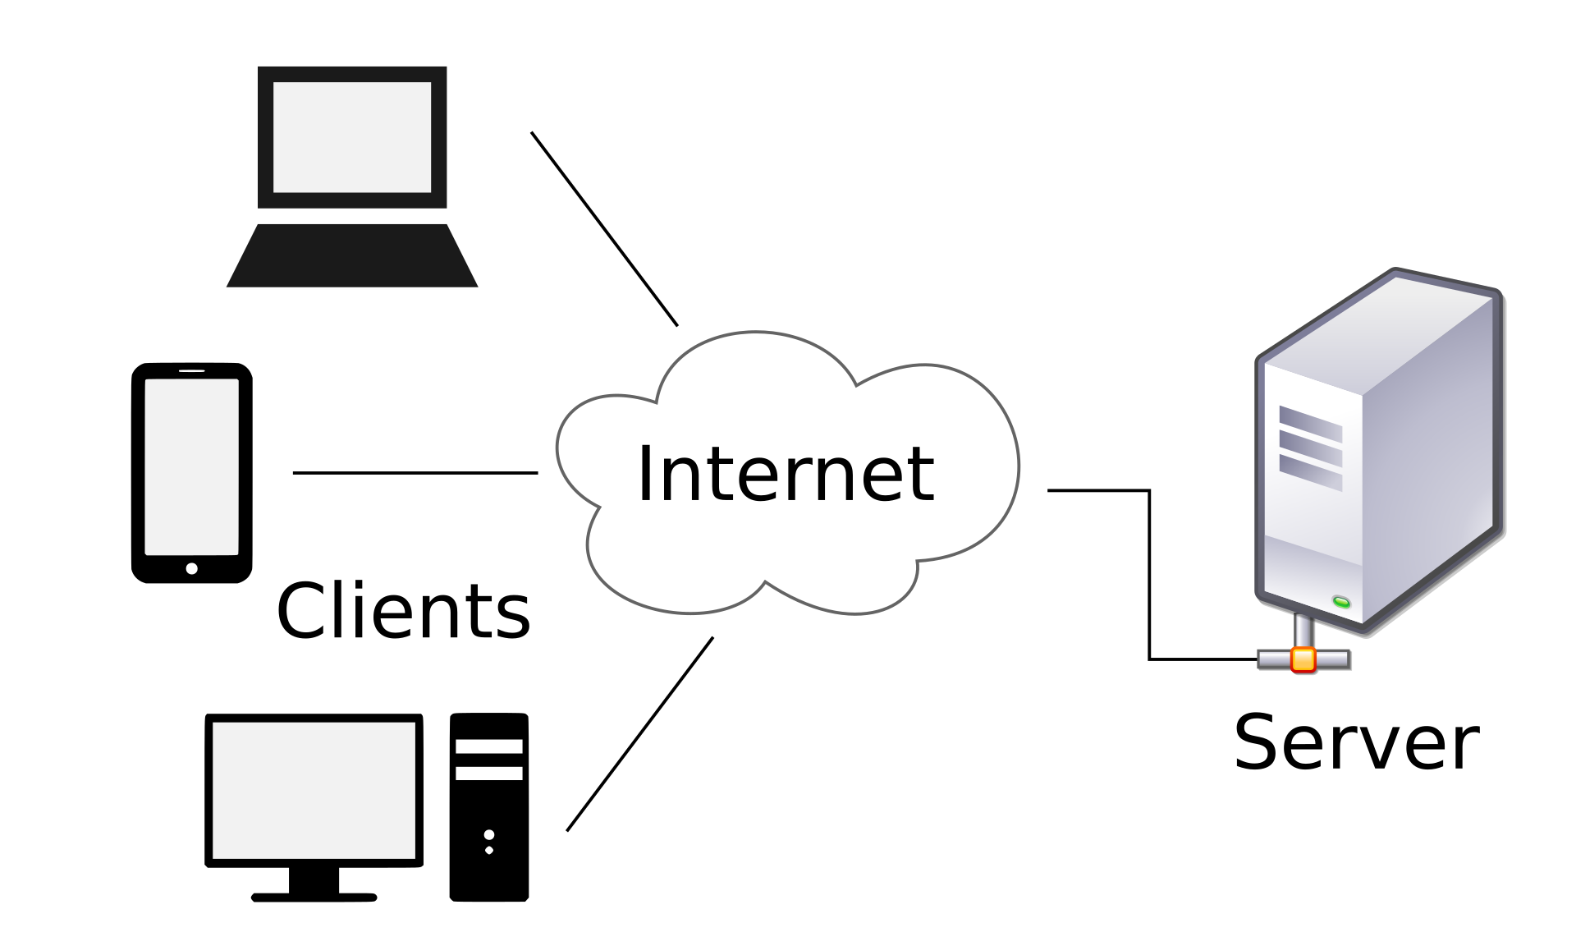

How DNS (Domain Name System) works [33]?
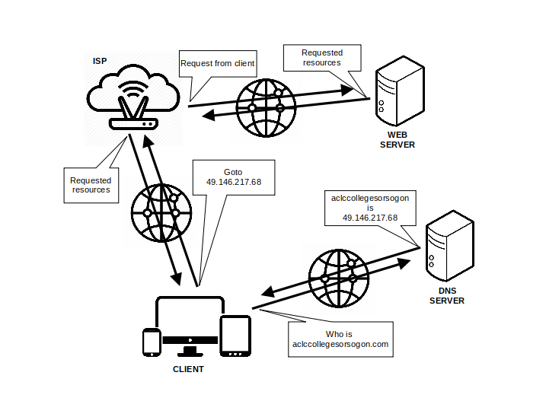
Cost Benefit Analysis
This study will benefit from open-source software, which will be utilized to host and build the website. Most of the software that will make up the website is free of charge. This makes this study cost-effective. These softwares include Apache, MariaDB, LAMP stack and Wordpress. However, since this study utilizes mostly free and open-source software, the proponents prefer self-hosting the web-server to maximize cost-effectiveness configuration process may cost time since they will have to dedicate a significant amount of additional research effort in configuring the server. Compared to prefering third-party web-hosting services where providers take care of the web-server configuration. Anyway, the benefit of using WordPress is that, migration could be convenient; this is by using a plug-in like Duplicator, the migration from self-hosted server to a third-party hosting service is made easy. For the website to be accessible to the user, the proponents acquired a registered domain name which makes it easy to visit the website rather than typing an IP (Internet Protocol) address. This may largely impact the way the accessibility of the site from a visitors perspective. The proponents will then need to evaluate the website after building it; in this process they may gather data from the users and determine if the website is effective as the proposed solution. Moreover, they may as well use some of that data collected to make use of it in improving the website based on visitors preferences.
Requirement Analysis
ACLC College Sorsogon is known for its reputation in providing IT (Information Technology) related courses. The proponents have observed that the institution primarily utilizes Facebook for disseminating information; this includes critical public advisories, school announcements, etc. Based on their observation, most of the educational institutions these days possess websites, then utilize it to spread information relevant to their institutions; their websites provide positive impact to these institutions. Aside from the efficiency of publishing content to the internet, by utilizing a proprietary website, it provides an institution with a professional approach to their online presence. It is the proponents objective to establish an effective primary online platform in the form of a website to improve the institutions credibility, especially in it's professional online aspects.

- A domain name is required before configuring the server as it is needed in the configuration process.
- As this website will be run on top of a self-hosted web-server, the proponents will apply their knowledge in IT on configuring the server and installing WordPress.
- Before conducting the evaluation phase, the website must be established online and basic fundamental contents should have been published.
- The evaluation should be as simple as possible, for it is only to validate the changes made after the testing phase and provide information to determine if a reiteration to this phase is needed, making sure that the website is well-established and functional.
- Data will be gathered from the website administrator (the website administrator is the institution personnel responsible for managing the website after the deployment).
- Data should also be extracted from the selected website visitors; these visitors will provide the proponents with the most important data for they represent the common website visitors.
- The findings of the data analysis phase should be presented as well as the conclusion of the study.

System Architecture/System Flow
The website to be built was deemed to serve as a primary platform for which visitors could view important information relevant to the institution. The homepage of this website will contain three main navigation elements such as announcements, posts, contact-us. The about-us hyperlink may not be necessary, for the proponents have thought of placing information commonly found in it to place directly on the homepage body. Each navigation element will be associated with a hyperlink that points to a relevant webpage and content. For the administrator there is a dedicated WordPress dashboard where he/she can login, create, modify, delete, and publish webpages. The diagrams below should represent the basic client-server relationship [32] as well as the system flow of the website for both the visitors and the admin.

Block Diagrams
Below is the basic concept of the website input-output which illustrates both the admin’s and the user/website visitor’s perspective. The first illustration presents the basic process of accessing the website from the end-user’s perspective. The last illustration provides a simple view of the underlying process of accessing the website on the administrator’s perpective.
Front-end System Flow Diagram
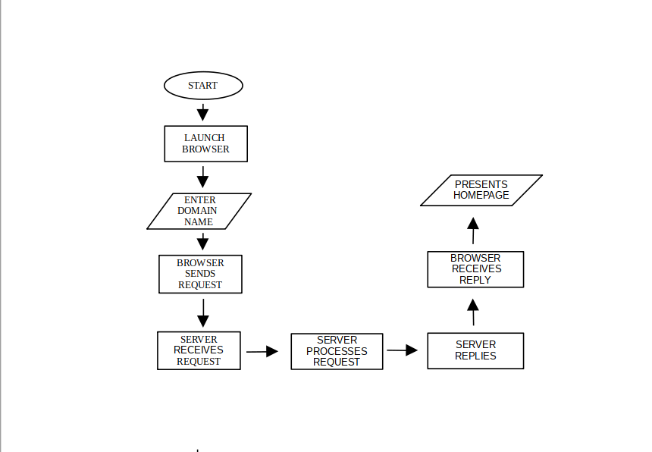
Back-end System Flow
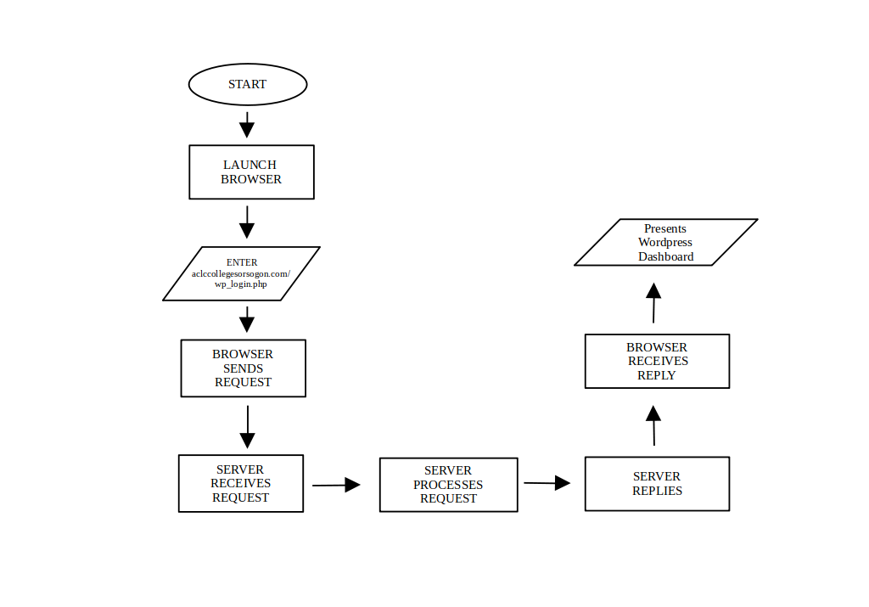
Development and Testing
In developing the website, the proponents will take an unconventional approach based on the waterfall model. The waterfall model is one of the earliest models of software development in which tasks are executed in a sequence manner where we start from the top with feasibility and flow down through various tasks with implementation into the live environment [37], [38]. A waterfall model is a breakdown of project activities into linear sequential phases [36] it originated in the manufacturing and construction industries [36].

Waterfall Model
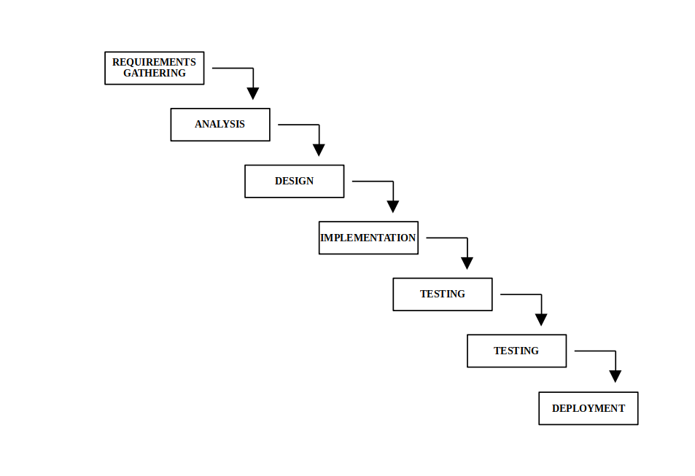

It will be built and structured with the help of a CMS. Its front-end structure will take the top-down approach and will be based on a sequential model. The first phase of building this website is requirements gathering and analysis. All possible requirements for the system to be developed were captured in this phase and documented [38].

The second phase will be the design phase. The requirement specifications from the first phase are studied in this phase and the system design is prepared. This system design helps in specifying hardware and system requirements and helps in defining the overall system architecture [38].

In the third phase, which is the implementation, the input from the design phase is implemented. The actual work will begin, building the website following the design made in the previous phase.The testing phase is where the website will be placed to user acceptance testing. After the testing the software will be deployed through the deployment phase. The last phase provide improvement as well as appropriate modifications.
Input and Output Reports and Analysis
Here’s a visual representation of the websites basic input/output process, which provide a brief introduction of how a website is displayed on the web-browser window. After landing on to the homepage the user may click the navigation element to simply request for the content of that hyperlink, e.g., clicking the category video on the navigation simply brings-up a webpage containing all the videos which are published in the site.

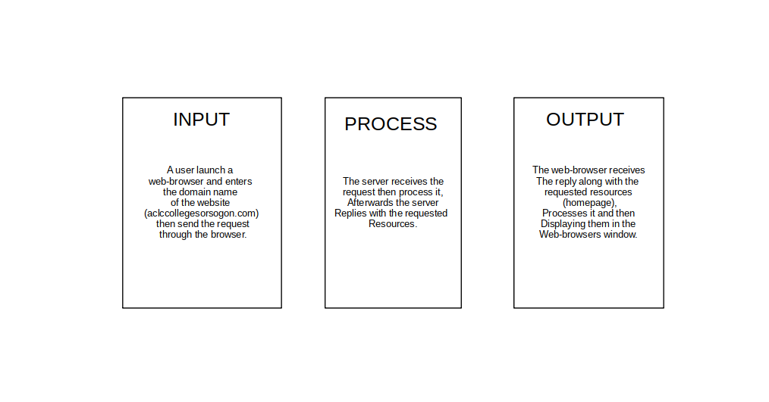

The same process can be observed in real world resource sharing using a URL (Universal Resource Locator) as well as a URI (Universal Resource Identifier) e.g., aclccollegesorsogon.com/post/. Otherwise, common visitors utilize those navigation elements available in the interface. Below is the input/output process for the admin dashboard since the website utilizes wordpress. One of the biggest benefits of utilizing WordPress as the CMS for this site is that the administrator can easily manage the website through its dashboard anytime, anywhere with the help of a web-browser connected to the internet, making the process less complicated.

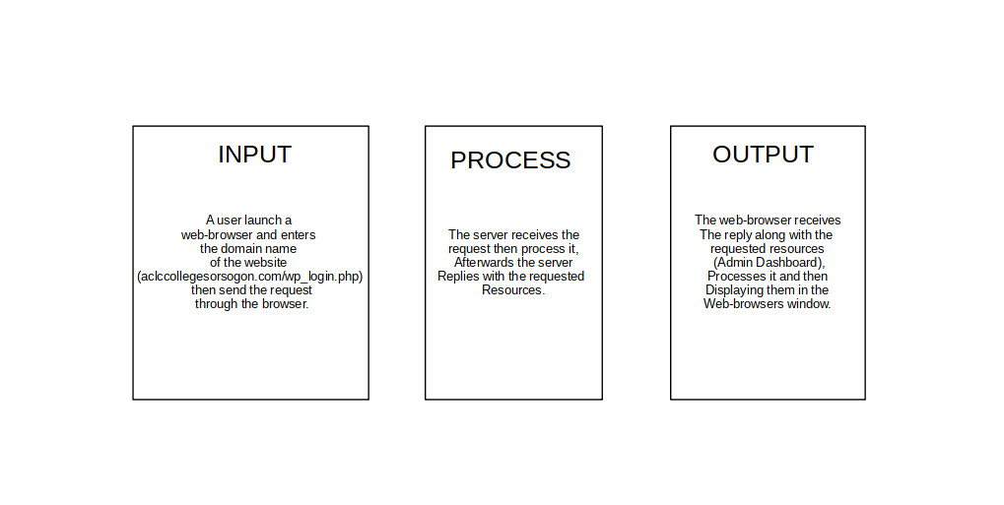
Description of the Prototype
This study is very much concerned with the front-end. This website will encompass a minimal and intuitive design as well as the structure. The homepage will contain the ACLC College logo along with its name for its header. Then the navigation will have the navigation elements, announcements which will contain critical press-releases, public advisories including the soft copies of these documents, etc... posts that contain those important non-critical information, contact-us will provide the quick view of contact information relevant to the institution that will be helpful in reaching the institution. Along with previously mentioned navigation elements, are videos and images categories. Clicking one of these, e.g., videos will present the webpage containing all the videos published on the website.

Implementation Plan
In implementing the website the requirements are strictly needed to be achieved. In setting-up and configuring the web-server, it would consume at least a day considering that a domain name is already acquired and available. In implementing the design and giving the website its structure, this task will be allotted with two to five days of executing the task. All in all, in putting the website online, the proponents will dedicate five days to a week since a CMS will be used, which will greatly impact the building of the website. The availability considering that most of the software is open-source, makes the implementation cost-effective. Structuring the website will be based on the top-down approach [39] as well as the sequential model [40] since this website will be mainly for disseminating information and information is time sensitive. Implementing this website is very critical for this study as it will also be subjected to an evaluation to determine the website’s effectiveness as proposed. However, if the study is a success, the solution may be adapted in to production. Though this document states that a personnel with little to no knowledge can manage the website, since the website is crucial component to the institution in providing accurate information, the institution itself can provide the administrator with a self-paced training which is highly available through online tutorials as well as the wordpress documentation which would largely aid in understanding and learning the WordPress.
References

[1] S. McCartney, “Stella McCartney - Quotes: Topics: Movie quotes: Proverbs,” Quotes, 03-Nov-2020. [Online]. Available: https://quoteslib.com/authors/stella-mccartney-quotes/. [Accessed: 07-Jan-2022].
[2] J. McKenzie, “Why in the World Wide Web? Reasons for Schools to Create Web Sites”, [Online]. Available: fno.org/mar97/why.html. [Accessed: 7-Jan.-2022].
[3] C. S. -, “Importance of a website for Educational Institutions”, NewZNew. 23-Aug.-2018. [Online]. Available: www.newznew.com/importance-of-a-website-for-educational-institutions/. [Accessed: 7-Jan.-2022].
[4] E. H. Delgado, “Advantages and benefits of having a Website on internet”, Website Design akus.net. 26-Jan.-2019. [Online]. Available: disenowebakus.net/en/website-benefits. [Accessed: 7-Jan.-2022].
[5] Aprillia Adella Suyanto, “Increasing the Brand Awareness of Ambassador School Surabaya through A Website”, K@ta Kita. [Online]. Available: katakita.petra.ac.id/index.php/sastra-inggris/article/view/11023. [Accessed: 7-Jan.-2022].
[6] [Online]. Available: www.scitepress.org/Papers/2018/100455/100455.pdf. [Accessed: 7-Jan.-2022].
[7] 7-Mar.-2016. [Online]. Available: namp.americansforthearts.org/sites/default/files/Netmarks-2016-Guide-to-Digital-Marketing.pdf. [Accessed: 7-Jan.-2022].
[8] [Online]. Available: files.eric.ed.gov/fulltext/EJ1121620.pdf. [Accessed: 7-Jan.-2022].
[9] [Online]. Available: kth.diva-portal.org/smash/get/diva2:1612392/FULLTEXT01.pdf. [Accessed: 7-Jan.-2022].
[10] [Online]. Available: digitalcommons.unf.edu/cgi/viewcontent.cgi. [Accessed: 7-Jan.-2022].
[11] “ResearchGate”, [Online]. Available: www.researchgate.net/publication/351628369_Development_of_a_Secure_Website_to_Facilitate_Information_Sharing_in_Families_at_High_Risk_of_Bowel_Cancer-The_Familyweb_Study. [Accessed: 7-Jan.-2022].
[12] [Online]. Available: uu.diva-portal.org/smash/get/diva2:515782/FULLTEXT01.pdf. [Accessed: 7-Jan.-2022].
[13] “ResearchGate”, [Online]. Available: www.researchgate.net/profile/Muthuraj-Anbalagan/publication/324154769_Information_Management_Using_CMS_An_Overview/links/5ac20456a6fdcccda65e5445/Information-Management-Using-CMS-An-Overview.pdf. [Accessed: 7-Jan.-2022].
[14] “Will Rogers Quotes famous Quotes”, Epic Phrase. 27-Mar.-2021. [Online]. Available: epicphrase.com/book-author/will-rogers-quotes/. [Accessed: 7-Jan.-2022].
[15] “What Is a Content Management System (CMS)?”, 2-Sept.-2021. [Online]. Available: kinsta.com/knowledgebase/content-management-system/. [Accessed: 8-Jan.-2022].
[16] R. Robinson, “What is WordPress? Difference Between WordPress.org vs WordPress.com”, 11-Dec.-2021. [Online]. Available: www.ryrob.com/what-is-wordpress/. [Accessed: 8-Jan.-2022].
[17] “Debian -- Introduction to Debian”, [Online]. Available: www.debian.org/intro/. [Accessed: 10-Jan.-2022].
[18] “Debian -- About Debian”, [Online]. Available: www.debian.org/intro/about. [Accessed: 10-Jan.-2022].
[19] “Debian -- News -- Debian 11 "bullseye" released”, [Online]. Available: www.debian.org/News/2021/20210814. [Accessed: 10-Jan.-2022].
[20] “What is Linux?”, Linux.com. [Online]. Available: www.linux.com/what-is-linux/. [Accessed: 10-Jan.-2022].
[21] R. Stallman, “About the GNU Project - GNU Project”, Free Software Foundation. [Online]. Available: www.gnu.org/gnu/thegnuproject.en.html. [Accessed: 10-Jan.-2022].
[22] “WordPress”, Wikipedia. 19-Apr.-2004. [Online]. Available: en.wikipedia.org/wiki/WordPress. [Accessed: 10-Jan.-2022].
[23] “Php”, Wikipedia. 1-Oct.-2001. [Online]. Available: en.wikipedia.org/wiki/PHP. [Accessed: 10-Jan.-2022].
[24] “LAMP (software bundle)”, Wikipedia. 5-Aug.-2005. [Online]. Available: en.wikipedia.org/wiki/LAMP_(software_bundle). [Accessed: 10-Jan.-2022].
[25] “Install Wordpress on Debian 11”, Linux Windows and android Tutorials. 16-Sept.-2021. [Online]. Available: www.osradar.com/install-wordpress-debian/. [Accessed: 10-Jan.-2022].
[26] “What is a relational database?”, Oracle. [Online]. Available: www.oracle.com/database/what-is-a-relational-database/. [Accessed: 10-Jan.-2022].
[27] “MariaDB”, Wikipedia. 4-Nov.-2009. [Online]. Available: en.wikipedia.org/wiki/MariaDB. [Accessed: 10-Jan.-2022].
[28] “MySQL”, Wikipedia. 4-Sept.-2001. [Online]. Available: en.wikipedia.org/wiki/MySQL. [Accessed: 10-Jan.-2022].
[29] “Plasma”, KDE Community. [Online]. Available: kde.org/plasma-desktop/. [Accessed: 11-Jan.-2022].
[30] “Install Wordpress on Debian 11”, Linux Windows and android Tutorials. 16-Sept.-2021. [Online]. Available: www.osradar.com/install-wordpress-debian/. [Accessed: 11-Jan.-2022].
[31] “KDE Plasma 5.20.5, Bugfix Release for January”, KDE Community. 5-Jan.-2021. [Online]. Available: kde.org/announcements/plasma/5/5.20.5/. [Accessed: 13-Jan.-2022].
[32] “Clientserver model”, Wikipedia. 25-Sept.-2001. [Online]. Available: en.wikipedia.org/wiki/Client–server_model. [Accessed: 18-Jan.-2022].
[33] “Sucuri WebSite Firewall”, Access Denied. [Online]. Available: www.wpbeginner.com/glossary/dns/. [Accessed: 18-Jan.-2022].
[34] J. Morales, “A Guide to Different Types of Website Structures”, Adobe XD Ideas. 10-Sept.- 2020. [Online]. Available: xd.adobe.com/ideas/process/information-architecture/different-types- of-website-structures/. [Accessed: 19-Jan.-2022].
[35] “Creating Website Structures that Are Built to Last”, Slickplan. 21-Mar.-2018. [Online]. Available: slickplan.com/blog/creating-website-structures-built-last. [Accessed: 19-Jan.-2022].
[36] “Waterfall model”, Wikipedia. 25-Feb.-2002. [Online]. Available: en.wikipedia.org/wiki/Waterfall_model. [Accessed: 20-Jan.-2022].
[37] “Waterfall Model”, Different Phases With Advantages & Disadvantages. 20-May-2019. [Online]. Available: www.educba.com/waterfall-model/. [Accessed: 20-Jan.-2022].
[38] “Sdlc”, Waterfall Model. [Online]. Available: www.tutorialspoint.com/sdlc/sdlc_waterfall_model.htm. [Accessed: 20-Jan.-2022].
[39] “Basics of HTML5”, [Online]. Available: mason.gmu.edu/~apapas3/375/webdesign.html. [Accessed: 10-Feb.-2022].
[40] “Creating Website Structures that Are Built to Last”, Slickplan. 21-Mar.-2018. [Online]. Available: slickplan.com/blog/creating-website-structures-built-last. [Accessed: 10-Feb.-2022].

