Que3:

Code:

print('Welcome to python programming')

a = 50

b = 75

print(a+b)

O/P:



Que4:

Code:

Numbers1 = 12

Numbers2 = 1.6

List = ['daivik', 1, 2]

Tuple = ('daivik', 1, 2)

Bytes = bytes(2)

ByteArray = bytearray(str(List), 'utf-8')  *# Encode the list as bytes*

Set = {1, 2, 3, 4, 5}

FrozenSet = frozenset(Tuple)

Dictionary = {

    "daivik": "MAN",

    "Work": "Study"

}

print(Numbers1)

print(Numbers2)

print(List)

print(Tuple)

print(Bytes)

print(ByteArray)

print(Set)

print(FrozenSet)

print(Dictionary)

O/P:

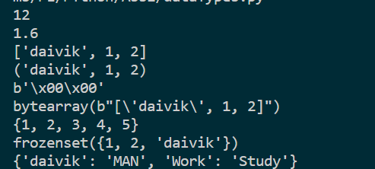

Que5:

Code:

km=float(input("Enter the Kilometers: "))

meter=km*1000

cm=meter*100

mm=cm*10

print(**f**"{km}kms | in meters = {meter}m| in centimeters = {cm}cm | in millimeter = {mm}mm")

o/p:



Que6:

Code:

height=float(input("Height in meters: "))

weight=float(input("Weight in Kgs: "))

BMI=weight/(height*height)

print(**f**"BMI value is {BMI}")

o/p:

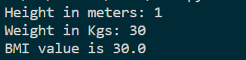

Que7:

Code:

num=float(input("Enter the number: "))

x=num%2

if(x==0):

    print(**f**"{num} is even")

else:

    print(**f**"{num} is odd")

o/p:

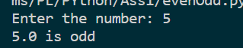

Que8:

Code:

year=int(input("Enter the Year: "))

if(year%4==0):

    if(year%100==0):

        if(year%400==0):

            print(**f**"{year} is a leap year")

        else:

            print(**f**"{year} is not a leap year")

    else:

        print(**f**"{year} is a leap year")

else:

    print(**f**"{year} is not a leap year")

o/p:

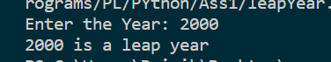

Que9:

Code:

num=int(input("Enter the Number: "))

fact=1

for i in range (1,num+1):

    fact*=i

print(**f**"Factorial of {num} is {fact}")

o/p:



Que10:

string=input("Enter the String: ")

string2=string[::-1]

if(string==string2):

    print(**f**"{string} is a Palindrome")

else:

    print(**f**"{string} is not a Palindrome")

o/p:

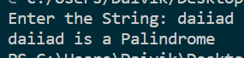

Que11:

Code:

string=input("Enter the String: ")

cnt=0

for i in string:

    if(i=='a' or i=='e' or i=='i' or i=='o'or i=='u'):

        cnt+=1

print(**f**"The number of Vowels are: {cnt}")

o/p:

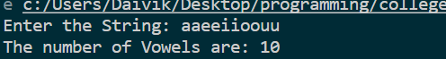

Que12:

Code:

x=input("Celsius to Farenheit = y , farenheit to celsius = n")

if(x == 'y'):

    a=float(input("Enter Temp in Celsius: "))

    b=a*9/5+32

    print(**f**"{a} celsius in Fahrenheit is: {b}")

else:

    a=float(input("Enter Temp in Fahrenheit: "))

    b=(a-32)*5/9

    print(**f**"{a} celsius in Fahrenheit is: {b}")

o/p:

