Que1.

age = int(input("Enter your age: "))

if age < 18:

    print("You are a minor.")

elif age >= 18 and age < 65:

    print("You are an adult.")

else:

    print("You are a senior citizen.")



Que 2.

n = int(input("Enter the value of N: "))

fibonacci_list = []

*# Initializing the first two numbers of the Fibonacci sequence*

a, b = 0, 1

*# Generating the first N Fibonacci numbers using a while loop*

while len(fibonacci_list) < n:

    fibonacci_list.append(b)

    a, b = b, a + b

print(fibonacci_list)

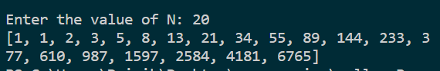

Que 3.

**def** is_leap_year(year):

    if year % 4 == 0:

        if year % 100 == 0:

            if year % 400 == 0:

                return True

            else:

                return False

        else:

            return True

    else:

        return False

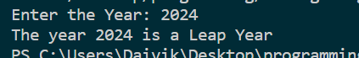

Que 4.

numbers = [2, 4, 6, 8, 10]

*# calculate sum*

sum_of_numbers = sum(numbers)

*# calculate average*

average_of_numbers = sum_of_numbers / len(numbers)

print(**f**"The numbers are {numbers}")

print("Sum of numbers:", sum_of_numbers)

print("Average of numbers:", average_of_numbers)

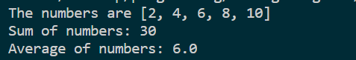

Que 5.

n = int(input("Enter the number of rows: "))

for i in range(n):

    print("*" * n)

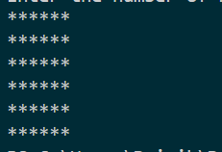

Que 6:

filename = input("Enter the file name: ")

with open(filename, 'r') as file:

    word_count = 0

    for line in file:

        word_count += len(line.split())

print("The number of words in the file is:", word_count)

Que 7.

**def** factorial(n):

    if n == 1:

        return 1

    else:

        return n * factorial(n-1)

n = int(input("Enter the value of N: "))

print(**f**"the factorial of {n} is {factorial(n)}")



Que 8.

**def** find_min_max(numbers):

    min_num = numbers[0]

    max_num = numbers[0]

    for num in numbers:

        if num < min_num:

            min_num = num

        elif num > max_num:

            max_num = num

    return min_num, max_num

numbers = [5, 2, 8, 1, 9, 3]

print("The numbers are ", numbers)

min_num, max_num = find_min_max(numbers)

print("Smallest number:", min_num)

print("Largest number:", max_num)

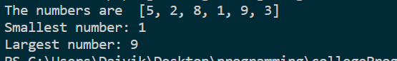

Que 9

string = input("Enter a string: ")

vowels = 0

consonants = 0

for char in string:

    if char.isalpha():

        if char.lower() in ['a', 'e', 'i', 'o', 'u']:

            vowels += 1

        else:

            consonants += 1

print("Number of vowels:", vowels)

print("Number of consonants:", consonants)

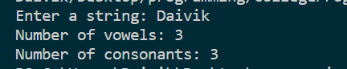

Que 10.

while True:

*# Take user input for operation*

    operation = input("Enter an operation (+, -, *, /) or 'exit' to quit: ")

*# Check if user wants to exit*

    if operation == "exit":

        break

*# Take user input for operands*

    num1 = float(input("Enter first number: "))

    num2 = float(input("Enter second number: "))

*# Perform operation and display result*

    if operation == "+":

        result = num1 + num2

        print(**f**"{num1} + {num2} = {result}")

    elif operation == "-":

        result = num1 - num2

        print(**f**"{num1} - {num2} = {result}")

    elif operation == "*":

        result = num1 * num2

        print(**f**"{num1} * {num2} = {result}")

    elif operation == "/":

        if num2 == 0:

            print("Error: Cannot divide by zero")

        else:

            result = num1 / num2

            print(**f**"{num1} / {num2} = {result}")

    else:

        print("Invalid operation")

