Que 1.

Code:

num = int(input("Enter a number: "))

if num % 2 == 0:

    print(num, "is even")

else:

    print(num, "is odd")

age = int(input("Enter your age: "))

if age >= 18:

    print("You are eligible to vote")

else:

    print("You are not eligible to vote")

num1 = int(input("Enter first number: "))

num2 = int(input("Enter second number: "))

if num1 > num2:

    print(num1, "is the largest")

else:

    print(num2, "is the largest")

year = int(input("Enter a year: "))

if year % 4 == 0:

    if year % 100 == 0:

        if year % 400 == 0:

            print(year, "is a leap year")

        else:

            print(year, "is not a leap year")

    else:

        print(year, "is a leap year")

else:

    print(year, "is not a leap year")

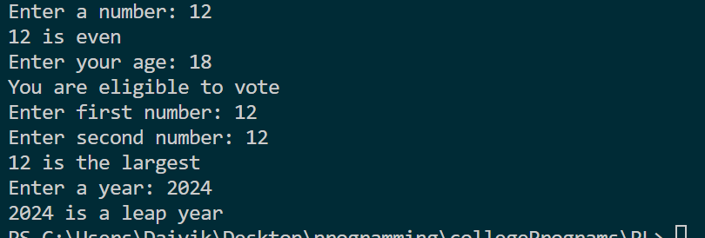

Que 2.

start = int(input("Enter the starting number of the range: "))

end = int(input("Enter the ending number of the range: "))

print("Prime numbers between", start, "and", end, "are:")

while start <= end:

    if start > 1:

        for i in range(2, start):

            if (start % i) == 0: break

            else: print(start)

    start += 1

*#b*

num = int(input("Enter a number: "))

factorial = 1

for i in range(1, num + 1):

    factorial *= i

print("Factorial of", num, "is", factorial)

*#c*

terms = int(input("Enter the number of terms: "));

n1, n2 = 0, 1;

count = 0;

if terms <= 0:

    print("Please enter a positive integer")

elif terms == 1:

    print("Fibonacci sequence upto", terms, "term:")

    print(n1)

else:

    print("Fibonacci sequence:")

    while count < terms:

        print(n1)

        nth = n1 + n2

        n1 = n2

        n2 = nth

        count += 1

*#d*

sum = 0

for i in range(2, 101, 2): sum += i

print("Sum of all even numbers from 1 to 100 is", sum)

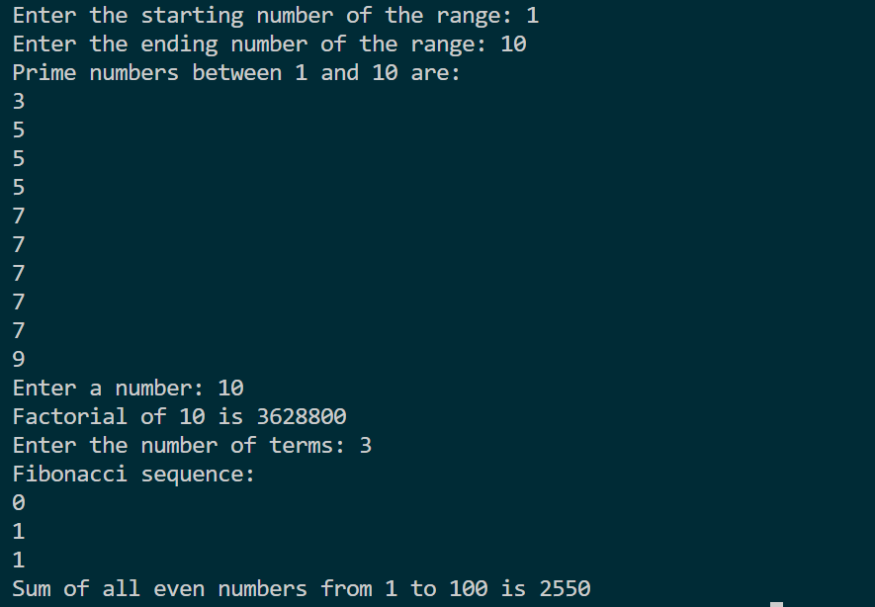

Que 3.

import math

import math

*# a. function to add two numbers*

**def** add_numbers(num1, num2):

    return num1 + num2

*# b. function to check if a string is palindrome*

**def** is_palindrome(string):

    return string == string[::-1]

*# c. function to calculate area of circle*

**def** calculate_area(radius):

    return math.pi * radius ** 2

*# a. function to add two numbers*

**def** add_numbers(num1, num2):

    result = num1 + num2

    print(**f**"Adding {num1} and {num2}. Result: {result}")

    return result

*# b. function to check if a string is palindrome*

**def** is_palindrome(string):

    result = string == string[::-1]

    print(**f**"Checking if '{string}' is a palindrome. Result: {result}")

    return result

*# c. function to calculate area of circle*

**def** calculate_area(radius):

    result = math.pi * radius ** 2

    print(**f**"Calculating area of circle with radius {radius}. Result: {result}")

    return result

*# d. function to convert temperature from Celsius to Fahrenheit and vice versa*

**def** convert_temperature(temp, unit):

    if unit == 'C':

        result = (temp * 9/5) + 32

        print(**f**"Converting {temp} degrees Celsius to Fahrenheit. Result: {result}")

        return result

    elif unit == 'F':

        result = (temp - 32) * 5/9

        print(**f**"Converting {temp} degrees Fahrenheit to Celsius. Result: {result}")

        return result

    else:

        result = "Invalid unit. Please enter 'C' or 'F'."

        print(result)

        return result

*# example usage*

print("Result of adding 5 and 7:", add_numbers(5, 7)) *# output: Adding 5 and 7. Result: 12*

print("Is 'racecar' a palindrome?", is_palindrome('racecar')) *# output: Checking if 'racecar' is a palindrome. Result: True*

print("Area of circle with radius 5:", calculate_area(5)) *# output: Calculating area of circle with radius 5. Result: 78.53981633974483*

print("Converting 32 degrees Celsius to Fahrenheit:", convert_temperature(32, 'C')) *# output: Converting 32 degrees Celsius to Fahrenheit. Result: 89.6*

print("Converting 89.6 degrees Fahrenheit to Celsius:", convert_temperature(89.6, 'F')) *# output: Converting 89.6 degrees Fahrenheit to Celsius. Result: 32.0*

print("Converting 89.6 degrees Fahrenheit to Celsius:", convert_temperature(89.6, 'F')) *# output: 32.0*

print("Converting 100 degrees Kelvin to Celsius or Fahrenheit:", convert_temperature(100, 'K')) *# output: Invalid unit. Please enter 'C' or 'F'.*

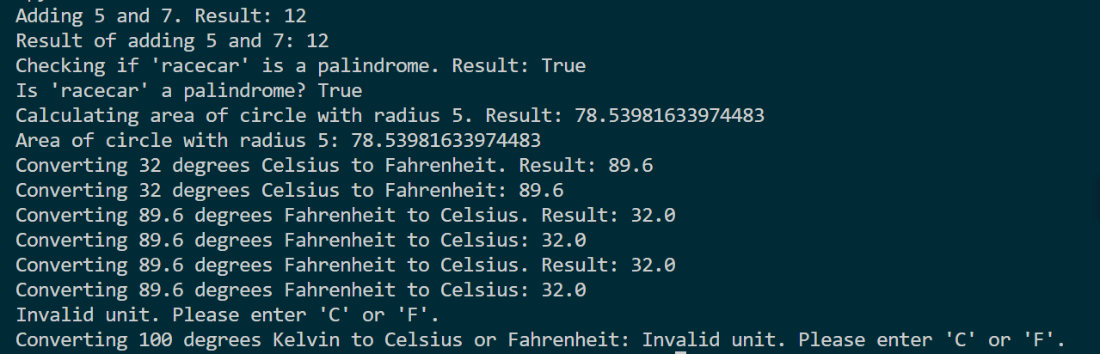

Que 4.

import random

import math

*# a. function to calculate average, sum, and maximum value of a list of numbers*

**def** calculate_stats(numbers):

    average = sum(numbers) / len(numbers)

    total_sum = sum(numbers)

    max_value = max(numbers)

    return average, total_sum, max_value

*# b. function to generate a random number and ask the user to guess it*

**def** guess_number():

    random_number = random.randint(1, 100)

    while True:

        guess = int(input("Guess the number (between 1 and 100): "))

        if guess == random_number:

            print("Congratulations! You guessed the number.")

            break

        elif guess < random_number:

            print("Too low. Try again.")

        else:

            print("Too high. Try again.")

*# c. function to calculate the factorial of a number using recursion*

**def** factorial(n):

    if n == 0:

        return 1

    else:

        return n * factorial(n-1)

*# d. function to print all prime numbers up to a given number*

**def** print_primes(n):

    primes = []

    for i in range(2, n+1):

        is_prime = True

        for j in range(2, int(math.sqrt(i))+1):

            if i % j == 0:

                is_prime = False

                break

        if is_prime:

            primes.append(i)

    print("Prime numbers up to", n, "are:", primes)

*# test the functions*

numbers = [1, 2, 3, 4, 5]

print(**f**"Numbers Are {numbers}")

average, total_sum, max_value = calculate_stats(numbers)

print("The average of the numbers is:", average)

print("The sum of the numbers is:", total_sum)

print("The maximum value of the numbers is:", max_value)

guess_number()

n = 5

print("The factorial of", n, "is", factorial(n))

n = 20

print("The prime numbers up to", n, "are:")

print_primes(n)

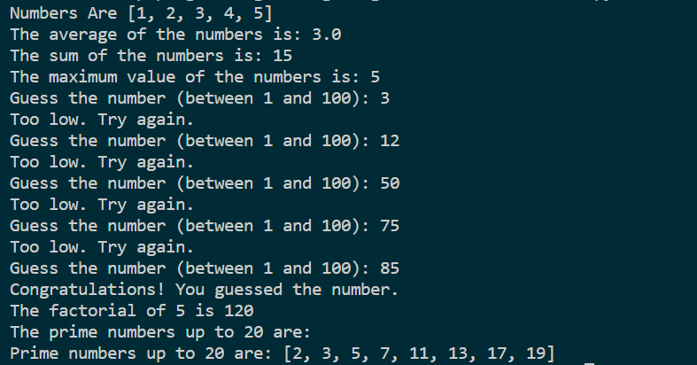

Que 5.

*# Multiplication table for numbers from 1 to 10*

for i in range(1, 11):

    for j in range(1, 11):

        print(i * j, end="\t")

    print()

*#ATM*

balance = 0

**def** check_balance():

    print("Your balance is:", balance)

**def** withdraw(amount):

**global** balance

    if amount <= balance:

        balance -= amount

        print("Withdrawal successful. Your new balance is:", balance)

    else:

        print("Error: Insufficient balance.")

**def** deposit(amount):

**global** balance

    balance += amount

    print("Deposit successful. Your new balance is:", balance)

while True:

    print("Choose an option:")

    print("1. Check balance")

    print("2. Withdraw")

    print("3. Deposit")

    print("4. Quit")

    choice = int(input("Enter your choice: "))

    if choice == 1:

        check_balance()

    elif choice == 2:

        amount = int(input("Enter amount to withdraw: "))

        withdraw(amount)

    elif choice == 3:

        amount = int(input("Enter amount to deposit: "))

        deposit(amount)

    elif choice == 4:

        print("Thank you for using our ATM. Goodbye!")

        break

    else:

        print("Invalid choice. Please try again.")

*#C*

age = int(input("Enter your age: "))

grade = int(input("Enter your grade: "))

if age >= 18 and grade >= 12:

    print("Congratulations on being a senior in high school! Enjoy your last year.")

elif age >= 18:

    print("You are an adult now. Make sure to take responsibility for your actions.")

elif grade >= 12:

    print("You are a senior in high school. Make the most of it!")

else:

    print("You have a lot of life ahead of you. Enjoy the journey!")

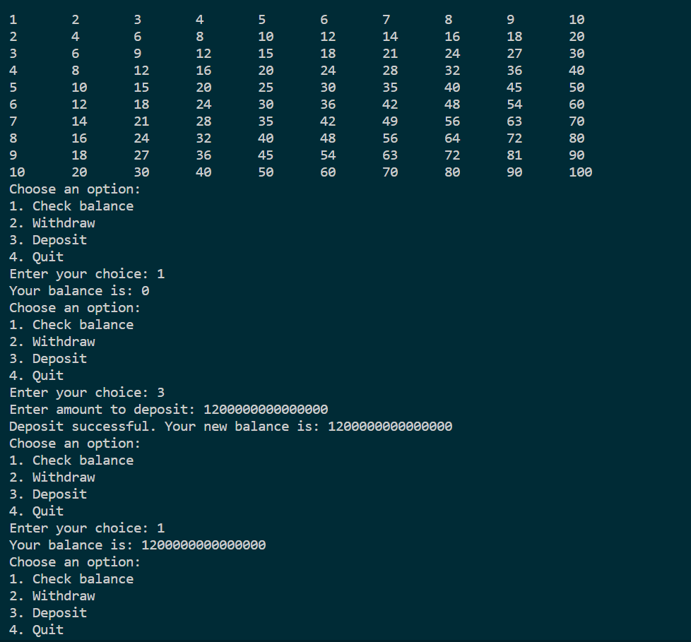

Que 6.

from tkinter import *

from tkinter import messagebox

**def** show_details():

    name = a1.get()

    address = a2.get()

    mobile = a3.get()

    email = a4.get()

    gender = gender_var.get()

    state = states.curselection()

    hostel_req = hostel_var.get()

    state_names = ["California", "Texas", "New York", "Florida", "Illinois"]

    selected_states = [state_names[i] for i in state]

    details = **f**"Name: {name}\nAddress: {address}\nMobile Number: {mobile}\nEmail: {email}\nGender: {gender}\nState: {selected_states}\nHostel Required: {hostel_req}"

    print(details)

    messagebox.showinfo("Details", details)

master=Tk()

Label(master,text="Name").grid(row=0)

Label(master, text="Address").grid(row=2)

Label(master, text="Mobile Number").grid(row=4)

Label(master, text="Email id").grid(row=6)

a1=Entry(master)

a1.grid(row=0,column=2)

a2=Entry(master)

a2.grid(row=2,column=2)

a3=Entry(master)

a3.grid(row=4,column=2)

a4=Entry(master)

a4.grid(row=6,column=2)

gender_var = IntVar()

gender1 = Radiobutton(master, text='male', value=1, variable=gender_var)

gender1.grid(row=8, sticky=W)

gender2 = Radiobutton(master, text='female', value=2, variable=gender_var)

gender2.grid(row=10, sticky=W)

gender3 = Radiobutton(master, text='other', value=3, variable=gender_var)

gender3.grid(row=12, sticky=W)

states = Listbox(master, selectmode=MULTIPLE)

states.grid(row=14)

states.insert(1, "California")

states.insert(2, "Texas")

states.insert(3, "New York")

states.insert(4, "Florida")

states.insert(5, "Illinois")

hostel_var = BooleanVar()

hostel = Checkbutton(master, text="Hostel", variable=hostel_var)

hostel.grid(row=16, sticky=W)

Button(master, text='Show Details', command=show_details).grid(row=18, column=2, sticky=W, pady=4)

mainloop()

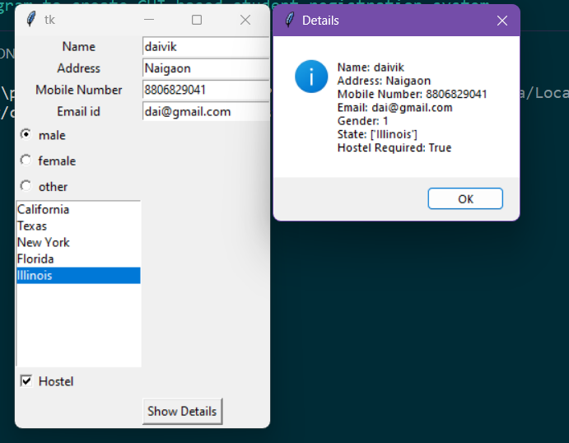

Que 7.

*# Open the input file in read mode*

with open("input.txt", "r") as input_file:

*# Read the contents of the input file*

    input_text = input_file.read()

*# Replace consecutive spaces with a single space*

output_text = " ".join(input_text.split())

*# Open the output file in write mode*

with open("output.txt", "w") as output_file:

*# Write the modified text to the output file*

    output_file.write(output_text)