**Batch T4**

**Practical No. 1**

**Title of Assignment: Introduction to Web**

**Student Name: Daivik karbhari**

**Student PRN: 22510111**

**Problem Statement 2:**

Study of Different HTML and CSS tags:

1. Study different tags of HTML and CSS

**Structural Elements:**

* <html>: Root element of an HTML document.
* <head>: Contains metadata and links to scripts and styles.
* <title>: Sets the title of the document.
* <body>: Contains the content of the document.
* <header>: Defines a header section for a document or section.
* <footer>: Defines a footer for a document or section.
* <main>: Specifies the main content of the document.
* <section>: Defines sections in a document.
* <article>: Defines independent, self-contained content.
* <aside>: Defines content aside from the main content.
* <nav>: Defines navigation links.

**Content Elements:**

* <h1> to <h6>: Heading tags.
* <p>: Paragraph.
* <div>: Generic container for content.
* <span>: Inline container for text.
* <a>: Anchor/link.
* <img>: Image.
* <ul>: Unordered list.
* <ol>: Ordered list.
* <li>: List item.
* <table>: Table.
* <tr>: Table row.
* <th>: Table header cell.
* <td>: Table data cell.
* <form>: Form for user input.
* <input>: Input field.
* <button>: Button.
* <label>: Label for form element.
* <textarea>: Multi-line text input.
* <select>: Drop-down list.
* <option>: Option in a drop-down list.

**Media Elements:**

* <audio>: Embeds sound content.
* <video>: Embeds video content.
* <source>: Specifies multiple media resources for media elements (<audio>, <video>).
* <track>: Specifies text tracks for media elements.

**Semantics and Metadata:**

* <meta>: Metadata about the HTML document.
* <link>: Links to external resources like stylesheets.
* <style>: Embeds CSS within the HTML document.
* <script>: Embeds or references JavaScript.

**Commonly Used CSS Properties**

**Box Model:**

* width: Sets the width of an element.
* height: Sets the height of an element.
* padding: Sets the padding space inside an element.
* margin: Sets the margin space outside an element.
* border: Sets the border around an element.

**Typography:**

* font-family: Specifies the font for text.
* font-size: Sets the size of the font.
* font-weight: Sets the weight (boldness) of the font.
* color: Sets the color of the text.
* text-align: Sets the horizontal alignment of text.
* line-height: Sets the height of lines of text.

**Background:**

* background-color: Sets the background color of an element.
* background-image: Sets a background image for an element.
* background-size: Sets the size of the background image.
* background-position: Sets the initial position of the background image.

**Positioning:**

* position: Specifies the type of positioning for an element (static, relative, absolute, fixed, sticky).
* top, right, bottom, left: Specifies the position of an element.
* z-index: Sets the stack order of an element.

**Display and Visibility:**

* display: Specifies the display behavior of an element (block, inline, flex, grid, etc.).
* visibility: Specifies whether an element is visible or hidden.
* overflow: Specifies what happens if content overflows an element's box (visible, hidden, scroll, auto).

**Flexbox:**

* display: flex: Enables flexbox layout for an element.
* flex-direction: Specifies the direction of flex items (row, column, etc.).
* justify-content: Aligns flex items along the main axis.
* align-items: Aligns flex items along the cross axis.

**Grid:**

* display: grid: Enables grid layout for an element.
* grid-template-columns: Defines the columns of the grid.
* grid-template-rows: Defines the rows of the grid.
* gap: Sets the gap between grid items.

**Animations and Transitions:**

* transition: Specifies the transition effect for properties.
* transform: Applies a transformation (rotate, scale, etc.) to an element.
* animation: Defines keyframe animations.

1. Create a static web page for “Portfolio” of your own. Which will include photo, name, class, College name, Achievements/ Certificates, Extracurricular Activities, Courses Completed, hobbies, Technical expertise, etc

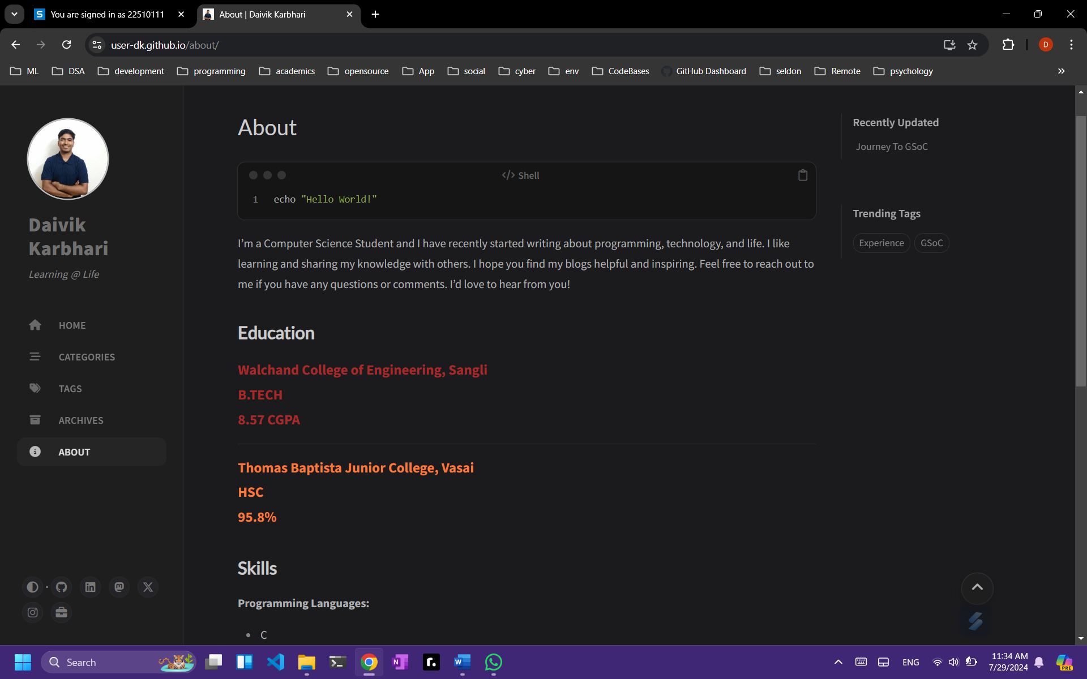

**The above website is live on:** [**https://user-dk.github.io/about/**](https://user-dk.github.io/about/)

**And the code can be seen here:** [**https://github.com/User-DK/User-DK.github.io**](https://github.com/User-DK/User-DK.github.io)