**Batch T4**

**Practical No. 2**

**Title of Assignment: Html, Css**

**Student Name: Daivik Karbhari**

**Student PRN: 22510111**

**Problem Statement #:**

Technologies/frameworks used: HTML, CSS

Related theory or any related information you want to add

1. Screenshots of the output according to the problem statements
2. 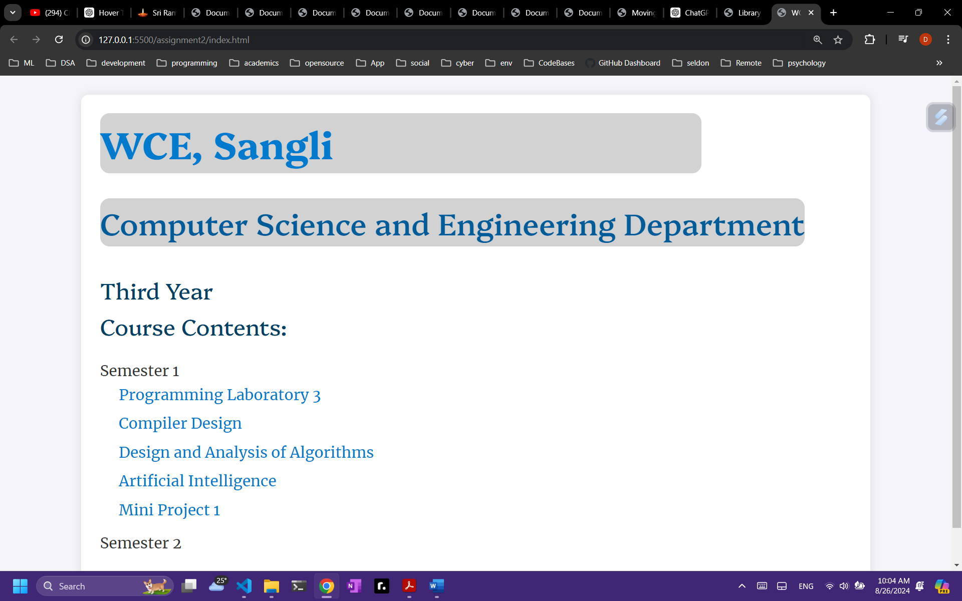
3. 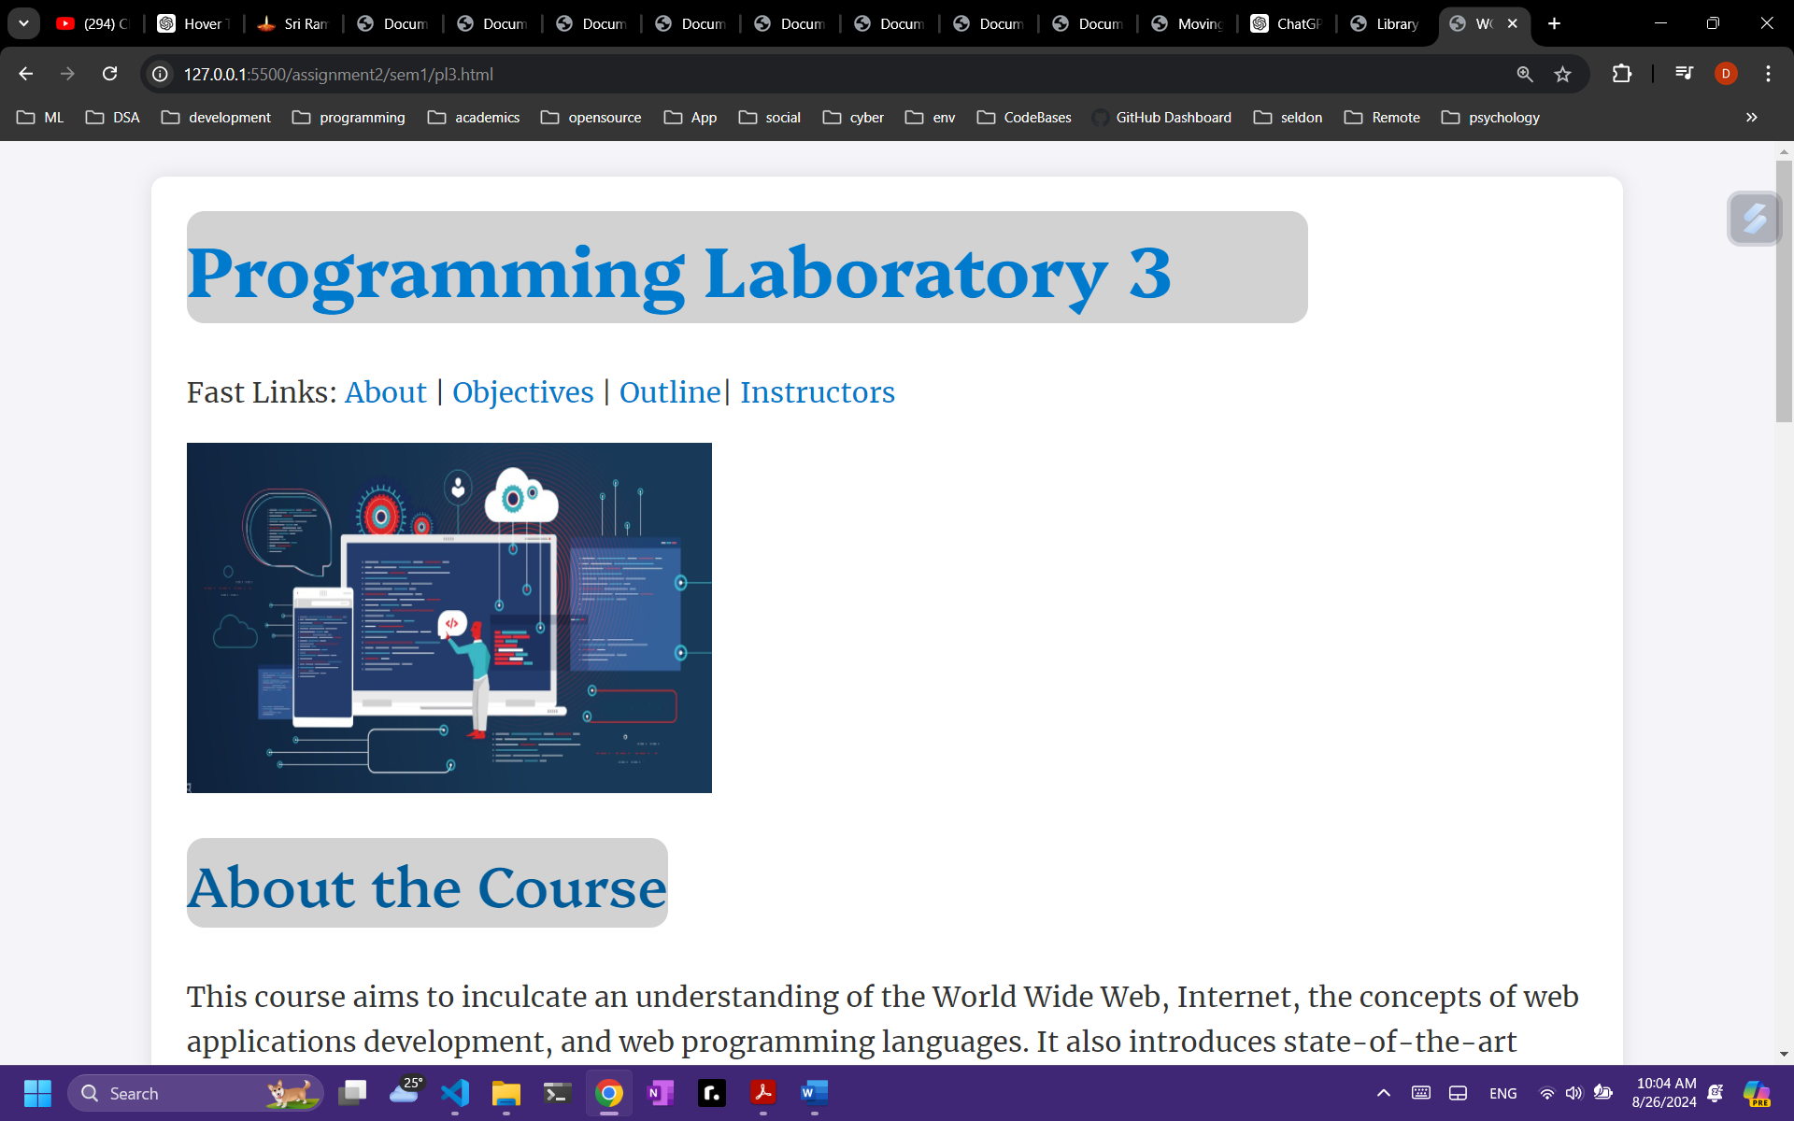
4. 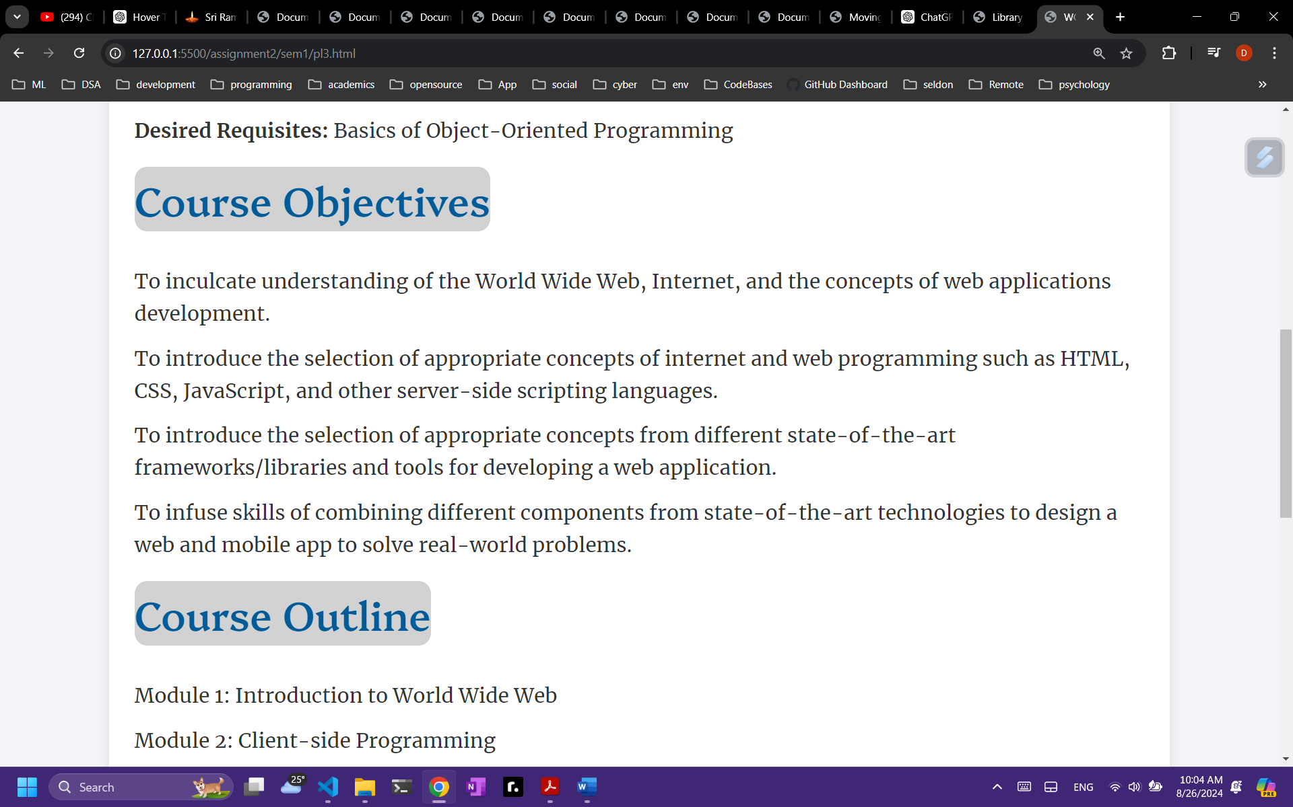
5. 