

**BSc (Hons) in Information Technology**

**Software Engineering – Year 3**

**Lab sheet 04**

**IT3050 – User Experience Engineering**

**Semester 2, 2021**



2

**Cake Hut- Cake Ordering Mobile Application**

**User Research Plan**

**GROUP ID: 2021S1_JUNE_WD_11**

|  |  |
| --- | --- |
| Student ID | Student Name |
| IT19953052 | K. A. S. S Rupasinghe |
| IT19047720 | B. N. V Mendis |
| IT19953984 | Y. N Sajani |
| IT19974774 | N. A. C. H Dasanayake |

**Table of Content**

1. Introduction 4

2. Test Objectives 5

3. Methodology 5

3.1 Interviews 6

3.1.1 Script – User 1 6

3.1.2 Script – User 2 9

3.2 Video Recordings 15

3.3 Questionnaires 15

3.3.1 Questions – Google Form 16

4. Participants Profiles 18

5. User Research – Tasks/ Scenarios 19

6. Plan for Data Analysis 20

6.1 Interviews, Video Recordings 20

6.2 Questionnaires 20

7. Conclusion and Recommendations 31

8. Appendices 32

9. Contribution 34

**List of Figures**

Figure 01 - Data Analysis - Question 01 20

Figure 02 - Data Analysis - Question 02 20

Figure 03 - Data Analysis - Question 03 21

Figure 04 - Data Analysis - Question 04 22

Figure 05 - Data Analysis - Question 05 23

Figure 06 - Data Analysis - Question 06 24

Figure 07 - Data Analysis - Question 07 24

Figure 08 - Data Analysis - Question 08 25

Figure 09 - Data Analysis - Question 09 26

Figure 10 - Data Analysis - Question 10 26

Figure 11 - Data Analysis - Question 11 27

# **Introduction**

The cake heart app is mostly used to purchase and deliver cakes, and anybody may choose a cake, place an order, pay for it online, and send it. This app is used by someone who does not return home on a regular basis to place orders for special occasions or if someone wants to deliver a cake as a gift or themselves too.

We chose a group of people who use the app. We polled the users, interviewed them, and solicited their feedback. We were able to learn more about this app's flaws, and we are now able to rebuild it to eradicate all of the flaws.

When developing the Cake Hut app, a usability test will be performed. Main focus of usability test is finding where people struggle with the app and gain recommendations for improvement. The goal is to gain a better understanding of how user engage with this mobile application and then enhance it based on the findings. This usability test's primary goal is to improve a design. Usability testing aims to increase efficiency, productivity, accuracy, overall success, and end-user satisfaction by establishing a baseline of user performance, defining and validating user performance measures, and identifying potential design flaws that need to be addressed. These observation aids team members in developing empathy for users and thinking of alternative designs, and implement that support tasks and workflow better.

# **Test Objectives**

Usability testing of Cake Hut mobile application has number of objectives.

* To identify discrepancies in design and usability issues in the user interface and content sections. The following are examples of possible sources of error:
* Navigation errors: inability to identify functions, using too many keystrokes to perform task, and failing to follow the suggested screen flow.
* Presentation mistakes include inability to identify and act on required information on displays, as well as selection errors caused by ambiguous labeling.
* Problems with control usage, such as incorrect toolbar or entry field usage.
* Under controlled test conditions with representative users, put the app to the test. The data will be utilized to see if the usability goals of an effective, efficient, and well-received user interface were met.
* Establish a baseline for user performance and satisfaction with the user interface in order to conduct future usability tests.

This test will focus on cake buyers those who are interested in purchasing cakes and exited with surprise someone by sent a cake on special occasions.

# **Methodology**

The research was carried out using two approaches. A survey and an interview were conducted online.

To collect data, an online questionnaire was employed. We research about methods we have used to gather data for confirming whether it is simple to disseminate and gather data, as well as to analyze data.

The findings of team members who employed these strategies were obtained using both quantitative and qualitative approaches. We were able to easily analyze the data from those findings and were able to quickly extract the facts we needed.

## **3.1 Interviews**

The interview conducted on Zoom technology. This was done by Software Engineer at Person private limited and chief petty officer at Sri Lanka navy forces. Participants was expected to perform a set of realistic task scenarios provided to them as quickly and efficiently as feasible, as well as offer comments on the usability and acceptability of the user interface. Participants was asked to give candid feedback on the app's usability. Each question was asked based on the app’s shortcomings and interfaces and user-friendliness. Participants was asked about how this app needs to be further improved and user journey so far with this app.

### **3.1.1 Script – User 1**

00:00:02

**Rupasinghe K.A.S.S:** Good evening, Mr. Shashi Krishan.

00:00:06

**Mr. Shashi Krishan:** Good evening.

00:00:08

**Rupasinghe K.A.S.S:** First of all, thank you very much for giving me a few minutes of your valuable time and I wanted to do a usability test. Therefore, here I will ask for few questions about Cake Hut app. The important point is I'm recording this session. Do you agree with that point?

00:00:27

**Mr. Shashi Krishan:** Yeah, I agree with that point.

00:00:29

**Rupasinghe K.A.S.S**: OK. First of all, could you please tell me some background details about you like the name, occupation, age and which time you use this mobile application?

00:00:42

**Mr. Shashi Krishan:** My name is Shashi Krishan. I'm 27 years old, currently working as a chief petty officer in Sri Lanka Navy Forces. Actually, I don't have a chance to go home often. So, I use this app to send cakes in occasions like birthdays, anniversaries of my family members.

00:01:14

**Rupasinghe K.A.S.S:** Yeah. I got the point. Well, let's move to main focus. Could you please share your screen and show me how you use this app and what do you think about this app do you like or dislike it? And if you like why you like it? If you dislike, why you dislike it. OK, tell me your opinions.

00:01:37

**Mr. Shashi Krishan:** OK, let me share my screen.

00:01:40

**Rupasinghe K.A.S.S:** Yeah, sure.

00:01:42

**Mr. Shashi Krishan:** Can you see my screen?

00:01:44

**Rupasinghe K.A.S.S:** Yeah, I can see your screen.

00:01:47

**Mr. Shashi Krishan:** OK. I will open this app.Actually it is not working I think. Let me try it again. **(**Had some difficulty while opening the app**)**

00:02:25

**Rupasinghe K.A.S.S:** Yeah. Now it's loading right, yeah?

00:02:32

**Mr. Shashi Krishan:** According to my point of view, this app should be modified. The details of this app should be updated. The logging page is also hide in here. When we moved into the logging page you can see it looks like a small card. So, it's a problem, one of the problems of this app.

00:03:10

**Rupasinghe K.A.S.S:** So, what do you think about the interfaces of this app?

00:03:15

**Mr. Shashi Krishan:** When we talk about the interfaces I think these photos are not clear and these fonts are not clear. You can see when we moved into the category page, there are some categories here. But, I can't get a clear idea about the categories, because it isn't mentioned here clearly.So, the pictures of these cakes can't be identified clearly and the fonts are not clear. They are small in size and the details that mentioned is not very clear and not well organized. So, these are some problems of this page.

00:04:18

**Rupasinghe K.A.S.S:** Yeah. OK, I can get you. So, there's a cart management feature on this app. So, what do you think about the cart management feature of this app?

00:04:32

**Mr. Shashi Krishan:** OK, I'll navigate to that page. Navigations also it's getting so much time to load when we navigate to the other page. In cart management page, you can see I have already added two cakes into this cart. But, there isn't a picture that mentions that show the actual cake, actual design of the cake. So, it's a problem. These two cakes that I added to this cart. I can't recognize easily what cake that I added to this cart.So, it's a problem.

00:05:31

**Rupasinghe K.A.S.S:** Yeah. It means you can't recognize the item you've added exactly, right?

00:05:37

**Mr. Shashi Krishan:** Yeah, I can't recognize the cake that I added to through this cart.

00:05:46

**Rupasinghe K.A.S.S:** Yeah, I got the point and it's really difficult. Yeah, OK, I'm going to give you a task. Is it OK with you?

00:05:56

**Mr. Shashi Krishan:** Yeah, it's OK with me.

00:05:58

**Rupasinghe K.A.S.S:** OK, assuming now you want to go for the homepage again, how you going to navigate? Can you show it to me?

00:06:08

**Mr. Shashi Krishan:** OK. I can show it.To go to the home page, I should, I must click back button. So, when clicking the back button, you can see it came to the category page so it won't navigate to the main page or get to the home page directly. So, it's a problem. There isn't an option to navigate to the home page easily. There isn't a button or tab to navigate to the home page easily. It's a problem.

00:06:54

**Rupasinghe K.A.S.S:** Yeah, seems like it's very difficult tasks, right?

00:06:58

**Mr. Shashi Krishan:** Yeah, it's a difficult one.

00:06:59

**Rupasinghe K.A.S.S:** Yeah, what are the other difficulties that you have faced when you using this app?

00:07:05

**Mr. Shashi Krishan:** When I go to checkout page there are so many fields to fill here. So, it's a problem.

00:07:22

**Rupasinghe K.A.S.S:** So that's another difficulty you have faced?

00:07:25

**Mr. Shashi Krishan:** Yeah, in mobile view it can't touch needed field once easily. So, it's a problem.

00:07:39

**Rupasinghe K.A.S.S:** You can't recognize details and you can't touch it easily because of the because it's small. Those fields are very small, right? Yeah, OK, So what are the things that should be corrected on this app according to your point of view?

00:08:03

**Mr. Shashi Krishan:** Actually, this form should be more user friendly. Otherwise, users have to face some difficulties. And this is thepage of checkout that means they have to use much time to purchase for the cake.

00:08:35

**Rupasinghe K.A.S.S:** So, it's very difficult to do a purchase process also, right? It wastes too much time.

00:08:44

**Mr. Shashi Krishan:** Yes, it wastes too much time

00:08:46

**Rupasinghe K.A.S.S:** OK, if this app provide facility to buy a customized cake, which means facility to design your own cake? Would you happy about that? What do you think about that opinion?

00:09:00

**Mr. Shashi Krishan:** Actually, if there is a facility like that I will be so happy because I can design my own. Cake, that means my wife and daughter can be happy because, I know the actual theme and actual design and the actual taste they like. So, I can design the cakethat I want.

00:09:34

**Rupasinghe K.A.S.S:** You can design your desired cake for them, right?

00:09:37

**Mr. Shashi Krishan:** Yeah.

00:09:38

**Rupasinghe K.A.S.S:** I noticed those suggestions and the problems difficulties. As a final question, could you please describe your user experience with this mobile application?

00:09:52

**Mr. Shashi Krishan:** Yes, definitely. I should mention those things. This app is manageable, but there are some major problems with this app and those problems should be fixed.

00:10:06

**Rupasinghe K.A.S.S:** Yeah, OK. Mr. Shashi, thank you very much for your participation.

00:10:12

**Mr. Shashi Krishan:** Thank you so much.

### **3.1.2 Script – User 2**

00:10:16

**Rupasinghe K.A.S.S:**Good evening, Mr. Janith.

00:10:20

**Mr. Janith:**Good evening.

00:10:25

**Rupasinghe K.A.S.S:**OK. Thank you very much for giving me a few minutes of your valuable time and I want to do a usability test. So, therefore here I will ask few questions about Cake Hut app and the important point is I'm recording this session. Do you agree with that point?

00:10:38

**Mr. Janith:**Of course, of course. You can record the session.

00:10:40

**Rupasinghe K.A.S.S:**OK, first of all, could you please tell me some background details about you like the name, occupation, age and which time you use this mobile app and how often do you use it?

00:10:54

**Mr. Janith:**Alright, my name is Janith. I'm 27 years old and I work as a software engineer and because of the travel restrictions which impost on the country, I was not able to visit my girlfriend and I had to use the app to send her gifts you know typical relationship stuff. I used the app quite often within this period, now also with this travel restrictions.

00:11:26

**Rupasinghe K.A.S.S:**Yeah, well. Let's move to the main focus. Could you please share your screen and show me how you use this app and what do you think about this app? Do you like it or dislike it?

00:11:46

**Mr. Janith:**Yes, yes. So, should I share my screen now?

00:11:56

**Rupasinghe K.A.S.S:**Yeah.

00:12:01

**Mr. Janith:**All right, am I visible?

00:12:02

**Rupasinghe K.A.S.S:**Yeah, yeah. OK, now I can visible. OK, tell me what do you think about the Cake Hut app and do you like or dislike it and tell me why you like it? Why you dislike it?

00:12:22

**Mr. Janith:**As an app it works of course, but the way the app is made is quite not user friendly. I'd say yeah, it's not user friendly at all, right.So, one my first and the main concern is that the font size of this app is quite horrible, all right. I mean, you can barely see the descriptions on these lists of the products that they're selling on this app and the the icons aren't really user friendly. I mean sometimes the items aren't even that recognizable, so it's really hard. Really, really uninteresting to use the app. It feels like a chore. I'm sure you get my point.

00:13:22

**Rupasinghe K.A.S.S:**Yeah, I got the point. OK, what do you think of the interfaces of this app? Give me your opinion.

00:13:31

**Mr. Janith:**Well, I use that quite a lot and specially, when it comes to the login page, the fields are really small and it's hard to handle because we're working on touchscreen right. So, when you touch the screen it doesn't always touch the field I want to touch because it's so small. I'm guessing you're quiet, you're catching my drift.

00:13:58

**Rupasinghe K.A.S.S: C**ould you please navigate to the login page and say.

00:14:03

**Mr. Janith:**OK, of course. Here we have the login page and one of my other main concern is that the footer of this page, just feels way too big for the login interface and like you would expect the login fields to be somewhere around here, right, in the middle of the screen where, it normally should be in in order to be user friendly, right.But this app doesn't give you that option and it's, way over here and it's too small, like you can't even recognize this page as a login page. That's one of my main concerns with the login page and here as you can see here, this font size is really small and this is really uninspired. I mean the colors, there are no pictures at all in the login screen and it's really boring to use.

00:15:05

**Rupasinghe K.A.S.S:**Which means the colors not OK, font size and all those things? Yeah, you are not OK with those things right. OK, So what do you think about the Cart management feature of this app?

00:15:24

**Mr. Janith:**Let me go to the cart management first. One of my main concerns about the cart management is that when you add something to the cart it doesn't show you a picture of what you already added. I mean, it's kind of like comprehend what you have already added to the cart of your app right. So, sometimes I can't even recognize what I have already wanted to purchase when I add something to the cart because I can't see what it is and the font size is so small. I mean like you can see right here, right. Yeah, I mean it's completely unreadable and even if you read the font size this information doesn't really matter to the cart, right.We just need the name of the product that you are purchasing and I also have that other concern I had before, like right here, the footer is way too big and this is just a cart, right.I mean, you don't even need a footer here, but it is there. I mean, it doesn't feel like an app it feels like some sort of a website. I'm guessing you're catching my drift.

00:16:43

**Rupasinghe K.A.S.S:**Yeah, yeah, I caught your clips and you mean that you cannot recognize which items you added to the cart right, without images?

00:16:54

**Mr. Janith:**Yeah, and it's very, very uninspired. I mean, it looks horrible. I'm sorry, but it looks horrible. OK. You wouldn't even want to buy something of this app unless you had the need to. That's what I'm saying.

00:17:10

**Rupasinghe K.A.S.S:**Yeah, OK, I can clearly get you. OK, now I'm going to give you a small task. Are you OK with it?

00:17:19

**Mr. Janith:**OK.

00:17:21

**Rupasinghe K.A.S.S:**OK, assuming now we are going to purchase for some cake. So, can you show me how you are going to navigate to payment options and how you are going to check out particular cake?

00:17:42

**Mr. Janith:**Well.Since I'm already here. These items already added. I'm sorry, can you repeat the question please?

00:17:57

**Rupasinghe K.A.S.S:**OK, I mean that can you show me how you are going to check out particular cake? Can you show me the steps?

00:18:07

**Mr. Janith:**OK, I picked something here and then if I need to enter the coupon.

00:18:19

**Rupasinghe K.A.S.S: C**ould you go with checkout options?

00:18:35

**Mr. Janith:**OK. It takes so much time to load too.

00:18:40

**Rupasinghe K.A.S.S:**Yeah, I can see it.

00:18:41

**Mr. Janith:**It's unbearable. And yeah, that is the other concern I have about the checkout option. Is it OK if I go now or do you have a particular question that you had asked me?

00:18:56

**Rupasinghe K.A.S.S:**I'm sorry.

00:19:02

**Mr. Janith:**Is it OK if I just go on with the concerns I have or do you have a particular question that you have to ask me about the checkout option?

00:19:10

**Rupasinghe K.A.S.S:**Tell me your concerns. It's OK.

00:19:13

**Mr. Janith:**OK, so you see, when you usually get to checkout option you just want to buy what you added to the cart, right. But here you can see there are multiple pages that you have to go through, and each page has a form which has way too much information to fill. All right? So, let me just, I gave some random email and.

00:19:41

**Rupasinghe K.A.S.S:**And now you can go through checkout right, because we don't have much time to go further registration and other things.

00:19:52

**Mr. Janith:**All right, so my concern was that this has way too many pages like you see right here. There are so many fields that you have to fill in all right and it's just very tiring and this is just a second page and there are like 6 pages after this. I mean four pages after this even after you fill this much fields in the second page. I mean, you don't want to use something like this. I mean, unless you have the need to. That's my point

00:20:26

**Rupasinghe K.A.S.S:**Yeah, I can get you so these are the very difficult talks to you, right?

00:20:30

**Mr. Janith:**Yes, yes, it's really tired.

00:20:31

**Rupasinghe K.A.S.S:**OK. OK, what are the other difficulties that you faced when you using this app?

00:20:41

**Mr. Janith:**One of my main concern is the color palette they use. I mean, it's a food purchasing app, right? It should be like interesting and then like fun to use, yeah? But right now, right here it is not. I mean, it just has some brown theme and I seriously hate it. And the icons are too small and unrecognizable. And yeah, the font size of course, I'm just filtering back it always.Yeah, that is one of my biggest concerns. The font size, it's horrible.

00:21:16

**Rupasinghe K.A.S.S:**OK, so, that's the biggest difficulties you have faced so far, right?

00:21:26

**Mr. Janith:**Yeah, yeah.

00:21:27

**Rupasinghe K.A.S.S:**According to you, what are the things that should be corrected on this app?

00:21:33

**Mr. Janith:**Well, actually there is one more. Would you give me time to present it? Is it OK?

00:21:47

**Rupasinghe K.A.S.S:**Yeah, it's OK.

00:21:49

**Mr. Janith:**OK, let's say we're here, right? We are in the checkout and we are on the second page of the checkout. Let's say you abandoned the checkout for some reason you have to do that and if you try to go back to the home page, you can't really go back to the home page. There is no button to go back to the home page. You have to go through every step, step by step back each step we have to go back to again. It can be really, really terrible to use sometimes. Yeah, that is also one of the other concerns that I have.

00:22:22

**Rupasinghe K.A.S.S:**There's no home button or a tab in this app they provide, right?

00:22:28

**Mr. Janith:**Yeah, yeah, there's no home button.

 00:22:19

**Rupasinghe K.A.S.S:**It seems like it's really horrible yeah. So, I want to know about your opinion if this app provides the facility to buy a customized cake, which means facilitated to design your own cake. Would you happy about that? What do you think about that?

00:22:48

**Mr. Janith:**Yeah, that would really be wonderful. Yeah, I'd be able to send multiple gifts to multiple people, not just my girlfriend.

00:23:00

**Rupasinghe K.A.S.S:**OK, great, I notice those things. As final question could you please describe your user experience with this at mobile application?

00:23:11

**Mr. Janith:**Well, that's the app work done, but the app is horrible, just horrible. It's not interesting to use, it's not inspiring. The colors are just terrible and it was not a good time to use.

00:23:28

**Rupasinghe K.A.S.S:**Seems your user journey make you troublesome right?

00:23:32

**Mr. Janith:**Yeah, definitely.

00:23:34

**Rupasinghe K.A.S.S:**OK, OK, Mr. Janith. Thank you so much for your participation.

00:23:41

**Mr. Janith:**Yeah, I thought you asked me what are the improvements that you can do to the app right? Should I list them down? I actually have few suggestions.

00:23:55

**Rupasinghe K.A.S.S:**Yes, you can.

00:23:56

**Mr. Janith:**Well, you can start by changing the font size, right? The font size is a disaster. In this app you just have to make it bigger, right. And give the user less information. I mean whenever you are making a checkout, adding less steps or whenever you are showing. In the cart option, like right here, let me show you. OK, like right here there is too much information about the product we're purchasing. We don't need this much information. We already checked this and then put it into the cart right. So, you don't have to show everything to us, so you can just give the name and picture so it would be visible, right. I would go for much user-friendly icons than this. These icons are not very interesting at all and the and the color palette. I'd go with a different color. I mean the theme. I'd go with a different theme. That's pretty much.

00:25:06

**Rupasinghe K.A.S.S:**OK, thank you so much Mr. Janith. You have provided too much information about this app too much suggestions.

00:25:13

**Mr. Janith:**My pleasure.

00:25:16

**Rupasinghe K.A.S.S:**Thank you so much for your participation. Actually, we are looking forward to improving this app very better way, right. So, thank you for your suggestions Mr. Janith. Thank you for your participation again.

00:25:30

**Mr. Janith:**Alright, should I stop sharing my screen?

00:25:37

**Rupasinghe K.A.S.S:**OK thank you Mr. Janith and goodnight.

00:25:42

**Mr. Janith:**Good night to you too.

## **3.2 Video Recordings**

The participant was seated at their workstation in their work environment. We conducted our interview through zoom platform and we recorded the interview through the ice cream screen recorder and before the interview we have train them to get their mobile screen view on their laptop via team viewer. After interviewed the two participant we merged two video and presented them as one.

Video reference link: <https://mysliit-my.sharepoint.com/:f:/g/personal/it19953984_my_sliit_lk/Eih2cVbzMd5KsMnGPyNoSCkBExJViO_KiOTrcaWD5U6m0A?e=PKRcn2>

### **3.3 Questionnaires**

The Google form was used to create the questionnaire. The reason to use of Google form because it is easy to distribute and collect data and also it is easy to data analyzation

We selected 117 users and distributed the link through WhatsApp groups.

Questionnaire is included,

* Ensure that the user has prior familiarity with mobile apps.
* What do consumers anticipate from them when they utilize them?
* Is the product satisfactory to them?
* What challenges did they encounter when using the application?
* What are the anticipated enhancements?

We used both open-ended and closed-ended questions in our online poll. However, we have included more closed ended questions to increase ensure and ensure that participants do not become bored while going through it. Finally, we analyzed the answers and determined which functions needed to be changed.

### **3.3.1 Questions – Google Form**

**Cake Hut App User Experience Feedback**

1. Gender *

* Male
* Female

1. Age *

* Below 18
* 18 – 30
* 30 – 40
* 40 – 50
* Above 50

1. Are you someone who often order cakes to celebrate your special occasions? *

* Yes
* No

1. In what kind of occasions do you usually order cakes to celebrate? *

* Birthday
* Anniversary
* Valentine
* Wedding
* Christmas

1. Ease of finding the desired category? *

|  |  |  |  |  |  |  |
| --- | --- | --- | --- | --- | --- | --- |
|  | 1 | 2 | 3 | 4 | 5 |  |
| Easy |  |  |  |  |  | Difficult |

1. Is it easy to do the registration and payment process? *

* Yes, it is easy
* Yes, it has good user experience
* No, I found it difficult
* No, too much steps to go through

1. How do you feel about the login experience? *

* Interface is too small
* Could not recognize at first glance
* Easy to logging

1. Support you get from the app to manage shopping cart? *

* Difficult to recognize added items
* Difficult to increase quantity
* Easy to manipulate

1. Is it easy to navigate through the app? *

* Yes
* No

1. Would you like to add a feature to buy customized cake instead of pre-made? *

* Yes
* No

1. Rate your experience about *

1 – Good, 5 – Bad

|  |  |  |  |  |  |
| --- | --- | --- | --- | --- | --- |
|  | 1 | 2 | 3 | 4 | 5 |
| Color theme |  |  |  |  |  |
| Font size |  |  |  |  |  |
| User friendliness |  |  |  |  |  |
| Attractiveness |  |  |  |  |  |

1. Suggestions about the overall experience *

# **Participants Profiles**

|  |  |  |
| --- | --- | --- |
| **Name** | **Demography** | **Location, Date and Time** |
| **User 1**  Shashi Krishan | Age: 27 years  Gender: Male  Occupation: Chief petty  officer in Sri Lanka Navy  Forces  Status: Married  Location: Hambantota | Location: Zoom Platform    Date: 18/08/2021    Time: 8.00 P.M. |
| **User 2**    Janith Perera | Age: 27  Gender: Male  Occupation: Software  Engineer  Status: Unmarried  Location: Matale | Location: Zoom Platform    Date: 19/08/2021  Time: 6.30 P.M. |

# **User Research – Tasks/ Scenarios**

|  |  |  |  |
| --- | --- | --- | --- |
| **No.** | **Task Instruction** | **Target** | **Probes** |
| 1 | Share the screen and open the Cake Hut app on the mobile phone. | Check whether is there any issues with opening the mobile application. | The user was struggling when  opening the mobile app but  after the second attempt he  was able to open the app. |
| 2 | Ask to show the issues in point of view of the user. | Identify the issues with the mobile application that the users have to deal with. | The user successfully pointed  out the issues that he  identified by using the mobile  application. |
| 3 | Ask user to navigate to the  home page again. | Check the issues with the navigation through the mobile application. | The user was struggling when  navigate to the home page again  because within the app there is no  option to navigate to the home page directly. Finally, he navigated to the home page by clicking back button several times. He had to pass each and every step back to navigate the home page again. |
| 4 | Ask user to navigate to the  login page and ask what is  opinion about the login  page. | Identify the issues with the login interface. | The user successfully navigated to  the login page and listed the issues with the login page. |
| 5 | Ask user to show how to  checkout particular cake  and what are the steps to  purchase a cake through  the mobile application. | Identify the issues with the payment process. | The user had faced some difficulties when go through the payment process and he said that the checkout process is a troublesome because there are so many steps to go through. |

# **Plan for Data Analysis**

## **6.1 Interviews, Video Recordings**

According to the opinions of the users in the two interviews, the most important things are that the app should be more user friendly and there are many steps in the payment and registration processes. Because of the font sizes are small, it is difficult to identify the description in the cake list view. Interfaces are difficult to handle because they work with touch screens. The other thing is that the app is hard to navigate between UIs. Cart Management needs to be more user friendly and users have liked to add the feature to this app which can customized cakes. At the end of those interviews, the final conclusion was that this app needs to be rebuild by adding more user friendliness to all features of the app.

## **6.2 Questionnaires**

This is the data analysis of our questionnaire**:**

This data analysis covers all the questions we used to collect data from the survey. All the data have been presented by using pie charts, bar graphs, and detailed graphs.

1. **Gender**

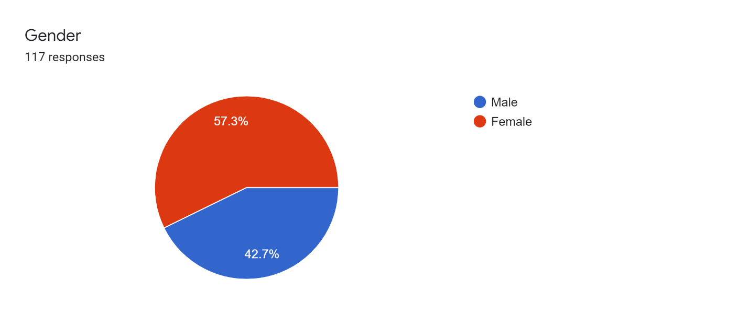

Figure 01 - Data Analysis - Question 01

Gender is the first fact focused on. From 117 respondents, more than half (57.3%) were females. The rest proportion at 42.7% is males. Compared to men, mostly girls and women love to celebrations, surprises and parties. That may be the reason for 57.3% of majority comes under female category.

1. **Age**

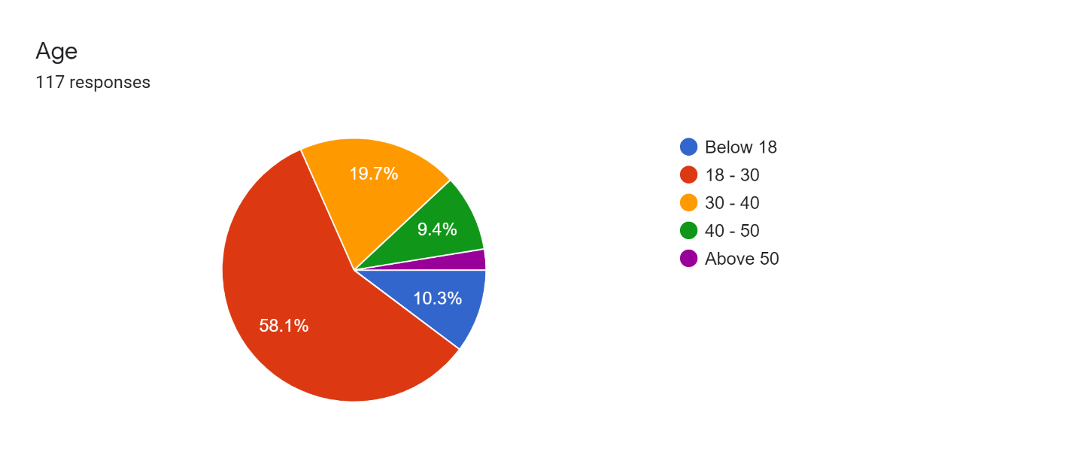

Figure 02 - Data Analysis - Question 02

According to this chart, approximately a three – fifths (58.1 %) of the sample population were age of 18 – 30. About a fifth (19.7%) has represented the age of 30 – 40. Only 9.4% of respondents are between the ages of 40 and 50. More than one in ten (10.3%) were under 18 years of age. From the 117 respondents, only 3 were above 50 years of age. As can be seen from this chart, most of the youngers celebrate their special occasions with cakes.

1. **Are you someone who often order cakes to celebrate your special occasions?**

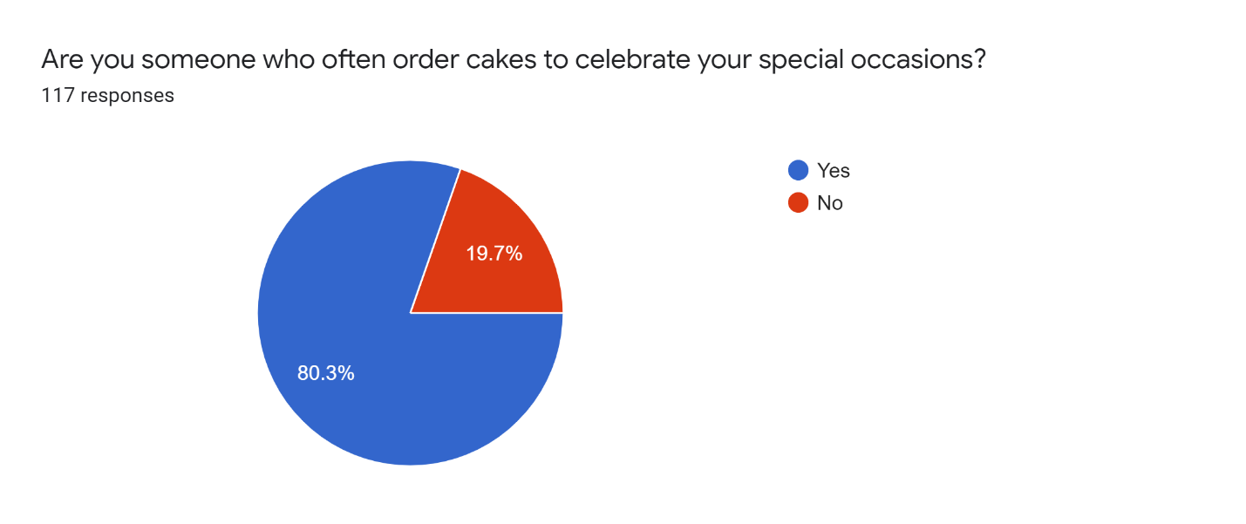

Figure 03 - Data Analysis - Question 03

According to this data, more than a fourth – fifths (80.3%) of the sample population were the people who often order cakes to celebrate their special occasions and rest of about one-fifth were the people who often do not order cakes at their special occasions.

1. **In what kind of occasions do you usually order cakes to celebrate?**

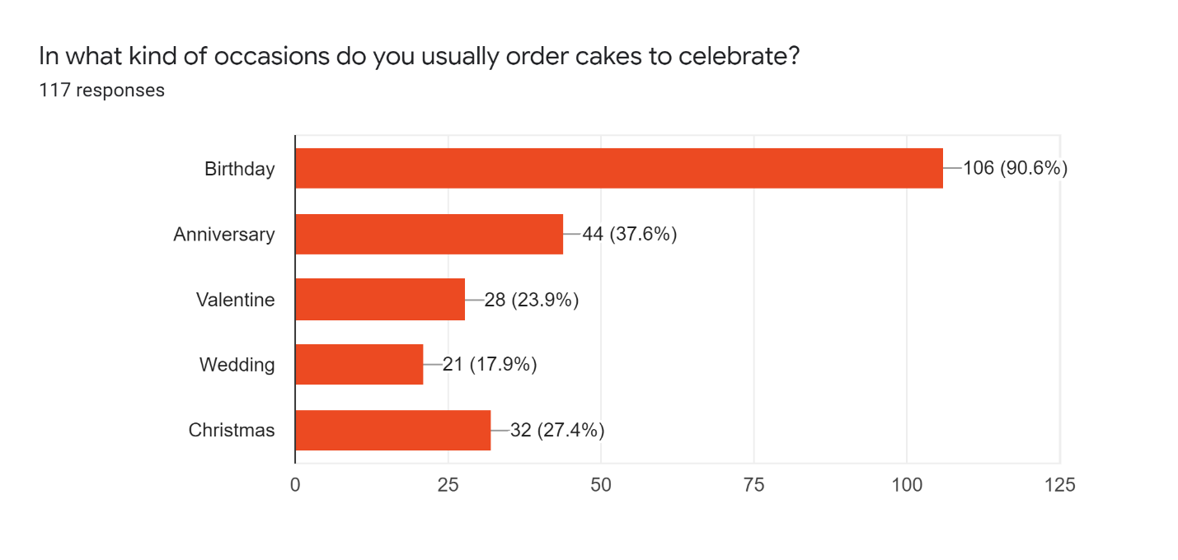

Figure 04 - Data Analysis - Question 04

This bar chart illustrates the occasions which people usually order cakes to celebrate. One respondent can have one or more occasions. The majority (106) of the sample population order cakes for birthdays. The considerable number (44) of the people order cakes for anniversary celebrations. 21 people have selected the wedding as the occasion which they order cakes to celebrate. Valentine has been selected by 28 people as their occasion to celebrate by ordering cakes. As well as, 32 people celebrate Christmas by ordering Christmas cakes. It seems, most of the people ordering cakes for birthday celebrations. Because, each and everyone has a birthday once a year. They celebrate it with cakes and their friends organizes surprise parties for them. And also they give parties with cakes for their friends. According to these reasons, birthday celebrations are common occasion to everyone. That is why majority comes under birthday category.

1. **Ease of finding the desired category?**

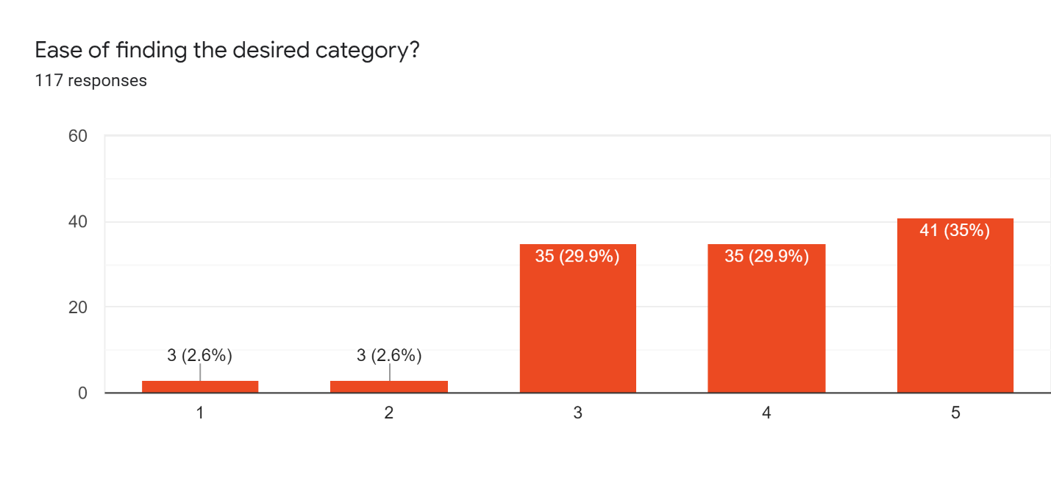

Figure 05 - Data Analysis - Question 05

This bar chart depicts the ease of finding their own desired category through the cake hut mobile application.

In this questionnaire we used rating method-linear scale for this feedback. These are the values and the status which representing the values,

1-Very Easy

2-Easy

3-Moderate

4-Difficult

5-Very Difficult

The majority (35%) of the sample population has mentioned finding desired category is too difficult (5). Approximately, a third (29.9%) has a moderate (3) idea about ease of finding the desired category and similar proportion (29.9%) has mentioned that task was difficult for them. Small fraction (2.6%) depicts 3 respondents have voted by saying finding the desired category is very easy (1) and similar proportion (2.6%) has mentioned as this task is easy (2).

1. **Is it easy to do the registration and payment process?**

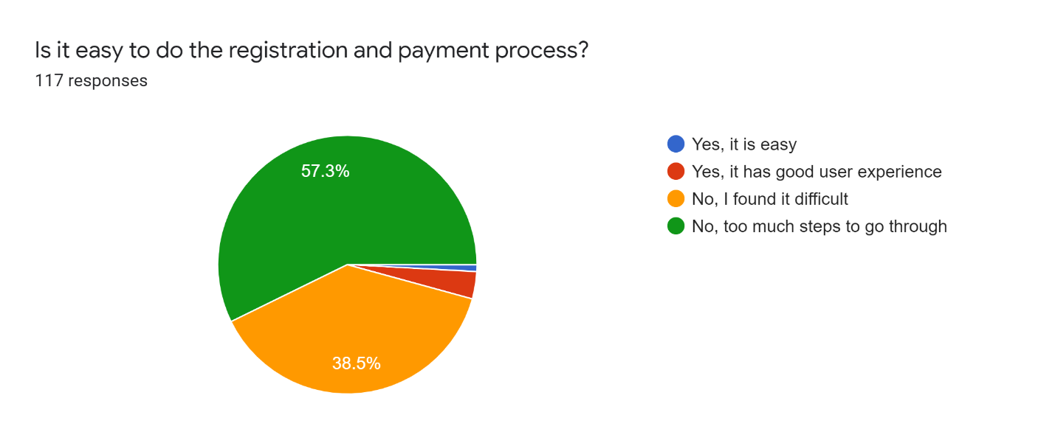

Figure 06 - Data Analysis - Question 06

This pie chart illustrates the respondent’s idea about registration and payment process in the app. Approximately, a third – fifth (57.3%) have said too much steps to go through to complete registration and payment process. About, a second – fifth (38.5%) says they found payment and registration processes difficult. When considering the details, small fraction has good user experience. 1 respondent has responded as payment and registration processes are easy. Above graph shows that the payment process and the registration processes have a difficulty with too much steps to go through.

1. **How do you feel about the login experience?**

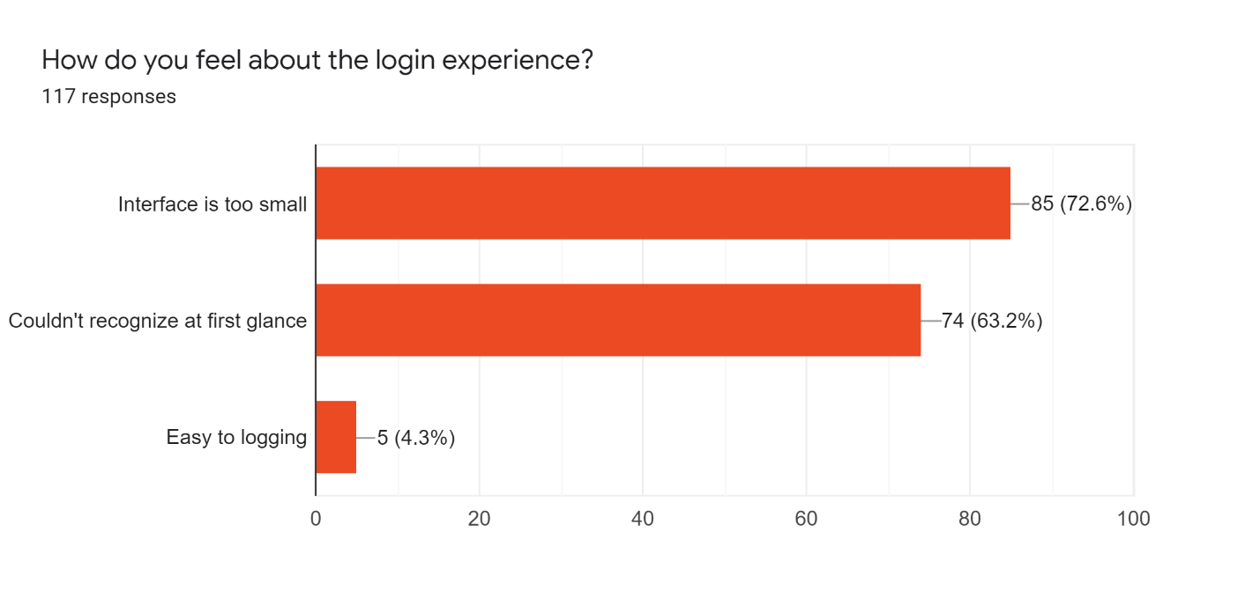

Figure 07 - Data Analysis - Question 07

This chart represents the feelings about login experience in the app. One respondent can have one or multiple options. Majority (85 respondents) has said login interface is too small and considerable number of respondents (74) have felt that login could not recognize at first glance. Small proportion (5 respondents) has held easy to logging opinion. According to above analysis, login experience is difficult because majority have said that login interface is too small and could not recognize at first glance.

1. **Support you get from the app to manage shopping cart?**

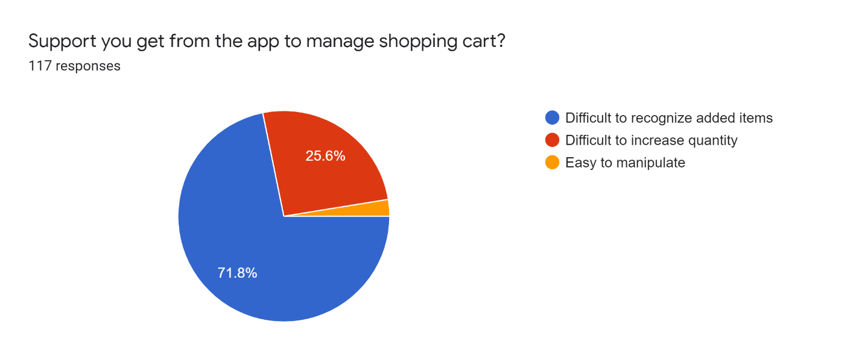

Figure 08 - Data Analysis - Question 08

This chart depicts idea about the support users can get from the app to manage the shopping cart. Among the 117 respondents, the majority (71.8%) has held the difficult to recognize added item opinion. Approximately, a quarter of respondents have said that difficult to increase quantity of the product after adding to the shopping cart. Only 3 respondents have held the opinion of easy to manipulate. According to above details, managing the shopping cart is difficult because difficult to recognize added items to the shopping cart and difficult to increase quantity after adding the product to the shopping cart.

1. **Is it easy navigate through the app?**

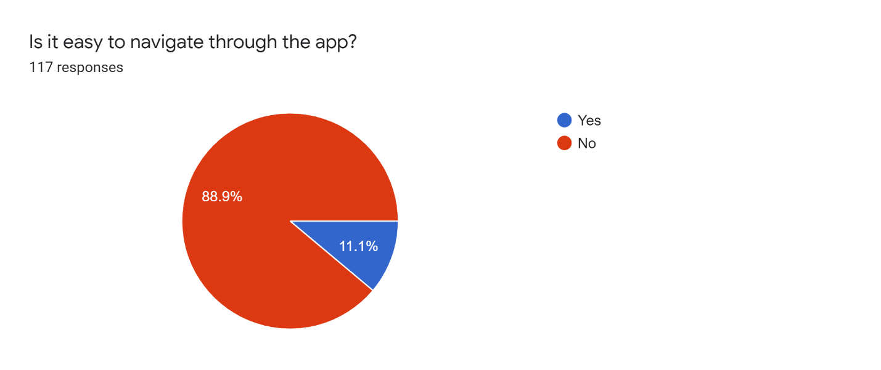

Figure 09 - Data Analysis - Question 09

This chart illustrates the opinion of users about the navigation through the app. Majority (88.9%) has said that navigation through the app is difficult and small fraction (11.1%) has held the opinion of easy to navigate through the app.

1. **Would you like to add a feature to buy customized cake instead of pre-made?**

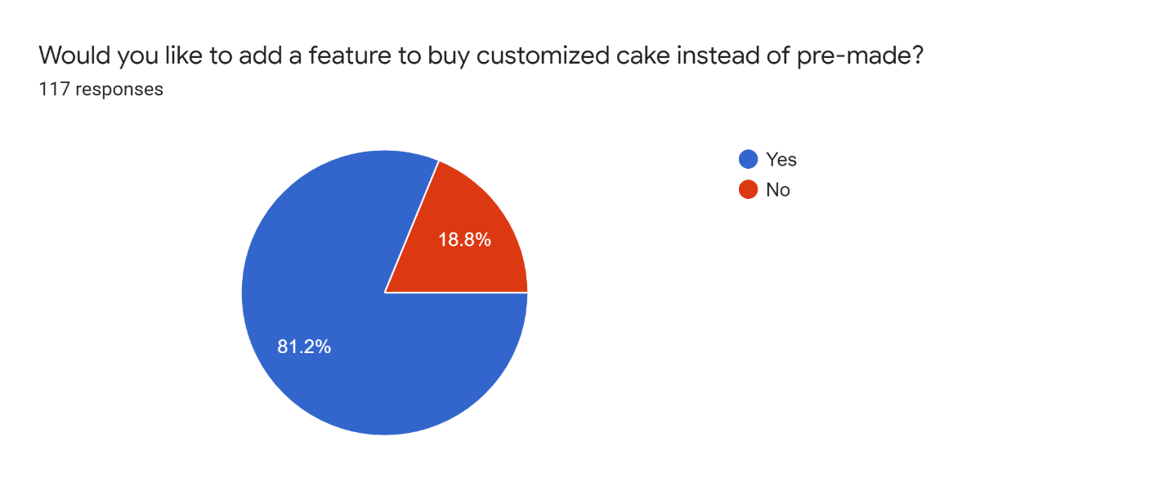

Figure 10 - Data Analysis - Question 10

This chart shows the preference of the users to add a feature to buy customized cake instead of pre-made. Majority (81.2%) has liked to add that feature. Rest (18.8%) of the population do not like to add the customized cake feature. According to above details, this shows that most of the users prefer to buy customized cakes according to their requirements rather than pre-made cakes.

1. **Rate your experience about**

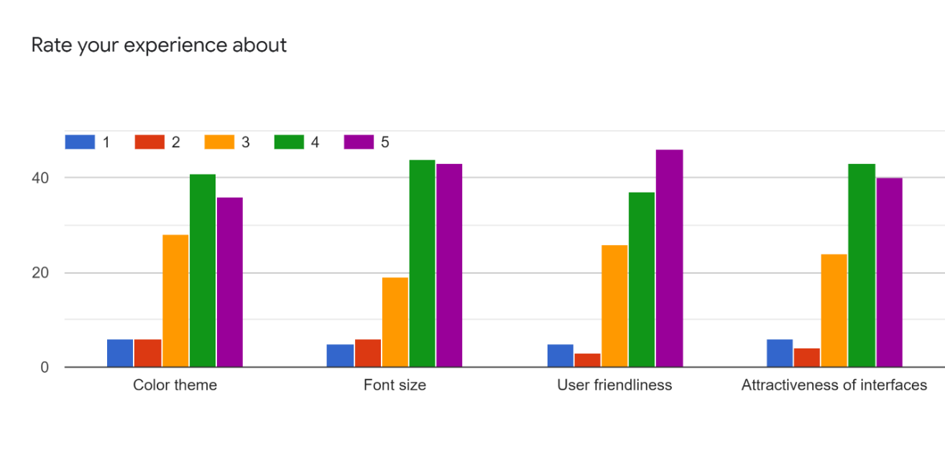

Figure 11 - Data Analysis - Question 11

This bar chart illustrates the ratings of users’ experiences about color theme, font sizes, user friendliness and the attractiveness of interfaces in the app.

In this questionnaire we used rating method-linear scale for this feedback. These are the values and the status which representing the values,

1-Very Good

2-Good

3-Moderate

4-Bad

5-Very Bad

According to this chart, 41 from 117 respondents have said that color theme is bad and 36 respondents have held color theme is very bad opinion. 28 users have moderate idea about the color theme of the app. Very few users have said that color theme is good. When considering about the font sizes of the app, 44 respondents and 43 respondents have said that font sizes are bad and very bad respectively. 19 out of 117 users have a moderate idea about the font sizes. Same as the font colors, only very few have satisfied with the font sizes of the app. When considering the above details, majority have said that app this not user friendly. 46 respondents from 117 have said that app has very bad user friendliness. 37 respondents have the opinion of bad user friendly. 36 have moderate idea about the user friendliness of the app. Again similarly, a small fraction has said that app has good user friendliness. The last fact that has been considered is attractiveness of the interfaces. Opinions on attractiveness of interfaces of the app are similar to opinions on other facts. 43 respondents have given their vote for the 4 (Bad) and 40 respondents have given for the 5 (Very Bad). Majority are not satisfied with the attractiveness of the interfaces. And 24 users have moderate idea about that. A few of respondents have said that attractiveness of interfaces are very good. This shows that most of the users have given a bad rating to this app for its color theme, font size, user- friendliness and attractiveness of the interfaces.

1. **Suggestions about the overall experience**

Less user friendliness

Not good

Can't search cakes

No

Bad

bad

Can't search cakes

Cannot search cakes

It would be nice if some features were further developed by increasing user experience. Ex: payment process, registration process, login

It's better to add the customized cake feature to the app

There is a bit difficulty in payment and registration process. Too many steps in here.

User journey is very troublesome so far

No experience

No experience

Better to increase user experience in this app. Difficult process in registration and payment. Too many steps.

Should be updated

Modify the app

Good

Need many more improvements

It is difficult to use

not good

This app is very bad

Make the font size smaller

This application needs to be further developed.

Useless 😑

Not good

Do not satisfy

Key features like registration, payment, search are very complex when using this app. If the app can be redesigned in an easy-to-use, user-friendly way, it will be a good thing for the users of the app.

Can't search cakes

Good

Can't search the cake categories.

It Should be increased user attraction & multiple functions

Payment process is too much long

page color theme is not good.

font sizes are not user friendly

This app should be more user friendly

Better to increase user friendless

Font size and color theme is not good.

If you can make the interfaces more user-friendly it will be fine

interfaces are not user friendly

Better to increase user friendliness and the usability

difficult to fill registration form. No order history. It is needed

this is not user-friendly app

difficult to use

Payment is so difficult. Too many steps

Color theme and font sizes are very bad. Too much information like a web site

interfaces are not attractive

not user-friendly

colors are not suitable

Difficult to use

too much steps in register form

Better to improve payment and the registration process.

Should improve the user experience of the app

Should be more user friendly

Must have to decrease steps of registration

Should improve the app

Should improve payment and registration

Less user friendliness

Should be modified

Cannot manage

Very bad

Difficult

Worst app ever

Needs lot of improvement

should increase user friendliness

should be more user friendly

Payment and registration are very difficult. Should be improved

too many steps in registration and payment. It should be more user friendly

Cannot find desired cakes at ones. no search bar

usability should be increased

payment and registration are difficult. too many steps.

Bad. app should be more improved

like a website. too many info.

Cannot search cakes

searching cakes is difficult

payment and registration process are difficult. No order history

Need some of big improvements

should be more user friendly

Can't search cakes

Categories are very hard to identify, registration, login are not user friendly

Color theme is not suitable

Steps are too much to find proper cake category

Need more user friendly UIs

cannot find cakes easily. payment process is difficult

Can’t find categories

should add more user friendliness

payment and registration processes are too long

These are the suggestions made by respondents, there are 117 responses for that section.

Most of the users have suggested to increase the user- friendliness of the app and most of the users have said that the registration process and the payment process are very complex. As well as, most of the users have said that there is no option to search cakes and hard to find desired cakes. And users have suggested to add a feature to order customized cakes.

# **Conclusion and Recommendations**

**Conclusion**

* Most of the users have the issues in registration and payment processes
* Most of the users had issues in searching cakes
* Some of users have suggested to add a feature to buy customized cake
* Majority are not satisfied with the app
* According to the responses most of the users are male
* Most of the users are age of between 18 and 30
* Many users like to develop the app by adding more user- friendliness
* Users have suggested to add user- friendly color theme and font sizes
* Some of the users have suggested to add order history feature
* Some users have issues in login
* Most of the users like to add a search bar to search cakes
* Many users have said that this app is like a web site because of its too much information

**Recommendations**

* Rebuild the payment and registration process by adding more user- friendliness
* In addition to buying pre- made cakes, add a feature to buy customized cakes
* Add an order history
* Add filtering, searching and sorting options to select desired cakes
* Add a new color theme and new fonts
* Redesign interfaces by adding more attractiveness and without including too much information
* Redesign the login UI more attractively

# **Appendices**

**8.1 Interview – Questions**

**Interview 1 – Questions**

1. In which time do you use this mobile app?
2. How do you use this app and what do you think about this app? Do you like or dislike it?
3. If you like why do you like it? If you dislike, why do no like it?
4. What do you think about the interfaces of this app?
5. What do you think about the cart management feature of this app?
6. How are you going to navigate back to the home page again?
7. What are the other difficulties that you have faced when you using this app?
8. What are the things that should be corrected on this app according to your point of view?
9. If this app provide facility to buy a customized cake, which means facility to design your own cake. Would you happy about that? What do you think about the opinion?
10. Could you please describe your user experience with this mobile application?

**Interview 2 – Questions**

1. In which time do you use this mobile app?
2. How do you use this app and what do you think about this app? Do you like or dislike it?
3. What do you think about the Cake Hut app and do you like or dislike it and tell me why do you like it? Why do you dislike it?
4. What do you think about the interfaces of this app?
5. What do you think about the cart management feature of this app?
6. How you are going to navigate to payment options and how you are going to checkout a particular cake?
7. What are the other difficulties that you have faced when you using this app?
8. According to you, what are the things that should be corrected on this app?
9. If this app provide facility to buy a customized cake, which means facility to design your own cake. Would you happy about that? What do you think about the opinion?
10. Could you please describe your user experience with this mobile application?

**8.2 Questionnaire – Google Form**

<https://forms.gle/v8MgH4ARuvfMAkyT7>

# **Contribution**

|  |  |  |
| --- | --- | --- |
| **IT Number** | **Name** | **Contribution** |
| IT19953052 | K. A. S. S Rupasinghe | * Contributed to conduct two interviews * Document preparation * Conducted research and caught important points |
| IT19047720 | B. N. V Mendis | * Contributed to conduct two interviews * Document preparation * Conducted research and caught important points |
| IT19953984 | Y. N Sajani | * Contributed to conduct two interviews * Document preparation * Conducted research and caught important points |
| IT19974774 | N. A. C. H Dassanayaka | Merge the video recodings |