Lab Practical 03 - Identify user groups

|  |  |
| --- | --- |
| IT19122656 | Kavishka K.A.L |
| IT19048642 | Rashmi Raveena .S |
| IT19023410 | Masakorala M.H |
| IT19158396 | Amarasinghe C.K. |

## Create Persona(s)

* **Persona 01**

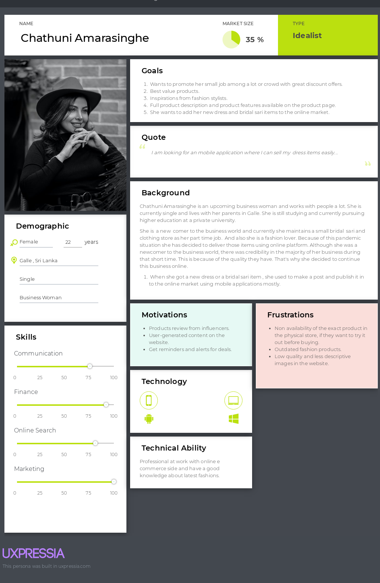

* 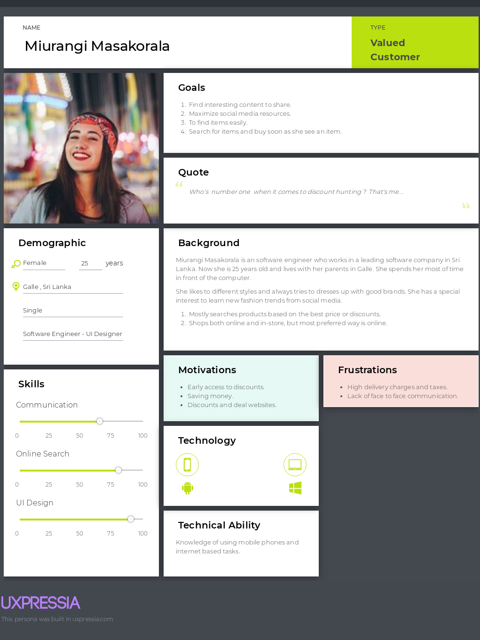**Persona 02**
* **Persona 03**

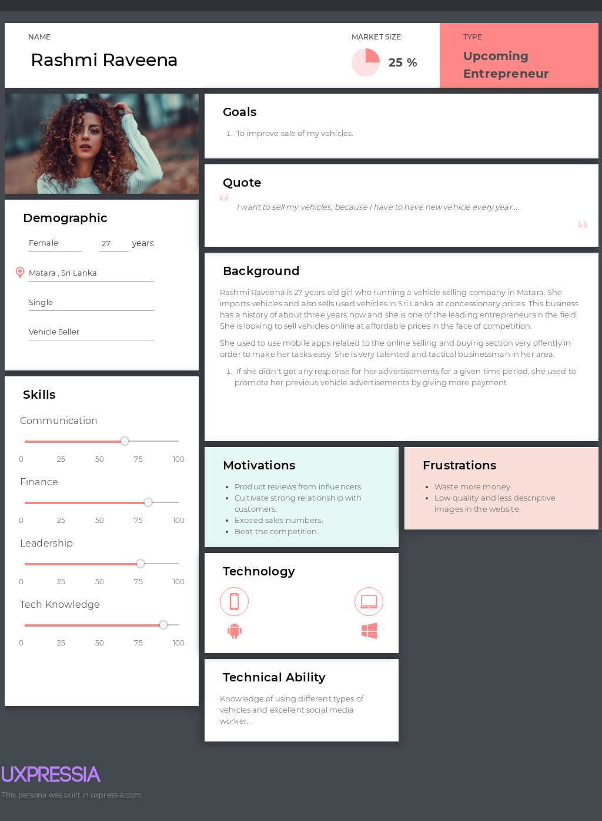

* 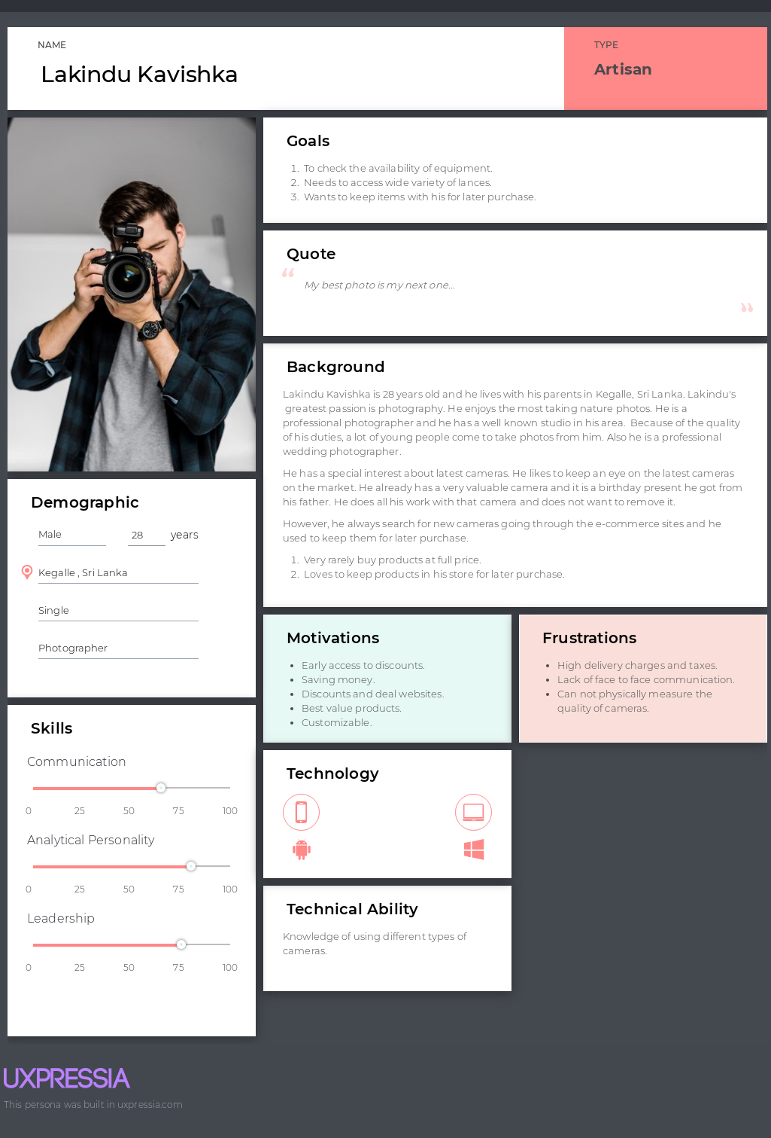 **Persona 04**

## Empathy map(s)

* 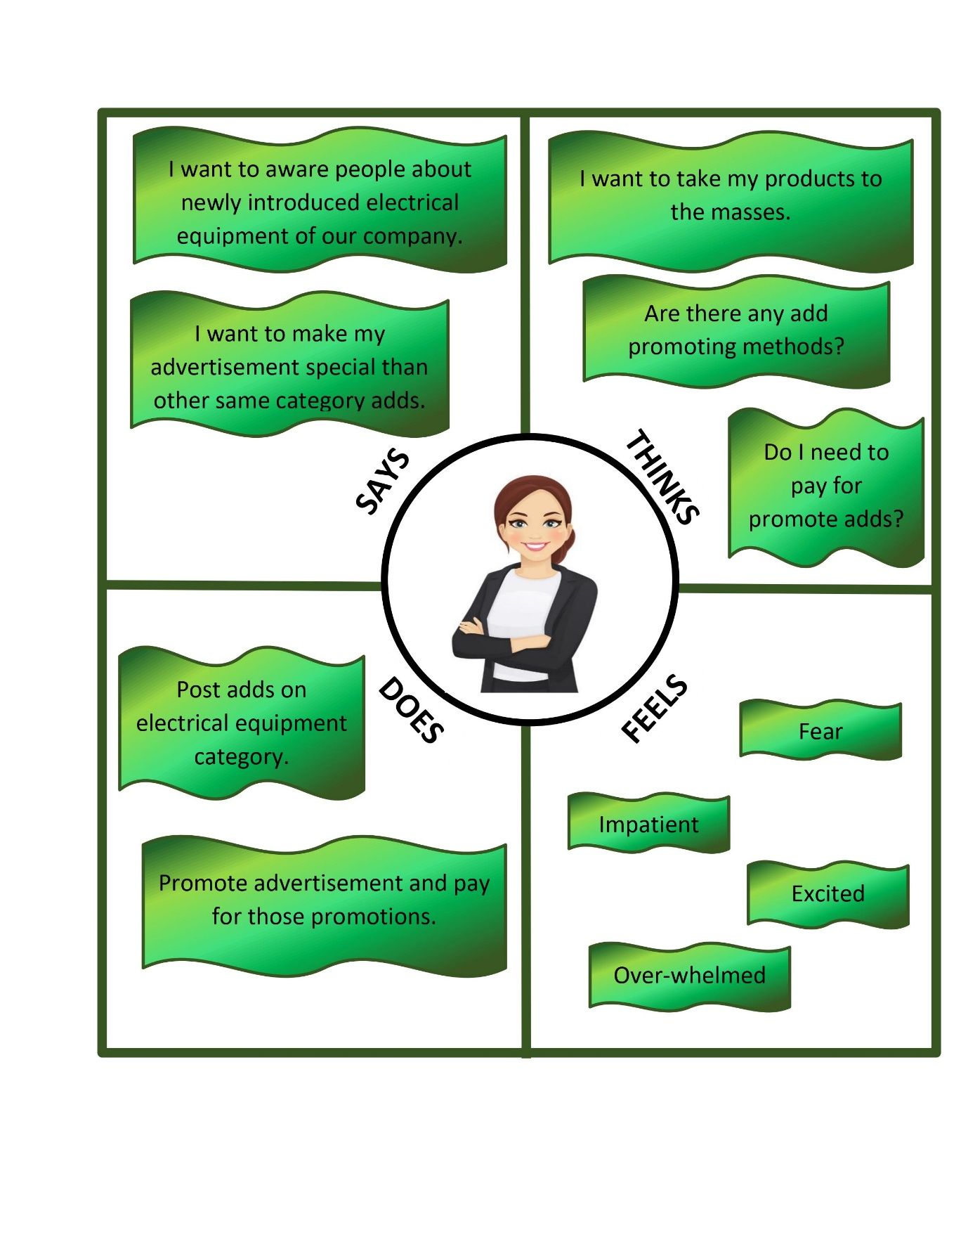A Business Woman is advertising newly introduced electrical equipments in her company.
* A Software Engineer is looking for a good quality laptop to buy.

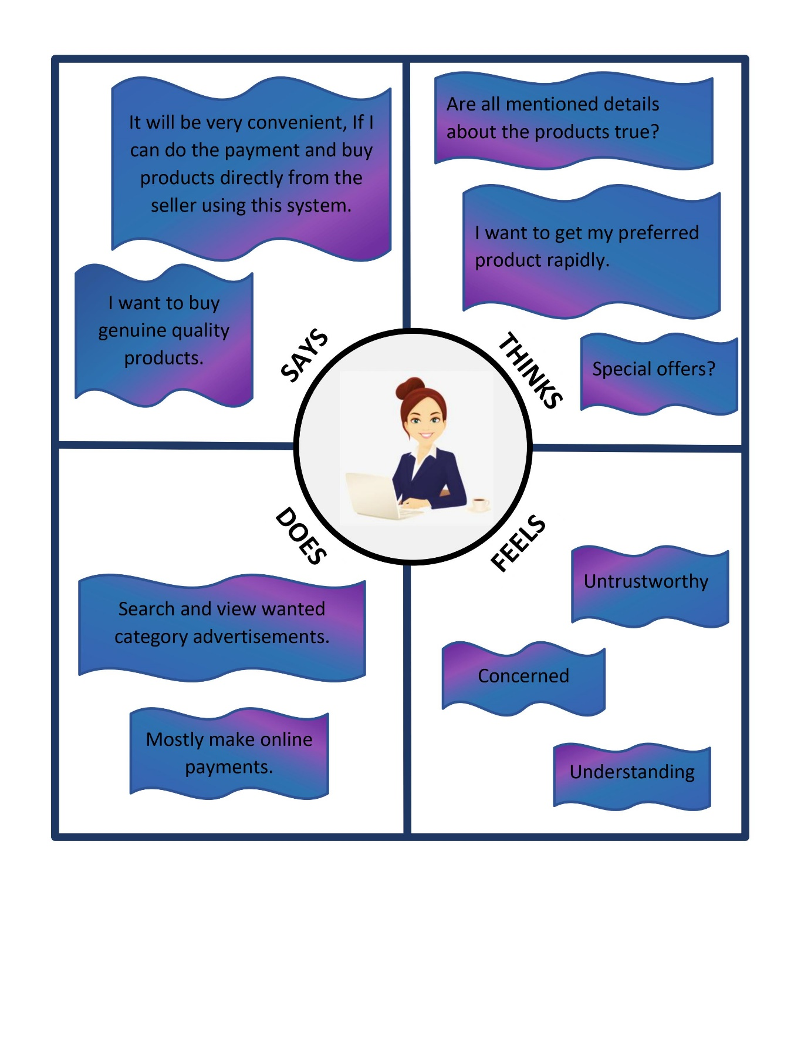

* 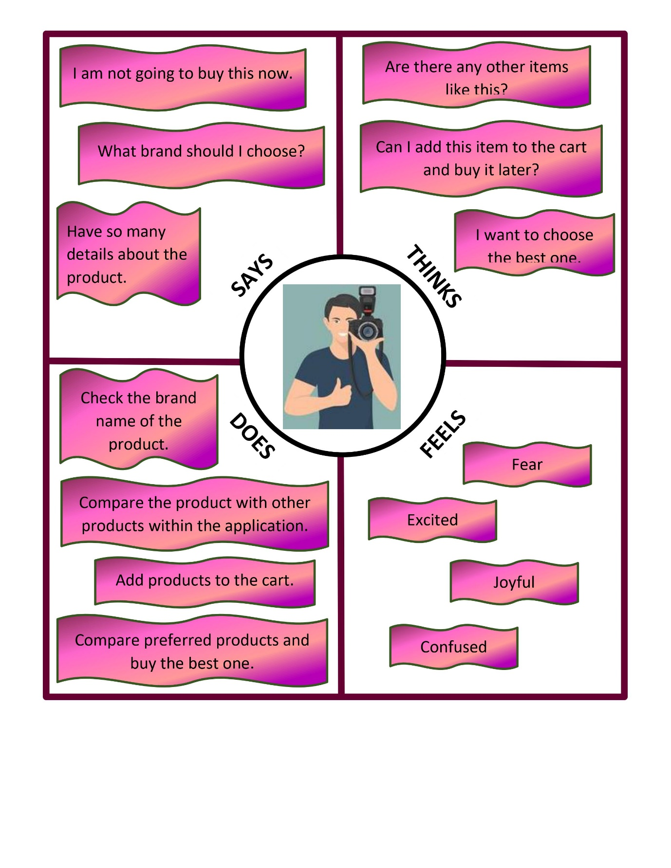A photographer is looking for a camera. If there are products he is satisfied he will add it to the cart to buy later.
* A car seller is advertising vehicles on this mobile application to sell vehicles.

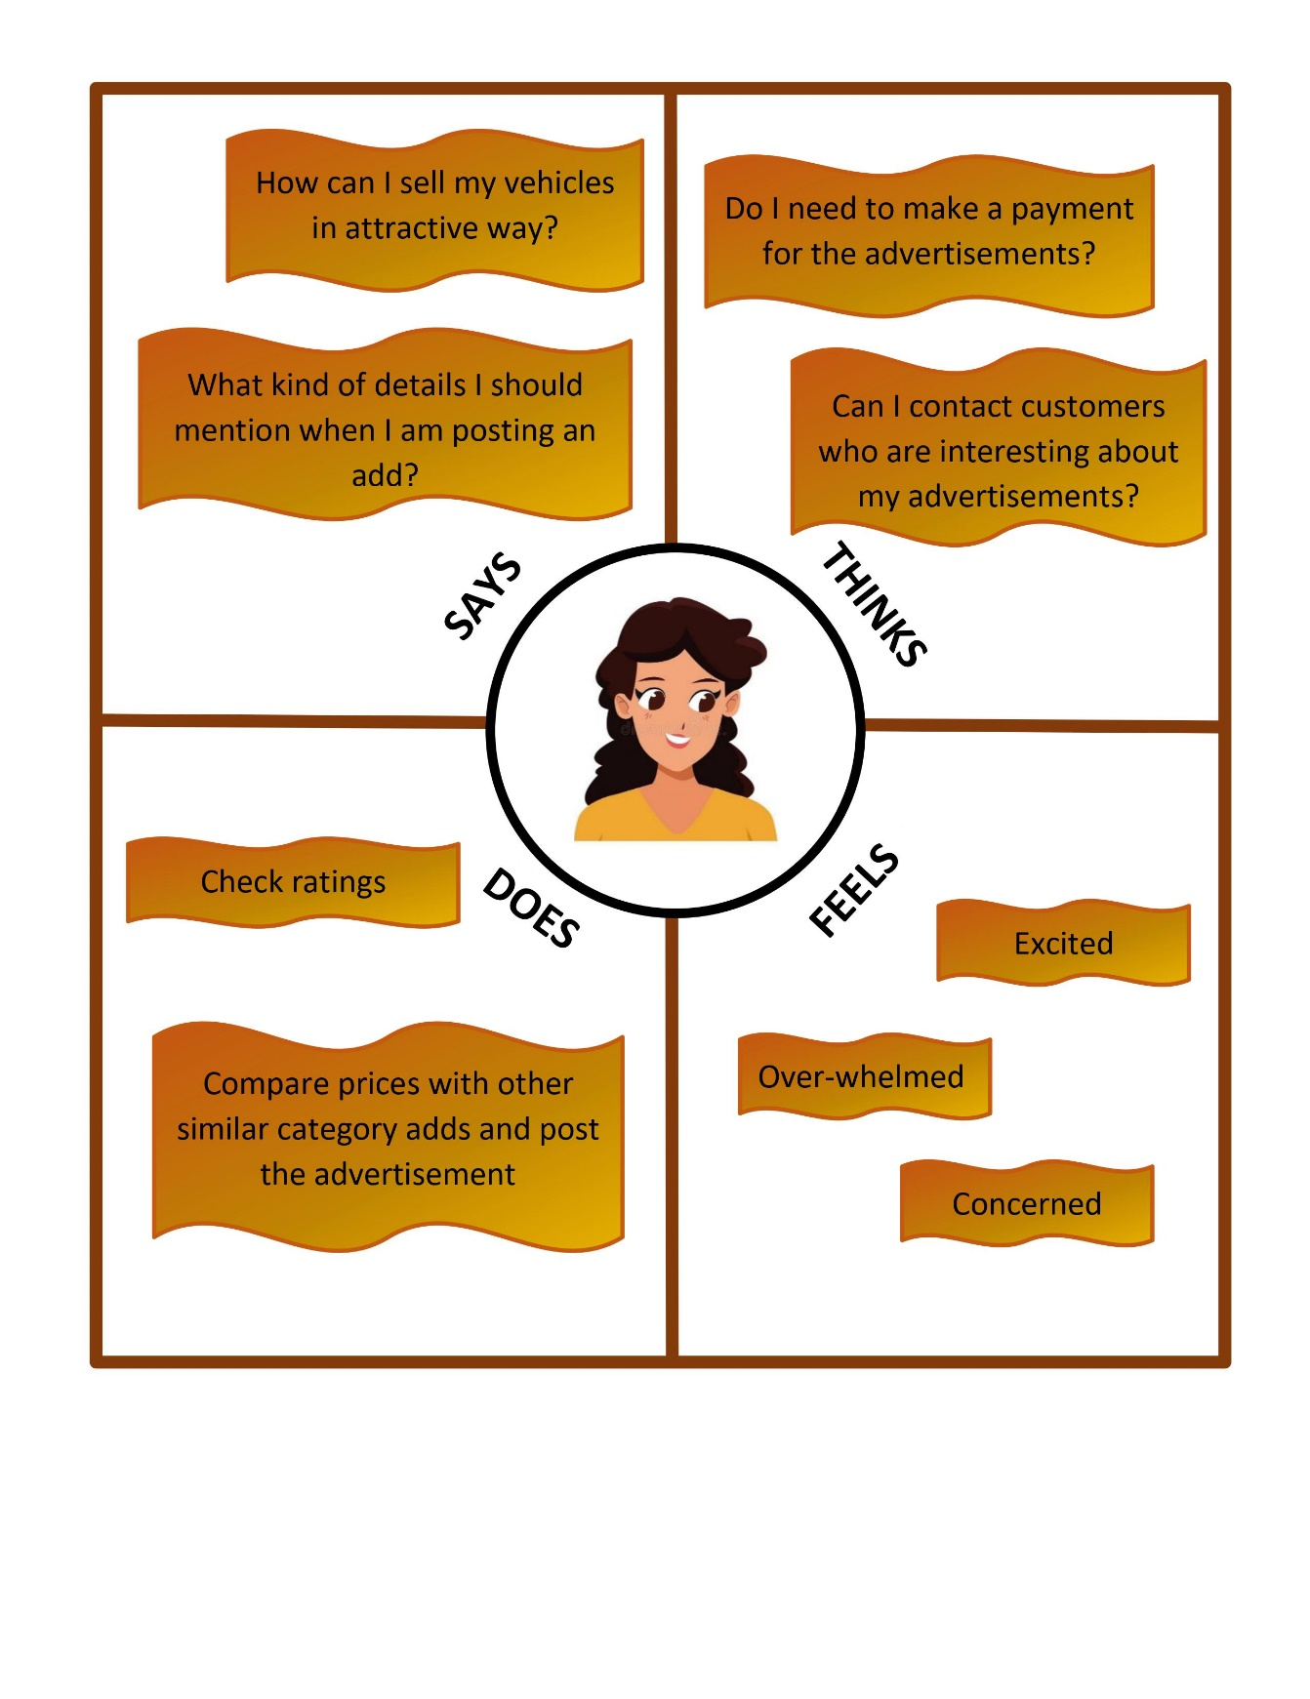

## User stories

User Story 01

* **As a** seller **I want to** advertise items in this mobile application **so that** customers can see those items.

User Story 02

* **As a** Customer **I want to** search item **so that** I can compare each item with others in the same category.

User Story 03

* **As an** admin **I want** **to** review items added by sellers **so that** I can upload those items to the application.

User Story 04

* **As a** seller **I want to** advertise about mobile phone in this mobile application **so that** I do not need to pay for that advertisement.

## Identify user flow(s)

1. Add an Advertisement- seller
2. Diagram

   Description automatically generatedLogin
3. Add an advertisement

2) Buy a product- customer

3) Boost an advertisement- seller

4) Add to cart- customer

5) Admin accept advertisements – admin

## Service Blueprint(s)

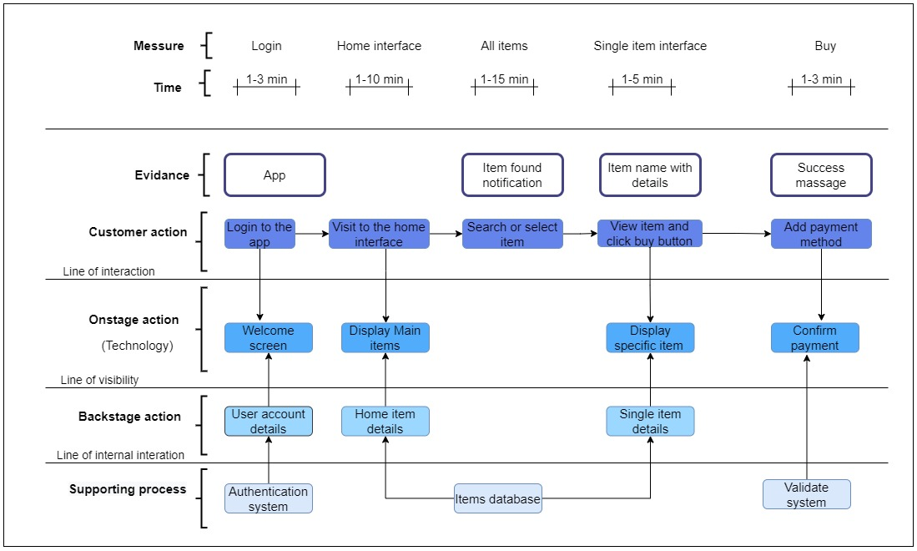

**All contribute as same to do the lab sheet 3.**