### Mobile App - Cargills Online

1. ***Create Persona(s)***

## IT19244044-J.S.Samaratunga

**IT19114590-G.Nivethika**

**IT19176802 – S.S.Eeswar**

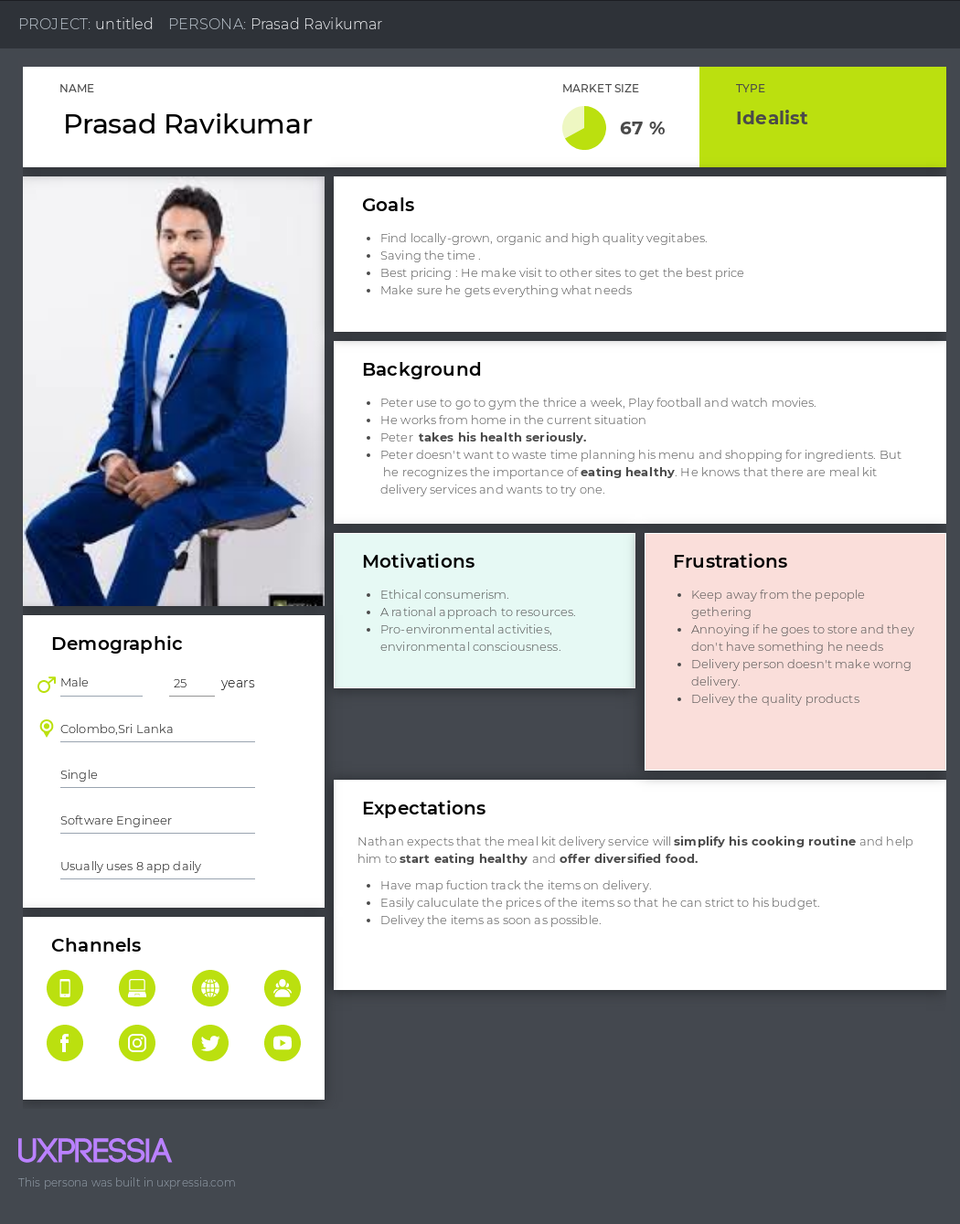

**IT19051376 – Anjana W.W.M**

1. ***Empathy map(s)***

**IT19244044-J.S.Samaratunga**

**IT19114590-G.Nivethika**

**IT19176802 – S.S.Eeswar**

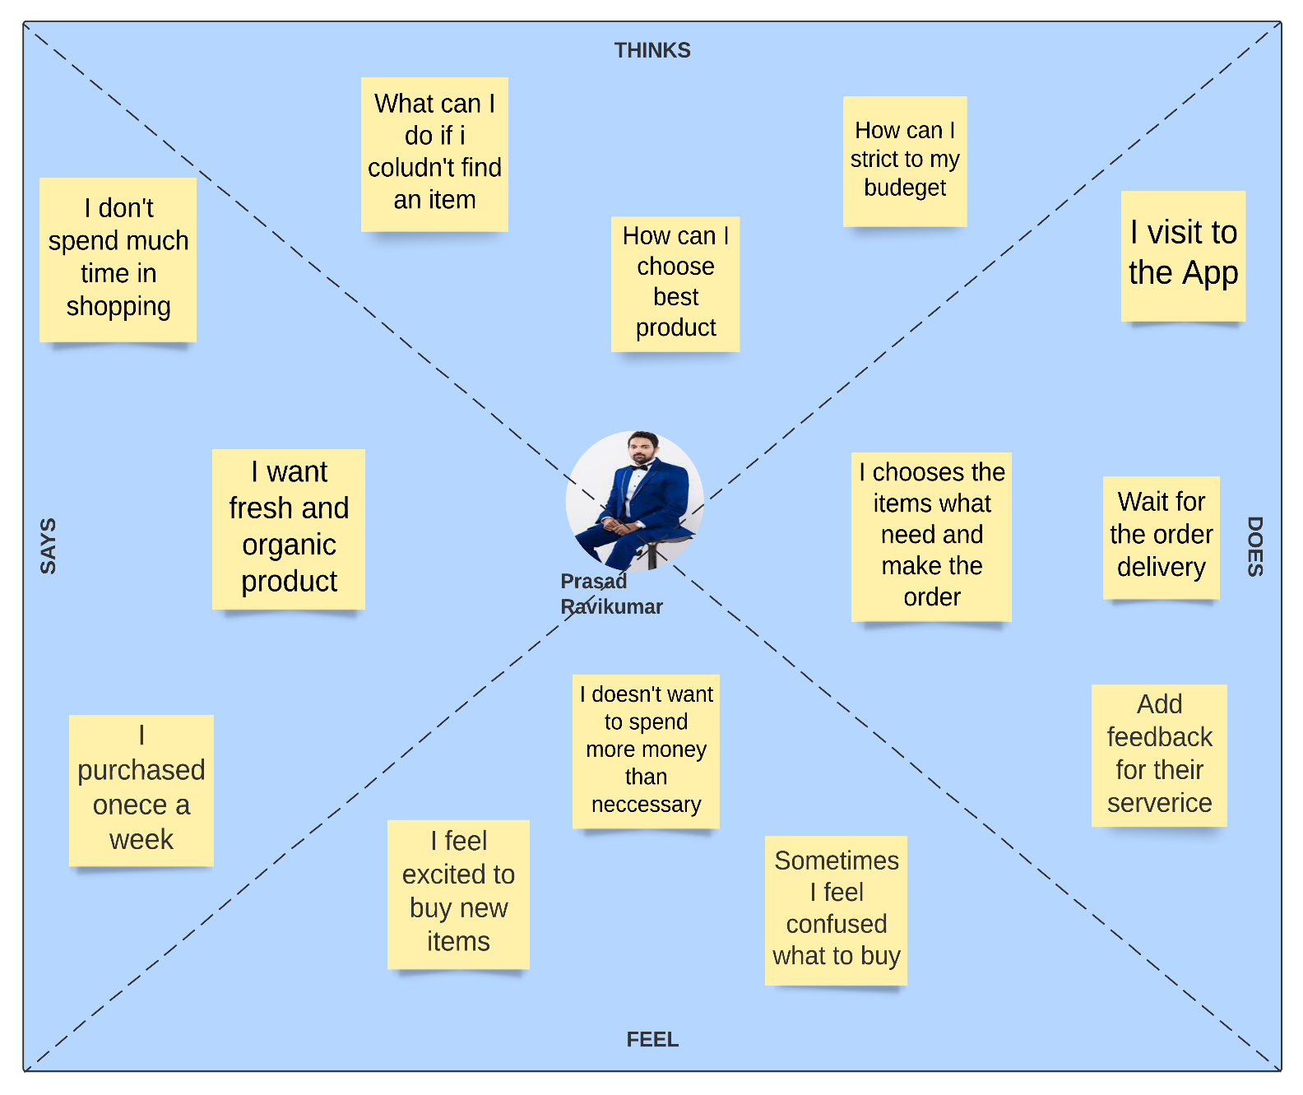

**IT19051376 – Anjana W.W.M**

#### User stories

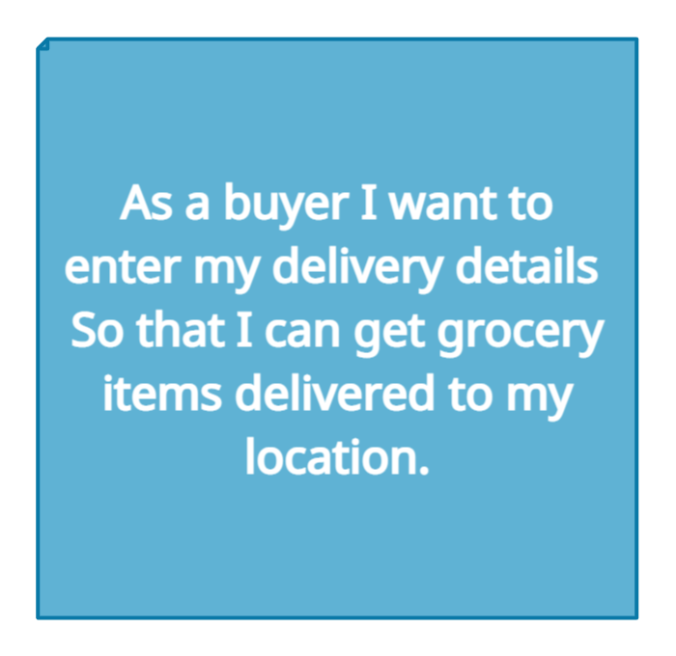 **IT19114590-G.Nivethika IT19244044-J.S.Samaratunga**

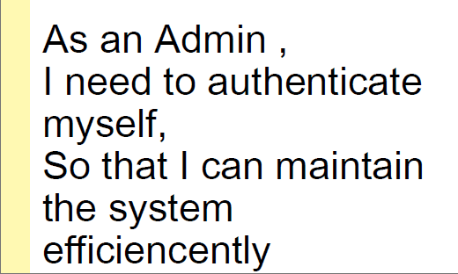**IT19176802 – S.S.Eeswar**

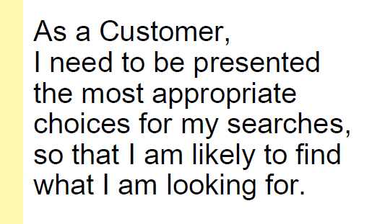

**IT19051376 – Anjana W.W.M**

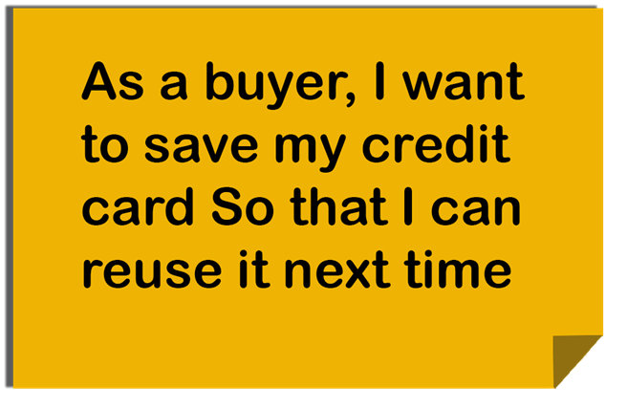

1. ***Identify user flow(s)***

**IT19114590-G.Nivethika**

**IT19176802 – S.S.Eeswar**

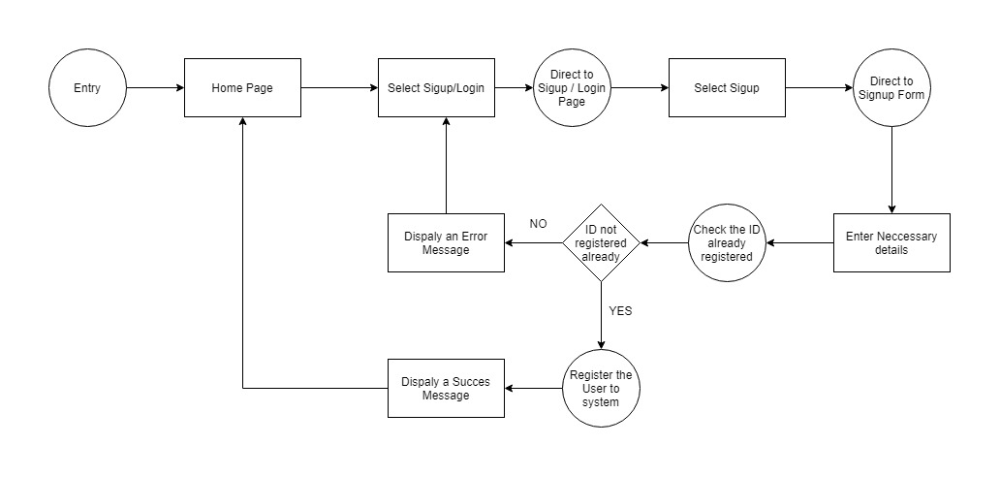

**IT19244044-J.S.Samaratunga**

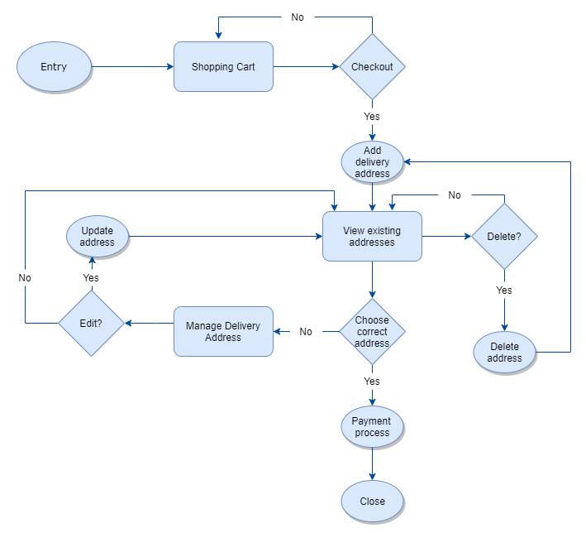

**IT19051376 – Anjana W.W.M**

1. ***Service Blueprint(s)***

