Lab Practical 03 - Identify user groups

**Group ID** – 2021S2_REG_WD_11

|  |  |
| --- | --- |
| **IT Number** | **Name** |
| IT19127538 | A. R. W. M. B. W. D. B. Jayawardana |
| IT19062266 | S. W. R. S. I. Rathnayake |
| IT19037998 | A. V. Joachim |
| IT19513188 | K. A. Yathushan |

1. **User Personas**

**IT19127538**

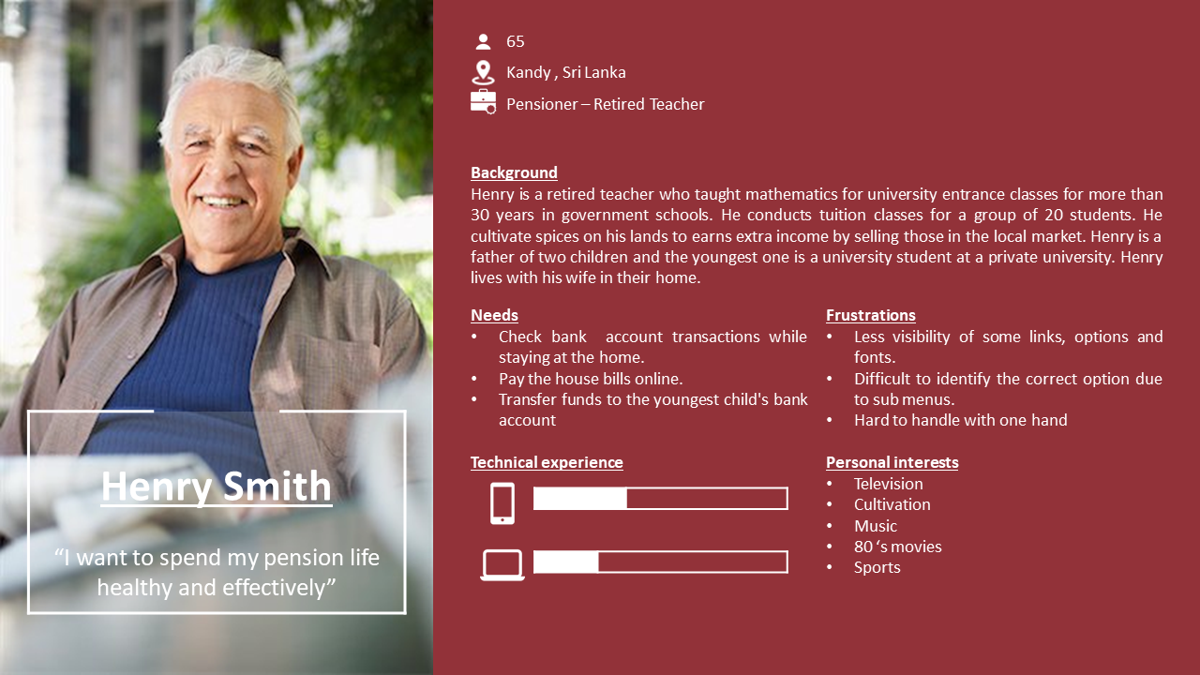

**IT19062266**

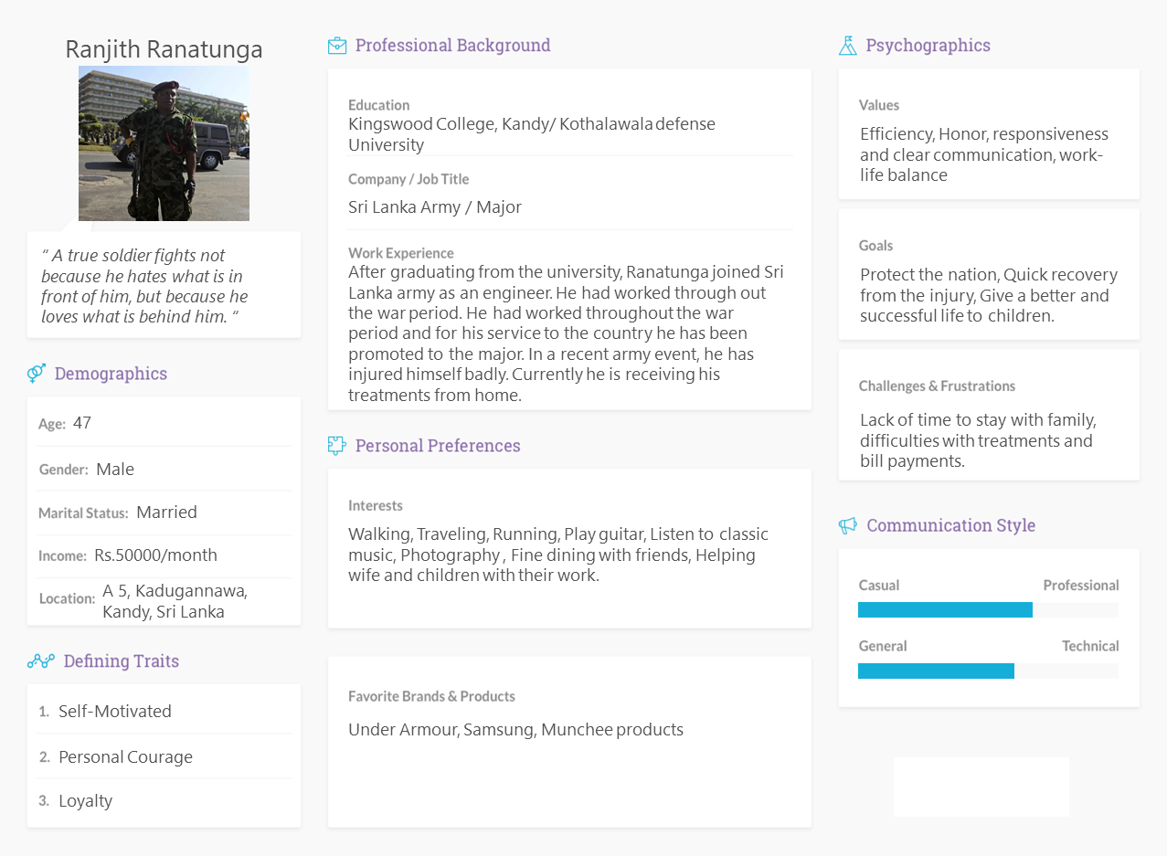

**IT19037998**

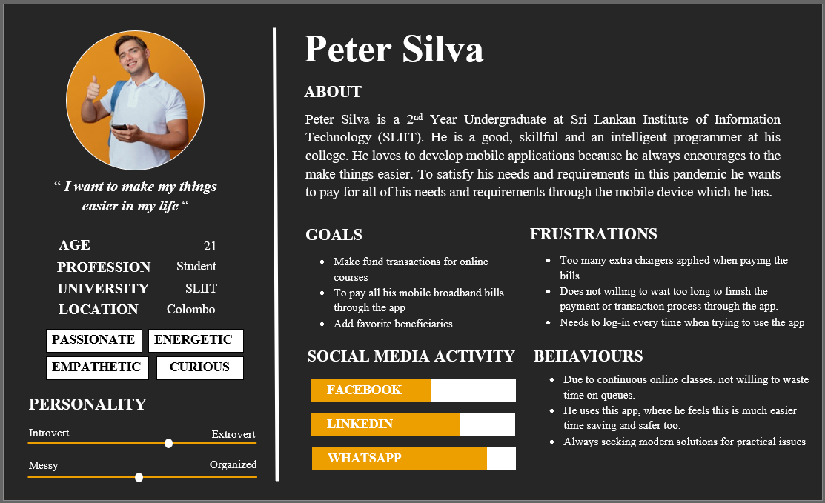

**IT19513188**

1. **Empathy maps**

**IT19127538**

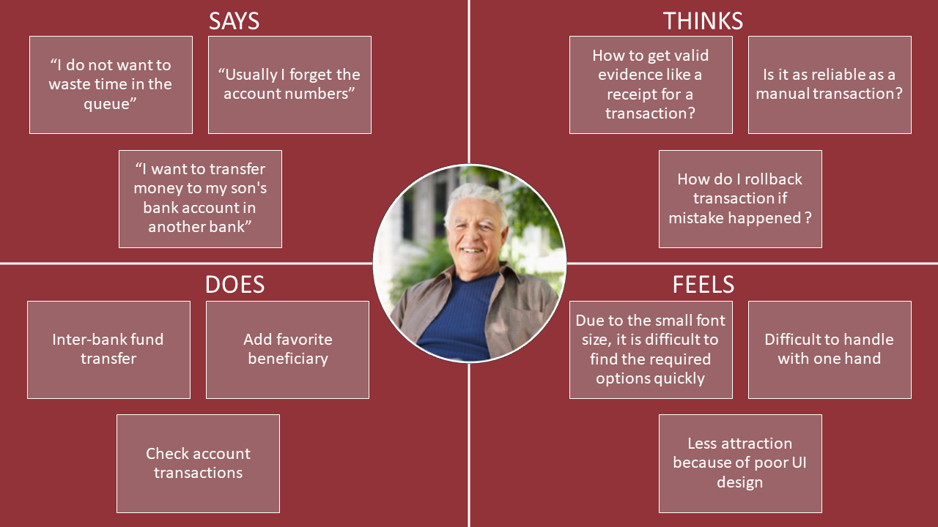

**IT19062266**

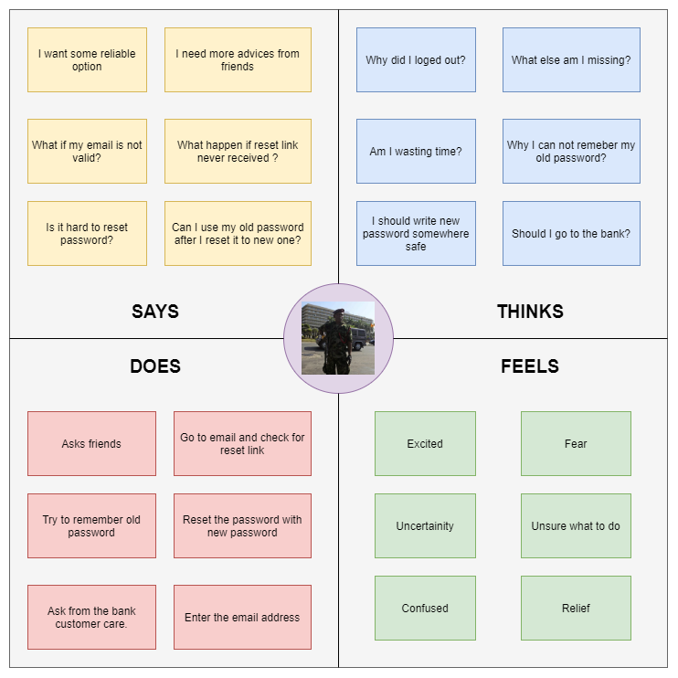

**IT19037998**

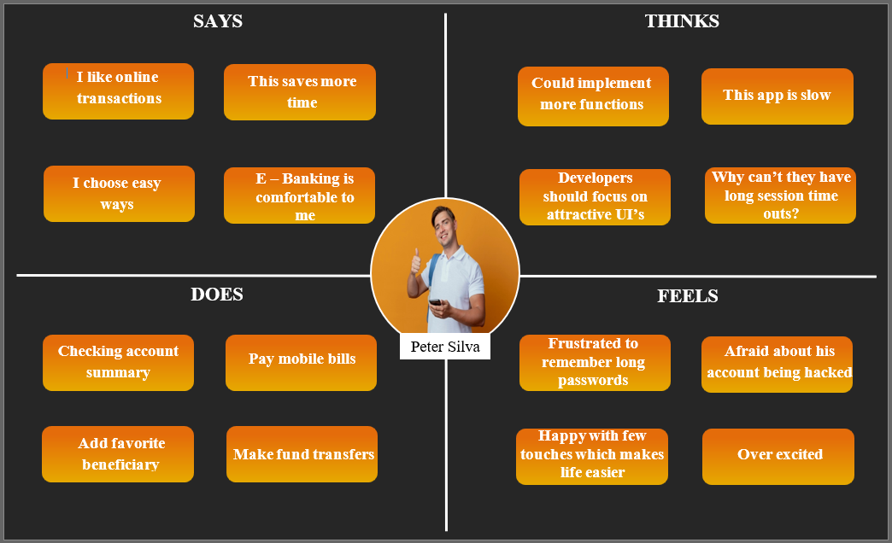

**IT19513188**

1. **User stories**

**IT19127538**

As a pensioner I want to transfer money to an account in another bank through the People’s Wave mobile application So that I can support my child’s higher education.

**IT19062266**

As a soldier I want to reset my forgot password so that I can login to the application.

**IT19037998**

As a university student I want to transfer my internship salary to my parents account, so that I can help my family financially.

**IT19513188**

As a business man I want to pay my household utility bills in People's Wave mobile banking app so that I can save time and expenses on travelling.

1. **User flows**

**IT19127538**

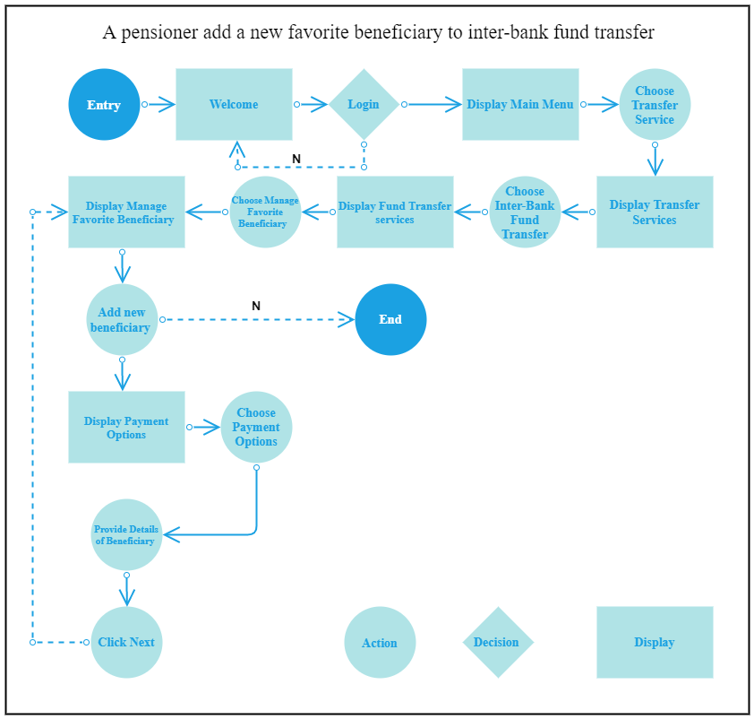

**IT19062266**

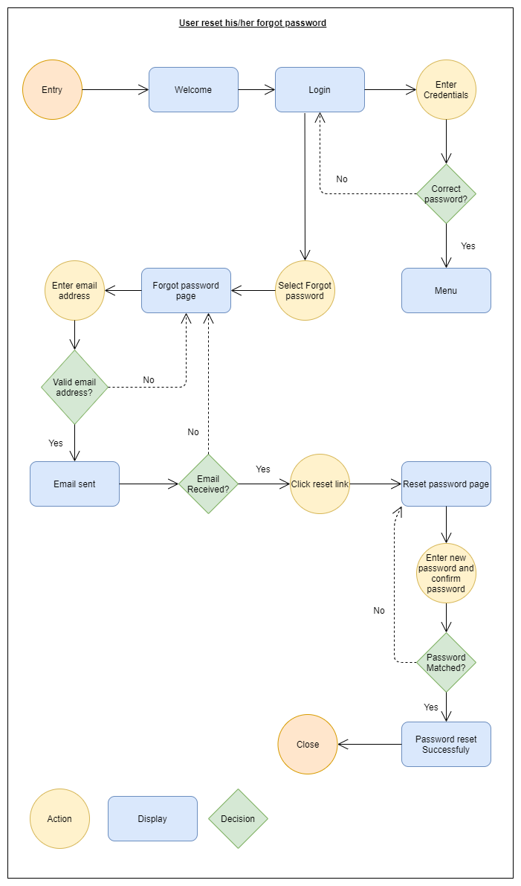

**IT19037998**

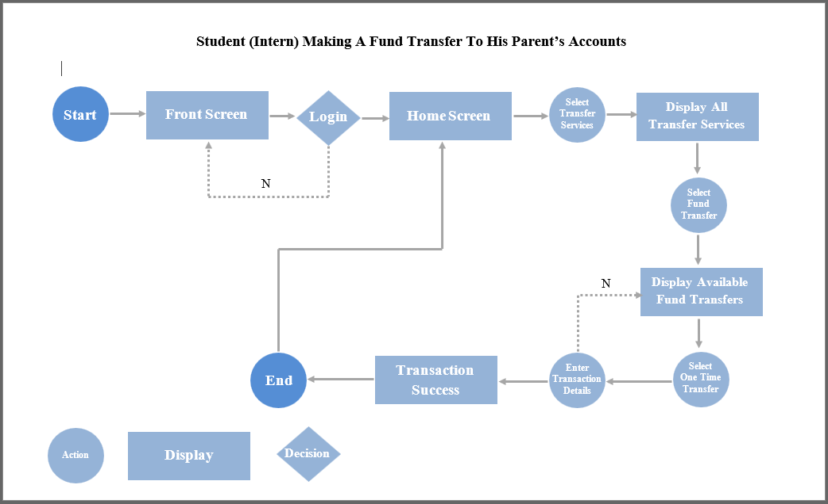

**IT19513188**

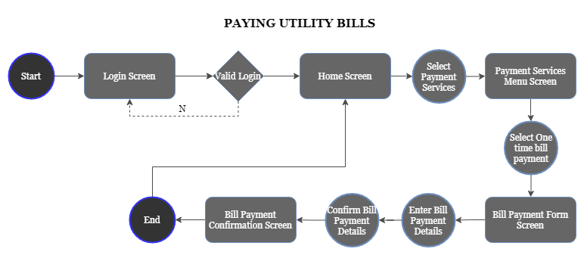

1. **Service Blueprint**

