

**Machan Eats**

**Group ID: 2021S2_REG_WE_10**

**Group Members:**

|  |  |
| --- | --- |
| **IT Number** | **Name** |
| IT19138732 | M.G.D.D.B. Ekanayaka |
| IT19167206 | S.A.S.D. Wijesinghe |
| IT19148014 | J.T. Jayasundara |
| IT19095240 | W.M.M.H.C. Mudannayake |

* **Persona**
* **M.G.D.D.B. Ekanayaka**

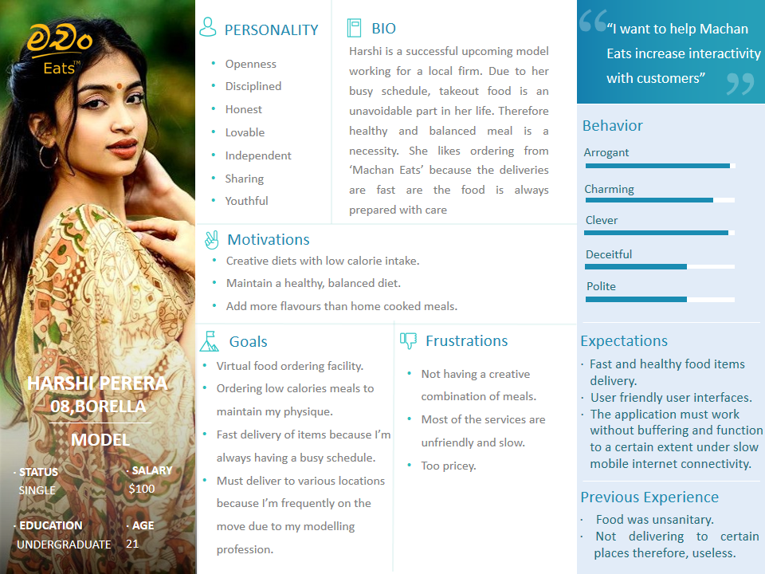

* **W.M.M.H.C. Mudannayake**

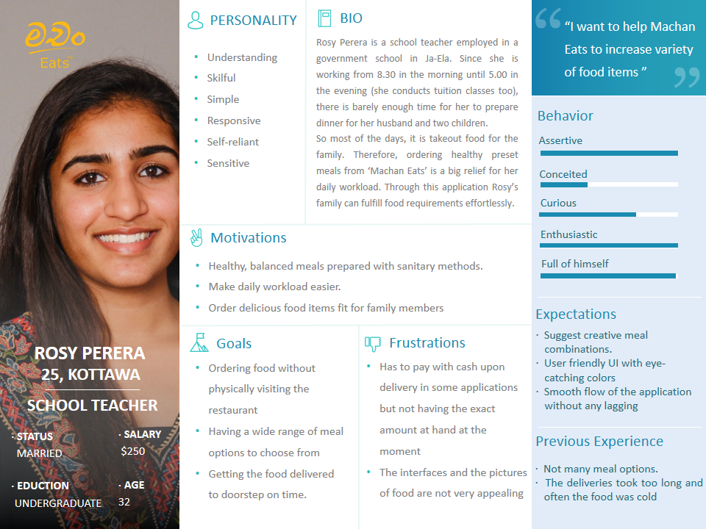

* **J.T. Jayasundara**

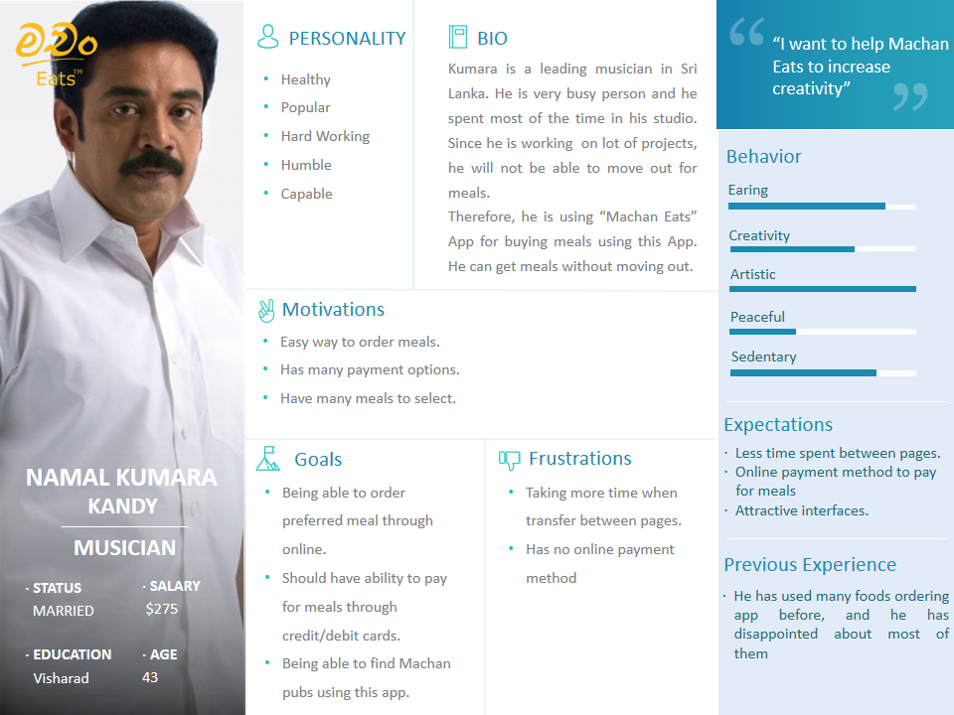

* **S.A.S.D. Wijesinghe**

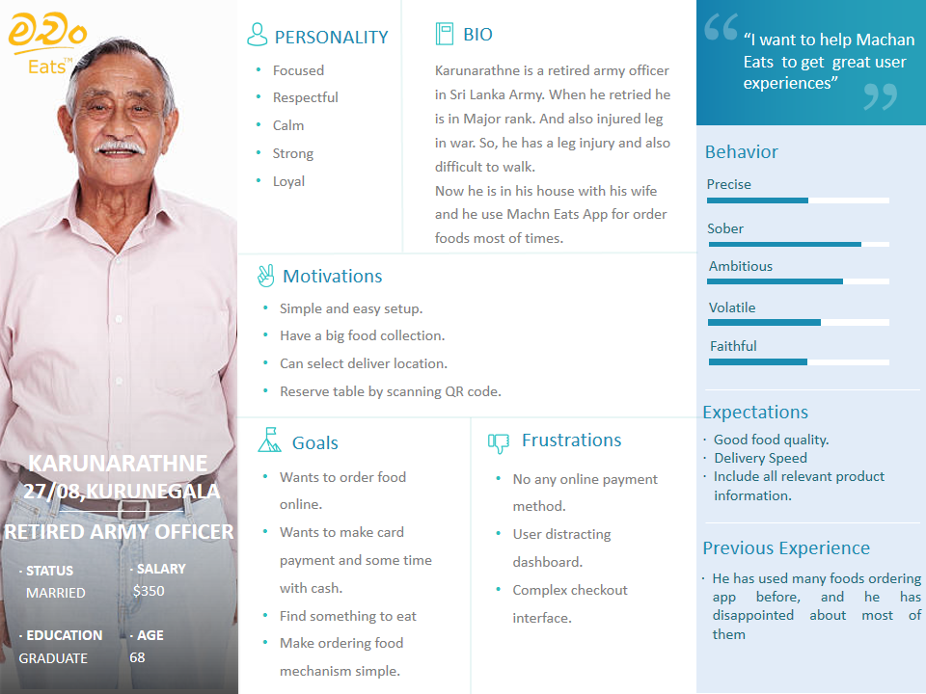

* **Empathy Maps**
* **M.G.D.D.B. Ekanayaka**

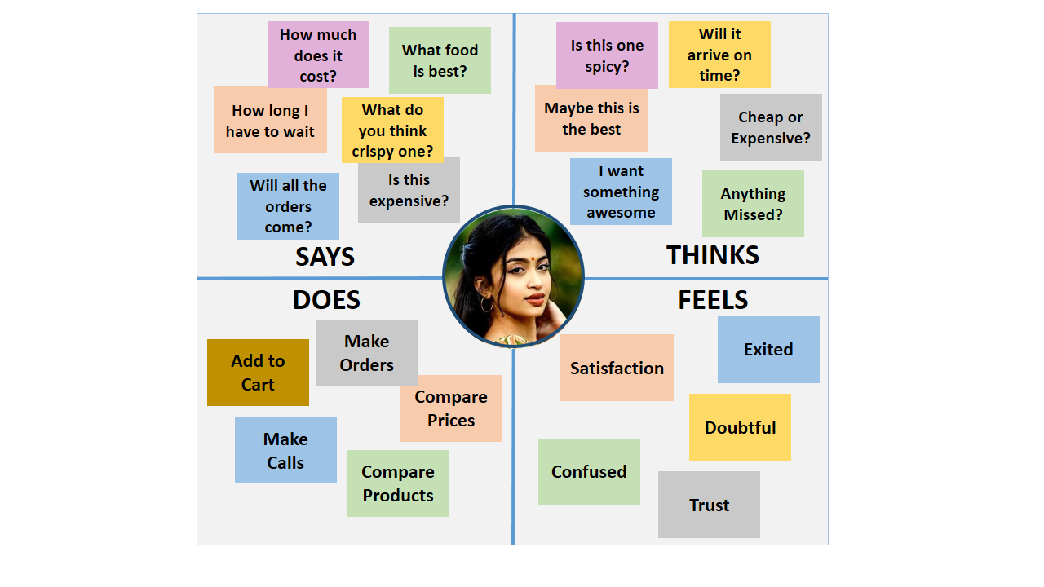

* **W.M.M.H.C. Mudannayake**

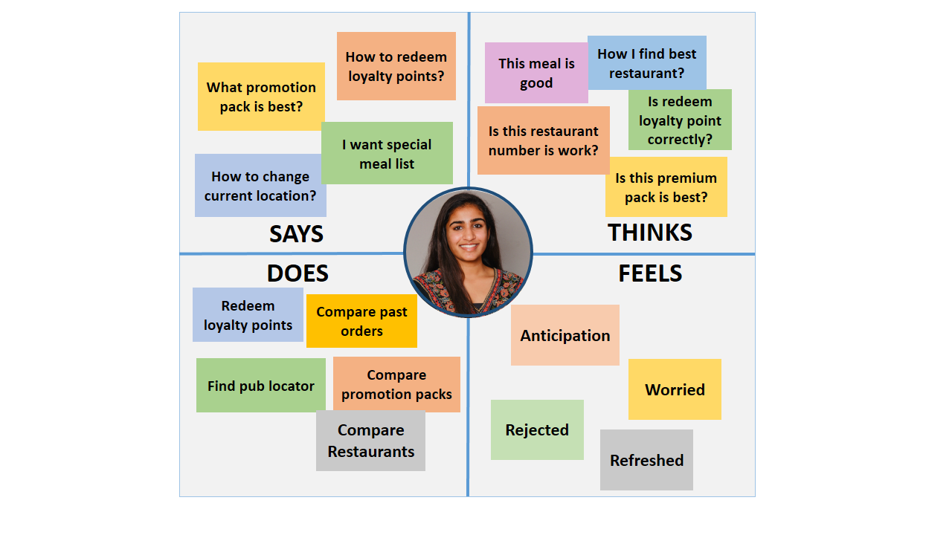

* **J.T. Jayasundara**

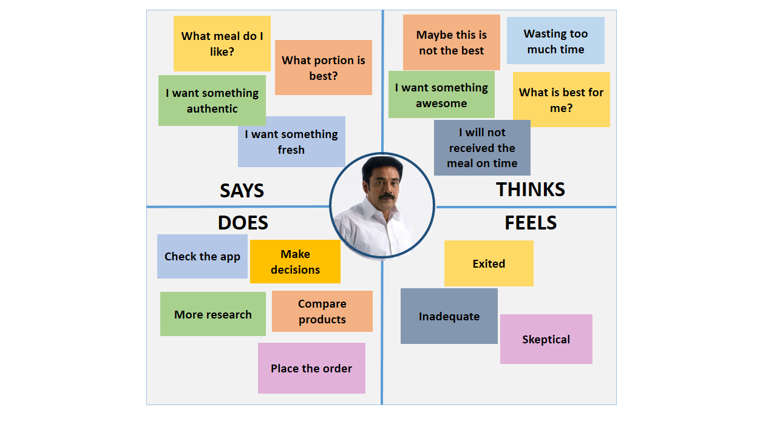

* **S.A.S.D. Wijesinghe**

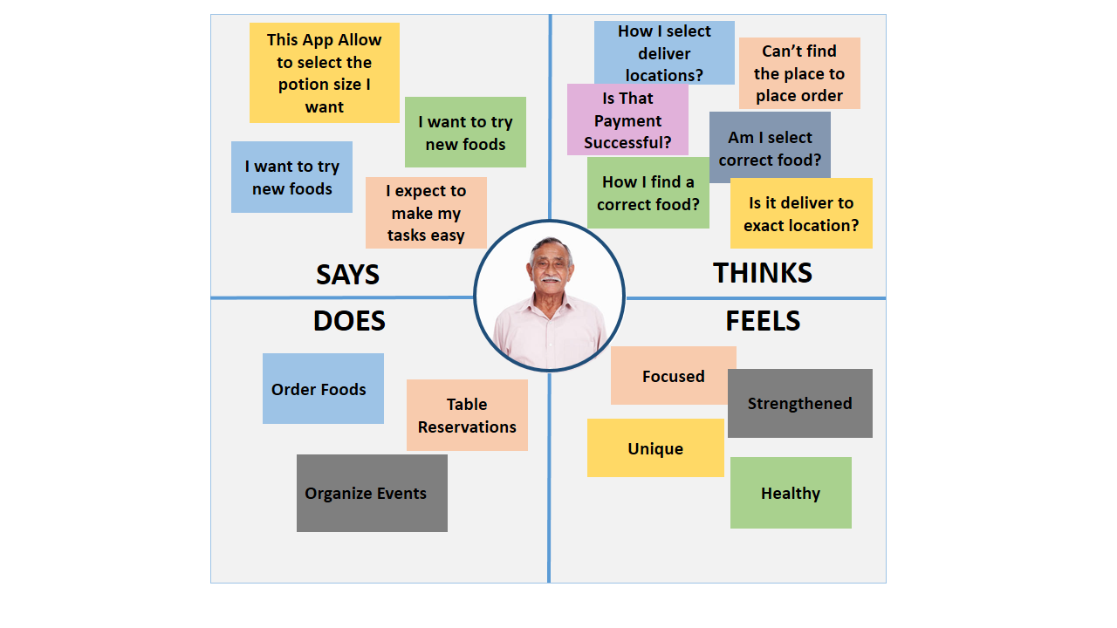

* **User Stories**
* **M.G.D.D.B. Ekanayaka**

**As a Customer**

**I want to view all available foods**

**So that I can select one and make an order**

**As a Customer**

**I want to search specific food items**

**So that I can view item available or sold out**

**As a Customer**

**I want to order specific food items**

**So that I can view my past orders**

* **W.M.M.H.C. Mudannayake**

**As a Customer**

**I want to redeem my loyalty points**

**So that I can pay using my loyalty points**

**As a Customer**

**I want to view all the promotions**

**So that I can go with the specific promotion pack**

* **J.T. Jayasundara**

**As a Customer**

**I want to log into the Machan Eats App**

**So that I can order foods**

**As a Customer**

**I want to see pub through the app**

**So that I can easily find a pub to get a fun.**

* **S.A.S.D. Wijesinghe**

**As a Customer**

**I want to pay orders**

**So that I can take it on time**

**As a Customer**

**I want to contact the shop**

**So that I can order foods adding extra things.**

* **User Flows**
* **M.G.D.D.B. Ekanayaka**

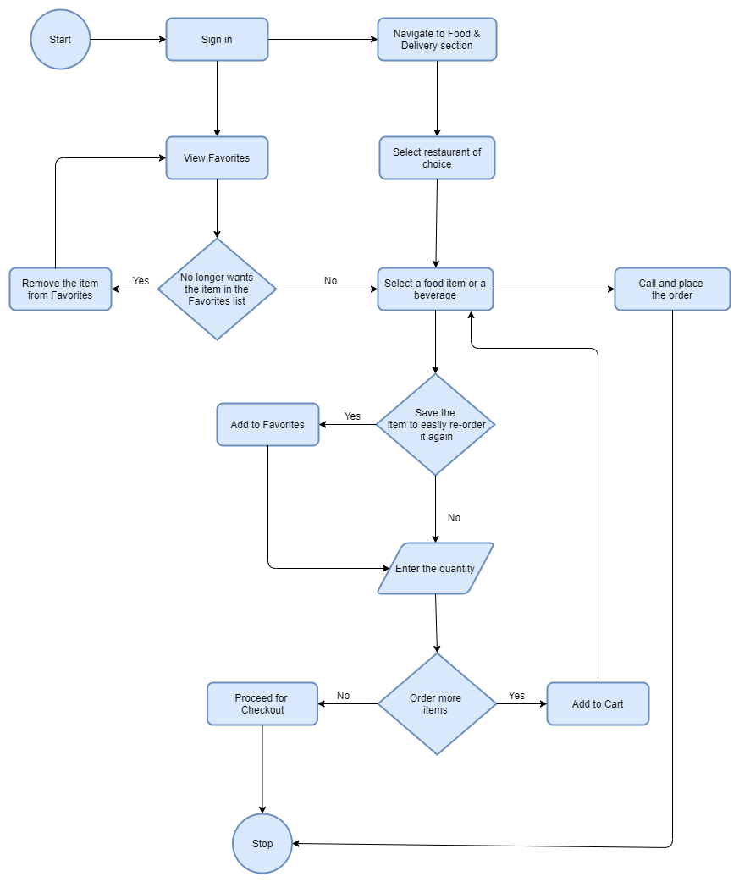

* **W.M.M.H.C. Mudannayake**

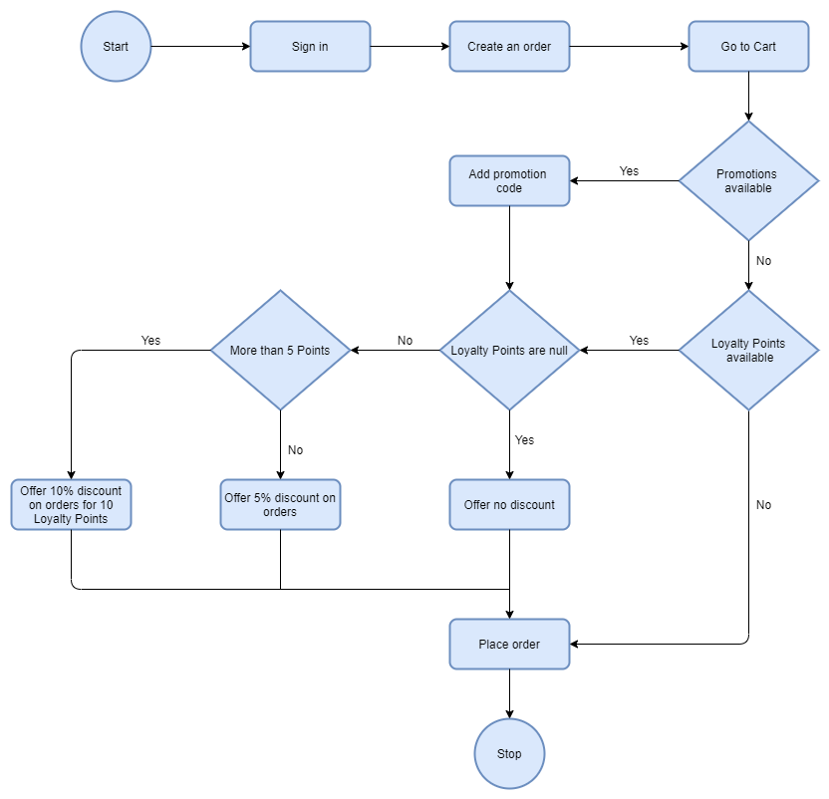

* **J.T. Jayasundara**

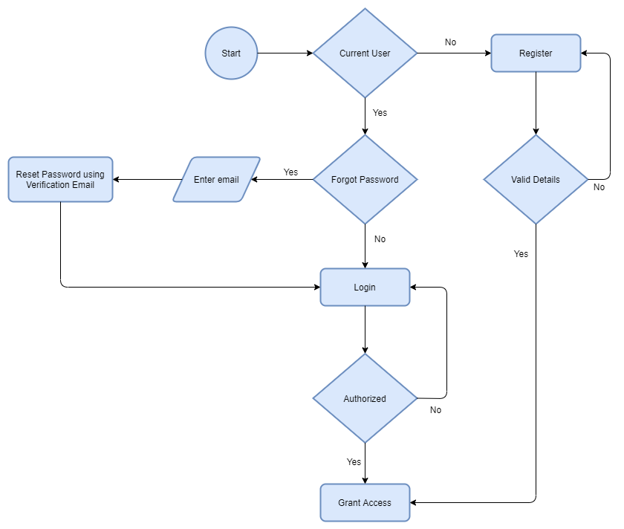

* **S.A.S.D. Wijesinghe**

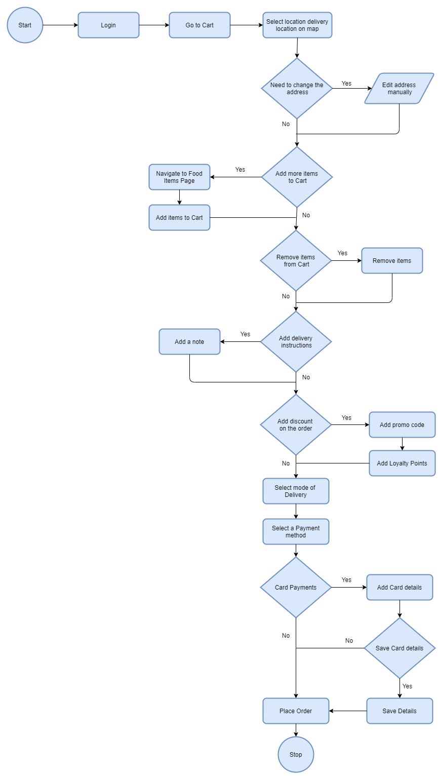

* 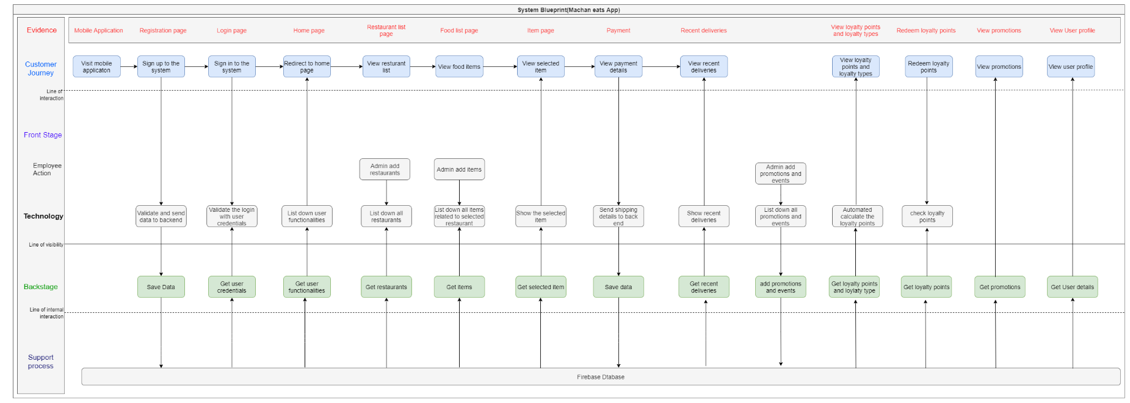**Service Blueprint**