# Lab Practical 03 – Identify user groups & Supervisor feedback

**Group ID:** 2021S2_REG_WE17

**Mobile App:** Peoples’ wave mobile banking

|  |  |
| --- | --- |
| **Student Reg. No** | **Name** |
| IT19148946 | I.T.Manuel |
| IT19220116 | N.I.T.Hewage |
| IT19009964 | Hakeem M.U.M.I. |
| IT19395906 | S.A.R.Wijayabandu |

IT19148946 - I.T.Manuel

1. **Persona**

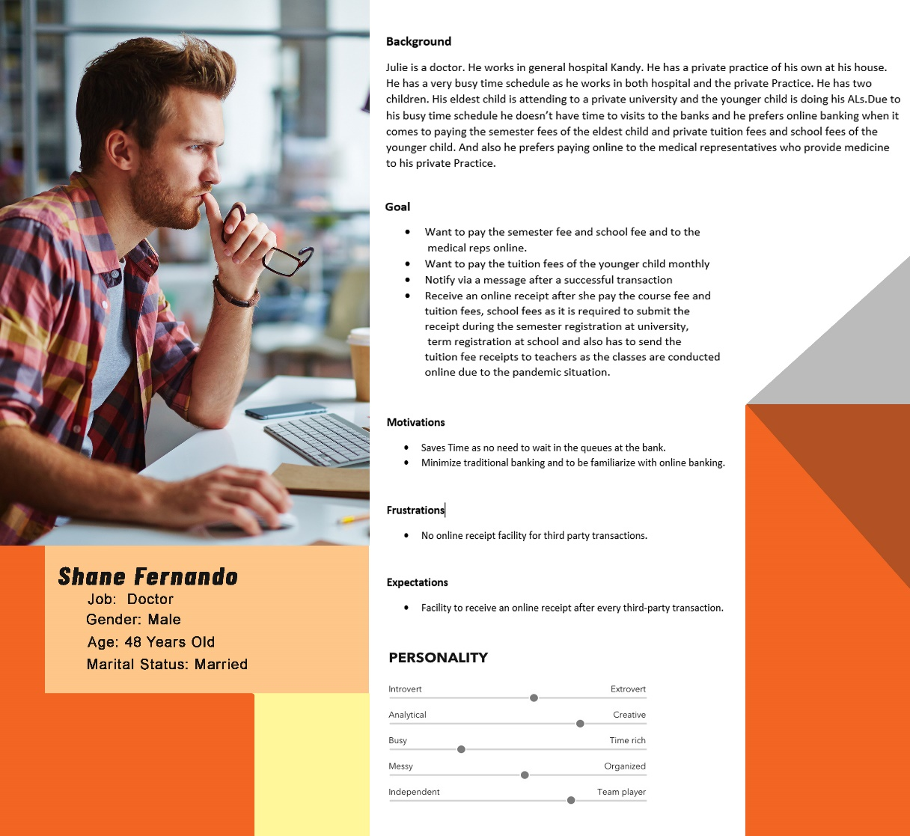

1. **Empathy Map**

1. 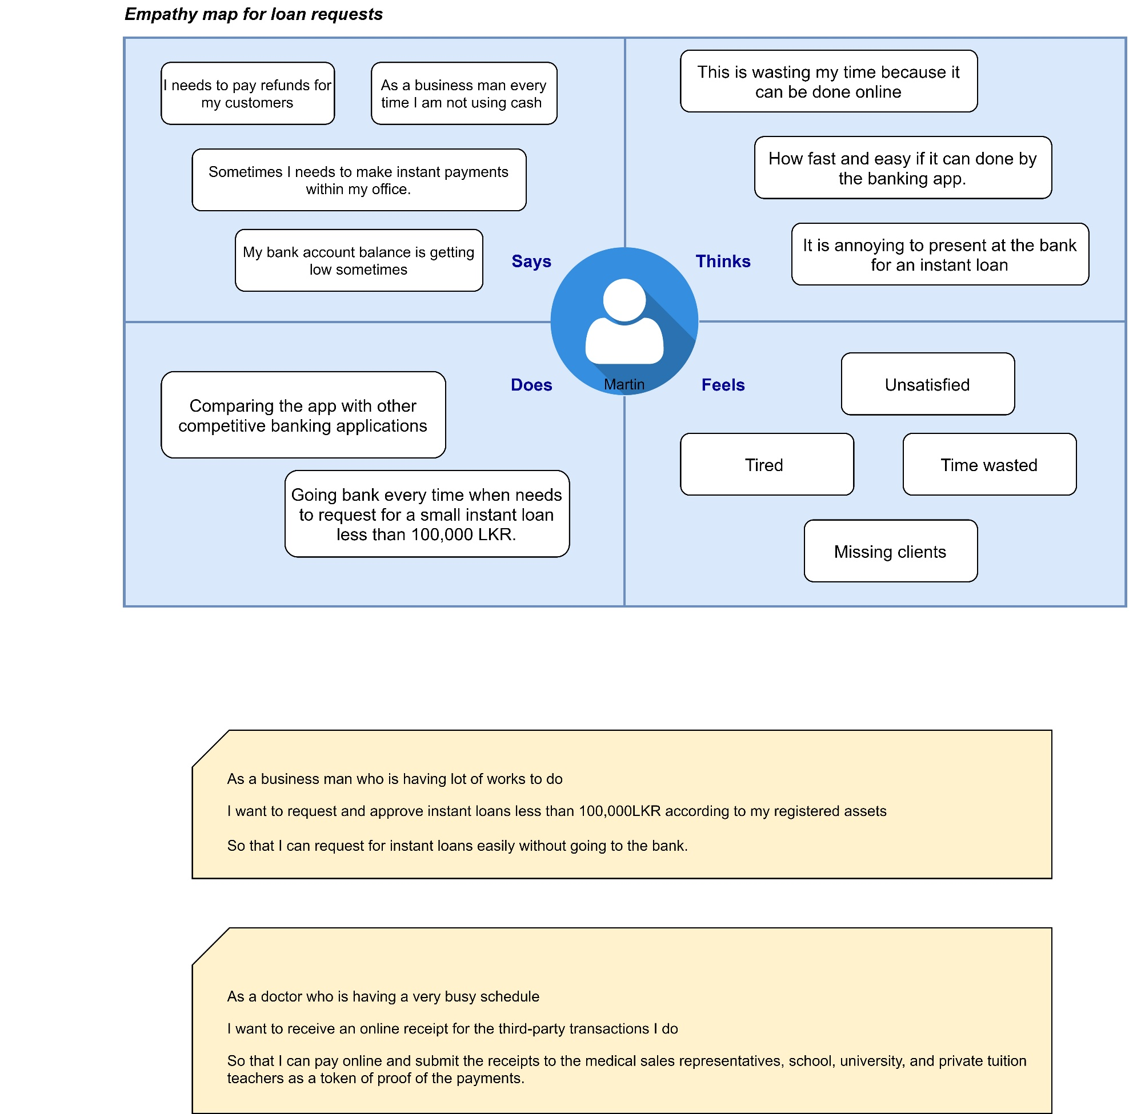**User Story**
2. **User flow**

IT19220116 - N.I.T.Hewage

1. **Persona**

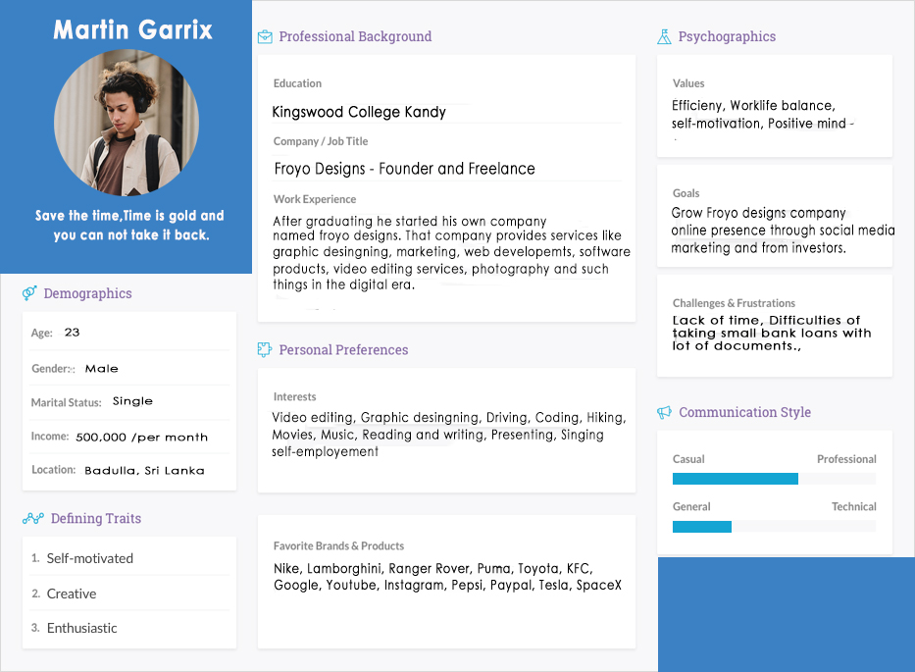

1. 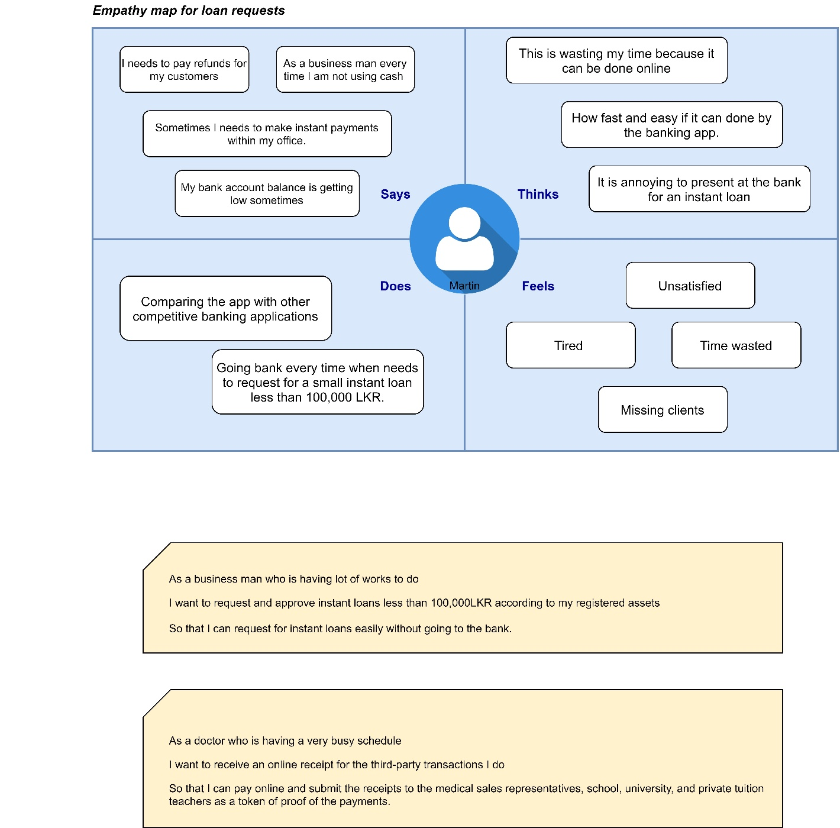**Empathy map**
2. 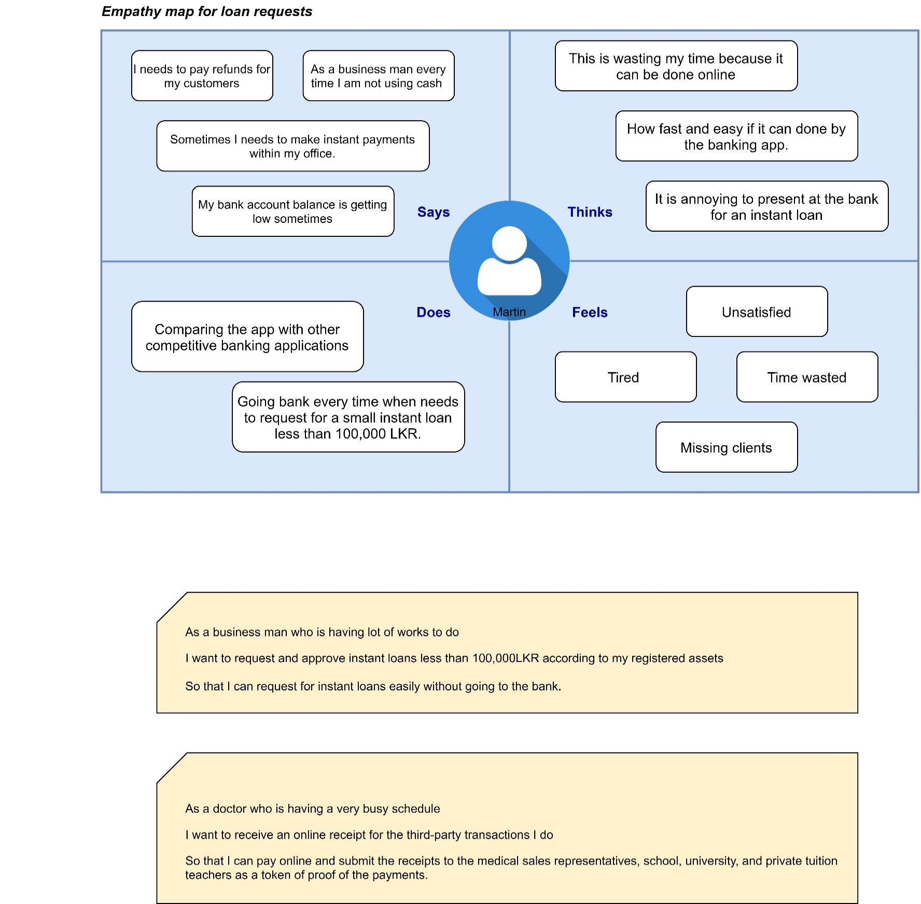**User story**
3. **User flow** ( Instant Loan Request )

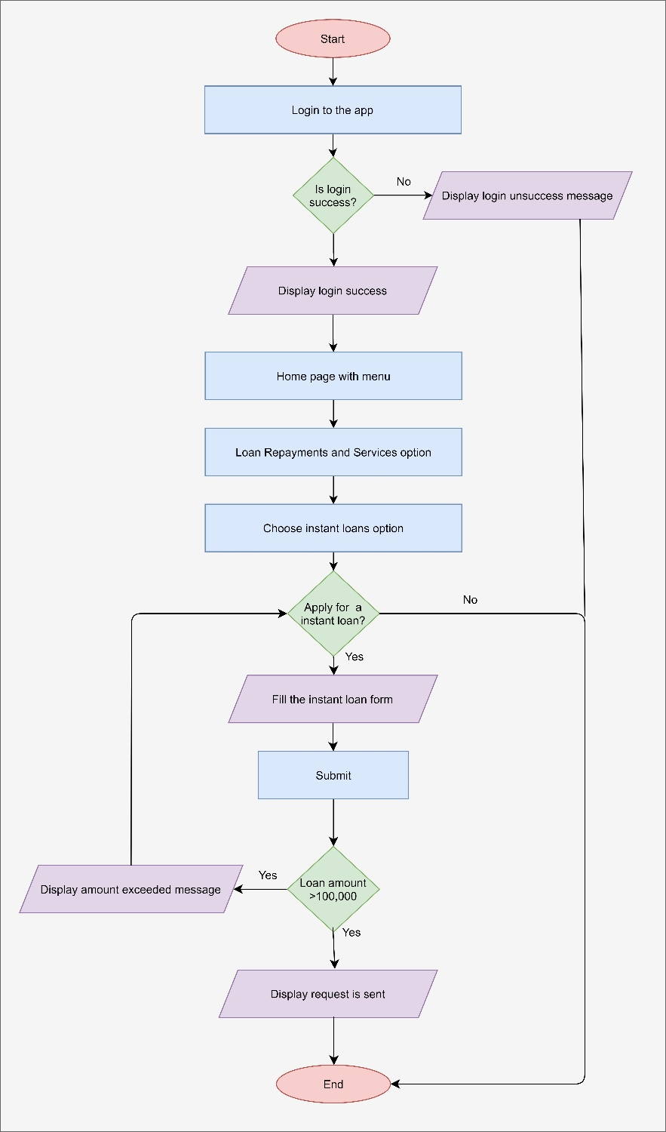

IT19009964 - Hakeem M.U.M.I.

1. 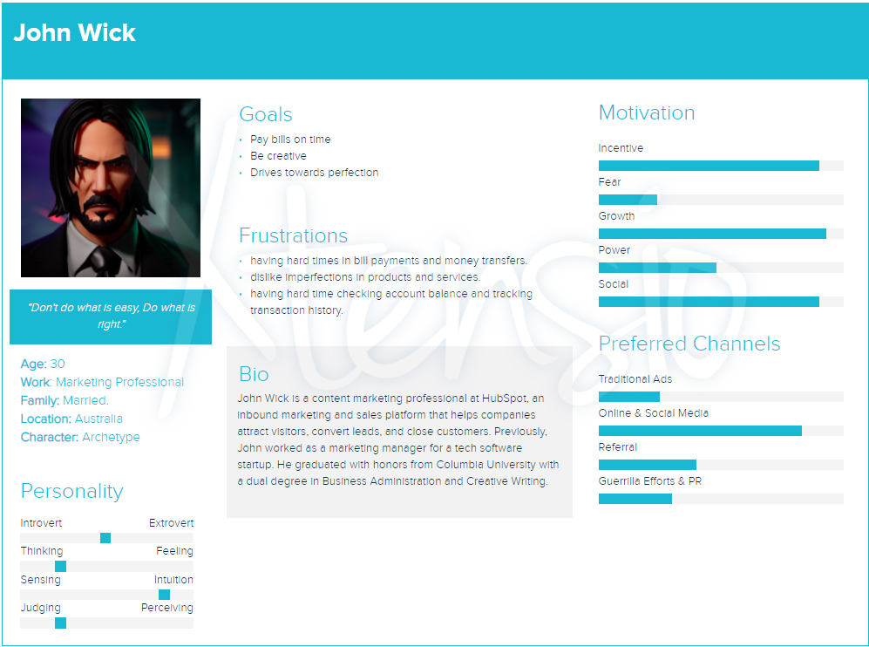**Persona**
2. **Empathy map**

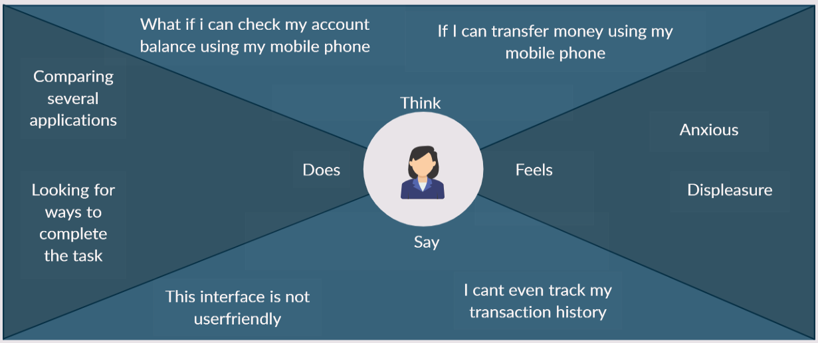

1. 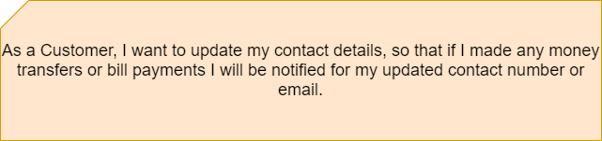**User story**
2. 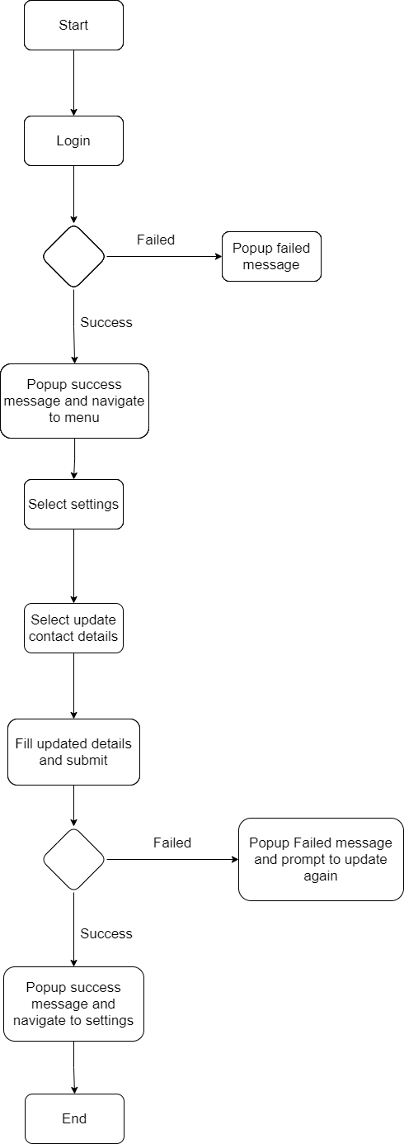**User flow**

IT19395906 - S.A.R.Wijayabandu

1. 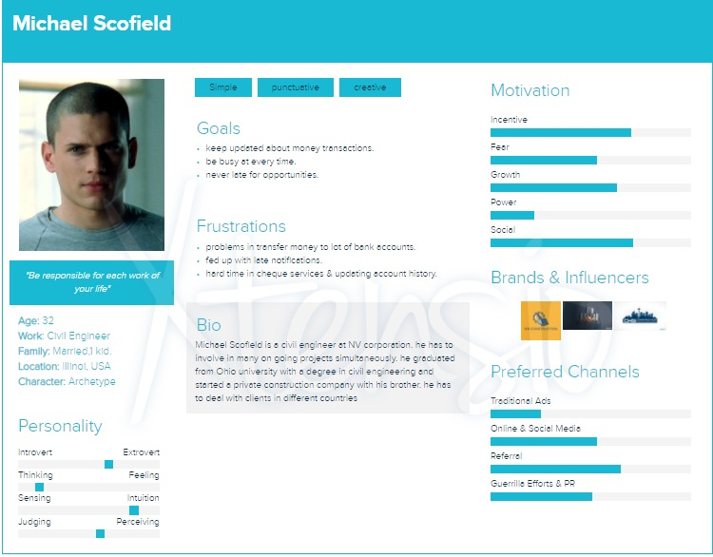**Persona**
2. **Empathy Map**

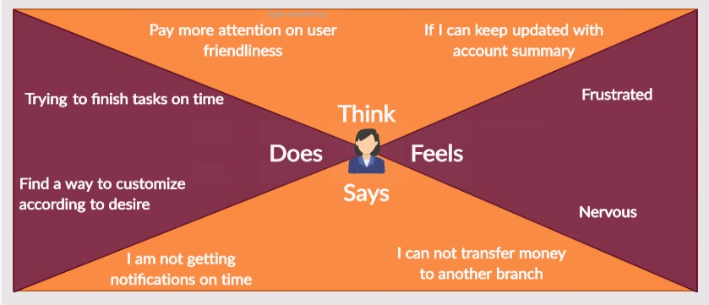

1. **User story**

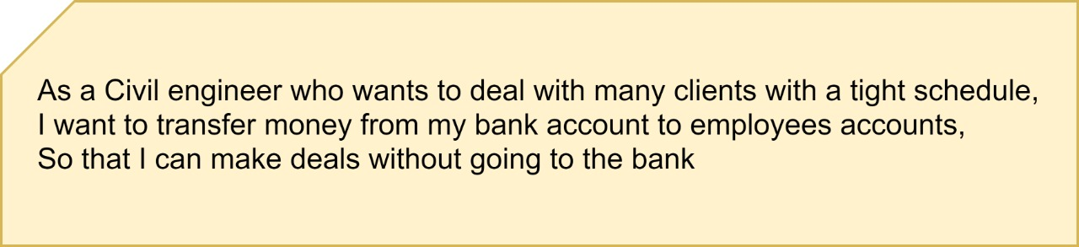

1. **User flow**

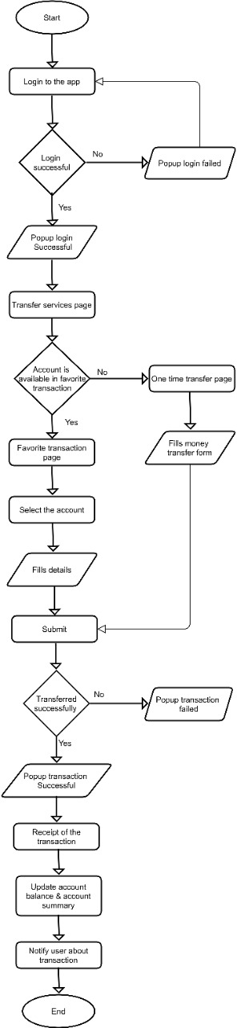

**Service Blue Print***: ONE TIME BILL PAYMENTS*

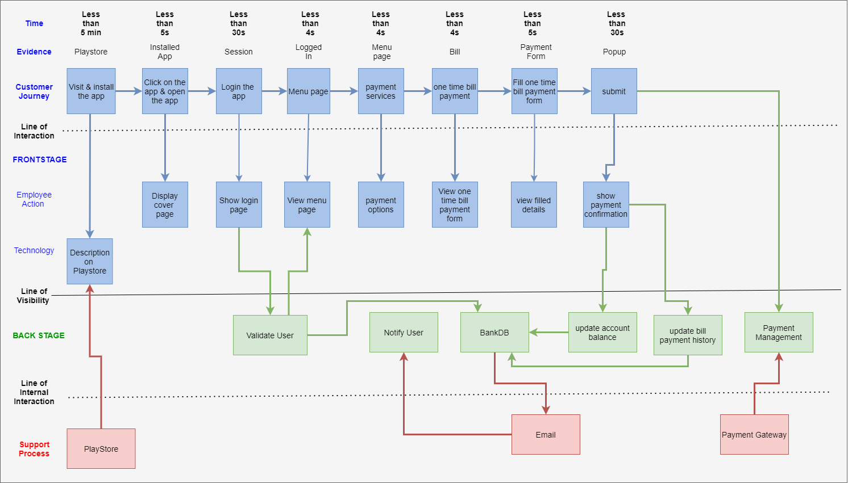

* **THE END -**