Sri Lanka Institute of Information Technology

Lab sheet 03

Group No - 2021S2_REG_WE_26

**Year 3 Semester 2, 2021**

|  |  |  |
| --- | --- | --- |
|  | **Student Registration Number** | **Student Name** |
| **1** | IT19017334 | Bandara W.A.I.U. |
| **2** | IT19028156 | Kuruppuarachchi K.A.D.K.S. |
| **3** | IT19016108 | Alwis T.A.D.T.N.D. |
| **4** | IT19026480 | Maduwantha N.N.D. |

**User Experience Engineering – SE3050**

B.Sc. (Hons) in Information Technology

|  |  |
| --- | --- |
| Registration No: IT19017334 | Name: Bandara W.A.I.U. |

**Persona**

**Empathy Map**

**User Story**

* As a user, I want to make a fund transfer. So that I can transfer money to the other party quickly as possible.

**User Flow**

|  |  |
| --- | --- |
| Registration No: IT19028156 | Name: Kuruppuarachchi K.A.D.K.S. |

**Persona**

**Empathy Map**

**User stories**

* As a Registered User I want pay bill for an already saved bill so that I can pay the biller online.

**User Flow**

|  |  |
| --- | --- |
| Registration No: IT19026480 | Name: Maduwantha N.N.D. |

**Persona**

**Empathy Map**

**User stories**

* As a user, I want to access my bank account records securely and easily without any interruptions, so that I can keep my privacy as it is and save my time.

**User Flow**

|  |  |
| --- | --- |
| Registration No: IT19016108 | Name: Alwis T.A.D.T.N.D. |

**Persona**

**Empathy Map**

**User Story**

* As a registered bank customer, I want to apply for a loan and manage the loan application

through a mobile application, so that I can get the best service by saving my valuable time.

**User Flow**

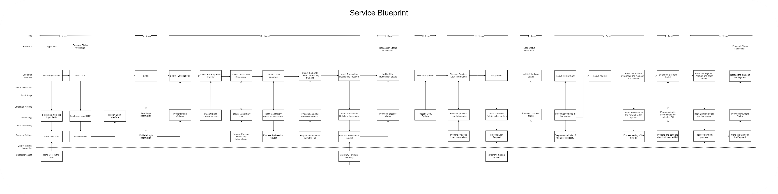

* Please find the attached PNG of the service blueprint inside the W3 branch for your reference.