Sri Lanka Institute of Information Technology

Lab sheet 05

Group No - 2021S2_REG_WE_26

**Year 3 Semester 2, 2021**

|  |  |  |
| --- | --- | --- |
|  | **Student Registration Number** | **Student Name** |
| **1** | IT19017334 | Bandara W.A.I.U. |
| **2** | IT19028156 | Kuruppuarachchi K.A.D.K.S. |
| **3** | IT19016108 | Alwis T.A.D.T.N.D. |
| **4** | IT19026480 | Maduwantha N.N.D. |

**User Experience Engineering – SE3050**

B.Sc. (Hons) in Information Technology

**IT19017334 - Bandara W. A. I. U.**

|  |  |  |
| --- | --- | --- |
| <<Member 01>>  **IT19017334** – **Bandara W. A. I. U.** | 01  Fail-points/blocking | 02  Fail-points/blocking |
| Fail-points/blocking | After entering the transaction details, it does not display a preview of that information before proceeding with the transaction, whereas it should be displayed.  If so, it might help the use user to get a clear idea about the inserted data. | After display the own account fund transfer interface it does not display the account list that was added by the user earlier. (Same as the display beneficiary list in the diagram). So, it should display the account list for the customer convenience. |
| Evidence |  |  |

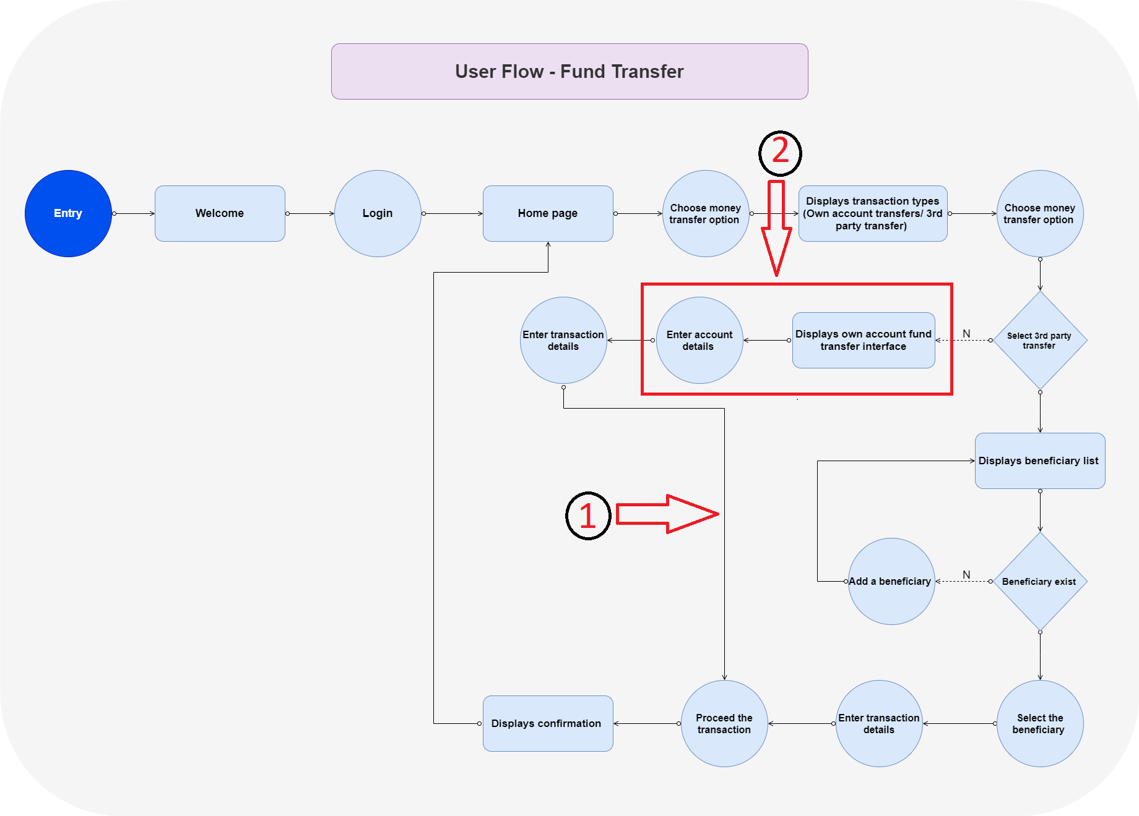

**IT19028156 – Kuruppuarachchi K.AD.K.S**

|  |  |  |
| --- | --- | --- |
| <<Member 02>>  IT19028156 – Kuruppuarachchi K.A.D.K.S | 01  Fail-points/blocking | 02  Fail-points/blocking |
| Fail-points/blocking | A Confirmation message is not displaying to the user before doing the payment, whether to confirm all are correct.  (Ex: Bill Account Number, Amount) details are correct. | All category of bills is displaying the same bill list. They are not categorized. It will be difficult for user to find a saved bill. |
| Evidence |  |  |

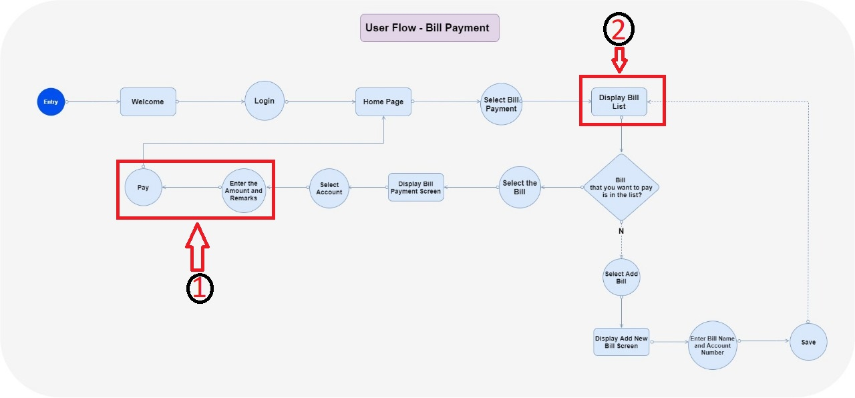

**IT19016108 – Alwis T.A.D.T.N.D**

|  |  |  |
| --- | --- | --- |
| <<Member 03>>  IT19016108 – Alwis T.A.D.T.N.D | 01  Fail-points/blocking | 02  Fail-points/blocking |
| Fail-points/blocking | In the current user flow diagram, If the user needs to add a loan application, users need to fill the form directly without knowing any information about the loan facilities that are provided by the bank.  So, there should be an option to view “loan information and facilities” in the user flow before filling the loan application. | When the user submits the filled loan application, users only get a successful message and don’t have a chance to check the filled information.  So, after submitting the filled loan application the application needs to provide a summary of the filled application details for the user. |
| Evidence |  |  |

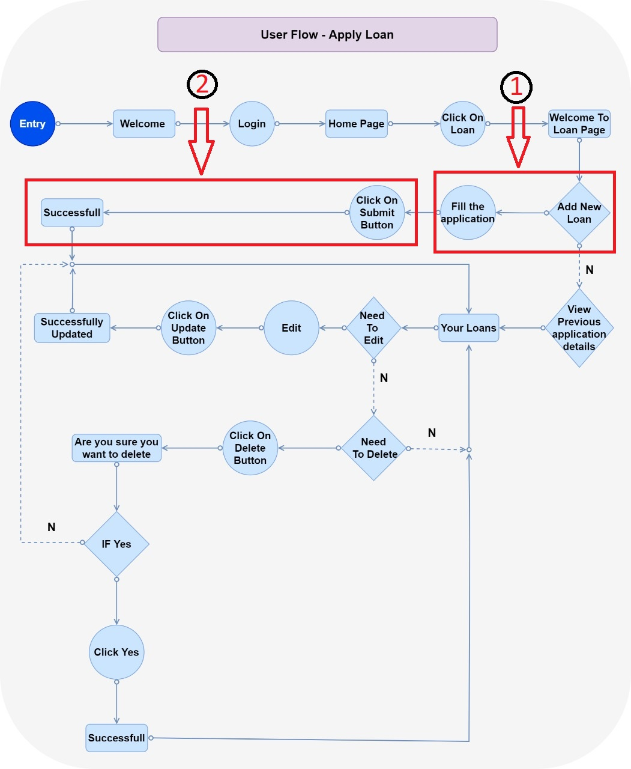

**IT19026480- Maduwantha N.N.D.**

|  |  |  |
| --- | --- | --- |
| <<Member 04>>  IT19026480 – Maduwantha N.N.D. | 01  Fail-points/blocking | 02  Fail-points/blocking |
| Fail-points/blocking | User data is not updating dynamically (ex: Bank Balances), even though user logged several times. | When entering NIC number to the registration, the letter 'V' at the end must be capital. If user enter it as simple 'v', it will not be proceeded, and the relevant error is not showing to the user. |
| Evidence |  |  |

