Sri Lanka Institute of Information Technology

Lab sheet 06

Group No - 2021S2_REG_WE_26

**Year 3 Semester 2, 2021**

|  |  |  |
| --- | --- | --- |
|  | **Student Registration Number** | **Student Name** |
| **1** | IT19017334 | Bandara W.A.I.U. |
| **2** | IT19028156 | Kuruppuarachchi K.A.D.K.S. |
| **3** | IT19016108 | Alwis T.A.D.T.N.D. |
| **4** | IT19026480 | Maduwantha N.N.D. |

**User Experience Engineering – SE3050**

B.Sc. (Hons) in Information Technology

**Sketching**

* **IT19017334 (Bandara W.A.I.U.) – Fund Transfer**

* **IT19028156 (Kuruppuarachchi K.A.D.K.S.) – Bill Payment**

* **IT19026480 (Maduwantha N.N.D.) – User Authentication and Dashboard**

* **IT19016108 (Alwis T.A.D.T.N.D) – Instant Loan**

**Wireframes**

* **IT19017334 (Bandara W.A.I.U.) – Fund Transfer**

Fund Transfer Menu Interface

Beneficiary List Interface

Third Party Fund Transfer Form

Add Beneficiary Interface

Own Account Transfers Form

Transaction Confirmation Form

* **IT19028156 (Kuruppuarachchi K.A.D.K.S.) – Bill Payment**

Bill List Interface

Bill Payment Interface

Save Bill Interface

Confirm Payment Interface

* **IT19026480 (Maduwantha N.N.D.) – User Authentication and Dashboard**

Sign In Interface

Sign Up Interface

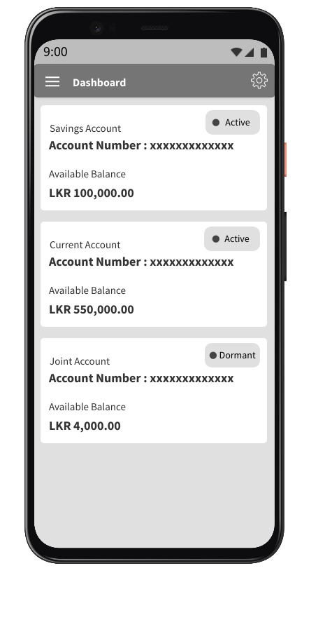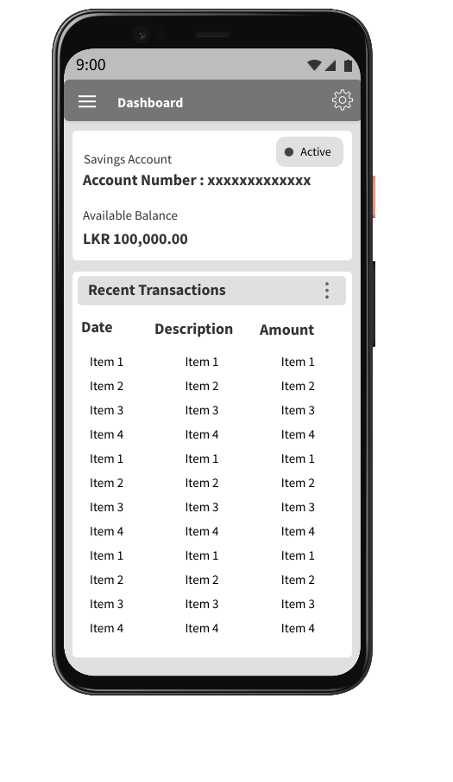

Recent Transactions Interface

Dashboard Interface

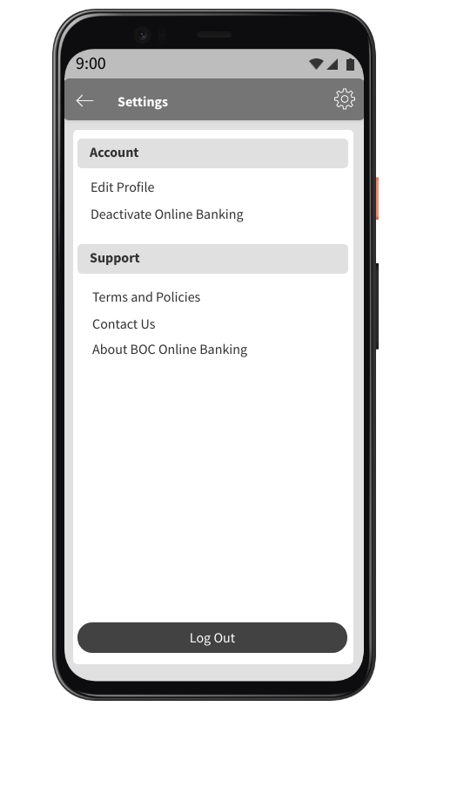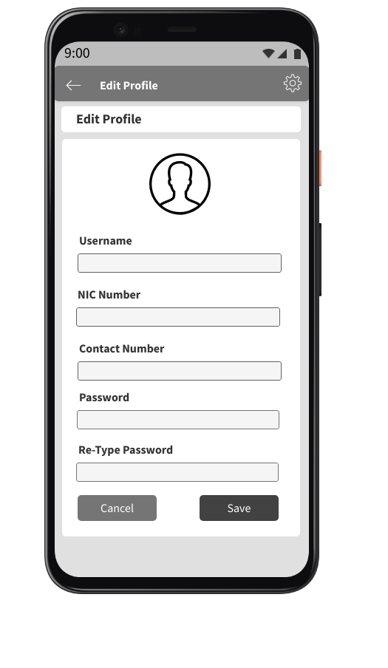

Edit Profile

Settings Interface

* **IT19016108 (Alwis T.A.D.T.N.D) – Instant Loan**

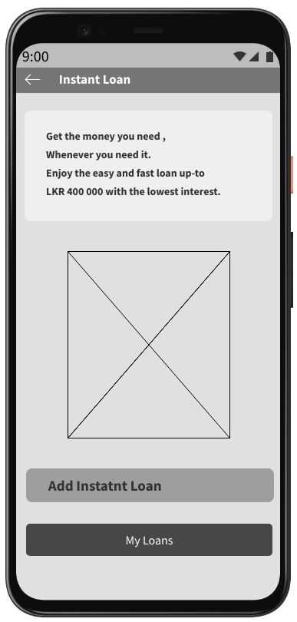

My Loans Interface

Instant Loan Interface

Loan Information

Add Instant Loan Interface

**Prototype – Version 1**

Left Menu

Welcome Page

* **IT19017334 (Bandara W.A.I.U.) – Fund Transfer**

Beneficiary List Interface

Fund Transfer Menu Interface

Add Beneficiary Interface

Third Party Fund Transfer Form

Own Account Transfers Form

Transaction Confirmation Form

* **IT19028156 (Kuruppuarachchi K.A.D.K.S.) – Bill Payment**

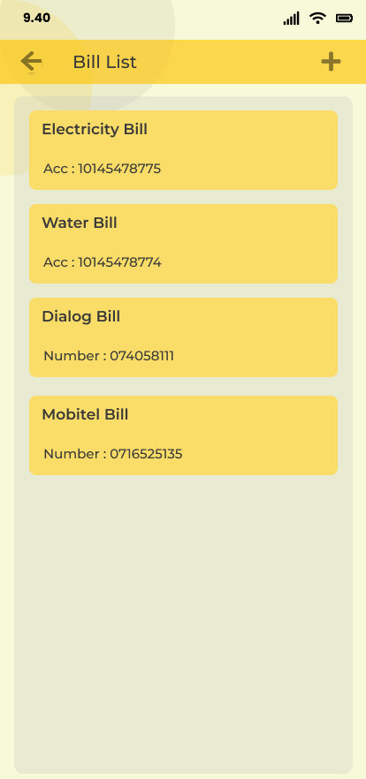

Bill List Interface

Bill Payment Interface

Updated Bill List Interface

Save Bill Interface

* **IT19026480 (Maduwantha N.N.D.) – User Authentication and Dashboard**

Reset Credentials Interface

Sign In Interface

Sign Up Interface

OTP Submission Interface

Dashboard Interface

Recent Transactions Interface

Settings Interface

Recent Transactions Filter

Edit Profile Interface

* **IT19016108 (Alwis T.A.D.T.N.D) – Instant Loan**

My Loans Interface

Instant Loan Interface

Loan Information

Add Instant Loan Interface

**Prototype – Version 2**

Welcome Page

Left Menu

* **IT19017334 (Bandara W.A.I.U.) – Fund Transfer**

Beneficiary List Interface

Fund Transfer Menu Interface

Third Party Fund Transfer Form

Add Beneficiary Interface

Own Account Transfers Form

Transaction Confirmation Form

* **IT19028156 (Kuruppuarachchi K.A.D.K.S.) – Bill Payment**

Bill List Interface

Bill Payment Interface



Updated Bill List Interface

Save Bill Interface

Confirm Payment Interface

* **IT19026480 (Maduwantha N.N.D.) – User Authentication and Dashboard**

Sign In Interface

Reset Credentials Interface

Sign Up Interface

OTP Submission Interface

Dashboard Interface

Recent Transactions Interface

Settings Interface

Recent Transactions Filter

Change Passcode Interface

Edit Profile Interface

* **IT19016108 (Alwis T.A.D.T.N.D) – Instant Loan**

My Loans Interface

Instant Loan Interface

Add Instant Loan Interface

Loan Information

**Script**

Hi, thank you again for taking the time to participate in this study. Before we begin, I’m going to give you a brief overview of the test and how it will work.

We are undergraduate students from SLIIT and this is a prototype that we have designed for BOC smart passbook application by suggesting the upgraded features.

This session will be rather simple: I'll give you a broad job to do and then ask you questions as we go. Before I tell you about the task, I'll give you some background information, such as why you might be performing it and what you want to accomplish.

It's critical to understand that we're simply testing the prototype, not you. There isn't anything you can say or do here that isn't correct. Please feel free to let me know at any time if there’s something you like, dislike, if you’re confused, etc. I promise you won’t hurt my feelings.

Also, as much as possible, I'd like you to "think aloud." That is to say, I'd like you to express yourself as often as possible. You might be browsing at a page and notice something you hadn't noticed before and want to click on it. In such instance, something along the lines of "something caught my eye, therefore I'm going to see what it is" would be really helpful.

Please do not hesitate to ask questions if you have any. Do you have any further questions?

Let's get this started.

So, this prototype contains the main functionalities that we are hoping to achieve through this application.

They are,

* User Registration/Authentication and Dashboard
* Fund Transfer
* Bill Payment
* Instance Loan

So, first we will go through the User Registration and Authentication part.

Assume that you want to access the application. Since you do not have an account, you must first create an account

**Task 1 - User Authentication and Dashboard**

1. **Create an Account**

Assume that you don’t have an account for BOC mobile app and start the application with sign up process please.

Expected Actions:

* 1. Click on Sign Up button

1. **Login to the application**

Now you already have an account, can you try Sign into the Application

Expected Actions:

* 1. Click on Sign In button

Questions

So, do you have any suggestions to further improve our login and registration interfaces or is this better than the previous application?

* **Yes, it is better, and I couldn’t feel any further modifications required.**

1. **Application Dashboard (Landing interface)**

Expected Actions:

* 1. Browse through the interface and detect the newly implemented account details displaying section.
  2. Click on the icon at the top left corner to open the ‘Left menu’.
  3. Click on the cog wheel icon at the top right corner to navigate to the ‘Settings’ interface.

1. **Recent Transactions Details**

You can tap on the first account details card to navigate recent transactions page.

Expected Actions:

* 1. Click on the ‘options’ icon at the top of the Recent Transactions to filter the transaction records.

Questions

Are you satisfied with the recent transactions table design? We have designed to display maximum of 3 months transactions and also you can filter out the transactions by tapping on the three dots.

* **Yes, it is enough to have maximum of 3 months transactions.**

1. **Application Settings**

Expected Actions:

* 1. Read through the available settings list and express the opinions.
  2. Click on the options available in the list.
  3. Navigate to ‘Edit Profile’ setting from the list.

Questions

Do you prefer any changes or improvements to the settings page rather than these?

* **It’s better to have the Sign Out option at the ‘Left Menu’. It will be much easier to access.**

1. **Edit User Profile Details**

Expected Actions:

* 1. Click on the ‘confirm’ button to save the changes.

Questions

Feel free to express your ideas on this interface as well.

* **I would like to have ‘Change passcode’ option in the settings view, rather than having it on the ‘Edit profile’ page.**

Ok, that’s all for the User Registration and Authentication.

So, from this left side navigation bar you can traverse through the functionalities that you want to do. So, let’s try out these functionalities one by one.

Let’s try out the Fund Transfer Facility

**Task 2 - Fund Transfer**

1. **Add a Beneficiary**

Expected Actions:

* 1. Tap on “Add Beneficiary” button in the Money Transfer Menu page.
  2. Navigates to the Beneficiary List view page.
  3. Tap the “Plus icon” at the top right corner.
  4. Navigates to the Add beneficiary form.
  5. Enter the required beneficiary details.
  6. Submit the form by taping “Save” button.

Questions

How do you feel about that process?

* **It fine but it’s better if there is a cancel button to cancel the process.**

Are there any difficulties?

* **No actually it’s ok, It’s way better than I though.**

1. **Third Party Fund Transfer**

Expected Actions:

* 1. Tap on “Third Party Fund Transfer” button in the Money Transfer Menu page.
  2. Navigates to the “Third Party Fund Transfer” form.’
  3. Select the beneficiary from the dropdown.
  4. Enter other required details.
  5. Tap on ‘Pay’ button.
  6. Navigates to the Confirmation page.
  7. Tap on confirm button.

Questions

How was that task?

* **Actually, it’s pretty good.**

Do you prefer any changes or improvements to the transaction page?

* **No actually it’s fine**

1. **Own Account Fund Transfer**

Expected Actions:

* 1. Tap on Own Account Fund Transfer button in the Money Transfer Menu page.
  2. Navigates to the “Own Account Fund Transfer” form.
  3. Select the source account and the Transferring account from the dropdown.
  4. Enter other required details.
  5. Tap on ‘Pay’ button.
  6. Navigates to the Confirmation page.
  7. Tap on confirm button.

Questions

What do you think about this confirmation page, is this page is ok?

* **Yes, it’s good to see that feature in this application.**

What would you think is it difficult to do a fund transfer or not?

* **No, it is pretty much easier actually, in this third-party fund transfer it is easy to access.**

Ok, that’s all for the Fund Transfer Facility.

Let’s try out the Bill Payment.

Can you go to the Bill Payment option by click on the Bill Payment form the left side menu?

**Task 3 - Bill Payment**

1. **Save a Bill**

Expected Actions:

* 1. Click on Select Bill Option from the Bill Payment Interface
  2. Navigates to the Bill List interface
  3. Click on Add icon at the top right corner of the interface
  4. Navigates to the Save Bill Interface.
  5. Enter new bill name and account number.
  6. Click on Save button

Questions

Are you Ok with these details that asked when saving a bill?

* **Yes, I am OK with the saving bill.**

1. **Pay a Bill**

Can you please pay a bill now?

Expected Actions:

* 1. Navigates to the Bill Payment Interface.
  2. Click on Select Bill
  3. Navigates to the Bill List Interface.
  4. Select a Bill that want to Pay
  5. Navigates again to the Bill Payment Interface.
  6. Select the Account that the Bill is going to pay from.
  7. Enter the Amount that want to pay.
  8. Enter the Remarks if want.
  9. Click on Pay Button.

Questions

Did you wish anything to add in this process bill payment process?

* **All are OK, but it is better to add a Confirmation message or something by showing**

Was there anything unnecessary?

* **Did not notice any unnecessary things. I think all the things that you have include is necessary and all are ok.**

Ok, So that’s all for the Bill Payment functionality.

Let’s Try out the Instant Loans by click on the Instant Loan option in the side bar from Dashboard

**Task 4 - Instant Loan**

1. **Apply a Loan**

Expected Actions:

* 1. Click on the Instant Loan icon in the side navigation bar.
  2. Navigate to the Instant Loan interface.
  3. Click on Add Instant Loan button.
  4. Navigate to Add Instant Loan Interface.
  5. Click on Apply Loan button.
  6. Navigate to the Loan Information Interface.
  7. Click on Confirm button.

Questions

Are you satisfying with the flow of the apply loan process?

* **Yeah, the flow is really good.**

Do you think there is anything to change in these interfaces?

* **Actually, the interfaces are simple and user-friendly. I like the simplicity of these interfaces.**
* **One thing I like to say that if you can add a cancel button to the Add Instant Loan interface it will be better.**

1. **Check previously purchased loans.**

Now you have purchased a loan from the bank. So, you can check purchased loans from My loans page.

* 1. Go Back to the Instant Loan Interface.
  2. Click on My Loans button.
  3. Navigate to the My Loans interface.

Questions

Are you satisfying with the flow of the check previous loans process?

* **Yeah, all are good, I am satisfying with the flow.**

Do you think there is anything to change in these interfaces?

* **No, I think all the interfaces are perfect. I like the simplicity of these interfaces.**

Ok, so that’s all for the Loan Apply functionality.

So fantastic. So now, we are done with the task portion of the session. All that’s left is just few questions. Sound, Ok?

**Overall Questions asked from the Interviewees**

What was your experience?

* **It is better than previous one**

Are you OK with the Design?

* **Yes, I am satisfied with the design also, alignments of the elements are also seemed to be okey and also navigation between user interfaces are smoothly happening**

What about the used theme color?

* **I think it is matching with the bank theme also, so it is good**

What would you think about the difficulty level of these tasks?

* **For me nothing is difficult all are easy to understand**

Ok Thank you.

That’s all for our interview. Thank you very much for your valuable time. Your responses are very helpful to improve our application. So once again Thank you very much**.**

**Contribution**

|  |  |  |
| --- | --- | --- |
| **IT19017334** | **Bandara W.A.I.U.** | * Welcome page * Left menu * Fund transfer menu interface * Beneficiary list interface * Add beneficiary interface * Third party fund transfer interface * Own account fund transfer interface * Fund transfer confirmation interface |
| **IT19028156** | **Kuruppuarachchi K.A.D.K.S.** | * Bill Payment * Bill Payment Confirmation * Bill List * Add Bill |
| **IT19026480** | **Maduwantha N.N.D.** | * Sign In * Sign up * Reset Credentials * Reset Credentials - OTP Submission * Dashboard * Recent Transactions * Recent Transactions - with filter * Settings * Edit Profile * Change Passcode |
| **IT19016108** | **Alwis T.A.D.T.N.D.** | * Instant Loan Menu Interface * My Loans Interface * Apply Loan Interface * Loan Confirmation Interface |