**BSc (Hons) in Information Technology**

**Software Engineering – Year 3 Semester 2, 2021**

**Lab sheet 06**

**SE3050 – User Experience engineering**

**User Research**

**2021S2_REG_WE_67**

**Group Members: -**

|  |  |
| --- | --- |
| Registration Number | Name |
| IT19119786 | **Sivarajah.K** |
| IT19123400 | **Soujanyaah.K** |
| IT19107110 | **Viknatharshan.N** |
| IT19047102 | **Sivashankar.S** |

**Sketching**

**IT19123400 – Soujanyaah. K**

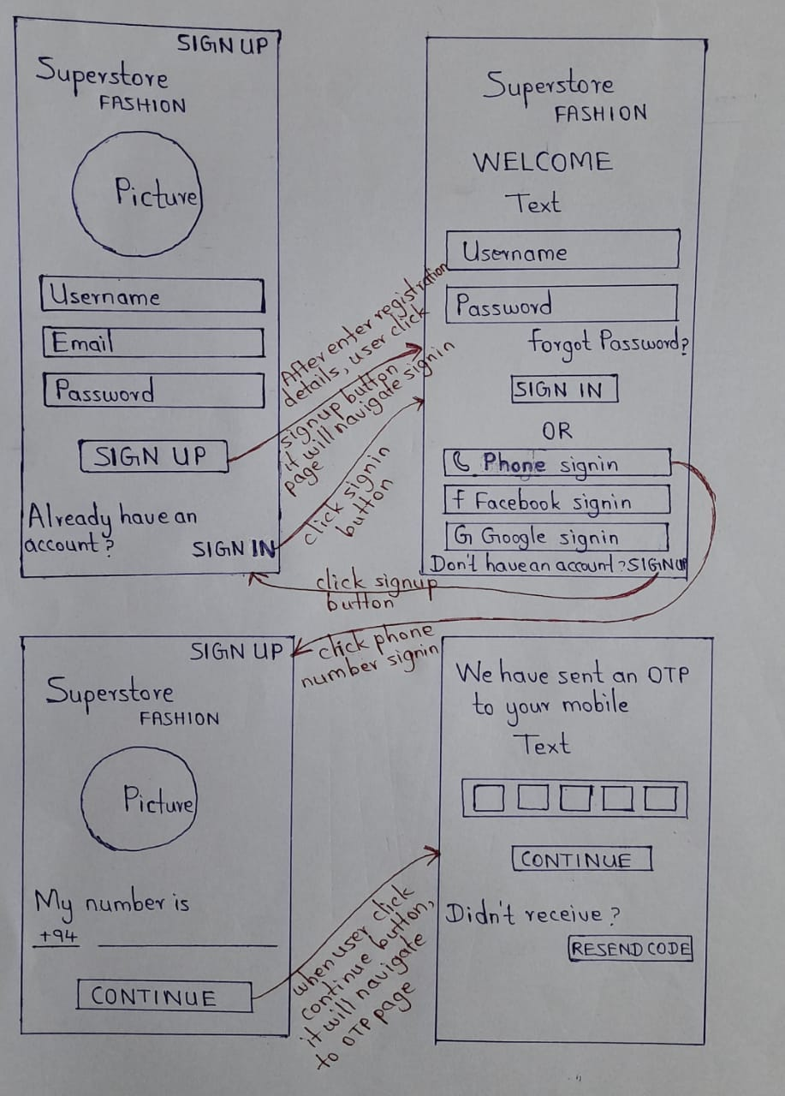

**IT19119786 – Sivarajah. K**

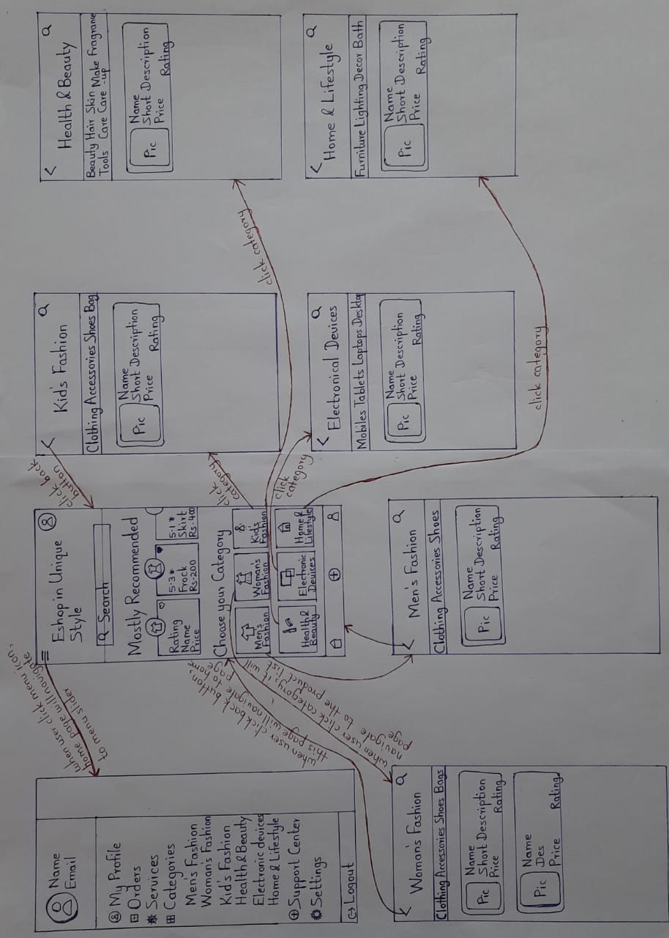

**IT19047102 - Sivashankar. S**

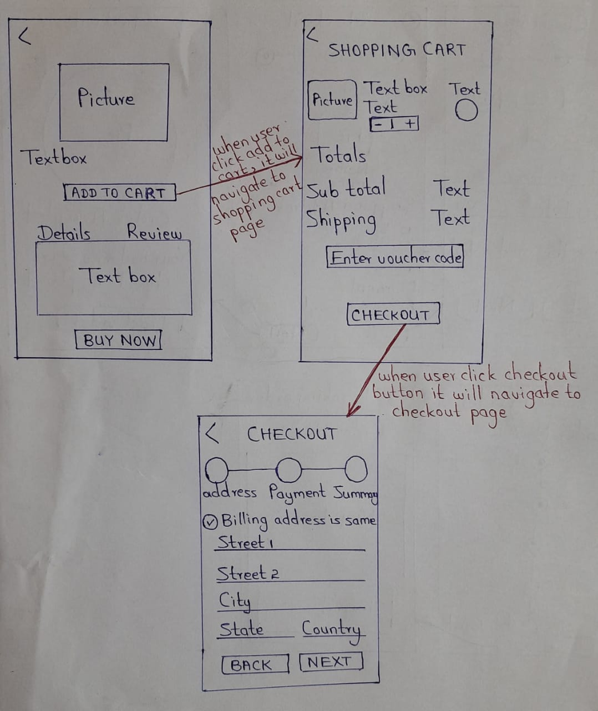

**IT19107110 – Viknatharshan. N**

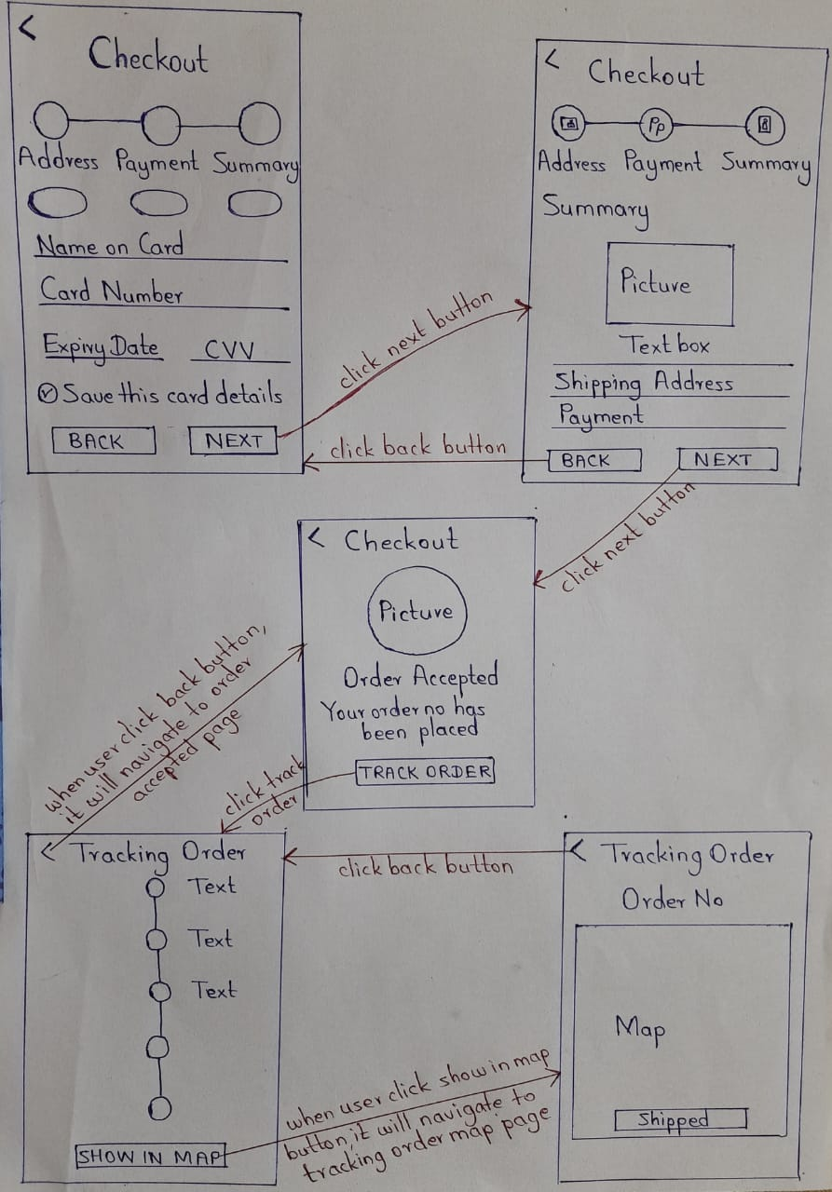

**Wireframes**

**Figma Link -** <https://www.figma.com/file/kkFhxtNZSwLKZeG76n7Qpi/Ecommerce-Application?node-id=0%3A1>

**Team – Ecommerce Application**

**IT19123400 – Soujanyaah. K**

**IT19119786 – Sivarajah.K**

**IT19047102 - Sivashankar. S**

**IT19107110 – Viknatharshan. N**

**Prototype**

**Adobe XD Link –** <https://xd.adobe.com/view/47579302-5d5e-4e78-9b87-db6bfd6b0564-1204/>

**Team – Ecommerce Application**

**IT19123400 – Soujanyaah. K**

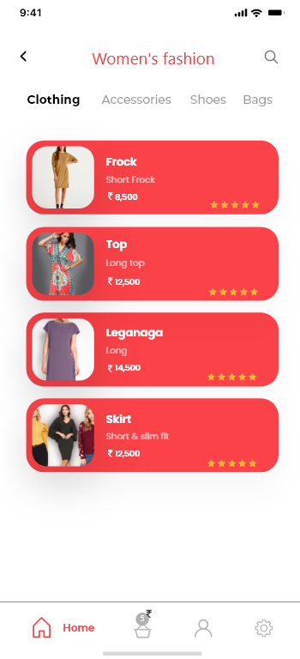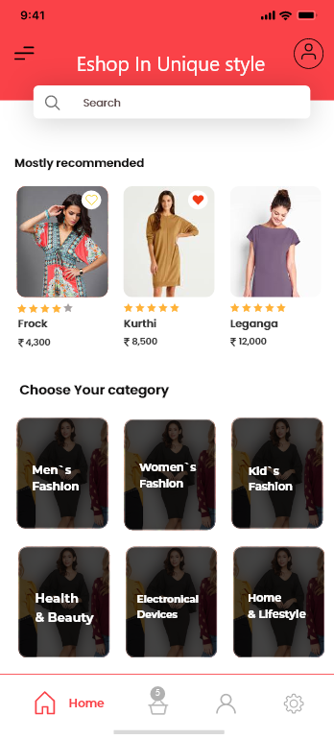**IT19119786 – Sivarajah. K**

**IT19047102 – Sivashankar. S**

**IT19107110 – Viknatharshan. N**

**User Feedback**

**Interview Video Link –** [**https://drive.google.com/file/d/1U3QlE7_TxsD58ocTwCGdrnHVqDo9WhdZ/view?usp=sharing**](https://drive.google.com/file/d/1U3QlE7_TxsD58ocTwCGdrnHVqDo9WhdZ/view?usp=sharing)

**Script**

Hello Abilash,

Good evening

First of all, thank you so much for joining us today. Last time, we were discussing about the e commerce application and collecting some suggestions and feedback from you for the better of the application. We have now modified the application and today, and I hope you've had taken a look at our interfaces. So, during this interview, we would once again like you to review our newly redesigned e commerce application and share your thoughts on it. So, shall we start now?

**Q1**

At your first sight after the re designing, were you able to spot clear improvements or did it look almost the same?

**Answer: -** Yeah definitely. I could see some real improvements, especially in the UI with all those changes in the colors and theme, I'm quite impressed how you have modified this application this far.

**Q2**

Do you find the colors used in the modified application attractive and user friendly?

**Answer: -** I would say yes. It was too dull and old fashioned when I saw last time but this one looks more attractive as well as professional.

**Q3**

How satisfied are you with how the components are organized in each UI? Did you find anything inconvenience about their placements while using the app?

**Answer: -** I would say you guys have brought this app's UIs to the professional level now. Any improvements from here and going to be plus points for you. Everything looks organized and trendy so, what I can say is..... Good work guys.

**Q4**

How satisfied are you with the current validation level of the input fields?

**Answer: -** Yeah it's good to see you guys using the api concept to retrieve the country and city details and I could see good improvements in the validation part of the other fields too.

**Q5**

Does this app look professional and up to the current trend?

**Answer: -** Yeah exactly. I'm pretty much satisfied with the work.

**Q6**

Do you think the Home Page is attractive enough and well organized to keep the user engaged in the application, exploring more products than what he came for?

**Answer: -** Yeah I think there's a high possibility for that. You guys have organized the product under certain categories which makes it easier for the customer to search what they want. It would be better if you can add the best rated or mostly viewed product as recommendations so that the user can find the best products easily.

**Q7**

What are your thoughts about the order tracking page? Does it contain enough details and well-organized components?

**Answer: -** Yeah looks good to me. Good that you have added the date & time to the page. Consider adding the Google maps if you can. That would be an added advantage.

**Q8**

How likely are you to recommend this application to another person?

**Answer: -** If you are going to launch this app with all functionalities working perfectly, I'd surely recommend to all my friends and family. Looking forward for the day.

• **Changes requested by the interview respondent**

* Add the best rated or mostly viewed product as recommendations so that the user can find the best products easily.
* Add Google maps to the order tracking functionality

**• Changes made after the interview**

* Added recommended products to the Home Page
* Added Order Tracking via Google Map Service