|  |  |  |  |
| --- | --- | --- | --- |
|  | Bansilal Ramnath Agarwal Charitable Trust's  Vishwakarma Institute of Information Technology  **Department of**  **Artificial Intelligence and Data Science** | | |
| Name: Satyam Mahadev Jadhav | | | |
| Class: TY | Division: B | | Roll No: 372021 |
| Semester: V | | Academic Year: 203-2024 | |
| Subject Name & Code: Cloud Computing and DevOps | | | |
| Title of Assignment: Assignment 1: Linux Commands for Cloud computing and DevOps | | | |

1)ls :

Descp: Lists’ information about the FILEs (the current directory by default).

Syntax : ls [OPTION]... [FILE]...

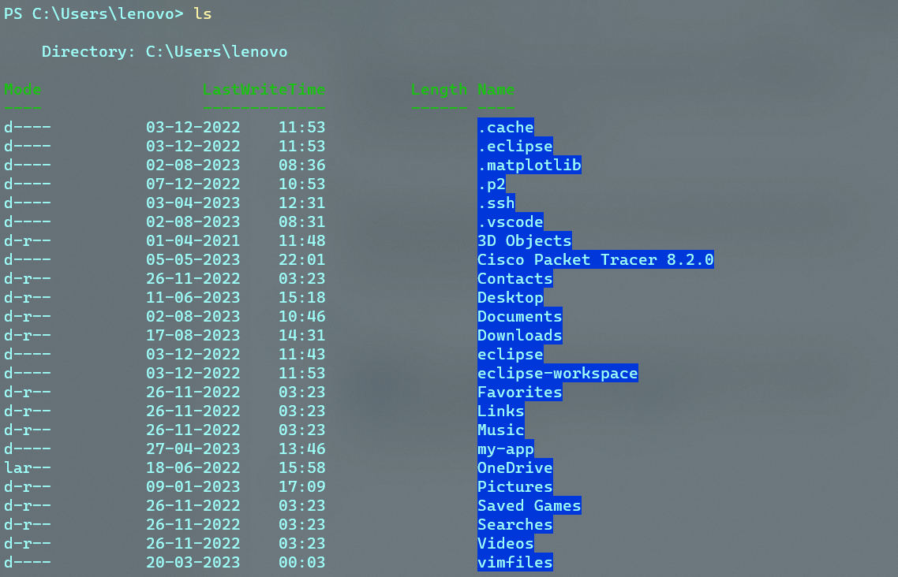

2)cd :

Description: It stands for change directory. It lets user change the working directory.

Syntax: cd [directory_name]

3)chmod:

Description: chmod changes the file mode bits of each given

file according to mode, which can be either a symbolic representation of changes to make, or an octal number representing the bit pattern for the new mode bits.

syntax: chmod [OPTION]... MODE[,MODE]... FILE...

chmod [OPTION]... OCTAL-MODE FILE...

chmod [OPTION]... --reference=RFILE FILE...

4)cat:

Description: Stands for concatenate, lets you create, view, and concatenate files directly from the terminal.

Syntax: cat [OPTION]... [FILE]...

5)grep:

Description:  It searches for lines that match a regular expression. This really helped navigating large log files.

Syntax: grep [OPTION...] PATTERNS [FILE...]

6)htop:

Description: interactive process viewer that lets you manage your machine’s resources directly from the terminal.

Syntax: htop [-dCFhpustvH]

7)tail :

Description:

it's pretty similar to cat, but only print last 10 lines by default, but it can be changed by adding -n. You can also have a live tail of log file running

syntax: tail [OPTION]... [FILE]...

8)mkdir: