1.1 Introduction to Current System

In today's competitive business environment, distributors and wholesalers manage large numbers of products, invoices, inventory transactions, and customer records daily. Many small and medium-sized distributors still rely on manual registers, spreadsheets, and disconnected software solutions to manage their operations. Such approaches often result in data inconsistency, inventory mismatches, delayed billing processes, and difficulties in maintaining historical business records.

BizFlow Version 1 was developed as a web-based Inventory and Billing Management System to digitize these processes. The system enabled distributors to maintain a product catalog, generate bills, automatically update inventory, and download invoices in PDF format. While the system successfully automated the core workflow of inventory and billing, it was primarily designed as a single-user solution focused on validating the business workflow.

As the requirements evolved, additional business challenges became evident. Distributors needed better visibility into their business performance, tracking of payments and pending invoices, support for multiple users within a company, and stronger data organization mechanisms. These requirements led to the development of BizFlow Version 2.

BizFlow Version 2 is a comprehensive tenant-based Distributor Inventory, Billing and Business Management System. The application allows each company to maintain its own isolated business environment, including users, products, inventory, invoices, and payments. The system integrates inventory management, billing, payment tracking, dashboard analytics, and PDF invoice generation into a unified platform.

The application is built using modern web technologies including React, Node.js, Express.js, Sequelize ORM, PostgreSQL, and React Query. The architecture emphasizes scalability, maintainability, security, and data consistency while providing a simple and intuitive user experience for distributors.

1.2 Need of Proposed System

Traditional inventory and billing management approaches suffer from numerous limitations that negatively impact business efficiency.
Many distributors maintain stock records using physical registers or spreadsheet software. Such methods require manual updates and are highly prone to human errors. A mistake in inventory calculations can lead to stock shortages, incorrect billing, or inaccurate financial records.
Similarly, invoice generation is often performed manually or through disconnected software tools. Since inventory and billing systems are not integrated, stock levels must be updated separately, increasing workload and creating opportunities for inconsistencies. Several additional business problems are commonly observed including difficulty in tracking customer and supplier transactions, delayed payment recording, lack of real-time inventory visibility limited reporting and analytics capabilities.

Inventory Problems
- Difficulty in tracking real-time stock levels.
- Manual stock updates after each transaction.
- High possibility of inventory mismatches.
- Lack of centralized product management.

Billing Problems
- Time-consuming invoice generation.
- Repeated manual data entry.
- Difficulty maintaining invoice history.
- Inability to monitor pending payments effectively.

Business Management Problems
- No consolidated dashboard for business insights.
- Lack of visibility into receivables and payables.
- Limited reporting and analytics capabilities.
- Difficulty tracking business growth trends.

Scalability Problems
- Single-user systems limit collaboration.
- No support for multiple staff members.
- Difficulty maintaining data separation between organizations.

To overcome these limitations, there is a need for a unified business management platform capable of handling inventory, billing, payments, and business analytics within a single integrated environment.

BizFlow Version 2 addresses these challenges by providing:
- Automated inventory management.
- Invoice generation with PDF export.
- Payment tracking and bill-state monitoring.
- Dashboard analytics.
- Multi-user support.
- Tenant-based data isolation.
- Secure authentication mechanisms.
- Centralized business records.
- Generating Revenue reports.

The proposed system significantly improves operational efficiency while reducing manual effort and human errors.
By integrating inventory management, billing, customer and supplier management, payment tracking , and business analytics into a single platform.

1.3 Objectives

The primary objective of BizFlow Version 2 is to provide distributors with a complete business management solution that simplifies inventory control, billing operations, payment tracking, and business monitoring.

Technical Objectives
- To design and develop a scalable web application using modern web technologies.
- To implement a secure backend using Node.js, Express.js, Sequelize, and PostgreSQL.
- To develop a responsive frontend using React and Vite.
- To implement tenant-based architecture for secure business data isolation.
- To ensure transactional consistency for invoice generation and inventory updates.
- To provide reliable data storage and retrieval mechanisms.
- To implement React Query for efficient server-state management.
- To provide a maintainable and modular software architecture.

Functional Objectives
- To provide secure user authentication and authorization.
- To allow organizations to maintain independent business environments.
- To provide product catalog management functionality.
- To automate inventory updates through invoice transactions.
- To support generation of stock-in and stock-out invoices.
- To calculate taxes, discounts, subtotals, and totals automatically.
- To generate downloadable PDF invoices.
- To maintain complete invoice history.
- To track payments against invoices.
- To calculate pending amounts automatically.
- To classify invoices as Pending, Partial, or Paid.
- To provide dashboard analytics for business monitoring.
- To provide search, filtering, and data retrieval capabilities.
- To improve business decision-making through centralized records.

1.4 Scope of the System

The scope of BizFlow Version 2 includes the automation of major distributor business processes through a web-based platform. The system enables product catalog management, inventory tracking, stock-in and stock-out invoice generation, customer/supplier management.
The system covers:

User Management
- User registration and login.
- Tenant onboarding.
- Owner and staff roles.
- Session management.

Product Management
- Product catalog creation.
- Product information maintenance.
- Product search and retrieval.

Inventory Management
- Real-time stock visibility.
- Automatic stock updates.
- Inventory quantity tracking.

Billing Management
- Stock-in invoice generation.
- Stock-out invoice generation.
- Invoice history management.
- Invoice detail viewing.

Payment Management
- Recording payments.
- Tracking pending balances.
- Bill-state calculation.

Analytics
- Business summary dashboard.
- Monthly business insights.
- Inventory and invoice statistics.

Reporting
- PDF invoice generation.
- Historical record maintenance.

1.5 Problem Statement

Distributors frequently face challenges in managing inventory, invoices, and payment records due to fragmented systems and manual processes. Many small and medium-sized businesses continue to rely on paper-based records, spreadsheets, or multiple disconnected software applications to manage their daily operations. This often leads to stock inconsistencies, duplicate data entry, delayed billing, inaccurate inventory records, difficulty in tracking customer and supplier transactions, and an increased risk of human error. As the volume of business grows, these issues become more significant, reducing operational efficiency and affecting customer satisfaction.

Another major challenge is the lack of real-time visibility into inventory levels and business performance. Since inventory updates are often performed manually, businesses may experience stock shortages or overstocking, resulting in financial losses and poor inventory planning. Payment tracking also becomes difficult when invoices and transaction records are scattered across different systems, making it harder to monitor outstanding balances and maintain accurate financial records. In addition, generating business reports for sales analysis and decision-making requires considerable manual effort.

There is a need for an integrated software solution that centralizes distributor operations into a single platform. Such a system should automate inventory updates based on stock-in and stock-out transactions, simplify invoice generation, maintain organized product, customer, and supplier records, track business transactions accurately, and provide analytical insights to support better decision-making. The solution should reduce manual intervention, improve data accuracy, and increase the overall efficiency of distributor operations.

BizFlow Version 2 addresses these challenges by providing a secure, scalable, and user-friendly web-based Distributor Inventory, Billing, and Business Management System. The application integrates inventory management, billing, customer and supplier management, invoice generation, and business analytics into a unified platform. Automated inventory synchronization ensures that stock levels remain accurate after every transaction, while reporting and analytics provide valuable insights into sales trends and business performance.

2.1 Introduction to System Development Life Cycle

The Software Development Life Cycle (SDLC) is a structured framework used for planning, designing, developing, testing, deploying, and maintaining software systems. It provides a systematic approach to software development, ensuring that the final product meets user requirements while maintaining quality, reliability, and scalability.

The primary purpose of SDLC is to divide software development into manageable phases. Each phase produces specific deliverables that contribute to the successful completion of the project. By following a defined life cycle, developers can reduce risks, improve software quality, and ensure efficient resource utilization.

For the development of BizFlow Version 2, SDLC played a critical role in transforming business requirements into a fully functional web-based Distributor Inventory, Billing, and Business Management System. The project involved multiple interconnected modules such as authentication, tenant management, dashboard analytics, inventory management, product catalog management, invoice generation, payment tracking, and PDF invoice generation. A structured development approach was therefore necessary to ensure smooth integration of all modules.

The SDLC process followed in BizFlow consisted of the following phases:
- Requirement Analysis
- System Design
- Implementation
- Testing
- Deployment
- Maintenance and Future Enhancements
Each phase contributed to the development of a reliable and scalable business management platform.

2.2 SDLC Model Selected – Agile Methodology

For the development of BizFlow Version 2, the Agile Software Development Model was selected due to its flexibility, iterative nature, and ability to accommodate changing requirements. Unlike traditional models such as Waterfall, Agile allows software to be developed incrementally through small iterations called sprints. Each sprint focuses on delivering a functional part of the system that can be tested and evaluated independently.

This approach was particularly suitable for BizFlow because the project evolved significantly during development. Initially, the application focused only on inventory and billingsflksdjfk management. As development progressed, However, additional requirements such as tenant-based architecture, payment tracking, dashboard analytics, and multi-user support em during development. Agile methodology enabled these new requirements to be incorporated without
disrupting the entire system architecture.

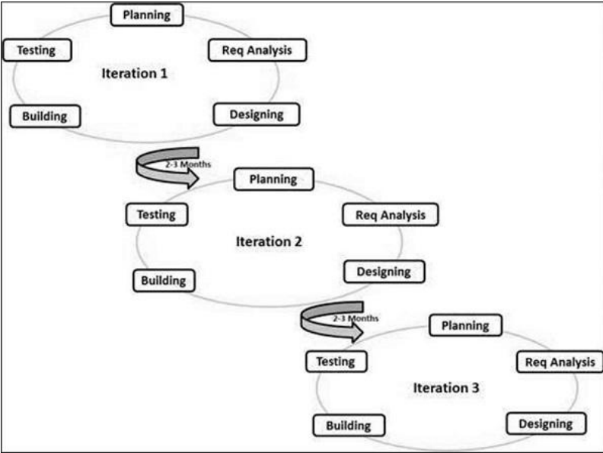
Fig 2.1: Agile SDLC Model

2.3 Requirement Analysis

Requirement Analysis is one of the most important phases of SDLC. During this phase, system requirements were collected, analyzed, and documented to ensure that the final product addresses actual business needs.

The requirement gathering process involved studying the workflow of distributors and identifying common operational challenges.
The primary stakeholders of the system are:

Stakeholders
- Business Owner (Tenant Owner)
- Staff Members
- Distributors
- System Administrator
- Customers (Indirect Stakeholders)
The collected requirements were classified into Functional and Non-Functional Requirements. Functional requirements describe the core features and operations that the system must perform, while non-functional requirements define the quality attributes such as performance security, reliability, scalability, and usability that ensure the system operates efficiently.

2.3.1 Functional Requirements
Functional requirements describe the services and operations that the system must perform.

1. User Authentication
- Allow user registration.
- Allow secure login.
- Maintain authenticated sessions.
- Support role-based access.

2. Tenant Management

Create separate business workspaces.

Isolate company data.

Allow owner-controlled onboarding.

3. Product Catalog
- Add products.
- Update product information.
- Delete products.
- Search products.

4. Inventory Management
- Maintain stock records.
- Increase stock for Stock-In invoices.
- Decrease stock for Stock-Out invoices.
- Prevent invalid inventory states.

5. Billing Module
- Generate invoices.
- Support Stock-In invoices.
- Support Stock-Out invoices.
- Calculate taxes automatically.
- Apply discounts automatically.
- Generate invoice numbers.
- Support supplier number.
- support custom date.

6. Payment Module
- Record payments.
- Calculate pending amounts.
- Track invoice payment status.

7. Dashboard Module
- Display monthly statistics.
- Show inventory information.
- Display invoice summaries.
- Show pending payment statistics.

8. PDF Generation
- Generate professional invoices.
- Allow PDF download.
- Maintain printable invoice records.

2.3.2 Non-Functional Requirements
Non-functional requirements define the quality characteristics of the system.

1. Security
- Protect business data.
- Use secure authentication mechanisms.
- Restrict unauthorized access.

2. Performance
- Respond quickly to user requests.
- Load dashboard data efficiently.
- Generate invoices with minimal delay.

3. Scalability
- Support increasing business data.
- Handle growing numbers of invoices.
- Support multiple users per organization.
- Accommodate future business expansion.
- Maintain performance as the number of products and transactions increases.

4. Reliability
- Maintain data consistency.
- Prevent data loss.
- Ensure system availability.

5. Maintainability
- Use modular architecture.
- Support future enhancements.
- Allow easy bug fixing.

6. Usability
- Provide intuitive navigation.
- Reduce learning curve.
- Support efficient workflows.

2.4 System Design

The System Design phase converts requirements into technical architecture and implementation plans. For BizFlow Version 2, the design focused on modularity, scalability, maintainability, and business workflow automation.

The system was divided into independent modules such as authentication, inventory management, billing, customer and supplier management, and analytics. This modular architecture simplifies development, and testing.
The system architecture consists of:

Frontend Layer

Technologies:
- React
- Vite
- React Router
- React Query

Responsibilities:
- User Interface
- Form Handling
- State Management
- API Integration
- Easy Navigation
- UseFull Interactions

Backend Layer

Technologies:
- Node.js
- Express.js
- Sequelize ORM

Responsibilities:
- Business Logic
- Authentication
- Invoice Processing
- Payment Processing

Database Layer
Technology:
- PostgreSQL ( supabase managed )

Responsibilities:
- Data Storage
- Data Integrity
- Transaction Management

Major Modules
- Authentication Module
- Dashboard Module
- Product Catalog Module
- Inventory Module
- Generate Bill Module
- View Bills Module
- Payment Module
- PDF Generation Module
- Reports Generation Module

The modular architecture ensures that each component can be maintained and enhanced independently.

2.5 Implementation

The implementation phase involved converting system designs into actual software components. The project was developed using modern web technologies and industry-standard development practices. Frontend Implementation :- The frontend was developed using React and Vite.

Key features implemented
- Protected Routes
- Dashboard UI
- Inventory Interface
- Product Catalog Interface
- Bill Generation Interface
- View Bills Interface

React Query was utilized for efficient server-state management and automatic data synchronization.

Backend Implementation :- The backend was developed using Node.js and Express.js, Key functionalities implemented:
- Authentication APIs
- Tenant Management APIs
- Product Catalog APIs
- Inventory APIs
- Billing APIs
- Payment APIs

Database Implementation :- PostgreSQL was used as the primary database Tables include:
- Tenants
- Users
- Products
- Inventory
- Invoices
- Invoice Items
- Payments
Database relationships were designed to maintain consistency and support future scalability.

2.6 Testing
Testing was performed throughout development to ensure correctness, reliability, and performance.

Types of Testing Performed

Unit Testing :- Individual modules were tested independently.
- Invoice calculations
- Payment calculations
- Tax calculations

Integration Testing :- Module interactions were verified.
- Invoice generation → Inventory updates
- Payment creation → Bill state updates

System Testing :- Entire workflows were tested from start to finish.
- Product creation to invoice generation
- Invoice creation to PDF generation

User Acceptance Testing (UAT) :- Real business scenarios were tested to ensure practical usability.

Test Cases Used during Implementation
Table 5.1: Test Cases for BizFlow Version 2
TC ID | TC Name | Input | Expected Outcome | Actual Outcome | Remarks (Best / Average / Worst Case)
TC001 | Product Creation | Navigate to Product Catalog → Enter valid product details → Click Save | Product Should be successfully created and visible in Product Catalog | Product is successfully created and displayed in Product Catalog | Best Case: Product is created instantly. Average Case: Product is saved after normal processing time.  Worst Case: Validation prevents invalid or duplicate product creation.
TC002 | Stock-Out Invoice Generation | Create a Stock-Out invoice with valid products and quantities | Invoice should be generated and Inventory updated accordingly | Invoice is generated successfully and inventory quantity decreases accordingly | Best Case: Invoice is generated and stock is updated immediately. Average Case: Minor processing delay. Worst Case: Invoice generation is blocked if stock is insufficient.
TC003 | Stock-In Invoice Generation | Create a Stock-In invoice with valid products and quantities | Invoice should be generated and inventory should increase accordingly. | Invoice is generated successfully and inventory quantity increases accordingly | Best Case: Stock is updated instantly. Average Case: Inventory updates after normal processing. Worst Case: Invalid quantities or products prevent invoice creation.
TC004 | Payment Recording and Bill State Update | Open an existing invoice → Record a partial payment | Payment should be recorded successfully, pending balance updated, and bill status changed appropriately. | Payment is saved, pending amount is recalculated, and bill state changes to "Partial" | Best Case: Payment is recorded instantly. Average Case: Payment is processed normally. Worst Case: Invalid payment amount is rejected.
TC005 | Product Update | Open Product Catalog → Select an existing product → Modify product details → Click Update | Product details should be updated successfully in the catalog. | Product details are updated successfully and reflected in the Product Catalog | Best Case: Changes appear immediately. Average Case: Update completes after validation. Worst Case: Invalid values prevent the update.
TC006 | Product Deletion | Open Product Catalog → Select a product → Click Delete → Confirm deletion | Product should be removed successfully from the Product Catalog. | Product is removed successfully from the Product Catalog | Best Case: Product is deleted instantly. Average Case: Deletion completes after confirmation. Worst Case: Product linked to existing records cannot be deleted.
TC007 | Invoice Search | Navigate to Bills → Search using Invoice Number or Customer Name | Matching invoice should be displayed accurately. | Matching invoice is displayed correctly | Best Case: Correct invoice appears instantly. Average Case: Results appear after a short delay. Worst Case: No matching invoice found message is displayed.
TC008 | Analytics Dashboard Update | Generate multiple invoices → Open Analytics Dashboard | Dashboard should display updated sales statistics, revenue, and invoice count. | Sales statistics, revenue, and invoice count are updated correctly | Best Case: Dashboard refreshes immediately. Average Case: Statistics update after page refresh. Worst Case: No new data shown if transactions are absent.
TC009 | Invalid Login Attempt | Enter incorrect username/password → Click Login | System should deny access and display an appropriate error message. | System denies access and displays an appropriate error message | Best Case: Unauthorized access is blocked immediately. Average Case: Error message is displayed after authentication. Worst Case: Multiple invalid attempts continue to be rejected securely.
TC010 | Reports PDF Generation | Reports screen, Click download | System should generate and download the selected month's revenue report as a PDF. | System Generates a PDF of the given’s Month’s Revenue Report | Best Case: PDF downloads instantly. Average Case: PDF is generated after normal processing. Worst Case: Report generation fails gracefully if no data exists for the selected month.

Test Case Analysis

TC001 validates the Product Catalog module by ensuring that product information is correctly stored and retrieved from the database.

TC002 verifies the integration between the Billing and Inventory modules. It confirms that Stock-Out invoices reduce inventory quantities correctly.

TC003 validates inventory increment functionality by ensuring validates inventory increment
functionality by ensuring that Stock-In invoices update inventory records accurately.

TC004 verifies the Payment Management module and confirms that pending amount calculations and bill-state transitions are functioning correctly.

TC005 validates the PDF Generation module and ensures that invoice data is converted into a downloadable business document without loss of information.

TC006 validates the Product Management module by ensuring that existing product information can be modified successfully and the updated details are stored correctly in the database.

TC007 verifies the Product Deletion functionality by confirming that products can be removed safely and that the Product Catalog reflects the changes accurately.

TC008 validates the Invoice Search functionality by ensuring that users can quickly retrieve invoices using invoice numbers or customer names.

TC009 verifies the Analytics Dashboard module by confirming that sales data, revenue, and invoice statistics are updated automatically after business transactions.

TC010 validates the Authentication module by ensuring that unauthorized users cannot access the system using invalid login credentials, thereby improving application security.

Result Summary
All selected test cases executed successfully and produced the expected results. The testing confirmed the correctness of inventory updates, invoice generation, payment tracking, and PDF generation functionalities. No critical defects were identified during final testing, indicating that the system is stable and ready for deployment.

2.7 Development
After successful testing, the system was prepared for deployment.

Development Environment
- Visual Studio Code
- Node.js Runtime
- PostgreSQL Database
- Git and GitHub

Deployment Activities
- Backend configuration.
- Environment variable setup.
- Database migration.
- Application testing.
- Production deployment.

The System is Deployed to online service “Render.com” That Hosts Both the Frontend and Backend of the Bizflow separately. The deployed system provides secure access to authenticated users while maintaining tenant-level data isolation.

2.8 Maintenance and Future Enhancements
Software maintenance is an essential phase of the software development life cycle that ensures the system remains reliable, secure, and efficient after deployment. Regular maintenance helps resolve issues, improve performance, adapt to changing business requirements, and extend the overall lifespan of the application.

Maintenance Activities
The following maintenance activities are planned to ensure the continued stability and effectiveness of the system:
- Bug Fixes: Identify and resolve defects reported by users to improve system reliability.
- Performance Optimization: Enhance application speed, database queries, and resource utilization for better performance.
- Database Maintenance: Perform regular database optimization, backup, and integrity checks to ensure data consistency and availability.
- Security Updates: Apply security patches, update dependencies, and address newly discovered vulnerabilities to protect user data.
- Feature Improvements: Refine existing features based on user feedback and evolving business requirements to enhance usability and functionality.

Planned Future Enhancements
Several enhancements are planned for future versions of the application to improve functionality, scalability, and user experience:
- Google Authentication: Enable users to sign in securely using their Google accounts.
- Owner Invite System: Allow business owners to invite employees or team members to join their organization with appropriate permissions.
- Advanced Dashboard Analytics: Provide interactive charts, trends, and business insights for improved decision-making.

3. REQUIREMENT ANALYSIS

Requirement Analysis is a systematic process of identifying, analyzing, and documenting the needs and expectations of stakeholders for a software system. It ensures that the system is designed in alignment with user requirements, institutional goals, and technical constraints, thereby forming a strong foundation for successful software development.

3.1 Functional Requirements Analysis
Functional requirements describe the services that the BizFlow system must provide to solve the operational challenges faced by distributors and small businesses. The analysis of these requirements helps identify how each feature contributes to business efficiency and system effectiveness.

3.1.1 Product Catalog Management Analysis

Problem Identified
During requirement gathering, it was observed that distributors frequently enter the same product information repeatedly while creating invoices. This repetitive process consumes time, increases the likelihood of typing errors, and creates inconsistencies in product records.

Analysis
A centralized Product Catalog was introduced to act as the master repository of product information. Instead of entering product details every time a bill is generated, users can maintain product information once and reuse it across all business operations.
The catalog serves as the foundation for both Inventory Management and Invoice Generation modules.

Impact on System Design
The introduction of the Product Catalog required the creation of a dedicated Product Catalog table and relationships with Inventory and Invoice modules. Search and filtering capabilities were also incorporated to improve usability when the number of products increases.

3.1.2 Inventory Management Analysis

Problem Identified :- Traditional inventory systems require manual stock updates after every purchase or sale transaction. Manual updates often result in stock mismatches and inaccurate inventory records. delayed stock reconciliation, and increased chances of human error during daily business operations.
Analysis :- To solve this issue, BizFlow treats invoices as the source of truth for inventory updates. Every Stock-In invoice increases inventory quantities, while every Stock-Out invoice decreases inventory quantities automatically.
This approach ensures that inventory always reflects actual business transactions.

Impact on System Design:
The Inventory module was designed as a dependent module that receives updates from the Billing module. Database transactions were introduced to guarantee consistency between invoice creation and inventory updates.

Benefits:
• Improved inventory accuracy.

3.1.3 Billing System Analysis

Problem Identified
Distributors spend considerable time preparing invoices manually and calculating taxes, discounts, and totals. Manual calculations increase the risk of financial errors.

Analysis
The Billing Module was designed to automate invoice creation by allowing users to select products from the Product Catalog or Inventory and automatically calculate:
- Subtotal
- CGST
- SGST
- Discounts
- Grand Total

The system supports both Stock-In and Stock-Out transactions to accommodate purchases and sales within the same workflow. Sequential invoice numbering was introduced to maintain organized business records and simplify invoice tracking.

Impact on System Design:
The Billing module became the central module of the system because it interacts directly with Product Catalog, Inventory, Payment, Dashboard, and PDF Generation modules.

Benefits:
- Reduced manual workload.
- Enhanced Accuracy.
- Increased Productivity.

3.1.4 Payment Management Analysis

Problem Identified
Many distributors struggle to track pending payments and determine which invoices have been fully paid.

Analysis
A Payment Module was introduced to allow payments to be recorded against invoices. The system automatically calculates pending balances and updates invoice status.
Invoice states are categorized as:
- Pending
- Partial
- Paid
This provides better financial visibility and improves receivable management.

Impact on System Design
The Payment table was linked directly to invoices through foreign-key relationships. Additional business logic was implemented to automatically update pending amounts and invoice status.

Benefits:
• Reduced financial confusion.

3.1.5 Dashboard Analysis

Problem Identified
Business owners often need a quick overview of operations without manually reviewing invoices and inventory records.

Analysis
The Dashboard module was introduced to provide summarized business insights.
The dashboard presents:
- Invoice statistics
- Pending payments
- Inventory summaries
- Business activity indicators
The purpose is to convert raw business data into meaningful information that supports decision-making. By presenting key business metrics in a centralized dashboard, the system enables distributors to monitor business performance, identify trends, track pending payments, and make timely, data-driven decisions that improve operational efficiency and overall business management.

Impact on System Design
Dashboard data is generated using aggregated database queries that combine information from multiple modules.

Benefits
• Improved operational visibility.

3.1.6 PDF Generation Analysis

Problem Identified :- Distributors require professional invoices for sharing, printing, and record keeping.

Analysis
PDF generation functionality was introduced to convert invoice data into standardized business documents. Generated invoices include:
- Company Information
- Customer Information
- Product Details
- Tax Information
- Grand Total

Impact on System Design
A dedicated PDF generation component was integrated into the billing workflow.

Benefits
• Permanent transaction records.

3.2 Non-Functional Requirements Analysis

Non-functional requirements define the quality attributes that influence user experience, system reliability, and long-term maintainability. Unlike functional requirements, they do not specify what the system should do, but rather how well it should perform. These requirements establish the standards for the overall quality of the software by focusing on aspects such as security, performance, scalability, reliability, usability, and maintainability. They ensure that BizFlow Version 2 not only delivers its intended functionality but also operates efficiently under different workloads, protects business data, provides a smooth user experience, and remains adaptable to future enhancements and increasing business requirements.

3.2.1 Usability Analysis

Reason for Selection
The primary users of BizFlow are distributors and small business owners who may not possess advanced technical knowledge.

Analysis
The interface was designed to minimize learning effort through:
- Clear navigation
- Consistent layouts
- Search functionality
- Simple workflows

Expected Impact:
- Faster adoption.
- Reduced training requirements.
- Improved productivity.

3.2.2 Performance Analysis

Reason for Selection
Business operations require quick access to inventory and invoice information.

Analysis
Performance requirements were established to ensure:
- Fast page loading.
- Responsive user interactions.
- Efficient database operations.

Optimization techniques include
- Indexed database queries.
- Efficient API responses.
- Client-side caching.

Expected Impact
- Better user experience.
- Reduced waiting times.
- Increased efficiency.

3.2.3 Reliability Analysis

Reason for Selection
Inventory and billing systems handle critical business data. Data inconsistencies can directly affect financial operations.

Analysis
Reliability was prioritized through:
- Transaction-based database operations.
- Validation mechanisms.
- Error handling strategies.
- Data consistency checks.

Expected Impact:
- Accurate records.
- Reduced system failures.
- Increased user trust.

3.2.4 Security Analysis

Reason for Selection
The system stores sensitive business information including invoices, payments, and inventory records.

Analysis
Security measures include
- Authentication mechanisms.
- Password encryption.
- Input validation.
- Session management.
- Tenant data isolation.

Expected Impact:
- Protection against unauthorized access.
- Improved data privacy.
- Reduced security risks.

3.2.5 Scalability Analysis
Reason for Selection
The amount of products, invoices, and users is expected to grow over time.

Analysis
The system architecture was designed using modular principles and a relational database structure capable of handling increasing workloads.

Expected Impact:
- Support for future growth.
- Easier feature expansion.
- Improved maintainability.

3.3 Use Case Analysis

Use case analysis identifies how different users interact with the BizFlow system. It focuses on understanding user actions, system responses, and the overall flow of operations from the distributor perspective. This analysis helps in defining system behavior and validating functional requirements.

The main actors involved in the BizFlow system are:
• Distributor

3.1.1 Use Case Diagram

A use case diagram visually represents the interactions between actors and the BizFlow system. It highlights the major functionalities such as user authentication, Product Catalog management, Generate Bill, View Bills, Inventory Management, Payment Management, Dashboard, and Report Generation.

The use case diagram of BizFlow provides a clear, high-level overview of how the Distributor interacts with various system modules. It helps stakeholders and developers understand the system scope, user responsibilities, and interaction flow, ensuring that the system is designed according to user expectations and business requirements. The diagram also serves as a blueprint for validating functional requirements and identifying the key services provided by the system before implementation.

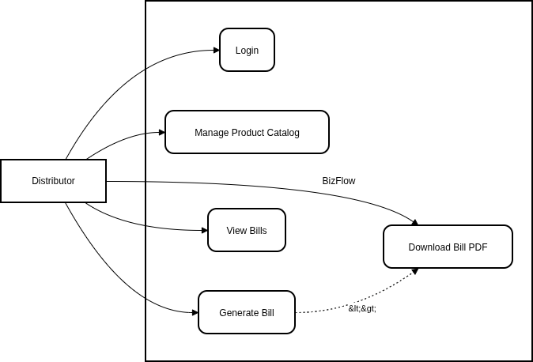
Fig 3.1: Use case Diagram

3.3.2 Use Case Description

The use case description provides a detailed understanding of how the actors interact with the BizFlow system. It identifies the system’s functionalities and clearly defines which actions are associated with each user role.

Use Case :- Generate Invoice
- Actor: Distributor
- Description:- User creates a new bill by In GenerateBill Screen by selecting customer, adding products, and get redirected with downloadable PDF invoice
- Pre-condition: User logged in, products available in inventory
- Post-condition: Invoice created, stock updated, PDF generated

Steps
1. Select "Create New Invoice"
2. Choose customer from list or add new
3. Search and add products with quantities
4. System calculates subtotal
5. Apply discounts if any
6. System calculates taxes and total
7. Generate PDF invoice
8. Download or print invoice
9. System updates inventory levels

Use Case: Manage Product Catalog
- Actor: Distributor
- Description: User adds new products, updates existing ones, or removes products

Steps:
1. Navigate to Product Catalog
2. Choose action (Add product)
3. Enter product details
4. Save changes
5. System updates database

3.3.3 Activity Diagram

An activity diagram is a behavioral diagram in Unified Modeling Language (UML) that represents the flow of activities within a system. It shows the sequence of actions, decision points, and parallel processes involved in completing a task. Activity diagrams are used to model workflows and illustrate how different users interact with the system dynamically.

In BizFlow Version 2, the activity diagram represents the complete workflow of key business operations, including user authentication, product management, invoice generation, inventory updates, payment processing, and report generation. It provides a clear understanding of how data and control flow through the system, helping developers and stakeholders visualize the execution of business processes and identify the interactions between different system modules.

see the diagram of the next page.
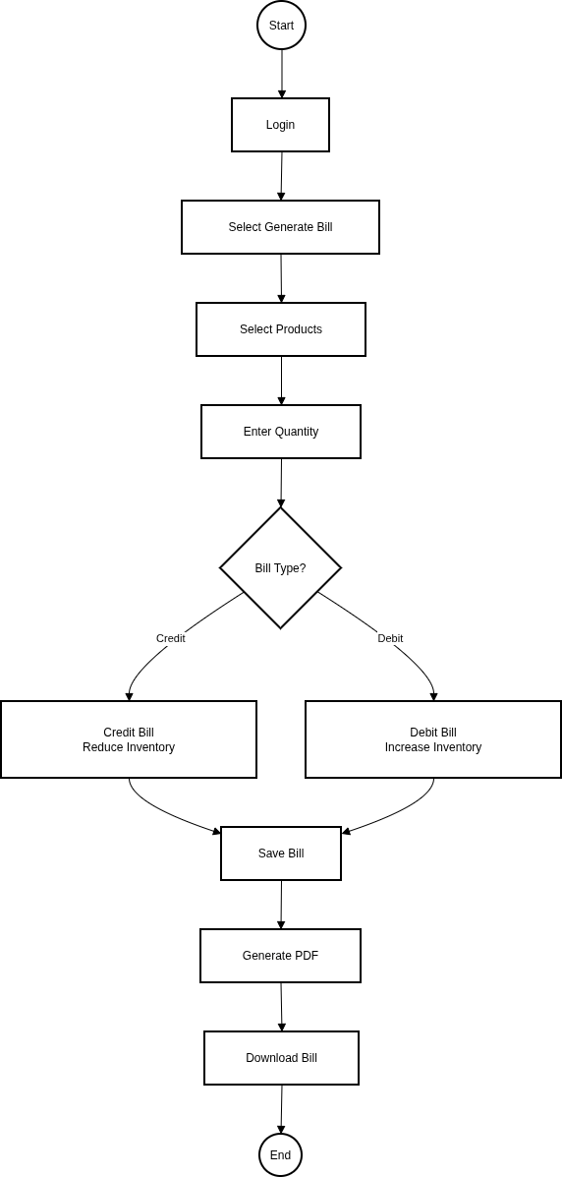

Fig 3.2: Activity diagram

4.1 SYSTEM DESIGN

A System Flow Diagram is a graphical representation that illustrates the overall flow of processes within a system. It provides a high-level view of how inputs are transformed into outputs and how different modules interact with one another to complete business operations. The diagram helps visualize the sequence of activities, movement of information, and relationships between various components of the system.

In BizFlow Version 2, the System Flow Diagram represents the complete workflow from user authentication to inventory management, invoice generation, payment processing, report generation, and dashboard analytics. It serves as a blueprint for understanding the overall system architecture and ensures that all modules are integrated to provide a smooth and efficient business management process.

4.2 Data Flow Diagrams

A Data Flow Diagram (DFD) is a graphical representation that illustrates the flow of data within a system. It shows how data enters the system, how it is processed, where it is stored, and how it is transferred between different entities. DFDs help in understanding the logical structure of a system and the movement of information.

4.2.1 DFD level 0

DFD Level 0, also known as the Context Diagram, represents the entire system as a single process. It shows the interaction between the system and external entities such as users or other systems. This level focuses on what data enters and leaves the system without showing internal processing details. The main purpose of DFD Level 0 is to provide a high-level overview of the system boundaries.

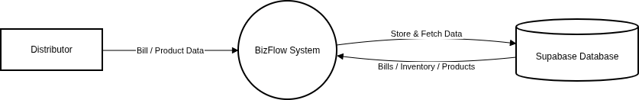

Fig 4.2.1: Data Flow Diagram – Level 0

4.2.2 DFD level 1

DFD Level 1 breaks down the main process shown in DFD Level 0 into multiple sub-processes. It explains how data flows between these internal processes, data stores, and external entities. This level provides more detail about how the system functions internally while still keeping the design understandable. DFD Level 1 helps in identifying major system functions and their data interactions.

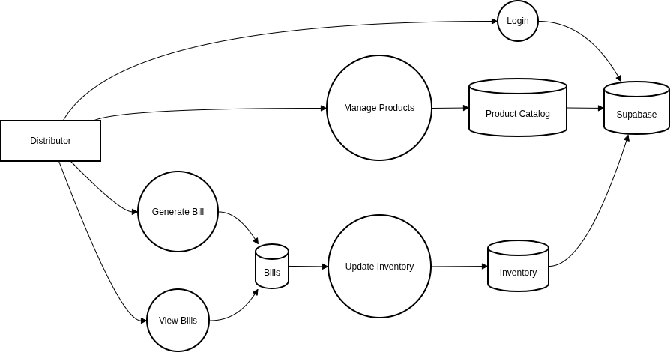

Fig 4.2.2: Data Flow Diagram – Level 1

Purpose of Data Flow Diagram

The purpose of the Data Flow Diagram in BizFlow is to represent the flow of data between distributors. It helps in understanding how information such as Generate Bill , product Catalog , View Bill is processed and stored within the system.

Processes:
1.Authentication: User login validation
2.Inventory Management: Product CRUD operations
3.Billing Processing: Invoice creation and calculation
4. PDF Generation: Convert invoice to PDF format
5. Report Generation: Create business reports
6. Data Backup: Regular data backup process

Data Flows:
- Product data → Inventory module → Database - Customer data → Billing module

5.1 Platform Used:

BizFlow Version 2 was developed using modern web technologies that provide scalability, maintainability, security, and efficient performance. The system follows a client-server architecture where the frontend and backend operate independently while communicating through RESTful APIs.

Since it’s essentially a web app, so a any computer device capable of running a fully fledged chromium browser can also run this application.

Hardware Requirements
- Processor: Intel Core i3 or equivalent
- RAM: 4 GB
- Storage: 10 GB Free Space
- Internet Connection

5.2 Implementation Level Details

BizFlow Version 2 follows a modular implementation approach where each business feature is developed as an independent module.

Major modules include:
- Authentication Module
- Tenant Management Module
- Dashboard Module
- Product Catalog Module
- Inventory Module
- Generate Bill Module
- View Bills Module
- Payment Module
- PDF Generation Module
This modular architecture improves maintainability and simplifies future enhancements.

1 & 2. Authentication and Tenant Management Module
The Authentication Module is responsible for secure access to the system and tenant-based user management.

Purpose :- The module ensures that only authorized users can access business resources while maintaining complete separation between different organizations.

Features Implemented

I. User Registration
- Company Name
- GST Number
- Company Address
- Phone Number
- Owner Email
- Password
Upon successful registration:
- A new Tenant is created.
- An Owner User is created.
- Tenant ownership is established.

II. User Login
The login functionality verifies:
- Email
- Password
- Tenant Information
After successful authentication:
- Session is established.
- Protected routes become accessible.

III. Role Management
Current Roles:
- Owner
- Staff
Owner privileges include:
- User Management
- Business Management
- Product Management
- Invoice Management

Security Features
- Password Hashing
- Protected APIs
- Session Validation
- Tenant Isolation

IV. Benefits
- Secure business access.
- Separation of organization data.
- Multi-user support.
- Better scalability.

3. Dashboard Module
The Dashboard serves as the primary monitoring screen of BizFlow.

Purpose
he dashboard provides a high-level overview of business operations and key performance indicators.

Features Implemented

Business Summary Cards
I. Display:
- Total Invoices
- Total Sales
- Total Purchases
- Pending Payments
- Inventory Statistics

II. Business Insights
- Monthly Activity Summary
- Pending Invoice Information
- Operational Status

III. Quick Navigation :- Users can quickly access
- Inventory
- Product Catalog
- Generate Bill
- View Bills

IV. Benefits
- Improved business visibility.
- Faster decision making.
- Centralized monitoring.

4. Product Catalog
The Product Catalog Module acts as the master repository of all products used within the system. To maintain reusable product information for inventory and billing operations.

Features Implemented

I. Product Creation
Users can create products by entering:
- Product Name
- Brand
- HSN Code
- Unit Name
- Unit Quantity
- MRP

II. Product Search
Products can be searched using:
- Product Name
- Brand
- HSN Code

III. Product Deletion
- Users can remove obsolete products from the catalog.
- Products are displayed through a searchable interface for quick access.

IV. Database Operations
Implemented CRUD Operations:
- Create
- Read
- Update
- Delete

V. Benefits
- Faster invoice generation.
- Reduced duplicate entries.
- Centralized product management.

5. Inventory Module
The Inventory Module maintains stock information automatically.

Purpose
To provide real-time stock visibility while eliminating manual inventory calculations.

Features Implemented

I. Inventory Listing
Displays:
- Product Name
- Brand
- Available Quantity
- Unit Information
- HSN Code

II. Search Functionality
Inventory can be searched using:
- Product Name
- Brand
- HSN Code

III. Automatic Updates
- No manual inventory modification is required.
- Inventory updates occur automatically after invoice generation.

IV. Benefits
- Real-time stock visibility.
- Reduced human errors.
- Automated stock management.

6. Generate Bill Module
The Generate Bill Module is the core functionality of BizFlow.

Purpose
To create invoices while automatically updating inventory and maintaining transaction records.

Invoice Types
Stock-In Invoice :- Represents product purchases.
Inventory Impact:- Increases inventory quantity.

Stock-Out Invoice :- Represents product sales.

Inventory Impact :- Decreases inventory quantity.

Invoice Creation Workflow

Step 1 :- Select Invoice Type
- Stock-In
- Stock-Out

Step 2 :- Enter Party Information
- Party Name
- Address
- Phone Number
- GST Number

Step 3 :- Add Products
Products are selected from:
- Product Catalog
- Inventory

Step 4 :- Enter Product Information
- Quantity
- Rate
- Discount

Step 5 :- Automatic Calculations
System calculates:
- Item Total
- Discount
- CGST
- SGST
- Subtotal
- Grand Total

Step 6 :- Save Invoice
Invoice information is stored in PostgreSQL.

Step 7 :- Inventory Update
Inventory quantities are automatically adjusted.

Step 8 :- PDF Generation
Invoice PDF becomes available for download.

Benefits
- Faster billing.
- Accurate calculations.
- Automatic inventory synchronization.

7. Payment Management Module
The Payment Module was introduced in BizFlow Version 2 to improve financial tracking.

Purpose :- To track payments received or paid against invoices.

Features Implemented

I. Payment Recording
Users can record:
- Amount
- Payment Method

Supported Methods:
- Cash
- UPI
- Bank Transfer
- Online Payment

II. Pending Amount Calculation
Formula:
Pending Amount = Grand Total − Total Payments

III. Bill State Management
Pending = No payment received.
Partial = Some payment received.
Paid = Full payment received.

IV. Benefits
- Better financial visibility.
- Accurate receivable tracking.
- Improved business monitoring.

8. View Bills Module
The View Bills Module provides access to historical invoices.Purpose :- To allow users to review and manage invoice records.

Features Implemented

I. Invoice Listing
Displays:
- Invoice Number
- Invoice Type
- Party Name
- Invoice Date
- Bill Status

II. Search Functionality
Search by:
- Invoice Number
- Party Name
- Date

III. Filters
Filter invoices using:
- Stock-In
- Stock-Out
- Pending
- Partial
- Paid

IV. Invoice Details
Users can view:
- Product Details
- Payment Information
- Tax Details
- PDF Invoice

V. Benefits
- Organized record keeping.
- Faster invoice retrieval.
- Better transaction tracking.

9. PDF Generation Module

The PDF Generation Module creates professional invoices.
Purpose
To generate downloadable and printable business documents.

Features Implemented

I. Invoice PDF
- Company Information
- Invoice Number
- Party Details
- Product Information
- Tax Information
- Grand Total

II. Download Functionality
Invoices can be:
- Downloaded
- Shared
- Printed

III. Benefits
- Professional documentation.
- Offline storage.
- Easy sharing.
- Simplified printing and record keeping.
- Standardized invoice formatting.
- Improved customer communication.

5.3 Project Gallery

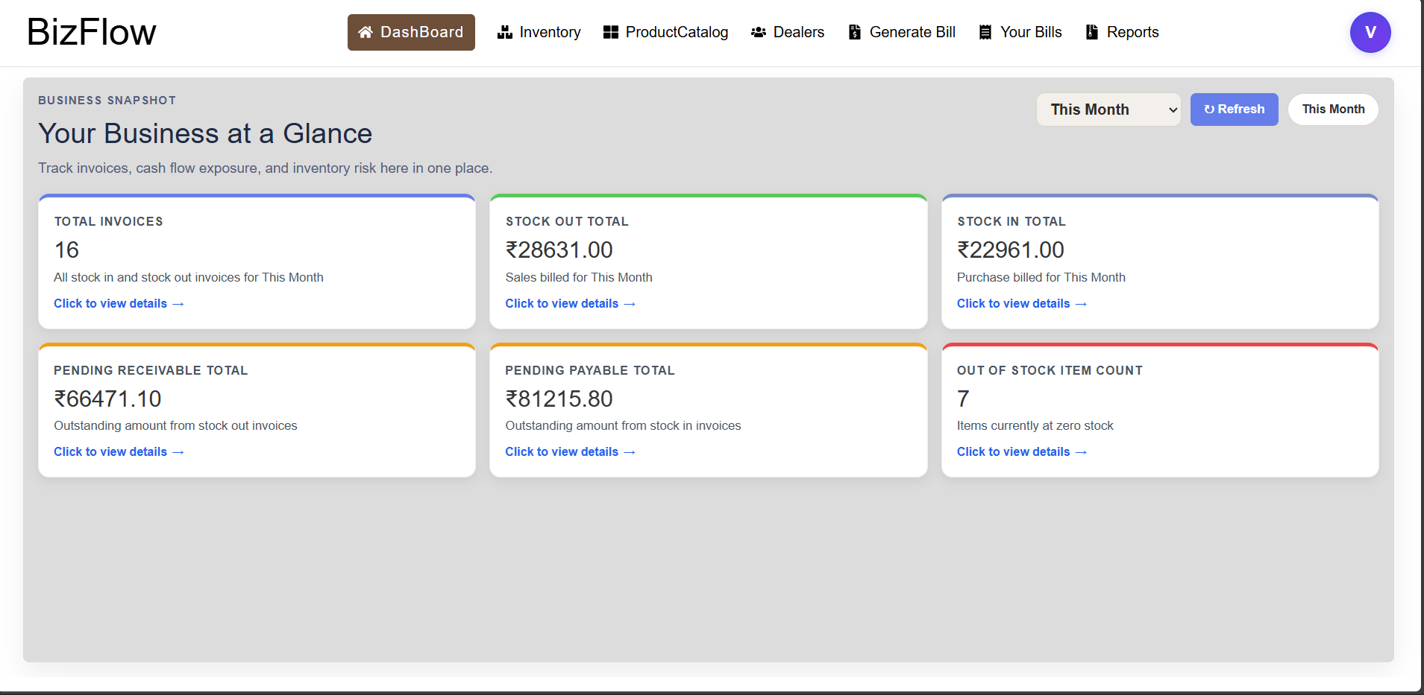

Fig: 5.3.1 Dashboard Screen

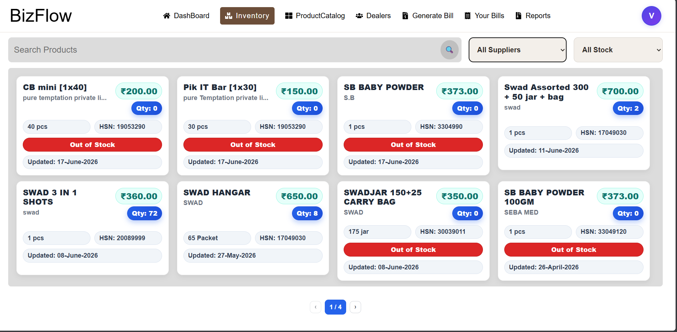
Fig: 5.3.2 Inventory Screen

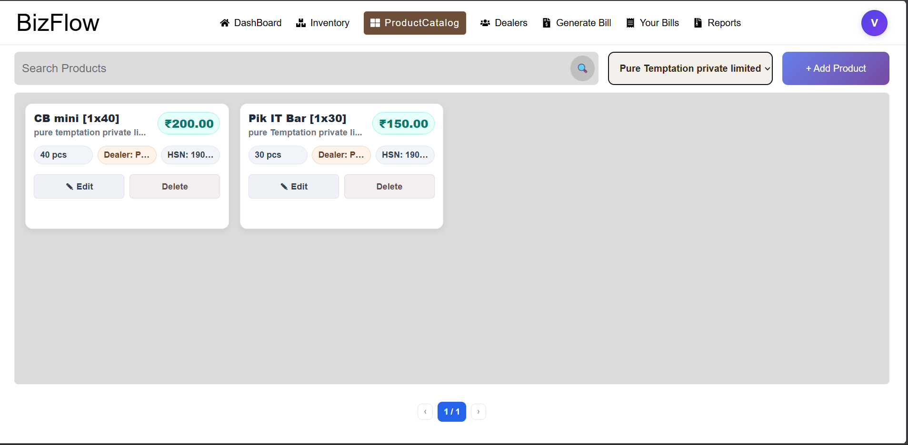
Fig: 5.3.3 Product Catalog Screen

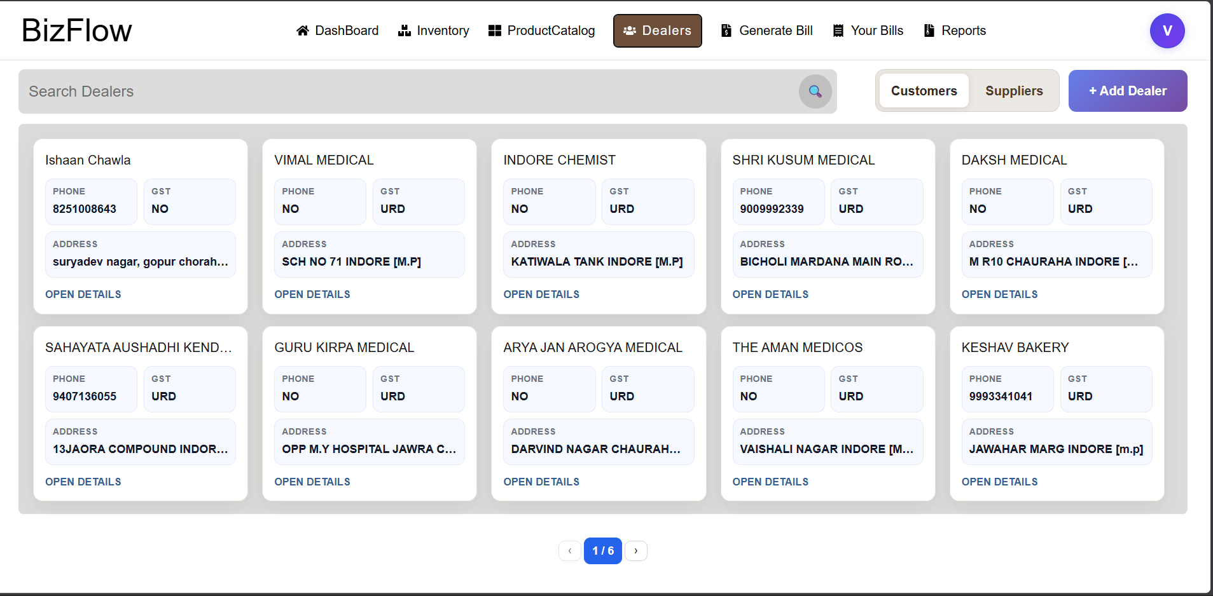
Fig: 5.3.4 Dealers Screen

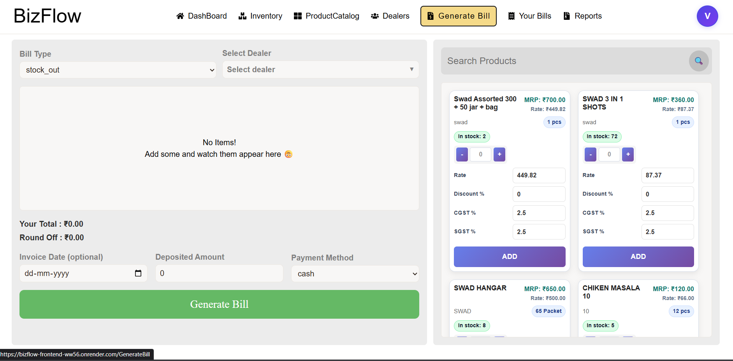
Fig: 5.3.4 Generate Bill Screen

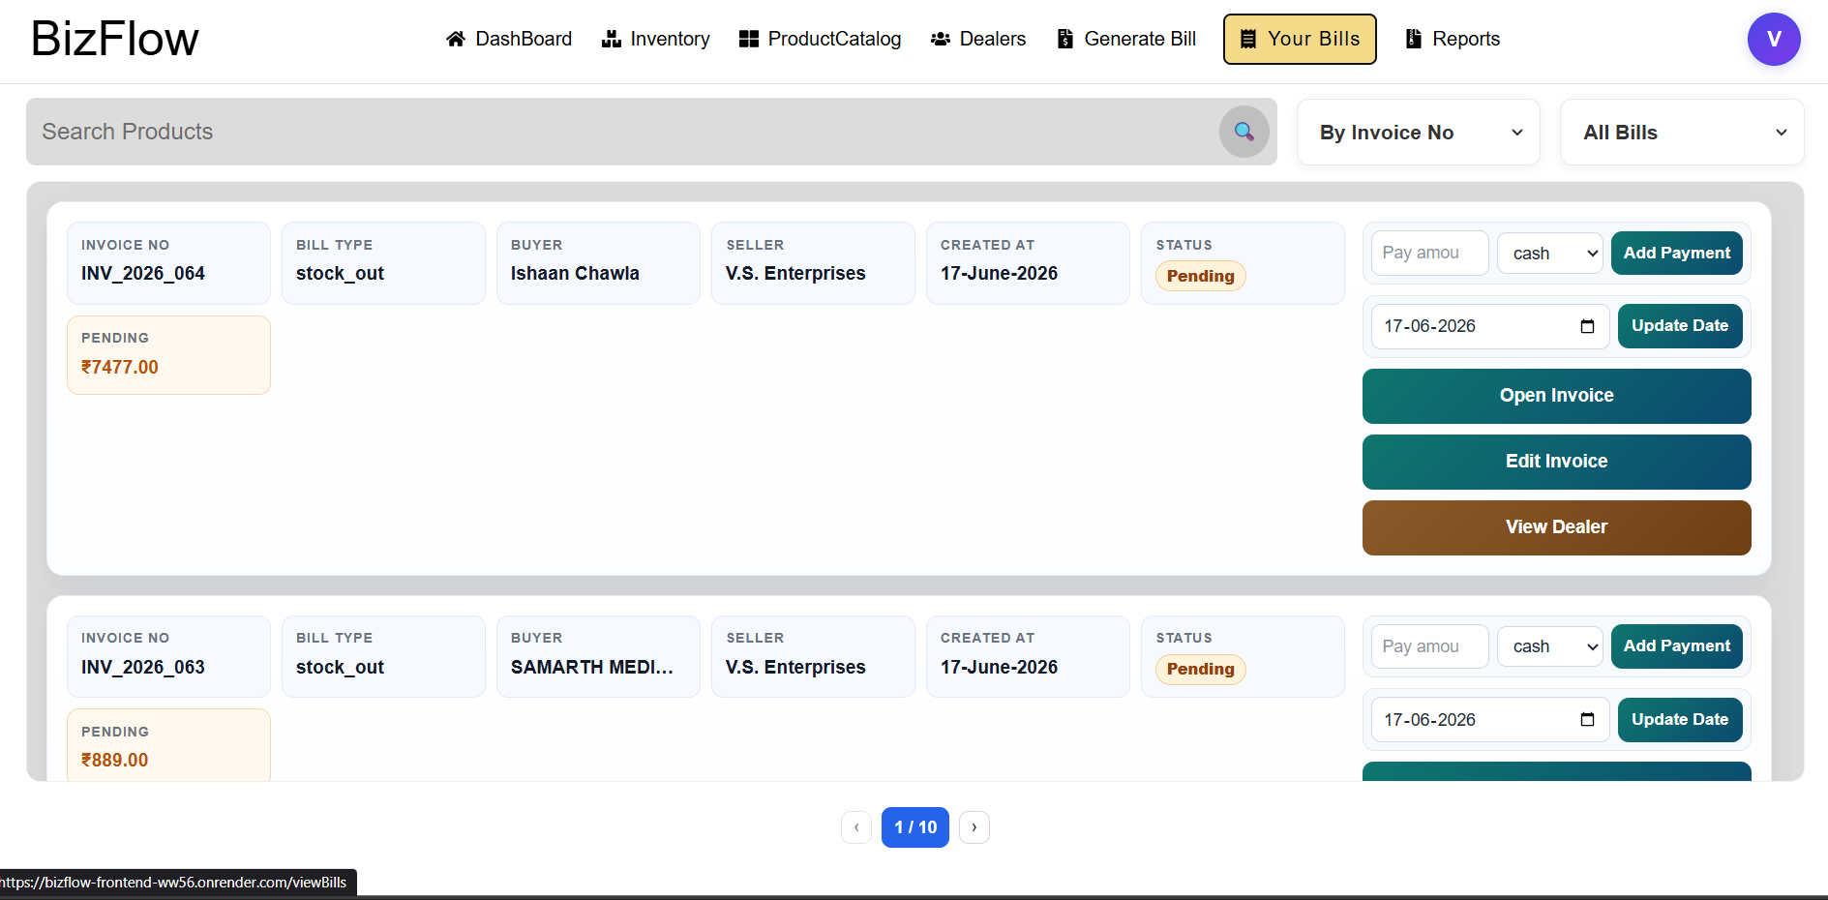
Fig: 5.3.5 View Bills Screen

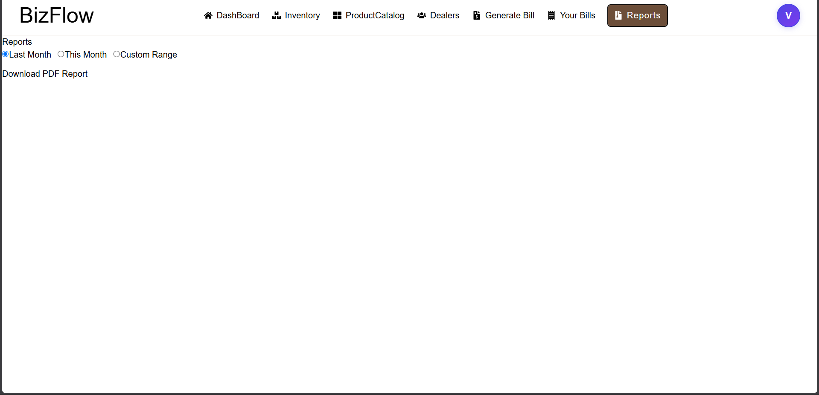
Fig: 5.3.6 Reports Screen

6. Conclusion

The rapid growth of digital technologies has created a strong need for software solutions that can simplify business operations and improve efficiency. Small and medium-sized distributors often face challenges in managing inventory, generating invoices, tracking payments, and maintaining business records due to reliance on manual processes or disconnected software systems. These challenges frequently result in inventory discrepancies, delayed billing operations, calculation errors, and difficulties in monitoring business performance.

BizFlow Version 2 was developed as a comprehensive solution to address these challenges through a unified web-based platform. The system successfully integrates inventory management, billing, payment tracking, dashboard analytics, and PDF invoice generation into a single business management application.

The project achieved its primary objectives by providing:
- Secure user authentication and tenant-based organization management.
- Product catalog management for reusable business data.
- Automatic inventory updates through invoice transactions.
- Support for both Stock-In and Stock-Out billing workflows.
- Automated calculation of taxes, discounts, subtotals, and grand totals.
- Payment tracking and pending amount management.
- Bill-state monitoring through Pending, Partial, and Paid statuses.
- Dashboard analytics for business visibility.
- Professional PDF invoice generation.
- Centralized record management for invoices and inventory.

One of the most significant achievements of BizFlow Version 2 is the implementation of automated inventory synchronization. By treating invoices as the source of truth for inventory updates, the system eliminates the need for manual stock adjustments and greatly reduces the chances of inventory inconsistencies.

The adoption of a tenant-based architecture further improves scalability and security by ensuring complete separation of data between organizations. This design enables BizFlow to evolve beyond a single-user inventory application into a platform capable of supporting multiple businesses and users simultaneously.

The project also demonstrates the practical application of modern web technologies such as React, Node.js, Express.js, Sequelize ORM, PostgreSQL, and React Query in solving real-world business problems. Through careful system design, modular architecture, and robust implementation practices, BizFlow provides distributors with a reliable, scalable, and user-friendly solution for managing their daily operations.
Overall, BizFlow Version 2 successfully transforms traditional distributor workflows into a digital ecosystem that improves operational efficiency, data accuracy, business visibility, and long-term scalability.

6.1 Important Features

BizFlow Version 2 provides numerous features that contribute to efficient business management. The system integrates multiple business operations into a single web-based platform, enabling distributors to manage inventory, billing, payments, and business records with greater accuracy and efficiency. Its modular architecture and user-friendly interface simplify daily operations while reducing manual effort and improving productivity. The following are the key features implemented in BizFlow Version 2.

1. Secure Authentication System
The system provides secure login and session management mechanisms that ensure only authorized users can access business data.

2. Tenant-Based Architecture
Each organization operates within its own isolated workspace, ensuring data privacy and security.

3. Product Catalog Management
A centralized catalog allows businesses to maintain reusable product information and reduce repetitive data entry during invoice generation.

4. Automatic Inventory Management
Inventory quantities are updated automatically based on Stock-In and Stock-Out invoices, eliminating manual stock calculations.

5. Intelligent Invoice Generation
Users can create invoices quickly using preconfigured product information while the system automatically calculates taxes, discounts, and totals.

6. Payment Tracking
Payments can be recorded against invoices, allowing businesses to monitor outstanding balances and financial transactions effectively.

7. Bill-State Management
Invoices are automatically categorized into: Pending , Partial, Paid. This helps businesses track receivables and payables efficiently.

8. Dashboard Analytics
The dashboard provides important business insights, helping users monitor operations and make informed decisions.

9. PDF Invoice Generation
Professional PDF invoices can be generated, downloaded, shared, and archived for future reference.
10. Scalable Database Design
The PostgreSQL-based relational database ensures data integrity, consistency, and support for future expansion.

11. Modular Architecture
The separation of modules improves maintainability and enables future enhancements without affecting existing functionalities.

12. Responsive User Interface
The React-based frontend provides an intuitive and user-friendly experience across different devices and screen sizes.

6.2 Limitations

Although BizFlow Version 2 successfully implements the core business management workflow, certain limitations remain due to the project's scope and development constraints. The current version focuses on essential distributor operations and therefore does not include several advanced features that could further enhance usability and scalability. These limitations provide opportunities for future improvements and the addition of more sophisticated business management capabilities as the system evolves.

1. Limited Role Management

Currently, the system supports Owner and Staff roles only. More granular permission management has not yet been implemented.

2. Absence of Mobile Application
The system currently operates as a web application and does not provide dedicated Android or iOS applications.

3. Basic Reporting Features
Advanced business reporting and visualization capabilities are limited in the current version.

4. Limited Dashboard Analytics
The dashboard provides summary-level insights but lacks advanced business intelligence and forecasting capabilities.

5. No Offline Support
An active internet connection is required to access the system.

6. Limited Notification System
The application currently does not provide automated notifications for:
- Low inventory levels
- Due payments
- Overdue invoices

7. Google Authentication Not Yet Implemented
Although planned, social authentication mechanisms have not been integrated into the current version.

8. No Multi-Branch Management
The system currently assumes a single business location and does not support branch-wise inventory separation.

9. No Automated GST Filing
GST calculations are supported, but automated tax filing functionality is not available.

10. No Customer Portal
Customers cannot directly access invoices or payment information through a dedicated portal.
Despite these limitations, the system successfully fulfills its primary objective of providing an integrated inventory, billing, and business management platform.

6.3 Future Work

Several enhancements can be incorporated into future versions of BizFlow to improve functionality, scalability, and user experience. While the current version provides a comprehensive solution for inventory, billing, payment tracking, and business management, additional features can further expand its capabilities. Future development will focus on improving system flexibility, automation, reporting, security, and support for larger organizations. These enhancements will enable BizFlow to meet evolving business requirements and provide a more robust and scalable platform for distributors and small businesses.

1. Google Authentication Integration
Support for Google Sign-In can simplify user onboarding and improve authentication convenience.

2. Owner-Based Staff Invitation System

Business owners will be able to invite staff members directly into their organization, improving user management and security.

3. Advanced Dashboard Analytics

Future versions can provide:
- Revenue trends
- Sales forecasting
- Inventory turnover analysis
- Customer analytics

4. Role-Based Access Control (RBAC)
Granular permission management can be introduced to support multiple business roles with different access privileges.

5. Inventory Alerts
Automatic notifications can be generated for:
- Low stock items
- Out-of-stock products
- Overstock conditions

6. Advanced Reporting System
Businesses can benefit from:
- Monthly reports
- Sales reports
- Purchase reports
- Profit analysis reports

7. Mobile Application Development

Dedicated Android and iOS applications can improve accessibility and usability.

8. Offline-First Architecture
Future versions may incorporate local storage and synchronization capabilities to allow operation without continuous internet connectivity.

9. Multi-Branch Management
Support for multiple warehouses and branch locations can be introduced to accommodate larger organizations.

10. Cloud Backup and Recovery
Automated backup systems can improve data protection and disaster recovery capabilities.

11. Barcode and QR Code Integration
Barcode scanning can accelerate inventory operations and reduce manual entry errors.

12. AI-Based Business Insights
Machine learning techniques may be incorporated to provide intelligent recommendations, demand forecasting, and predictive inventory management.

13. Customer and Supplier Management
Dedicated modules can be added for maintaining customer and supplier relationships.

14. GST Compliance and Tax Reporting
Future enhancements may include automated GST reports and tax filing assistance.

15. Export and Import Features
Businesses may be allowed to import and export data using:
- Excel, CSV, PDF formats.

7. References

The development of BizFlow Version 2 involved the use of modern web technologies, software engineering principles, database management concepts, and official technical documentation. The following references were consulted during the design, development, implementation, and testing phases of the project. These resources provided guidance on software architecture, web application development, database design, user interface development, API implementation, version control, and best practices for building secure, scalable, and maintainable software systems. They served as valuable sources of technical knowledge throughout the project lifecycle.

Books :-

[1] I. Sommerville, Software Engineering, 10th ed.
Harlow, England: Pearson Education, 2016.

[2] R. S. Pressman and B. R. Maxim,
Software Engineering: A Practitioner's Approach,
9th ed. New York, NY, USA: McGraw-Hill Education, 2019.

[3] A. Silberschatz, H. F. Korth, and S. Sudarshan,
Database System Concepts, 7th ed.
New York, NY, USA: McGraw-Hill Education, 2019.

Websites :-

[4] React Documentation.
Available: https://react.dev
[Accessed: mar. 2026].

[5] Node.js Documentation.
Available: https://nodejs.org/docs
[Accessed: mar. 2026].

[6] Express.js Documentation.
Available: https://expressjs.com
[Accessed: mar. 2026].

[7] PostgreSQL Documentation.
Available: https://www.postgresql.org/docs
[Accessed: apr. 2026].

[8] Sequelize ORM Documentation.
Available: https://sequelize.org
[Accessed: apr. 2026].

[9] TanStack Query Documentation.
Available: https://tanstack.com/query
[Accessed: mar. 2026].

[10] OWASP Foundation, “OWASP Top 10 Web Application Security Risks.”
Available: https://owasp.org
[Accessed: may. 2026].

