CHAPTER 1
INTRODUCTION

1.1 Introduction to Current System

The "BizFlow” is a Distributor Inventory & Billing Management System addresses critical business challenges through a digital solution. (A web App )

- Automated Tracking: Automatic updates on stock movements.
- Intuitive Billing Operations: Quick bill creation with minimal input.
- Automated Invoice Generation: Generates beautiful invoices automatically in PDF format.
- Inventory: to see distributors whole inventory at one place. And fully searchable.
- Dash Board: to see analytics of the whole system at one place.
- Generate Bill: create Bills (credit or debit) with a clean and intuitive UI and with minimum inputs.
- View Bills: view and download and search all your bills at one place.

The BizFlow is made with distributor’s comfort in mind, by making the UI as intuitive as needed. And by not clogging the application with features that introduce unnecessary learning curve for small distributor

the Bizflow system is intended to use for personal business management and inside. It does not contact with outside world ( such as between distributor and distributor’s seller or buyer )

1.2 Need of Proposed System

The current inventory management landscape for small and medium-sized distributors is characterized by manual processes and fragmented systems. Distributors typically rely on Manual Record Keeping: Physical registers and notebooks for inventory tracking Spreadsheet-based Systems: Basic Excel sheets without real-time updates.

Disconnected Software: Separate systems for inventory and billing without integration Paper-based Invoicing: Manual calculation and handwritten receipts Limited Analytics: No data-driven insights for business decisions.

These traditional approaches suffer from significant drawbacks: Human Errors: Manual data entry leads to calculation mistakes and discrepancies Time-Consuming Processes: Extensive time spent on routine inventory Lacks of Real-time Visibility: No instant access to stock levels and availability.

Inefficient Billing: Manual invoice generation with potential calculation errors Poor Record Management: Difficulty in retrieving historical data and No Digital Receipts: Inability to provide professional PDF invoices to customers Limited Scalability: Manual systems cannot handle business growth effectively.

This outdated approach creates operational inefficiencies, financial inaccuracies, and customer.

Centralized Inventory Control The need for a unified platform that provides: Real-time Stock Monitoring: Instant visibility of inventory levels dissatisfaction in today's competitive distribution landscape.

1.3 Objectives

The primary objectives of developing the BizFlow Inventory & Billing Management System are:

Technical Objectives
- To design and develop a responsive web application using React + Supabase.
- To implement a robust PostgreSQL database for efficient inventory and billing data management.
- To create an intuitive user interface with seamless navigation
- To integrate PDF generation for professional invoice creation
- To implement secure data handling and transaction processing

Functional Objectives
- To provide comprehensive Bill Generation capabilities based on bill type, ( credit or debit )
- To enable efficient billing and invoice generation with automatic calculations
- To create digital PDF receipts that can be saved and shared
- to implement a Dashboard so user can see their business insights at a glance.
- To implement search and filtering capabilities for quick data access.

CHAPTER 2
SOFTWARE DEVELOPMENT
LIFE CYCLE

2.1 Introduction to System Development Life Cycle

The Software Development Life Cycle (SDLC) is a structured framework used for designing, developing, testing, and maintaining software systems. It provides a systematic approach to ensure that the developed system meets user requirements, maintains quality, and is delivered efficiently. Each phase of the SDLC plays a crucial role in transforming user needs into a fully functional system. For the development of BizFlow, inventory and billing management web application, a suitable SDLC model was selected to support flexibility, scalability, and continuous improvement.

2.2 SDLC Model Selected – Agile Methodology

The Agile SDLC model has been adopted for the development of BizFlow due to its iterative and flexible nature. Agile methodology allows the system to be developed in incremental phases, enabling continuous feedback and improvements throughout the development process. Bizflow consists of multiple modules such as Dashboard for analytics, Automatic Inventory Management, product catalog management, ViewBills Management. Agile supports evolving requirements and ensures timely delivery of functional components.

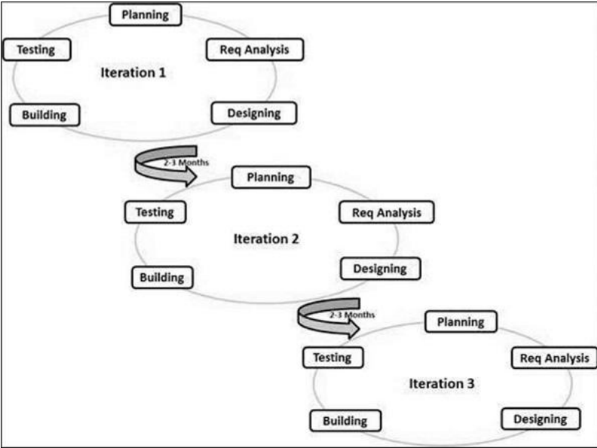
Fig 2.1: Agile SDLC Model

2.3 Requirement Analysis

The requirement analysis phase focuses on identifying the functional and non-functional requirements of the BizFlow system. This phase ensures that the system addresses the needs of all stakeholders and defines the scope of development clearly.

Stakeholders:
• Distributors
• Administrator

2.3.1 Functional Requirements

Functional requirements describe the specific services and operations that the BizFlow system must perform to support its requirement.

1. Secure User Authentication
The system shall provide secure login and role-based authentication distributors to ensure authorized access.

2. Intuitive and Fast Bill Generation
The system shall allow distributor to generate bill with few inputs as possible, this is achieved through:
- Pre-made select-able, searchable, editable product catalog cards, to distributor can quickly create bills.
- smart card selections based on credit and debit bills.

3. Easily accessible Bills
The system shall allow distributor to view and search all bills based on filters of choice, and would be able to download selected bill in PDF format.

2.3.2 Non-Functional Requirements

Non-functional requirements define the quality attributes of the BizFlow system

- Security: Secure authentication and controlled access to data
- Performance: Fast response time and dashboard response
- Scalability: Ability to handle increasing number of products.
- Usability: Simple and user-friendly interface
- Reliability: Consistent system availability and data integrity

2.4 System Design

The system design phase converts requirements into a structured architecture.

Design Components:
• Four dashboards: Inventory, ProductCatallog, GenerateBill, ViewBills.
• Entity Relationship (ER) diagrams defining database structure.
• Data Flow Diagrams (DFDs) GenerateBill, ProductCatalog.

Output:
Complete system design documentation.

2.5 Implementation

The implementation phase involves actual development of the BizFlow system.

Technologies Used:

- Backend : Supabase ( database postgreSQL )
- Frontend : React + Vite

Core Modules Implemented:

- Inventory
- Product Catalog
- Generate Bill
- View Bills

Sub Modules:
- Pdf generation
- db connectivity and config
- routing

2.6 Testing:

Testing ensures the correctness and reliability of the system.

• Unit Testing
• Integration Testing
• System Testing
• User Acceptance Testing (UAT)

Output:
A stable and reliable TeachTrack system.

2.7 Development

After successful testing. BizFlow is deployed on a secure web service named Render.com.

Activities:
• Server and database configuration
• Access verification
• Final system validation

2.8 Maintenance and Future Enhancements

This phase ensures long-term system effectiveness.

• Bug fixing and optimization
• Feature enhancements
• Performance monitoring
• Database maintenance

CHAPTER 3
ANALYSIS

3 REQUIREMENT ANALYSIS

Definition:
Requirement Analysis is a systematic process of identifying, analyzing, and documenting the needs and expectations of stakeholders for a software system. It ensures that the system is designed in alignment with user requirements, institutional goals, and technical constraints, thereby forming a strong foundation for successful software development.

3.1 Functional Requirements

1. Product Catalog:
- Add new products with details only once (name, category, price, quantity)
- Edit existing product information
- Delete products from product Catalog
- View ProductCatalog with search and filter options

2. Billing System:
- Create new bills with customer details
- search premade product cards, just need to fill rate and quantity from inventory or product catalog based on Bill-Type based on credit or debit
- Add multiple products to invoice
- Automatic calculation (subtotal, taxes, discounts, total)
- Generate invoice numbers sequentially
- Save invoice history

3.PDF Generation:
- Convert invoices to PDF format
- Professional invoice template
- Download PDF functionality
- Save PDF copies in system

3.2 Non-Functional Requirements

1. Usability:
- Intuitive interface with clear navigation
- Responsive design for different devices
- Easy learning curve for non-technical users

2. Performance:
- Quick page loading (< 3 seconds)
- Efficient database queries
- Fast PDF generation (< 5 seconds)

3. Reliability:
- System availability 99% of time
- Data consistency across modules
- Error handling and recovery

4. Security:
- Secure authentication
- Data validation on all inputs
- Protection against SQL injection
- Session security

5. Scalability:
- Support for increasing data volume
- Modular architecture for enhancements
- Database optimization for performance

3.3 Use Case Analysis

Use case analysis identifies how different users interact with the BizFlow system. It focuses on understanding user actions, system responses, and the overall flow of operations from the distributor perspective. This analysis helps in defining system behavior and validating functional requirements.

The main actors involved in the TeachTrack system are:
• Distributor

3.1.1 Use Case Diagram

A use case diagram visually represents the interactions between actors and the BizFlow system. It highlights the major functionalities such as user authentication, productCatalog, generateBill , ViewBills, and Inventory.

The use case diagram of BizFlow provides a clear, high-level overview of how Distributor interact with various system modules. It helps stakeholders and developers understand system scope, responsibilities, and interaction flow, ensuring that the system is designed according to user expectations and requireme

see the diagram of the next page.
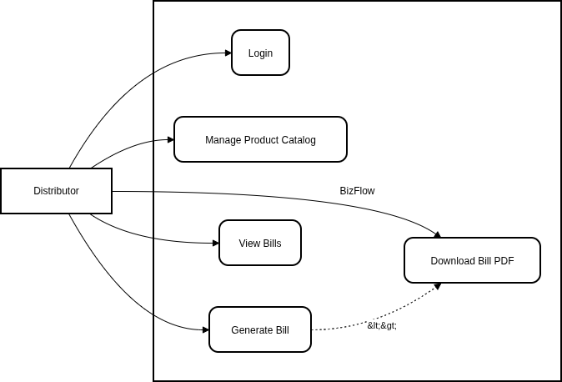
Fig 3.1: Use case Diagram

3.3.2 Use Case Description

The use case description provides a detailed understanding of how the actors interact with the BizFlow system. It identifies the system’s functionalities and clearly defines which actions are associated with each user role.

Use Case: Generate Invoice
- Actor: Distributor
- Description: User creates a new bill by In GenerateBill Screen by selecting customer, adding products, and get redirected with downloadable PDF invoice
- Pre-condition: User logged in, products available in inventory
- Post-condition: Invoice created, stock updated, PDF generated
- Steps:

1. Select "Create New Invoice"
2. Choose customer from list or add new
3. Search and add products with quantities
4. System calculates subtotal
5. Apply discounts if any
6. System calculates taxes and total
7. Generate PDF invoice
8. Download or print invoice
9. System updates inventory levels

Use Case: Manage Product Catalog
- Actor: Distributor
- Description: User adds new products, updates existing ones, or removes products
- Steps:
1. Navigate to Product Catalog
2. Choose action (Add product)
3. Enter product details
4. Save changes
5. System updates database

3.3.3 Activity Diagram

Definition
An activity diagram is a behavioral diagram in Unified Modeling Language (UML) that represents the flow of activities within a system. It shows the sequence of actions, decision points, and parallel processes involved in completing a task. Activity diagrams are used to model workflows and illustrate how different users interact with the system dynamically.

see the diagram of the next page.
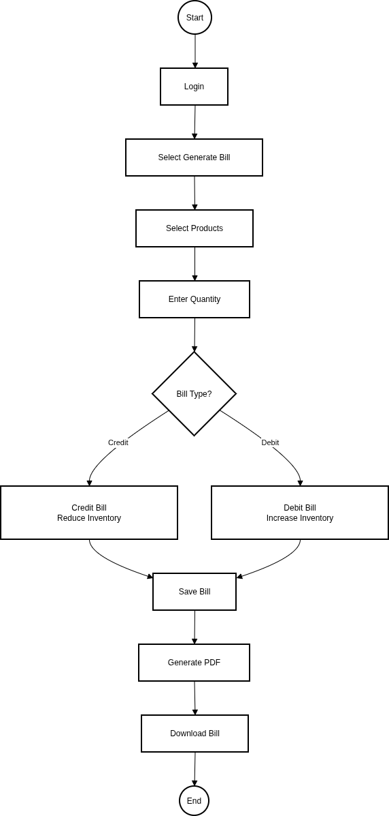

Fig 3.2: Activity diagram

CHAPTER 4
DESIGN

4.1 SYSTEM DESIGN

System flow diagram is a graphical representation that shows the overall flow of processes within a system. It provides a high-level view of how inputs are transformed into outputs and how subsystems interact.

4.2 Data Flow Diagrams

Definition:
A Data Flow Diagram (DFD) is a graphical representation that illustrates the flow of data within a system. It shows how data enters the system, how it is processed, where it is stored, and how it is transferred between different entities. DFDs help in understanding the logical structure of a system and the movement of information.

4.2.1 DFD level 0

DFD Level 0, also known as the Context Diagram, represents the entire system as a single process. It shows the interaction between the system and external entities such as users or other systems. This level focuses on what data enters and leaves the system without showing internal processing details. The main purpose of DFD Level 0 is to provide a high-level overview of the system boundaries.

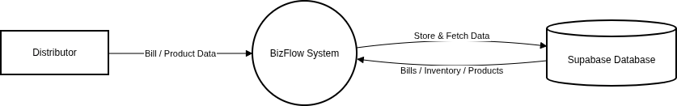

Fig 4.2.1: Data Flow Diagram – Level 0

4.2.2 DFD level 1

DFD Level 1 breaks down the main process shown in DFD Level 0 into multiple sub-processes. It explains how data flows between these internal processes, data stores, and external entities. This level provides more detail about how the system functions internally while still keeping the design understandable. DFD Level 1 helps in identifying major system functions and their data interactions.

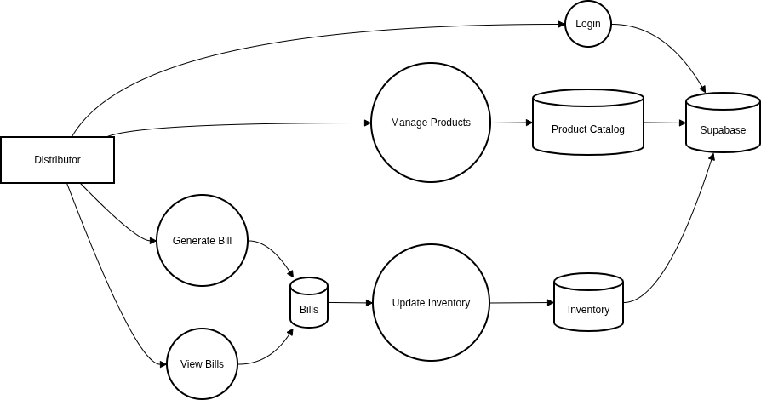

Fig 4.2.2: Data Flow Diagram – Level 1

Purpose of Data Flow Diagram

The purpose of the Data Flow Diagram in BizFlow is to represent the flow of data between distributors. It helps in understanding how information such as GenerateBill , productCatalog , View Bill is processed and stored within the system.

Processes:
1.Authentication: User login validation
2.Inventory Management: Product CRUD operations
3.Billing Processing: Invoice creation and calculation
4. PDF Generation: Convert invoice to PDF format
5. Report Generation: Create business reports
6. Data Backup: Regular data backup process

Data Flows:
- Product data → Inventory module → Database - Customer data → Billing module → Database- Invoice data → PDF generator → PDF file- Report requests → Report generator → Display

CHAPTER 5
IMPLEMENTATION

5.1 Platform Used:
- windows 11
- Vscode
- supabase
- render
- vite
- react
- for testing – react testing library

Software Requirements:
- A browser supporting modern features
- any system that can run browser based appications can run this appilcation efficiently.

5.2 Implementation Level Details

User Authentication
• Secure registration and login system using Supabase Auth.
• Passwords are encrypted for security..
• Access is restricted to verified distributors.

User Access Control
• Single-user system in the current MVP version.
- All operations (inventory, billing, reports) are accessible only after successful authentication
- Unauthorized users cannot access application data or screens.

Product Catalog Management
- Users can create and manage a product catalog.
- Each product stores details such as name, price, quantity, and type.
- Product data is stored persistently in the Supabase database.
- The catalog serves as the base for billing and inventory updates.

Inventory Management
• Inventory is automatically managed by the system.
- No manual stock update is required.
- Inventory quantity increases when a purchase (debit bill) is generated.
- Inventory quantity decreases when a sale (credit bill) is generated.
- The bill acts as the single source of truth for inventory changes.

Billing System
• Users can generate bills for both sales (credit) and purchases (debit).
- Each bill contains product details, quantities, prices, and total amount.
- Bills are stored securely in the database for future reference.
- Billing logic directly updates inventory to ensure data consistency.

Bill History & Viewing
• Users can view all previously generated bills in a dedicated “View Bills” screen.
• Bills are listed in a structured and readable format.
- This allows easy tracking of past transactions.

PDF Bill Generation
• Each generated bill can be downloaded as a PDF file.
- PDF download is available immediately after bill creation.
- Bills can also be downloaded later from the View Bills screen.
- This enables offline sharing and record-keeping.

Data Persistence
• All data (products, inventory state, bills) is stored in Supabase.
- Data remains consistent across sessions after logout and login.
- No local storage dependency for critical business data.

MVP Scope Limitations
• No admin dashboard in the current version.
- No multi-user or multi-role support (planned for future versions).
- No analytics or reporting dashboards in MVP.
- Designed to validate core workflow: inventory → billing → record keeping.

5.3 Project Gallery

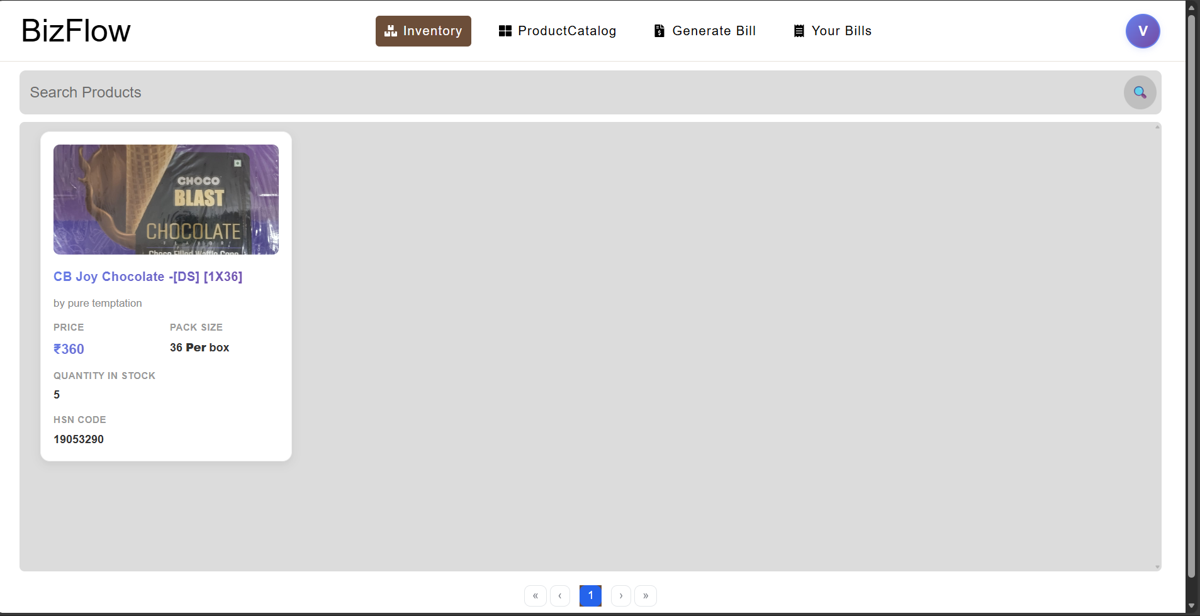

Fig: 5.3.1 Inventory Screen

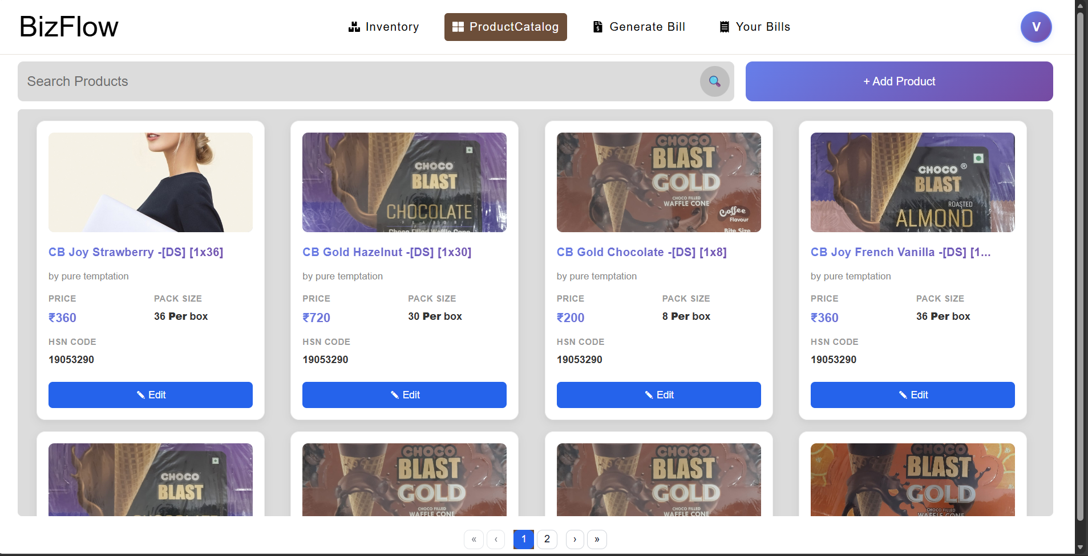

Fig: 5.3.2 Product Catalog Screen

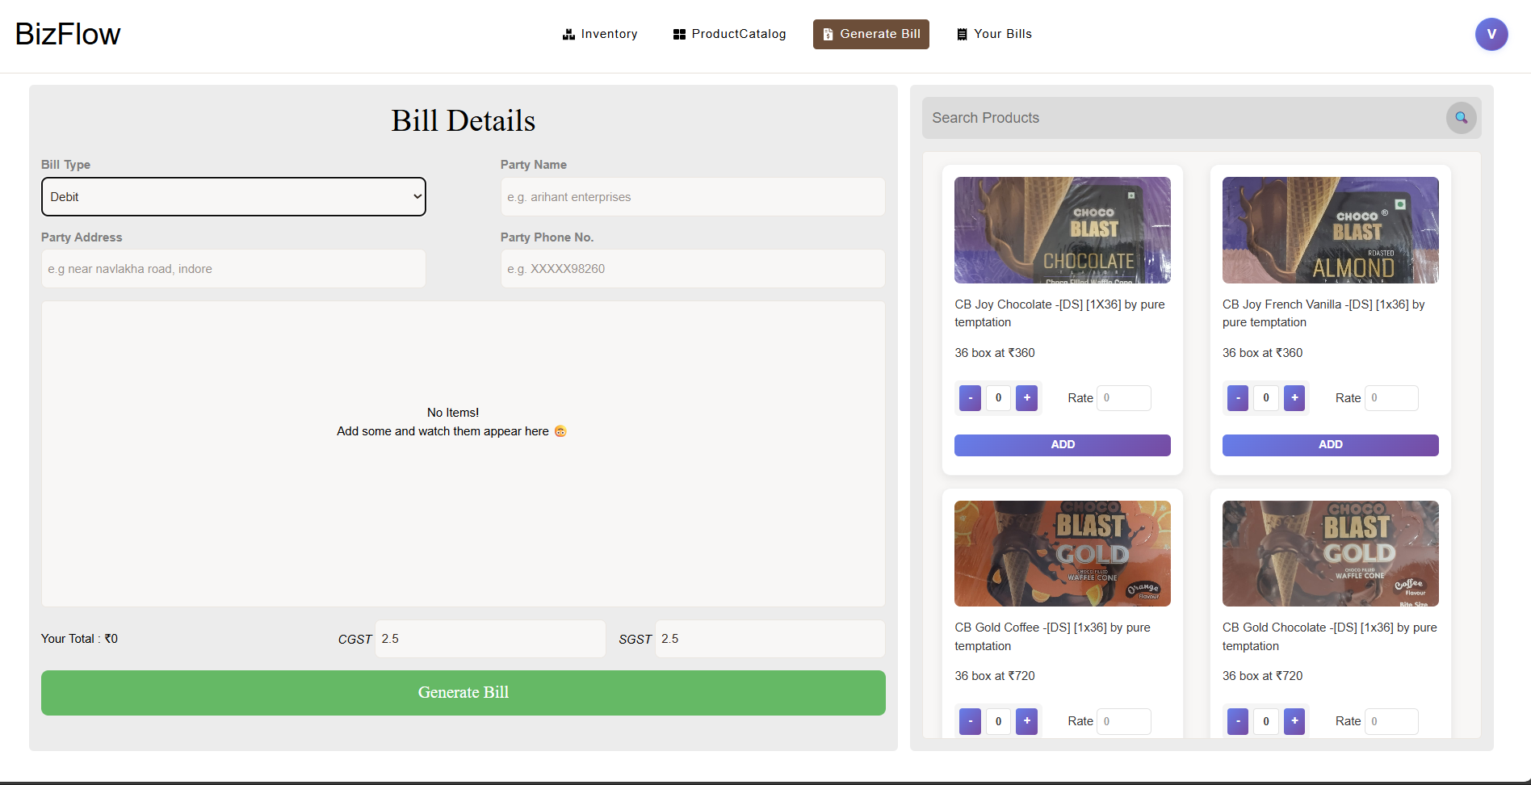
Fig: 5.3.3 Generate Bill Screen

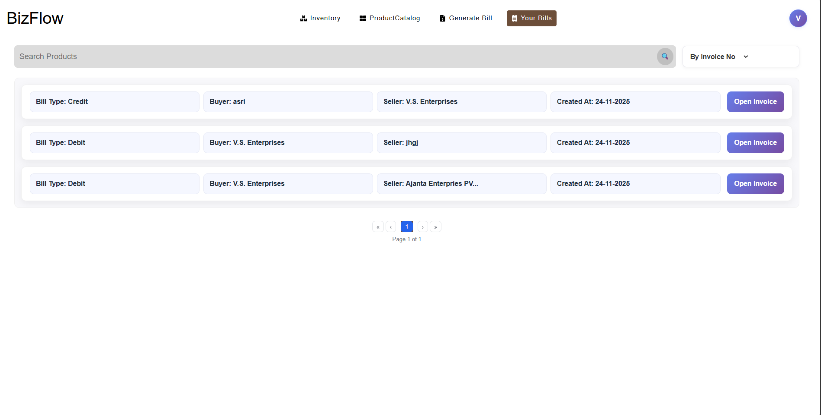
Fig: 5.3.4 View Bills Screen

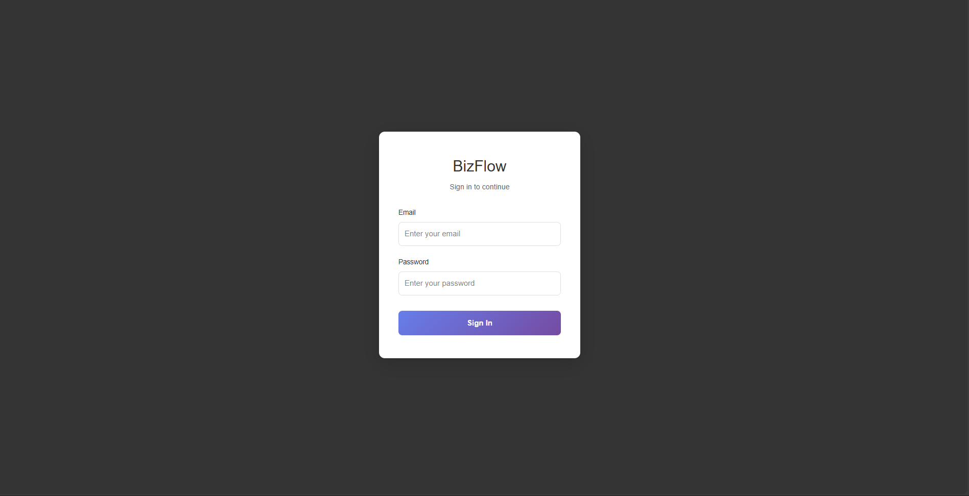
Fig: 5.3.4 Distributor Login Screen

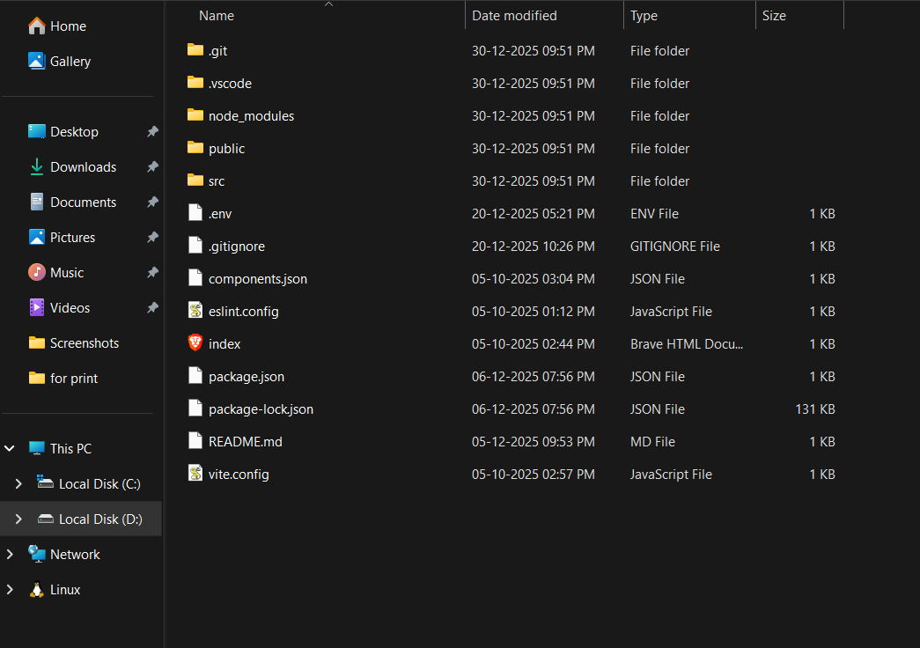

Fig: 5.3.5 project directory screenshot

5.3 Testing

Testing is a critical phase in the development of the BizFlow system. It was conducted to ensure that all modules function correctly, meet the specified requirements, and provide a reliable and user-friendly experience for Distributors.

Testing Objectives
The main objectives of testing the BizFlow system are:
• To identify and eliminate bugs and logical errors.
• To ensure all functional requirements are implemented correctly.
• To verify system reliability, performance, and data accuracy.
• To validate proper user interface behavior and ease of use.
• To ensure secure and role-based access to system features.

Testing Methodology:
- Black Box Testing: Focus on functionality without internal code knowledge
- White Box Testing: Some internal structure testing for critical modules
- Manual Testing: User interface and workflow testing
- Automated Testing: Basic test cases for forms and calculations

Test Cases Executed:

1. Product Catalog Management Tests:
- TC001: Add new product with valid data
- TC002: Add product with invalid price (negative)
- TC003: Edit existing product information
- TC004: Delete product from inventory
- TC005: View ProductCatalog with filters

2. Generate Bill Module Tests:
- TC006: Create new invoice with single product
- TC007: Create invoice with multiple products
- TC008: Apply percentage discount
- TC009: Apply fixed amount discount
- TC010: Tax calculation accuracy
- TC011: Total calculation verification

3. PDF Generation Tests:
- TC012: Generate PDF invoice
- TC013: Download PDF file
- TC014: PDF formatting check
- TC015: Data accuracy in PDF

4. Integration Tests:
- TC016: Inventory update after invoice generation
- TC017: Stock validation during billing
- TC018: Database consistency checks
- TC019: User session management

Test Results:
- Total Test Cases: 25
- Passed: 23 (92%)
- Failed: 2 (8%)
- Critical Bugs Found: 0
- Minor Issues: 2 (fixed during development)

Bug Report:
1. Bug ID: B001
- Description: Discount calculation error when both percentage and fixed discount applied.
- Severity: Medium - Status: Fixed

CHAPTER 6
CONCLUSION

6. Conclusion

BizFlow streamlines everyday business operations by unifying inventory management, product cataloging, billing, and bill tracking into a single, reliable system. By treating bills as the source of truth, it ensures automatic and accurate inventory updates with minimal manual effort. The application is designed with simplicity, correctness, and real-world usability in mind, making it practical for small distributors and businesses. Overall, BizFlow demonstrates how a focused, well-designed system can replace fragmented manual workflows with an efficient digital solution.

6.1 Important Features

The BizFlow system successfully implements several key features:

1. Comprehensive Inventory Management:
- Real-time stock tracking and updates
- Easy product addition, editing, and deletion
- Category-based organization
- Low stock alerts and notifications

2. Automated Billing System:
- Quick invoice generation with minimal input
- Automatic calculation of taxes and discounts
- Multiple product support in single invoice
- Sequential invoice numbering

3. Professional PDF Invoicing:
- High-quality PDF generation
- Professional invoice templates
- Download and save functionality
- Company branding support

4. User-Friendly Interface:
- Intuitive navigation and layout
- Responsive design for all devices
- Clear error messages and validations
- Fast loading times

5. Data Management:
- Secure data storage
- Complete transaction history
- Easy search and retrieval
- Basic reporting capabilities

6.2 Limitations

While the current system fulfills core requirements, it has certain limitations:

1. Authentication System:
- Basic authentication without advanced security features
- No password recovery mechanism
- Limited user role management

2. Feature Limitations:
- Limited reporting capabilities
- No barcode scanning support
- No mobile application version

3. Scalability Concerns:
- May require optimization for very large inventories
- Limited concurrent user support
- Basic database optimization

6.3 Future Work

Potential enhancements for future development:

1. Advanced Features:
- User authentication with role-based access control
- Purchase order management system
- Supplier management module
- Advanced analytics and forecasting
- Barcode scanning integration

2. Technical Improvements:
- REST API development for mobile apps
- Cloud deployment optimization
- Database performance enhancements
- Caching mechanisms implementation
- Real-time notifications

Chapter 8
REFERENCES

Books :-

[1] R. N. Rao, Core Python Programming, 2020.

[2] A. Holovaty and J. Kaplan-Moss, The Definitive Guide to Django, 2018.

[3] P. Raj, MySQL for Beginners, 2019.

[4] International Journal of Educational Technology, 2022.

Websites:

[5] W3Schools, Python & Django Tutorials, [Online]. Available: https://www.w3schools.com/

[6] Python Software Foundation, Python Documentation, [Online]. Available: https://www.python.org/doc/

[7] Django Software Foundation, Django Documentation, [Online]. Available: https://docs.djangoproject.com/en/4.3/

