**Generating Usability Reports from User Inputs and Eye Movements**

Ganesh Sekhar (CHN16CS055)

Shan Eapen Koshy (CHN16CS095)

Sachin Sajan Punoose (CHN16CS092)

S Hemanth (CHN16CS098)

**Guide: Asst. Prof. Angel Thankam Thomas**

**Coordinator: Asst. Prof. Shiny B**

Department Of Computer Science Engineering

College of Engineering Chengannur June 2020

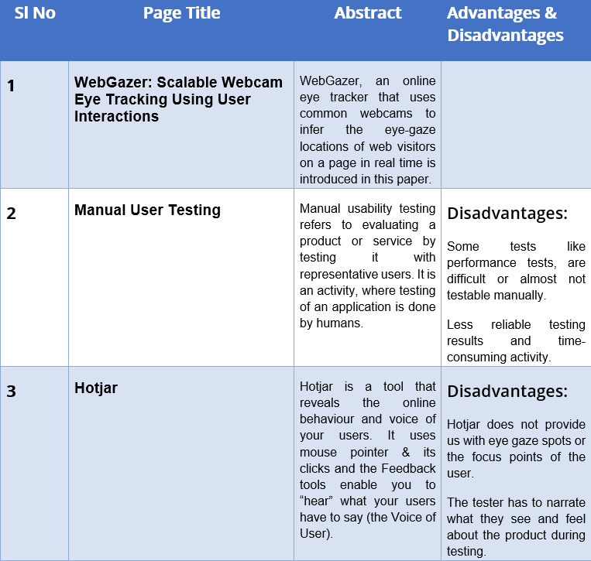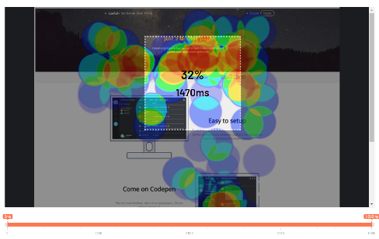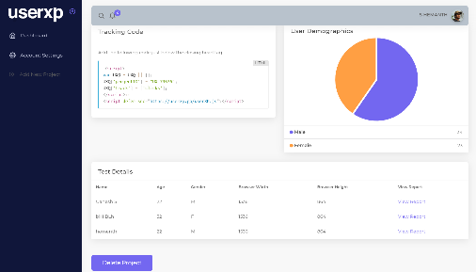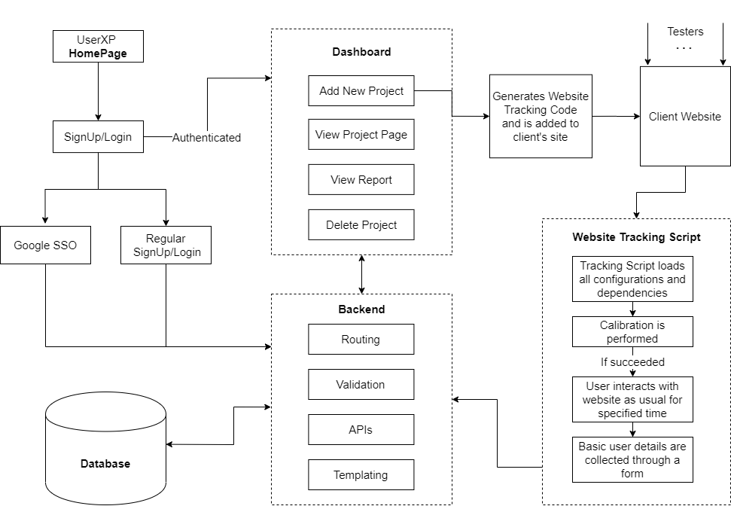

**REFERENCES**

[1] Chynal, Piotr & Szyma´nski, Jerzy (2011). *Remote Usability Testing Using Eyetracking*

[2] Agnieszka Bojko (2015). *Eye Tracking in User Experience Testing: How to Make the Most of It*

[3] Papoutsaki, Alexandra & Sangkloy, Patsorn & Laskey, James & Daskalova, Nediyana &Huang, Jeff & Hays, James. (2016). *WebGazer: Scalable Webcam Eye Tracking Using User Interactions*

[4] Jennifer Romano Bergstrom & Andrew Jonathan Schall *Eye Tracking in User Experience Design*

[5] Kiril Alexiev, Teodor Toshkov and Peter Dojnow. 2019*. Accuracy and Precision of eye tracker by head movement compensation and calibration. 20th International Conference on Computer Systems and Technologies (CompSysTech’19)*

**METHODOLOGY**

In this proposed system, a user can submit a URL of the website to be analyzed. The system then generates a unique tracking code for this website which can be manually inserted into the website to be tested. Testers can access this URL and interact with the website normally while we collect the tester’s eye coordinates that we obtained through webgazer.js. Basic demographic of the tester such as age and gender are also collected for categorization and report generation. The collected data is then stored in the server. The testing details can be reviewed from the admin’s dashboard. Several features such as timeline, demographic filtering, heatmap, AOI, etc, are provided for easily analyzing the data.

**BLOCK DIAGRAM**

**CONCLUSION**

At present, existing Usability Testing methods for web based platforms are quite expensive and requires a considerable amount of resources including man-power and time. From using this platform a firm/organisation have many advantages over manual user testing such as, faster feedback, testing efficiency improvements, thoroughness in testing, reduced business expenses and more.

**INTRODUCTION**

**WEB USER INTERFACE**

**AIM & OBJECTIVES**

Usability testing is a technique used to evaluate a product by testing it on users. It is an important factor in marketing a product since it gives a complete structure of how the users use the product. After understanding how real users interact with your product, you can improve the product based on the results.

The proposed system uses eye detection to locate the positions on the screen where the user pays more attention and a heat map is generated from it. This testing is done for different age groups and a final report listing all the findings (positives and negatives) is generated. Positive findings will help the team to know that they’re on the right track and the negative findings provide proposals to solve them.

**LITERATURE REVIEW**

**TOOLS REQUIRED**

Hardware: Standard Webcam

Software: JavaScript, nodeJS, mongoDB,

Our aim is to provide a more accurate usability report which accounts eye tracking, click points, demographics and other data. The objectives include:

* Eliminate or reduce the need for a UX researcher to observe, analyse and validate designs
* Reduce the cost of usability testing and provide a platform to conduct large scale remote usability studies

**ALGORITHM FLOWCHART**