Atomic Red Team and APT29 analysis
  - Weeks 9 and 10 project report
Introduction to Threat Hunting | Academic year 2026–2027
Group project: Forensic Analysis and Detection of Simulated Infostealer-Like Activity in Windows Environments
Revised 12 November 2026 | Practice instructor: Noyan Tendikov

Results and scope
On Linux, five of seven profile archive attempts succeeded and two failed to write. On Windows Server 2022, six controls generated 20 native Security records. Elasticsearch linked two archive commands to reads of the synthetic profile. The authorized backup was one of the two.
The APT29 analysis maps ten techniques. Volexity’s July 2020 case identifies a local PST as the input to 7-Zip. The Windows artifact review also examines the group’s archived PowerShell evidence and published investigations into browser passwords and cookies.
Syllabus requirement | Delivered evidence
Week 9 selected Atomic tests | Three pinned tests, native traces, outcome checks and cleanup
Week 9 SIEM analysis | Linux process hunts and six Windows 4688/4663 controls
Week 10 APT29 or APT41 analysis | APT29 source analysis, ten mappings and a Navigator layer
Transparent increments and defense | Separate commits with real dates; a 7 minute 30 second defense outline

This report accompanies the complete Markdown documentation, scripts and machine-readable evidence in the GitHub repository. The group must perform the oral defense; no teacher evaluation or successful defense is claimed.
GitHub project and evidence

Week 9 laboratory design
The original Linux experiment used three official Atomic Red Team procedures. The Windows follow-up recreated the archive scenario with built-in tar.exe, a synthetic profile and five comparison cases. Both platforms used disposable training inputs.
Technique and test | GUID | Action
T1059.004 test 8 | b04ed73c-7d43-4dc8-b563-a2fc595cba1a | Shell loop prints five markers
T1560.001 test 6 | cde3c2af-3485-49eb-9c1f-0ed60e9cc0af | gzip compresses mock-browser.json
T1560.001 test 7 | 7af2b51e-ad1c-498c-aca8-d3290c19535a | tar archives the lab-browser folder

The commands were executed manually through the documented executor model, with a custom strace wrapper. Invoke-AtomicRedTeam was not used. Test numbers are recorded at source commit a0e3f9bc69fed2fd711bd1f1aa87a40c33482fe6; GUIDs and YAML file hashes make the selection traceable even if upstream ordering changes.
All inputs are generated training data. The folder contains a fake browser credential record and an invalid session token. The gzip output remains present until after the tar test, so the tar member list also contains that earlier compressed file. No browser profile, DPAPI store, valid token, external receiver or persistence mechanism is involved.
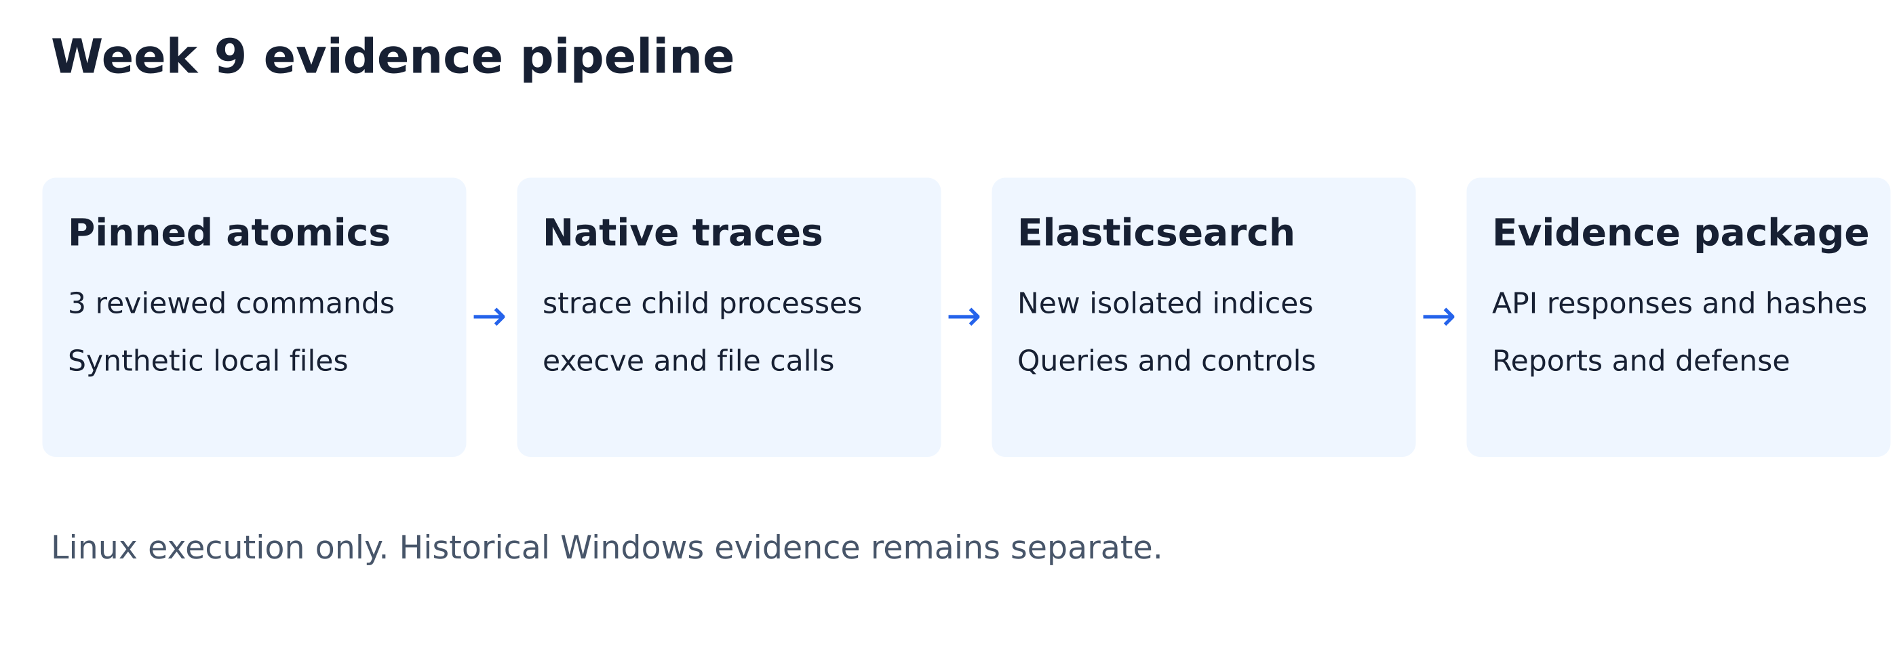
Figure 1. Evidence collection and analysis workflow. Original diagram, not a tool screenshot.
The collector traces only its child processes. The resulting events are labelled lab.strace and host.name is the fixed pseudonym LAB-LINUX. They are not Sysmon, Windows Security events or system-wide endpoint telemetry.

Original execution evidence from 8 November
Case | Exit code | execve events | Outcome
atomic_shell | 0 | 7 | Verified markers
atomic_gzip | 0 | 2 | Verified archive
atomic_tar | 0 | 4 | Verified archive
benign_backup | 0 | 4 | Benign control
plain_control | 0 | 1 | Benign control

The raw strace files preserve successful execve calls and file operations. Each normalized event records the originating trace filename and line number. Failed PATH lookups are excluded. Five parser/provenance tests cover successful launches, failed lookups, file-only calls, escaped arguments and reconstruction of every archived event.
The shell test produced all five expected marker lines. Decompressing the gzip file reproduced the exact mock-browser bytes. Reading the expected tar members reproduced the source browser and cookie files. SHA-256 values were saved before the generated archives were removed by cleanup. Synthetic inputs, output streams, traces and outcome records remain in the evidence directory.
Collection interval: 8 November 2026, 14:59:56–15:00:01 UTC, equivalent to 19:59:56–20:00:01 in Asia/Almaty. These are actual execution times, not assigned week dates.
Run ID: 20261108T145956001720Z

Reproducible commands
python3 scripts/collect_week9_atomics.py
python3 scripts/analyze_week9_elastic.py evidence/week9/<NEW_RUN_ID>
python3 -m unittest discover -s tests -v
Start the dedicated Elasticsearch instance first using config/week9-elasticsearch.yml. The full Markdown runbook gives the verified archive version, loopback ports, Kibana data-view setup and preservation rules. Each new collection has a unique directory and index; the analyzer refuses to overwrite an existing run.
Published source hashes permit byte-integrity checks. They establish consistency of the retained artifacts, not independent certification of the lab or production detection accuracy.

Original SIEM results from 8 November
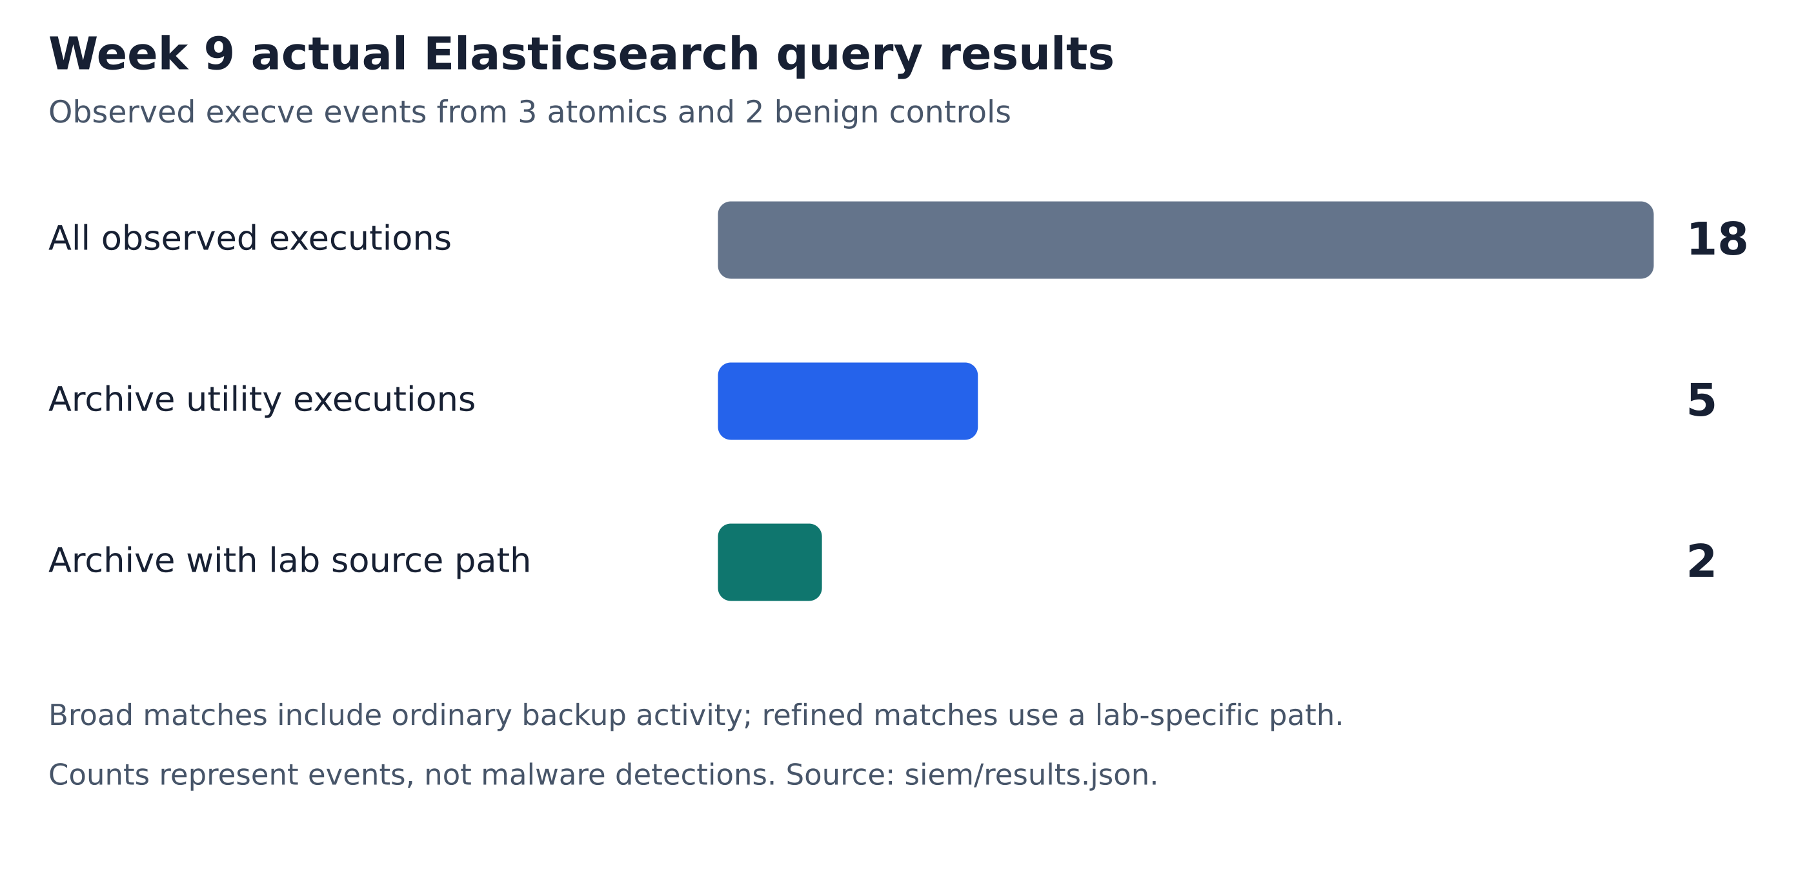
Figure 2. Counts calculated from the saved Elasticsearch responses.
The broad query selects process.name equal to tar or gzip within lab.strace. It excludes shell wrapper events even when their command strings mention an archiver. The refined query additionally requires an argument containing lab-browser. Neither query selects on case labels, expected outcomes or Atomic test IDs.
In the original five-case run, the refined query selected the two actual profile archives. The expanded experiment on the next page tests whether this interpretation holds when the marker appears only in the output name or a listing command.
The original search matched a substring anywhere in the argument list. The final query combines creation mode, a same-process open of a registered input and the archiver’s exit status.
Validation | Result
Collection versus ingestion count | Matched
Expected refined cases | atomic_gzip and atomic_tar
Separate boundary fixtures | 10 synthetic documents; 20 assertions passed
Archive integrity and cleanup | Passed

Elasticsearch and Kibana run as a separate loopback-only teaching instance. This increment implements custom collection and hunting in Elastic; it does not configure an Elastic Security integration or scheduled alerts. Use the archived UTC time range when demonstrating the observations.

Archive creation and write failures
15 scenarios, 43 process executions and 18 tar/gzip launches. Seven archiver processes opened a registered training input in create mode. Five exited 0 and two exited 2. All 60 expected case-level query counts matched the live Elasticsearch responses.
Control | Attempt / exit 0 / failed | Independent evidence
Atomic gzip and tar | 1 / 1 / 0 each | The original profile bytes were recovered from each output.
Backup of renamed profile | 1 / 1 / 0 | Both source members matched.
--file=out/long.tar | 1 / 1 / 0 | Long-form creation succeeded. Both members matched.
--file out/separate.tar.gz | 1 / 1 / 0 | Reordered long options and gzip compression succeeded.
List or extract archive | 0 / 0 / 0 each | Long-form listing and extraction exited normally.
Short or long write to /dev/full | 1 / 0 / 1 each | Both writers received ENOSPC and exited 2.
Other negative controls | 0 / 0 / 0 each | Six cases: shell atomic, ordinary backup, plain shell, destination-only backup, short listing and decompression.

Follow the evidence in one PID
The collector identifies the synthetic inputs before execution. The analyzer reads the archive mode from the command line and the input path from a successful read-only open. Its attempt query requires both. The success and failure queries add the native exit code of the same process image. Missing exit evidence leaves the attempt unclassified.
In the long-option failure trace, lines 12–13 show source opens, line 14 shows the failed write and line 22 records exit 2. In the successful long-option controls, the utility exited 0 and the archived members matched the expected bytes. Legitimate backups can meet the same conditions.
Fifteen executed cases and their Elasticsearch results
Native tar trace for a failed long-option write

Week 9 Windows archive controls
Windows Server 2022 Datacenter, build 20348 | 12 November 2026, 00:55 Almaty
We ran six tar.exe processes on a fresh VM with successful process and file auditing and an inherited audit rule on the training directory. Elasticsearch 9.5.5 indexed six 4688 process starts and fourteen 4663 file-access events.
Scenario | Qualifying native record IDs | Expected / observed pair
Profile archive | 4688 #1559826, 4663 #1559829 | Yes / Yes
Ordinary backup | 4688 #1559842 | No / No
Profile in output name | 4688 #1559858 | No / No
List archive | Neither predicate matched | No / No
Authorized backup | 4688 #1559876, 4663 #1559879 | Yes / Yes
List raw profile JSON | 4663 #1559893 | No / No

Read one pair from the Security log
PID 5116 (0x13fc) launched tar -cf at 19:55:22.6852380 UTC. About 65 ms later, the same process and logon 0x94dcb read profile\cookies.json with access mask 0x1. Independent extraction reproduced the input SHA-256. The authorized backup produced the same sequence.
Four processes requested create mode. Three read the registered file. Two satisfied both conditions on the same host, PID and logon within ten seconds. PID 3980 read the file in list mode and exited 1. All six outcomes matched the declared expectations.
Windows runner · Security XML · EQL request and response

Week 10 APT29 case analysis
APT29 is the selected group. MITRE identifies it as G0016 and links it to Russia’s SVR. SolarWinds is the main case; the later StellarParticle investigations are identified separately. Attribution is reported intelligence, not a conclusion drawn from our local test results. [1, 2]
FireEye’s December 2020 report describes SUNBURST delivery through compromised SolarWinds Orion updates. Its May 2022 attribution update associates the original UNC2452 activity with APT29. The investigation also reports temporary scheduled-task modifications followed by restoration. [3]
Microsoft’s January 2021 investigation describes archiving with 7-Zip, including password-protected and split archives. This is the direct behavioral bridge to our tar/gzip exercise, while the operating system, utility and additional options differ. [4]
CrowdStrike’s January 2022 StellarParticle report includes investigations extending into 2021. It reports Chrome profile and DPAPI material being accessed for cookies, as well as evidence of saved-password export. These observations are relevant to infostealers but must not be collapsed into a universal sequence for every Orion compromise. [5]
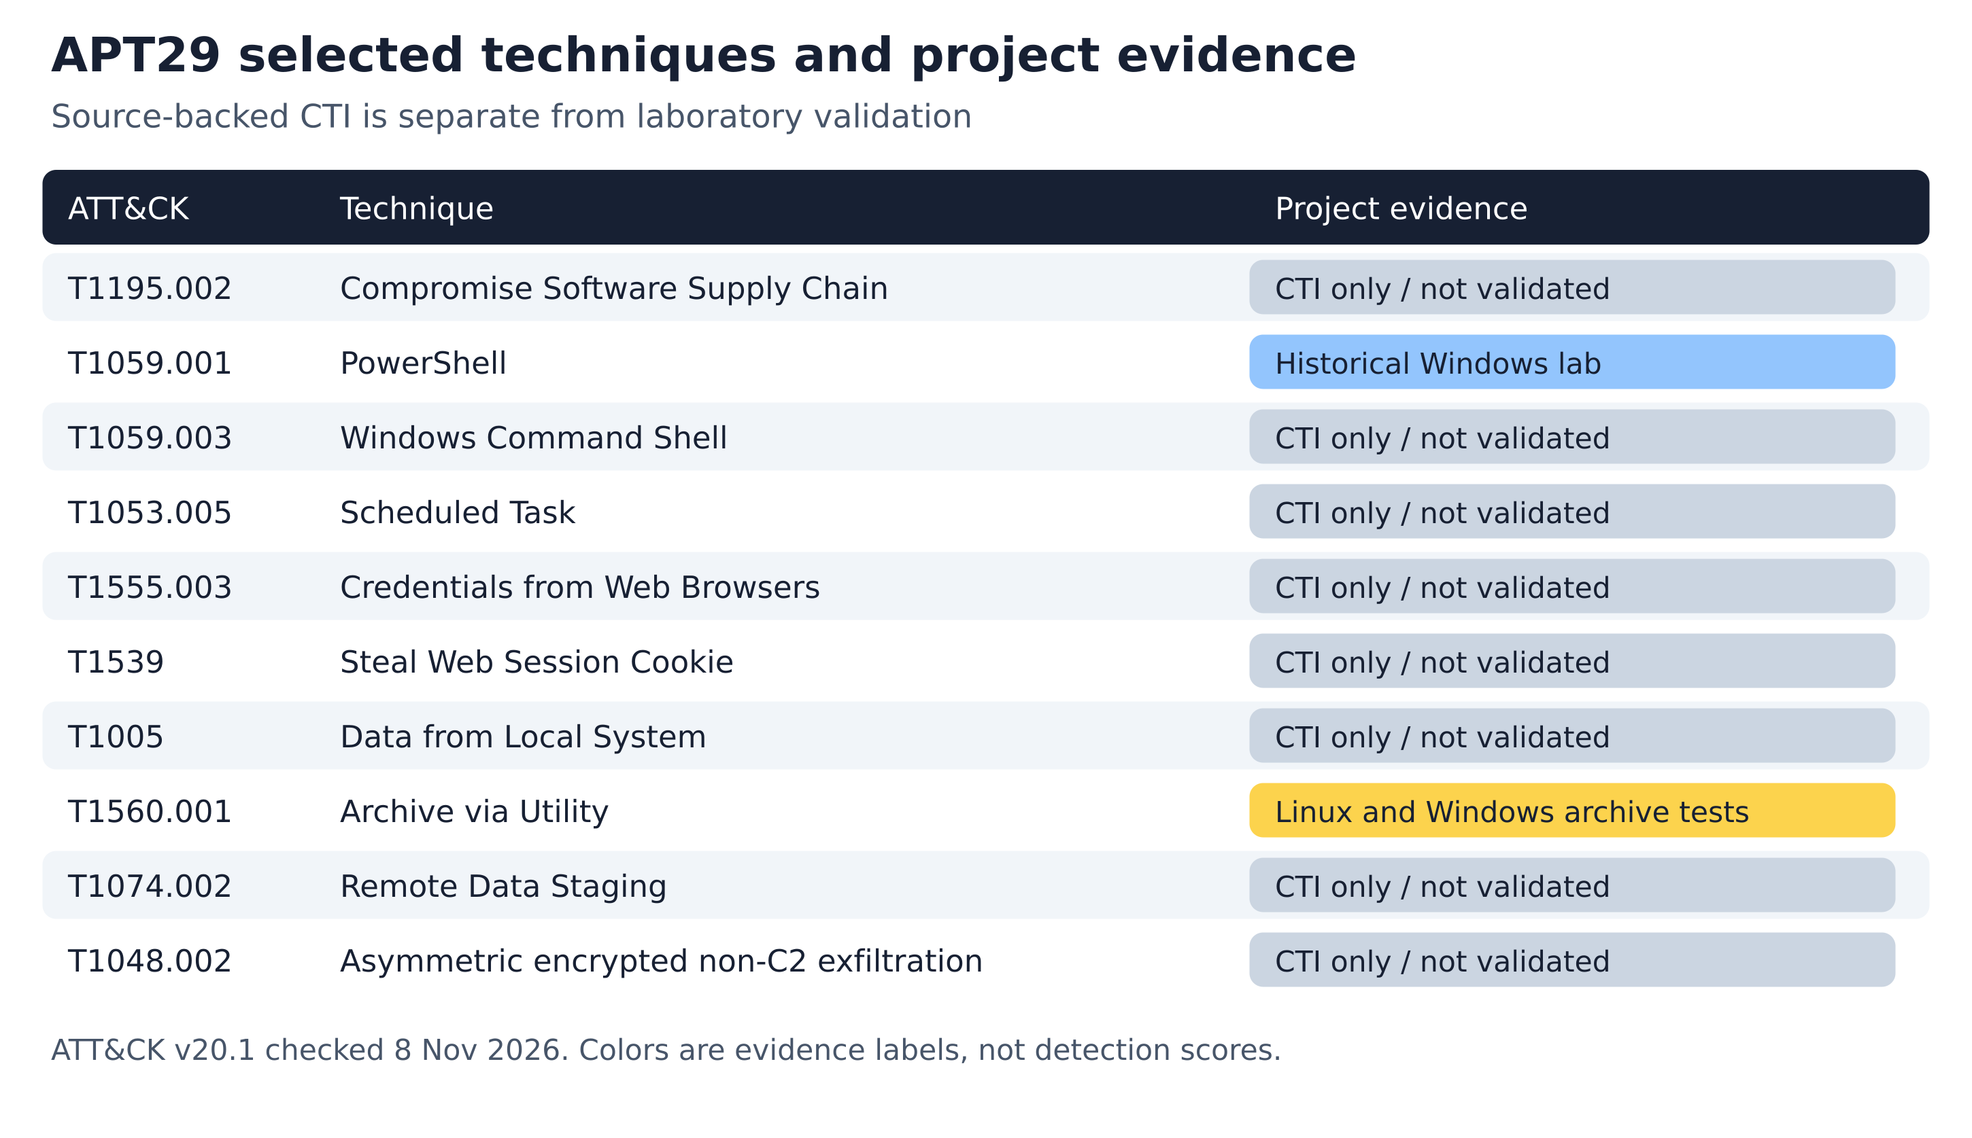
Figure 3. Ten selected mappings. Evidence categories are not coverage scores.
ATT&CK v20.1 was current on 8 November 2026. The Navigator layer identifies major version 20 and retains evidence-status comments. Its colors distinguish CTI-only items, historical Windows work and the Linux and Windows archive tests. [6]

Week 10 mapping and hunt priorities
ATT&CK | Observed behavior in sources | Project implication
T1195.002 | Trojanized software updates [3] | Delivery context only
T1059.001 / .003 | PowerShell and cmd activity [2] | Earlier Windows evidence stays historical
T1053.005 | Temporary task modification [3] | Collect task changes in a future VM run
T1555.003 | Saved browser-password export [5] | Mock JSON does not test credential access
T1539 | Browser cookie theft [5] | Fake cookies do not prove session theft
T1005 | Local PST supplied to 7-Zip [9] | Check a PST read by the archiver process
T1560.001 | 7-Zip archive creation [4] | Linux tar/gzip and Windows tar.exe tests
T1074.002 | Archives on an OWA server [2] | Local output is not remote staging
T1048.002 | HTTPS retrieval of staged data [2] | No transfer executed in this lab

Volexity documented the July 2020 mailbox export and the local 7-Zip input C:\Temp\b.pst. The PST operand supports the T1005 mapping. The export is remote email collection, compression is T1560.001, and the Redir.png output under the OWA web directory is staging. Volexity reported later retrieval and illustrated an HTTPS URL. The command does not itself establish a download or provide a file-read audit record. [9]

Remaining hunt priorities
The Windows run covers an archiver reading a registered file on one host. Collection by a separate process, remote staging and session reuse would each need additional telemetry. The Volexity PST and 7-Zip procedure remains a source-backed hunt proposal.
Process creation and file-created events alone do not demonstrate file reads. A local archive does not establish exfiltration. A plaintext mock record does not test browser credential decryption. The Unix shell test is T1059.004 and is not relabelled PowerShell or attributed to APT29.

Transparency and defense
The original increments were committed on 8 November. The 12 November work adds Linux failure controls, Windows Security audit evidence and a primary-source PST analysis. The timed defense guide covers both platforms.

Windows evidence for execution and browser access

Local PowerShell execution on 22 October
Event 400 record 28101 identifies PID 12292 and engine startup at 11:17:22.8355311 UTC. A CIM sample at 11:17:22.9908514 UTC identifies powershell.exe and its parent pwsh.exe (PID 2732). A run-specific stdout marker and identical SHA-256 values for the source and staged mock files corroborate the local copy. File access and identity activity require separate sensors.
Group evidence: native PowerShell event

Published StellarParticle investigation
T1555.003. RDP Bitmap Cache reconstruction displayed Chrome exporting saved passwords to a plaintext CSV. This supports an export in the observed session. Further evidence would be needed to determine subsequent use of that file.
T1539. Shellbags documented navigation through Chrome and DPAPI directories. A Falcon NewScriptWritten event identified the Cookie Editor extension. The investigators correlated these artifacts with session impersonation and assessed offline decryption as likely. Directory navigation alone cannot establish a copy or successful reuse.
CrowdStrike investigation, figures 2–4

Windows Security audit on 12 November
The Week 9 native Windows run linked 4688 NewProcessId with 4663 ProcessId, host, logon and event order. The six controls appear on the Windows archive page. A positive read needs both the registered input file and ReadData access mask bit 0x1.
Microsoft documentation for file access auditing (4663)
Microsoft documentation for process creation (4688)

Sources and deliverable guide
[1] MITRE ATT&CK APT29 group G0016
Live profile checked 2026-11-08. Accessed 8 November 2026.
[2] MITRE ATT&CK SolarWinds Compromise C0024
Live profile checked 2026-11-08. Accessed 8 November 2026.
[3] FireEye Mandiant SolarWinds supply chain investigation
2020-12-13; attribution update May 2022. Accessed 8 November 2026.
[4] Microsoft Solorigate second-stage investigation
2021-01-20. Accessed 8 November 2026.
[5] CrowdStrike Observations from the StellarParticle Campaign
2022-01-27; includes investigations extending into 2021. Accessed 8 November 2026.
[6] MITRE ATT&CK version history
v20.1 current when checked 2026-11-08. Accessed 8 November 2026.
[7] Atomic Red Team pinned source
[8] Syllabus 2026–2027 section 3.3
The syllabus file was read locally and checked against the authenticated LMS folder. Only a paraphrase of the relevant requirements is included; the course document is not republished.
[9] Volexity · Dark Halo and the SolarWinds compromise, 14 December 2020
Repository material | Purpose
docs/week9-atomic-red-team.md | Practical report and full reproduction guide
docs/week10-apt29-analysis.md | Source-qualified analysis and links
docs/weeks9-10-defense.md | Timed script and rehearsal questions
evidence/week9/<RUN_ID>/ | Native traces, collection checks and SIEM evidence
data/week9/ and data/week10/ | Pinned tests, source register and ATT&CK mapping

AI assistance: OpenAI Codex assisted with research, mapping, code, lab execution, verification and writing. The group should review and understand the work and follow the instructor’s AI-permission and disclosure requirements. This document does not assert that instructor permission was granted.

