ClaimIQ
Project Architecture & Execution Evidence
Claims Management • Document Processing • AI/RAG Policy Query

TEAM MEMBERS
Praneetha • Segu • Tasmiya • Karthik

1. Project Overview
ClaimIQ is a claims-management application with a document-processing and AI-assisted policy-search capability. The claims module supports creating and viewing claims, assigning claims to adjusters, changing workflow status, recording notes, and retrieving summary analytics. The document/RAG path lets a user register a policy document, process its content, and ask a question that is answered using relevant policy text.

2. Solution Architecture
The diagram below is a logical view of the components and request flow. It describes the intended integration reflected in the project workflow; it is not a deployment diagram showing network boundaries or production hosting.
USER / REVIEWER / ADJUSTER
Uses Swagger UI or the ClaimIQ dashboard to sign in and operate the application.
↓
FASTAPI APPLICATION
Authenticates requests and exposes claim, assignment, workflow, notes, analytics, document, and AI query APIs.
↓
CLAIMS MANAGEMENT + AUTHORIZATION
Validates access, manages claims and status history, assigns adjusters, stores notes, and returns analytics.
↓
POSTGRESQL DATABASE
Stores application records such as users, policies, claims, assignments, notes, workflow history, and document metadata.
↓
DOCUMENT / RAG PIPELINE
Uploads a policy file to Blob Storage, extracts and chunks text, creates embeddings, and indexes chunks for retrieval.
↓
AZURE SERVICES FOR RAG
Azure Blob Storage holds source files; Azure OpenAI provides embeddings and answer generation; Azure AI Search retrieves relevant indexed chunks.
↓
ANSWER + SOURCES
The API returns an AI-generated response based on retrieved policy content, with source information when provided by the implementation.

3. Main Components in Simple Terms
- Swagger UI: A browser page used to call and test the APIs without writing a separate client application.
- FastAPI: The backend service. It receives API requests, checks authentication and permissions, runs the application logic, and returns responses.
- PostgreSQL: The relational database used for structured application records. The exact tables and fields are defined by the project models.
- Azure Blob Storage: Stores uploaded policy-document files.
- Azure AI Search: Searches indexed text chunks so the application can retrieve policy passages relevant to a question.
- Azure OpenAI: Creates vector embeddings for text and helps generate an answer using retrieved policy information.
- Dashboard: A Streamlit interface that calls the FastAPI API to display claim analytics; locally, it normally runs as a separate process.

4. End-to-End Workflows

4.1 Claims Management
- The user signs in and receives an access token.
- The customer creates a claim with a description and claimed amount.
- The application stores the claim and returns its claim ID.
- An authorized user retrieves the claim, assigns an adjuster, and updates its status with a justification.
- The adjuster adds a note; the note can then be retrieved for review.
- Authorized users can request analytics summaries and audit information.

4.2 Policy Document and RAG
- Upload a policy document with its policy code, document name, version, effective date, and file.
- The application stores document metadata and the file in the configured storage location.
- Call the process endpoint for the returned document ID.
- The processing pipeline extracts text, splits it into chunks, creates embeddings, and indexes those chunks in Azure AI Search.
- Submit a natural-language question to the AI/RAG query endpoint.
- The application retrieves relevant policy text and uses the configured Azure OpenAI deployment to formulate a response.
Important: uploading a PDF directly into Azure Blob Storage by itself does not necessarily register it in the application database or index it for RAG. Use the application document-upload endpoint and then process the returned document ID when following the API workflow.

5. Database Tables and Their Purpose
ClaimIQ uses PostgreSQL for structured application data. The following tables are defined by the project’s SQLAlchemy models. This section explains the purpose of each table and the main information it stores; it does not expose passwords or other secret values.
Table | Information stored | Why it is used
users | User ID, username, password hash, role, active flag. | Identifies people who can sign in and records their application role. The password is stored as a hash, not plain text.
policies | Policy ID/number, holder, optional owner user ID, active flag. | Represents policies that can be associated with claims. The owner links a policy to a customer account.
claims | Claim ID, policy ID, owner ID, assigned adjuster ID, description, status, amount, created/assigned/decision/closed timestamps. | Stores the main claim record and supports assignment and workflow tracking.
claim_status_history | Claim ID, actor ID, old status, new status, justification, timestamp. | Keeps a record of claim status transitions and the justification provided for a change.
claim_notes | Claim ID, author ID, note text, timestamp. | Stores comments or notes added by users, such as adjuster review notes.
audit_logs | Actor ID, action, resource, timestamp. | Records audit events so application activity can be reviewed.
documents | Document ID, policy code, document name and filename, blob path, file type/size, version, processing status, active flag, effective dates, checksum, uploader, superseded document link, processing error, and timestamps. | Tracks policy documents uploaded to ClaimIQ, their versions, lifecycle status, and processing information.
document_chunks | Chunk ID, document ID, chunk number, extracted text, optional page/section, active flag, timestamp. | Stores text segments produced during document processing. These chunks are used to connect a source document with its extracted content.
chat_query_logs | Query ID, user ID, question, answer, serialized source information, response time, status, timestamp. | Keeps a record of AI/RAG questions and responses for traceability and troubleshooting.

6. API Groups Visible in Swagger
API group | Purpose
System | Health check endpoint.
Authentication | Login and token issuance.
Users | User-related read endpoints.
Policies | Policy lookup/listing endpoints.
Claims | Create and retrieve claims.
Assignment | Assign a claim to an adjuster.
Workflow | Change claim status and retrieve status history.
Notes | Add and list claim notes.
Analytics | Retrieve claims summary metrics.
Audit | Retrieve audit-log information.
Documents | List, upload, process, retrieve, and activate/deactivate policy documents.
AI / RAG | Submit a policy question and retrieve an answer based on indexed document content.

7. Execution Evidence
The following screenshots are preserved from the supplied execution document. Each screenshot is introduced with a heading and a short explanation. The screenshots show the request forms and visible API responses in Swagger UI; where a response value is too small to read clearly, this document does not guess it.

6.1 Swagger API Catalogue
The overview lists the available API groups for claims, assignment, workflow, notes, analytics, audit, document management, and AI/RAG queries.
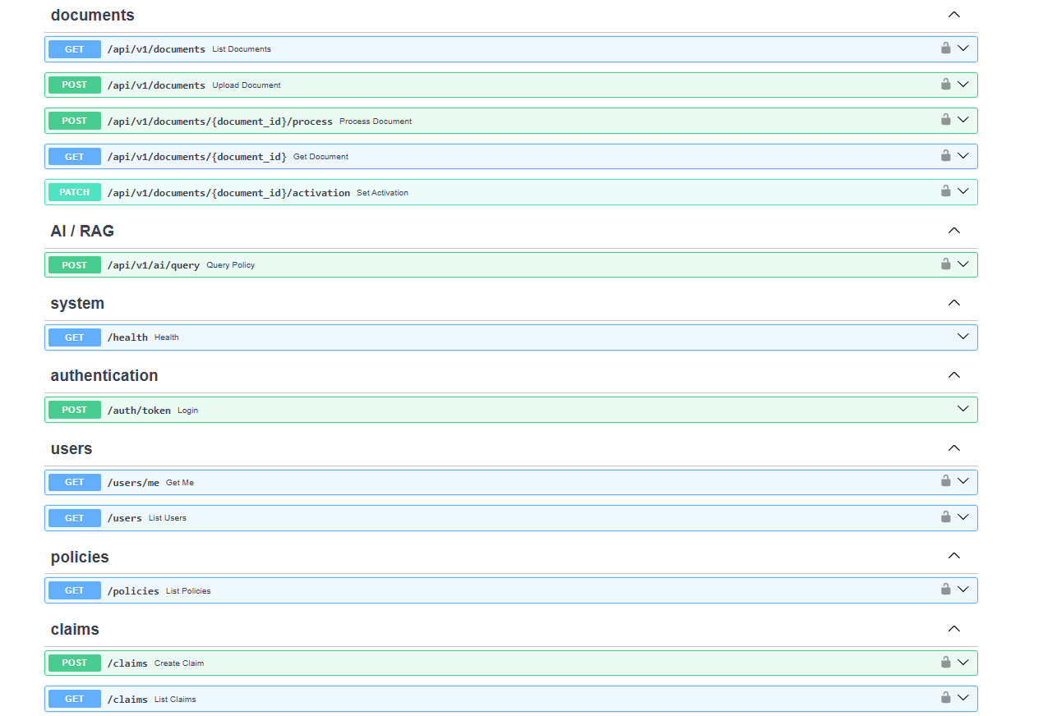

6.2 Create a Claim
The POST claim endpoint is used to submit a claim description and amount. The response shown in Swagger provides the created claim record and its identifier.
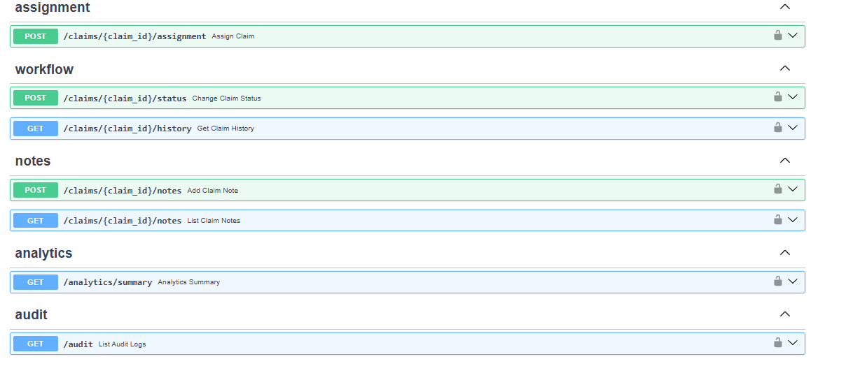

6.3 Retrieve a Claim
The GET claim endpoint retrieves the claim by its claim ID so the user can confirm the saved details.
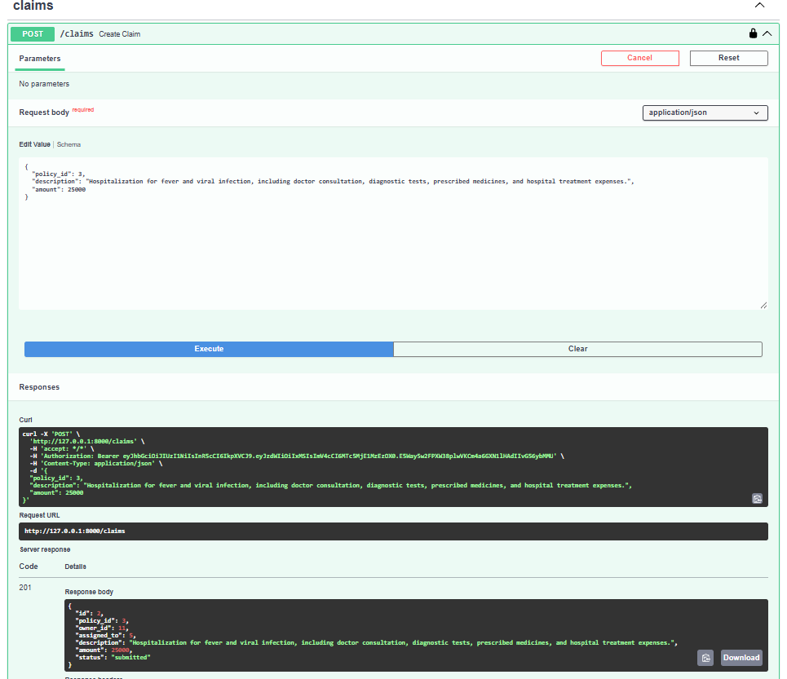

6.4 Update Claim Status
The workflow endpoint submits a new status and a justification. This is the evidence for the status-transition step.
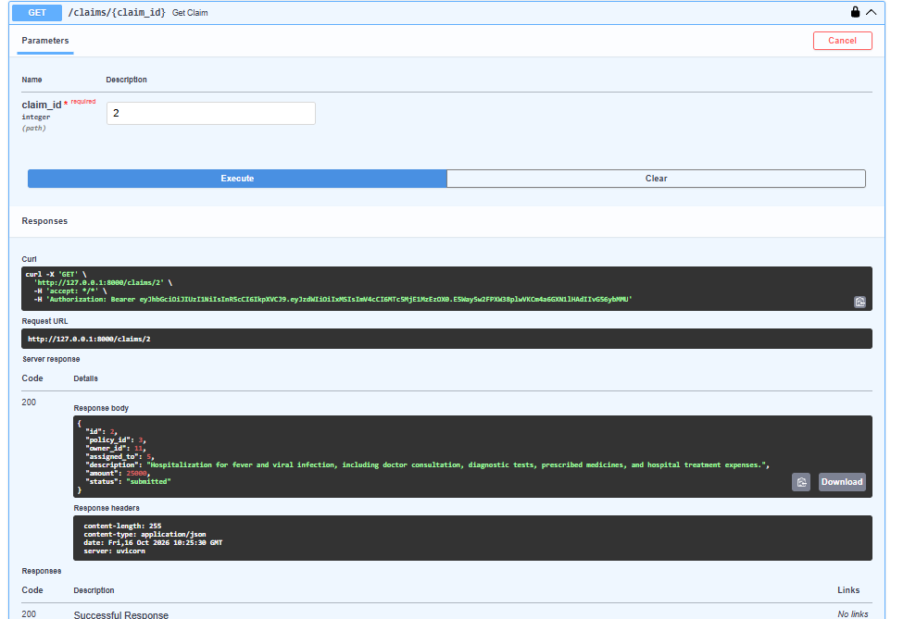

6.5 Add an Adjuster Note
The notes endpoint records a note against the claim for review and follow-up.
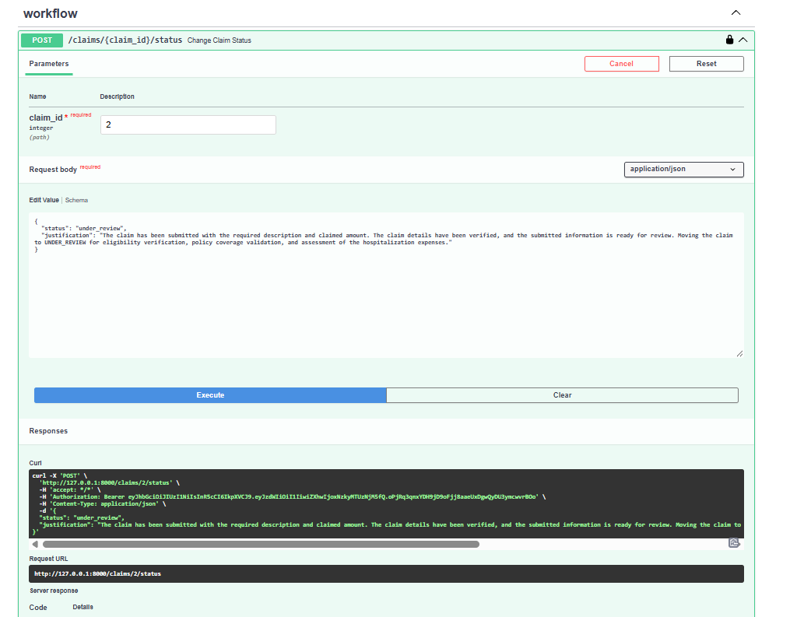

6.6 Retrieve Claim Notes
The GET notes endpoint returns notes associated with the selected claim.
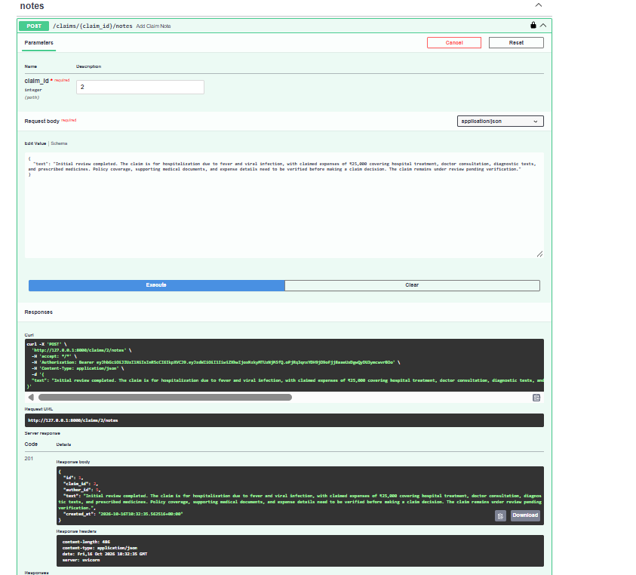

6.7 Upload a Policy Document
The document-upload endpoint accepts policy metadata and a selected file. The response includes a document ID used by the next processing step.
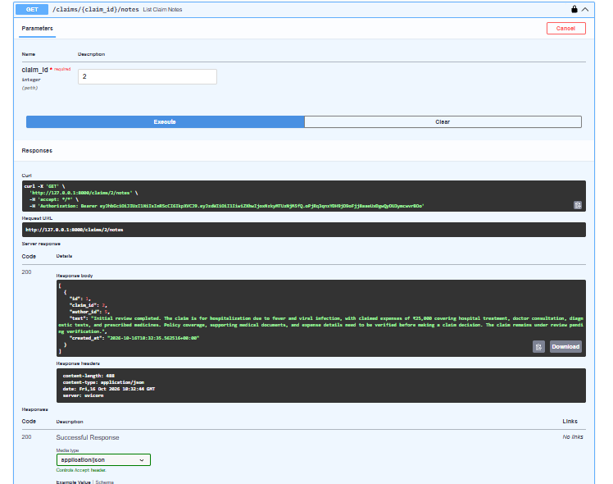

6.8 Process the Uploaded Document
The process endpoint is called with the document ID. The visible response indicates the processing result/status returned by the API.
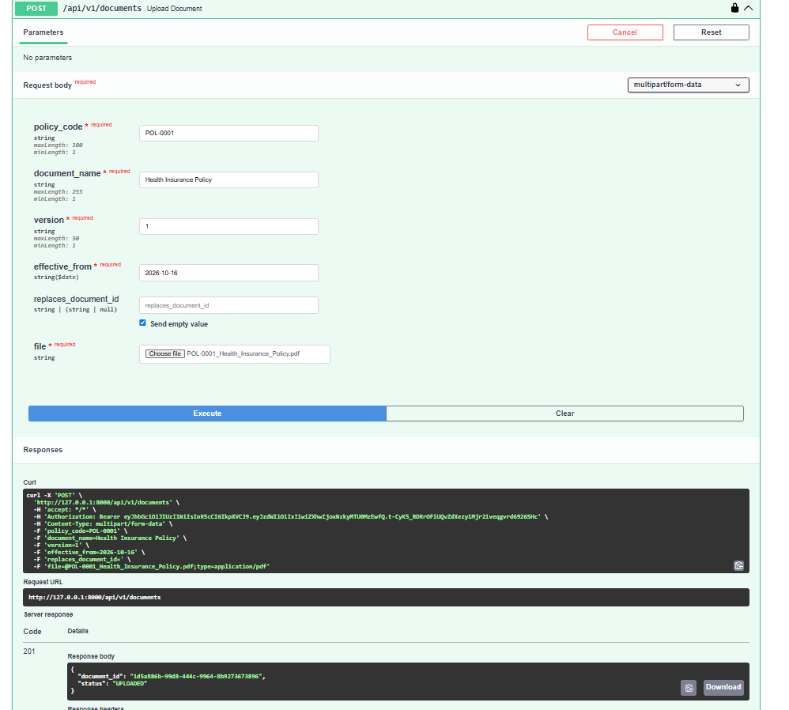

6.9 Ask a Policy Question with AI/RAG
The query endpoint submits a question about the hospitalization claim and requests relevant policy guidance from the processed policy documents.
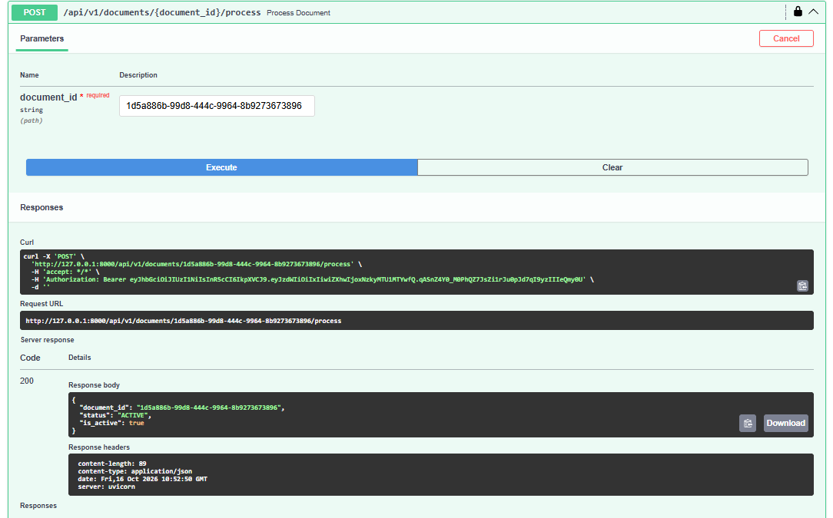

6.10 Additional Swagger Evidence
Additional screenshot from the supplied document, retained in its original order for completeness.
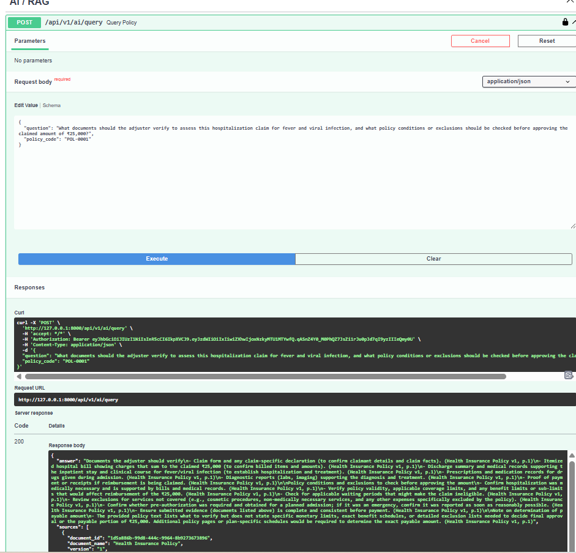

8. Scope and Important Notes
- This document describes the functionality evidenced by the supplied screenshots and the known project architecture.
- The architecture is a logical component view; exact production network topology, scaling, monitoring, and deployment boundaries are not represented here.
- Policy coverage decisions must be made by an authorized reviewer using the applicable policy and claim evidence. An AI-generated answer is assistance, not an automatic claim decision.
- Screenshots are retained from the provided source document; some small response text may not be legible at print size. Use Swagger directly for live values during a client demonstration.

