CLOUDGUARD

Architecture Document
Phase 1 • Azure infrastructure compliance and remediation
Document purpose: explain the implemented application architecture, request flows, API surface, database tables, authentication, Azure access, and operational boundaries in plain language.

Document control
System | CloudGuard
Implementation style | Modular monolith
API framework | FastAPI / Uvicorn
Database | PostgreSQL via SQLAlchemy
Azure authentication | AzureCliCredential (Azure CLI session)
API prefix | /api/v1
Scope | Two initial policies: VM tag and NSG inbound source

1. Executive summary
CloudGuard is a FastAPI application that checks registered Azure subscriptions for two initial compliance conditions. It stores scan metadata, findings, remediation actions, users, policy configuration, and audit events in PostgreSQL. It uses a modular monolith structure: a single application process with separated API, core, database, model, schema, and service modules.
The low-risk policy automatically attempts to add Environment=dev to a VM when the Environment tag is missing. The high-risk policy detects inbound NSG Allow rules whose source is 0.0.0.0/0 and waits for approval by a CloudGuard SECURITY_OFFICER or ADMIN before attempting a source-CIDR change.

2. Logical architecture
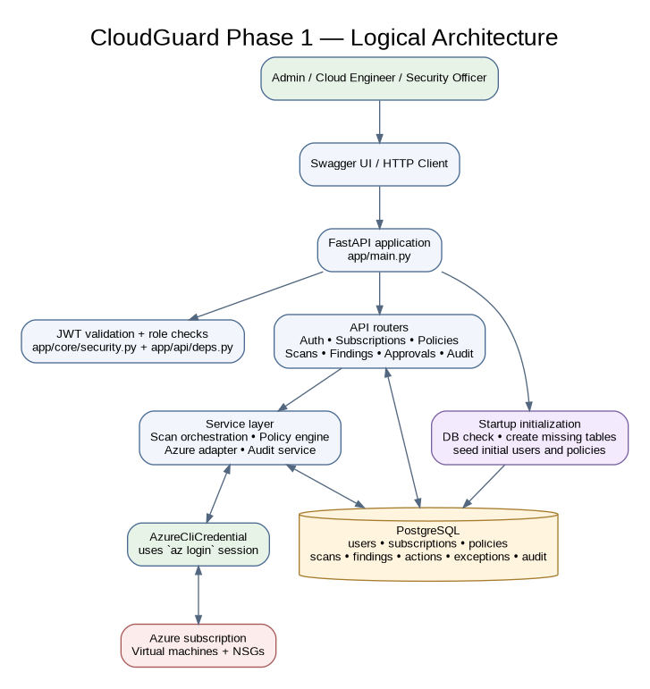
Figure 1. Main runtime components and integrations.

2.1 Component responsibilities

FastAPI app (`app/main.py`)
Creates the app, initializes the database at startup, and mounts routers under /api/v1.

API routers (`app/api/`)
Expose login, subscription, policy, scan, finding, approval, health, and audit endpoints.

Core (`app/core/`)
Reads configuration and implements password/JWT helpers.

Database (`app/db/`)
Builds the SQLAlchemy engine/session and performs startup database/table/seed initialization.

Models (`app/models/`)
Declare the PostgreSQL table structure.

Schemas (`app/schemas/`)
Validate request payloads and shape API responses.

Services (`app/services/`)
Implement scan orchestration, Azure SDK calls, policy predicates, and audit recording.

PostgreSQL
Persists CloudGuard application metadata; it is started by Docker Compose.

Azure SDK
Reads VMs and NSGs and attempts tag/rule changes using the Azure CLI identity.

3. Execution and request flow
- The developer starts PostgreSQL with Docker Compose and launches Uvicorn on the local machine.
- At application startup, CloudGuard checks the configured database, creates missing tables, and inserts configured users/policies if they do not exist.
- The user calls POST /api/v1/auth/login. CloudGuard verifies the stored password hash and returns a signed JWT.
- Protected routes validate the bearer token and reload the active user from PostgreSQL. Role-restricted routes check ADMIN or SECURITY_OFFICER as appropriate.
- A scan request must reference an active subscription already registered in CloudGuard.
- The scan service loads enabled policies, calls AzureService, creates findings and remediation records, and writes audit events.
- For a low-risk missing-tag finding, the service attempts the tag update during the scan. For a high-risk NSG finding, it sets PENDING_APPROVAL and does not change the NSG at scan time.
- An authorized Security Officer or Admin submits a restricted IPv4 CIDR to the approval endpoint. That endpoint records the action and attempts the Azure NSG update.
- The client verifies actual Azure state and checks findings/audit logs to confirm the outcome.

4. Policy behavior

4.1 Low risk: VM Environment tag
Policy code: VM_REQUIRED_ENVIRONMENT_TAG. Target resource type: Microsoft.Compute/virtualMachines. Severity: LOW. Configuration defaults: required_tag=Environment, default_value=dev, auto_remediate=true. When the tag is missing, a finding and remediation action are created; Azure tag merge is attempted. On success, action status becomes SUCCEEDED and finding status RESOLVED. On failure, action status becomes FAILED and finding status OPEN.

4.2 High risk: NSG inbound open to all IPv4
Policy code: NSG_INBOUND_ANY_IPV4. Target resource type: Microsoft.Network/networkSecurityGroups. Severity: HIGH. A matching inbound Allow rule with a source prefix representing IPv4 /0 creates a PENDING_APPROVAL finding. Only SECURITY_OFFICER or ADMIN may list/approve pending items. Approval validates that the replacement is IPv4 and has a prefix length greater than zero, then attempts to update the NSG rule. The correct CIDR must be supplied by the organization; the application cannot infer it.
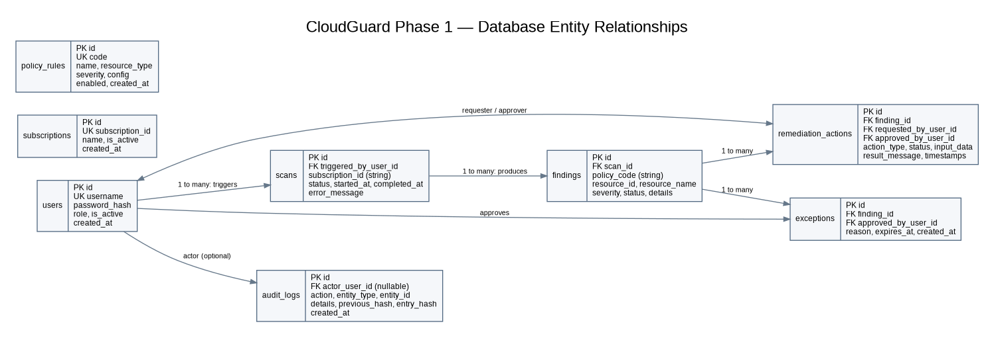
Figure 2. Entity relationships. Solid edges represent declared foreign-key relationships. String fields such as scans.subscription_id and findings.policy_code are not foreign keys in the current models.

5. Database design
The database contains eight model tables. `Base.metadata.create_all()` creates missing tables, but it is not a schema migration system. Existing rows are preserved; initial users and policies are inserted only when the corresponding username/policy code is absent.
Table | Purpose
users | Stores user accounts, Argon2 password hashes, role, active state and creation time.
subscriptions | Stores the Azure subscriptions registered by an Admin.
policy_rules | Stores policy code, description, resource type, severity, JSON configuration and enabled state.
scans | Stores each scan run, the subscription ID, triggering user, status, timestamps and error text.
findings | Stores discovered compliance issues, resource identity, policy code, severity, status and JSON details.
remediation_actions | Stores requested/approved user references, action type/status, input and result messages.
exceptions | Stores exception reason, approver and expiry. A model/table exists, but no exception API routes are exposed in this phase.
audit_logs | Stores actor/action/entity/details plus previous and current hashes for a hash-linked audit chain.

5.1 Relationships and schema notes
- users.id is referenced by scans.triggered_by_user_id, remediation_actions requester/approver IDs, exceptions.approved_by_user_id, and audit_logs.actor_user_id (nullable).
- scans.id is referenced by findings.scan_id.
- findings.id is referenced by remediation_actions.finding_id and exceptions.finding_id.
- subscriptions.subscription_id is not a declared foreign key from scans.subscription_id in this version.
- findings.policy_code is a string and is not a declared foreign key to policy_rules.code.
- Changing SEED_*_PASSWORD does not reset an already-existing user password; initialization only seeds users that are missing.

6. API reference
All endpoints below use the /api/v1 prefix. Except for the health check and login, the listed endpoints require a CloudGuard bearer JWT.
Method | Endpoint (relative to /api/v1) | Purpose | Access
GET | /health | Health check | Public
POST | /auth/login | Verify credentials and return access token | Public
GET | /subscriptions | List registered subscriptions | Authenticated
POST | /subscriptions | Register Azure subscription | ADMIN
GET | /policies | List seeded/configured policies | Authenticated
PATCH | /policies/{policy_id}/enabled?enabled=true | Toggle policy enabled state | ADMIN
POST | /scans | Start scan for registered active subscription | Authenticated
GET | /scans/{scan_id} | Read scan status | Authenticated
GET | /findings | List findings; supports status/severity filters | Authenticated
GET | /approvals/pending | List pending approval findings | SECURITY_OFFICER or ADMIN
POST | /approvals/findings/{finding_id}/approve | Approve and execute NSG rule source update | SECURITY_OFFICER or ADMIN
GET | /audit-logs?limit=100 | Read audit entries; limit 1–500 | ADMIN

7. Authentication and authorization
CloudGuard user login and Azure login are separate. CloudGuard login uses a password hash stored in users and issues a JWT signed with JWT_SECRET_KEY. The bearer token identifies a user and role. Protected routes decode the token, check its expiry, load the current user, and apply role checks. AzureCliCredential instead uses the Azure CLI login session created by az login to authenticate Azure SDK requests.
Seed roles: ADMIN, CLOUD_ENGINEER, SECURITY_OFFICER. Subscription registration and audit-log reading are Admin-only. Pending approval listing and NSG approval are allowed to Security Officer or Admin. Other protected routes require any active authenticated user unless otherwise noted.

8. Configuration and deployment assumptions
- The current code uses AzureCliCredential; UAMI-specific AZURE_CLIENT_ID is not used by the AzureService implementation.
- The supplied Docker Compose file runs postgres:16-alpine and maps host port 5433 to container port 5432. The local Python app should use port 5433 in DATABASE_URL.
- The database password in DATABASE_URL must match the initialized PostgreSQL user. Changing POSTGRES_PASSWORD after a persistent volume is initialized does not rotate the existing database password.
- CLOUDGUARD_AZURE_MOCK=true uses hard-coded sample VMs/NSG data and suppresses Azure changes; false enables real Azure SDK calls.
- The app runs directly in Python for this phase. Docker/Kubernetes deployment of the app, AKS, CI/CD, scheduled scans and email notifications are not implemented here.

9. Security considerations and known limitations
- Change the default JWT secret and development seed passwords before use beyond a disposable local environment. Never commit .env.
- Use least-privilege Azure RBAC. Scanning requires read access; VM tagging and NSG remediation require narrowly scoped write access.
- Use a safe test subscription and a reviewed replacement CIDR for NSG remediation.
- The approval endpoint records approval and executes the NSG change in the same request; it is not a separate asynchronous approval workflow.
- Audit hashes make the chain tamper-evident, not immutable against an administrator who can rewrite the entire database. Production should export/anchor audit records to protected storage.
- The current tests cover policy/security helpers only. They do not prove live Azure permission behavior or production readiness.
- The NSG scan enumerates NSGs in the registered subscription and does not currently restrict itself to NSGs attached to VM NICs.

10. Repository documentation
README_ARCHITECTURE.md explains the codebase and diagrams. README_RUNBOOK.md provides the command-by-command local setup and Swagger test flow. The repository README.md should link to both documents so new contributors can find them quickly.

