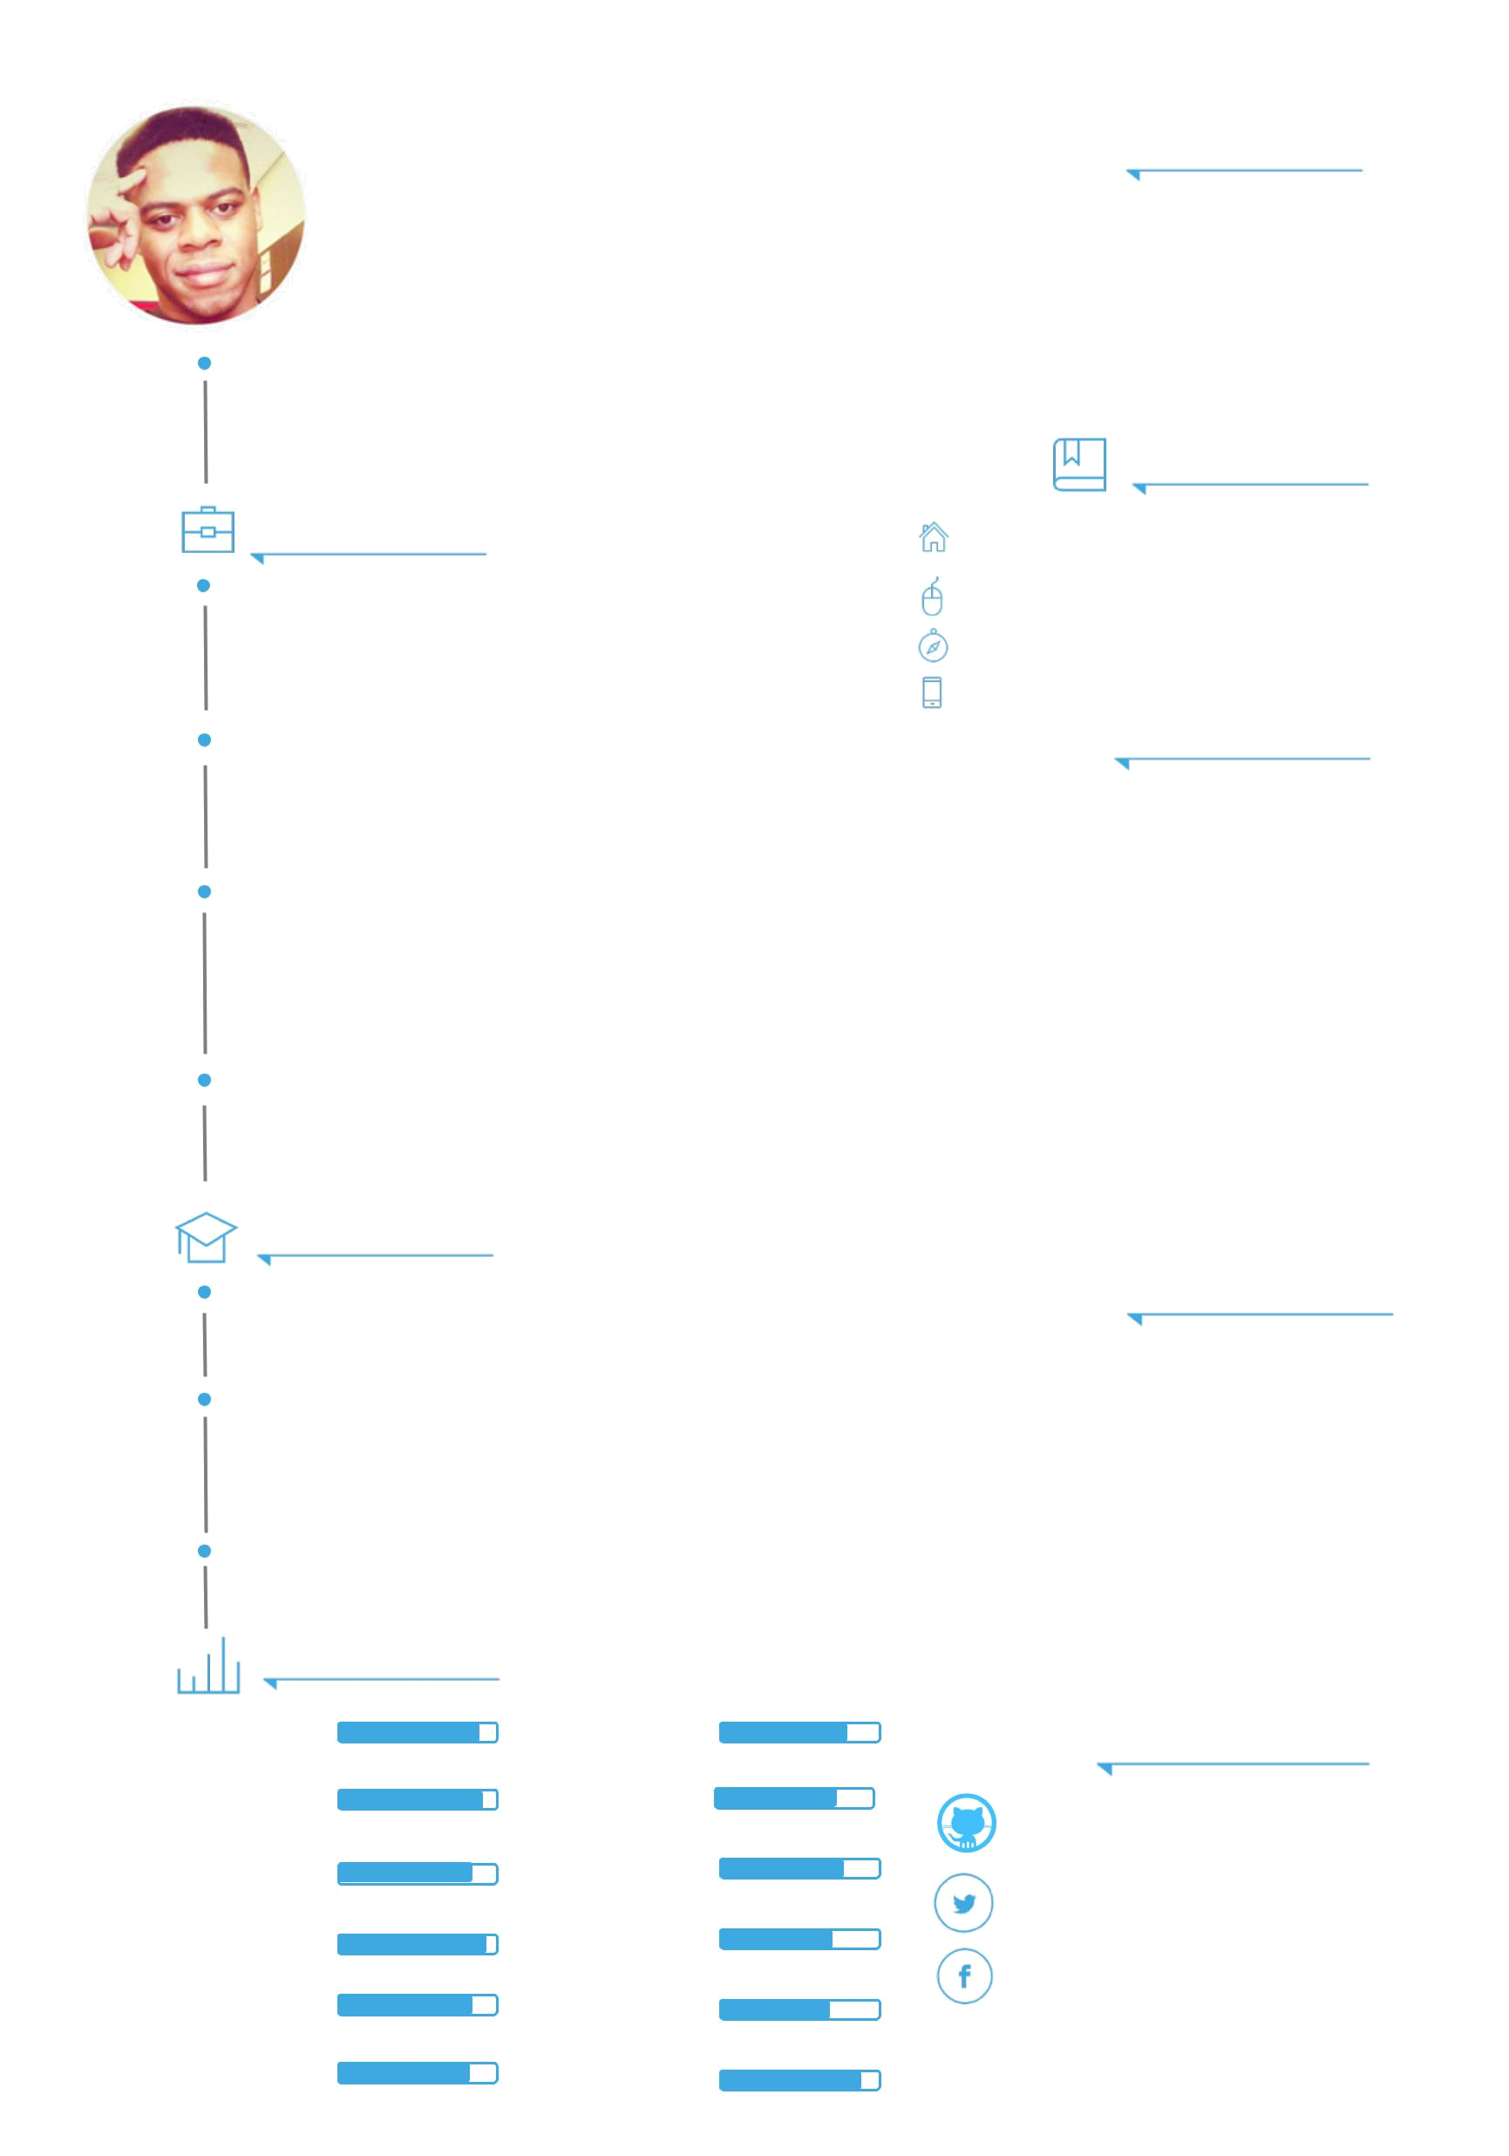
Mbemba
Claudius

Adventure addict, Life learner,

World traveler, Entrepreneur,

Software Engineer

 | WORK EXPERIENCE
MAR 2016 | M I C R O S O F T
PRESENT | Software Development Engineer: Working under the Office
 | Product Group (OPG) developing applications to solve the issue of
 | productivity on mobile. Shipped Version 3 of Outlook for Apple
 | Watch / iOS. Built Outlook for Alexa/Amazon Echo
MAY 2015 | M I C R O S O F T
AUG 2015 | SDE Intern: Built an internal health-monitoring dashboard that
 | would alert Service Engineers & Program Managers of outages and
 | service downtime so problems could be promptly resolved for our
SEPT 2014 | customers.
SEPT 2014 | O S U T E C H C O M M E R C I A L I Z A T I O N O F F I C E
MAY 2015
 | Software Developer: Built an inventorying and reordering system
 | for dermatologists consisting of an iOS mobile application with
 | barcode scanning functionality, a SQL database, and a Ruby on
 | Rails backend system for the Administrator to monitor the data
NOV 2013 | received, patients, and inventory.
NOV 2013 | F U N D S T A R T E R
DEC 2014 | F U N D S T A R T E R
DEC 2014 | Co-Founder & CEO: Developed a web-based platform that helps
 | non-profits fundraise. Registered company as an LLC, secured legal
 | aid for our operations. Partnered with various charities &
 | corporate entities.
 | EDUCATION
AUG 2011 | B A C H E L O R ’ S D E G R E E
DEC 2015 | The Ohio State University: Majored in Computer Science with a
 | minor in Spanish and a strong focus on Entrepreneurship.
ONGOING | O N L I N E L E A R N I N G
ONGOING | University of the Web: From Lynda to Udemy, I’ve taken my
 | education beyond the classroom walls & constantly take MOOCS
 | to improve my knowledge of different programming languages /
AUG 2008 | emerging web & mobile tech.
AUG 2008 | H I G H S C H O O L D I P L O M A
JUN 2011
 | Olentangy High School: Summa Cum Laude; Graduated top 5% of
 | class.
 | SKILLS
TEAM WORK |  | HTML5
INNOVATION |  | CSS3
COMMUNICATION |  | PHP/MYSQL
 | AMBITION | JAVA
 | PROJECT | RUBYONRAILS
MANAGEMENT |  | RUBYONRAILS
 | JS | OBJECTIVE-C
 PROFILE

Hola I’m Claudius: I am an aspiring entrepreneur and

a mobile / web developer residing in Seattle, WA. When I’m not busy building mobile apps or side hustling, I love to travel, play sports and spend time with friends and family.

CONTACT ME

4717 Brooklyn Ave NE, Seattle WA 98105

mbembac@gmail.com

www.claudiusmbemba.com

740 641 0248

ORGANIZATIONS

OSU ALUMNI SOCIETY, SEATTLE CHPT, BOARD CHAIR

MICORSOFT VENTURES ACCELERATOR, MENTOR

COSTART ENTREPRENEURSHIP ORG, PRESIDENT

SPHINX SENIOR CLASS HONORARY, VICE PRESIDENT

BUSINESS BUILDERS CLUB, MEMBER

STARTUP WEEKEND COLUMBUS, ORGANIZER

NAT. SOCIETY OF COLLEGIATE SCHOLARS, MEMBER

VARSITY FOOTBALL, FORMER BUCKEYE DEF. END

HONORS / AWARDS

OSU Scholar Athlete (2 time)

National MLK Jr. Scholar

Dean’s List (3 time)

Governor’s Certificate of Achievement

National Wendy’s Heisman Athlete

Columbus Dispatch Scholar Athlete

OSU Morrill Excellence Scholar

REACH ME ONLINE AT

GITHUB.COM/USER1M

TWITTER.COM/CTHABEAST_1

FACEBOOK.COM/MBEMBAC

